Oracle 11g step-by-step Installation Guide with Screenshots

This is a 16 step Oracle 11g installation guide that covers a typical installation scenario with screenshots.
1. Select installation method
Following two installation methods are available:
- Basic Installation – Choose this to perform the full Oracle Database 11g installation with standard configuration options. You can use only filesystem for storage in this option.
- Advanced Installation – This gives your full control over the installation, including the ability to choose Automatic Storage Management. Select this option as shown below.

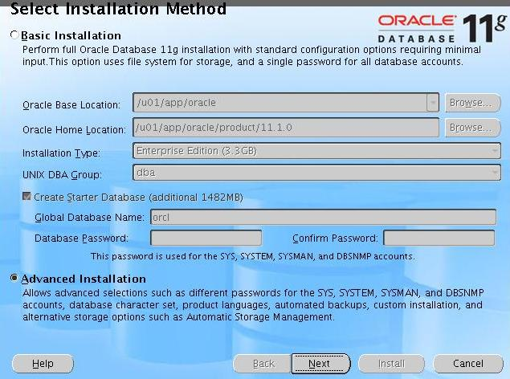
Fig - Select Installation Method

2. Specify Inventory directory and credentials
Enter the following information:
- Enter the inventory directory: /u01/app/oraInventory
- Specify operating system group name: oinstall

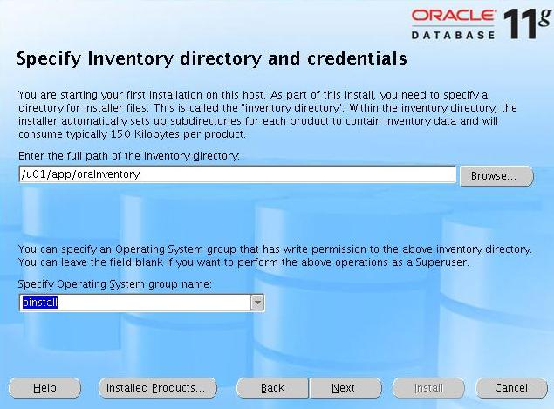
Fig - Specify Inventory directory and credentials

3. Select Installation Type
Following three installation types are available:
- Enterprise Edition – Select this option.
- Standard Edition
- Custom

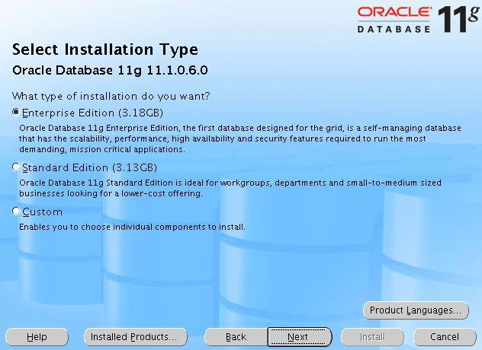

Fig - Select Installation Type

4. Specify Install Location
Enter the following information:
- Oracle Base: /u01/app/oracle
- Name: Oracle_Home
- Path: /u01/app/oarcle/product/11.1.0

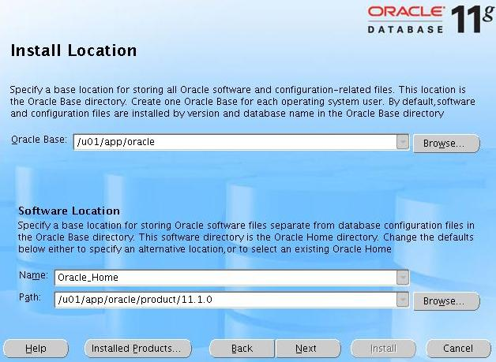
Fig - Select Install Location

5. Product-Specific Prerequisite Checks
In this screen, the Installer verifies that your environment meets all of the minimum requirements for installing and configuring the products that you have chosen to install. You must manually verify and confirm the items that are flagged with warnings and items that require manual checks.

6. Select Configuration Option
Following three configuration options are available:
- Create a Database – Select this option.
- Configure Automatic Storage Management (ASM)
- Install Software Only

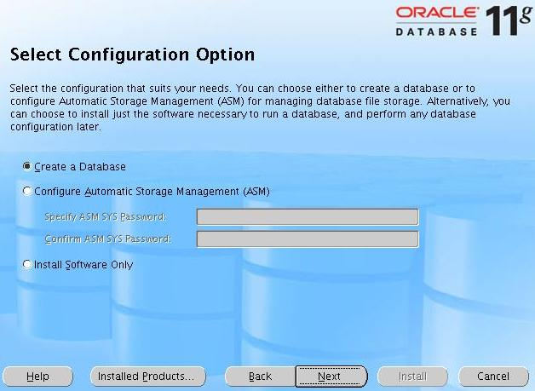
Fig - Select Configuration Option

7. Select a Database Configuration
Following three database configuration options are available.
- General Purpose/Transaction Processing – Select this option.
- Data Warehouse
- Advanced

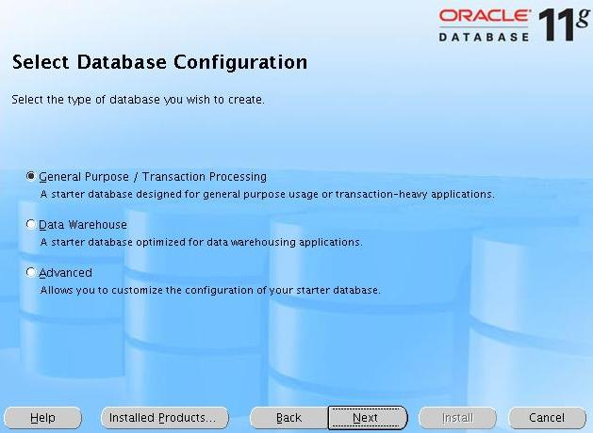
Fig - Select Database Configuration

8. Specify Database Configuration
Enter the following information:
- Global Database Name: devdb.example.com . An Oracle database is uniquely identified by a Global Database Name, typically of the form “name.domain”
- SID: devdb

9. Specify Database Configuration Details
There are four different tabs in this screen as shown below:
- Memory Tab
  - Select the check-box to Enable Automatic Memory Management
  - Drag the bar to allocate the memory. This will automatically allocate memory size for SGA and PGA depending on the total database memory allocated.
- Character Sets Tab. Following three character set options are given in this tab.
  - Use the default
  - Use Unicode (AL32UTF8)
  - Choose from the list of character sets. Select Database Character Set as Unicode standard UTF-8AL32UTF8 – Select this option.
- Security Tab – Just leave the defaults in this tab.
- Sample Schema Tab – Just leave the defaults in this tab.

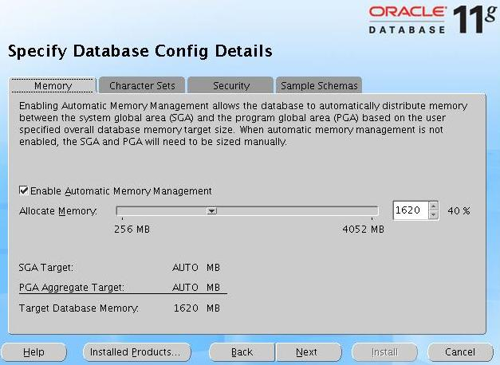
Fig - Select Database Config Details with Memory Tab

10. Select Database Management Option
Following two management options are available:
- Use Grid Control for Database Management
  - Management Service: Choose an agent.
- Use Database Control for Database Management- Select this option.
  - Select the check-box to Enable Email Notifications
  - Outgoing mail (SMTP) Server:
  - Email Address:

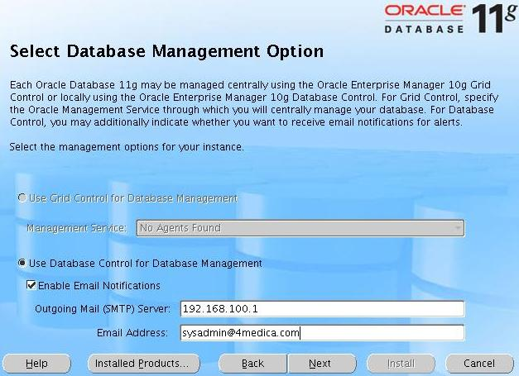
Fig - Select Database Management Option

11. Specify Database Storage Option
Following two storage options are available:
- File System – Select this option.
  - Specify Database File location: /u01/app/oracle/oradata/
- Automatic Storage Management. ASM simplifies database storage administration and optimizes database layout for I/O performance.

12. Specify Backup and Recovery Option
Enable automated backup as shown below. If you’ve configured ASM, you can choose to store the automated backups on ASM. If not, select File System option.

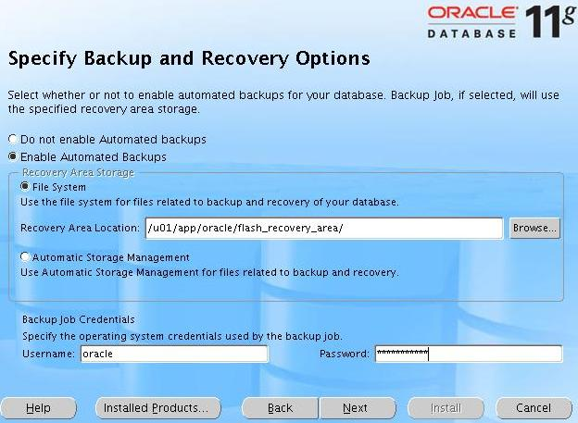

Fig - Specify Backup and Recovery Options

13. Specify database schema password
Enter the password for sys, system, sysman, dbsnmp schemas. You have the option of either using the same passwords or different password for all the accounts in this screen.

14. Privileged Operating System Groups
Enter the following information in this screen:
- Database Administrator (OSDBA) Group: dba
- Database Operator (OSOPER) Group: dba
- ASM administrator (OSASM) Group: dba

15. Oracle Configuration Manager Registration
You can associate your configration information with your metalink account as shown below.

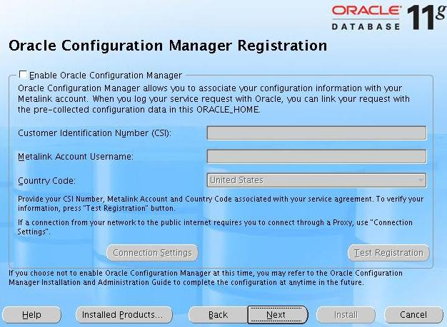
Fig - Oracle Configuration Manager Registration

16. Final Summary Screen
This will display a summary of all the installation option you’ve selected so far. Click on Install to complete the installation.

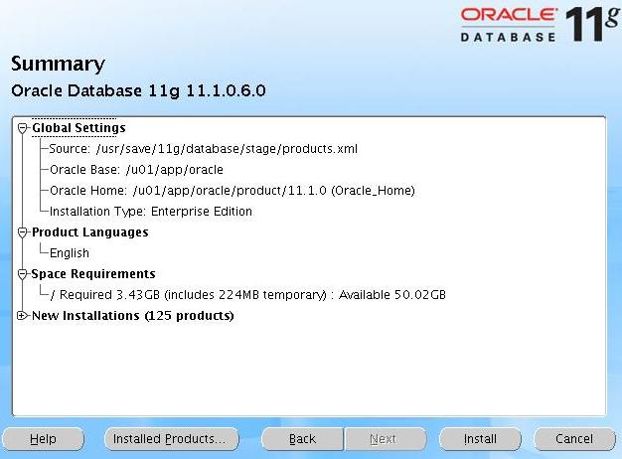

Fig - Installation Summary Screen

