Guide

Requirements: .NET Framework 4.5, vs2015, MS SQL Server

1. 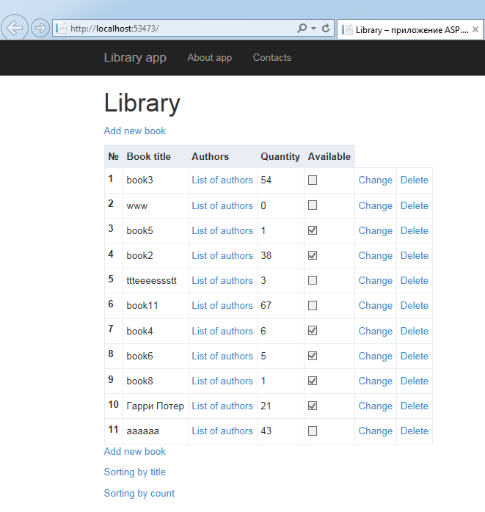Run Library application in VS 2015. Open your browser and enter url address:

http://localhost:53473/

1. You can see all books in grid on start page
2. 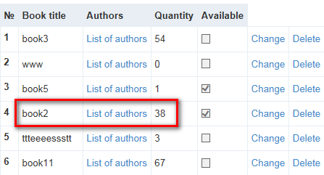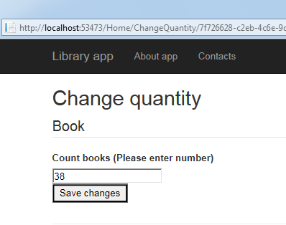If you want change count book, you should click “Change” and you will redirected to change page. Enter new value quantity and click “Save changes” button.
3. You can add new book. You should click to “Add new book” on start page and enter required fields. Finish you need button “Add book”

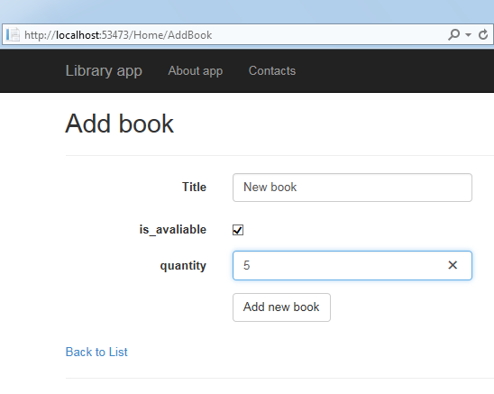

Result:

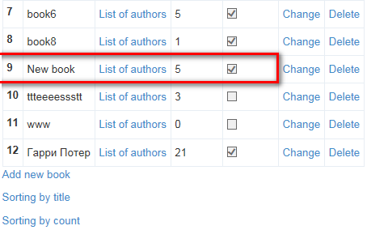

1. If you want see all authors for selected book you should click link “Authors” and you will redirected to page with authors list for selected book. In database is empty, but for test book “ttteeeessstt” #5 has a few authors:

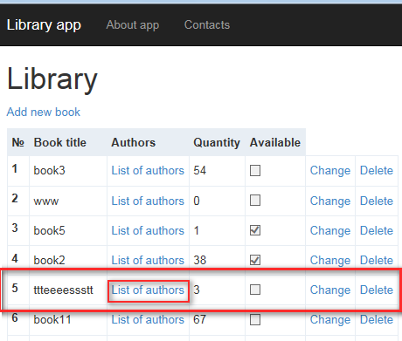

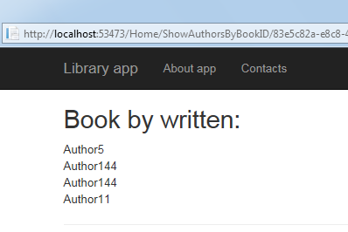

1. You can sort book using appropriate links. There are 2 sort mode: by title and by quantity.

For example sorting by quantity.

