Deployment Methods for Data Pipelines and Automated Processes
Task 3 (LO3) – P4, P5, P6 and M2
Case study: SkyRoute Logistics Ltd

Student | Valerica Stoica
Unit | Data Pipelines – Learning Outcome 3
Submission date | November 2026
Word count (main body) | 968 words (excluding headings, captions, tables, references and appendices)

Contents
1. Introduction
2. Deployment processes for new data pipelines (P4)
3. Functions and features of the pipeline (P5)
4. Identifying and troubleshooting pipeline issues (P6)
5. Version control and rollback planning (M2)
6. Conclusion
References
Appendix A – Project files and how to run them
Appendix B – Dataset sample
Appendix C – Pipeline source code

1. Introduction
SkyRoute Logistics Ltd wants to automate its daily shipment reporting. To compare deployment options, I built a small Python pipeline that reads 241 shipment records, checks them, enriches them and publishes regional KPIs to a dashboard. Eight faulty rows were added to the dataset on purpose, so monitoring and troubleshooting could be tried on realistic problems.

2. Deployment processes for new data pipelines (P4)
Figure 1 compares the three approaches I prepared.
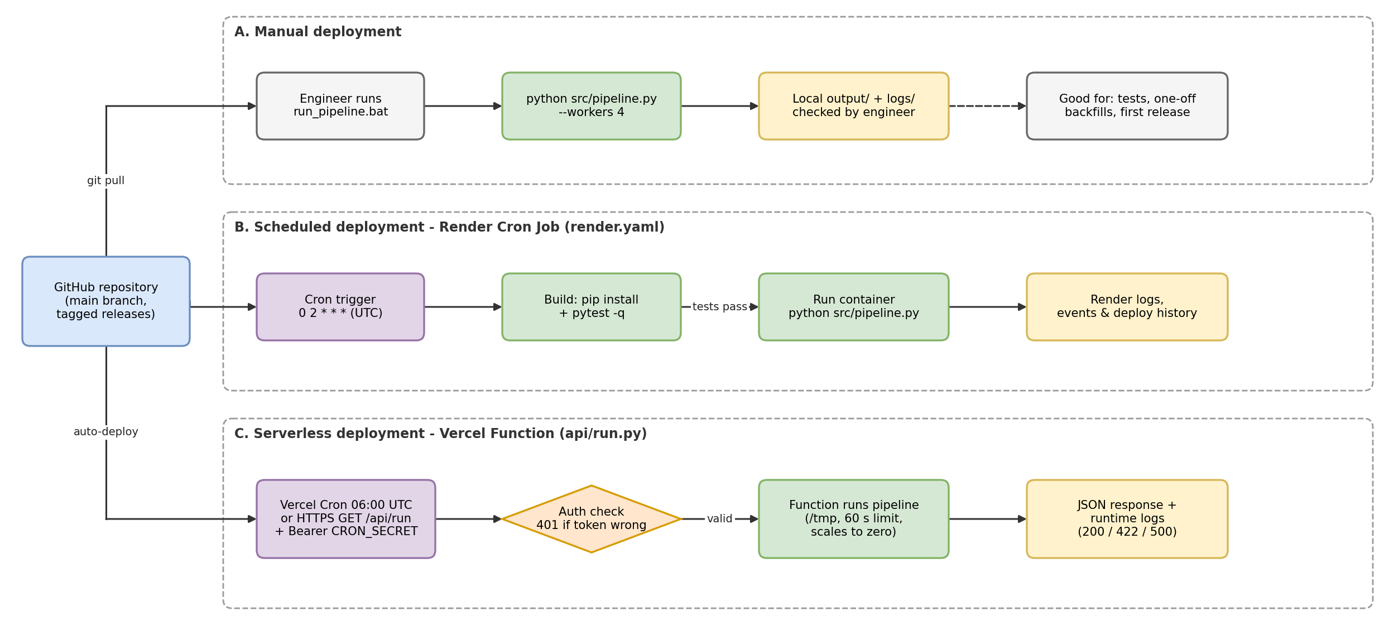
Figure 1: Manual, scheduled and serverless deployment of the SkyRoute pipeline (draw.io)
Manual deployment: an engineer runs the pipeline on demand with run_pipeline.bat. It needs no infrastructure and suits testing or one-off backfills, but depends on someone running it on a correctly configured machine, so results are hard to repeat (Densmore, 2021).
Scheduled deployment: the job runs at fixed times. The render.yaml blueprint (Figure 2) defines a Render Cron Job that installs the dependencies, runs the unit tests during the build and starts the pipeline at 02:00 UTC every day (Render, 2025). This fits SkyRoute's daily data batches, although a run happens even when no new data has arrived.
Serverless deployment: the pipeline is packaged as a Vercel Function (api/run.py) started by Vercel Cron or an authenticated HTTPS request (Vercel, 2025a). There are no servers to manage, but functions have time limits and only /tmp is writable (Eismann et al., 2021). Figure 3 shows the function refusing a request without a token (HTTP 401) and completing a run with one.
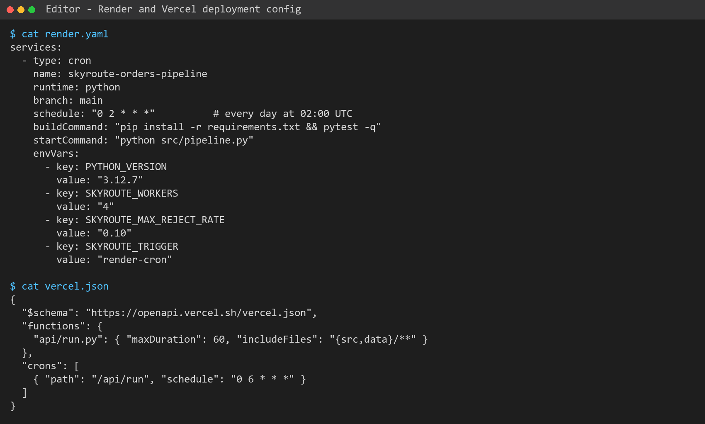
Figure 2: Deployment configuration: Render Cron Job (render.yaml) and Vercel Function with cron (vercel.json)
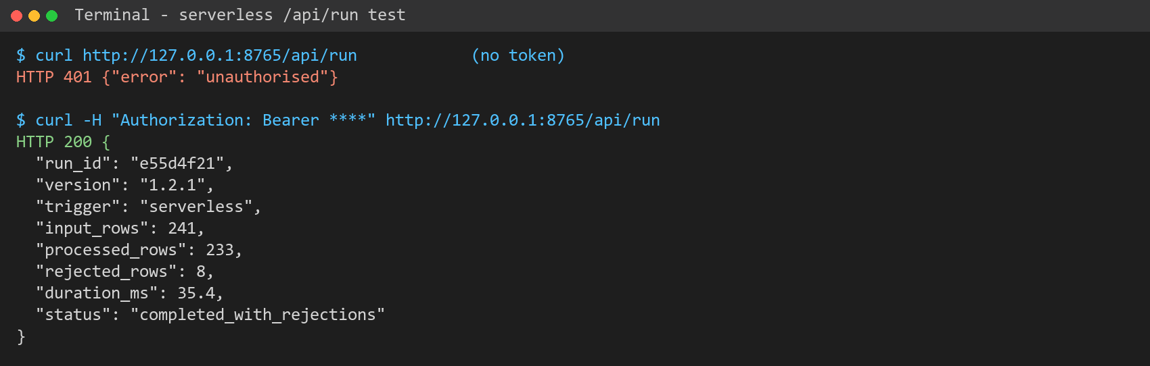
Figure 3: Local test of the serverless endpoint /api/run with and without the secret token
Table 1: Comparison of deployment approaches
 | Manual | Scheduled (Render Cron) | Serverless (Vercel)
Trigger | A person | Cron expression (UTC) | Cron, HTTP call or event
Set-up effort | Very low | Low | Medium
Reliability | Depends on the person | High | High, but time-limited
Cost model | Staff time | Per run (container) | Per invocation
Best SkyRoute use | Testing, backfills | Nightly reporting | On-demand reports

3. Functions and features of the pipeline (P5)
Figure 4 shows the six stages. Extract reads the CSV and retries three times if the file has not yet arrived. Validate applies nine rules covering dates, regions, statuses, numeric ranges and delivery days, and removes duplicate order IDs. Failed rows are kept in rejected_orders.csv with a reason instead of being silently dropped. Transform adds value per item and an on-time flag, Aggregate builds regional KPIs, and Load writes atomically (temporary file, then rename) so readers never see a half-written file.
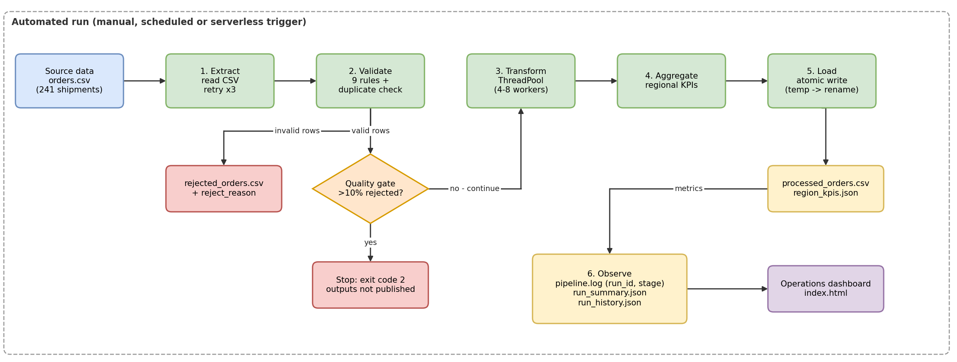
Figure 4: SkyRoute pipeline architecture and data flow (draw.io)
These features keep the data flow reliable, secure and efficient. Reliability comes from retries, a quality gate that blocks publication when over 10% of rows fail, and exit codes a scheduler can act on. Security comes from keeping the CRON_SECRET token in platform environment variables rather than in code, and from authenticating the serverless endpoint. Efficiency comes from automation and scheduling, which remove manual effort, and from parallel transformation. Every run records its timings, row counts and status for monitoring (Raj et al., 2020; Reis and Housley, 2022).

4. Identifying and troubleshooting pipeline issues (P6)
I followed the workflow in Figure 5: detect, locate, classify, fix and verify.
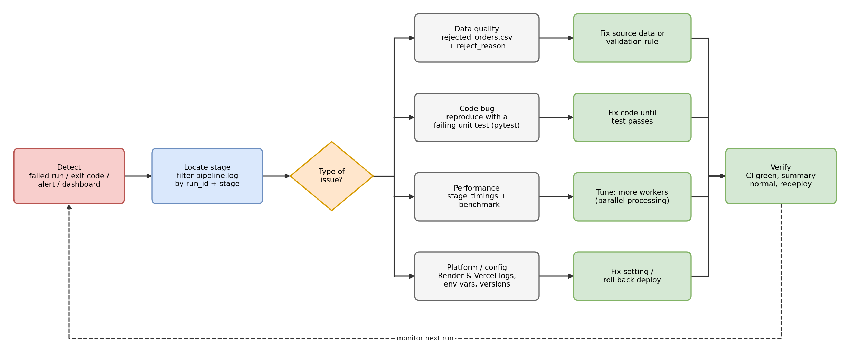
Figure 5: Troubleshooting workflow used for pipeline issues (draw.io)
Monitoring and logging: each log line holds a timestamp, level, run ID and stage name (Figure 7), so a fault can be traced to the exact step. The dashboard (Figure 6) shows status, rejections by reason, stage timings and run history. In my runs, eight rows were rejected, including a negative order value, a UK-style date and an unknown region. Each was listed in rejected_orders.csv with its reason. Data problems like these are among the most common causes of pipeline faults (Munappy, Bosch and Olsson, 2020; Foidl et al., 2024). When the input file was missing, the extract stage retried three times and then stopped with exit code 1 (Figure 8).
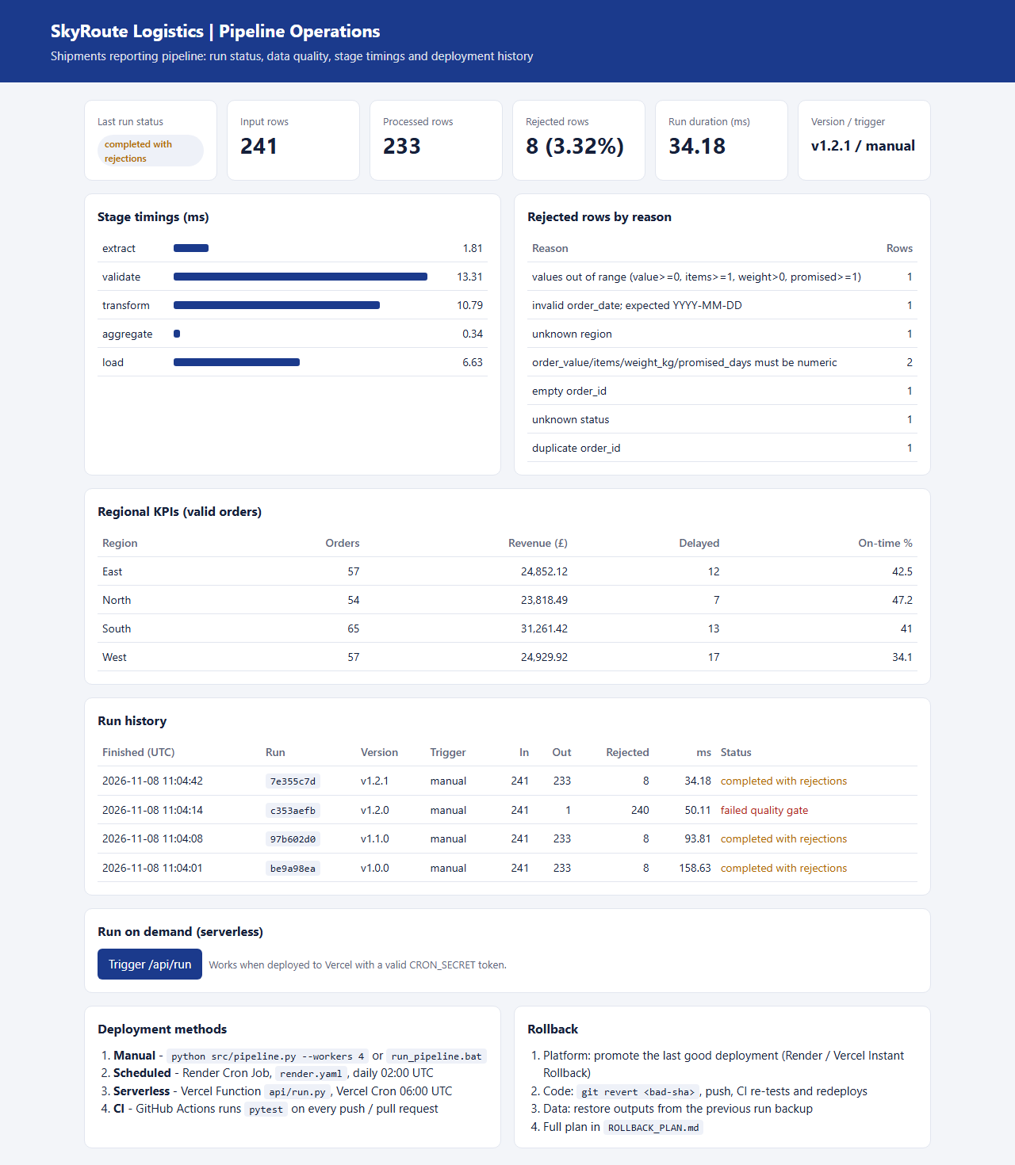
Figure 6: Operations dashboard (index.html) built from run_summary.json, region_kpis.json and run_history.json
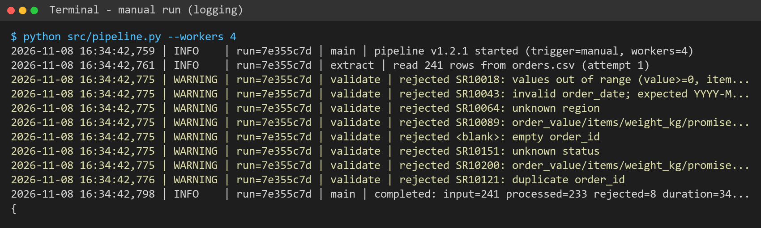
Figure 7: Structured log output of a manual run, showing each rejected row and the run result
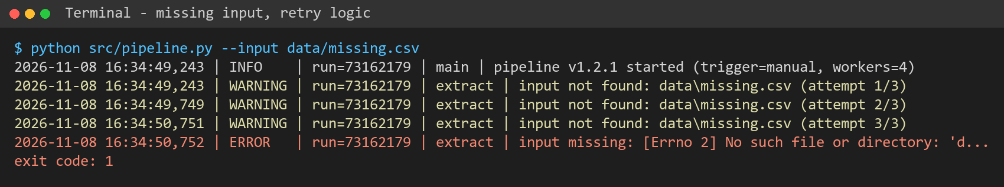
Figure 8: Missing input file: three retries, then a clear error and exit code 1
Debugging with unit tests: eighteen pytest tests cover every validation rule, the transformation, duplicate handling, the quality gate and a full end-to-end run (Figure 9). For a new fault, I first write a test that reproduces it, then fix the code until it passes; the test then guards against the bug returning (Okken, 2022).
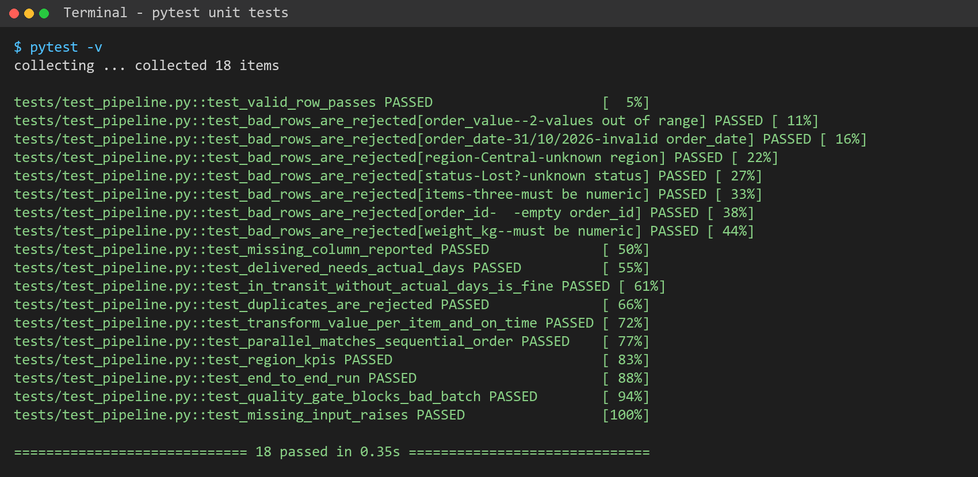
Figure 9: pytest run: all 18 unit and integration tests passing
Performance tuning: the stage timings showed that transform became the slowest stage once a per-record carrier lookup was simulated. As this work waits on I/O, I used a thread pool (Python Software Foundation, 2025). With 20 ms of latency per row, going from one to eight workers cut the stage from 4.98 s to 0.63 s (Figure 10). A test confirms parallel and sequential results are identical. CPU-heavy work would need processes instead of threads (Gorelick and Ozsvald, 2020).
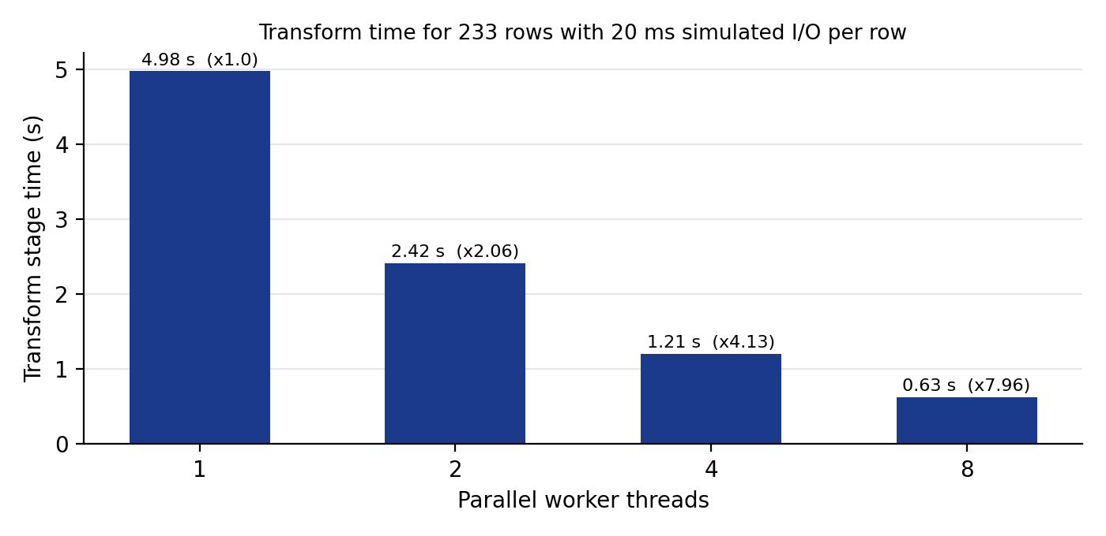
Figure 10: Effect of parallel processing on the transform stage

5. Version control and rollback planning (M2)
Git recorded the whole development history (Figure 11). New work was done on a feature branch and merged through a reviewed pull request. This supports collaboration, because developers can work in parallel without overwriting each other, and tracking, because every commit shows what changed and why. Releases were tagged (v1.0.0, v1.1.0, v1.2.1), so the last known good version is always easy to find.
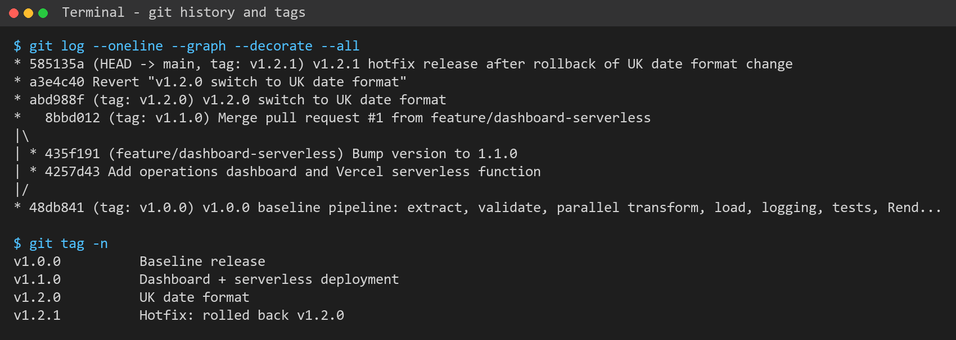
Figure 11: Git branch, merge and release-tag history
Automated testing connects version control to deployment. The GitHub Actions workflow runs the tests and a smoke run on every push and pull request, and Render repeats the tests during its build, so a change that fails cannot be merged or deployed (GitHub, 2025; Kim et al., 2021).
To test the rollback plan, I released a faulty change on purpose: v1.2.0 switched the date format to UK style. Eleven tests failed (Figure 12), and against real data the quality gate rejected 99.6% of rows and refused to publish (exit code 2, Figure 16). I rolled back with git revert, which adds a new commit that undoes the change instead of rewriting shared history. All tests passed again and the fix was tagged v1.2.1 (Figure 13).
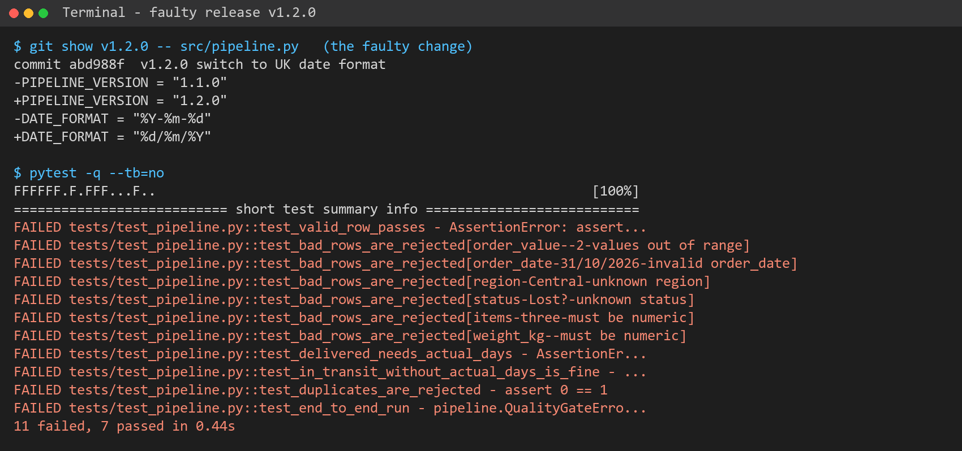
Figure 12: Faulty release v1.2.0: the code change and the failing tests
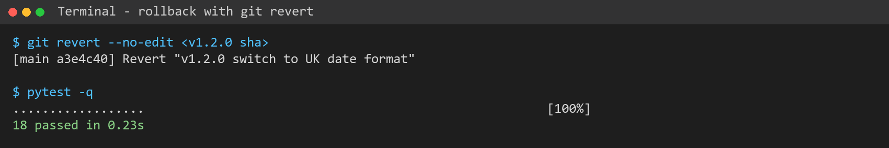
Figure 13: Rollback with git revert: all tests pass again
The rollback plan (Figure 14 and ROLLBACK_PLAN.md) sets out triggers, steps and an owner: pause the schedule, use the platform's instant rollback to restore the previous deployment, revert the code, then restore data from the last good run, because rolling back code does not undo data already written (Vercel, 2025b). DORA (2024) links fast recovery from failed changes with stronger delivery performance. Version control makes failures traceable and reversible, and a rehearsed plan turns a bad release into a short, controlled event.
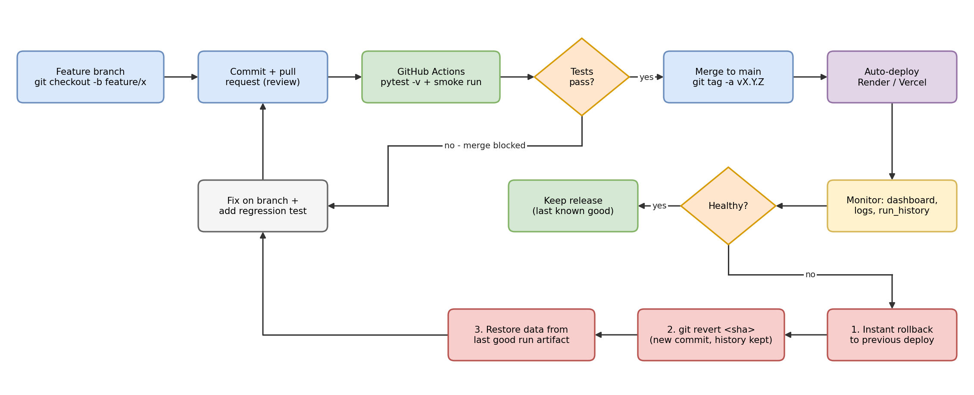
Figure 14: Version control, CI testing and rollback process (draw.io)

6. Conclusion
For SkyRoute, a scheduled Render cron job best suits nightly reporting, with a serverless function for on-demand runs and manual runs kept for testing. Logging, unit tests and parallel processing made faults quick to find and fix, while Git, automated testing and a rehearsed rollback plan made each deployment safer.

References
Densmore, J. (2021) Data pipelines pocket reference: moving and processing data for analytics. Sebastopol, CA: O'Reilly Media.
DORA (2024) Accelerate State of DevOps Report 2024. Mountain View, CA: Google Cloud. Available at: https://dora.dev/research/2024/dora-report/ (Accessed: 8 November 2026).
Eismann, S., Scheuner, J., van Eyk, E., Schwinger, M., Grohmann, J., Herbst, N., Abad, C.L. and Iosup, A. (2021) 'Serverless applications: why, when, and how?', IEEE Software, 38(1), pp. 32–39.
Foidl, H., Golendukhina, V., Ramler, R. and Felderer, M. (2024) 'Data pipeline quality: influencing factors, root causes of data-related issues, and processing problem areas for developers', Journal of Systems and Software, 207, 111855.
GitHub (2025) GitHub Actions documentation. Available at: https://docs.github.com/en/actions (Accessed: 8 November 2026).
Gorelick, M. and Ozsvald, I. (2020) High performance Python. 2nd edn. Sebastopol, CA: O'Reilly Media.
Kim, G., Humble, J., Debois, P., Willis, J. and Forsgren, N. (2021) The DevOps handbook. 2nd edn. Portland, OR: IT Revolution Press.
Munappy, A.R., Bosch, J. and Olsson, H.H. (2020) 'Data pipeline management in practice: challenges and opportunities', in Product-Focused Software Process Improvement (PROFES 2020). Cham: Springer, pp. 168–184.
Okken, B. (2022) Python testing with pytest. 2nd edn. Raleigh, NC: The Pragmatic Bookshelf.
Python Software Foundation (2025) concurrent.futures – launching parallel tasks. Available at: https://docs.python.org/3/library/concurrent.futures.html (Accessed: 8 November 2026).
Raj, A., Bosch, J., Olsson, H.H. and Wang, T.J. (2020) 'Modelling data pipelines', in 46th Euromicro Conference on Software Engineering and Advanced Applications (SEAA). Portorož: IEEE, pp. 13–20.
Reis, J. and Housley, M. (2022) Fundamentals of data engineering. Sebastopol, CA: O'Reilly Media.
Render (2025) Cron jobs. Available at: https://render.com/docs/cronjobs (Accessed: 8 November 2026).
Vercel (2025a) Cron jobs. Available at: https://vercel.com/docs/cron-jobs (Accessed: 8 November 2026).
Vercel (2025b) Instant Rollback. Available at: https://vercel.com/docs/instant-rollback (Accessed: 8 November 2026).

Appendix A – Project files and how to run them
Table A1: Project contents
File / folder | Purpose
data/orders.csv | Synthetic SkyRoute dataset: 241 shipments, 8 faulty rows added on purpose
scripts/generate_dataset.py | Rebuilds the dataset with a fixed random seed
src/pipeline.py | Pipeline: extract, validate, parallel transform, aggregate, load, logging
tests/test_pipeline.py | 18 pytest unit and integration tests
run_pipeline.bat / .sh | Manual deployment
render.yaml | Scheduled deployment – Render Cron Job (02:00 UTC)
api/run.py, vercel.json | Serverless deployment – Vercel Function and Vercel Cron
.github/workflows/ci.yml | GitHub Actions: tests and smoke run on every push / pull request
index.html | Operations dashboard reading output/*.json
ROLLBACK_PLAN.md | Rollback triggers, steps and safeguards
diagrams/*.drawio | Editable draw.io source for Figures 1, 4, 5 and 14
evidence/ | Terminal captures and screenshots used in this report

pip install -r requirements.txt
python src/pipeline.py --workers 4
python src/pipeline.py --benchmark --simulate-latency 20
pytest -v
python -m http.server 8000 (then open http://localhost:8000)

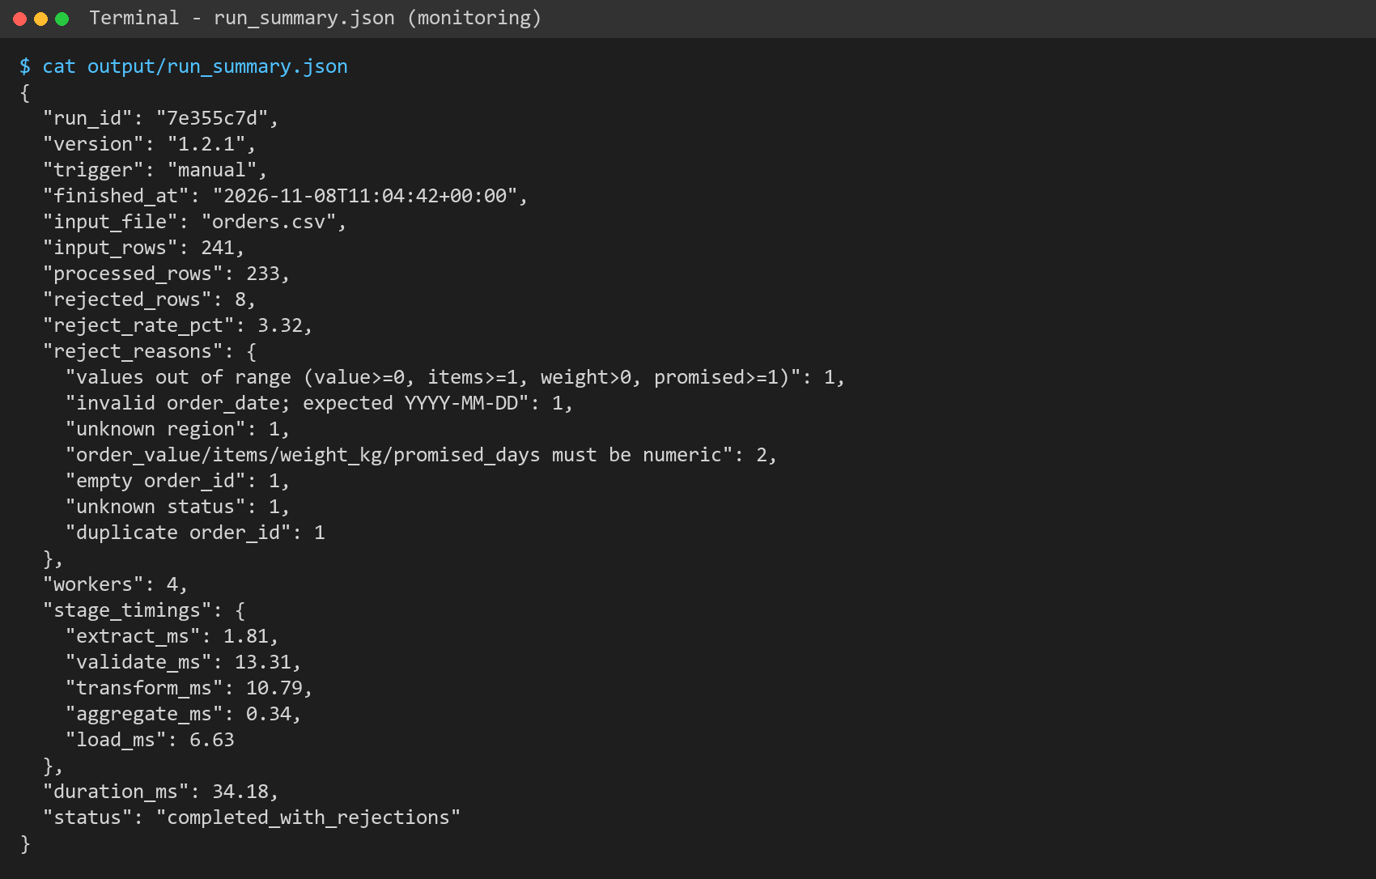
Figure 15: run_summary.json produced by every run (monitoring data)
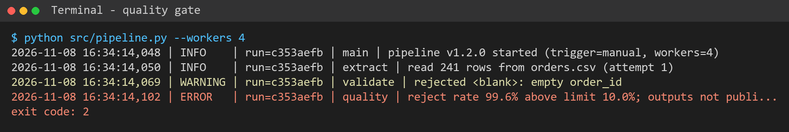
Figure 16: Quality gate stopping the faulty v1.2.0 release from publishing output

Appendix B – Dataset sample
Table B1: First eight rows plus three of the faulty rows (SR10018, SR10043, SR10064)
order_id | order_date | region | depot | carrier | status | order_value | items | weight_kg | promised_days | actual_days
SR10001 | 2026-09-15 | North | Leeds | SwiftHaul | Delivered | 105.71 | 12 | 59.0 | 3 | 3
SR10002 | 2026-09-06 | North | Leeds | SkyRoute Fleet | Delayed | 462.24 | 7 | 3.9 | 1 | 2
SR10003 | 2026-09-15 | South | Brighton | SwiftHaul | Processing | 261.20 | 11 | 62.7 | 5
SR10004 | 2026-09-18 | South | Southampton | SkyRoute Fleet | Processing | 862.13 | 7 | 17.2 | 3
SR10005 | 2026-10-25 | North | Newcastle | SwiftHaul | In Transit | 249.10 | 2 | 1.3 | 3
SR10006 | 2026-10-06 | West | Cardiff | SwiftHaul | Delayed | 562.39 | 2 | 11.3 | 5 | 6
SR10007 | 2026-10-13 | South | Southampton | ParcelLink | Processing | 886.92 | 2 | 11.2 | 1
SR10008 | 2026-10-11 | North | Newcastle | SkyRoute Fleet | In Transit | 342.61 | 5 | 8.4 | 5
SR10018 | 2026-09-08 | North | Newcastle | ParcelLink | Delayed | -45.00 | 6 | 11.2 | 5 | 6
SR10043 | 31/10/2026 | West | Bristol | SwiftHaul | Processing | 110.66 | 12 | 68.6 | 2
SR10064 | 2026-10-26 | Central | Newcastle | SkyRoute Fleet | Delivered | 59.50 | 11 | 29.8 | 5 | 5

Appendix C – Pipeline source code (src/pipeline.py)
"""SkyRoute Logistics - shipments reporting pipeline.

Stages: extract -> validate -> transform (parallel) -> aggregate -> load -> observe.

Only the Python standard library is used, so the same file runs on a laptop
(manual), on a Render cron job (scheduled) and inside a Vercel function
(serverless) without extra packages.

Usage:
python src/pipeline.py --workers 4
python src/pipeline.py --benchmark --simulate-latency 5
"""
from __future__ import annotations

import argparse
import csv
import json
import logging
import os
import sys
import tempfile
import time
import uuid
from concurrent.futures import ThreadPoolExecutor
from datetime import datetime, timezone
from pathlib import Path

PIPELINE_VERSION = "1.2.1"

ROOT = Path(__file__).resolve().parents[1]
DEFAULT_INPUT = ROOT / "data" / "orders.csv"
DEFAULT_OUTPUT = ROOT / "output"
DEFAULT_LOG = ROOT / "logs" / "pipeline.log"

REQUIRED = ["order_id", "order_date", "region", "depot", "carrier", "status",
"order_value", "items", "weight_kg", "promised_days", "actual_days"]
VALID_STATUSES = {"Delivered", "In Transit", "Delayed", "Processing"}
VALID_REGIONS = {"North", "South", "East", "West"}
DATE_FORMAT = "%Y-%m-%d"

# Settings can be changed per platform through environment variables.
MAX_REJECT_RATE = float(os.getenv("SKYROUTE_MAX_REJECT_RATE", "0.10"))
EXTRACT_RETRIES = int(os.getenv("SKYROUTE_EXTRACT_RETRIES", "3"))

log = logging.getLogger("skyroute")

class QualityGateError(RuntimeError):
"""Raised when too many rows fail validation."""

# ---------------------------------------------------------------- logging
def configure_logging(log_path: Path | None, run_id: str) -> None:
fmt = logging.Formatter(
f"%(asctime)s | %(levelname)-7s | run={run_id} | %(stage)s | %(message)s")
handlers: list[logging.Handler] = [logging.StreamHandler(sys.stdout)]
if log_path is not None:
log_path.parent.mkdir(parents=True, exist_ok=True)
handlers.append(logging.FileHandler(log_path, encoding="utf-8"))
log.handlers.clear()
log.setLevel(logging.INFO)
log.propagate = False
for h in handlers:
h.setFormatter(fmt)
h.addFilter(_StageFilter())
log.addHandler(h)

class _StageFilter(logging.Filter):
def filter(self, record: logging.LogRecord) -> bool:
if not hasattr(record, "stage"):
record.stage = "main"
return True

def _info(stage: str, msg: str, *args) -> None:
log.info(msg, *args, extra={"stage": stage})

def _warn(stage: str, msg: str, *args) -> None:
log.warning(msg, *args, extra={"stage": stage})

# ---------------------------------------------------------------- extract
def extract(path: Path, retries: int = EXTRACT_RETRIES, wait: float = 0.5) -> list[dict]:
"""Read the CSV, retrying a few times in case the file is still arriving."""
for attempt in range(1, retries + 1):
try:
with path.open(newline="", encoding="utf-8-sig") as f:
rows = list(csv.DictReader(f))
_info("extract", "read %d rows from %s (attempt %d)", len(rows), path.name, attempt)
return rows
except FileNotFoundError:
_warn("extract", "input not found: %s (attempt %d/%d)", path, attempt, retries)
if attempt == retries:
raise
time.sleep(wait * attempt)
return []

# ---------------------------------------------------------------- validate
def validate(row: dict) -> str | None:
"""Return None when the row is valid, otherwise a short reject reason."""
missing = [c for c in REQUIRED if c not in row]
if missing:
return f"missing column(s): {', '.join(missing)}"
if not (row["order_id"] or "").strip():
return "empty order_id"
try:
datetime.strptime(row["order_date"], DATE_FORMAT)
except (TypeError, ValueError):
return "invalid order_date; expected YYYY-MM-DD"
if row["region"] not in VALID_REGIONS:
return "unknown region"
if row["status"] not in VALID_STATUSES:
return "unknown status"
try:
value = float(row["order_value"])
items = int(row["items"])
weight = float(row["weight_kg"])
promised = int(row["promised_days"])
except (TypeError, ValueError):
return "order_value/items/weight_kg/promised_days must be numeric"
if value < 0 or items < 1 or weight <= 0 or promised < 1:
return "values out of range (value>=0, items>=1, weight>0, promised>=1)"
if row["status"] in {"Delivered", "Delayed"} and not (row["actual_days"] or "").strip():
return "actual_days required for delivered/delayed orders"
return None

def split_valid(rows: list[dict]) -> tuple[list[dict], list[dict]]:
valid, rejected, seen = [], [], set()
for row in rows:
reason = validate(row)
if reason is None and row["order_id"] in seen:
reason = "duplicate order_id"
if reason:
rejected.append({**row, "reject_reason": reason})
else:
seen.add(row["order_id"])
valid.append(row)
return valid, rejected

# ---------------------------------------------------------------- transform
def transform(row: dict, latency: float = 0.0) -> dict:
"""Clean and enrich one row. `latency` imitates a slow lookup (e.g. a carrier API)."""
if latency:
time.sleep(latency)
value = round(float(row["order_value"]), 2)
items = int(row["items"])
promised = int(row["promised_days"])
actual = int(row["actual_days"]) if (row["actual_days"] or "").strip() else None
on_time = "" if actual is None else ("yes" if actual <= promised else "no")
return {
"order_id": row["order_id"].strip(),
"order_date": row["order_date"],
"region": row["region"],
"depot": row["depot"],
"carrier": row["carrier"],
"status": row["status"],
"order_value": f"{value:.2f}",
"items": items,
"weight_kg": f"{float(row['weight_kg']):.1f}",
"value_per_item": f"{value / items:.2f}",
"promised_days": promised,
"actual_days": "" if actual is None else actual,
"on_time": on_time,
}

def transform_all(rows: list[dict], workers: int, latency: float = 0.0) -> list[dict]:
"""Transform rows in parallel. executor.map keeps the original row order."""
with ThreadPoolExecutor(max_workers=max(1, workers)) as pool:
return list(pool.map(lambda r: transform(r, latency), rows))

# ---------------------------------------------------------------- aggregate
def region_kpis(processed: list[dict]) -> list[dict]:
out = []
for region in sorted(VALID_REGIONS):
rows = [r for r in processed if r["region"] == region]
delivered = [r for r in rows if r["on_time"]]
on_time = sum(1 for r in delivered if r["on_time"] == "yes")
out.append({
"region": region,
"orders": len(rows),
"revenue": round(sum(float(r["order_value"]) for r in rows), 2),
"delayed": sum(1 for r in rows if r["status"] == "Delayed"),
"on_time_rate": round(on_time / len(delivered) * 100, 1) if delivered else 0.0,
})
return out

# ---------------------------------------------------------------- load
def atomic_write_csv(path: Path, rows: list[dict], fields: list[str]) -> None:
"""Write to a temp file first, then swap it in, so readers never see half a file."""
path.parent.mkdir(parents=True, exist_ok=True)
fd, tmp = tempfile.mkstemp(dir=path.parent, suffix=".tmp")
with os.fdopen(fd, "w", newline="", encoding="utf-8") as f:
writer = csv.DictWriter(f, fieldnames=fields)
writer.writeheader()
writer.writerows(rows)
os.replace(tmp, path)

def write_json(path: Path, data) -> None:
path.parent.mkdir(parents=True, exist_ok=True)
tmp = path.with_suffix(".tmp")
tmp.write_text(json.dumps(data, indent=2), encoding="utf-8")
os.replace(tmp, path)

def append_history(path: Path, summary: dict, keep: int = 30) -> None:
history = []
if path.exists():
try:
history = json.loads(path.read_text(encoding="utf-8"))
except json.JSONDecodeError:
history = []
history.append({k: summary[k] for k in
("run_id", "finished_at", "version", "trigger", "input_rows",
"processed_rows", "rejected_rows", "duration_ms", "status")})
write_json(path, history[-keep:])

# ---------------------------------------------------------------- orchestration
def run_pipeline(input_path: Path = DEFAULT_INPUT, output_dir: Path = DEFAULT_OUTPUT,
workers: int = 4, latency: float = 0.0,
log_path: Path | None = DEFAULT_LOG,
trigger: str = os.getenv("SKYROUTE_TRIGGER", "manual"),
max_reject_rate: float = MAX_REJECT_RATE) -> dict:
run_id = uuid.uuid4().hex[:8]
configure_logging(log_path, run_id)
timings: dict[str, float] = {}
started = time.perf_counter()
_info("main", "pipeline v%s started (trigger=%s, workers=%d)", PIPELINE_VERSION, trigger, workers)

t = time.perf_counter()
rows = extract(input_path)
timings["extract_ms"] = round((time.perf_counter() - t) * 1000, 2)

t = time.perf_counter()
valid, rejected = split_valid(rows)
timings["validate_ms"] = round((time.perf_counter() - t) * 1000, 2)
for r in rejected:
_warn("validate", "rejected %s: %s", r.get("order_id") or "<blank>", r["reject_reason"])
reject_rate = len(rejected) / len(rows) if rows else 0.0

t = time.perf_counter()
processed = transform_all(valid, workers, latency)
timings["transform_ms"] = round((time.perf_counter() - t) * 1000, 2)

t = time.perf_counter()
kpis = region_kpis(processed)
timings["aggregate_ms"] = round((time.perf_counter() - t) * 1000, 2)

status = "success" if not rejected else "completed_with_rejections"
if reject_rate > max_reject_rate:
status = "failed_quality_gate"

t = time.perf_counter()
if status != "failed_quality_gate":
atomic_write_csv(output_dir / "processed_orders.csv", processed,
list(processed[0]) if processed else ["order_id"])
write_json(output_dir / "region_kpis.json", kpis)
atomic_write_csv(output_dir / "rejected_orders.csv", rejected,
REQUIRED + ["reject_reason"])
timings["load_ms"] = round((time.perf_counter() - t) * 1000, 2)

reasons: dict[str, int] = {}
for r in rejected:
reasons[r["reject_reason"]] = reasons.get(r["reject_reason"], 0) + 1

summary = {
"run_id": run_id,
"version": PIPELINE_VERSION,
"trigger": trigger,
"finished_at": datetime.now(timezone.utc).isoformat(timespec="seconds"),
"input_file": input_path.name,
"input_rows": len(rows),
"processed_rows": len(processed),
"rejected_rows": len(rejected),
"reject_rate_pct": round(reject_rate * 100, 2),
"reject_reasons": reasons,
"workers": max(1, workers),
"stage_timings": timings,
"duration_ms": round((time.perf_counter() - started) * 1000, 2),
"status": status,
}
write_json(output_dir / "run_summary.json", summary)
append_history(output_dir / "run_history.json", summary)

if status == "failed_quality_gate":
log.error("reject rate %.1f%% above limit %.1f%%; outputs not published",
reject_rate * 100, max_reject_rate * 100, extra={"stage": "quality"})
raise QualityGateError(summary)
_info("main", "completed: input=%d processed=%d rejected=%d duration=%.1fms status=%s",
len(rows), len(processed), len(rejected), summary["duration_ms"], status)
return summary

def benchmark(input_path: Path, latency: float, worker_counts=(1, 2, 4, 8)) -> list[dict]:
"""Time the transform stage with different worker counts (performance tuning)."""
rows, _ = split_valid(extract(input_path))
results = []
for w in worker_counts:
t = time.perf_counter()
transform_all(rows, w, latency)
ms = round((time.perf_counter() - t) * 1000, 1)
results.append({"workers": w, "transform_ms": ms})
print(f"workers={w:<2} transform={ms:>8.1f} ms rows={len(rows)}")
base = results[0]["transform_ms"]
for r in results:
r["speedup"] = round(base / r["transform_ms"], 2)
return results

def main(argv=None) -> int:
p = argparse.ArgumentParser(description="SkyRoute shipments pipeline")
p.add_argument("--input", type=Path, default=DEFAULT_INPUT)
p.add_argument("--output", type=Path, default=DEFAULT_OUTPUT)
p.add_argument("--workers", type=int, default=int(os.getenv("SKYROUTE_WORKERS", "4")))
p.add_argument("--simulate-latency", type=float, default=0.0,
help="milliseconds of fake I/O per row")
p.add_argument("--benchmark", action="store_true")
args = p.parse_args(argv)
latency = args.simulate_latency / 1000
if args.benchmark:
configure_logging(None, "bench")
res = benchmark(args.input, latency)
write_json(args.output / "benchmark.json", res)
return 0
try:
summary = run_pipeline(args.input, args.output, args.workers, latency)
except QualityGateError:
return 2
except FileNotFoundError as exc:
log.error("input missing: %s", exc, extra={"stage": "extract"})
return 1
print(json.dumps(summary, indent=2))
return 0

if __name__ == "__main__":
sys.exit(main())

