COMP 421
Group 11
Project – Part 2

David Blader
Valerie Saunders Duncan
Yang David Zhou
Gurshane Sidhu

Question 1:
Output from DB when triggers.sql is run:

CS421=> \i triggers.sql
CREATE TABLE
CREATE FUNCTION
CREATE TRIGGER
UPDATE 1
UPDATE 1
CS421=>

Result of UPDATE pet_pages SET species = 'Donkhay' WHERE page_id = 1; :
SELECT * FROM pet_pages;
page_id | species | gender | age | birthday
---------+---------+--------+-----+------------
2 | Dog | F | 7 |
3 | Fish | M | 1 |
4 | Fish | F | 1 | 2013-11-02
5 | Cat | F | 1 |
6 | Cat | N | 6 |
7 | Dog | M | 1 |
8 | Cat | F | 1 |
9 | Turtle | M | 2 | 2013-03-09
10 | Cat | F | 1 | 2013-09-14
11 | Pig | M | 1 | 2014-01-30
12 | Gerbil | M | 3 |
1 | Donkhay | M | 1 | 2014-02-15

SELECT * FROM pet_page_backup_table;
page_id | species | gender | age | birthday
---------+---------+--------+-----+------------
1 | Donkhay | M | 1 | 2014-02-15

Result of UPDATE pet_pages SET species = 'Dog' WHERE page_id = 2;
SELECT * FROM pet_page_backup_table;
page_id | species | gender | age | birthday
---------+---------+--------+-----+------------
1 | Donkhay | M | 1 | 2014-02-15

SELECT * FROM pet_pages;
page_id | species | gender | age | birthday
---------+---------+--------+-----+------------
2 | Dog | F | 7 |
3 | Fish | M | 1 |
4 | Fish | F | 1 | 2013-11-02
5 | Cat | F | 1 |
6 | Cat | N | 6 |
7 | Dog | M | 1 |
8 | Cat | F | 1 |
9 | Turtle | M | 2 | 2013-03-09
10 | Cat | F | 1 | 2013-09-14
11 | Pig | M | 1 | 2014-01-30
12 | Gerbil | M | 3 |
1 | Donkhay | M | 1 | 2014-02-15

Question 2:

Question 3:

Question 4 Indexes:
Index 1:
--Index responses by num_votes to speed up retrieval of popular responses.

--This is for quickly accessing popular responses to polls.
Index 2:
--Index on creator attribute to speed up retrieval of posts made by given page.

--This is for quickly gathering posts made by a specific page.
Question 4 Timing:
First picture indicates the time on the machine before running: (in console area and in terminal)
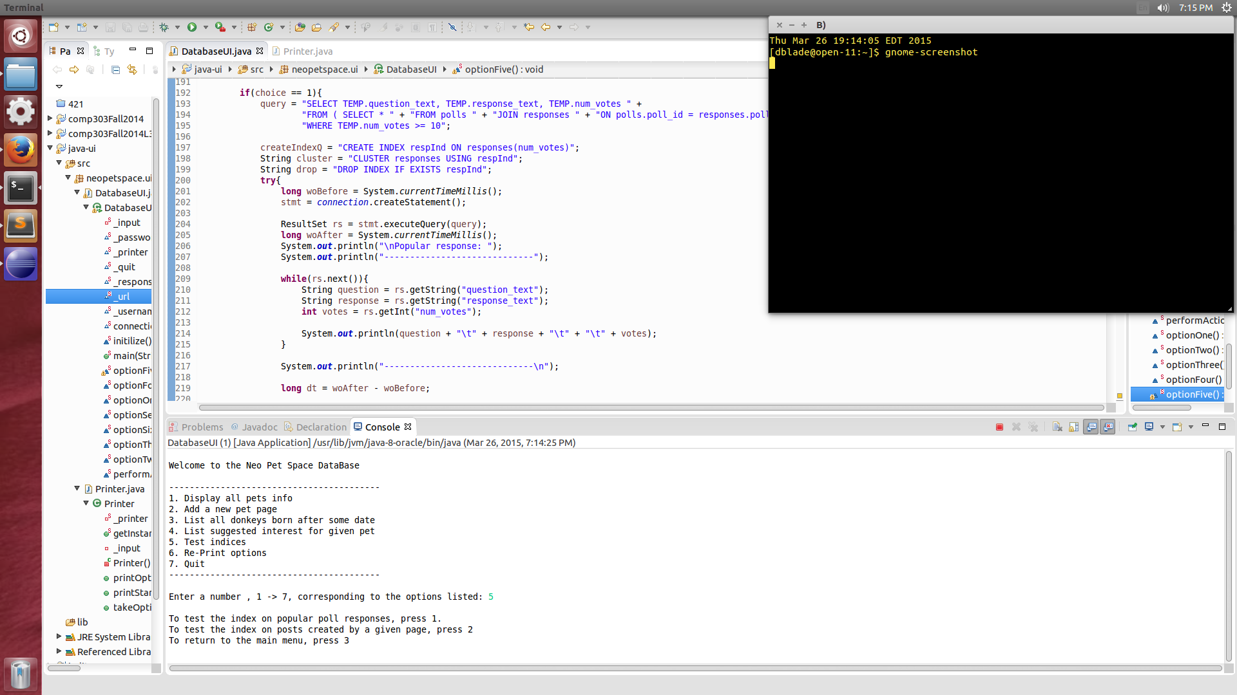

Images 2 and 3 are the results from each index:

