Figure 1
Distribution of Frequencies of Regions by Method Group
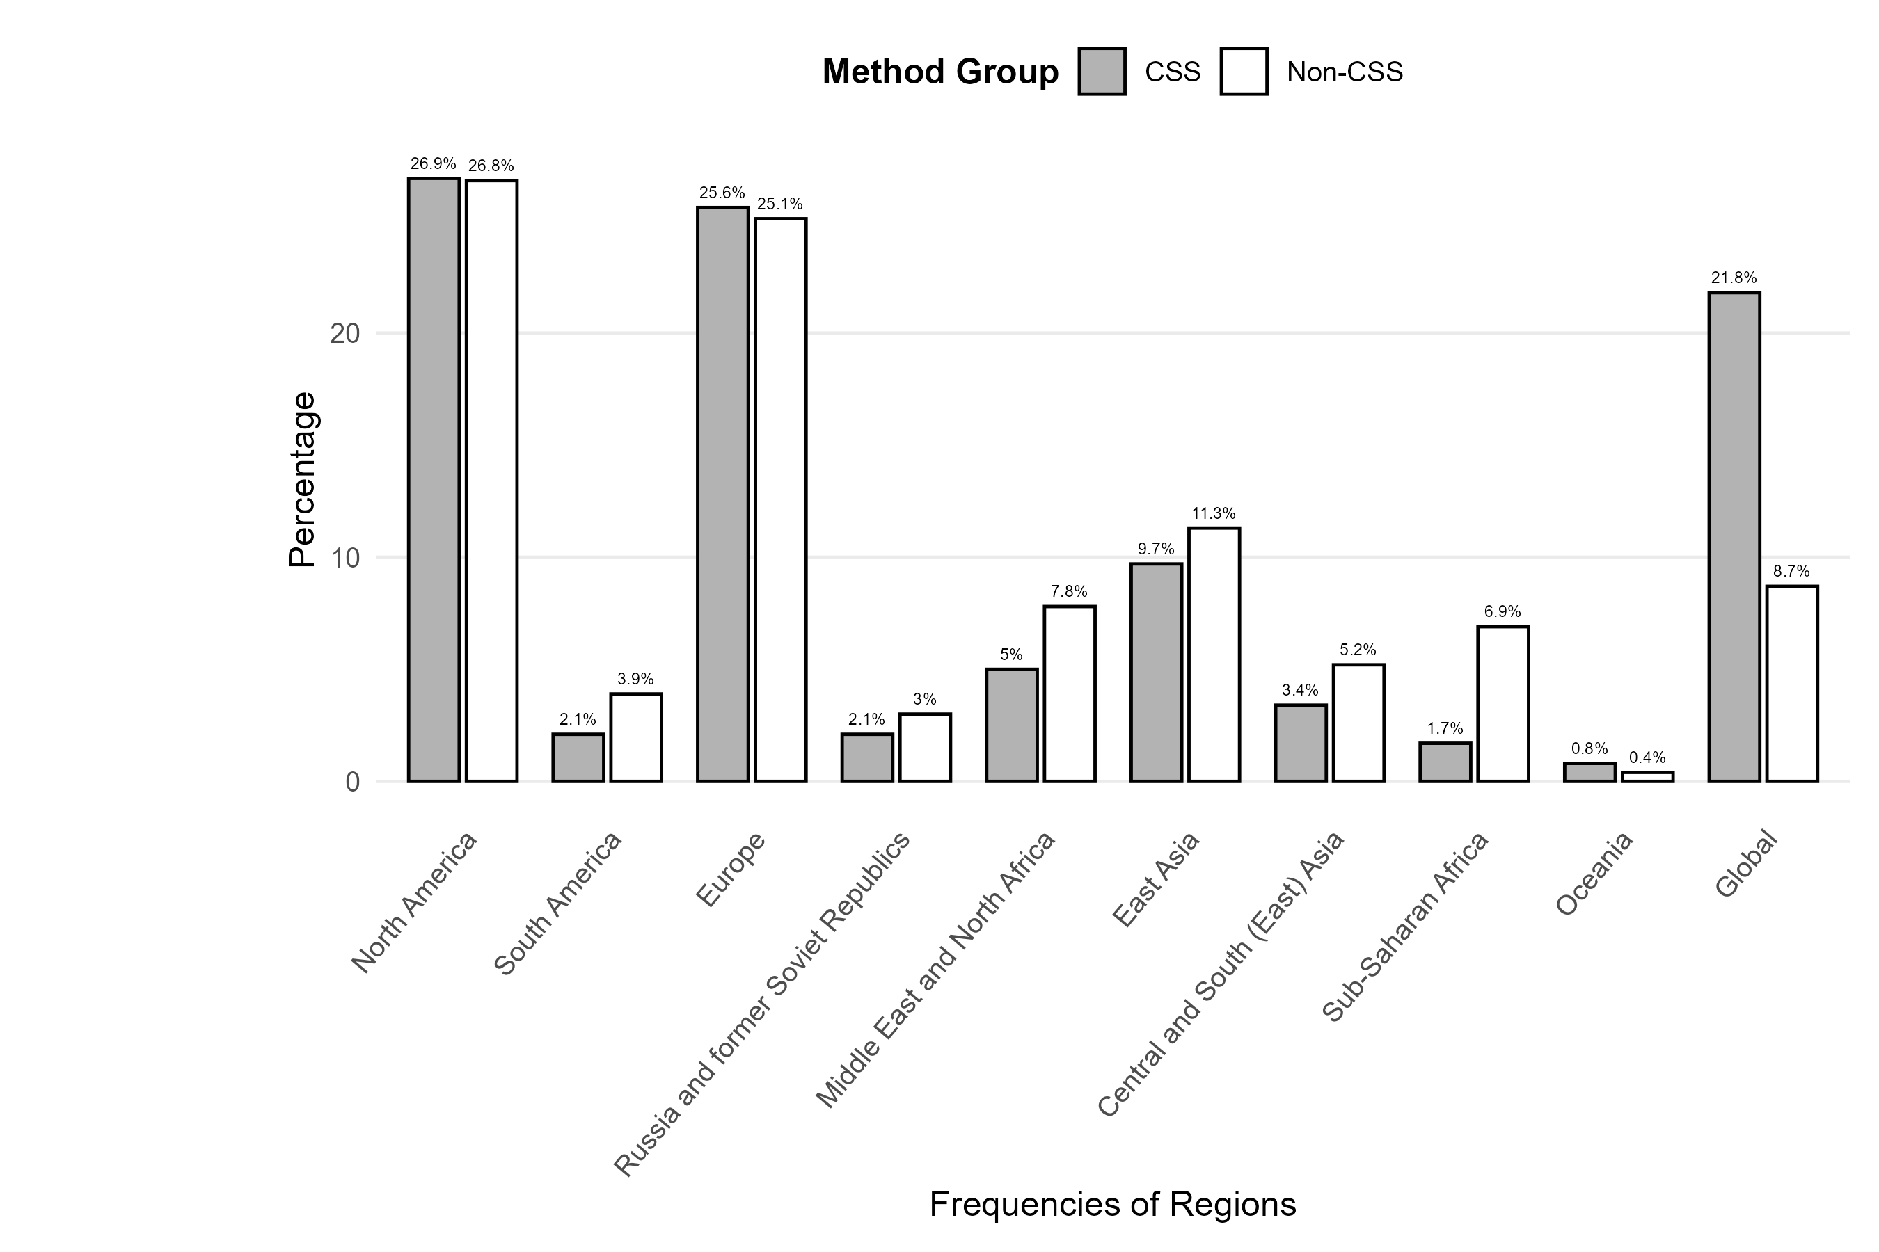

Figure 2
Distribution of Frequencies of Platforms by Method Group
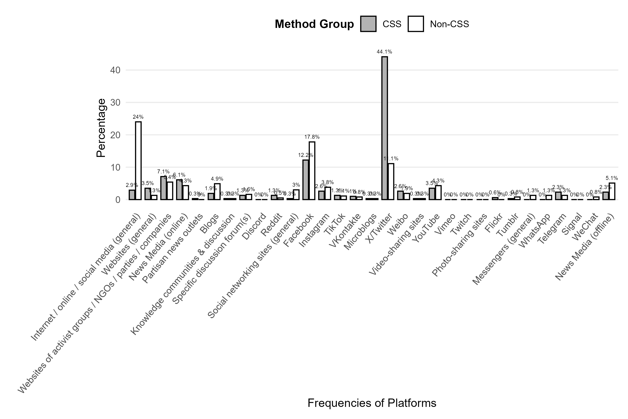

Figure 3
Distribution of Frequencies of Platforms (aggregated) by Method Group
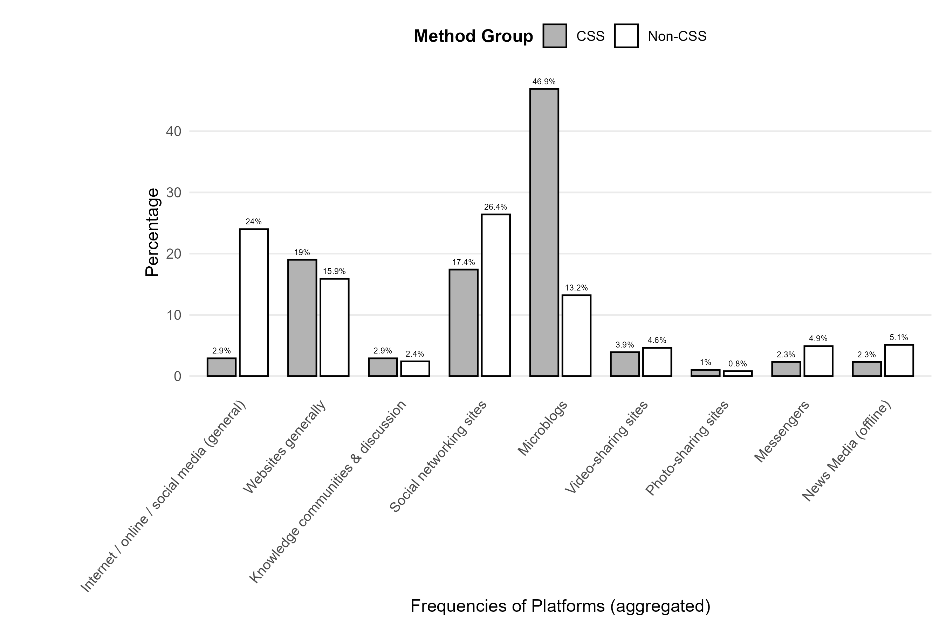

Figure 4
Distribution of Frequencies of Analysis Methods by Method Group
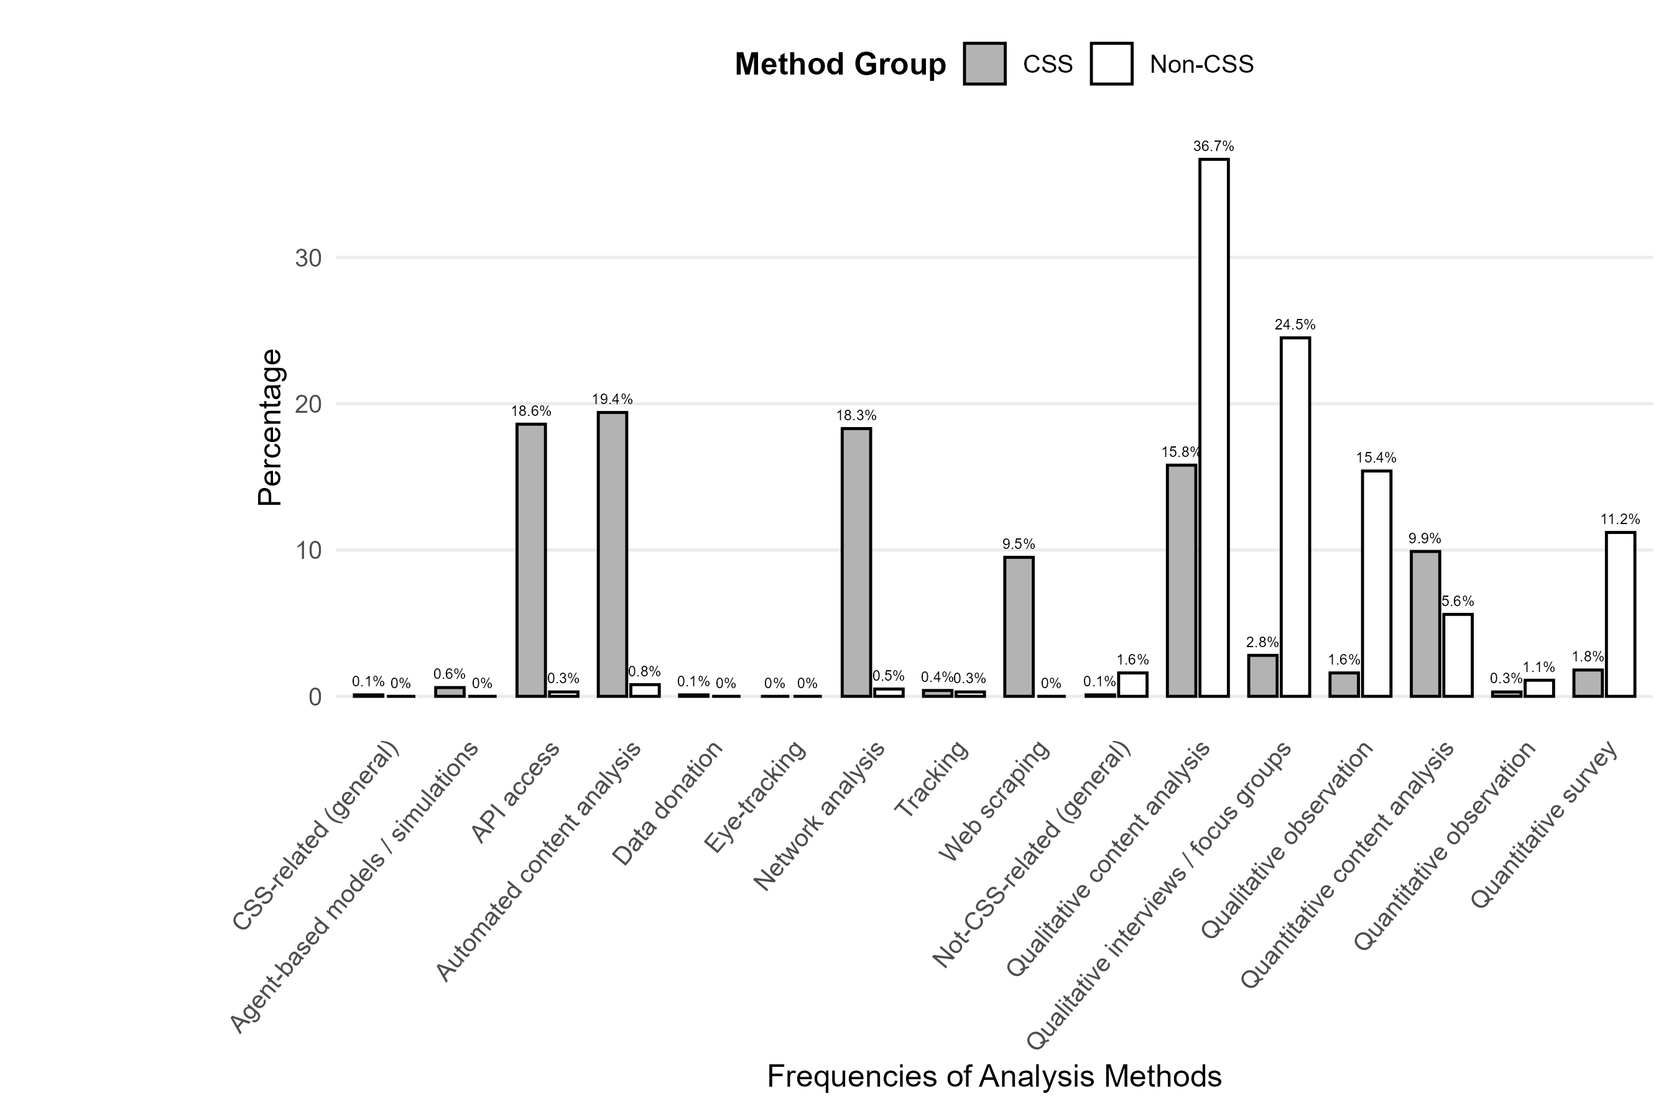

Figure 5
Distribution of Frequency of Cross-National Research Designs by Method Group
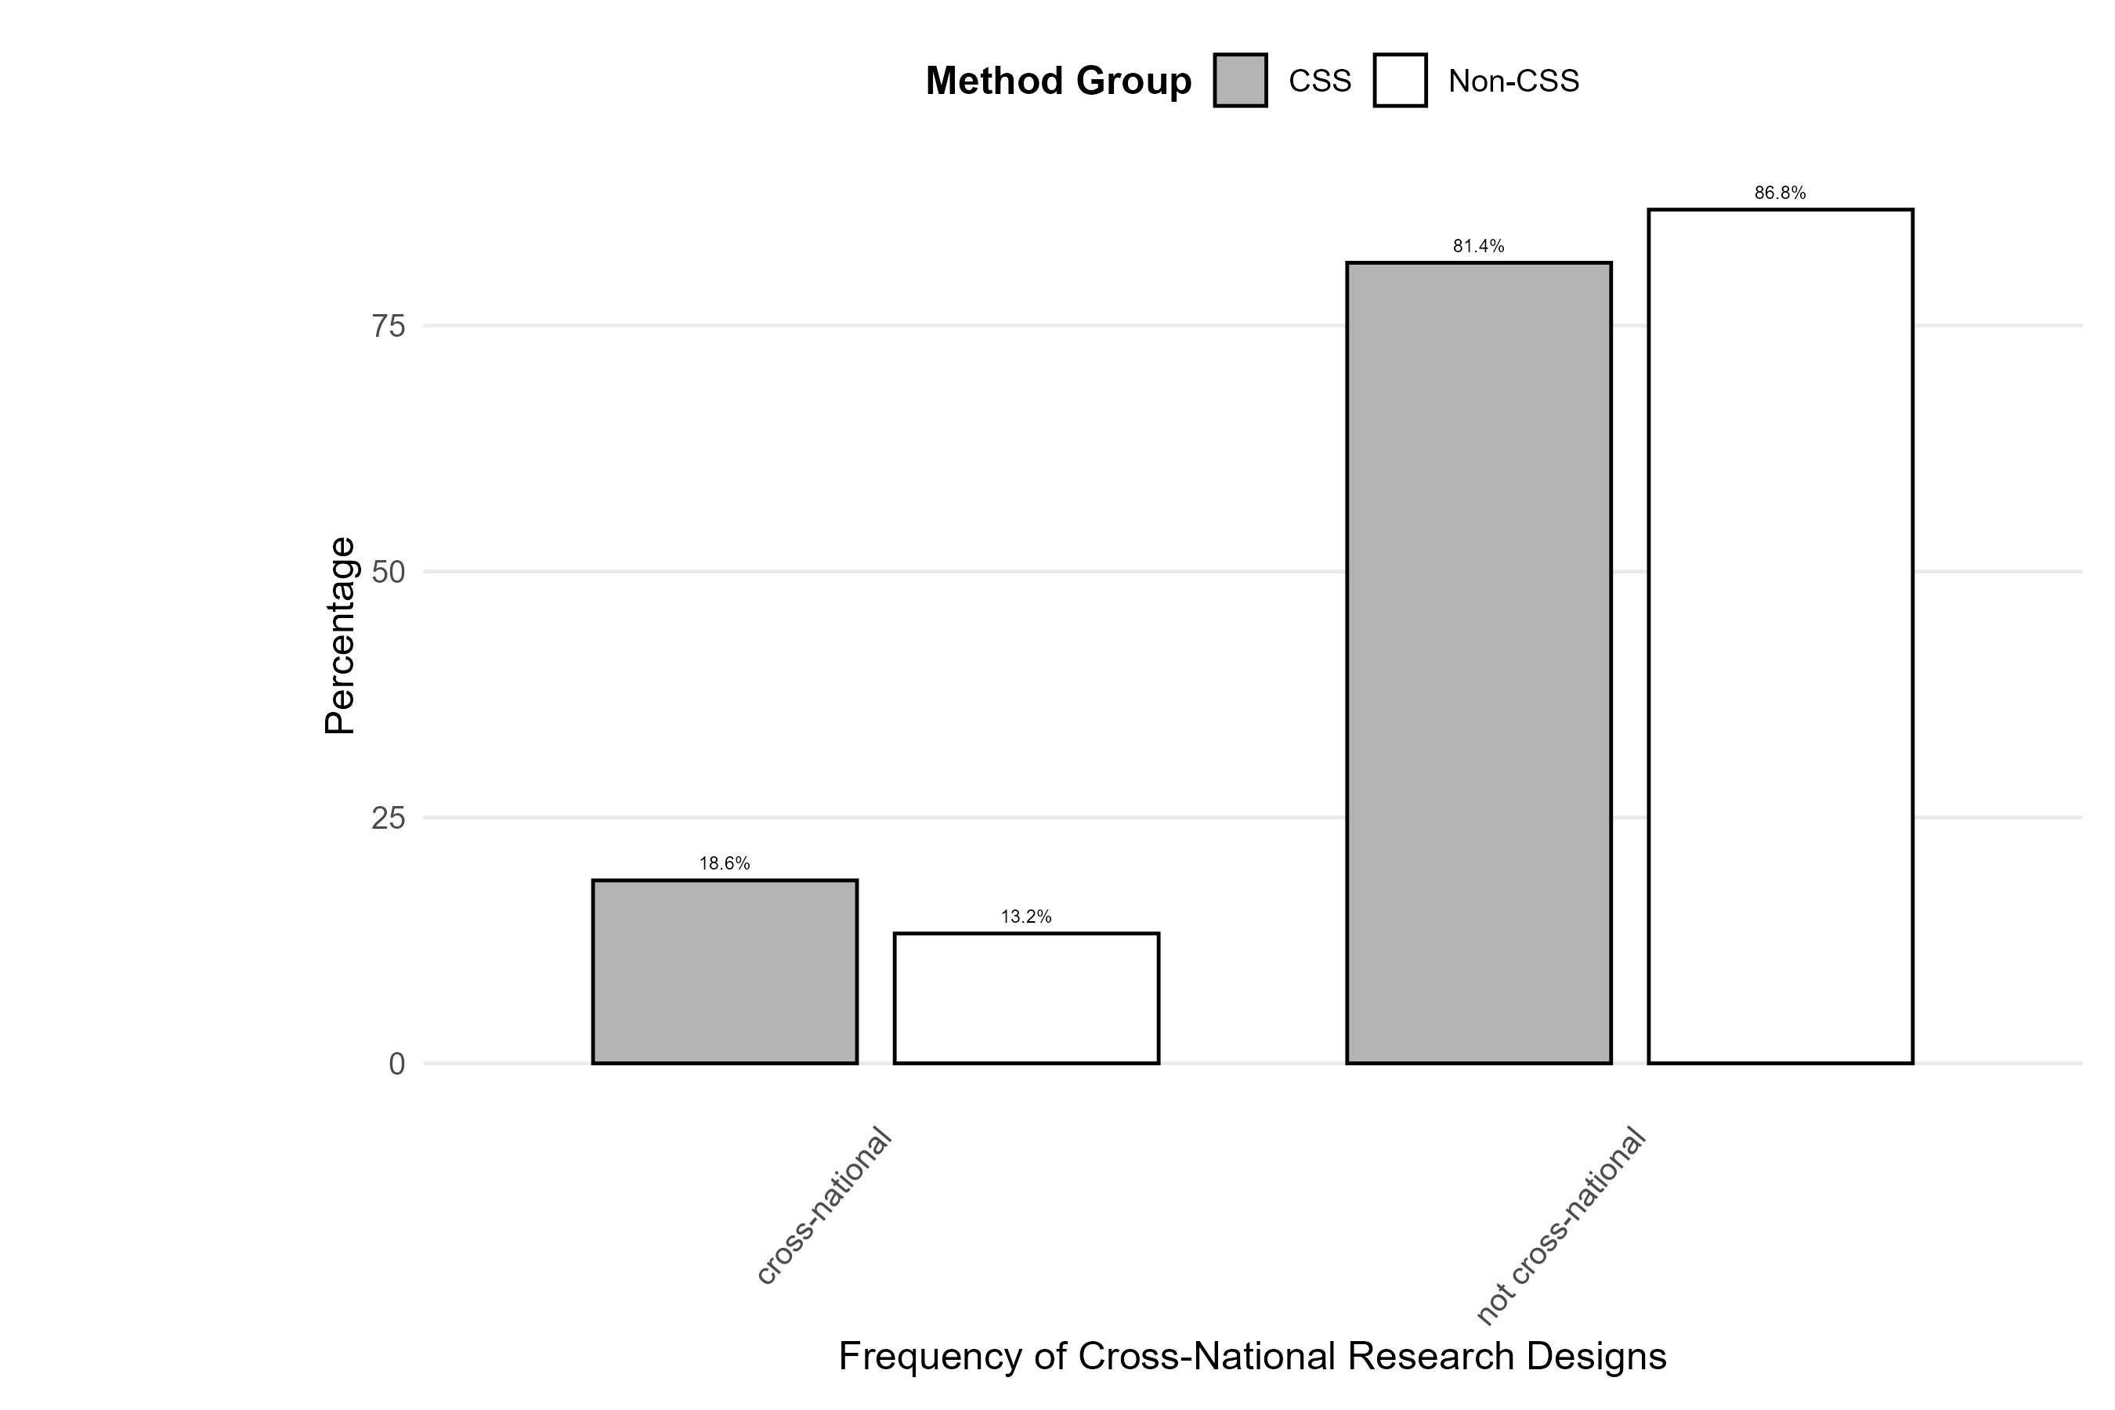

Figure 6
Distribution of Frequency of Experimental Research Designs by Method Group
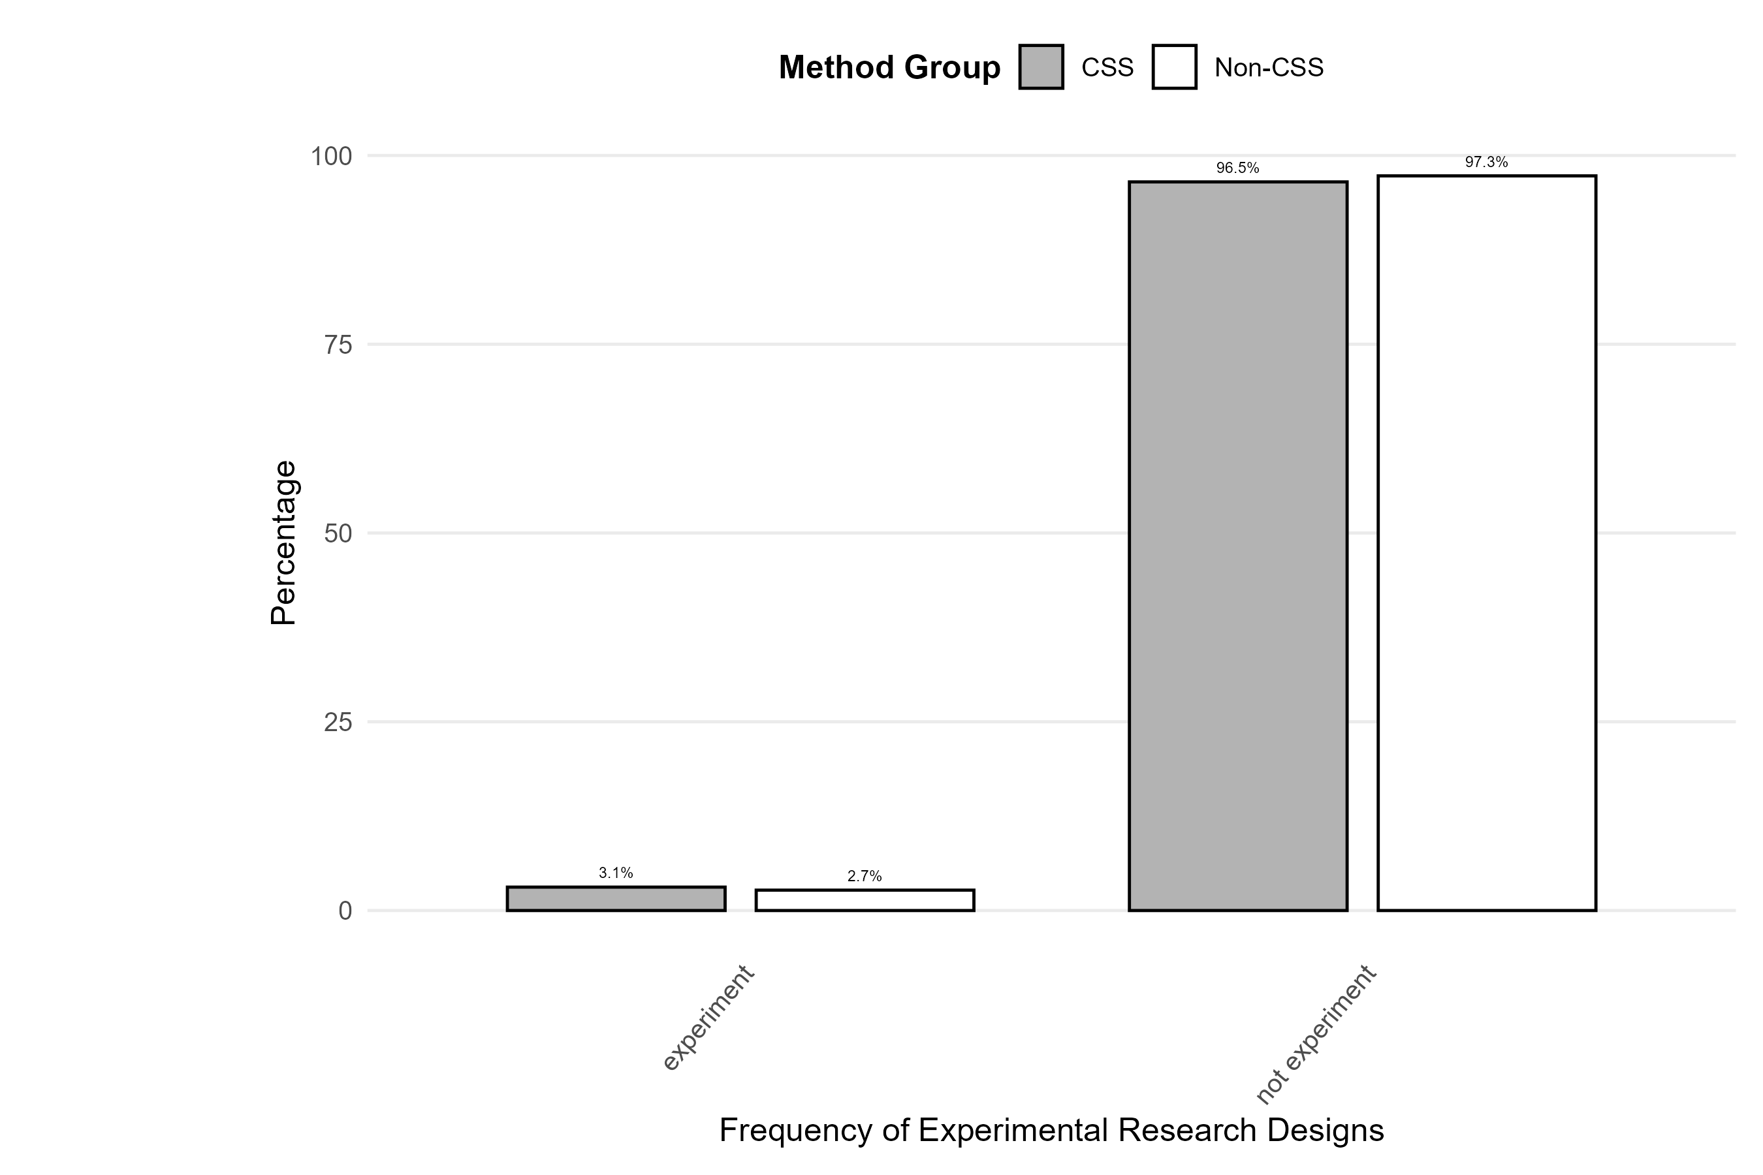

Figure (supplement): Analysis Methods — % overall (no split)
Overall distribution of analysis methods (V11) across the full sample.
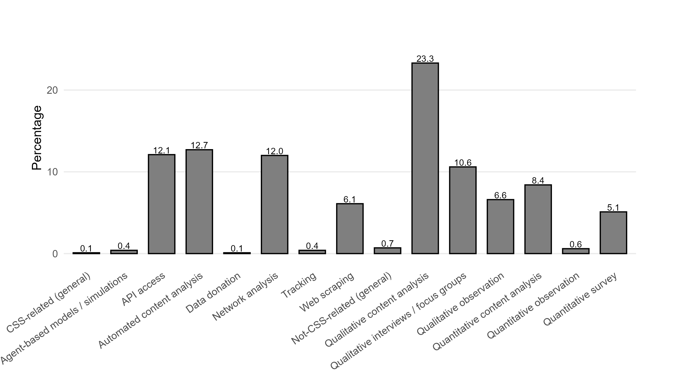

Figure (supplement): Geographic distribution of studies across world regions
Shaded world maps by method group (CSS vs. Non-CSS). Darker shading indicates more studies in that region. Facet titles include % of studies using global samples.
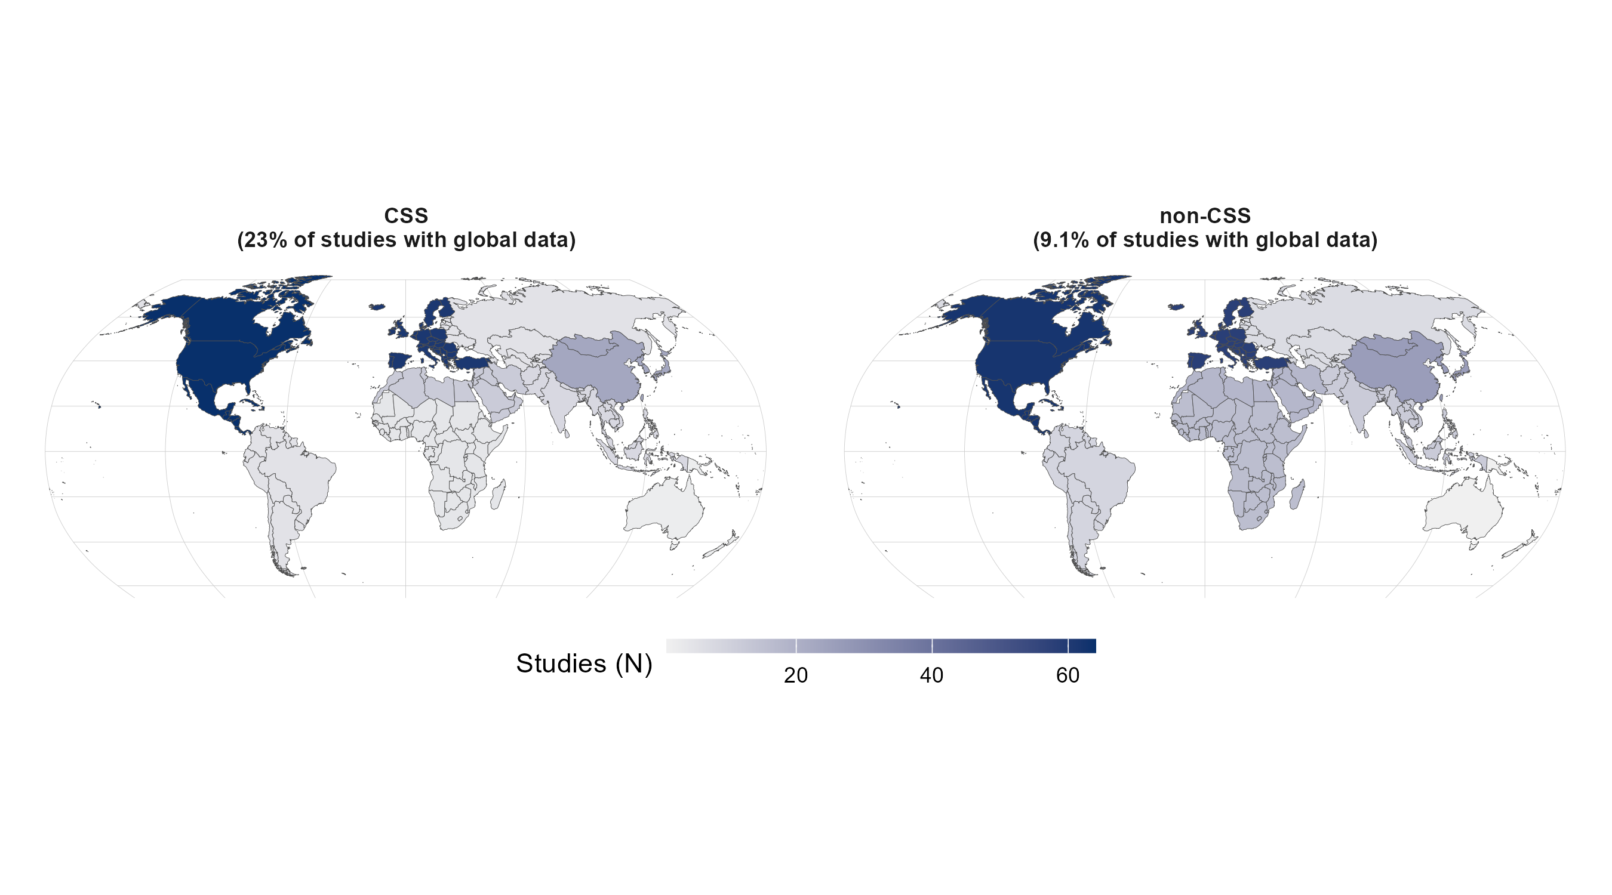

Figure (supplement): Cross-national, Cross-platform, and Experimental Designs
Share of studies by design feature (cross-national, cross-platform, experimental), split by method group (CSS vs. Non-CSS).
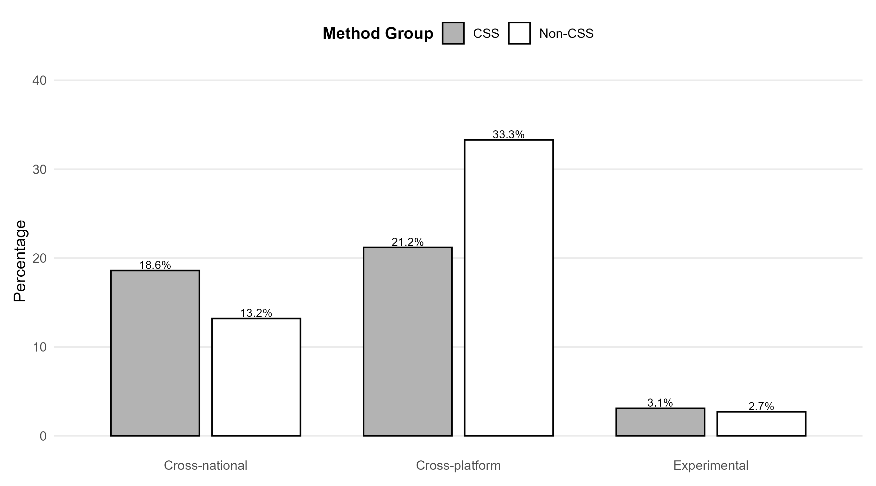

Figure (supplement): Analysis Methods — % within design (cross-national only)
Bar chart of cross-national design by analysis method, split by CSS vs. Non-CSS. Matches the left block of the V11 × V12 table.
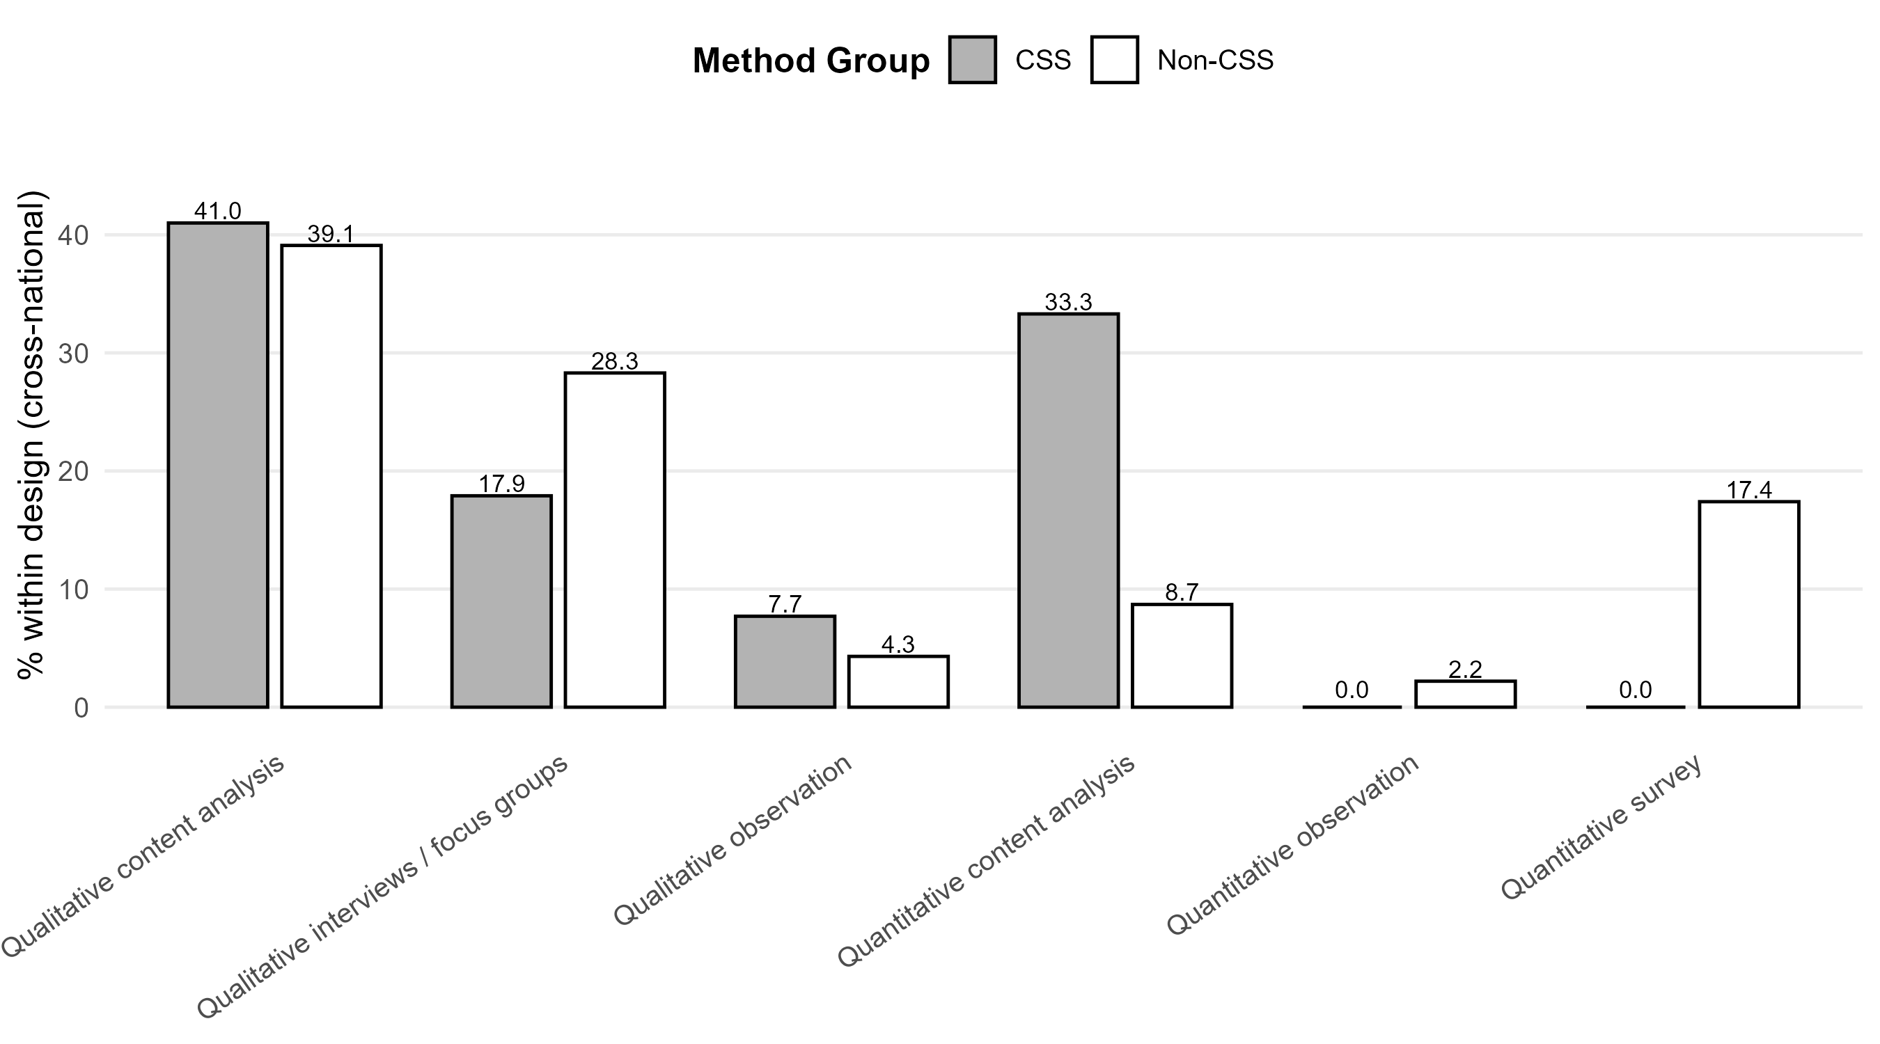

Figure (supplement): Platforms — % within design (cross-national only)
Bar chart of cross-national design by platform type (V10_agg), split by CSS vs. Non-CSS. Matches the left block of the V12 × V10_agg logic.
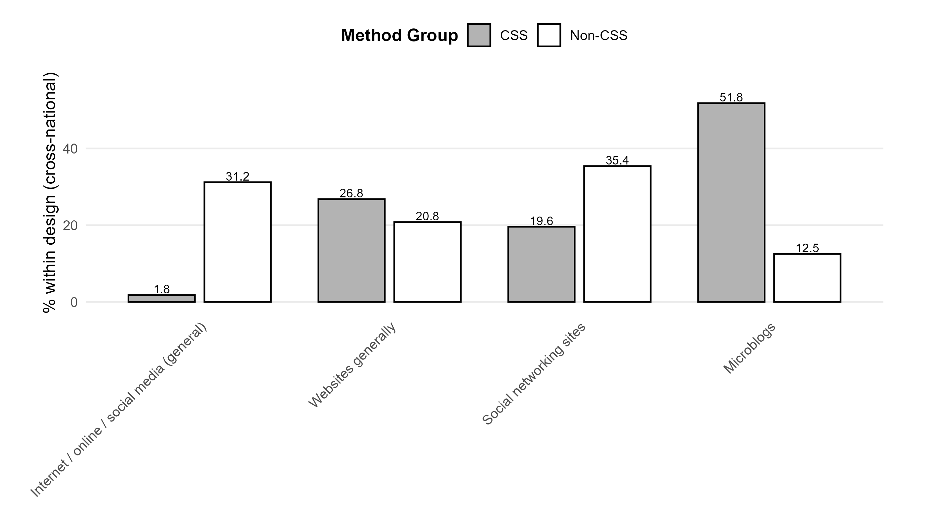

Figure (supplement): Method combinations — overall %
Bar chart of method-combination types.
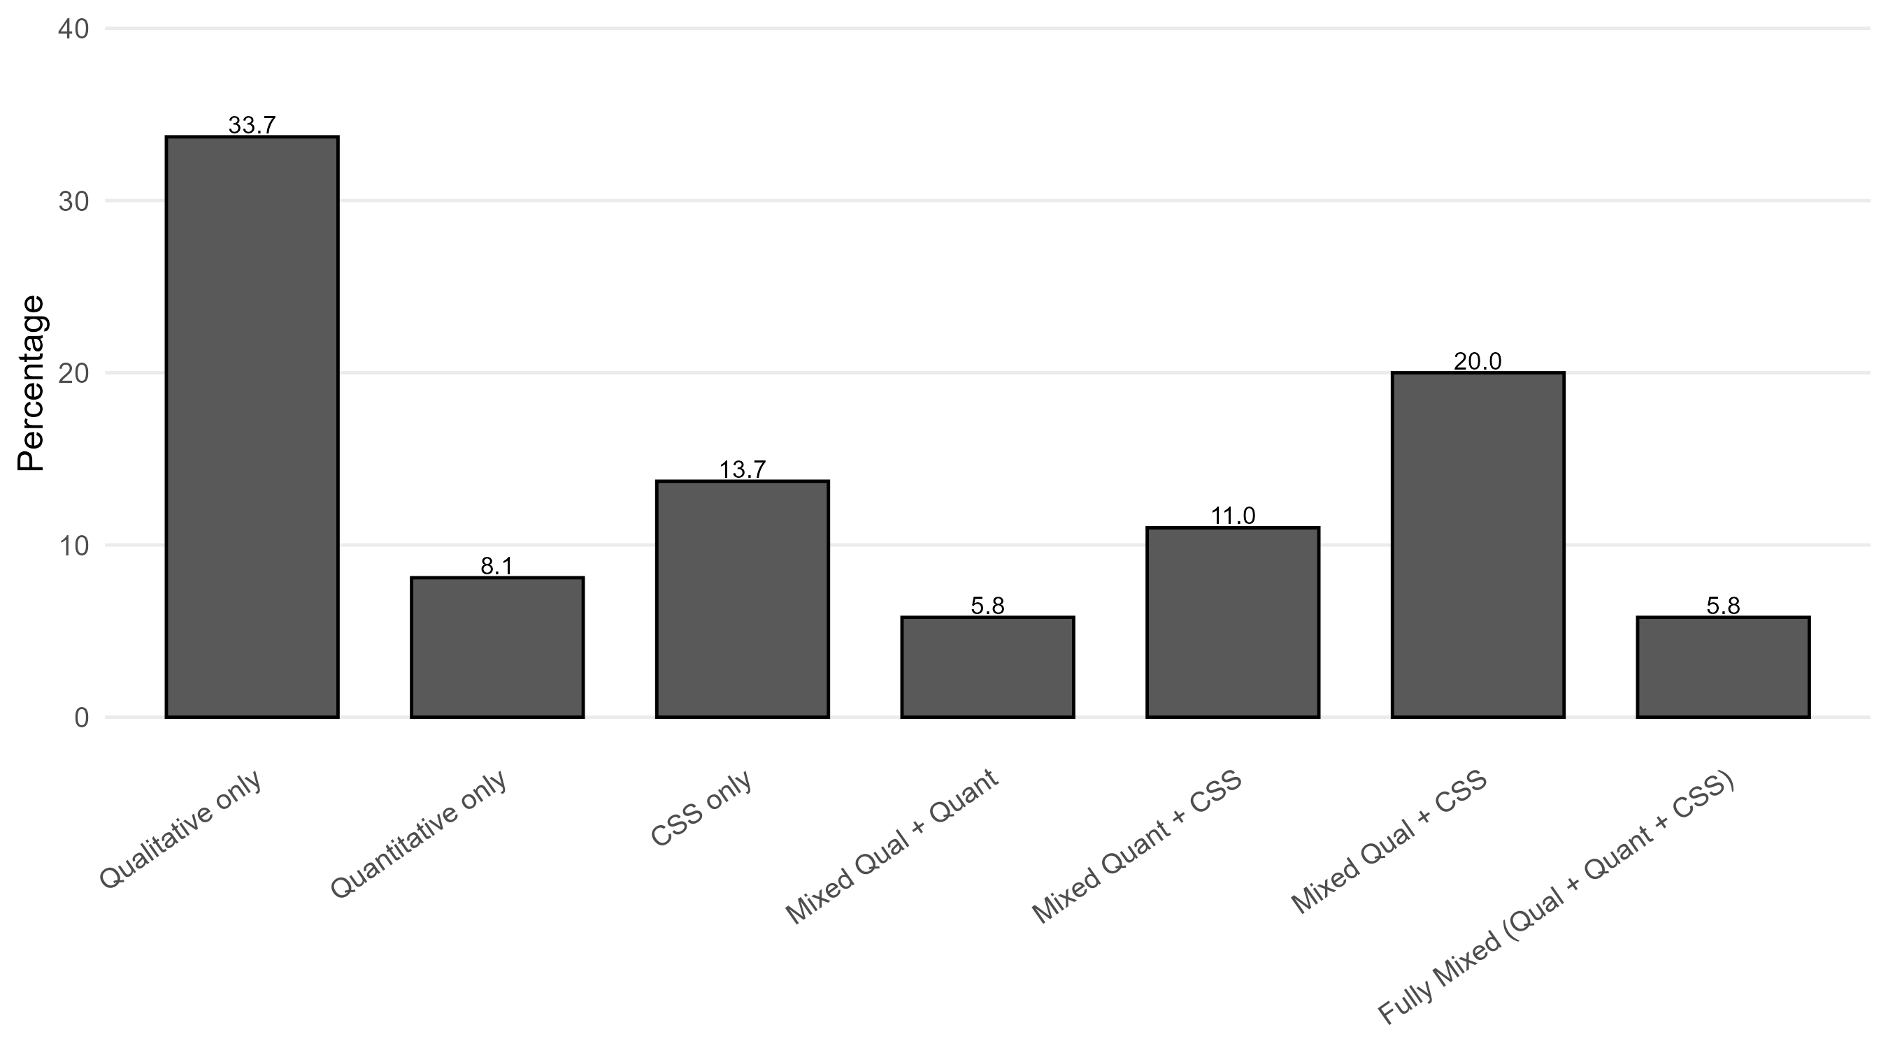

Figure (supplement): Protest Case Presence by Method Group (≥5% in both groups)
Percentage of studies per protest case, split by CSS vs. Non-CSS. Cases are shown only if both groups have at least 5%.


