Table 1
Frequencies of Regions
Frequencies of Regions
Code | Category | Non-CSS n (n=231) | CSS n (n=238) | Non-CSS % | CSS %
1 | North America | 62 | 64 | 26.8 | 26.9
2 | South America | 9 | 5 | 3.9 | 2.1
3 | Europe | 58 | 61 | 25.1 | 25.6
4 | Russia and former Soviet Republics | 7 | 5 | 3.0 | 2.1
5 | Middle East and North Africa | 18 | 12 | 7.8 | 5.0
6 | East Asia | 26 | 23 | 11.3 | 9.7
7 | Central and South (East) Asia | 12 | 8 | 5.2 | 3.4
8 | Sub-Saharan Africa | 16 | 4 | 6.9 | 1.7
9 | Oceania | 1 | 2 | 0.4 | 0.8
10 | Global | 20 | 52 | 8.7 | 21.8
NA | Not mentioned | 2 | 2 | 0.9 | 0.8
Note. CSS = computational social science; n = frequency; % = percentage.
Percentages are calculated within each method group.
N = 445 studies.

Table (supplement): Method (CSS vs. non-CSS) × V7 (Regions)
Chi-square Test: Method (CSS vs. non-CSS) X V7 (Regions)
Metric | Value
Test | Method (CSS vs. non-CSS) X V7 (Regions)
df | 9
χ² | 25.423
p | 0.003
N | 465
Cramér's V | 0.234
Note. Chi-square computed on expanded rows after splitting multi-coded V7 entries (matching the figure’s approach). 'N (expanded)' counts region mentions, not unique studies. Excluding Region = NA. Method: 0 = Non-CSS, 1 = CSS.

Figure 1
Distribution of Frequencies of Regions by Method Group
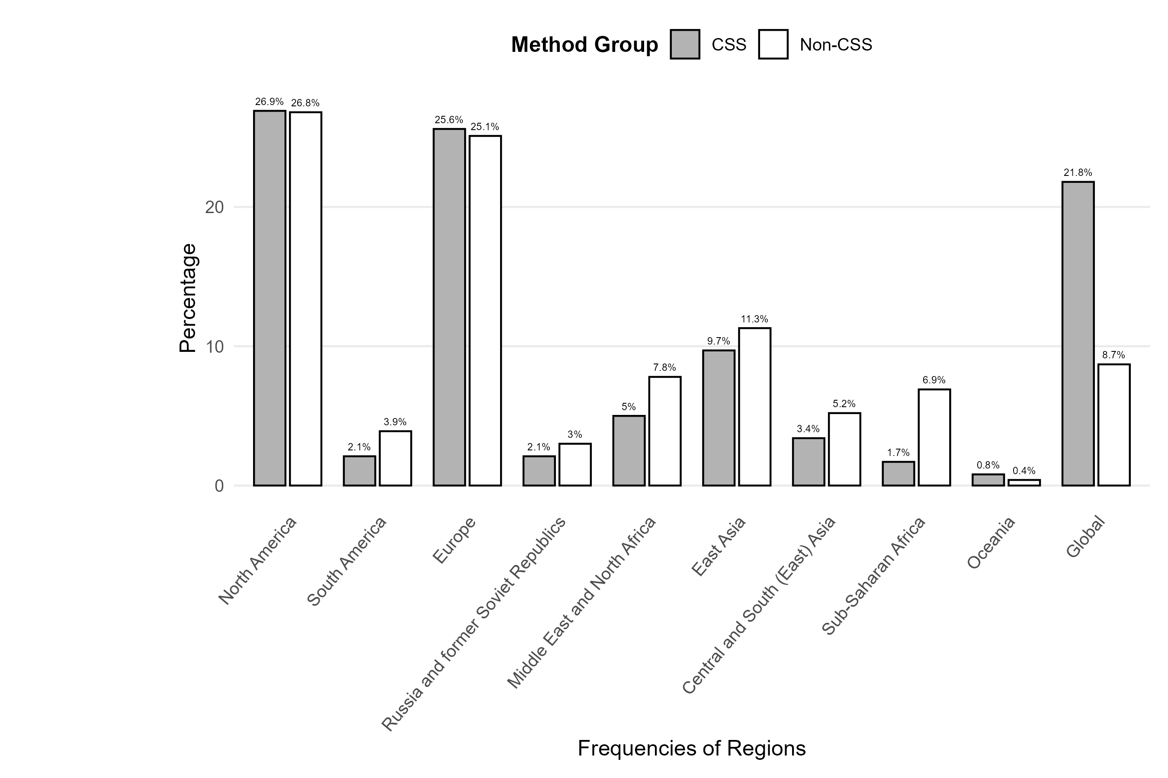

Table 2
Frequencies of Platforms
Frequencies of Platforms
Code | Category | Non-CSS n (n=371) | CSS n (n=311) | Non-CSS % | CSS %
100 | Internet / online / social media (general) | 89 | 9 | 24.0 | 2.9
110 | Websites (general) | 5 | 11 | 1.3 | 3.5
111 | Websites of activist groups / NGOs / parties / companies | 20 | 22 | 5.4 | 7.1
112 | News Media (online) | 16 | 19 | 4.3 | 6.1
113 | Partisan news outlets | 0 | 1 | 0.0 | 0.3
114 | Blogs | 18 | 6 | 4.9 | 1.9
120 | Knowledge communities & discussion | 1 | 1 | 0.3 | 0.3
121 | Specific discussion forum(s) | 6 | 4 | 1.6 | 1.3
122 | Discord | 0 | 0 | 0.0 | 0.0
124 | Reddit | 2 | 4 | 0.5 | 1.3
130 | Social networking sites (general) | 11 | 1 | 3.0 | 0.3
131 | Facebook | 66 | 38 | 17.8 | 12.2
132 | Instagram | 14 | 8 | 3.8 | 2.6
133 | TikTok | 4 | 4 | 1.1 | 1.3
134 | VKontakte | 3 | 3 | 0.8 | 1.0
140 | Microblogs | 1 | 1 | 0.3 | 0.3
141 | X/Twitter | 41 | 137 | 11.1 | 44.1
142 | Weibo | 7 | 8 | 1.9 | 2.6
150 | Video-sharing sites | 1 | 1 | 0.3 | 0.3
151 | YouTube | 16 | 11 | 4.3 | 3.5
152 | Vimeo | 0 | 0 | 0.0 | 0.0
153 | Twitch | 0 | 0 | 0.0 | 0.0
160 | Photo-sharing sites | 0 | 0 | 0.0 | 0.0
161 | Flickr | 0 | 2 | 0.0 | 0.6
162 | Tumblr | 3 | 1 | 0.8 | 0.3
200 | Messengers (general) | 5 | 0 | 1.3 | 0.0
201 | WhatsApp | 5 | 0 | 1.3 | 0.0
202 | Telegram | 5 | 7 | 1.3 | 2.3
203 | Signal | 0 | 0 | 0.0 | 0.0
204 | WeChat | 3 | 0 | 0.8 | 0.0
300 | News Media (offline) | 19 | 7 | 5.1 | 2.3
400 | Other | 8 | 5 | 2.2 | 1.6
NA | Not mentioned | 2 | 0 | 0.5 | 0.0
Note. CSS = computational social science; n = frequency; % = percentage.
Percentages are calculated within each method group.
N = 445 studies.

Figure 2
Distribution of Frequencies of Platforms by Method Group
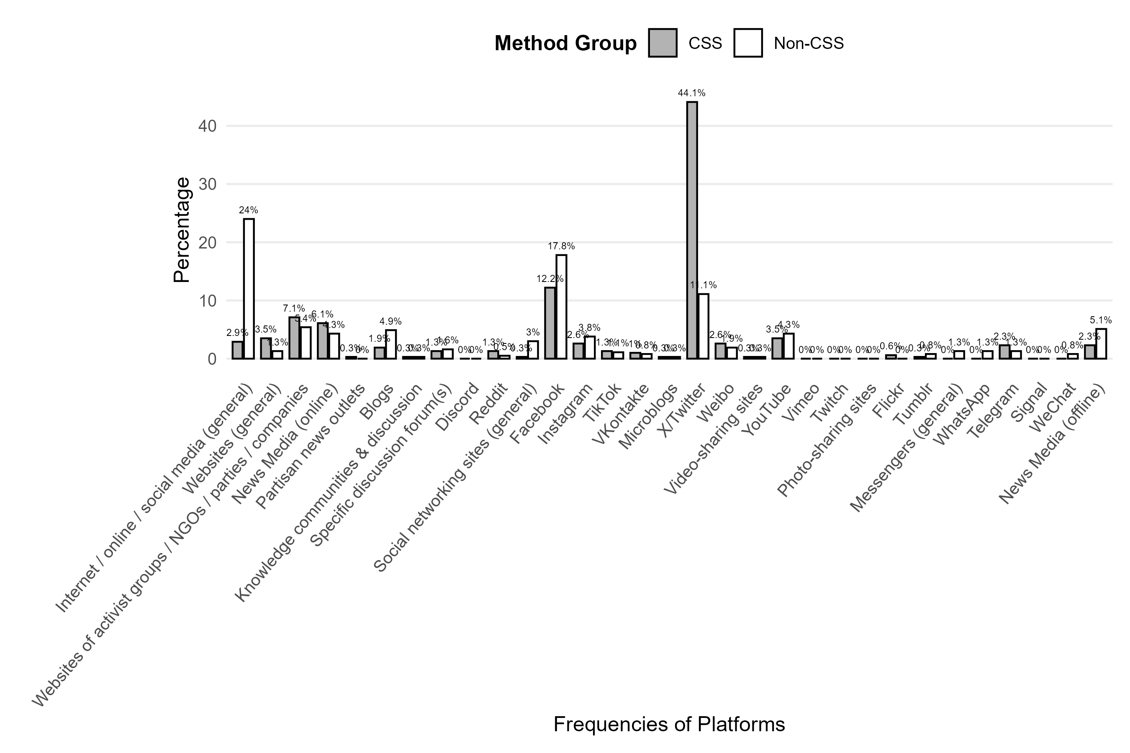

Table 3
Frequencies of Platforms (aggregated)
Frequencies of Platforms (aggregated)
Code | Category | Non-CSS n (n=371) | CSS n (n=311) | Non-CSS % | CSS %
100 | Internet / online / social media (general) | 89 | 9 | 24.0 | 2.9
110 | Websites generally | 59 | 59 | 15.9 | 19.0
120 | Knowledge communities & discussion | 9 | 9 | 2.4 | 2.9
130 | Social networking sites | 98 | 54 | 26.4 | 17.4
140 | Microblogs | 49 | 146 | 13.2 | 46.9
150 | Video-sharing sites | 17 | 12 | 4.6 | 3.9
160 | Photo-sharing sites | 3 | 3 | 0.8 | 1.0
200 | Messengers | 18 | 7 | 4.9 | 2.3
300 | News Media (offline) | 19 | 7 | 5.1 | 2.3
400 | Other | 8 | 5 | 2.2 | 1.6
NA | Not mentioned | 2 | 0 | 0.5 | 0.0
Note. CSS = computational social science; n = frequency; % = percentage.
Percentages are calculated within each method group.
N = 445 studies.

Figure 3
Distribution of Frequencies of Platforms (aggregated) by Method Group
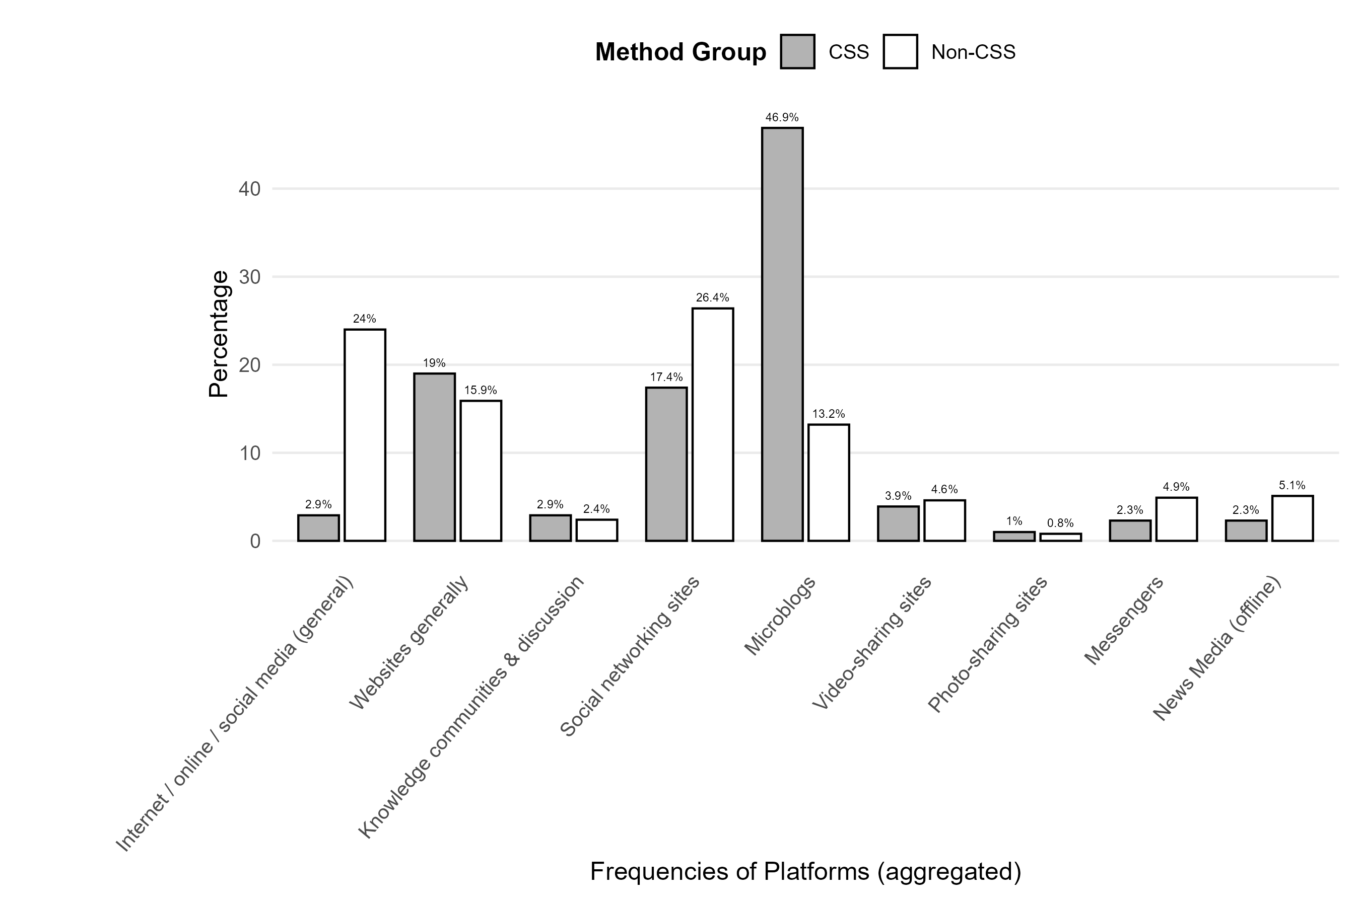

Table 4
Frequencies of Analysis Methods
Frequencies of Analysis Methods
Code | Category | Non-CSS n (n=376) | CSS n (n=676) | Non-CSS % | CSS %
10 | CSS-related (general) | 0 | 1 | 0.0 | 0.1
11 | Agent-based models / simulations | 0 | 4 | 0.0 | 0.6
12 | API access | 1 | 126 | 0.3 | 18.6
13 | Automated content analysis | 3 | 131 | 0.8 | 19.4
14 | Data donation | 0 | 1 | 0.0 | 0.1
15 | Eye-tracking | 0 | 0 | 0.0 | 0.0
16 | Network analysis | 2 | 124 | 0.5 | 18.3
17 | Tracking | 1 | 3 | 0.3 | 0.4
18 | Web scraping | 0 | 64 | 0.0 | 9.5
20 | Not-CSS-related (general) | 6 | 1 | 1.6 | 0.1
21 | Qualitative content analysis | 138 | 107 | 36.7 | 15.8
22 | Qualitative interviews / focus groups | 92 | 19 | 24.5 | 2.8
23 | Qualitative observation | 58 | 11 | 15.4 | 1.6
24 | Quantitative content analysis | 21 | 67 | 5.6 | 9.9
25 | Quantitative observation | 4 | 2 | 1.1 | 0.3
26 | Quantitative survey | 42 | 12 | 11.2 | 1.8
99 | Other | 6 | 3 | 1.6 | 0.4
NA | Not mentioned | 2 | 0 | 0.5 | 0.0
Note. CSS = computational social science; n = frequency; % = percentage.
Percentages are calculated within each method group.
N = 445 studies.

Figure 4
Distribution of Frequencies of Analysis Methods by Method Group
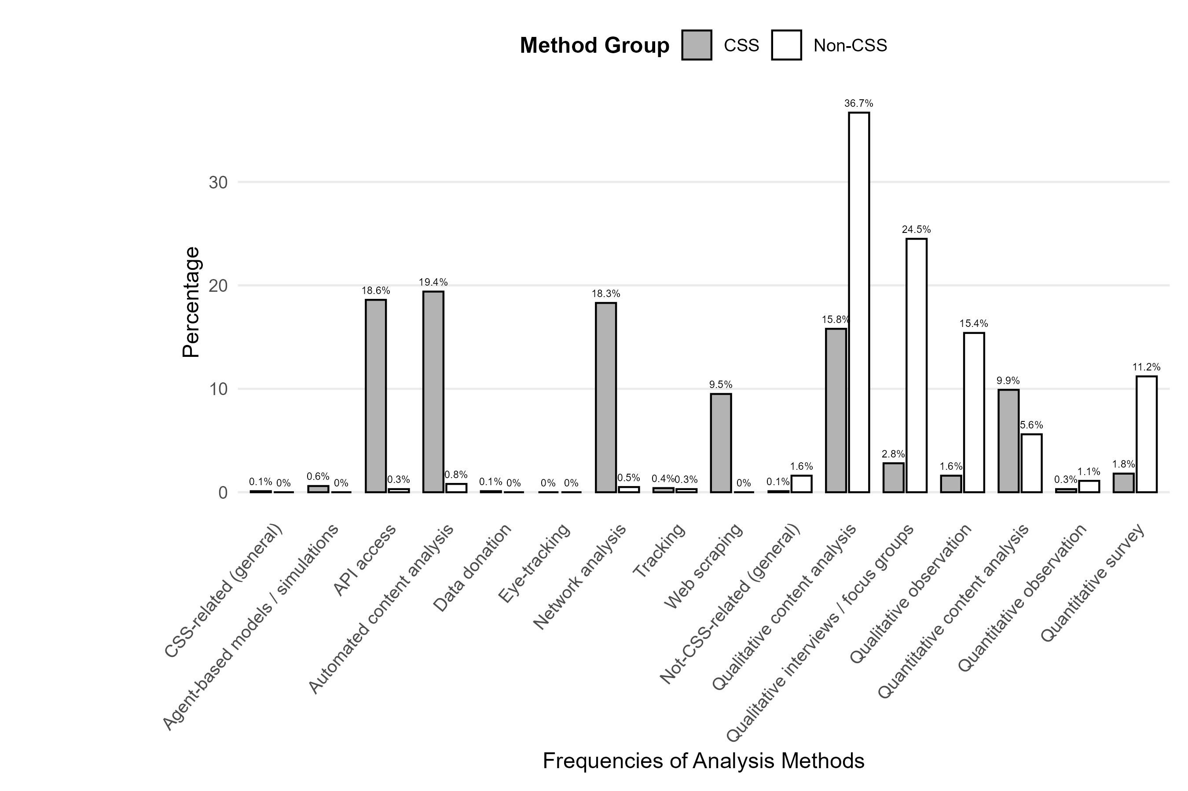

Table 5
Frequency of Cross-National Research Designs
Frequency of Cross-National Research Designs
Code | Category | Non-CSS n (n=219) | CSS n (n=226) | Non-CSS % | CSS %
1 | cross-national | 29 | 42 | 13.2 | 18.6
0 | not cross-national | 190 | 184 | 86.8 | 81.4
Note. CSS = computational social science; n = frequency; % = percentage.
Percentages are calculated within each method group.
N = 445 studies.

Figure 5
Distribution of Frequency of Cross-National Research Designs by Method Group
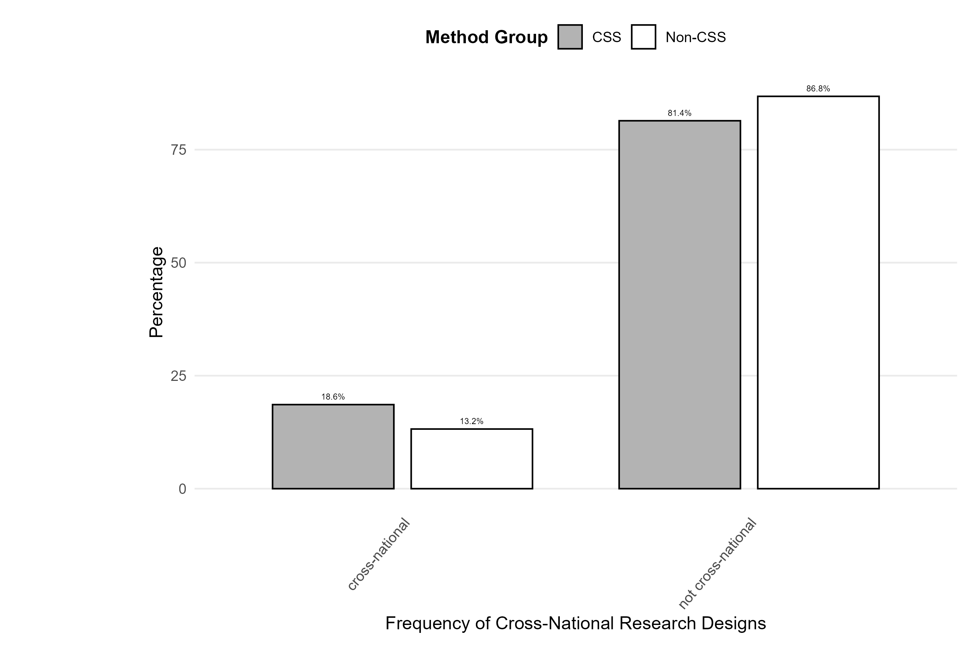

Table 6
Frequency of Experimental Research Designs
Frequency of Experimental Research Designs
Code | Category | Non-CSS n (n=219) | CSS n (n=226) | Non-CSS % | CSS %
1 | experiment | 6 | 7 | 2.7 | 3.1
0 | not experiment | 213 | 218 | 97.3 | 96.5
Note. CSS = computational social science; n = frequency; % = percentage.
Percentages are calculated within each method group.
N = 445 studies.

Figure 6
Distribution of Frequency of Experimental Research Designs by Method Group
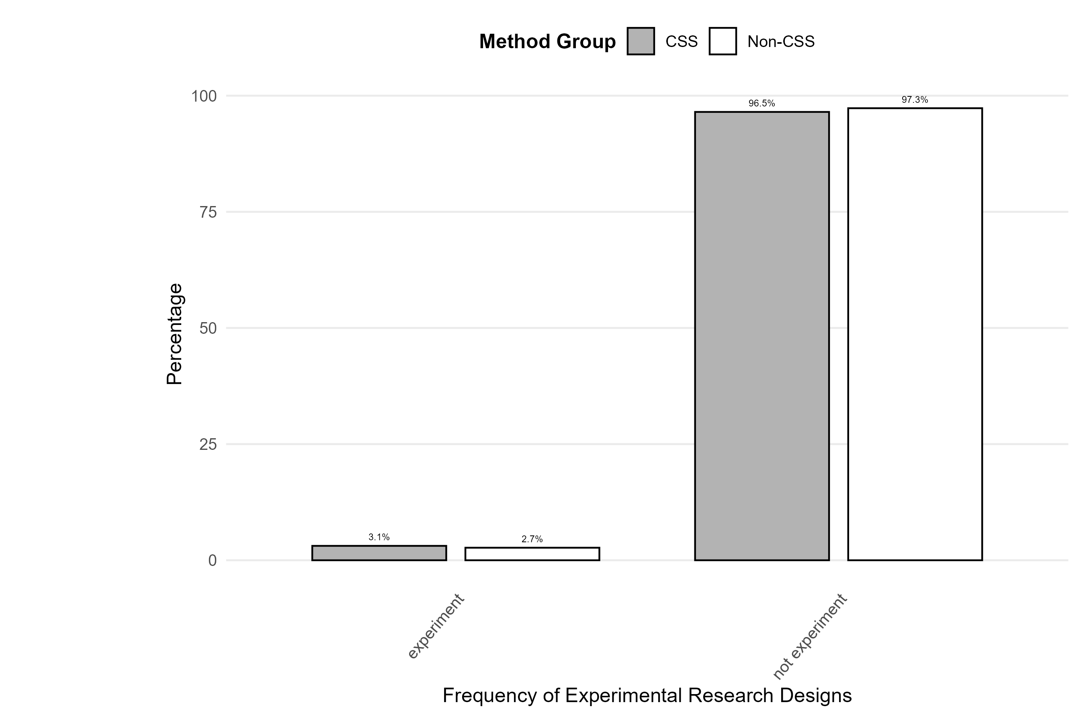

Figure (supplement): Cross-national and Experimental Designs
Share of studies with cross-national and experimental research designs by method group (CSS vs. Non-CSS)
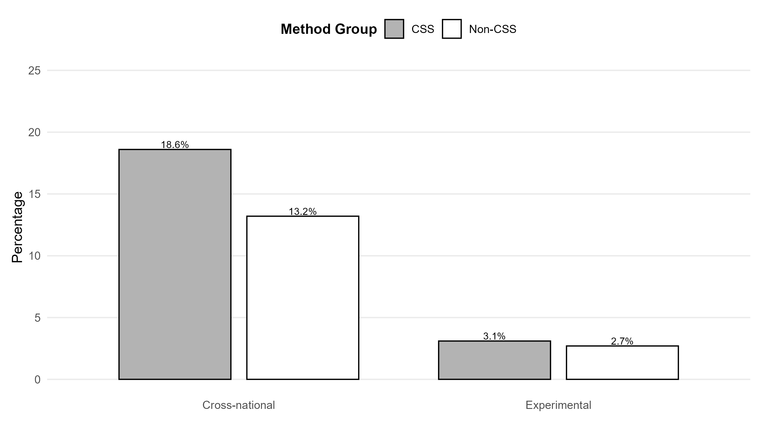

Table (supplement): V11 × V10_agg (Non-CSS/CSS %)
Analysis Methods × Major Platform Types — % within platform
 | Internet / online / social media (general) |  | Websites generally |  | Social networking sites |  | Microblogs
 | Non-CSS % | CSS % | Non-CSS % | CSS % | Non-CSS % | CSS % | Non-CSS % | CSS %
Qualitative content analysis | 34.0 | 18.2 | 39.4 | 41.0 | 36.1 | 39.2 | 36.2 | 50.8
Qualitative interviews / focus groups | 28.4 | 18.2 | 26.0 | 11.5 | 26.0 | 9.5 | 21.2 | 8.3
Qualitative observation | 15.6 | 9.1 | 14.4 | 3.3 | 16.6 | 6.8 | 18.8 | 5.3
Quantitative content analysis | 2.1 | 27.3 | 6.7 | 39.3 | 6.5 | 28.4 | 7.5 | 29.5
Quantitative observation | 0.7 | 0.0 | 1.0 | 0.0 | 0.6 | 2.7 | 0.0 | 0.8
Quantitative survey | 19.1 | 27.3 | 12.5 | 4.9 | 14.2 | 13.5 | 16.2 | 5.3
Note. Table limited to the four most frequently used platform types: Internet / online / social media (general); Websites general; Social Networking Sites; Microblogs.
Percentages are calculated within each platform column, separately for CSS and Non-CSS studies.
CSS = computational social science.

Table (supplement): V12 × V10_agg (Non-CSS/CSS %)
Cross-National Designs × Major Platform Types — % within platform (overall)
RowLabel | Internet / online / social media (general) | Websites generally | Social networking sites | Microblogs
cross-national | 16.3 | 21.2 | 18.4 | 17.9
not cross-national | 83.7 | 78.8 | 81.6 | 82.1
Note. Column percentages are computed overall (CSS and Non-CSS combined).

Table (supplement): V11 × V12 (Non-CSS/CSS %)
Analysis Methods × Cross-National Design — % within design
 | cross-national |  | not cross-national
 | Non-CSS % | CSS % | Non-CSS % | CSS %
Qualitative content analysis | 39.1 | 41.0 | 38.8 | 50.8
Qualitative interviews / focus groups | 28.3 | 17.9 | 25.6 | 6.7
Qualitative observation | 4.3 | 7.7 | 18.1 | 4.5
Quantitative content analysis | 8.7 | 33.3 | 5.5 | 30.2
Quantitative observation | 2.2 | 0.0 | 1.0 | 1.1
Quantitative survey | 17.4 | 0.0 | 11.0 | 6.7
Note. Columns show research design categories (cross-national; experimental).
Percentages are calculated within each research design column, separately for CSS and Non-CSS studies.
CSS = computational social science.

Figure (supplement): Analysis Methods — % within design (cross-national only)
Bar chart of cross-national design by analysis method, split by CSS vs. Non-CSS. Matches the left block of the V11 × V12 table.
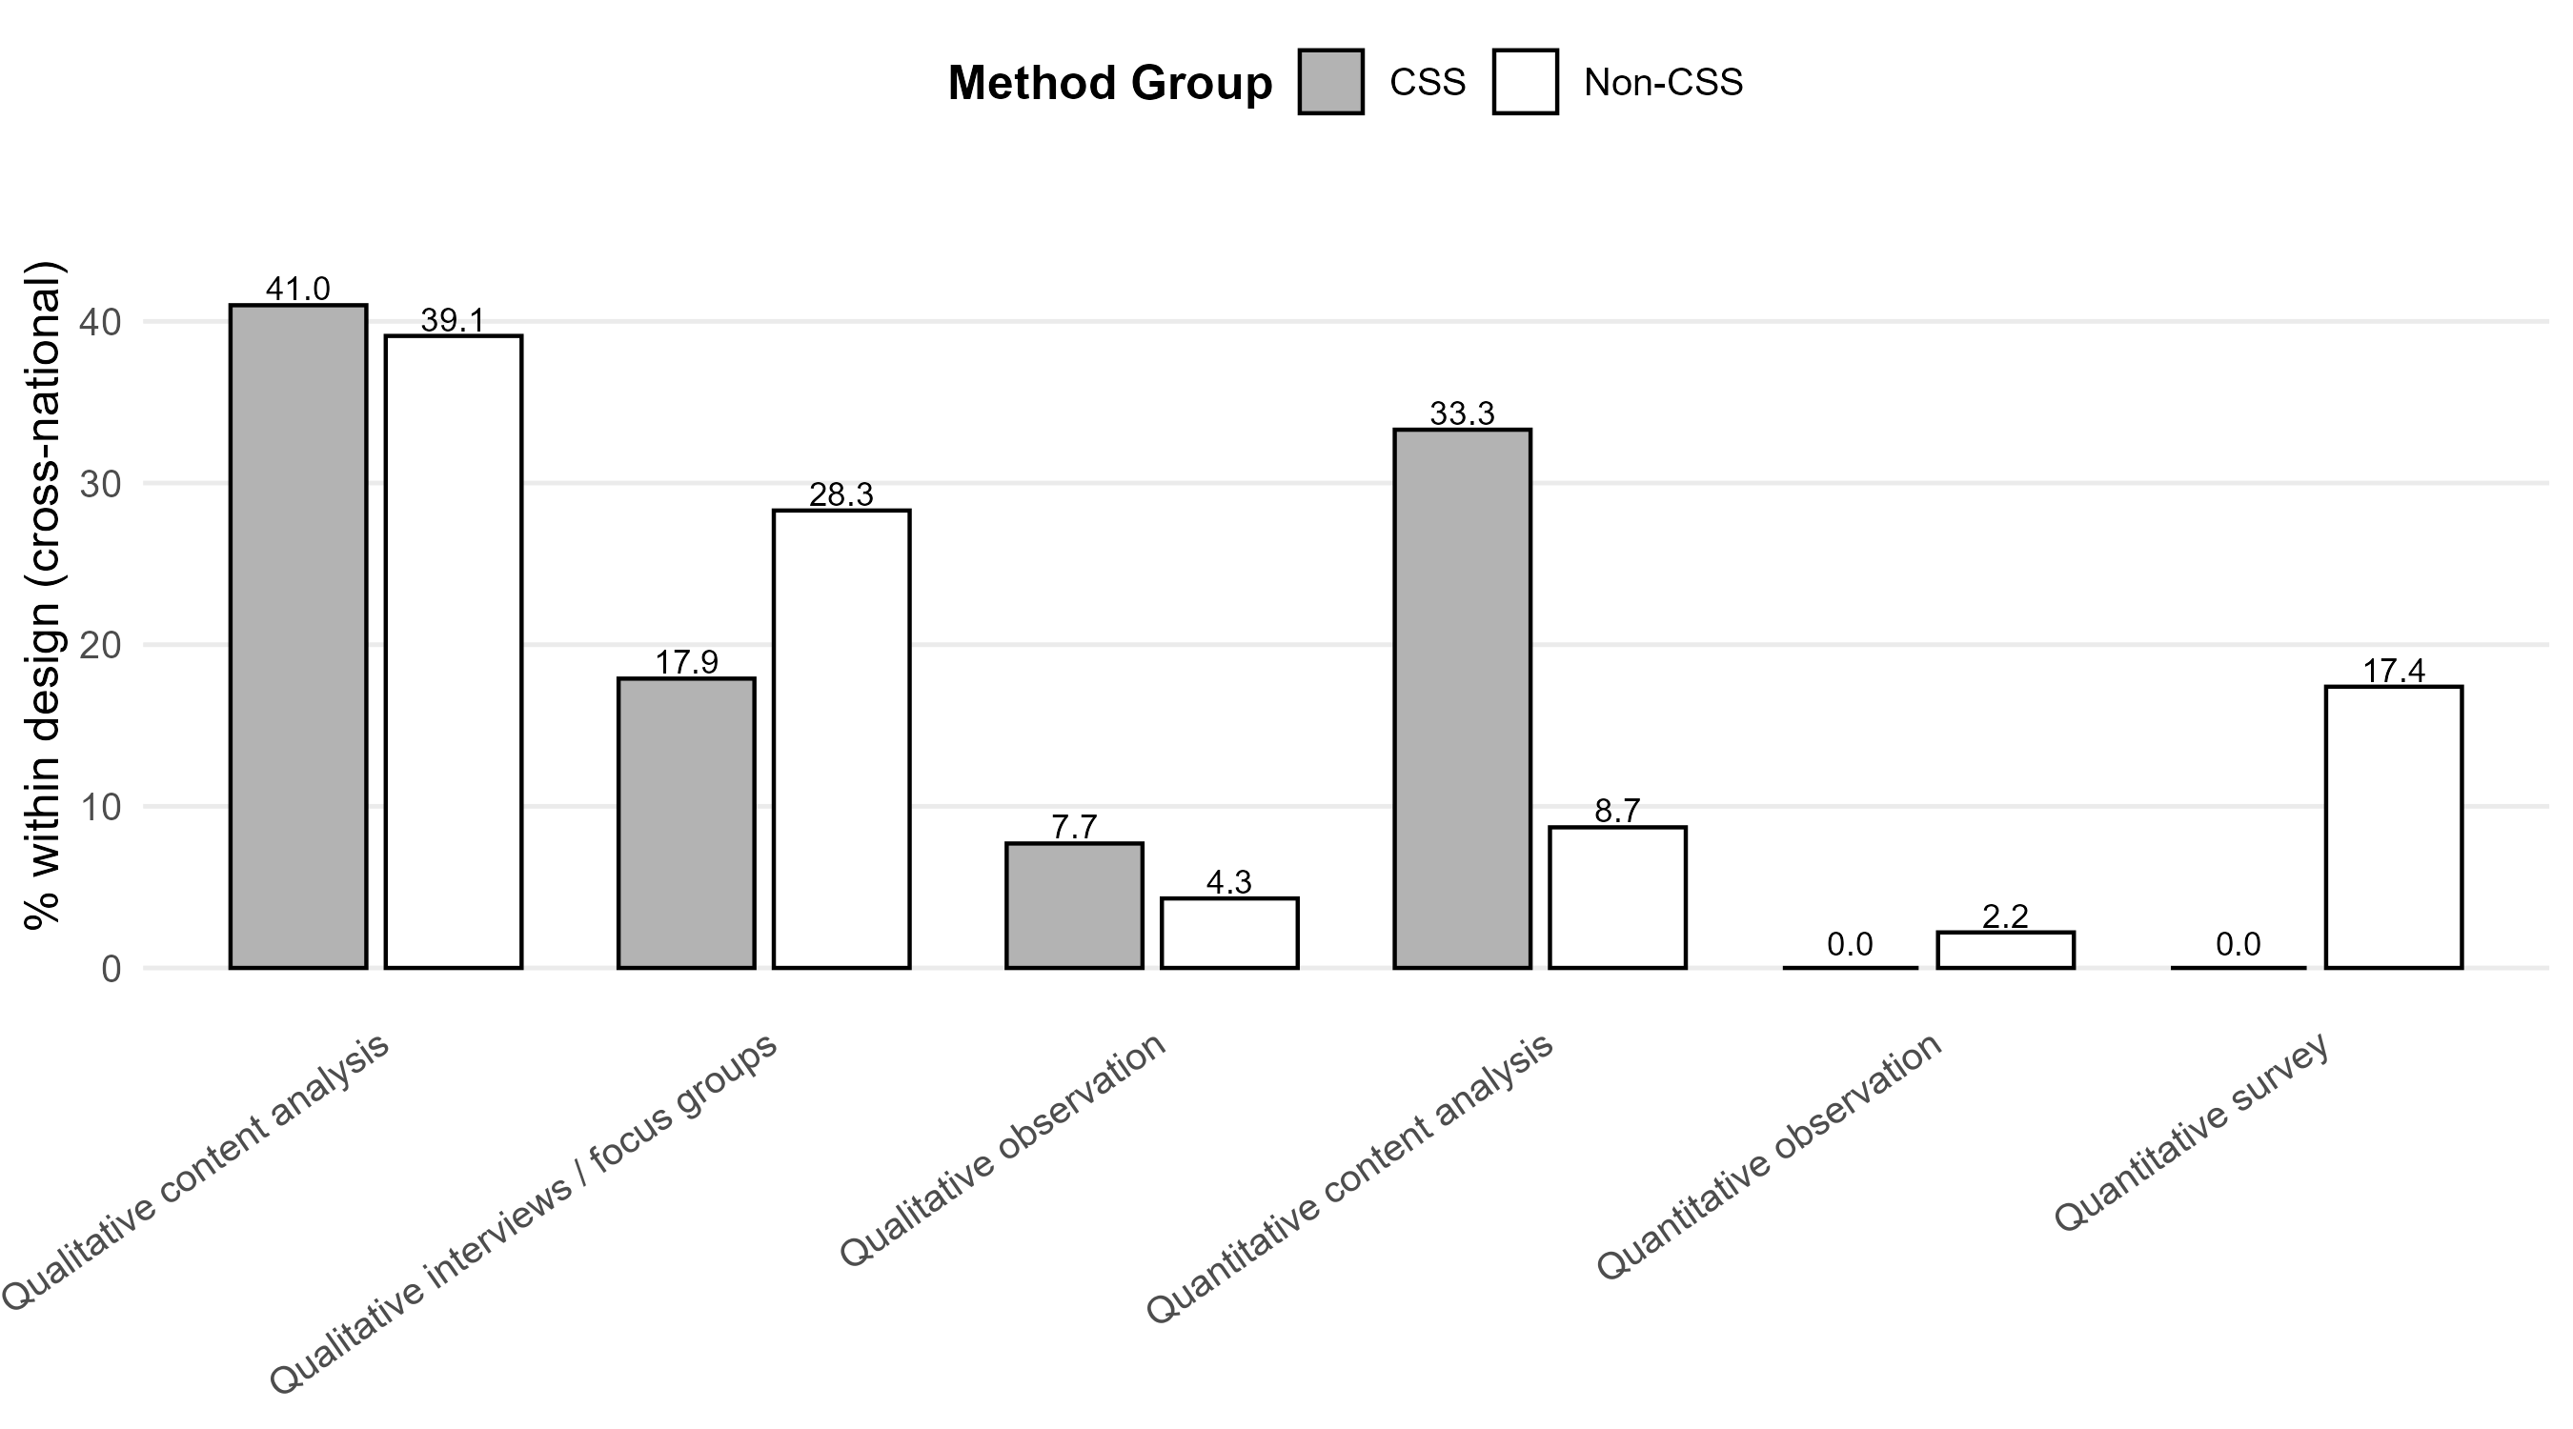

Figure (supplement): Platforms — % within design (cross-national only)
Bar chart of cross-national design by platform type (V10_agg), split by CSS vs. Non-CSS. Matches the left block of the V12 × V10_agg logic.
