Table 1
Frequencies of Regions
Frequencies of Regions
Code | Category | Non-CSS n (n=231) | CSS n (n=238) | Non-CSS % | CSS %
1 | North America | 62 | 64 | 26.8 | 26.9
2 | South America | 9 | 5 | 3.9 | 2.1
3 | Europe | 58 | 61 | 25.1 | 25.6
4 | Russia and former Soviet Republics | 7 | 5 | 3.0 | 2.1
5 | Middle East and North Africa | 18 | 12 | 7.8 | 5.0
6 | East Asia | 26 | 23 | 11.3 | 9.7
7 | Central and South (East) Asia | 12 | 8 | 5.2 | 3.4
8 | Sub-Saharan Africa | 16 | 4 | 6.9 | 1.7
9 | Oceania | 1 | 2 | 0.4 | 0.8
10 | Global | 20 | 52 | 8.7 | 21.8
NA | Not mentioned | 2 | 2 | 0.9 | 0.8
Note. CSS = computational social science; n = frequency; % = percentage.
Percentages are calculated within each method group.
N = 445 studies.

Figure 1
Distribution of Frequencies of Regions by Method Group
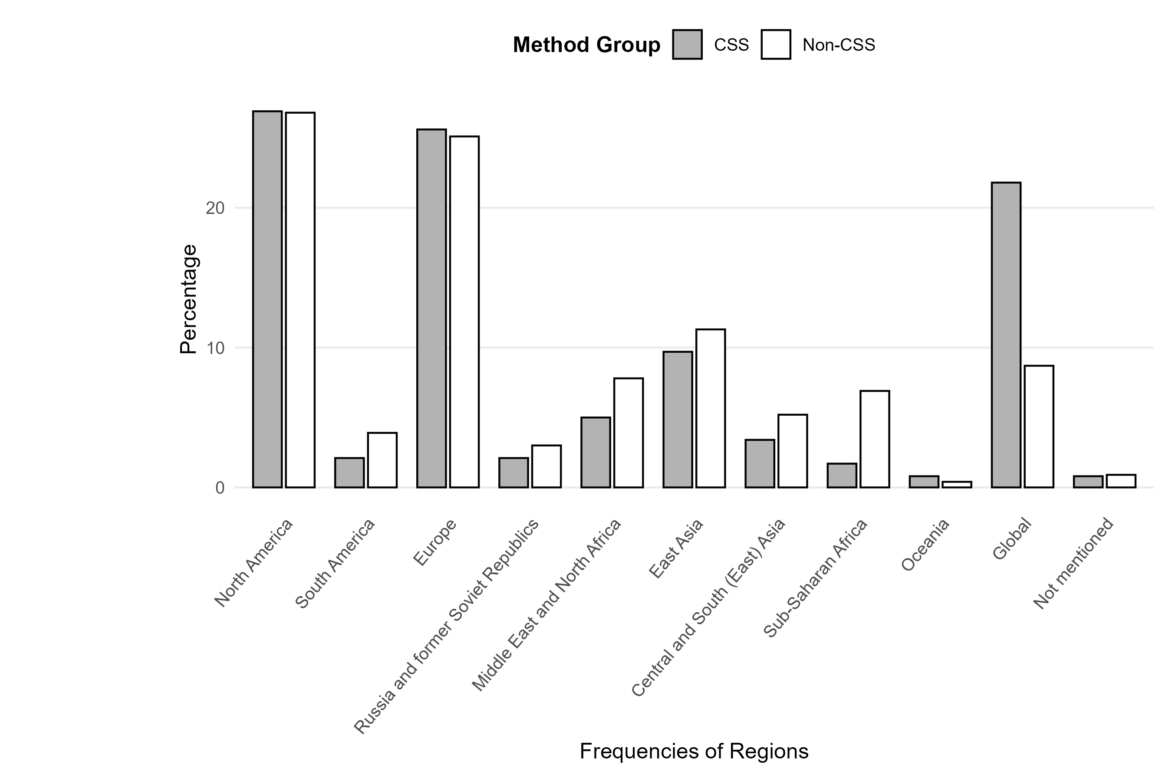
Table 2
Frequencies of Platforms
Frequencies of Platforms
Code | Category | Non-CSS n (n=371) | CSS n (n=311) | Non-CSS % | CSS %
100 | Internet / online / social media (general) | 89 | 9 | 24.0 | 2.9
110 | Websites (general) | 5 | 11 | 1.3 | 3.5
111 | Websites of activist groups / NGOs / parties / companies | 20 | 22 | 5.4 | 7.1
112 | News Media (online) | 16 | 19 | 4.3 | 6.1
113 | Partisan news outlets | 0 | 1 | 0.0 | 0.3
114 | Blogs | 18 | 6 | 4.9 | 1.9
120 | Knowledge communities & discussion | 1 | 1 | 0.3 | 0.3
121 | Specific discussion forum(s) | 6 | 4 | 1.6 | 1.3
122 | Discord | 0 | 0 | 0.0 | 0.0
124 | Reddit | 2 | 4 | 0.5 | 1.3
130 | Social networking sites (general) | 11 | 1 | 3.0 | 0.3
131 | Facebook | 66 | 38 | 17.8 | 12.2
132 | Instagram | 14 | 8 | 3.8 | 2.6
133 | TikTok | 4 | 4 | 1.1 | 1.3
134 | VKontakte | 3 | 3 | 0.8 | 1.0
140 | Microblogs | 1 | 1 | 0.3 | 0.3
141 | X/Twitter | 41 | 137 | 11.1 | 44.1
142 | Weibo | 7 | 8 | 1.9 | 2.6
150 | Video-sharing sites | 1 | 1 | 0.3 | 0.3
151 | YouTube | 16 | 11 | 4.3 | 3.5
152 | Vimeo | 0 | 0 | 0.0 | 0.0
153 | Twitch | 0 | 0 | 0.0 | 0.0
160 | Photo-sharing sites | 0 | 0 | 0.0 | 0.0
161 | Flickr | 0 | 2 | 0.0 | 0.6
162 | Tumblr | 3 | 1 | 0.8 | 0.3
200 | Messengers (general) | 5 | 0 | 1.3 | 0.0
201 | WhatsApp | 5 | 0 | 1.3 | 0.0
202 | Telegram | 5 | 7 | 1.3 | 2.3
203 | Signal | 0 | 0 | 0.0 | 0.0
204 | WeChat | 3 | 0 | 0.8 | 0.0
300 | News Media (offline) | 19 | 7 | 5.1 | 2.3
400 | Other | 8 | 5 | 2.2 | 1.6
NA | Not mentioned | 2 | 0 | 0.5 | 0.0
Note. CSS = computational social science; n = frequency; % = percentage.
Percentages are calculated within each method group.
N = 445 studies.

Figure 2
Distribution of Frequencies of Platforms by Method Group
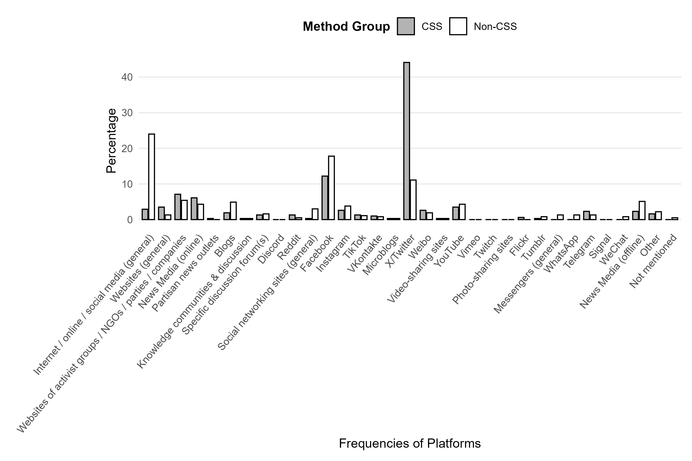

Table 3
Frequencies of Platforms (aggregated)
Frequencies of Platforms (aggregated)
Code | Category | Non-CSS n (n=371) | CSS n (n=311) | Non-CSS % | CSS %
100 | Internet / online / social media (general) | 89 | 9 | 24.0 | 2.9
110 | Websites generally | 59 | 59 | 15.9 | 19.0
120 | Knowledge communities & discussion | 9 | 9 | 2.4 | 2.9
130 | Social networking sites | 98 | 54 | 26.4 | 17.4
140 | Microblogs | 49 | 146 | 13.2 | 46.9
150 | Video-sharing sites | 17 | 12 | 4.6 | 3.9
160 | Photo-sharing sites | 3 | 3 | 0.8 | 1.0
200 | Messengers | 18 | 7 | 4.9 | 2.3
300 | News Media (offline) | 19 | 7 | 5.1 | 2.3
400 | Other | 8 | 5 | 2.2 | 1.6
NA | Not mentioned | 2 | 0 | 0.5 | 0.0
Note. CSS = computational social science; n = frequency; % = percentage.
Percentages are calculated within each method group.
N = 445 studies.

Figure 3
Distribution of Frequencies of Platforms (aggregated) by Method Group
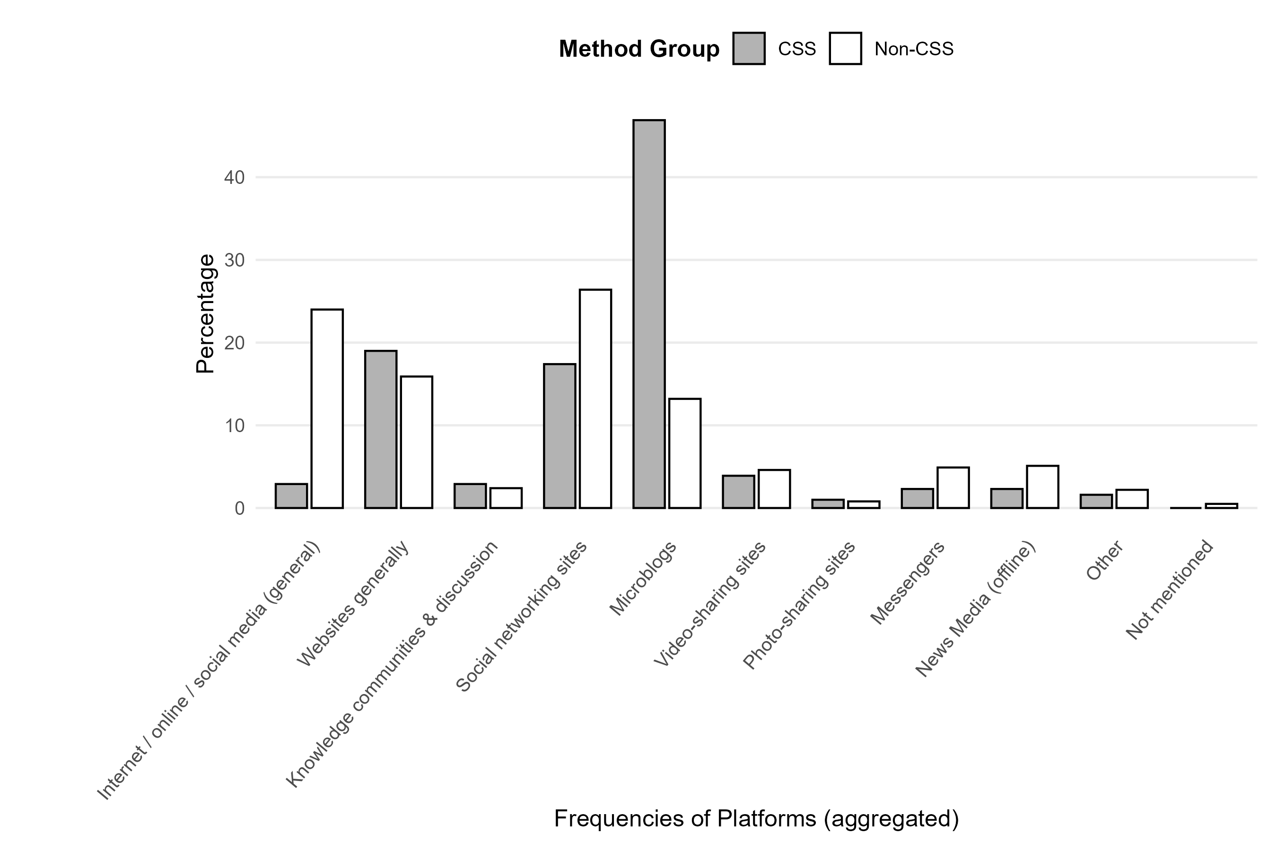
Table 4
Frequencies of Analysis Methods
Frequencies of Analysis Methods
Code | Category | Non-CSS n (n=376) | CSS n (n=676) | Non-CSS % | CSS %
10 | CSS-related (general) | 0 | 1 | 0.0 | 0.1
11 | Agent-based models / simulations | 0 | 4 | 0.0 | 0.6
12 | API access | 1 | 126 | 0.3 | 18.6
13 | Automated content analysis | 3 | 131 | 0.8 | 19.4
14 | Data donation | 0 | 1 | 0.0 | 0.1
15 | Eye-tracking | 0 | 0 | 0.0 | 0.0
16 | Network analysis | 2 | 124 | 0.5 | 18.3
17 | Tracking | 1 | 3 | 0.3 | 0.4
18 | Web scraping | 0 | 64 | 0.0 | 9.5
20 | Not-CSS-related (general) | 6 | 1 | 1.6 | 0.1
21 | Qualitative content analysis | 138 | 107 | 36.7 | 15.8
22 | Qualitative interviews / focus groups | 92 | 19 | 24.5 | 2.8
23 | Qualitative observation | 58 | 11 | 15.4 | 1.6
24 | Quantitative content analysis | 21 | 67 | 5.6 | 9.9
25 | Quantitative observation | 4 | 2 | 1.1 | 0.3
26 | Quantitative survey | 42 | 12 | 11.2 | 1.8
99 | Other | 6 | 3 | 1.6 | 0.4
NA | Not mentioned | 2 | 0 | 0.5 | 0.0
Note. CSS = computational social science; n = frequency; % = percentage.
Percentages are calculated within each method group.
N = 445 studies.

Figure 4
Distribution of Frequencies of Analysis Methods by Method Group
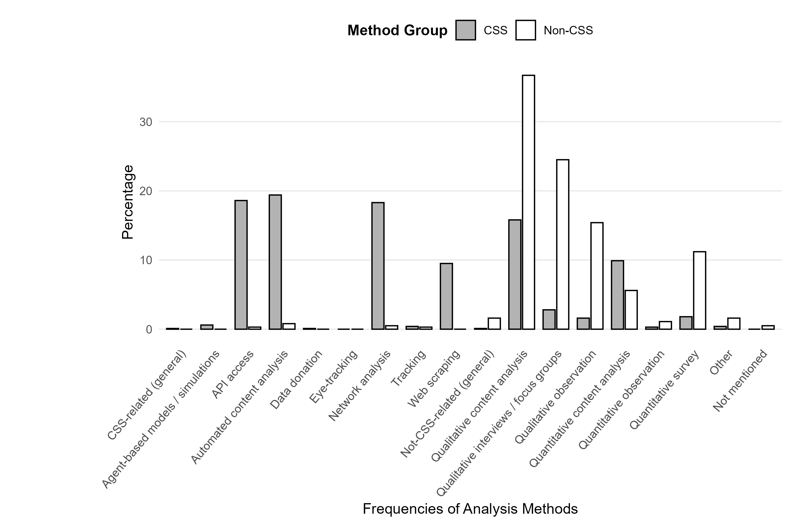
Table 5
Frequency of Cross-National Research Designs
Frequency of Cross-National Research Designs
Code | Category | Non-CSS n (n=219) | CSS n (n=226) | Non-CSS % | CSS %
1 | cross-national | 29 | 42 | 13.2 | 18.6
0 | not cross-national | 190 | 184 | 86.8 | 81.4
Note. CSS = computational social science; n = frequency; % = percentage.
Percentages are calculated within each method group.
N = 445 studies.

Figure 5
Distribution of Frequency of Cross-National Research Designs by Method Group
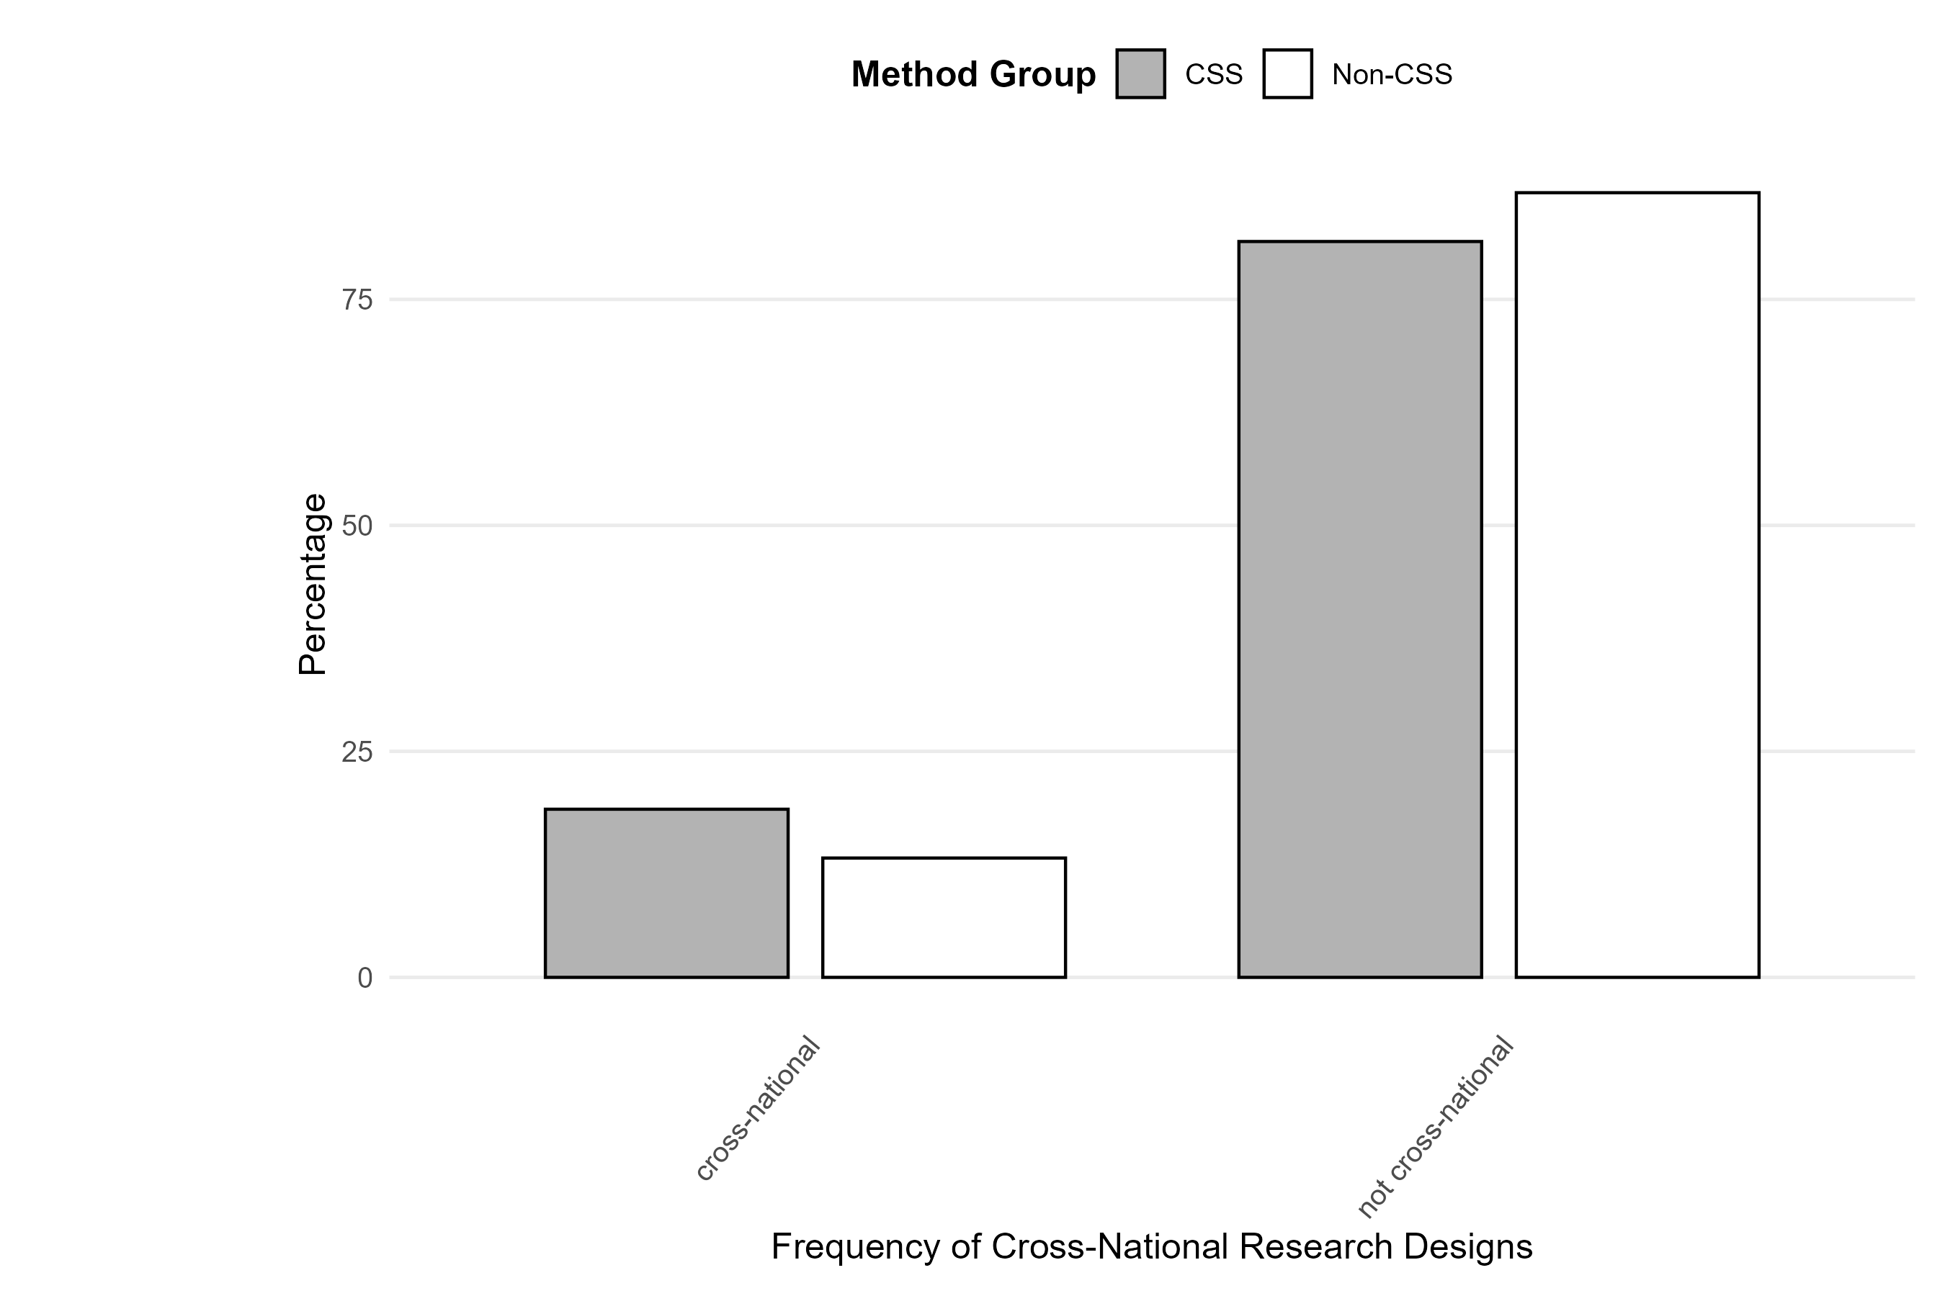

Table 6
Frequency of Experimental Research Designs
Frequency of Experimental Research Designs
Code | Category | Non-CSS n (n=219) | CSS n (n=226) | Non-CSS % | CSS %
1 | experiment | 6 | 7 | 2.7 | 3.1
0 | not experiment | 213 | 218 | 97.3 | 96.5
Note. CSS = computational social science; n = frequency; % = percentage.
Percentages are calculated within each method group.
N = 445 studies.

Figure 6
Distribution of Frequency of Experimental Research Designs by Method Group
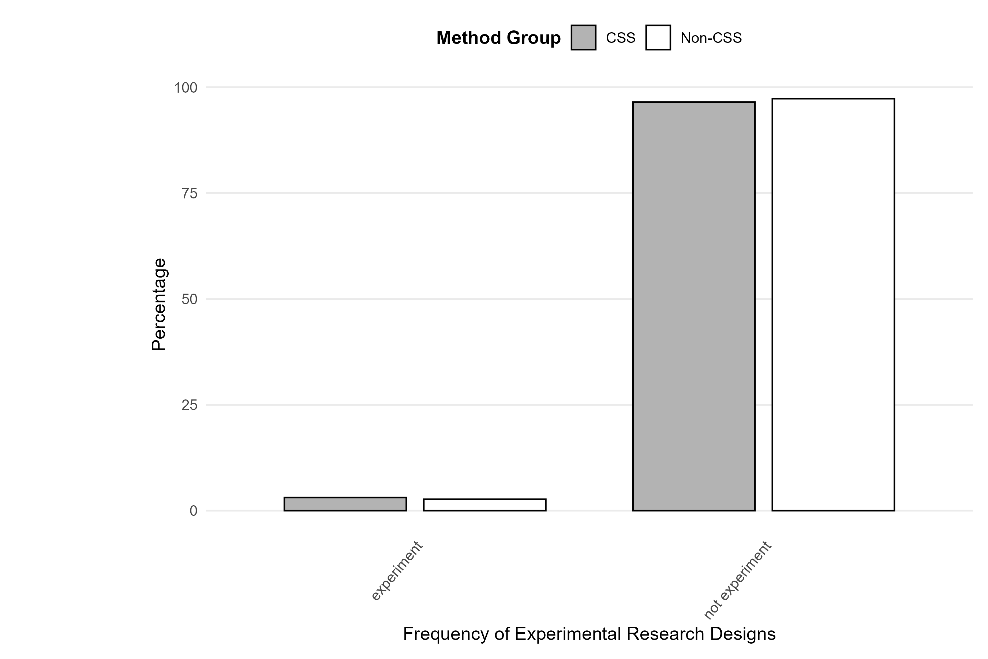

Figure (supplement): Cross-national and Experimental Designs
Share of studies with cross-national and experimental research designs by method group (CSS vs. Non-CSS)
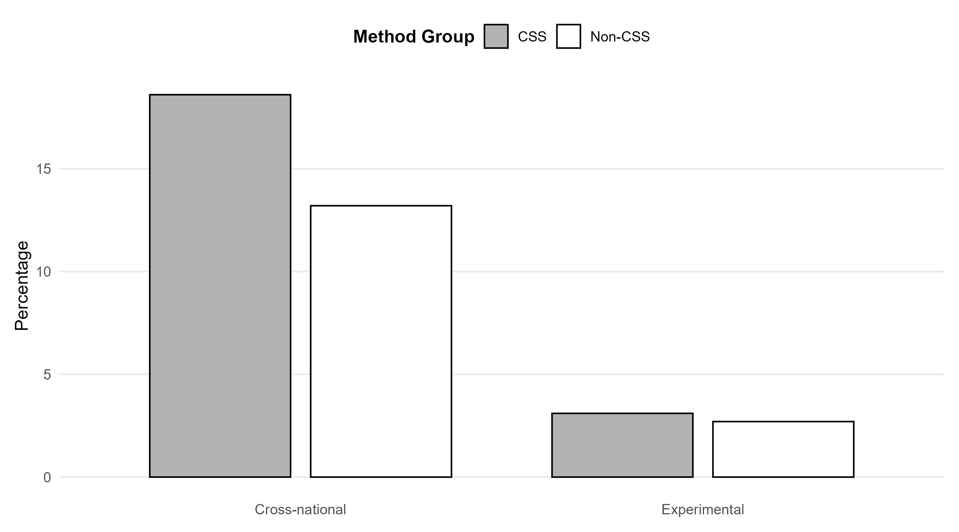

Table (supplement): V11 × V10_agg (Non-CSS/CSS %)
Analysis Methods × Major Platform Types — % within platform
 | Internet / online / social media (general) |  | Websites generally |  | Social networking sites |  | Microblogs
 | Non-CSS % | CSS % | Non-CSS % | CSS % | Non-CSS % | CSS % | Non-CSS % | CSS %
CSS-related (general) | 0.0 | 0.0 | 0.0 | 0.0 | 0.0 | 0.6 | 0.0 | 0.0
Agent-based models / simulations | 0.0 | 8.7 | 0.0 | 0.0 | 0.0 | 0.6 | 0.0 | 0.2
API access | 0.0 | 8.7 | 0.0 | 7.1 | 0.6 | 15.7 | 0.0 | 22.4
Automated content analysis | 0.0 | 17.4 | 0.9 | 17.3 | 1.1 | 17.6 | 1.2 | 20.6
Data donation | 0.0 | 0.0 | 0.0 | 0.0 | 0.0 | 0.0 | 0.0 | 0.2
Eye-tracking | 0.0 | 0.0 | 0.0 | 0.0 | 0.0 | 0.0 | 0.0 | 0.0
Network analysis | 0.0 | 8.7 | 0.0 | 19.0 | 1.1 | 11.9 | 0.0 | 18.4
Tracking | 0.0 | 0.0 | 0.0 | 0.0 | 0.6 | 0.0 | 0.0 | 0.7
Web scraping | 0.0 | 8.7 | 0.0 | 20.2 | 0.0 | 6.3 | 0.0 | 7.3
Not-CSS-related (general) | 2.7 | 0.0 | 0.9 | 0.0 | 0.0 | 0.6 | 1.2 | 0.2
Qualitative content analysis | 32.0 | 8.7 | 38.0 | 14.9 | 34.7 | 18.2 | 34.9 | 14.9
Qualitative interviews / focus groups | 26.7 | 8.7 | 25.0 | 4.2 | 25.0 | 4.4 | 20.5 | 2.4
Qualitative observation | 14.7 | 4.3 | 13.9 | 1.2 | 15.9 | 3.1 | 18.1 | 1.6
Quantitative content analysis | 2.0 | 13.0 | 6.5 | 14.3 | 6.2 | 13.2 | 7.2 | 8.6
Quantitative observation | 0.7 | 0.0 | 0.9 | 0.0 | 0.6 | 1.3 | 0.0 | 0.2
Quantitative survey | 18.0 | 13.0 | 12.0 | 1.8 | 13.6 | 6.3 | 15.7 | 1.6
Other | 2.0 | 0.0 | 1.9 | 0.0 | 0.6 | 0.0 | 1.2 | 0.7
Not mentioned | 1.3 | 0.0 | 0.0 | 0.0 | 0.0 | 0.0 | 0.0 | 0.0
Note. Table limited to the four most frequently used platform types: Internet / online / social media (general); Websites general; Social Networking Sites; Microblogs.
Percentages are calculated within each platform column, separately for CSS and Non-CSS studies.
CSS = computational social science.

Table (supplement): V7 × V10_agg (Non-CSS/CSS %)
Regions × Major Platform Types — % within platform
 | Internet / online / social media (general) |  | Websites generally |  | Social networking sites |  | Microblogs
 | Non-CSS % | CSS % | Non-CSS % | CSS % | Non-CSS % | CSS % | Non-CSS % | CSS %
North America | 28.9 | 44.4 | 16.1 | 38.3 | 29.4 | 20.0 | 28.8 | 30.5
South America | 4.1 | 0.0 | 6.5 | 0.0 | 4.9 | 5.0 | 5.8 | 1.9
Europe | 20.6 | 11.1 | 33.9 | 25.0 | 28.4 | 35.0 | 23.1 | 20.1
Russia and former Soviet Republics | 5.2 | 0.0 | 3.2 | 1.7 | 3.9 | 5.0 | 1.9 | 1.9
Middle East and North Africa | 7.2 | 0.0 | 1.6 | 1.7 | 9.8 | 6.7 | 7.7 | 6.5
East Asia | 10.3 | 11.1 | 16.1 | 5.0 | 3.9 | 6.7 | 15.4 | 8.4
Central and South (East) Asia | 7.2 | 0.0 | 4.8 | 1.7 | 5.9 | 1.7 | 5.8 | 5.2
Sub-Saharan Africa | 5.2 | 0.0 | 6.5 | 0.0 | 5.9 | 1.7 | 1.9 | 1.9
Oceania | 1.0 | 0.0 | 0.0 | 0.0 | 0.0 | 0.0 | 0.0 | 0.6
Global | 10.3 | 11.1 | 9.7 | 26.7 | 7.8 | 18.3 | 9.6 | 22.7
Not mentioned | 0.0 | 22.2 | 1.6 | 0.0 | 0.0 | 0.0 | 0.0 | 0.0
Note. Table limited to the four most frequently used platform types: Internet / online / social media (general); Websites general; Social Networking Sites; Microblogs.
Percentages are calculated within each platform column, separately for CSS and Non-CSS studies.
CSS = computational social science.

Table (supplement): V12 × V10_agg (Non-CSS/CSS %)
Cross-National Designs × Major Platform Types — % within platform
 | Internet / online / social media (general) |  | Websites generally |  | Social networking sites |  | Microblogs
 | Non-CSS % | CSS % | Non-CSS % | CSS % | Non-CSS % | CSS % | Non-CSS % | CSS %
cross-national | 16.9 | 11.1 | 16.9 | 25.4 | 17.3 | 20.4 | 12.2 | 19.9
not cross-national | 83.1 | 88.9 | 83.1 | 74.6 | 82.7 | 79.6 | 87.8 | 80.1
Note. Table limited to the four most frequently used platform types: Internet / online / social media (general); Websites general; Social Networking Sites; Microblogs.
Percentages are calculated within each platform column, separately for CSS and Non-CSS studies.
CSS = computational social science.

Table (supplement): V13 × V10_agg (Non-CSS/CSS %)
Experimental Designs × Major Platform Types — % within platform
 | Internet / online / social media (general) |  | Websites generally |  | Social networking sites |  | Microblogs
 | Non-CSS % | CSS % | Non-CSS % | CSS % | Non-CSS % | CSS % | Non-CSS % | CSS %
experiment | 3.4 | 11.1 | 1.7 | 0 | 5.1 | 3.7 | 4.1 | 2.7
not experiment | 96.6 | 88.9 | 98.3 | 100 | 94.9 | 96.3 | 95.9 | 96.6
Note. Table limited to the four most frequently used platform types: Internet / online / social media (general); Websites general; Social Networking Sites; Microblogs.
Percentages are calculated within each platform column, separately for CSS and Non-CSS studies.
CSS = computational social science.

Table (supplement): V11 × V12 (Non-CSS/CSS %)
Analysis Methods × Cross-National Design — % within design
 | cross-national |  | not cross-national
 | Non-CSS % | CSS % | Non-CSS % | CSS %
CSS-related (general) | 0 | 0.0 | 0.0 | 0.2
Agent-based models / simulations | 0 | 0.0 | 0.0 | 0.7
API access | 0 | 19.1 | 0.3 | 18.5
Automated content analysis | 0 | 13.7 | 0.9 | 20.7
Data donation | 0 | 0.8 | 0.0 | 0.0
Eye-tracking | 0 | 0.0 | 0.0 | 0.0
Network analysis | 2 | 24.4 | 0.3 | 16.9
Tracking | 0 | 0.0 | 0.3 | 0.6
Web scraping | 0 | 11.5 | 0.0 | 9.0
Not-CSS-related (general) | 4 | 0.0 | 1.2 | 0.2
Qualitative content analysis | 36 | 12.2 | 36.8 | 16.7
Qualitative interviews / focus groups | 26 | 5.3 | 24.2 | 2.2
Qualitative observation | 4 | 2.3 | 17.2 | 1.5
Quantitative content analysis | 8 | 9.9 | 5.2 | 9.9
Quantitative observation | 2 | 0.0 | 0.9 | 0.4
Quantitative survey | 16 | 0.0 | 10.4 | 2.2
Other | 0 | 0.8 | 1.8 | 0.4
Not mentioned | 2 | 0.0 | 0.3 | 0.0
Note. Columns show research design categories (cross-national; experimental).
Percentages are calculated within each research design column, separately for CSS and Non-CSS studies.
CSS = computational social science.

Table (supplement): V11 × V13 (Non-CSS/CSS %)
Analysis Methods × Experimental Design — % within design
 | experiment |  | not experiment
 | Non-CSS % | CSS % | Non-CSS % | CSS %
CSS-related (general) | 0 | 0.0 | 0.0 | 0.2
Agent-based models / simulations | 0 | 16.7 | 0.0 | 0.2
API access | 0 | 22.2 | 0.3 | 18.6
Automated content analysis | 10 | 22.2 | 0.5 | 19.2
Data donation | 0 | 0.0 | 0.0 | 0.2
Eye-tracking | 0 | 0.0 | 0.0 | 0.0
Network analysis | 0 | 22.2 | 0.5 | 18.3
Tracking | 0 | 0.0 | 0.3 | 0.5
Web scraping | 0 | 5.6 | 0.0 | 9.6
Not-CSS-related (general) | 0 | 0.0 | 1.6 | 0.2
Qualitative content analysis | 10 | 0.0 | 37.4 | 16.3
Qualitative interviews / focus groups | 0 | 0.0 | 25.1 | 2.9
Qualitative observation | 0 | 0.0 | 15.8 | 1.7
Quantitative content analysis | 0 | 5.6 | 5.7 | 9.9
Quantitative observation | 30 | 0.0 | 0.3 | 0.3
Quantitative survey | 30 | 5.6 | 10.7 | 1.7
Other | 20 | 0.0 | 1.1 | 0.5
Not mentioned | 0 | 0.0 | 0.5 | 0.0
Note. Columns show research design categories (cross-national; experimental).
Percentages are calculated within each research design column, separately for CSS and Non-CSS studies.
CSS = computational social science.

