COVER LETTER FOR PUBLIC REVIEW DRAFT STANDARDS

**CPR 183/F13**

|  |  |  |
| --- | --- | --- |
| **Title:** | DKS 606:2021 Bedsheets made from blended polyester/cellulosic fabric or polyester and cellulosic combination fabric-Specification | |
| **Document Type:** | Public review draft | |
| **Dates:** | Circulation date | Closing date |
| 10th September 2021 | 10th November 2021 |

**PUBLIC REVIEW DRAFT**

**1.**  DKS 606:2021 Bedsheets made from blended polyester/cellulosic fabric or polyester and cellulosic combination Fabric-Specification

This Draft Kenya Standard has been prepared by the TC 70 Ready Technical Committee in accordance with the procedures EASC, and is now being circulated for public comments.

The Committee would appreciate any comments on this Draft Standard, which should be submitted before **10th November 2021 using** the attached template. It will also be appreciated if those who have no specific comments to make but find the draft standard generally acceptable can notify us accordingly.

Suggestions entailing amendments of the text should include wording preferred and the relevant clause number quoted against any comments made.

**This draft standard is subject to change and should not be referred to or used as a Kenya Standard.**

All correspondence pertaining to this draft standard should be addressed to the Managing Director, Kenya Bureau of Standards for the attention of [tonuiw@kebs.org](mailto:tonuiw@kebs.org)

#### Yours faithfully,

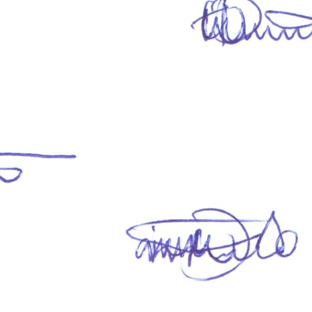

##### For: DIRECTOR

# STANDARDS DEVELOPMENT AND INTERNATIONAL TRADE