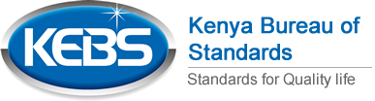

QUALITY ASSURANCE IN LABORATORY TESTING SEMINAR 2018

**Course Outline**

**Overview of ISO/IEC 17025:2017 & ISO 15189**

**Quality Assurance of Laboratory results**

**Basic Analytical Statistics**

**Test Method Validation**

**Approaches to determination of Measurement Uncertainty**

**Data Management and Trend Analysis**

**Good Laboratory Practice**

**Laying The Foundation for ISO/IEC 17025:2017**

**Date: 26th - 30th November 2018**

**Venue: Mombasa**

**Cost: Kshs. 100,000/- Non Residential inclusive of 16% VAT. This amount includes lunch, morning and afternoon tea, seminar fee and stationery.**

* **For enquiries contact Selma at** [**sanyas@kebs.org**](mailto:sanyas@kebs.org) **or +254 721 961 019**
* **To register your course, fill in attached nomination form from KEBS website www.kebs.org and return to**

**sanyas@kebs.org along with proof of payment i.e. KEBS receipt**

**NOTE: for most current revision of Training Calendar visit www.kebs.org**