COVER LETTER FOR PUBLIC REVIEW DRAFT STANDARDS

**CPR 183/F13**

|  |  |  |
| --- | --- | --- |
| **Title:** | 1.Long lasting insecticide treated mosquito nets — Specification  2. Textiles — Requirements for inspection and acceptance of used textile products DRAFT AMENDMENT 1 | |
| **Document Type:** | Public review drafts | |
| **Dates:** | Circulation date | Closing date |
| 10th September 2021 | 10th November 2021 |

**PUBLIC REVIEW DRAFT**

**1.**  **DEAS 455:2021 Long lasting insecticide treated mosquito nets — Specification**

**2. DEAS 356:2021 Requirements for inspection and acceptance of used textile products DRAFT AMENDMENT**

These Draft Kenya Standards has been prepared by the EASC/TC 61 Technical Committee in accordance with the procedures EASC, and are now being circulated for public comments.

The Committee would appreciate any comments on these Draft Standards, which should be submitted before **10th November 2021 using** the attached template. It will also be appreciated if those who have no specific comments to make but find the draft standards generally acceptable can notify us accordingly.

Suggestions entailing amendments of the text should include wording preferred and the relevant clause number quoted against any comments made.

**These draft standards are subject to change and should not be referred to or used as a Kenya Standards.**

All correspondence pertaining to these draft standards should be addressed to the Managing Director, Kenya Bureau of Standards for the attention of [tonuiw@kebs.org](mailto:tonuiw@kebs.org)

#### Yours faithfully,

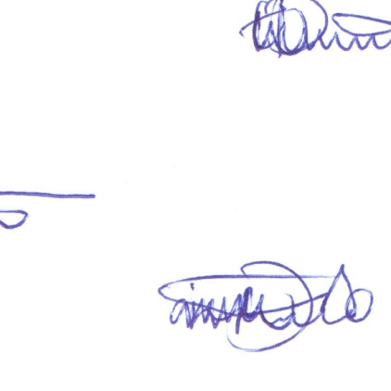

##### For: DIRECTOR

# STANDARDS DEVELOPMENT AND INTERNATIONAL TRADE