CSIS 4495 - Applied Research Project

Proposal Report

**NATIVESPARK INTEGRATION SOLUTIONS CORP.**

Valeriia Nikitina (300374609)

Contents

Introduction 3

The origin of the idea 3

Problem framing 3

Competitive advantage among others 4

Overview of the platform 5

Users 5

Features 6

The architecture of the system 7

The hardware and software configuration of the system 8

Hardware Requirements 8

Software Configuration 8

The database design preliminary 9

Project Planning and Timeline 10

Planning and Proposal 10

System Design 10

Development Phase 10

Testing Phase 10

Final Submission and Presentation 10

Gantt Chart 11

Hours logs 12

References 13

# Introduction

## The origin of the idea

Originally developed by Valeriia Nikitina and Valeriya Saltykova, NativeSpark Integration Solutions Corp. emerged from their unique expertise and shared vision. Although the platform was initially a collaborative effort, Valeriia Nikitina will now continue to develop the idea and platform independently.

This transition marks a new chapter for NativeSpark, as Valeriia takes the lead in refining the platform's features, expanding its capabilities, and advancing its mission. By leveraging her background in data analysis and her commitment to empowering Indigenous communities, Valeriia aims to ensure that NativeSpark evolves into a robust, scalable solution that meets the current needs of its users while adapting to future challenges.

The project will maintain its original vision of fostering Indigenous entrepreneurship, with a strong focus on enhancing user experience, integrating advanced technologies, and exploring growth opportunities in the United States market. Valeriia is dedicated to preserving the collaborative spirit of the initiative while elevating the platform to new heights.

## Problem framing

NativeSpark is dedicated to helping Indigenous communities overcome barriers to participation in industry. Many Indigenous entrepreneurs lack access to essential resources, mentorship, and training necessary for successful competition [1]. Additionally, Indigenous products often struggle to reach mainstream markets, and cultural and regulatory obstacles further complicate participation.

Indigenous entrepreneurs face several systemic barriers that impede their ability to engage effectively in industrial and commercial opportunities, including:

* Many Indigenous communities are situated in remote areas, making it challenging for entrepreneurs to access the funding, tools, and infrastructure needed to grow their businesses.
* Entrepreneurs frequently lack mentors who understand their unique challenges, as well as training programs tailored to their cultural and business contexts.
* Indigenous products and services often encounter difficulties navigating regulatory frameworks and facing cultural biases that prevent them from accessing mainstream markets.
* Ongoing economic exclusion has perpetuated cycles of poverty, limiting opportunities for Indigenous entrepreneurs to thrive.

These challenges are further exacerbated by the impact of social determinants of health, as highlighted in research by Richmond et al. (2017) in Social Science & Medicine. The study underscores that structural inequities, including limited access to education, employment, and economic opportunities, disproportionately affect Indigenous communities. These inequities diminish quality of life and hinder participation in economic systems, perpetuating cycles of poverty in marginalized communities [2, 3].

## Competitive advantage among others

Existing platforms like the Indigenous Industrial and Contracting Network (IMCN) and Indigenous Business Development Services (IBDS) have made significant strides in supporting Indigenous entrepreneurs. However, they lack advanced technological features that could greatly enhance their effectiveness.

IMCN offers resources and networking opportunities but does not utilize AI-driven tools to optimize connections between businesses and entrepreneurs. On the other hand, IBDS emphasizes business development services but does not make use of predictive modeling or natural language processing (NLP) to improve decision-making and communication [4, 5].

These limitations hinder these platforms from effectively meeting the complex needs of Indigenous entrepreneurs, such as identifying market opportunities, facilitating collaboration, and offering personalized recommendations. NativeSpark aims to bridge these gaps by integrating:

* AI-Powered Matchmaking: Automatically connecting businesses with the most relevant Indigenous entrepreneurs based on their skills, location, and project requirements.
* NLP Capabilities: Enabling smooth communication across diverse linguistic and cultural backgrounds.

By addressing these gaps, NativeSpark strives to create a more comprehensive and inclusive platform for Indigenous entrepreneurs.

# Overview of the platform

The platform will serve as a bridge connecting three distinct types of users—Indigenous Peoples, businesses, and regular consumers—while also integrating an administrative role for monitoring and oversight. Its core mission is to empower Indigenous communities by providing a space to showcase their craftsmanship, connect with opportunities, and facilitate transactions in an engaging and supportive environment.

## Users

Indigenous Peoples will be at the heart of the platform, showcasing their unique skills and products. They can create detailed profiles that act as portfolios, including information about their craftsmanship, experience, and photos of their work. These users can sell products individually or in bulk, catering to both regular consumers and businesses. Additionally, they can browse job postings or bulk order requests created by businesses and apply for opportunities that match their expertise. The platform will also incorporate a social networking aspect, allowing users to like and comment on profiles, thereby promoting visibility and community interaction.

Businesses will have the ability to place large-scale orders or post projects that require skilled craftsmanship. They can specify requirements for these orders or jobs, such as quantity, materials, or delivery timelines, to attract relevant Indigenous Peoples. Businesses will pay a commission on all transactions, which will contribute to the platform's revenue model. Additionally, they can communicate with sellers to discuss customizations or other specifics related to their orders.

Regular consumers can browse the marketplace to purchase unique, handmade items in small or individual quantities. Similar to businesses, they will also pay a commission on their purchases. The platform will allow consumers to directly communicate with sellers to clarify details, request customizations, or provide feedback.

The administrator role is critical for maintaining the platform's integrity. Administrators can monitor user activity, moderate content, oversee the matchmaking process, and intervene in unresolved disputes or escalations. They ensure smooth platform operations and foster a positive user experience.

## Features

Social Networking for Indigenous Profiles:

Indigenous people will create profiles that function like portfolios, complete with photos, descriptions, and user reviews. Other users can like and comment on these profiles, enhancing engagement and visibility. This feature focuses on community-building and recognizing talent.

AI-Powered Matchmaking:

The platform will use AI algorithms to efficiently connect users. Businesses seeking specific skills or products will be matched with Indigenous individuals based on factors such as expertise, ratings, location, and availability. Consumers will also receive personalized recommendations for items or sellers. The AI system will leverage historical data and user preferences to optimize these connections.

Integrated Chatbot with Escalation to Admins:

A chatbot will handle common queries, guiding users through the platform's features, facilitating transactions, and assisting with profile creation. If the chatbot is unable to resolve an issue, it will seamlessly escalate the query to an admin. This ensures that users always receive the help they need.

Admin Dashboard:

Administrators will have access to a comprehensive dashboard to monitor transactions, moderate profiles and comments, and manage chatbot escalations. This tool guarantees that the platform remains safe, fair, and operational.

# The architecture of the system

In the development of NativeSpark's platform, we will adopt the Model-View-Controller (MVC) architecture model coupled with MySQL integration. This architectural approach is widely recognized and utilized in web application development due to its several advantages in terms of organization, scalability, and maintainability.

The MVC architecture separates an application into three interconnected components: Model, View, and Controller. Each component has specific responsibilities and interacts with the others to ensure efficient functionality and seamless user experience.

# The hardware and software configuration of the system

## Hardware Requirements

* Processor: Intel Core i5 or higher processors are recommended for smooth performance during development tasks.
* Memory (RAM): A minimum of 8GB RAM is recommended to handle the resource intensive tasks of running servers, databases, and development tools simultaneously.
* Network Connectivity: Stable internet connectivity is essential for accessing external resources, libraries, and version control systems during development.

## Software Configuration

1) Development Environment:

* Integrated Development Environment (IDE): IntelliJ IDEA will be used as the primary IDE for Java development. It provides robust features for Java programming, Spring framework support, and seamless integration with version control systems.
* Version Control: Git will be utilized for version control management, allowing collaborative development, code review, and version tracking.
* Build and Dependency Management: Maven will be used for managing dependencies and building the project.

2) Programming Languages and Frameworks:

* Java: The backend logic and business rules of the application will be developed using Java programming language.
* Spring Framework: Specifically, the Spring Boot framework will be used for rapid application development, dependency injection, and MVC architecture implementation.
* Thymeleaf: Thymeleaf will serve as the templating engine for generating dynamic HTML content in the View layer.
* Bootstrap: Bootstrap will be used for front-end styling, responsiveness, and user interface design.
* OpenAI: <https://github.com/openai/openai-java>, https://platform.openai.com/docs/
* Spring Boot WebClient: <https://spring.io/guides/gs/reactive-rest-service/>
* **Smile Java Library**: <https://haifengl.github.io/>
* **Bootstrap Chat Widgets**: <https://getbootstrap.com/docs/5.3/examples/chat/>

3) Database Management System (DBMS):

* MySQL: The MySQL relational database management system will be used to store and manage application data. It provides a robust and scalable solution for structured data storage.

## The database design preliminary

The database design for NativeSpark will include the following key tables (might be changed through the platforms developing):

1) Users Table

2) Listings Table

3) Products Table

4) Postings Table

5) Subscriptions Table

7) Messages Table

8) AIMatchmakingLogs Table

9) Orders Table

10) ShippingInfo Table

11) Admin Table

The mock-up of database can be found here: https://dbdiagram.io/d/667661005a764b3c7220043d

# Project Planning and Timeline

## **Planning and Proposal**

**Milestone:** Proposal Approval (Jan 26)

**Deliverables:** Approved proposal document, initial project plan, and timeline allocation.

## **System Design**

**Milestone:** Finalize System Architecture (Feb 9)

**Deliverables:** Database schema and Interface design.

## **Development Phase**

**Milestone:** Initial Working Demo (Feb 24)

**Deliverables:** Partially functional prototype demonstrating core features and database integration, Video showing a demo of the implementation, midterm report.

**Milestone:** Advanced Feature Implementation (Mar 30)

**Deliverables:** Functional implementation of all platform features (e.g., AI-matchmaking, chatbot, admin dashboard if time permits).

## Testing Phase

**Milestone:** Refinement and testing (April 6)

**Deliverables:** Usability testing and revision.

## **Final Submission and Presentation**

**Milestone:** Final Submission and Presentation (Apr 13)

**Deliverables:** Fully functional platform, final report.

# Gantt Chart

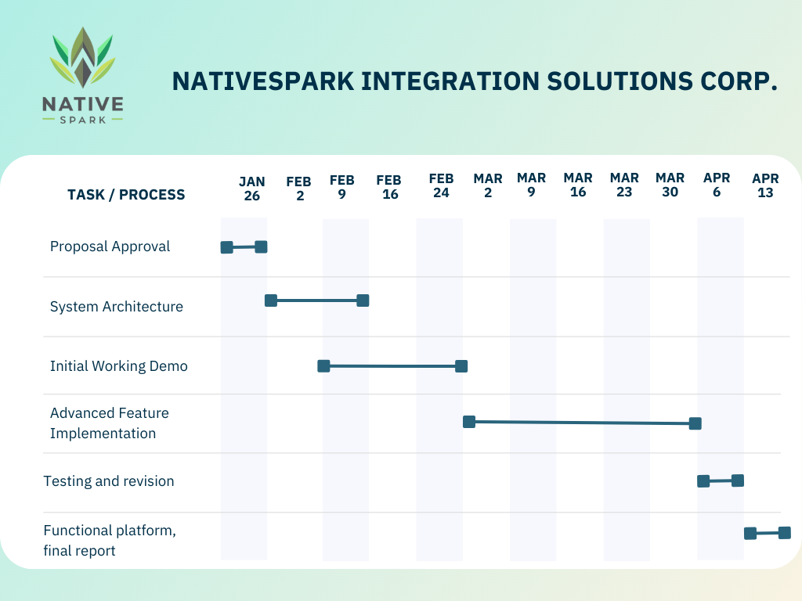

# Hours logs

|  |  |  |
| --- | --- | --- |
| Date | # Hours | Description of work |
| 12.01.2025 | 1 | I spent time brainstorming the main idea for my project by reviewing my past work to analyze its strengths and identify areas for improvement. I focused on finding a completely new scope of work that could add unique value and elevate the project's impact. |
| 17.01.2025 | 2 | I wrote a project proposal and conducted research to establish the domain, define the problem. Created project contract. |
| 20.01.2025 | 3 | Explore existing literature to identify knowledge gaps. This included developing hypotheses, outlining the research design, methodology, technologies, and expected results, emphasizing how the findings could address practical challenges and contribute to the field. Created Repo on GitHub. |
| 21.01.2025 | 2 | Reading different articles, watching YouTube videos about regarding AI and chatbot implementation. |
| 23.01.2025 | 1,5 | I wrote a project proposal (section project planning and timeline). Creating Gantt Chart. |

# References

1. Statistics Canada. (2023, July 18). Indigenous entrepreneurship in Canada. Retrieved from <https://www150.statcan.gc.ca/n1/daily-quotidien/230718/dq230718c-eng.htm>
2. Richmond, C. A. M., & Cook, C. (2017). Creating conditions for Canadian Aboriginal health equity: The promise of healthy public policy. Social Science & Medicine, 176, 93–103.
3. Indigenous Corporate Training Inc. (n.d.). 8 key issues for Indigenous peoples in Canada. Retrieved from <https://www.ictinc.ca/blog/8-key-issues-for-indigenous-peoples-in-canada>
4. **Indigenous Industrial and Contracting Network. (n.d.). Retrieved from**[**https://www.imcn.ca/**](https://www.imcn.ca/)
5. **Indigenous Business Development Services. (n.d.). Retrieved from**[**https://ibdssk.com/**](https://ibdssk.com/)

**Project Contract**

**CSIS 3275 - Software Engineering**

**Project Title:** NativeSpark Integration Solutions Corp.

**Agreement Between:**

* **Student:** Valeriia Nikitina
* **Professor:** Padmapriya Arasanipalai Kandhadai

**Scope of Work**

The student agrees to complete the NativeSpark Integration Solutions Corp. project as outlined in the proposal, which includes:

1. Developing a web-based platform aimed at empowering Indigenous entrepreneurs.
2. Implementing functionalities such as user registration, job posting, AI-powered matchmaking, administration of the platform, search and filter functionality, chatbot, and etc (subject to change, depending on complexity and timeline).
3. Completing all deliverables, including reports, presentation.

**Timeline**

The project will adhere to the following milestones:

1. **Proposal Approval:** Jan 26
2. **Development Phase (Initial working Demo):** 24 Feb
3. **Final Submission and Presentation:** Apr 13

**Meeting Frequency and Format**

* **Meeting Frequency:** Weekly progress meetings.
* **Format:** Meetings will be held virtually or in person, as agreed upon. Each meeting will last approximately 30 minutes to discuss progress, challenges, and feedback.

**Responsibilities**

**Student Responsibilities:**

1. Deliver high-quality work that meets the outlined requirements.
2. Communicate progress regularly and attend all scheduled meetings.
3. Incorporate feedback provided by the professor.

**Professor Responsibilities:**

1. Provide timely feedback and guidance during the project.
2. Clarify any doubts or ambiguities related to the project requirements.
3. Evaluate the project deliverables based on the agreed scope and timeline.

**Signatures**

By signing this contract, both parties agree to the terms outlined above and commit to the successful completion of the project.

|  |  |
| --- | --- |
| **Student:** | **Professor:** |
| Valeriia Nikitina | Padmapriya Arasanipalai Kandhadai |
| Signature:  ___________________________________ | Signature:  ___________________________________ |

Date: ________________