# **Directions to Run NativeSpark Application**

### Product description

The platform will serve as a bridge connecting three distinct types of users—Indigenous Peoples, businesses, and regular consumers—while also integrating an administrative role for monitoring and oversight. Its core mission is to empower Indigenous communities by providing a space to showcase their craftsmanship, connect with opportunities, and facilitate transactions in an engaging and supportive environment.

Indigenous Peoples will be central to the platform, showcasing their unique skills and products through detailed profiles that include craftsmanship information and photos. They can sell items individually or in bulk and browse job postings and bulk order requests from businesses. A social networking feature will promote visibility through likes and comments.

Businesses can place large-scale orders or post projects, specifying requirements like quantity and materials, and will pay a commission on transactions. Communication with sellers for customizations is encouraged.

Regular consumers can purchase unique, handmade items, also paying a commission. They can communicate with sellers for details or customizations.

The administrator role is vital for platform integrity, overseeing user activity, moderating content, and resolving disputes to ensure a positive experience.

### Start XAMPP:

* + Open the XAMPP control panel.
  + Start the **Apache** and **MySQL** services.
  + A screenshot of a computer

    Description automatically generated

### Open the NativeSpark Project:

* + Launch **IntelliJ IDEA**.
  + Open the NativeSpark project

### Run the Application:

* + Click the **Run** button in IntelliJ IDEA to start the application.

* + In case of the warning like below, please press “Fix auto”

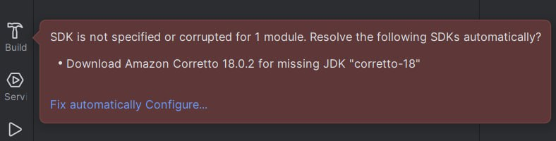

### Access the Application:

* + Open a web browser.
  + Navigate to http://localhost:8082 to access the NativeSpark application.

