Ploiesti: 10 June 1944 - a pivotal day for the Royal Romanian Air Force

June 10, 1944 will forever remain a glorious day for the Royal Romanian Air Force (RRAF). However, a good part of the laurels of victory are claimed by the anti-aircraft gunners around Ploiești and the Luftwaffe pilots stationed in Romania. On the other hand, the American 15th Army Air Force accomplished its difficult bombing mission, and the losses suffered were nowhere near as they were recorded at the time, by the Romanians and Germans, so it is worth reopening the archives of the three countries in order to finally answer, as accurately as possible, the question: "Whose was the victory?"

"Shortly after the end of the battle, General Gheorghe Jienescu, the [Romanian] Minister of Air, accompanied by Nicolae Dinischiotu, the [Romanian] Deputy Minister of National Economy, came to congratulate us and brought us 24 bottles of French champagne as a gift for our 24 aerial victories; as for me, I also received 3 bottles of whiskey for the 3 personal victories that had just been added to my tally" confesses fighter ace Dan Vizanty, commander of the 6th Fighter Group, a group flying exclusively with aircraft produced by Romanian factories, such as the IAR-80, and its modernized variant, IAR-81. It was "their finest hour", as Sir W. Churchill would have said.

Also on the same day, the Germans report 11 victories for Jagdgeschwader 77 (JG77), 5 victories for JG53, one for JG301 and 2 for Nachtjagdgeschwader NJG6. As the German claim system was very strict, we are justified in believing that on that day the Luftwaffe had achieved another 19 victories over the American Air Force over Romanian territory. The gunners around Ploieşti also requested, in writing, the approval of 7 victories, thus bringing the total of American fighter planes shot down to 50, a catastrophe never seen in any Allied attack carried out up to that date.

However, the reality is different: that evening, only 17 wrecks of the attacking aircraft could be inventoried. How the bubbles of champagne and the adrenaline of victory changed the statistics of the war so much we will find out in the following...

The American attack on June 10, 1944 was unique. Only four days had passed since the Normandy landings, and the tactic of bombing railway junctions – a tactic that had governed every attack on Romania up to that point – was about to change. From now on, the priority was the oil refineries. The bombing that was to take place did not target a city, but a particular refinery. It was the first time that a surgical bombing was planned. 60 years before the first drone attack, the Americans were making the most of the technology they had at their disposal in 1944, and were planning a similar attack. The 82nd Fighter Group of the US 15th Army Air Force was formed by veterans of bomber escorts to attack Ploieşti. This time, they were to be the bombers: in the strictest secrecy, their P-38 Lightnings were modified, with a single 1,000lb (445 kg) bomb slung under the left wing, and an additional 300-gallon (1,100 l) fuel tank under the right wing. After dropping the single bomb on the Romanian-American refinery (Rafinaria Romano-Americana), the mini-bombers were to revert to their original fighter aircraft roles.

The plan was bold: flying at the lowest possible altitude, the 82nd Fighter-Bombardment Group was to be escorted from Foggia, Italy, their operational base, to Giurgiu, Romania by the 1st Fighter Group, then it was to gain altitude by flying north to Ploieşti, from where it was to dive-bomb, then strafe any target that came their way on the way back. During the entire period of the flight at altitude, the 1st Group was to fly at high speed at low altitude to Ploieşti, where it would draw any Romanian or German aircraft into combat, thus allowing the 82nd Group to bomb using the element of surprise. That was the plan, but another enemy, more powerful than the Romanians and Germans combined, was going to wreak havoc among the Americans. This insidious enemy is called “mechanical gremlins.”

The die were cast - at 5:05 a.m. on June 10, 1944, 46 “bombers” (Lockheed P-38J Lighning figter-bombers) and 48 escort planes took off for Giurgiu, from Foggia. The mechanical gremlins began to strike: one by one, the engines began to malfunction and 17 planes were forced to turn back. Two of them did not even make it back – at 7:05 a.m., Walter Leslie was forced to parachute out of his plane near Tačevac, Serbia, and at 7:20 a.m., William Jefferson was taken prisoner after his plane crashed into the Danube near Calafat, Romania. The remaining 75 aircraft fly at 75-100m altitude on the northern bank of the Danube and, in 30 minutes, reach Giurgiu, from where they take up strike formation. A new “Tidal Wave” is about to happen. But...the 82nd Fighter Group – the “bombers” – misses the turn to the north at the Giurgiu rendezvous point and continues east. 1st Fighter Group – the escort – turns correctly, but, seeing that the “bombers” it was supposed to protect had taken a wrong turn, also to the east, turns right. As if on cue, the 82nd FG realizes its mistake and turns sharply left, entering the wave of aircraft of the 1st FG, thus splitting them in two: the first wave, 71st Fighter Squadron, remains on the right, and the other two squadrons, 27th and 94th, on the left. This separation ensured the "bombers" and the two escort squadrons reach the objective, but sealed the fate of those from the 71st Fighter Squadron, because, by misfortune, they arrive above the Popeşti-Leordeni airfield at the most unfavorable moment possible...

For about 30 minutes, the Romanian 6th Fighter Group (Grupul 6 Vanatoare) had been on alert and had taken off exemplary, lifting two complete squadrons and a command cell into the air, that is, 23 IAR-81C fighter aircraft. After the fighter planes took off, it was the turn of the training and utility planes. When these also took off, the Americans were heading towards them. In a terrible moment of the war, a few modest Romanian planes – some biplanes – became ad hoc bait for the powerful American planes. If we stop this moment in time and look at the situation further, we will notice that the American planes – the 71st FS – were themselves bait for the perfectly aligned Romanian fighters – the 6th Fighter Group. Looking even further, the moment reveals that this clash had itself become a trap into which the Romanians fell, because they believed that this was the main American attack (and, as a result, they did not attack other targets). In reality, however, the other 5 American squadrons reached their target, the Romanian-American refinery, unhindered, which they bombed with 33 of the 36 planned bombs.

Returning to the clash at Popeşti-Leordeni, in just 3 minutes, three IAR-39 biplane observation and light attack and 3 Focke Wulf FW-58 training aircraft are shot down. Adj. av. Ion Oprişan, cpt. av. Dumitrescu Constantin, lt. av. Dinu Marian, lt. av. Rovenţa Octavian, lt. Mec. Nanculescu Ion and sdt. mec. Păloiu Ion are all killed. In the next 5-7 minutes, the aircraft of the Romanian 6th Fighter Group shoot down 6 American Lightnings of the 71st FS. Vernon Baker, William Potter, Willie Flak Albert Smith, George Johnson and Joseph Jackson die, crashing with their aircraft. Willie Flak dies screaming in panic with his hand clenched on the radio broadcast button. On the Romanian side, lt. av. Limburg, adj. Giurgiu and adj. av. Mihail Tari fall in the ensuing battle. Of the 14 planes it had entered the battle with, the American 71st FS lost 6 aircraft in a flash. The other 8 also shot down 3 Romanian planes, but some were out of ammunition, and 2 others had engine problems. They regrouped and decided to return home. At that moment, Ralph Hisey called his comrades for help, because he was being attacked, but he found the humor to revoke the request, telling them over the radio: "Never mind, here come 4 of them, I guess I'm toast!" Hisey escaped with his life, executing a belly landing near Orăşti. Rudolph Janci, who had a damaged engine, also escaped with his life. He failed to find his colleagues and parachuted near Giurgiu, his plane crashing in the Danube. By now, the remaining 6 aircraft of 71st FS are already flying over Bulgaria, defending Carl Hoenshell who is having serious engine problems. They are attacked by Bulgarian Messerschmitts. Running out of bullets, the Americans perform aggressive maneuvers around the dying plane, but the Bulgarians do not give up and deal the final blow to Hoenshell's plane. The pilot parachutes, but is seriously injured in the fall and will die the next day as a prisoner of war, decorated in absentia with the Distinguished Flying Cross. 71st FS took the brunt of the Royal Romanian Air Force's attack, thus allowing the other 5 attack squadrons – 3 bombing and 2 escort – to attack the target unhindered. In turn, 82nd FG had lost one aircraft on the way due to engine problems. Raymond Geyman flawlessly landed the plane on its belly in a freshly plowed field, waved to his colleagues, and calmly waited to be taken prisoner.

Bombing the Romano-American Refinery

During the attack, the Romanian-American refinery was badly hit. The two primary oil refining plants were destroyed; one had been put into operation only the day before. The main tank, the loading ramp, 10 tanker railway cars full of gasoline, the mechanical workshops, and much more were also destroyed. The smoke screen used for camouflage was quickly put into operation, but, as instructed, the bombs were dropped into the center of the smoke cloud.

Immediately after the attack began, the anti-aircraft guns began firing. Charles Welch was hit full-on and crashed immediately. Thomas Hodgson was hit in one engine, so he managed to land and jump out. Elwin Henry Jackson also escaped. It is not known exactly what shot down John McMonegal, who had made a forced landing near the refinery: the anti-aircraft gun or the pilots of Jagdgeschwader 77 (JG77), stationed at Mizil? In the case of Charles Laugenour, we can say for certain that it was both. Hit in one of the engines, Laugenour was protected by his colleagues from 1st FG until near Chitila, where German fighters managed to shoot down the cumbersome American plane.

Going back to Italy

The attackers do not linger over Ploieşti at all. They have been in the air for 3 and a half hours and are running low on fuel. They will now fly over the Romanian Plains, looking for targets of opportunity. Going a little further south than they had set, the American pilots encounter the airfield at Boteni. German pilots from Jagdgeschwader 53, 301 and Nachtjagdgeschwader 6 also enter the fight. Only two German victories – that of Uffz. Martin Hain and that of Uffz. Johann Twietmeyer – are confirmed by two American crashes: James Joye and Harry Noone. The Americans manage to shoot down, in return, 5 Me 110s – 3 German and 2 Romanian – that were trying to flee the airfield. 2 Ju 52s at the disposal of Marshal Ion Antonescu, another 2 Ju 52s of LARES (Romanian Airlines) and a Savoia Marchetti are destroyed on the ground. Two more American planes crash, but this time due to pilot error, not because of anyone's bravery: August Bishoff attacks a train on the ground at Găeşti station, but does it so low that he hooks a horse carriage with his tail and crashes in flames. John Cannady also attacks a train on the ground near Curtişoara and has an engine failure at very low altitude. Both attackers die as a result of the attacks they themselves had launched. Finally, the last American plane to crash that day falls in Yugoslavia, shot down by the Germans. The pilot, William McClellan, escapes with his life, is discovered by partisans, and arrives back in Italy before the end of the month. At 1:00 PM, the last fire at the Romanian-American refinery is extinguished.

Balance sheet: the Americans lost 22 aircraft

22 American planes never returned to base. Compared to the number of those that initially departed – 94 – the loss is immense: 25% losses. Compared to the number that entered Romania – 75 – the loss is close to 30%, the record loss recorded on August 1, 1943, during Operation Tidal Wave, but the loss of human life was much lower than then, due to Lightnings being single seater fighters. In this new low-altitude attack, 12 American pilots perished – a little more than the crew of a single Liberator bomber (with two of them having died in accidents).

Statistically, of the 22 aircraft lost by the 15th Air Force on June 10, 1944, 2 were lost in accidents, 3 due to malfunctions, 4 due to AA artillery and only 13 in air combat: 5 shot down by the Luftwaffe and 8 by the Royal Romanian Aviation. Since the Romanians reported 24 victories, and the Germans 19, we can only conclude that the Romanian-German friendship of arms also had a unique aspect: each "borrowed" from the other's victories.

Epilogue

The balance of power in the Mediterranean and Balkans theatre of operations is clearly in favour of the USAAF, but, the Romanians are still offering stiff resistance, despite being exhaused after three years of war on the Eastern Front. The turning point came in the mid-summer of 1944, with the introduction of the powerful Mustang, and when the US numerical superiority reached untenable limits for the RRAF and Luftwaffe, but until then, and even right there and then, the Royal Romanian Air Force proved to be a worthy adversary to the Yankees.

Addendum: JG77 at Mizil, Romania, summer 1944

July 22, 1944 saw a repeat of the attack of the week before with approximately four hundred and fifty bombers launched. Four B-24s and one HSS were claimed by III./JG 77 as well as two P-38s. ‘Pummel' Böttner returned his 16th victory – another Liberator- and 8./JG 77 suffered only minor material losses. That day, at least nine B-24s were lost to the combined actions of the fighter force and the Flak arm. It was during this period that 8./JG 77 was taken over by Lt Wilhelm Mockel. Born in 1918 Mockel had spent a number of years as an instructor in training schools. Sent in mid-1944 to I./JG 53 operating in Romania, he was then posted to III./JG 77, a Gruppe short on officers. Mockel may have volunteered for combat but he had no experience of it - unlike the survivors of the African and Italian campaigns, aces such as Hackler or Böttner.

July 28, 1944 saw the 15th USAF mount its fourteenth attack on the Romanian oilfields; some 350 bombers were launched, fully intending in this last phase of the assault to deal the final blow to the defense of the oilfields and refineries. Some twenty four-engine bombers were lost, two of which were attributed to Uffz Böttner. But in the course of the fighting 8./JG 77 lost two pilots, both probably reinforcements having arrived in Romania at the beginning of 1944. On July 31, three hundred and fifty bombers were split between Bucharest and Ploesti. 7./JG 77 was decimated and 8./JG 77 lost three aircraft and one pilot killed. The Kapitän Mockel was wounded and temporarily put out of action (his post would then probably have been taken over by Hackler). Poorly guided from the ground, the Bf 109s were directed towards the escort which was present in much greater numbers, resulting in substantial losses.

On August 6, an internal note from the Luftwaffenmission in Romania stated brutally; Romanian airspace can no longer be defended by aircraft because 1°) the enemy is far superior in number; 2°) the German and Romanian fighter pilots no longer have enough experience. Indeed, apart from a few 'old hands', the ranks of III./JG 77 were largely made up of novices. Attacks could only be mounted when certain of having at least a slight tactical advantage. III./JG 77 had thus become no more than an auxiliary force, the defenders relying mainly on the Flak as well as on the units producing smoke to mask the objectives.

References

- https://historia.ro/sectiune/general/10-iunie-1944-intre-legenda-si-adevar-575708.html
- https://festungploesti.wordpress.com/2020/06/11/10-june-1944-objective-romana-americana-refinery/
- https://15thaf.org/XV%20FC/305th%20FW/82/aircraft/PDFs/82nd%20Fighter%20Group%20P-38%20Inventory.pdf
- https://15thaf.org/XV%20FC/305th%20FW/82/PDFs/82nd_wwii__casualties.pdf
- https://falkeeins.blogspot.com/2024/12/romanian-iar-8081-ibg-models-172-10.html
- https://asn.flightsafety.org/asndb/type/P38/1/YR
- https://valor.militarytimes.com/recipient/recipient-31290/
- https://falkeeins.blogspot.com/2020/07/iiijg-77-in-defence-of-ploesti-mizil.html

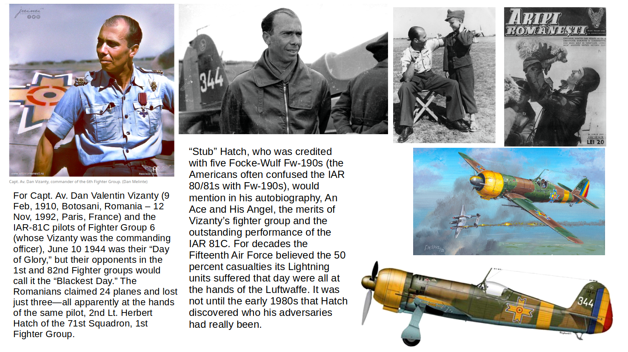
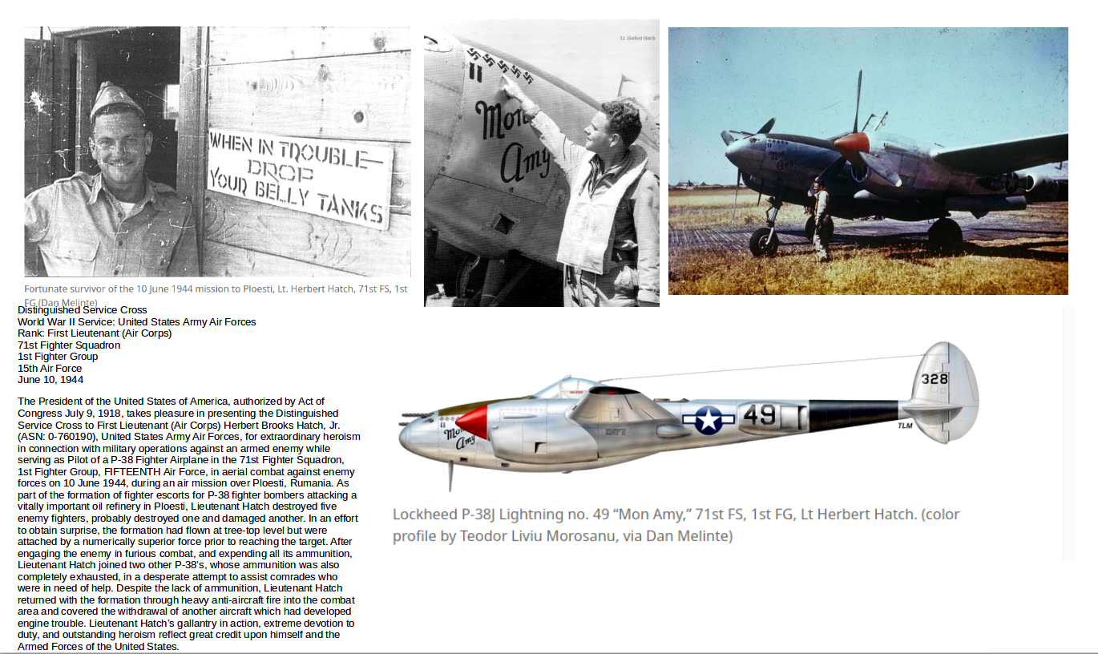
Two of the main characters of June 10th 1944: 1st Lt. Herbert Brooks Hatch, Jr (USAAF), and Capt. av. Dan Valentin Vizanty (RRAF).

→
Next page: Romanian IAR-81C fighters of the 6th Fighter Group, on June 10, 1944.


