Summer Days: Oher USAAF Missions to Romania in 1944

7 May 1944: Lockheed P-38J 42-104107 “JEWBOY” of 49th FS, 14th FG over Romania

On 15 April 1944 2nd Lt. Philip M. Goldstein gets assigned to Lockheed P-38J-15-LO 42-104107 Lightning (Numbered black 47 with small 07 on nose, named “JEWBOY”), on the day of an escort mission to Bucharest (though other listed sources already list Goldstein as the pilot of 42-104107 on 2 April 1944). Then, on 7 May 1944 he and the 14th FG execute a bomber escort mission to Bucharest (15th Air Force's third consecutive bombing raid to Romania, in three days):

- 75 Romanian (1st, 2nd, and 6th Fighter Groups) and 64 German fighters counter 500 B-17 and B-24 heavy bombers, escorted by 200 P-38 and P-51 fighters, of 15th AF;
- targets included Chitila, Grivita, Giulesti, Gara de Nord, also Bucharest city center; Romanian civilian casualties: 411 dead, and 920 wounded, largest number to date;
- Romanian fighter units involved: 1st, 2nd, and 6th Fighter Groups (Grupul 1, 2 and 6 Vanatoare);
- Goldstein claims one victory (Fiat G50 claimed - probably wrong designation, either IAR-80/81 or FW-190); US airmen claim 18 aerial victories, much more than the actual Romanian-German losses - Romanians had a few damaged IAR-80/81 and Germans lost one FW-190 (Richard Grafmueller);
- Earvie T. Cloyd 2nd Lt. 0-750541 of 37th FS, 14th FG gets shot down and taken POW (friend of Goldstein’s, freed in September 1944, during Operation Reunion);

Goldstein completed his 50th and last mission on 28 June 1944, and was sent home on 9 July 1944. He finished the war with three victories: a Bf-109 downed on 25 May 1944 over Steyr, Austria, the so-claimed Fiat G50 shot down over Bucharest, Romania on 7 May, and a FW-190 shot down over Piacenza, Italy, on 25 May 1944. On 31 July 1944, at the Group's base at Triolo, Italy, 42-104107 is destroyed by Kenneth R. Warren 2nd Lt. 0-763014, with no injury to pilot. That was a landing accident. 14th FG missions to Romania: total 9 missions between April and July 1944.

- 15 April 1944 - Bucharest - Escort B-24s to Bucharest, Romania
- 21 April 1944 - Bucharest - B-24 & B-17 Target Cover over Bucharest, Romania
- 05 May 1944 - Ploesti - Bomber Escort to Ploesti, Romania
- 07 May 1944 - Bucharest - Escort B-17s - 55th BW & B-24s - 47th, 55th & 304th BWs to Bucharest, Romania
- 15 May 1944 - Bucharest - Bomber escort to Bucharest, Romania
- 18 May 1944 - Ploesti - Escort & Top cover to Ploesti, Romania
- 05 June 1944 - Ploesti - Escort B-24s of the 47th, 49th & 55th BWs to Ploesti, Romania
- 22 June 1944 - Zilistea - Strafing Mission to Zilistea aerodrome, Romania
- 03 July 1944 - Arad - Escort B-17s of the 5th Bombardment Wing to Arad, Romania

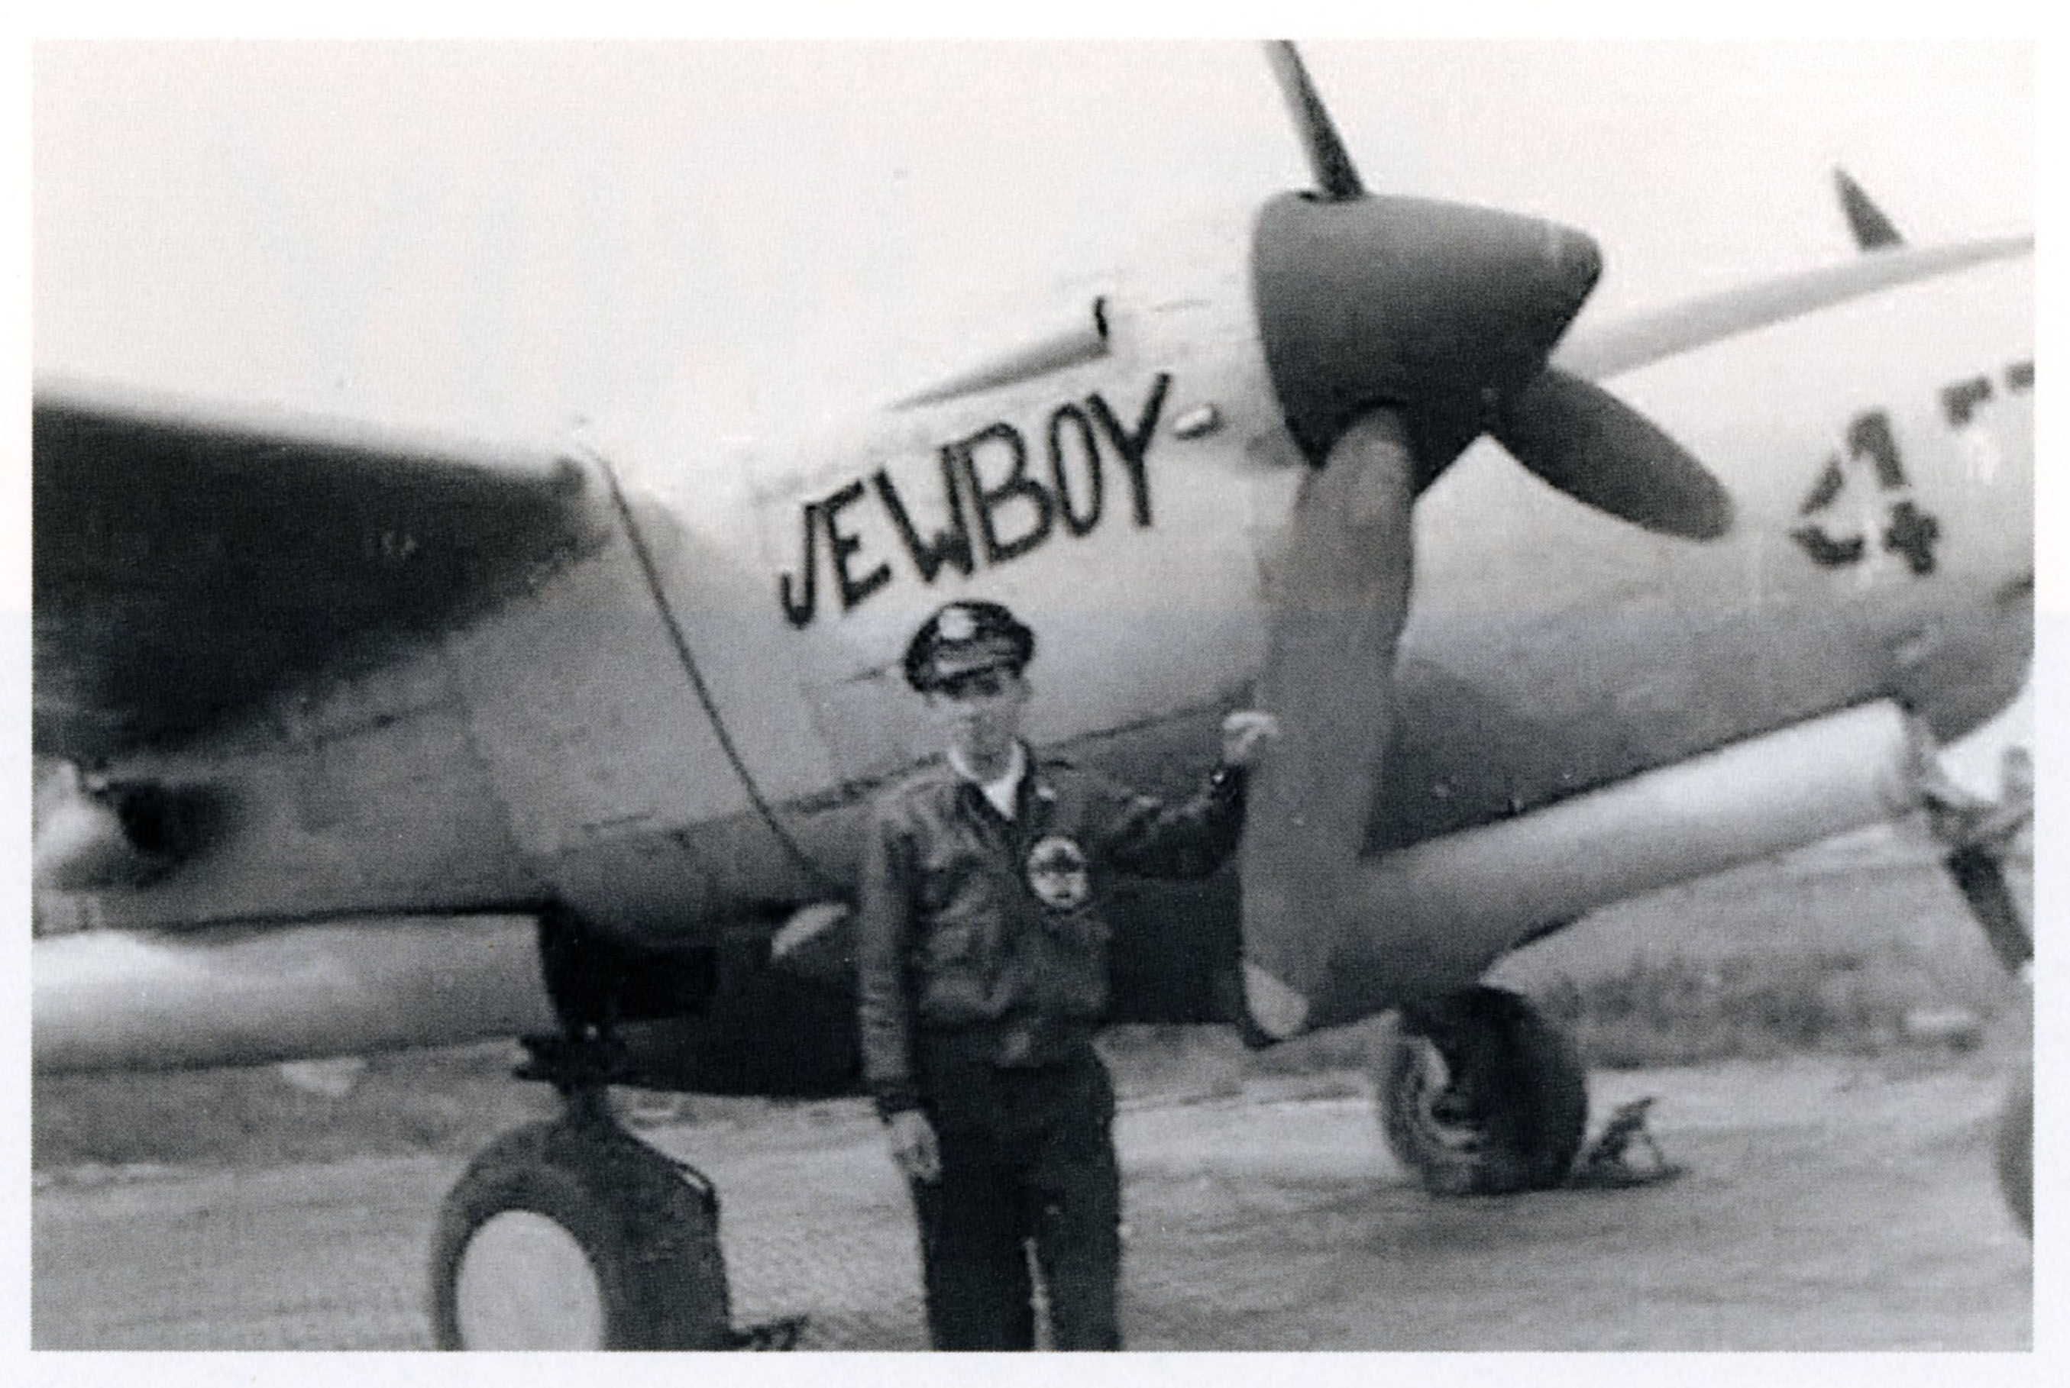

2nd Lt. Philip Goldstein and Lockheed P-38J 42-104107 “JEWBOY”, of 49th FS, 14th FG

23 June 1944: back to Ploiesti

450 US bombers take off with targets: Ploiesti - Societatea Romano-Americana and Dacia refineries (B-17 Flying Fortresses), and Giurgiu - harbour and oil pipeline installations (B-24 Liberators of multiple groups, including 485th BG). Results were mixed due to poor visibility. Ten USAAF bombers lost over both Ploiesti and Giurgiu. Romanian defenders were 1st, 6th, 7th, and 9th Figyhter Groups, that had to face a USAAF advance party made up of Mustangs, meant to strafe and saw chaos among the Royal Romanian Air Force. 1st Fighter Group lost their commander, Capt. Cdr. Ioan Sandu, shot down by USAAF north of Bucharest (pilot and wreck - IAR-80 serial 170 - found at Stefanesti, Jud. Ilfov). 7th Fighter Group also lost their commander, Capt. Av. Virgil Trandafirescu (Bf-109G), he led 11 Bf-109s off Boteni airfield, with heavy USAAF contact just north of Bucharest; Capt. Trandafirescu being shot down over Magurele, Jud. Ilfov. 31st FG claimed eight victories, one for Voll - his first victory. Possible IAR-80/81 or FW-190F, reference [1] says: "The Fw 190F of 4./SG 2 and II./SG 10 took the hardest punishment. 4./SG 10 lost three pilots (including the Staffelkapitän and ground-attack veteran, Knights Cross holder Hauptmann Günther Müller, who was killed in the Fw 190 F-8 white 13 on his 900th combat sortie). 4./SG 10 recorded four Fw 190 F-8 shot down with two pilots killed and one wounded. 31FG Lt. John J. Voll, who eventually would become the top scorer in the Fifteenth Air Force, scored his first victory (of 21 by the end of the war) with one of these Fw 190s, Rupert Weninger was shot down and killed by Mustangs on 24 June; four days later, Erich Gehring and Willi Dreyer were shot down and wounded.)" - though, from reference [2] (Luftwaffe records) we know II./SG 10 (moved to Bobruisk on 23 June 1944, though Hauptmann Muller of 4./SG 2 was indeed shot down over Ploiesti, and buried in Bucharest [3].

28 June 1944: 485th Bombardment Group goes to Bucharest

Target: Romania, Bucharest – Titan-Malaxa oil refinery, Mogosoaia oil depots, and adjacent buildings, railroad junctions, Chitila railroad depot, large number of bombs dropped over the city centre, over civilian neighbourhoods. Among other USAAF bombing groups, 485th BG suffered the worst losses, being escorted by 325th FG (“Checkertail Clan”) with aerial battles S/SW of Bucharest, between USAAF and RRAF and Luftwaffe

Royal Romanian Air Force (RRAF)’s 1st Fighter Group scrambled its 17 IAR-80/81 and intercepted a bomber formation and attacked it, while trying to avoid the escorting Mustangs. Three B-24s and B-17s were claimed shot down by RRAF pilots: one B-24 shot down by Capt. Constantin Georgescu, another by adj. Virgil Anghelescu, with the B-17 being claimed shot down by Slt. Av. Petre Mihailescu. Also, adj. av. Sava Zisu claimed a P-51, which remains probable to this day. This is the only case when a IAR-80 pilot claimed a Mustang (though US records don’t show any loss on that day). USAAF records confirm the loss of three B-24s, all belonging to the 485th BG that (at least one) fell in the vicinity of Vlasca County:

- B-24G 42-78147 “Nudist Kay” of 830th BS of Lt. Ivan Tyler, 7 KIA (crashed in Vlasca County, near Talpa Vlascoveni; two of the three survivors were picked up by av. Nicolae Ianculescu, and were sent to Bucharest, the third one being arrested by the Romanian Gendarmerie, and sent to the Romanian Army General Staff HQ);
- B-24G code BX 42-78122 of 831st BS of Lt. Robert F. Sloan with 2 men seen bailing out, 1 chute opened. w/Lt. E. A. LaMar; Romanian records indicate no survivors, with eight airmen buried in the Epuresti cemetery;
- B-24H code RJ 42-52701 “Miss Yankee Rebel” of 828th BS of Lt. Crouchley – eventually crash landed near Plovdiv, Bulgaria, 1 KIA (Lt. Crouchley), and 9 POW.

The Romanian 1st Fighter Group lost Cpt. Av. Parsifal Stefanescu (IAR-81C tail serial 228) and adj. Av. Gheorge Prasinopol (IAR-81C tail serial 359), both being shot down in a dogfight with 325th FG’s Lts Barrie Davis and Wayne Lowry (who had shot down Lt. Ion Dobran on May 6), both USAAF airmen claiming the victories as Focke Wulf 190s, a common misidentification for the Romanian IAR-80/81.

References

http://raf-112-squadron.org/325thfghonor_roll.html
https://aviationarchaeology.com/listPages/airforce/asp/AF_MACR_1944Jun.asp
https://www.americanairmuseum.com/archive/aircraft/42-52701?page=1
http://raf-112-squadron.org/14thfghonor_roll42_43.html
https://15thaf.org/XV%20FC/305th%20FW/14th/Aircraft/PDFs/000%20P-38%20List.pdf
Alexandru Arma, Sorin Turturica: Misiuni de Scarificiu, Editura Militara, Bucharest, 2013
http://theyweresoldiers.com/index.php/2017/05/01/the-flight-of-jewboy-a-jewish-p-38-lightning-pilot-in-the-second-world-war/
http://mail.aviation-safety.net/wikibase/108427
http://raf-112-squadron.org/31stfghonor_roll43_44.html
https://www.ww2.dk/air/attack/sg10.htm
https://www.tracesofwar.com/persons/25123/M%C3%BCller-G%C3%BCnther-Pan-Schlachtgeschwader-1.htm

