The USAAF raid over Galati, Romania, 6 June 1944

USAAF heavy bombers had already started flying to Ukraine, on 2nd June 1944, part of Operation Frantic I, and its “shuttle missions”. 483rd Bomb Group (equipped with B-17G Flying Fortress) flew from Foggia, Italy to Poltava, Ukraine, via a raid over Debreczen, Hungary, on 2nd June 1944 (see missions log https://15thaf.org/5th_BW/483rd_BG/PDFs/Missions.pdf), and, on 6th June 1944, they were tasked with bombing the Galati airfield, Romania, with them scheduled to return to Poltava, after the raid. Bomber escort was provided by North American P-51 Mustangs of the 325th Fighter Group ("Checkertail Clan"), based at Lesina, Italy, but immediately previous to the raid detached to the Soviet airfield at Pyriatyn, Ukraine, on the 2nd June 1944.

The attack on Galati started at 0930am on 6th June 1944; 104 USAAF B-17G Flying Fortress heavy bombers of the 483rd Bomb Group attacked from 25,000 feet, targeting the Galati airfield (and some harbour installations); fighter escort was provided by 54 Mustangs of the 325th Fighter Group, with its three Fighter Squadrons: 317th, 318th, and 319th. Since the attackers' altitude was very high, flak was ineffective, so defense was delegated to Royal Romanian Air Force (RRAF) fighter groups. The US bombers hit the airfield's hangars, the Eastern side of the airstrip, and the Lozoveni neighbourhood. Romanian Fighter Groups 6 (equipped with Romanian-built IAR-81C fighters), 7 and 9 (both equipped with Romanian-license built German Bf-109G fighters) are involved in defending against the USAAF Fortresses and their Mustang escorts, with the Romanian 9th Fighter Group, based at Tecuci, and commanded by Capt. Alexandru Serbanescu, being the main line of defense; the Group had 42 pilots (captains: Constantin Cantacuzino ("Bâzu"), lieutenants: Ion Dobran, Tudor Greceanu, Ioan Panaite, M.T. Şenchea, Scordilă, Vasile "Chiţu" Gavriliu, Constantin Rozariu, adjutants: Bălan, Ion Mucenica, Constantin Miron and many others). They will lose 6 aircraft out of 18 sent to battle the Forts and their 54 Mustang escorts, but no Romanian pilots were KIA that day.

According to Romanian records, USAAF lost eight aircraft (16 airmen KIA, and 59 taken prisoner - one captain, 24 second lieutenants, 23 warrant officers, 19 sergeants). Two of those eight aircraft shot down were fighter escort Mustangs (also confirmed by USAAF), the first Mustangs shot down by the RRAF:

- North American P-51C-5-NT Mustang, serial number 42-103369, pilot: Mumford, John D., serial O-811955, of 318FS, 325FG, 15AF, KIA, shot down by Capt. Constantin "Bazu" Cantacuzino, Romania's ace of aces, at the time part of 53rd Fighter Squadron, 9th Fighter Group; Mumford gets shot down in the vicinity of Reni, Romania, and he becomes the first Mustang shot down by the RRAF; Cantacuzino will land beside Mumford’s aircraft, and will collect Mumford's flying helmet as war trophy;
- North American P-51C-5-NT Mustang, serial number 42-103432, pilot: Lt. MacDonald, Donald J, serial O-667086, of 318FS, 325FG, 15AF, survives crash landing and is taken POW (shot down by a Romanian pilot of 9th Fighter Group, unclear who that was);

Further to the two Mustangs shot down over Romanian territory, one more Mustang is lost on its way back, over Ukraine:

- North American P-51B serial number 42-103519, pilot: 2nd Lt. Davis, Barrie S, serial O-811865 of 317FS, 325FG, 15AF. Lt. Davis gets shot down by Lt. Av. Ion Dobran of 48th Fighter Squadron, 9th Fighter Group, RRAF, but survives the ordeal (Davis crash landed at Mirogorod, Ukraine, his plane too badly damaged, and deemed a write-off, Davis himself being wounded), and, later, after the war, him and Dobran become friends. Dobran is himself shot down in the same air battle, by 1st Lt. Wayne Lowry (11 kills), the CO of 317th FS. Here is what Davis said about the incident (source http://raf-112-squadron.org/325thfghonor_roll.html):

"Soon after getting my Mustang, numbered 24, I gave it my mother’s nickname — Bee. After scoring my first victory over Ploesti, I added “Honey” to the name, because it proved it had a sting. With my crew chief’s help and over his objections, I painted garish red stripes from nose to tail down the side of the Mustang. They did not remain long. The next day, ordered came to remove all added decorations except names so that our P-51s looked the same. With the help again of my crew chief and to his great satisfaction, we used paint remover to take off the red stripes. The following day we took part in the first shuttle mission from Italy to the Soviet Union. This aircraft was his original P-51 left behind in Russia due to severe battle damage. The squadron callsign was Mayfair and Barries aircraft number was 24. The replacement (42-103519) looked exactly the same but with the addition of Honey to the nose and less checkerboard pattern paint due to a shortage of yellow paint at the time. The original P-51 was hit only once—during the June 6, 1944, mission flown from the Ukraine. Flying P-51s, we escorted B-17s attacking Galatz, Rumania (sic). The fourth member of our flight, which was led by Wayne Lowry, returned early. Bob Bass was third member. We met 16 enemy fighters (sic), and a fine battle ensued. I outmanoeuvred a Bf 109 and had him in my sights ready to achieve my first victory when he suddenly dropped wheels and flaps. He seemed to stop. I overshot and found myself in front of the Bf 109 desperately trying to escape. The hunter had become the hunted. As suddenly as it began, the fight was over. I searched the sky for other planes, finally finding my flight leader. I joined him, and we flew line abreast, with me on the right, toward our Russian base. By flying side by side, we could cover each other. Wayne saw a third plane approaching from our right rear. He believed it was Bob Bass rejoining us, until it began firing. The first round evidently hit my canopy, because I remember nothing from the explosion until I found myself flying alone at 23,000 feet. I was very, very cold. My shoes, wet with dew from walking through high grass to the plane in early morning, were frozen. My right wing tip was shredded. After landing, we found the tail was nearly shot off, all four propeller blades had been hit, and an unexploded cannon round was found in the fuel tank that sat behind the seat. The flight surgeon spent nearly an hour picking shell fragments from my head, shoulders, and thighs. Wayne shot down the Bf 109 that had clobbered me (nn Ion Dobran), and I received a Purple Heart."

A few more mentions about the air battle, via USAAF records: Lt. Hoffman became the first USAAF pilot to destroy an enemy aircraft while operating from Russian bases, Captain Hogg destroyed two (Luftwaffe) FW-190s, bringing his total to six. Lts. Barkey (later Captain Robert Barkey, in P-51B-15-NA s/n 43-24857, part of 319th FS, 325th FG) and Hoffman each got their fifth, becoming aces - Barkey's was his last kill, before going back to the US, and his only kill in a Mustang (unclear as to who he shot down). Lt. Barrie Davis was wounded and thus became the first man to earn a Purple Heart while operating from Russian bases.

As for the Romanian defenders of the 9th Fighter Group, on 6th June they flew for the first time against the Americans. The day, as recorderd by them: Lt. av. Dobran was playing bridge with Mucenica, Senchea and Simionescu, when the alarm was raised. They took off hastily and because of this rush, Dobran ended up without a wingman. He saw the USAAF bomber formation and then realized that he was flying alone. Below him were four fighters, and his first thought was they were Romanian Bf-109G's from 56th Fighter Squadron (9th Fighter Group). When he got closer, he correctly identified them as Mustangs. They were flying like they were at an air show - line abreast. Dobran dove and fired at the one on the right. Smoke started to come out of the airplane. The others dispersed. He then went for the bombers, but he fired from too far, because the Mustangs were closing in on himself. He plunged down and managed to shake off two of them after some aerobatics. But the one that stuck to his six, shot him down (ie 1st Lt. Wayne Lowry). Dobran sustained minor injuries while crash landing his Bf-109G ("Yellow 22"), and was back in action in a very short time (http://www.worldwar2.ro/arr/g9vt.htm).

This encounter with USAAF’s powerful Mustangs will set a pattern for the next missions the RRAF will fly against the Americans: suffering from inferiority in numbers, and flying less potent fighters, the Romanians will offer the USAAF a stiff opposition, oftentimes shooting down Mustangs and Lightnings, when numerical odds were stacked massively against them.

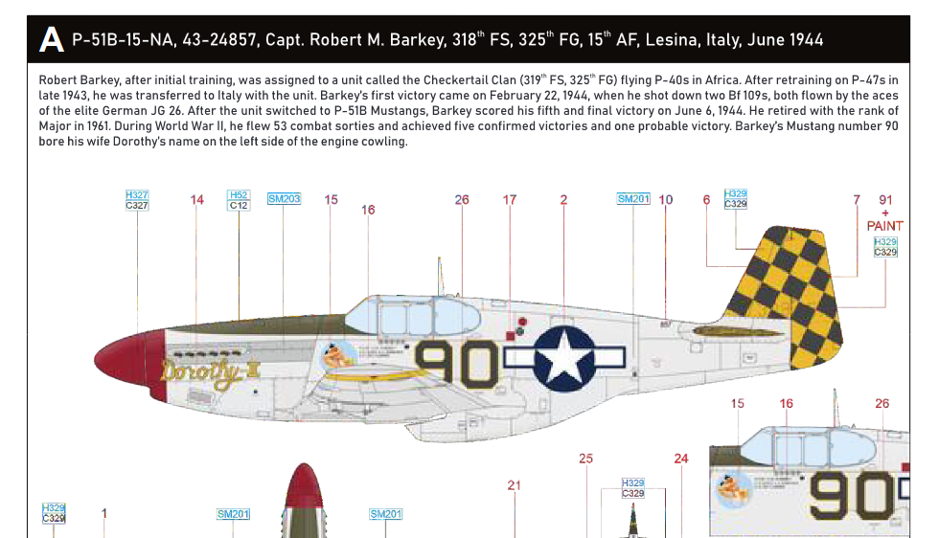
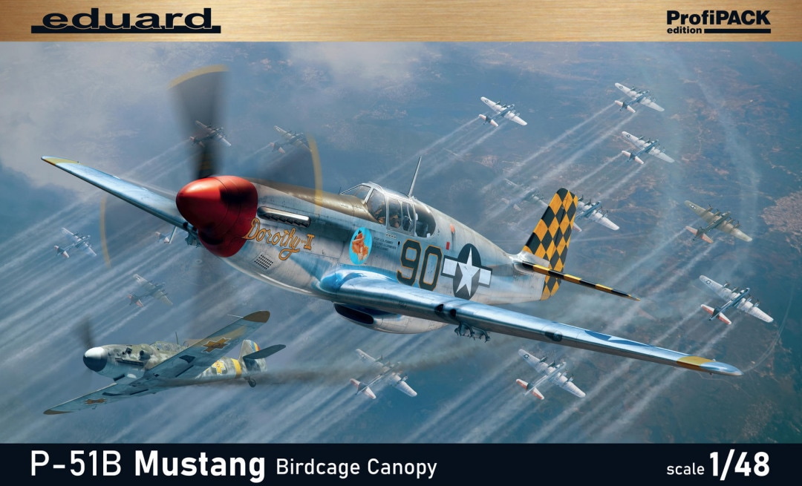
Eduard 82107 model kit: Captain Robert Barkey in P-51B-15-NA s/n 43-24857 “Dorothy II”, part of 319th Fighter Squadron, 325th Fighter Group, left Lesina, Italy for Ukraine on 2nd June 1944; on 6th June 1944 him and the rest of the 325th are escorting a wave of 104 USAAF B-17G bombers over Galati, Romania (with 54 Mustangs as escort); he shot down his fifth (and last) aircraft, granting him the Ace status; it is unclear who he shot down, of the 18 RRAF defenders of the 9th Fighter Group. This aircraft will later be renamed “Sweet Clara II”, and it will be used by Capt. Constanting “Bazu” Cantacuzino to fly back from San Giovanni airfield to Popesti-Leordeni airfield, to start Operation Reunion.

