North American P-51B 43-24857: a history

Last year I saw the box art of Eduard’s new Mustang release (kit number 82107) – Piotr Forkasiewicz’s wonderful digital paining was telling a story about a North American P-51B Mustang belonging to the famous “Checkertail Clan” fighter group (325th Fighter Group) having just damaged a Bf 109G of the Royal Romanian Air Force, somewhere, above a formation of B-17G Flying Fortresses. I immediately pre-ordered the kit, but, only now, months later, I decided to look closer at Piotr’s visual story, and try and make sense of it from a historical point of view. What I found out is detailed here, and it is a captivating story about an certain aircraft, about war and destruction, and, above all, it is a story about bravery and sacrifice.

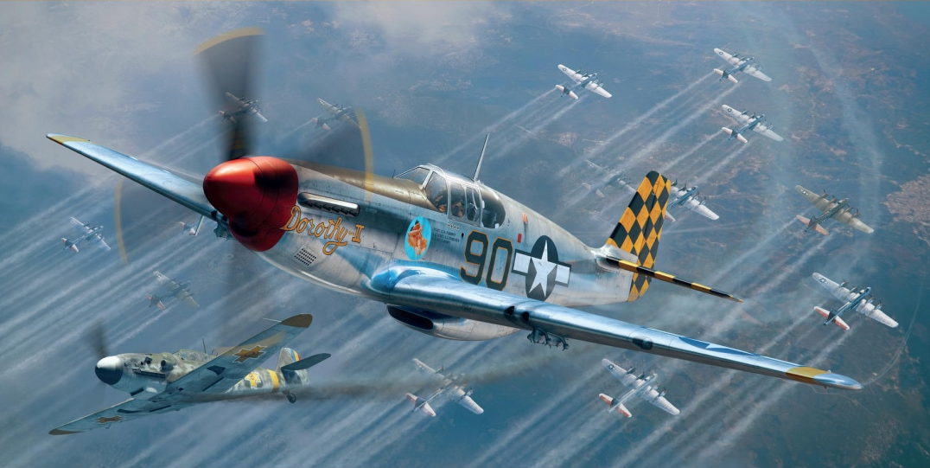
Eduard 82107 model kit’s wonderful box art by Piotr Forkasiewicz: Lt. (later Captain) Robert Merrill “Bob” Barkey in P-51B-15-NA s/n 43-24857 “Dorothy II”, part of 319th Fighter Squadron, 325th Fighter Group (“Checkertail Clan”), left Lesina, Italy for Ukraine on 2nd June 1944 part of the very first “shuttle” mission of Operation Frantic I (“Frantic Joe”); on 6th June 1944 him and the rest of the 325th FG are escorting a wave of 104 USAAF B-17G bombers of the 483rd Bomb Group over Galati, Romania (with 54 (42, from other sources) Mustangs as escort); that day, he shot down his fifth (and last) aircraft, granting him the Ace status; it is unclear who he shot down, of the 18 Royal Romanian Air Force defenders of the 9th Fighter Group (Grupul 9 Vanatoare), but it is a fact that that Bf 109G was Romanian. This aircraft will later be renamed “Sweet Clara II”, and will be handed over to Lt. Russell Elliott, then it will be used by Capt. Constantin “Bazu” Cantacuzino, the Romanian ace of aces of the 9th Fighter Group, to fly back from San Giovanni airfield, Italy to Popesti-Leordeni airfield, south of Bucharest, Romania, at the start of Operation Reunion (the evacuation of USAAF POWs from Romania to Italy), August 29, 1944.

The USAAF raid over Galati, Romania, 6 June 1944

Mr Forkasiewicz’s depiction of the Mustang is a moment frozen in time, during the destructive USAAF raid over Galati, Romania, on June 6 1944. USAAF heavy bombers had already started flying to Ukraine, on 2nd June 1944, part of Operation Frantic I, and its “shuttle missions”. 483rd Bomb Group (equipped with B-17G Flying Fortress) flew from Foggia, Italy to Poltava, Ukraine, via a raid over Debreczen, Hungary, on 2nd June 1944 (see missions log https://15thaf.org/5th_BW/483rd_BG/PDFs/Missions.pdf), and, on 6 June 1944, they were tasked with bombing the Galati airfield, Romania, with them scheduled to return to Poltava, after the raid. Bomber escort was provided by North American P-51 Mustangs of the 325th Fighter Group ("Checkertail Clan"), based at Lesina, Italy, but immediately previous to the raid detached to the Soviet airfield at Pyriatyn, Ukraine, on the 2nd June 1944.

The attack on Galati started at 0930am on 6th June 1944; 104 USAAF B-17G Flying Fortress heavy bombers of the 483rd Bomb Group attacked from 25,000 feet, targeting the Galati airfield (and some harbour installations); fighter escort was provided by 54 Mustangs of the 325th Fighter Group, with its three Fighter Squadrons: 317th, 318th, and 319th. Since the attackers' altitude was very high, flak was ineffective, so defense was delegated to Royal Romanian Air Force (RRAF) fighter groups. The US bombers hit the airfield's hangars, the Eastern side of the airstrip, and the Lozoveni neighbourhood. Romanian Fighter Groups 6 (equipped with Romanian-built IAR-81C fighters), 7 and 9 (both equipped with Romanian-license built German Bf-109G fighters) are involved in defending against the USAAF Fortresses and their Mustang escorts, with the Romanian 9th Fighter Group, based at Tecuci, and commanded by Capt. Alexandru Serbanescu, being the main line of defense; the Group had 42 pilots (captains: Constantin “Bazu” Cantacuzino, lieutenants: Ion Dobran, Tudor Greceanu, Ioan Panaite, M. T. Şenchea, Scordilă, Vasile "Chiţu" Gavriliu, Constantin Rozariu, adjutants: Bălan, Ion Mucenica, Constantin Miron and many others). They will lose 6 aircraft out of 18 sent to battle the Forts and their 54 Mustang escorts, but no Romanian pilots were KIA that day.

According to Romanian records, USAAF lost eight aircraft (16 airmen KIA, and 59 taken prisoner - one captain, 24 second lieutenants, 23 warrant officers, 19 sergeants). Two of those eight aircraft shot down were fighter escort Mustangs (also confirmed by USAAF), the first Mustangs shot down by the RRAF:

- North American P-51C-5-NT Mustang, serial number 42-103369, pilot: Mumford, John D., serial O-811955, of 318FS, 325FG, 15AF, KIA, shot down by Capt. Constantin "Bazu" Cantacuzino, Romania's ace of aces, at the time part of 53rd Fighter Squadron, 9th Fighter Group; Mumford gets shot down in the vicinity of Reni, Romania, and he becomes the first Mustang shot down by the RRAF; Cantacuzino will land beside Mumford’s aircraft, and will collect Mumford's flying helmet as war trophy;
- North American P-51C-5-NT Mustang, serial number 42-103432, pilot: Lt. MacDonald, Donald J, serial O-667086, of 318FS, 325FG, 15AF, survives crash landing and is taken POW (shot down by a Romanian pilot of 9th Fighter Group, unclear who that was);

Further to the two Mustangs shot down over Romanian territory, one more Mustang is lost on its way back, over Ukraine:

- North American P-51B serial number 42-103519, pilot: 2nd Lt. Davis, Barrie S, serial O-811865 of 317FS, 325FG, 15AF. Lt. Davis gets shot down by Lt. Av. Ion Dobran of 48th Fighter Squadron, 9th Fighter Group, RRAF, but survives the ordeal (Davis crash landed at Mirogorod, Ukraine, his plane too badly damaged, and deemed a write-off, Davis himself being wounded), and, later, after the war, him and Dobran become friends. Dobran is himself shot down in the same air battle, by 1st Lt. Wayne Lowry (11 kills), the CO of 317th FS. Here is what Davis said about the incident (source http://raf-112-squadron.org/325thfghonor_roll.html):

"Soon after getting my Mustang, numbered 24, I gave it my mother’s nickname — Bee. After scoring my first victory over Ploesti, I added “Honey” to the name, because it proved it had a sting. With my crew chief’s help and over his objections, I painted garish red stripes from nose to tail down the side of the Mustang. They did not remain long. The next day, ordered came to remove all added decorations except names so that our P-51s looked the same. With the help again of my crew chief and to his great satisfaction, we used paint remover to take off the red stripes. The following day we took part in the first shuttle mission from Italy to the Soviet Union. This aircraft was his original P-51 left behind in Russia due to severe battle damage. The squadron callsign was Mayfair and Barrie’s aircraft number was “24”. The replacement (42-103519) looked exactly the same but with the addition of Honey to the nose and less checkerboard pattern paint due to a shortage of yellow paint at the time. The original P-51 was hit only once—during the June 6, 1944, mission flown from the Ukraine. Flying P-51s, we escorted B-17s attacking Galatz, Rumania (sic). The fourth member of our flight, which was led by Wayne Lowry, returned early. Bob Bass was third member. We met 16 enemy fighters (sic), and a fine battle ensued. I outmanoeuvred a Bf 109 and had him in my sights ready to achieve my first victory when he suddenly dropped wheels and flaps. He seemed to stop. I overshot and found myself in front of the Bf 109 desperately trying to escape. The hunter had become the hunted. As suddenly as it began, the fight was over. I searched the sky for other planes, finally finding my flight leader. I joined him, and we flew line abreast, with me on the right, toward our Russian base. By flying side by side, we could cover each other. Wayne saw a third plane approaching from our right rear. He believed it was Bob Bass rejoining us, until it began firing. The first round evidently hit my canopy, because I remember nothing from the explosion until I found myself flying alone at 23,000 feet. I was very, very cold. My shoes, wet with dew from walking through high grass to the plane in early morning, were frozen. My right wing tip was shredded. After landing, we found the tail was nearly shot off, all four propeller blades had been hit, and an unexploded cannon round was found in the fuel tank that sat behind the seat. The flight surgeon spent nearly an hour picking shell fragments from my head, shoulders, and thighs. Wayne shot down the Bf 109 that had clobbered me (n.n. Ion Dobran), and I received a Purple Heart."

A few more mentions about the air battle, via USAAF records: Lt. Hoffman became the first USAAF pilot to destroy an enemy aircraft while operating from Russian bases, Captain Hogg destroyed two (Luftwaffe) Fw-190s (most probably Romanian IAR-81C of the 6th Fighter Group, easily confused by the Americans with Fw-190s) , bringing his total to six. Lts. Barkey (later Captain Robert Merrill “Bob” Barkey, in P-51B-15-NA s/n 43-24857, part of 319th FS, 325th FG) and Hoffman each got their fifth, becoming aces - Barkey's was his last kill, before going back to the US on a bond tour, and his only kill in a Mustang (unclear as to who he shot down, but it is certain it was a Bf 109G of the RRAF). Lt. Barrie Davis was wounded and thus became the first man to earn a Purple Heart while operating from Russian bases.

As for the Romanian defenders of the 9th Fighter Group, on 6th June they flew for the first time against the Americans. The day, as recorderd by them: Lt. av. Dobran was playing bridge with Mucenica, Senchea and Simionescu, when the alarm was raised. They took off hastily and because of this rush, Dobran ended up without a wingman. He saw the USAAF bomber formation and then realized that he was flying alone. Below him were four fighters, and his first thought was they were Romanian Bf-109G's from 56th Fighter Squadron (9th Fighter Group). When he got closer, he correctly identified them as Mustangs. They were flying like they were at an air show - line abreast. Dobran dove and fired at the one on the right. Smoke started to come out of the aeroplane. The others dispersed. He then went for the bombers, but he fired from too far, because the Mustangs were closing in on himself. He plunged down and managed to shake off two of them after some aerobatics. But the one that stuck to his six, shot him down (ie 1st Lt. Wayne Lowry). Dobran sustained minor injuries while crash landing his Bf-109G ("Yellow 22"), and was back in action in a very short time (http://www.worldwar2.ro/arr/g9vt.htm).

This encounter with USAAF’s powerful Mustangs will set a pattern for the next missions the RRAF will fly against the Americans: suffering from inferiority in numbers, and flying less potent fighters, the Romanians will offer the USAAF a stiff opposition, oftentimes shooting down Mustangs and Lightnings, when numerical odds were stacked massively against them.

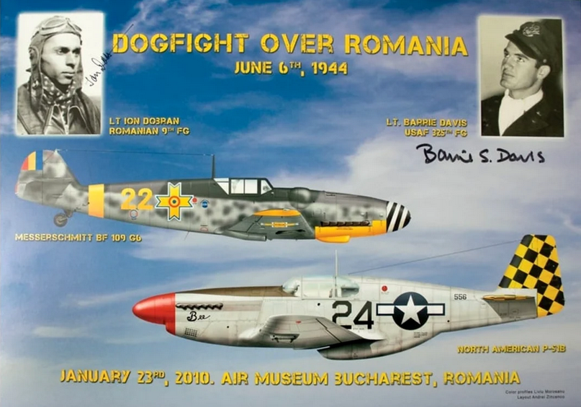

After keeping in touch over correspondence, Ion Dobran and Barrie Davis finally met each other in Bucharest, in 2010, and this is the poster of the public event. Davis will pass away in 2014, and Dobran, the last surviving Romanian ace for a long time, will join him in 2021. Godspeed, gentlemen!

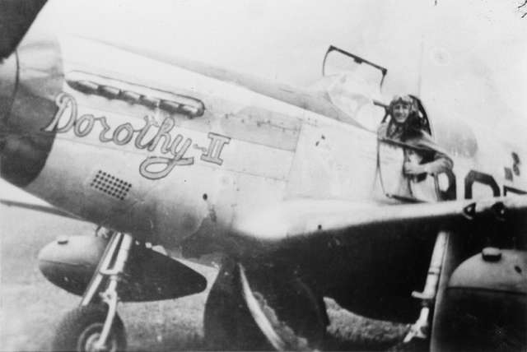
Lt. (later Captain) Robert Merrill “Bob” Barkey in the cockpit of P-51B Mustang “Dorothy II”.

“Sweet Clara II”

Sometime after June 1944, 43-24857 was handed over to Lt. Russell Elliott, preserving her number “90” but changing her nickname (and nose name) to “Sweet Clara II” on both sides of the nose (though it appears that the starboard inscription simply read “Sweet Clara”, without the Roman numeral ”II”). It kept flying with the 319th FS, 325th FG, until events of August 1944 entered her in history books yet again, and, again, it had something to do with Romania.

On August 23 1944 King Michael of Romania staged a coup d’etat, turning arms against Nazi Germany, in an attempt to save the country from total destruction at the hands of the Red Army, that had finally broken through into Romania on August 21 1944. The country, having effectively switched sides, was in turmoil – German forces, still present in large numbers, start a campaign against the freshly-Allied country, while Soviet troops are advancing at a breakneck pace towards Bucharest. Former prisoners of war are now liberated, and among them, there were more than 1,100 American POWs, all of them aviators shot down over Romania in the previous two years, during the Campaign against Oil. Neither the Americans, nor the newly appointed democratic government of Romania, wanted the Soviets to take over the prisoners and the prison camps, let alone allow the Germans to deport them towards Germany, so an evacuation plan was hatched – with time being the key element. Bucharest’s two largest airports (Otopeni and Baneasa) were solidly in Germans hands, so evacuation operations, if they were to happen, had to be done from elsewhere. Popesti-Leordeni airfield was a small airfield south of Bucharest – this was the place where Operation Reunion eventually took place. I am not describing in detail the actual operation – for that, I recommend James Emmett Thompson’s excellent book titled “Last flight of the Gustav”, but only the involvement of Capt. Constantin “Bazu” Cantacuzino and that of “Sweet Clara II”. Cantacuzino discussed with Col. James Gunn (the most senior of USAAF’s POWs), and they decided they should fly together to San Giovanni, Cerignola, Italy (at the time, home of the 454th and 455th Bomb Groups), so that Gunn can propose Gen. Twining (commander of 15th Army Air Force) the evacuation plan from Romania. Cantacuzino stuffed Gunn inside the windowless and extremely cramped radio compartment of a Romanian Bf 109G-6 (Werk No 166133. Erla canopy, the newest airframe at the base, with only 7.5 flight hours), garishly adorned with old (pre-1942) American roundels painted on top of the Romanian Michael crosses, and sporting huge US flags painted on both sides of the fuselage, and they flew, guided by a map Gunn drew on a piece of cardboard, safely arriving at San Giovanni in the evening of August 27, 1944. It was decided to return to Popesti-Leordeni the following two days later, so that to determine if the airfield was still in friendly hands, to commence the evacuations; Cantacuzino and Gunn flew in a Bf 109 whose DB605 engine was tuned for synthetic, low-octane petrol, and with the Americans using high-octance petrol, the Bf 109 would not be able to be refueled for the flight back; it was decided that “Bazu” will be loaned a Mustang – a plane he both feared and revered, and that he’d always wanted to fly – this time, he’d be at the controls of a Mustang! And what Mustang did “Bazu” get – 43-24857 “Sweet Clara II”! The task of training Cantacuzino on the Mustang was given to Cpt. Walter J. Goehausen, who only taught him the basic controls of the Mustang. Once in the air for a test flight, “Bazu” began performing some aerobatic maneuvers and landed the aeroplane "as if he had always flown it". (https://en.wikipedia.org/wiki/Operation_Reunion#CITEREFArm%C4%832020)

Cantacuzino was to be escorted by three other Mustangs who were ordered to shoot him down if anything suspicious happened. They were to take off on 29 August and once at Popesti-Leordeni, Cantacuzino was to land and assess the situation on the airfield. Afterwards, he was to signal the escorting P-51s by firing a double yellow-starred flare if the airfield was still in Romanian control, a double red flare if the airfield was not safe, and a single green flare if the escorting fighters should wait a further five minutes. If no signal came within 15 minutes, it was assumed that the area was not safe to land. All proceeded with no hitch, and the rest was, as they say, history! (during Operation Reunion more than 1,100 American airmen were successfully evacuated from Romania, to Italy, from Popesti-Leordeni airfield, on B-17 Flying Fortresses, in less than a single week!)
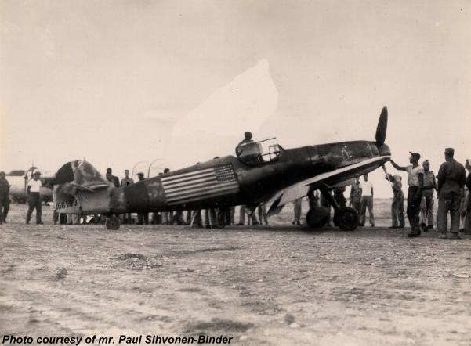

Constantin “Bazu” Cantacuzino arrives at San Giovanni, Italy, with Col. James Gunn stiffed in the Bf 109’s radio compartment, evening of August 27, 1944. The aircraft (Werk No 166133) belonged to Escadrila 48, Grupul 9 Vanatoare (48th Fighter Squadron, 9th Fighter Group, RRAF), but had all her national markings oversprayed, and large US flags and roundels painted over. It was a garishly looking aircraft with a bizarre paintwork!

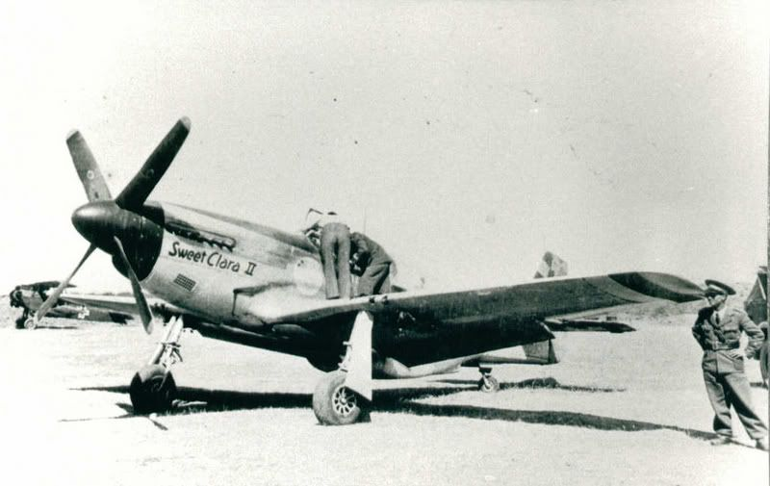
P-51B Mustang 43-24857 “Sweet Clara II” at Popesti-Leordeni airfield, south of Bucharest, Romania, August 29, 1944, being examined by Romanian ground personnel, after “Bazu” had landed her. A Romanian SET biplane can be seen in the background.

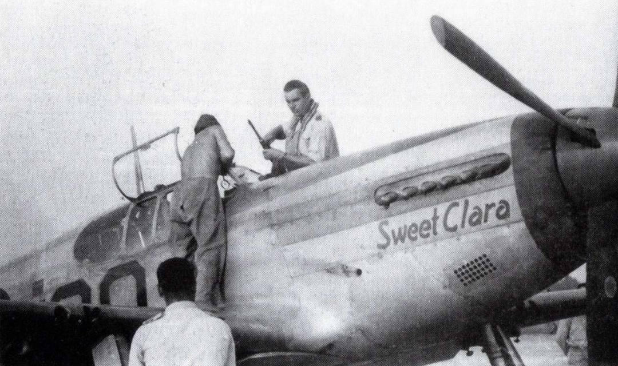
P-51B Mustang 43-24857 “Sweet Clara II” at Popesti-Leordeni airfield.

43-24857 was eventually returned to the 325th FG, and it flew combat missions until February 1945, when Lt. Conrad J. Cook damaged her while landing at Lesina, Italy; apparently she was salvaged in September 1945, but her fate is unknown after that date. “Bazu” went on to fight against the Germans in Transylvania, Hungary, then Czechoslovakia, finishing the war with 54 victories, the top Romanian ace, and one of the overall best pilots of the War; Col. Gunn stayed in the Air Force, yet only in 2014 was he awarded, posthumously, the Silver Star for Operation Reunion. Romania became a Soviet satellite after 1945, spending the next 45 years behind the Iron Curtain. Now, Romania is a proud NATO country. 325th Fighter Group is now 325th Operations Group, based at Tyndall AFB, and manages operations of F-35 Lightning IIs and F-22A Raptors.

Godspeed to heroes!

Dr Valeriu Predoi,
July 2025

