German-Romanian Operations in Bessarabia/Romania (first half of 1944)

Overview of first quarter of 1944

While Romanian troops may have left Transnistria with little resistance, this was not to be the intention with Basarabia, Bessarabia in English (the province to the south of Transnistria between the Bug and Prut rivers, now Republic of Moldova). This province, lost in 1940, was the reason the Romanians had entered the war in 1941, and they were determined not to give it up again without a fight. The Romanian and German units were in mixed commands, Group Wöhler consisted of the German Eighth Army and the Romanian Fourth Army and Group Dumitrescu contained the German Sixth Army and the Romanian Third Army. Both Mixed army groups were under German Army Group South Ukraine.

The Romanian Fourth Army dug-in on the hastily constructed Traian fortified line positioned below the Carpathian foothills on the Siret and Dnestr rivers, covering the northern approaches to Bessarabia. The German Sixth Army was positioned on the Stefan Line, a less complete position behind the eastern Traian Line. The Romanian Third Army was fortified along the lower Dnestr River. During May, Group Dumitrescu’s positions on the Dnestr solidified, but those of Group Wöhler in northern Bessarabia remained precarious into June.

The first of the re-constituted Romanian units in Group Wöhler to enter combat were the specialist mountain ski troops (Vanatori de Munte) and frontier guards in the Carpathian passes fighting alongside the German XVII Corps during April. Various Soviet Second Ukrainian Front probing attacks were conducted along the front line of Groups Wöhler and Dumitrescu throughout late April. On 28 April a counterattack by the German 23rd Panzer Division and 79th Infanterie Division halted the Soviet attacks towards Iasi. Other counterattacks were launched in late April with the Romanian Guard Division distinguishing itself while fighting alongside the elite German Grossdeutschland Division north of Targu Frumos.

The Romanian Guards penetrated the defences of the Soviet 81st Guards Rifle Division and drove northward to the outskirts of Harmanesti, turning the left flank of the Soviet 8th Guards Airborne Division and forcing them to withdraw. The Romanian attack was finally halted at Harmanesti. One regiment of the division attacked northward up a valley to the southwest of Crivesti, but was forced back by a counterattack by the Soviet 81st Guards Rifle Division’s rear area troops supported by the divisional artillery. To extract themselves from this difficult situation they required the aid of the Grossdeutschland Division’s Panzer Regiment. After further fighting the position stabilised. The Germans and Romanians had advanced the defensive lines about 6km.

First Battle of Targu Frumos

The Soviets pushed into Romania in two directions: first, from East over the Dnestr and second, further West, the pushed outwards from Dnestr bridgeheads near Yampol (now Yampil, Ukraine) and via Botosani (Romania). In this second direction, there were two central striking directions: Through the Prut valley just north-east of Iasi and along the major road "W3" leading from Botosani via Targul Frumos southwards into the Romanian heartland. April 8th, 1944, marks the 7th and 8th Romanian Infantry Divisions withdrawing slowly from Botosani to the West, also from Harlau to Belcesti, Erbiceni and Targu Frumos. This village is occupied by the Russian 35th Guards Rifle Corps (GRC), while ca. 600 of its cavalrists are approaching it from the North. Ca. 1.000 red infantrists march from Harlau towards Targu Frumos; these troops occupy Facuti during the night.

April 9th 1944: in the morning, vanguards ofthe 35th GRC reach as far as 6km SE of Targu Frumos, Twelve Panzers from 24th Panzer Division, backed up by Panzergrenadiere, attack Letcani from the West, but cannot overcome the tough defense including strong anti-tank gun emplacements. Elements of the 2nd Tank Army are tied by parts of 24th Panzer Division and thus cannot move to Targu Frumos to support the southwards push there. In the afternoon, 60 Soviet cars and hundreds of troops march SE from Targu Frumos. Munteni and Belcesti are taken by the Russians, as is Zahorna. The 7th Romanian Infantry Division retreats there on a broad front. West of Targu Frumos, Soviet cavalry attacks the Romanian Guards Division. In the evening, first elements of Grossdeutschland Panzergrenadiers arrive in Iasi. Romanian troops and one armed Reccon vehicle from 24th Panzer Division defend Podul Iloaiei. Approximately 1,500 Russian soldiers with horsecars approach Targu Frumos from the N. 50 to 60 soviet tanks are observed near Epureni.
During the night, a mixed Romanian-German grouping is attacked near Helestieni without result.
April 10th 1944: Soviet Recconaissance reaches 10km SW and SW of Targu Frumos. At noon, a German pincer-attack versus Targu Frumos begins: Sturmgeschutz Abteilung 335 with 18 StuG and 200 Rumanian infantrists moves in from Strunga, while Grossdeutschland pushes from North of Podu Iloaiei. The attack is backed up by the 4th Rumanian Army as flank protection in the South of the valley, where the main combat line (HKL) "Strunga-Line" is established. Its task is also to destroy Russians who have advanced South of the main road Iasi-Targu Frumos. In the early afternoon, the push from the South has reached up to 3km from Targu Frumos, while Grossdeutschland stormed a small dwelling Noth of Podu Iloaiei and later takes Erbiceni.
At evening, Grossdeutschland’s armoured spearhead reaches ca. 10km West of Targu Frumos. During the whole day, I. German Fliegerkorps and First Romanian Air Corps heavily support the German counterattack. From 22:00 up to 2:50, heavy night fighting in Targu Frumos brings the city back in Axis hands.

April 11th 1944: at 3:30, Sturmgeschutz Abteilung 335, now with 20 assault guns, attacks to the North. In the morning, Soviet troops South of the road Iasi-Targu Frumos retreat northwards. These troops block the road West of Podul Iloaiei. Tiger tanks are sent there and clear the situation until noon, while Rumanian infantry follows the Russian retreat for the whole day up to the road. In the afternoon, around Iasi two Soviet attacks with 6 and 10 tanks each (from Stanca and towards Ungheni) are repelled by 23rd Panzer Division. Until evening, Grossdeutschland reaches the railway line between Erbiceni and Belcestia and occupies the heights Noth of Targu Frumos. A lot of booty including 22 anti-tank guns is taken.

April 12th 1944: until the morning, Grossdeutschland takes ca. 100 POW from three Soviet regiments who tried to break through to the North. Grossdeutschland also pushes westwards from Targu Frumos with support by the Romanian Guards Division. The Prut-bridge between Iasi and Ungeni is destroyed by a Soviet air attack. In Harlau, a fuel depot of the Red Army explodes after an Axis air attack with a "200m high darting flame" at 3:30. In the afternoon, the Soviet 16th Tank Corps (70 tanks) attacks 24th Panzer Division (15 tanks, 30 StuG) North of Erbiceni and Letcani and reaches the main road.
April 13th 1944: with another attack, the Soviet 16th Tank Corps takes Erbiceni and adjacent areas in the morning, only to be pushed out again and to loose 9 tanks in the fights, one of which is captured in usable condition by the Germans. In Bals between Harlau and Targu Frumos, a Soviet courier plane with important post and a staff officer is captured by elements of Grossdeutschland. Until the evening, Grossdeutschland widens its Targu Frumos bridgehead up to ca. 6km East of Ruginoasa. Altogether, the Axis troops take ca. 1.000 POW's during these days.

Second Battle of Targu Frumos

On 2 May a major Soviet attack was launched towards Targu Frumos. It was preceded by a deafening 60-minute artillery barrage followed by a wave of infantry and tanks. The Romanian unit engaged by this assault was the Guard Division who were hit by the full force of the Soviet 8th Guards Airborne Division and a supporting tank brigade from the 18th Tank Corps. After several hours of intense fighting the Soviets had broken through the Romanian positions south of Helestieni. By noon the Soviets had cut the Pascani-Targu Frumos road and the Romanians had withdrawn to a secondary fortified line.

Many of the nearby German Grossdeutschland units had held at strong defensive positions, disrupting the Soviet attack and forcing them to leave behind infantry to deal with the stubborn defenders. The Grossdeutschland Panzer Regiment soon came to the rescue and drove the Soviets back towards their initial positions. Various breakthrough and counterattacks continued throughout the day. Grossdeutschland was joined by 24th Panzer Division from reserve and the attack/counterattack battle continued until 7 May when the final German counterattack halted the Soviet offensive. The German Sixth Army made an effort to clear Soviet bridgeheads across the Dnestr River during May with some success, but these operations were conducted by German troops who were more suited to offensive operations than the supporting Romanian infantry formations.

Early June fighting – German counteroffensive around Iasi: Operations Sonja and Katja

While the Soviets were still in planning for their drive into Romania, the German Eighth Army had plans of its own. Army Group Wöhler launched one of the few major offensives to be conducted by a German army during 1944 on the eastern front. Intelligence had identified large concentrations of Soviet troop north of Iasi and General Wöhler decided to form a Panzer group to attack and destroy these Soviet concentrations. In the region of Iasi, Romanian and German troops were intermingled defending the fortified lines. The Romanian 6th, Guard, and 4th divisions were in the rearward line and the 1st, 18th Mountain, 3rd, and 11th Divisions in the forward lines. The 5th Cavalry Division was also held in reserve with the German 14th Panzer Division. At the end of May, Wöhler concentrated the 14thPanzer Division, 23rd Panzer Division, 24th Panzer Division and Grossdeutschland Panzergrenadierdivision in the Iasi region. The operation was launched in two stages with Operation Sonja starting on 30 May and Operation Katja on 2 June. Operation Sonja was conducted by 23rd Panzer Division and 24th Panzer Division, respectively, and was launched north of Iasi towards the Soviet assembly areas. They were supported by 79. Infanteriedivision and the Romanian 11th Infantry Division. The Romanian 18th Mountain Division was to protect the attack’s left flank and the Romanian 3rd Infantry Division the right of the second phase Operation Katja, conducted mainly by the Grossdeutschland Panzergrenadierdivision.

On the Soviet side an operation was prepared by the 2nd Ukrainian Front: similar to the "Iasi-Kishinev"-operation realized in August 1944 , the attack was to take place near Iasi. The 2nd and 6th Tank Army were relocated there, coming from the area Targu Frumos, as well as from the Dnestr, to support 27th and 52nd Armies. These preparations were recorded by the German Reconnaissance and thus accelerated the German efforts. That meant, the Germans and Romanians had a time advantage.

Operation Sonja captured the area around the village of Sarca (south of the town of Cirpiti) and threw back four Soviet Rifle Divisions on 30 May. The following day attacks were launched against Soviet salients on their left flank. On the right flank the Romanian 11th Infantry Division supported 23rd Panzer Division Kampfgruppe. On the third day 24th Panzer Division withdrew to prepare for Operation Katja, and left their positions to the 14th Panzer Division and 79. Infanteriedivision, reinforced by the Romanian 3rd and 11th Infantry Divisions.

Operation Katja - the forces for Operation Katja formed around the village of Tautesti. The attack was launched on 2 June with the aim of taking the Soviet strong points at Horlesti and Zahorna, northwest of Iasi, before swinging right. The two regiments of the Romanian 3rd Infantry were to follow 24th Panzer Division and provide support and clean up bypassed pockets of resistance. To the 24th Panzer Division’s left was the Grossdeutschland Panzergrenadierdivision with the aim of taking strong points at Avantul, Movileni Station and Epureni before continuing north to take the high ground overlooking the Jijia River. The Romanian 18th Mountain Division was to follow Grossdeutschland to provide additional infantry support and clear isolated enemy pockets. The Romanian 4th Infantry Division would come up from reserve to take over the 18th Mountain’s positions.

The German Panzer Kampfgruppen set off early on 2 June and quickly advanced against weak Soviet opposition (three Rifle Divisions). After the first days fighting Grossdeutschland had reached all its objectives and turned the sector west of Epureni over to the Romanian 18th Mountain Division and reinforced the 24. Panzerdivision’s wing.

The assault resumed on 3 June as Grossdeutschland and 24th Panzer Division continued their assaults on the Soviet positions. The Romanian 3rd Infantry Division joined the assault on the 24. Panzerdivision’s right. The Romanians assaulted the positions north of Vulturi and south of Hill 164 held by the Soviet 116th Rifle Division. Fighting intensified during 3 June as Soviet reinforcements arrived, including tanks of the 16th Tank Corps and new IS-2 heavy tanks. By 4 June strong defences south of Epureni halted the Grossdeutschland advance. The Romanians continued in their supporting role, taking over freshly taken ground each time the German Panzertruppen moved forward. The Romanian 3rd Infantry Division also finally took Hill 164 with support from 24th Panzer Division and Grossdeutschland Panzergrenadiers. Heavy fighting continued into 5 June with fighting north of Hill 162. A Soviet counterattack almost overran the Romanian 18th Mountain Division, but Grossdeutschland intervention restored the situation. More Soviet forces shored up the Soviet line and fierce fighting continued into 6 June, but the attacks by German Kampfgruppen halted and the Axis defenders settled into the former Soviet trenches. The main objective had been achieved with the taking of the high ground overlooking the Jijia River.

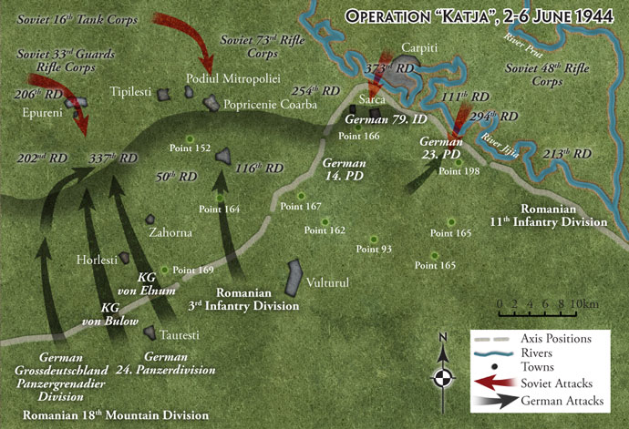

Frontline stabilized

The Romanian 18th Mountain and 3rd Infantry took up the defence and the 20th Infantry Division, German Grossdeutschland Panzergrenadierdivision and 23rd Panzer Division went into reserve behind the newly won positions. However, Epureni still remained in Soviet hands and a number of small bridgeheads remain on the southern bank of the Jijia River. A number of counterattacks were launched on 7-8 June by the Soviets, but most of the newly won ground was held and fighting died down by the end of 8 June. For the remainder of June and July the front remained relatively quite as events in Byelorussia drew Soviet and German attention elsewhere.

Photographs: Grossdeutschland and 23rd Panzer Division tanks

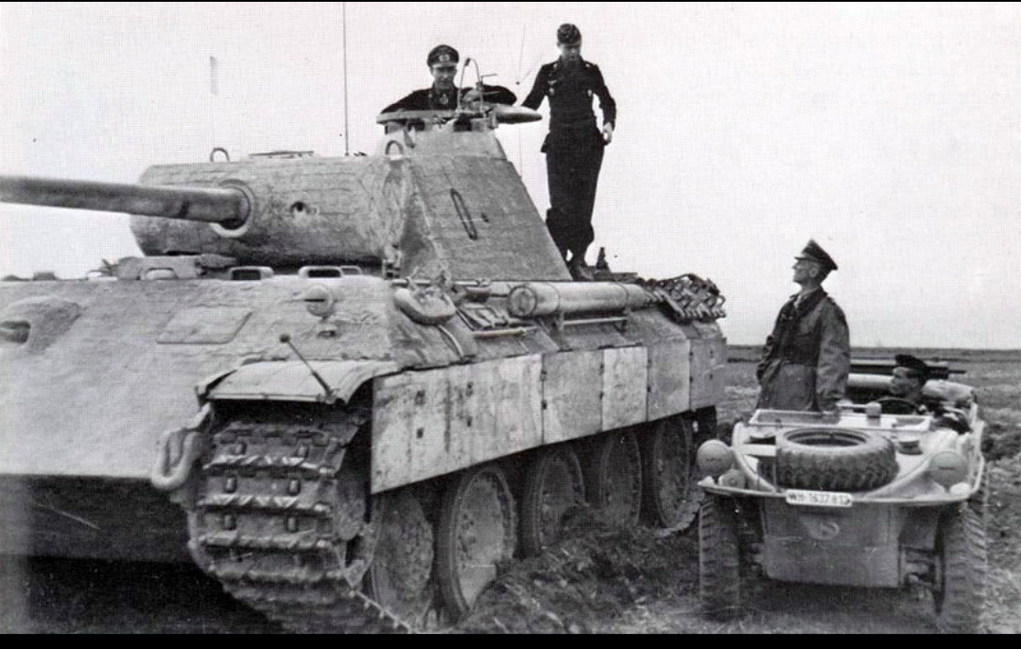
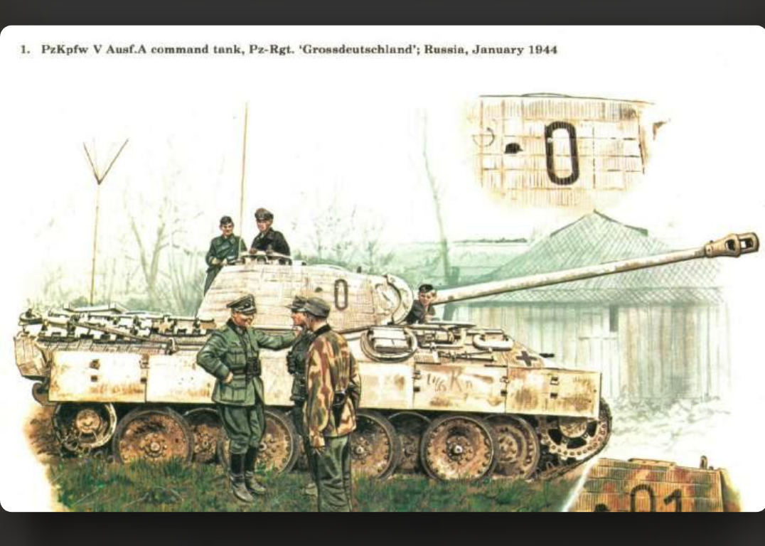
- 0 + helmet: Panther Ausf. A Befehlspanzer, Oberst Willi Langkeit, talking to Gen. Hasso von Manteuffel in his Schwimmwagen, Bessarabia, early 1944 (small GD helmet instead of letter R for regimental panzer); Willi Langkeit was the commander of Panzer-Regiment Grossdeutschland at the time
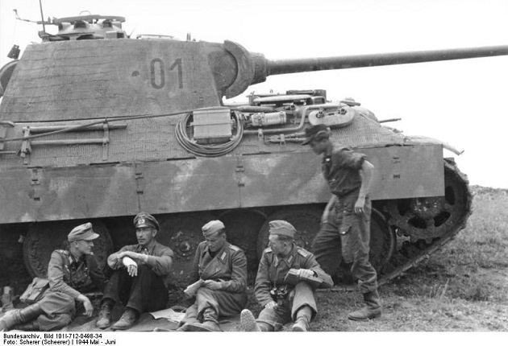
- 01 + helmet: Panther Ausf. A Befehlspanzer, Oberst Willi Langkeit, and his crew, Iasi, Romania (small GD helmet instead of letter R for regimental panzer); Willi Langkeit was the commander of Panzer-Regiment Grossdeutschland at the time

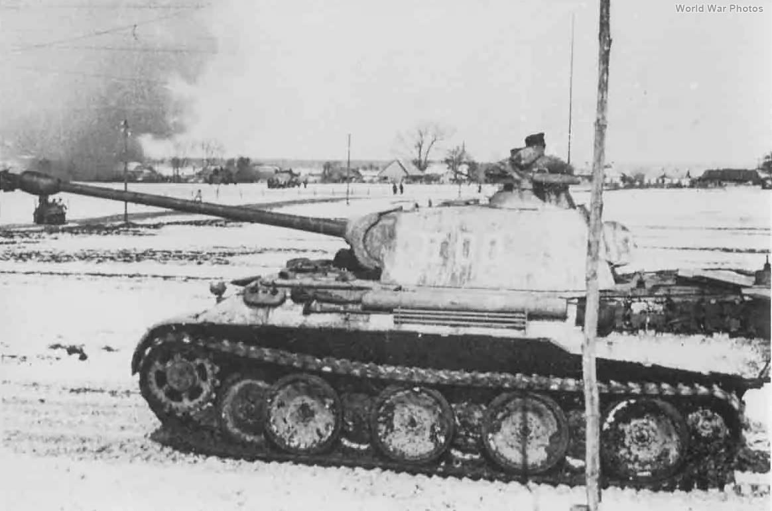

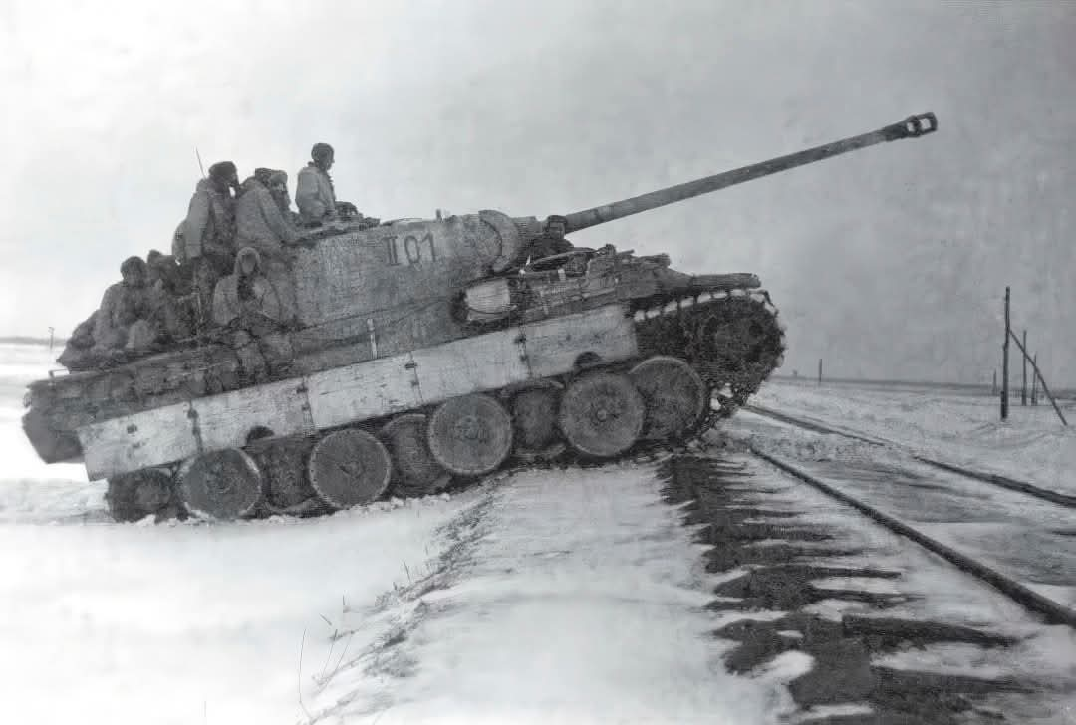
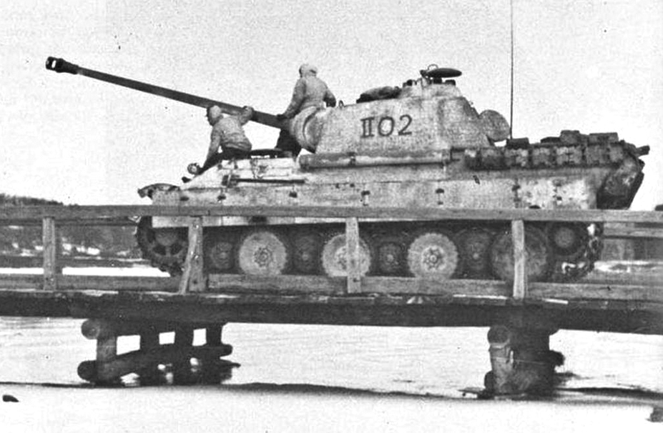
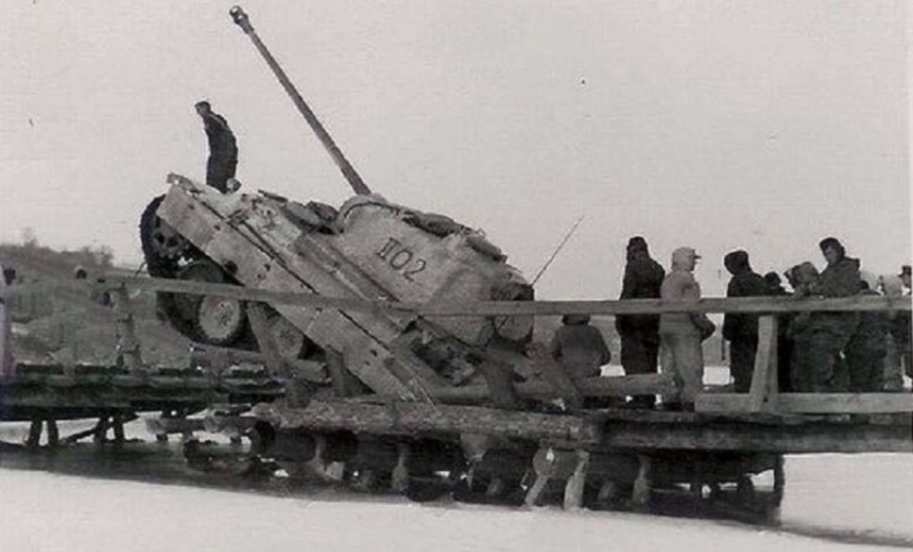

- II00, II01, II02 - all Panther Ausf. A of the Stab. (headquarters) II/23rd Panzer Regiment of the 23rd Panzer Division, early 1944 - most probably around Orativ (now Ukraine)/Tiraspol (now Republic of Moldova)/Bessarabia (now Republic of Moldova)
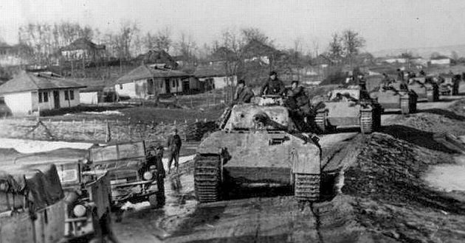
- column of Panther Ausf. A of Grossdeutschland Panzer Regiment, Bessarabia, April 1944
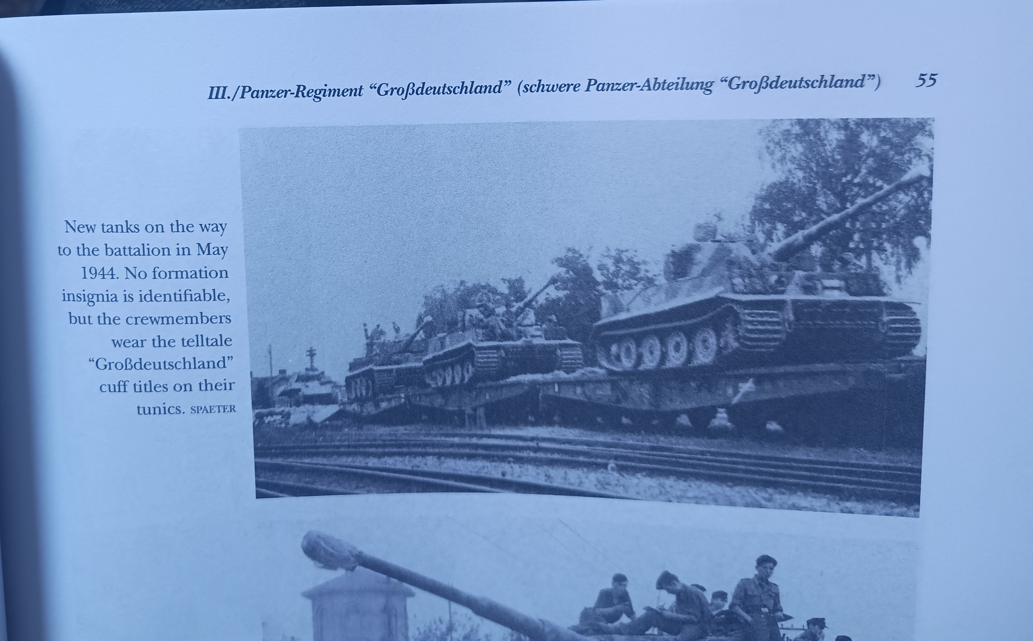
- May 1944: resupply with Tiger I Late for Grossdeutschland Division (Romania)
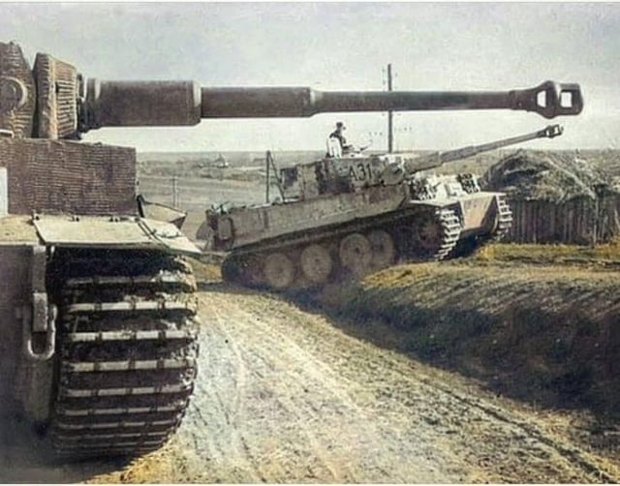
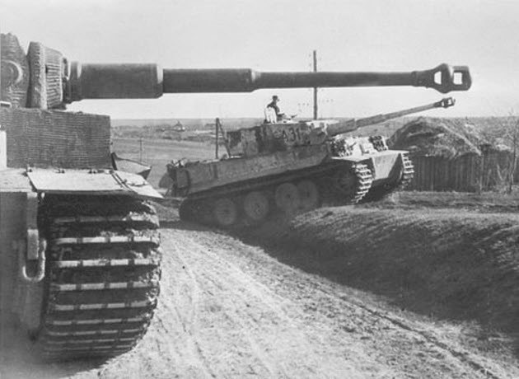
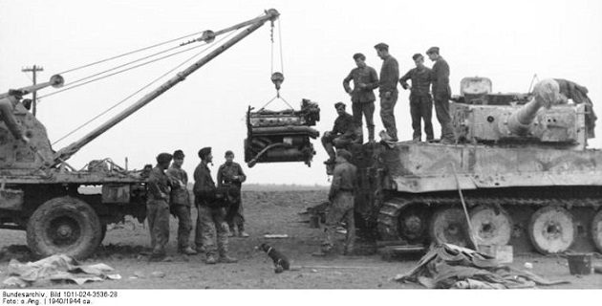
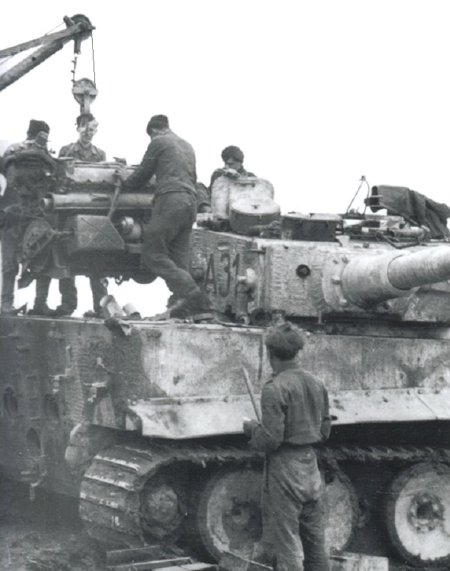
- A31: Tiger I Mid with Zimmerit, 9. Kompanie/III/Grossdeutschland Division, engine change April 1944 near Iasi, Romania
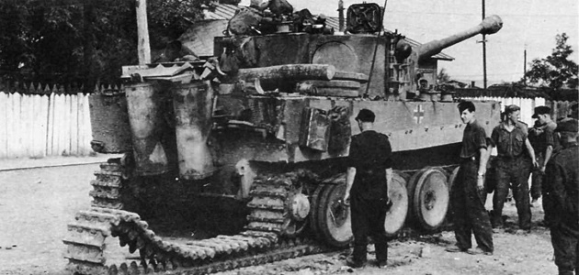
- A32: Tiger I Mid with Zimmerit, 9. Kompanie/III/Grossdeutschland Division, Gumbinnen (Gusev, East Prussia), just transited from Romania via rail, on or later 26 July 1944
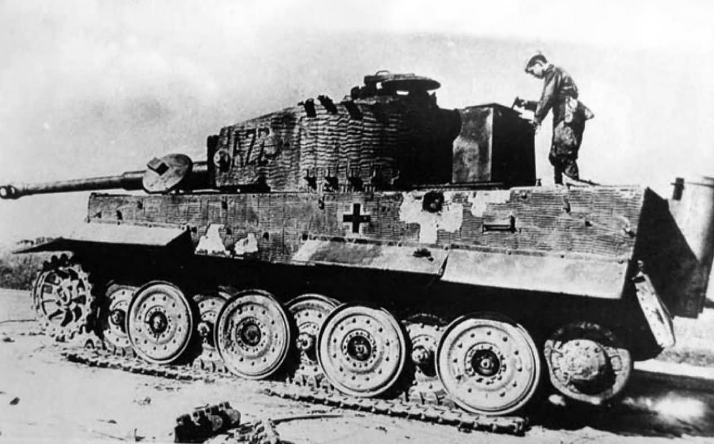
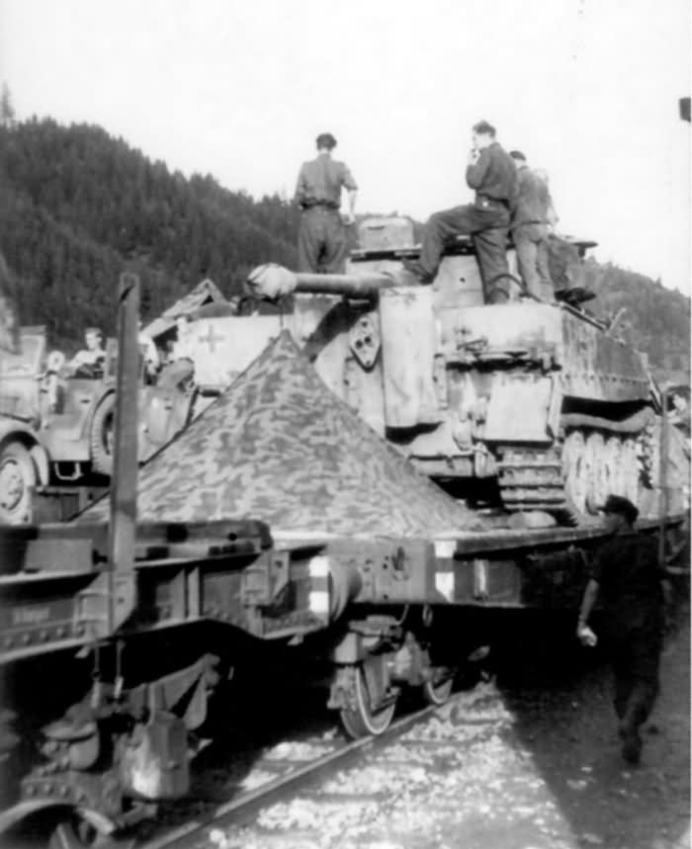
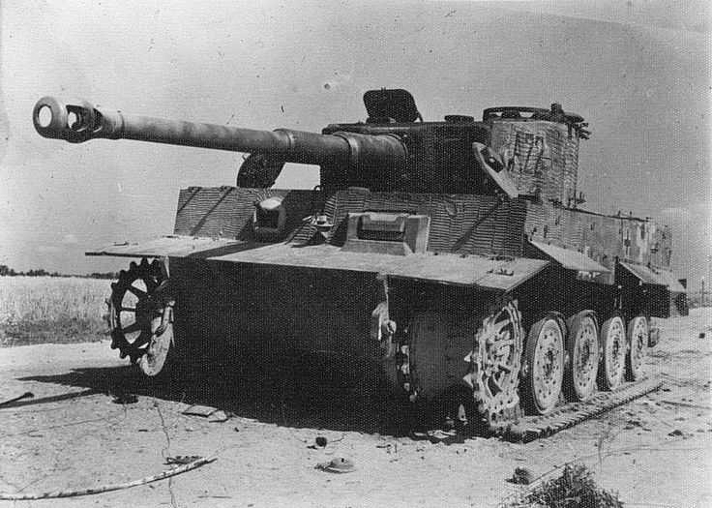
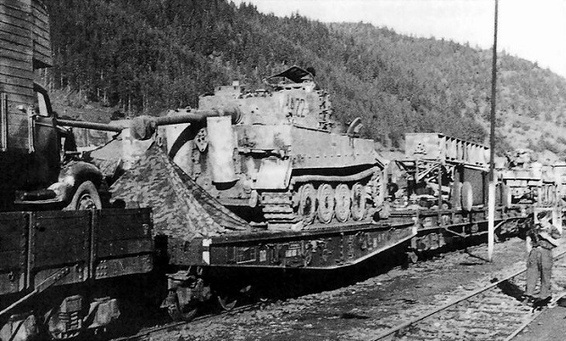
- A22: Tiger I Late with Zimmerit of Grossdeutschland Division, in transit from Romania (on or later 26 July 1944), eventually destroyed by German artillery (in error) on 9 October 1944 (first picture)
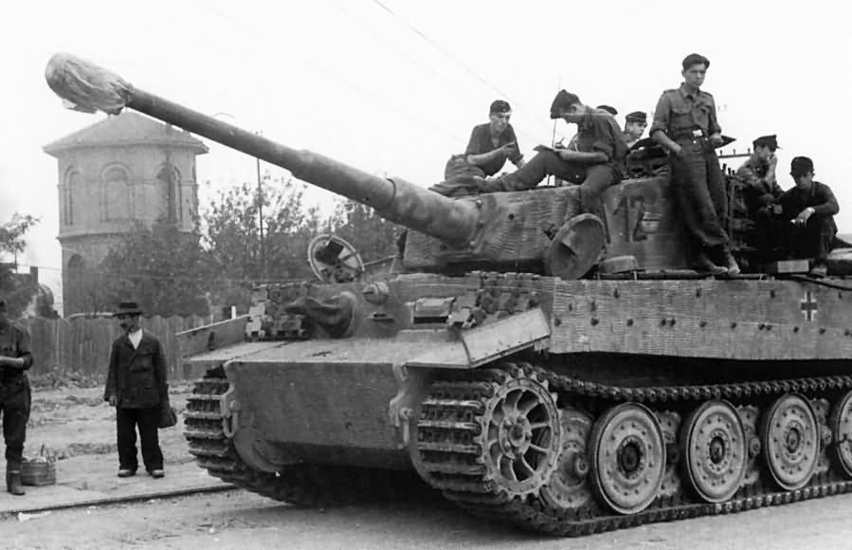
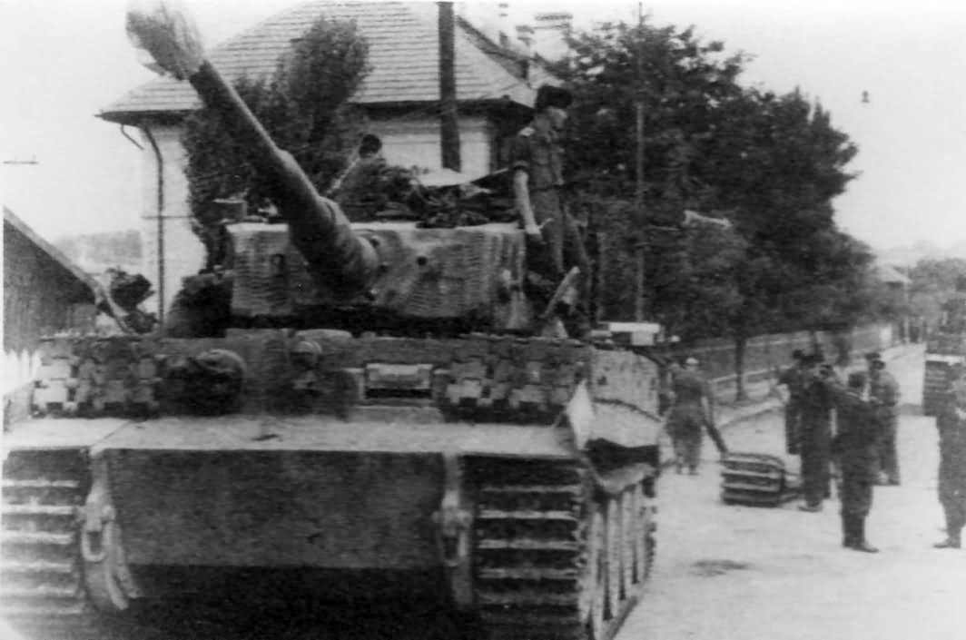
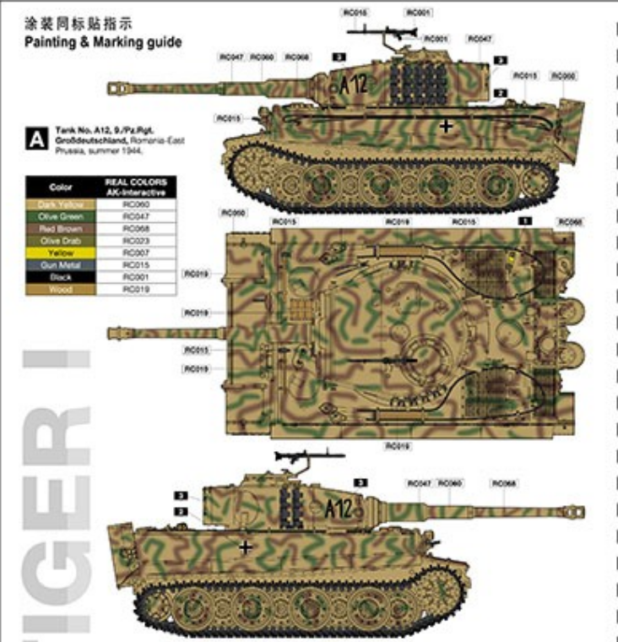
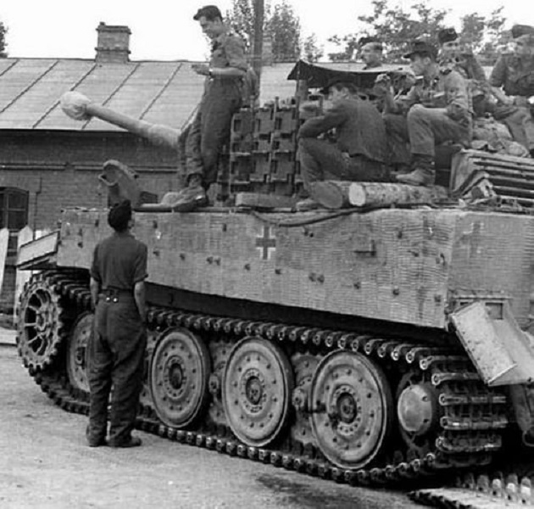
- A12: Tiger I Late with Zimmerit, 9. Kompanie/III/Grossdeutschland Division, Gumbinnen9Gusev, East Prussia), just transited from Romania via rail, on or later 26 July 1944

References

https://www.team-yankee.com/hobby.aspx?art_id=2610
http://www.yogysoft.de/Bessarabia_1.htm
http://www.worldwar2.ro/arr/?article=447
https://mikesresearch.com/2022/04/24/grosdeutschland-panzers-1942-45/

