“Bazu” and the Mustangs

North American P-51B 43-24857

Last year I saw the box art of Eduard’s new Mustang release (kit number 82107) – Piotr Forkasiewicz’s wonderful digital painting was telling a story about a North American P-51B Mustang belonging to the famous “Checkertail Clan” fighter group (325th Fighter Group) having just damaged a Bf-109G-6 of the Royal Romanian Air Force, somewhere, above a formation of B-17G Flying Fortresses. I immediately pre-ordered the kit, but, only now, months later, I decided to look closer at Piotr’s visual story, and try and make sense of it from a historical point of view. What I found out is narrated here, and it is a captivating story about an certain aircraft, a Romanian Prince and fighter ace, about war and destruction, and, above all, it is a story about bravery and sacrifice.

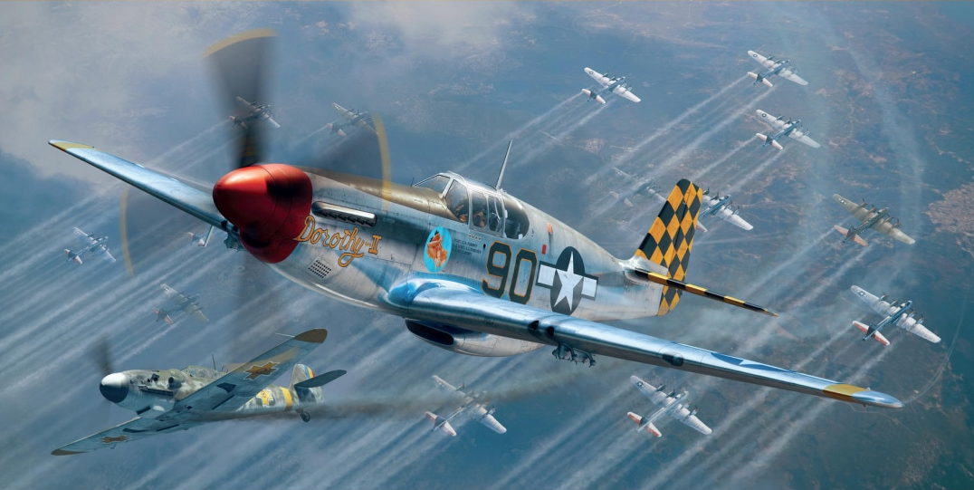
Eduard 82107 model kit’s wonderful box art by Piotr Forkasiewicz: Lt. (later Captain) Robert Merill “Bob” Barkey in P-51B-15-NA s/n 43-24857 “Dorothy II”, part of 319th Fighter Squadron, 325th Fighter Group (“Checkertail Clan”), left Lesina, Italy for Ukraine on 2nd June 1944 part of the very first “shuttle” mission of Operation Frantic I (“Frantic Joe”); on 6th June 1944 he and the rest of the 325th FG are escorting a wave of 104 USAAF B-17G bombers of the 483rd Bomb Group over Galati, Romania (with 54 (42 from the 325th ) Mustangs as escort); that day, he shot down his fifth (and last) aircraft, granting him the Ace status; it is unclear who he shot down, of the 18 Royal Romanian Air Force defenders of the 9th Fighter Group (Grupul 9 Vanatoare), but it is a fact that that Bf 109G-6 was Romanian. This aircraft will later be renamed “Sweet Clara II”, and will be handed over to Lt. Russell Elliott, then it will be used by Capt. Constantin “Bazu” Cantacuzino, the Romanian ace of aces of the 9th Fighter Group, to fly back from San Giovanni airfield, Italy to Popesti-Leordeni airfield, south of Bucharest, Romania, at the start of Operation Reunion (the evacuation of USAAF POWs from Romania to Italy), August 29, 1944.

The USAAF raid over Galati, Romania, 6 June 1944

Mr Forkasiewicz’s depiction of the Mustang is a moment frozen in time, during the destructive USAAF raid over Galati, Romania, on June 6 1944. USAAF heavy bombers had already started flying to Ukraine in the Soviet Union, on 2nd June 1944, part of Operation Frantic I, and its “shuttle missions”. 483rd Bomb Group (equipped with B-17G Flying Fortress) flew from Foggia, Italy to Poltava, Ukraine, via a raid over Debreczen, Hungary, on 2nd June 1944 (see missions log in References), and, on 6 June 1944, they were tasked with bombing the Galati airfield, Romania, with them scheduled to return to Poltava, after the raid. Bomber escort was provided by North American P-51 Mustangs of the 325th Fighter Group ("Checkertail Clan"), based at Lesina, Italy, but immediately previous to the raid detached to the Soviet airfield at Pyriatyn, Ukraine, on the 2nd June 1944.

The attack on Galati started at 0930am on 6 June 1944; 104 USAAF B-17G Flying Fortress heavy bombers of the 483rd Bomb Group attacked from 25,000 feet, targeting the Galati airfield (and some harbour installations); fighter escort was provided by 54 Mustangs of which 42 of the 325th Fighter Group, with its three Fighter Squadrons: 317th, 318th, and 319th. Since the attackers' altitude was very high, flak was ineffective, so defense was delegated to Royal Romanian Air Force (RRAF) fighter groups. The US bombers hit the airfield's hangars, the Eastern side of the airstrip, and the Lozoveni neighbourhood. Romanian Fighter Groups 6 (Grupul 6 Vanatoare, equipped with Romanian-built IAR-81C fighters), 7 and 9 (both equipped with Romanian-license built German Bf-109G fighters) are involved in defending against the USAAF Fortresses and their Mustang escorts, with the Romanian 9th Fighter Group, based at Tecuci, and commanded by Capt. Alexandru Serbanescu, being the main line of defense; the Group had 42 pilots (captains: Constantin “Bazu” Cantacuzino, lieutenants: Ion Dobran, Tudor Greceanu, Ioan Panaite, M. T. Şenchea, Scordilă, Vasile "Chiţu" Gavriliu, Constantin Rozariu, adjutants: Bălan, Ion Mucenica, Constantin Miron and many others). They will lose 6 aircraft out of the 18 sent to battle the Forts and their Mustang escorts, but no Romanian pilots were KIA that day.

According to Romanian records, USAAF lost eight aircraft (16 airmen KIA, and 59 taken prisoner - one captain, 24 second lieutenants, 23 warrant officers, 19 sergeants). Two of those eight aircraft shot down were fighter escort Mustangs (also confirmed by USAAF), the first Mustangs shot down by the RRAF:
- North American P-51C-5-NT Mustang, serial number 42-103369, pilot: Mumford, John D., serial O-811955, of 318th FS, 325th FG, 15AF, KIA, shot down by Capt. Constantin "Bazu" Cantacuzino, Romania's ace of aces, at the time part of 53rd Fighter Squadron, 9th Fighter Group; Mumford gets shot down in the vicinity of Reni, Romania, and he becomes the first Mustang shot down by the RRAF;
- North American P-51C-5-NT Mustang, serial number 42-103432, pilot: Lt. MacDonald, Donald J, serial O-667086, of 318th FS, 325th FG, 15AF, survives crash landing and is taken POW (shot down by a Romanian pilot of 9th Fighter Group, unclear who that was);
Further to the two Mustangs shot down over Romanian territory, one more Mustang is lost on its way back, over Ukraine:
- North American P-51B serial number 42-103519, pilot: 2nd Lt. Davis, Barrie S, serial O-811865 of 317th FS, 325th FG, 15AF. Lt. Davis gets hit by Lt. Av. Ion Dobran of 48th Fighter Squadron, 9th Fighter Group, RRAF, but survives the ordeal (Davis landed at Mirogorod, in Ukraine, his plane too badly damaged, and deemed a write-off, Davis himself being wounded), and, later, after the war, he and Dobran become friends, and, will eventually meet in person in 2010. Dobran is himself shot down in the same air battle, by 1st Lt. Wayne Lowry (11 kills), the CO of 317th FS. Here is what Davis said about the incident:

"Soon after getting my Mustang, numbered 24, I gave it my mother’s nickname — Bee. After scoring my first victory over Ploesti, I added “Honey” to the name, because it proved it had a sting. With my crew chief’s help and over his objections, I painted garish red stripes from nose to tail down the side of the Mustang. They did not remain long. The next day, ordered came to remove all added decorations except names so that our P-51s looked the same. With the help again of my crew chief and to his great satisfaction, we used paint remover to take off the red stripes. The following day we took part in the first shuttle mission from Italy to the Soviet Union. This aircraft was his original P-51 left behind in Russia due to severe battle damage. The squadron callsign was Mayfair and Barrie’s aircraft number was “24”. The replacement (42-103519) looked exactly the same but with the addition of Honey to the nose and less checkerboard pattern paint due to a shortage of yellow paint at the time. The original P-51 was hit only once—during the June 6, 1944, mission flown from the Ukraine. Flying P-51s, we escorted B-17s attacking Galatz, Rumania (sic). The fourth member of our flight, which was led by Wayne Lowry, returned early. Bob Bass was third member. We met 16 enemy fighters (sic – 18 in reality), and a fine battle ensued. I outmanoeuvred a Bf 109 and had him in my sights ready to achieve my first victory when he suddenly dropped wheels and flaps. He seemed to stop. I overshot and found myself in front of the Bf 109 desperately trying to escape. The hunter had become the hunted. As suddenly as it began, the fight was over. I searched the sky for other planes, finally finding my flight leader. I joined him, and we flew line abreast, with me on the right, toward our Russian base. By flying side by side, we could cover each other. Wayne saw a third plane approaching from our right rear. He believed it was Bob Bass rejoining us, until it began firing. The first round evidently hit my canopy, because I remember nothing from the explosion until I found myself flying alone at 23,000 feet. I was very, very cold. My shoes, wet with dew from walking through high grass to the plane in early morning, were frozen. My right wing tip was shredded. After landing, we found the tail was nearly shot off, all four propeller blades had been hit, and an unexploded cannon round was found in the fuel tank that sat behind the seat. The flight surgeon spent nearly an hour picking shell fragments from my head, shoulders, and thighs. Wayne shot down the Bf 109 that had clobbered me (n.n. Ion Dobran), and I received a Purple Heart."

A few more mentions about the air battle, via USAAF records: Lt. Hoffman became the first USAAF pilot to destroy an enemy aircraft while operating from Russian bases, Captain Hogg destroyed two (Luftwaffe) Fw-190s (most probably Romanian IAR-81C of the 6th Fighter Group, easily confused by the Americans with Fw-190s, due to similar shapes and radial engines) , bringing his total to six. Lts. Barkey (later Captain Robert Merill “Bob” Barkey, in P-51B-15-NA s/n 43-24857, part of 319th FS, 325th FG) and Hoffman each got their fifth, becoming aces - Barkey's was his last kill, before going back to the US on a bond tour, and his only kill in a Mustang (unclear as to who he shot down, but it is certain it was a Bf 109G of the RRAF). Lt. Barrie Davis was wounded and thus became the first man to earn a Purple Heart while operating from Russian bases.

As for the Romanian defenders of the 9th Fighter Group, on 6 June 1944 they flew for the first time against the Americans. The day, as recorderd by them: Lt. Av. Dobran was playing bridge with Mucenica, Senchea and Simionescu, when the alarm was raised. They took off hastily and because of the rushed take off, Dobran ended up without a wingman. He saw the USAAF bomber formation and then realized that he was flying alone. Below him were four fighters, and his first thought was they were Romanian Bf-109G's from 56th Fighter Squadron (9th Fighter Group). When he got closer, he correctly identified them as Mustangs. They were flying like they were at an air show - line abreast. Dobran dove and fired at the one on the far right. Smoke started to come out of the aeroplane. The others dispersed. He then went for the bombers, but he fired from too far, because the Mustangs were closing in on himself. He plunged down and managed to shake off two of them after some aerobatics. But the one that stuck to his six, shot him down (ie 1st Lt. Wayne Lowry). Dobran sustained minor injuries while crash landing his Bf-109G ("Yellow 22"), and was back in action in a very short time.

This encounter with USAAF’s powerful Mustangs will set a pattern for the next missions the RRAF will fly against the Americans: suffering from inferiority in numbers, and flying less potent fighters, the Romanians will offer the USAAF a stiff opposition, oftentimes shooting down Mustangs and Lightnings, when numerical odds were stacked massively against them.

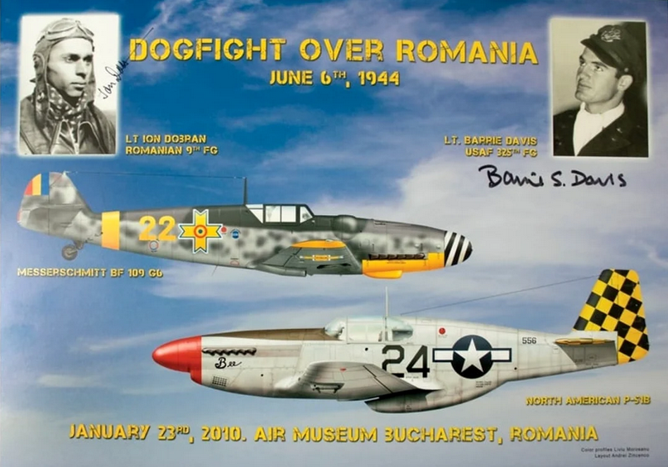

After keeping in touch over correspondence, Ion Dobran and Barrie Davis finally met each other in Bucharest, in 2010, and this is the poster of the public event. Davis will pass away in 2014, and Dobran, the last surviving Romanian ace for a long time, will join him in 2021. Godspeed, gentlemen!

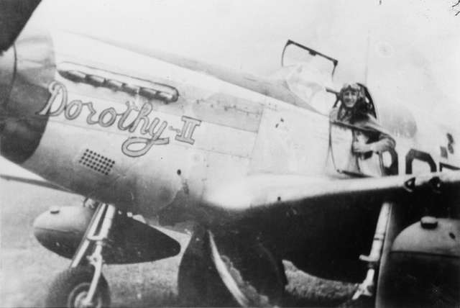
Lt. (later Captain) Robert Merill “Bob” Barkey in the cockpit of P-51B Mustang “Dorothy II”.

“Sweet Clara II”

Sometime after June 1944, 43-24857 was handed over to Lt. Russell Elliott, preserving her number “90” but changing her nickname (and writing on the nose) to “Sweet Clara II” on both sides of the nose (though it appears that the starboard inscription simply read “Sweet Clara”, without the Roman numeral ”II”). It kept flying with the 319th FS, 325th FG, until events of August 1944 entered her in history books yet again, and, again, it had something to do with Romania.

On 23 August 1944 King Michael of Romania staged a coup d’etat, turning arms against Nazi Germany, in an attempt to save the country from total destruction at the hands of the Red Army, that had finally broken through into Romania on 21 August 1944. The country, having effectively switched sides, was in turmoil – German forces, still present in large numbers, start a campaign against the freshly-Allied country, while Soviet troops are advancing at a breakneck pace towards Bucharest. Former prisoners of war are now liberated, and among them, there were more than 1,100 American POWs, all of them aviators shot down over Romania in the previous two years, during the Campaign Against Oil. Neither the Americans, nor the newly appointed democratic government of Romania, wanted the Soviets to take over the prisoners and the prison camps, let alone allow the Germans to recapture and deport them towards Germany, so an evacuation plan was hatched – with time being the key element. Bucharest’s two largest airports (Otopeni and Baneasa) were solidly in Germans hands, so evacuation operations, if they were to happen at all, had to be done from elsewhere. Popesti-Leordeni airfield was a small airfield south of Bucharest – this was the place where Operation Reunion eventually took place. James Emmett Thompson’s excellent book titled “Last flight of the Gustav” is a brilliant reference for this event. Capt. Constantin “Bazu” Cantacuzino discussed with Col. James Gunn (the most senior of USAAF’s POWs), and they decided they should fly together to San Giovanni, Cerignola, Italy (at the time, home of the 454th and 455th Bomb Groups), so that Gunn can propose Gen. Twining (commander of 15th Army Air Force) the evacuation plan from Romania. Cantacuzino stuffed Gunn inside the windowless and extremely cramped radio compartment of a Romanian Bf 109G-6 (Werk No 166133. Erla canopy, the newest airframe at the base, with only 7.5 flight hours), garishly adorned with old (pre-1942) American roundels painted on top of the Romanian Michael crosses, and sporting huge US flags painted on either side of the fuselage, and they flew, guided by a map Gunn drew on a piece of cardboard, safely arriving at San Giovanni in the evening of 27 August 1944. It was decided to return to Popesti-Leordeni in the following two days, so that to determine if the airfield was still in friendly hands, to commence the evacuations; Cantacuzino and Gunn flew in a Bf 109 whose DB605 engine was tuned for synthetic, low-octane petrol, and with the Americans using high-octance petrol, the Bf 109 would not be able to be refueled for the flight back; it was decided that “Bazu” will be loaned a Mustang – a plane he both feared and revered, and that he’d always wanted to fly – this time, he’d be at the controls of a Mustang! And what Mustang did “Bazu” get – none other than 43-24857 “Sweet Clara II”! The task of training Cantacuzino on the Mustang was given to Cpt. Walter J. Goehausen, who only taught him the basic controls of the Mustang, and the key speeds. Once in the air for a test flight, “Bazu” began performing some aerobatic maneuvers and landed the aeroplane "as if he had always flown it".

Cantacuzino was to be escorted by two other Mustangs who were ordered to shoot him down if anything suspicious happened. They were to take off on 29 August and once at Popesti-Leordeni, Cantacuzino was to land and assess the situation on the airfield. Afterwards, he was to signal the escorting P-51s by firing a double yellow-starred flare if the airfield was still in Romanian control, a double red flare if the airfield was not safe, and a single green flare if the escorting fighters should wait a further five minutes. If no signal came within 15 minutes, it was assumed that the area was not safe to land. All proceeded with no hitch, and the rest was, as they say, history! (during Operation Reunion more than 1,100 American airmen were successfully evacuated from Romania, to Italy, from Popesti-Leordeni airfield, on B-17 Flying Fortresses, in less than a single week!)
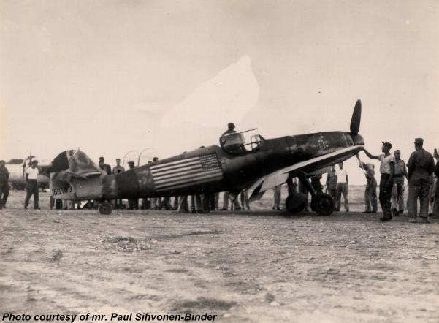

Constantin “Bazu” Cantacuzino arrives at San Giovanni, Italy, with Col. James Gunn stiffed in the Bf 109’s radio compartment, evening of 27 August 1944. The aircraft (Werk No 166133) belonged to Escadrila 48, Grupul 9 Vanatoare (48th Fighter Squadron, 9th Fighter Group, RRAF), but had all her national markings oversprayed, and large US flags and roundels painted over. It was a garishly looking aircraft with a bizarre paintwork!

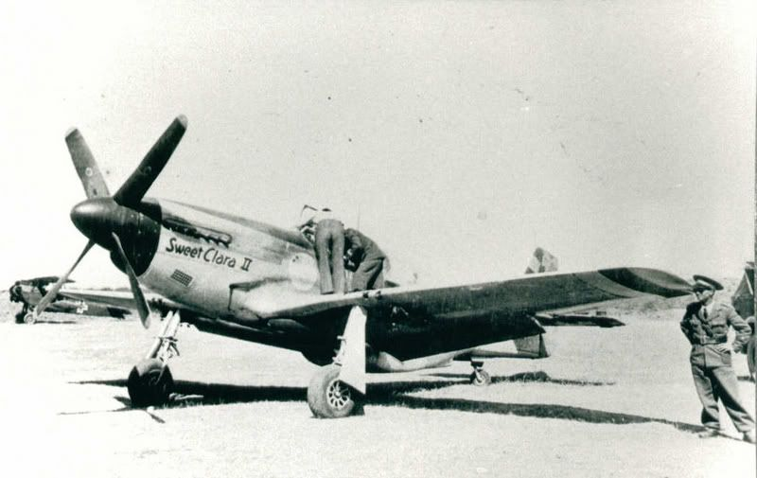
P-51B Mustang 43-24857 “Sweet Clara II” at Popesti-Leordeni airfield, south of Bucharest, Romania, August 29, 1944, being examined by Romanian ground personnel, after “Bazu” had landed her. A Romanian SET biplane can be seen in the background.

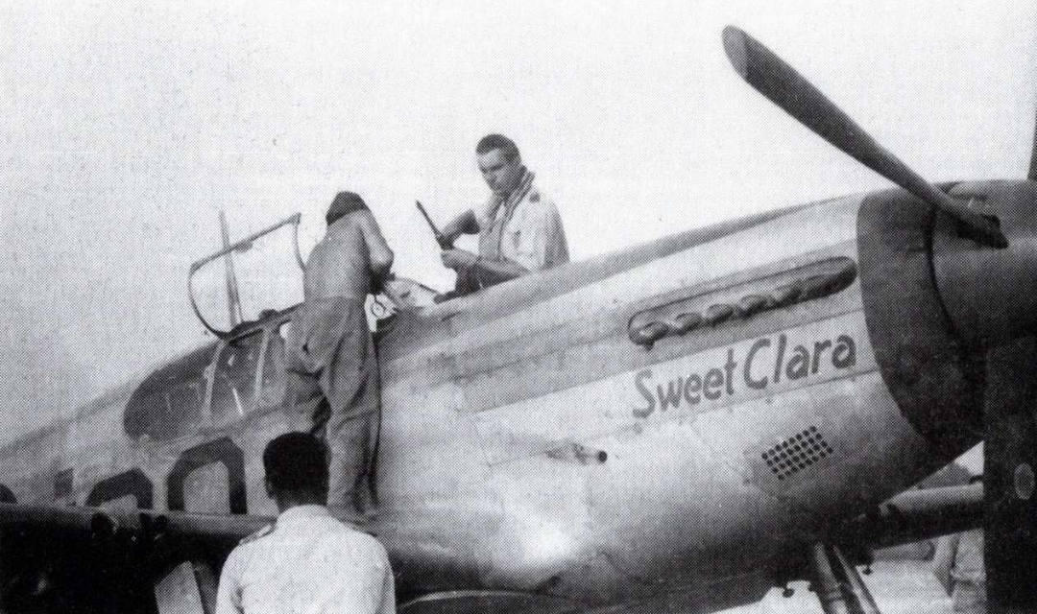
P-51B Mustang 43-24857 “Sweet Clara II” at Popesti-Leordeni airfield.

Operation Gunn: “Bazu” and the Mustangs

Operation Gunn aimed to prepare for the transfer to Italy of Allied prisoners of war, released from Romanian detention camps after 23 August, 1944, and took place between 27 and 30 August 1944.
– 2,500 American and British airmen were lost in the bombing of Romania between August 1, 1943 and August 23, 1944
– 2,290 were lost between April and August 1944
– 867 managed to return to base, mainly through Yugoslavia
– 1,500 – estimated number (USAAF) of prisoners in Romania on August 23, 1944
On August 23, 1944, there were 1,123 American prisoners in Romania (465 officers, 649 non-commissioned officers and 9 soldiers) and 39 British interned in Camp No. 13 Bucharest (the Normal School on Sfânta Ecaterina Street, the “Regina Elisabeta” Military Hospital) and in Camp No. 14 Timișul de Jos (the villas of the Brașov and Giurgiu city halls).

The operation was named after Lt. Col. James A. Gunn, the highest-ranking officer among the American prisoners, who played a prominent role in this USAAF action, in cooperation with the Romanian authorities. Lt. Col. James A. Gunn – 454th Bomb Group 304th Wing, born on 05/28/1912, enlisted 03/01/1939, he flew 32 missions before he was shot down on August 17, 1944 – he is taken prisoner after the B-24 “Bright Eyes” 41-28790 plane he was piloting was hit by anti-aircraft fire, the crew jumping out with parachutes, with one exception (MACR 7633). On August 20, 1944 he is transferred from Ploiești to the officers’ detention camp in Bucharest, the former Normal School on Sfânta Ecaterina Street (currently the Faculty of Orthodox Theology) where he takes command, being the officer with the highest rank among the prisoners.

On August 23 1944 - King Michael of Romania staged a coup d’etat, turning arms against Nazi Germany, in an attempt to save the country from total destruction at the hands of the Red Army, that had finally broken through into Romania on August 21 1944. The country, having effectively switched sides, was in turmoil – German forces, still present in large numbers, start a campaign against the freshly-Allied country, while Soviet troops are advancing at a breakneck pace towards Bucharest. Neither the Americans, nor the newly appointed democratic government of Romania, wanted the Soviets to take over the prisoners and the prison camps, let alone allow the Germans to deport them towards Germany, so an evacuation plan was hatched – with time being the key element. August 23 – 10:15 PM – Gunn finds out about the dramatic political events in Romania by listening to the radio hidden by prisoners planning an escape. August 24 – 9:40 AM a German bombardment begins and the prisoners are allowed to leave the camp and hide in trenches outside and are given several pistols and 4 automatic rifles. An attempt is made to find a radio transmitter or a means of communication through the Red Cross to organize the evacuation. August 26 – Gunn moves to Popești-Leordeni to fly out to Italy, onboard a IAR JRS-79 (Romanian license built Savoia-Marchetti SM-79), but the arrival of 50 American planes is announced. There are actually 230 bombers accompanied by fighters, which attack the Otopeni and Băneasa airfields, the two largest airfields around Bucharest, and both solidly in German hands. Romanians, now Allied, are also killed during the American raid. Around 13:00 – the JRS-79 takes off, but returns to Popești after 30 minutes, incurring a problem with one of the engines; after landing, Captain Constantin “Bâzu” Cantacuzino offers to transport Gunn in a Bf-109. The Minister of Air immediately agrees, deciding to take off the next morning. Gunn, while discussing with “Bâzu” Cantacuzino, the plan changes due to lax security, and the fear it’ll get leaked to the Germans.

On August 27 Gunn and “Bazu” fly together to San Giovanni, Cerignola, Italy (at the time, home of the 454th and 455th Bomb Groups), so that Gunn can propose Gen. Twining (commander of 15th Army Air Force) – and in fact, Gen. Born at Bari, since Twining was on leave, the evacuation plan from Romania. Cantacuzino stuffed Gunn inside the windowless and extremely cramped radio compartment of a Romanian Bf 109G-6 (Werk No/Works Number 166133. Erla canopy, the newest airframe at the base, with only 7.5 flight hours), garishly adorned with old (pre-1942) American roundels painted on top of the Romanian Michael crosses, and sporting huge US flags painted on both sides of the fuselage, and they flew, guided by a map Gunn drew on a piece of cardboard, safely arriving at San Giovanni, around 19:20 in the evening of August 27, 1944.
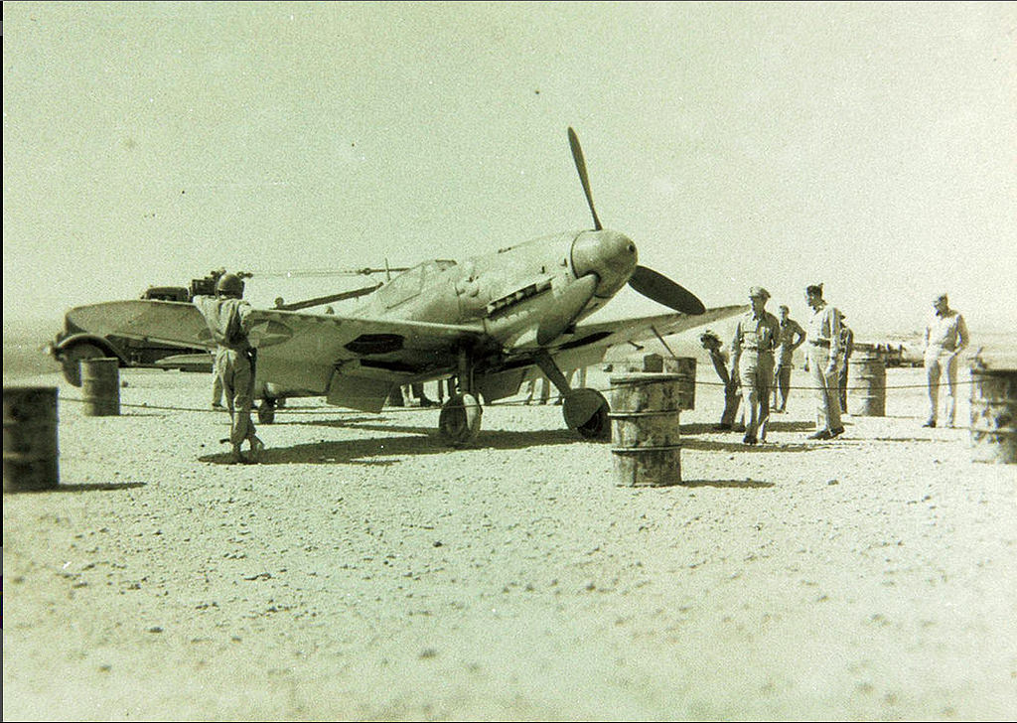
The Bf-109G-6 that Constantin “Bazu” Cantacuzino brought Col. Gunn in the radio compartment.
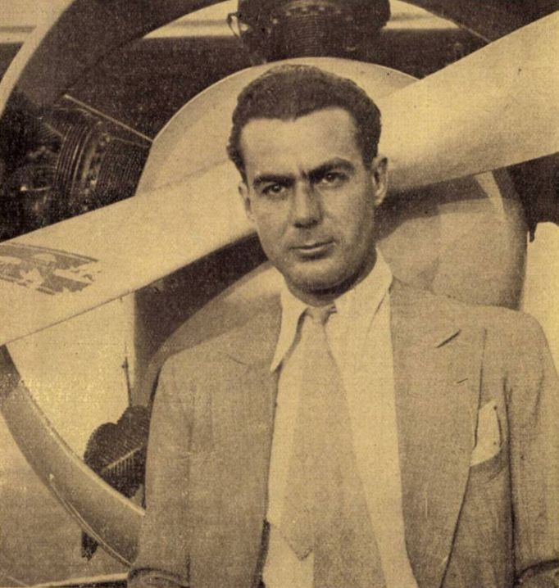
August 28 – the plan for Operation Gunn is developed with the following purpose: the transport of radio equipment and specialized personnel to establish a radio link between Popești- Leordeni-Bari. The flight to Popesti-Leordeni will comprise of of 4 P-51 Mustangs, one of which was piloted by Capt. Cantacuzino, to verify whether the airfield was still under Romanian control and was safe for landing. Another flight of 2 B-17s with OSS radio equipment and personnel, escorted by 32 P-51s would follow, if the Romanian airfield was secure.
Constantin “Bazu” Cantacuzino

First flight: P-51 pilot call signs:
– Capt. Constantin “Bazu” Cantacuzino: FUNNEL
– Lt. Col. William A. Daniel (CO of 31st FG): NORMAL
– Lt. Walter J. Goehausen: HOMEMADE
– Lt. Bohn CHEERUP
First flight aircraft specifics:
– Capt. Cantacuzino: P-51B-15-NA s/n 43-24857 “Sweet Clara II” ex “Dorothy II”, number 90, part of 319th FS, 325th FG (“Checkertail Clan”), 15 AF;
– Lt. Goehausen: P-51D-5-NA Mustang, 308th FS, 31st FG, 15 AF “HL-M” s/n 44-13494 "Miss Mimi II";
– Lt. Col. Daniel: P-51D-20-NA Mustang, 308th FS, 31st FG, 15 AF “HL-H” s/n 44-63273 “Tempus Fugit” (Latin for “Time Flies”);
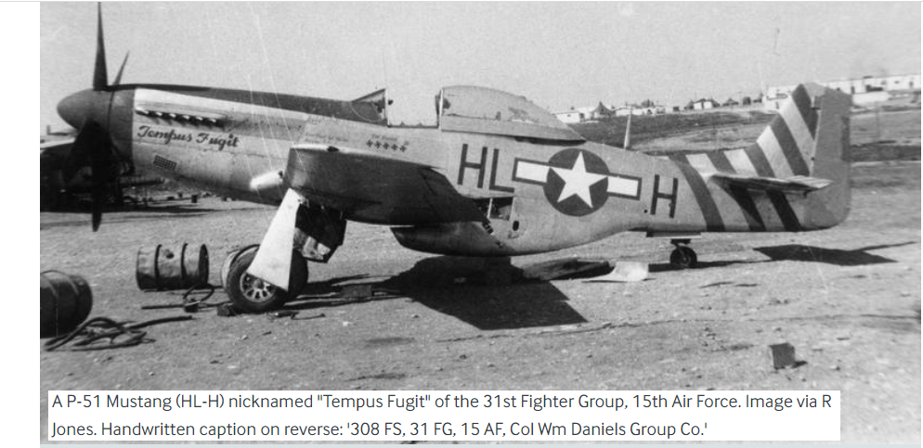
Lt. Col. Daniel: P-51D-20-NA Mustang, 308th FS, 31st FG, 15 AF “HL-H” s/n 44-63273 “Tempus Fugit” (Latin for “Time Flies”)
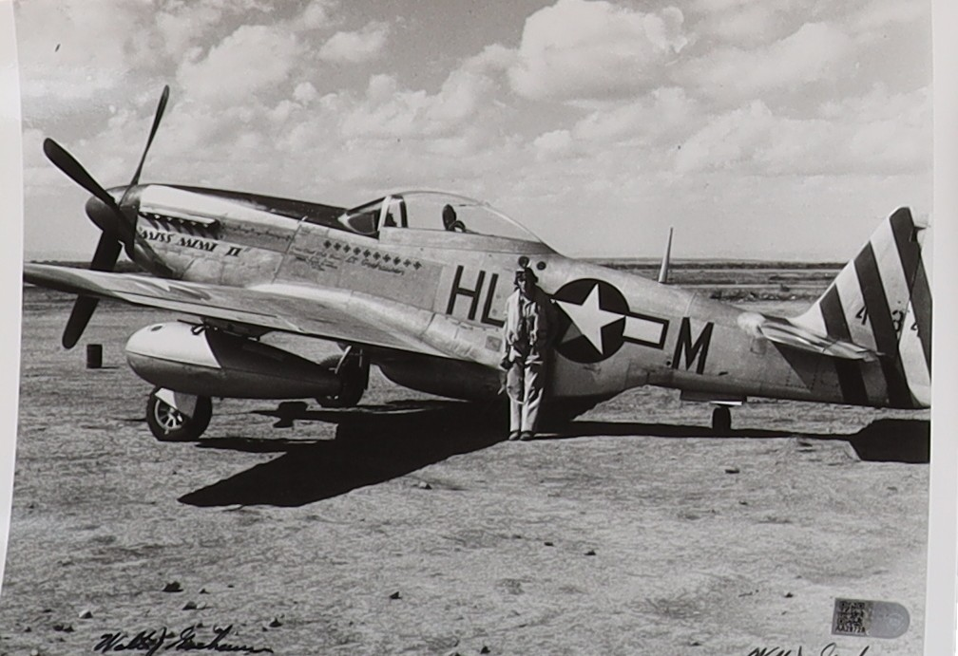
Lt. Goehausen: P-51D-5-NA Mustang, 308th FS, 31st FG, 15 AF “HL-M” s/n 44-13494 "Miss Mimi II"
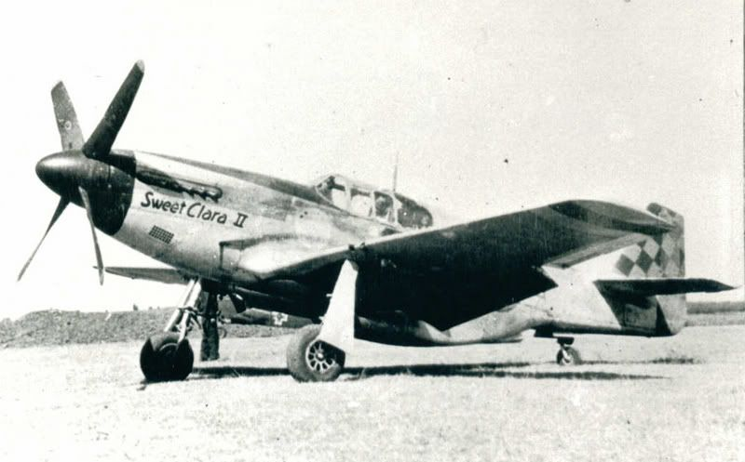
Capt. Cantacuzino: P-51B-15-NA s/n 43-24857 “Sweet Clara II” ex “Dorothy II”, number 90, part of 319th FS, 325th FG (“Checkertail Clan”), 15 AF
Lt. Goehausen gave “Bazu” a crash course in flying the Mustang; according to Goehausen, “Bazu” needed very little training, instantly converting the various speeds from miles per hour to the metric system (kilometers per hour) in his head, and, on his first test flight in the Mustang, he landed it as if “he had flown it all his life”. Also to note is that Lt. Bohn has not participated in that first flight, not being confirmed by some accounts, including that of Lt. Goehausen.
August 29 – takeoff at 8:00 from Bari towards Bucharest/Popesti-Leordeni. Cantacuzino will land at Popești-Leordeni and check the situation at the airfield. The following signals will be given:
– double yellow flare – Romanian-controlled airfield, the two B-17s and their escorts can take off, due course Romania: Popesti-Leordeni
– double red flare – American planes cannot land
– single green flare – wait 5 minutes
– no signal 15 minutes – no landing, assume airfield is not secure
After receiving the signal or after 15 minutes, the 2 other P-51s will fly to back Bari and will send the following radio signals:

– I have six zero six gallons of gasoline repeat I have six zero six which means Popești airfield is Romanian-controlled, and secure, the B-17s can take off
– Ceiling and visibility zero zero repeat zero zero means unsafe conditions for the mission

The pilots of the 2 P-51s escorting “Bazu” had strict orders to fire at “Bâzu”'s Mustang if anything suspicious appeared during the mission. According to Lt. Goehausen, “Bazu” flew in perfect formation to Popesti, only at one single point, did he break formation, distancing himself by an extra 100 yards or so, test firing his guns with a short burst; Goehausen immediately took position at “Bazu”’s six o’clock, but he immediately came back in formation after test-firing the guns. It’s not known by neither Goehausen nor Daniels why “Bazu” did that, since they’ve not seen him after that flight, they both assumed he wanted to make sure his guns were working, in case he got jumped by German fighters.
As for the B-17s waiting at Bari: starting at 10:00 they will be on alert, ready to take off within 30 minutes after receiving the signal:
– they will fly accompanied by two formations of 16 P 51s each: one en route and one to cover the Popești area– they will land after receiving the light signal from the ground and after the area has been checked by the escort planes
– the 2 B-17s will unload the radio equipment and personnel, take a maximum of 10 American prisoners each if there are any on the airfield and will take off as quickly as possible
“Bâzu” landed and sent the agreed light signal for the Romanian-controlled airfield, that triggered a series of events:
– The P-51s transmitted the radio signal which was received by a weather plane over Yugoslavia, which forwarded it to Bari
– The two B-17s landed at 15:30 with radio equipment and personnel, under the command of Col. George Kraiger (OSS), commander of rescue operations in the Balkans
– they were greeted by the Secretary of State of the Ministry of Economy Valeriu “Rică” Georgescu
– the two B-17s took off immediately after unloading their cargo
– the radio equipment was installed at the headquarters provided for this mission – Aleea Modrogan no. 5, building owned by Dumitru Bragadiru.
Start of Operation Reunion: August 30 1944
– Kraiger fails to establish radio contact with Bari
– 17:15 Capt. Cantacuzino takes off with P-51 “Sweet Clara II” again towards Bari, to send a letter with the information necessary for the Operation Reunion which begins the next day (the actual rescue of the American POWs).
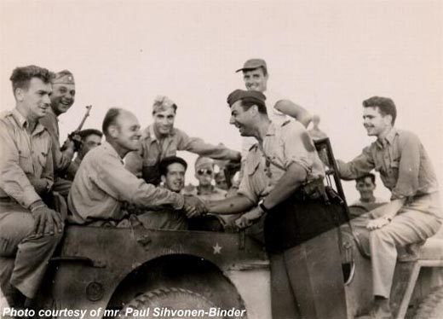

“Bazu” (right) and Col. Gunn (left)

End of story

43-24857 was eventually returned to the 325th FG, and it flew combat missions until February 1945, when Lt. Conrad J. Cook damaged her while landing at Lesina, Italy; apparently she was salvaged in September 1945, but her fate is unknown after that date. “Bazu” went on to fight against the Germans in Transylvania, Hungary, then Czechoslovakia, finishing the war with 54 confirmed victories, the top Romanian ace, and one of the overall best pilots of the War, he returned to Romania, now under a communist regime, and flew for the newly established TARS airlines (Transport Aerian Romano-Sovietic/Soviet-Romanian Airlines), but, facing persecution from the regime, for fighting against the Soviet Union, managed to flee, first to Milan, then on to Spain, where he became an aerobatic pilot. He died on 26 May 1958: there are two versions of how he died: one is after an unsuccessful surgery, and the other when his twin engine aircraft caught fire from the smoke candles attached to the wings and crashed, Bazu dying in hospital of his wounds. Col. Gunn stayed in the Air Force, yet only in 2014 was he awarded, posthumously, the Silver Star for Operation Reunion. Romania became a Soviet satellite after 1945, spending the next 45 years behind the Iron Curtain. Now, Romania is a proud NATO member. 325th Fighter Group is now 325th Operations Group, based at Tyndall AFB, and manages operations of F-35 Lightning IIs and F-22A Raptors.

References

[1] 483rd BG missions log https://15thaf.org/5th_BW/483rd_BG/PDFs/Missions.pdf
[2] 325th FG Honour Roll http://raf-112-squadron.org/325thfghonor_roll.html
[3] Grupul 9 Vanatoare http://www.worldwar2.ro/arr/g9vt.htm
[4] https://en.wikipedia.org/wiki/Operation_Reunion#CITEREFArm%C4%832020
[5] https://ziare.com/ion-dobran-barrie-davis/
[6] https://www.redescoperaistoria.ro/2014/08/21/barrie-davis-pilotul-american-care-a-fost-doborat-de-pilotul-roman-ion-dobran-in-timpul-celui-de-al-doilea-razboi-mondial-a-murit-la-varsta-de-90-de-ani/
[7] https://www.iar80flyagain.org/operatiunea-gunn/
[8] James E. Thompson, Last Flight of the Gustav, Amazon Publishing, 2016
[9] Robert J. Goebel, Mustang Ace, Memoirs of a P-51 Fighter Pilot, 2nd Edition, 1991
[10] https://www.worldwar2.ro/arr/?article=683

