Panzer III in Romanian Service: T-3 Tank

Brief Historical Context

Romania joined the Axis and started conducting military operations against the USSR at the onset of Operation Barbarossa, in June 1941, and, albeit fielding a numerically large force, the hardware used, especially when it came to armoured vehicles, was inferior to the German ally, and more alarmingly, inferior to the Soviet enemy. The Romanian tank force was an eclectic mix of French and Czech-built vehicles, reflecting the inter-war rearmament efforts conducted by the government in Buchararest (France – the traditional ally and Czechoslovakia – a conveneint partner for cheaper but still modern vehicles produced by companies like Skoda, Tatra and Praga). It contained, among other vehicles, the French Renault R35 (known as R-35 or T-35 in the Romanian Army) and Czechoslovak Skoda Lt. Vz. 35 (known as R-2 in the Romanian Army) light tanks – the main battle tanks of the 3rd and 4th Romanian Armies during operations in 1941 and most of 1942. Given that the Soviets were not well organized and their superior T-34s and KV-1s were poorly distributed, these light tanks performed well and were valiantly manned by their Romanian crews, hence the Romanian victories during 1941. Still, the battle for Odessa in the fall of 1941, inflicted massive casulaties and materiel losses in the Romanian Army; by the end of that year Romanians had almost no tanks left. This was sought to be remedied by Field Marshall Antonescu’s regime by means of approaching the German ally – a continuous need for hardware during the massive operations the German Army was conducting on the Eastern Front and the miser attitude from Berlin contributed to this effort proving largely fruitless until the end of 1942. This will change slightly with the large operations in and around Stalingrad in the fall of 1942, and with the Romanian Army given the key role to protect German 6th Army’s northern and southern flanks. The lack of available armor in the Romanian camp proved to be a red flag for the Germans and they finally decided to re-supply their ally, albeit in very small numbers.

Panzer III Delivery to the Romanian Army

On September 17, 1942 - the head of the German Military Mission in Romania, Major General Arthur Hauffe, announced the Romanian General Staff that, following the meeting between General Ilie Steflea and Col. Krammer, from 16 September, under the German Fuhrer’s special directive, the Romanian 1st Armored Division will receive, among other vehicles, 11 medium tanks Sd. Kfz. 141 Panzerkampfwagen III Ausfuhrung N equipped with the KwK 37 75mm/L24 short barrel gun (the last type iteration of the Panzer III before production completely switched to the Sturmgeschutz III), and 11 medium tanks Sd.Kfz. 161 Panzerkampfwagen IV Ausfuhrung G and G equipped with the KwK 40 L/43 long barrel gun. This materiel was supposed to be sent on September 21, 1942, together with the training Romanian detachment from Wunsdorf, Germany, directly to the Divisional headquarters on the front line, and was planned to be taken over by the Division at the railway station for immediate deployment. Instead, delivery was made on October 17, just a month before the start of the Soviet offensive at Stalingrad (Operation Uranus), and immediately 10 Panzer III tanks (redesignated by the Romanians as T-3, the T initial standing for “tanc” or tank in Romanian) were incorporated in the 1st Armoured Division, 1st Tank Regiment (under the command of Col. Emilian Popescu), that was operating in the Don Bend area part of the Don Front. It is possible that one T-3 was delivered to the 2nd Tank Regiment based at Tirgoviste, Romania, for training purposes, but returned to the frontline later on. These 11 frontline T-3 tanks, together with the 11 T-4s, albeit a minuscule force, proved to be a sizeable improvement to the existing Romanian force, comprised of well used and obsolete R-2 light tanks, and they immediately started operations.

T-3 Operational History

With the 22 T-3s and T-4s, the 1st Tank Regiment organized the 4th and 8th Companies, each with a platoon of five T-3s and five T-4s, plus the company commander's tank (one T-3 and one T-4). In the eve of the battle for the Don's Bend, the Romanian tank crews were not yet familliar with the new tanks, as the first exercise had taken place only three days before. As a consequence, besides massive losses in R-2 tanks, ten of the eleven T-3 tanks were lost in battle (only four were lost as result of enemy fire, the rest were lost due to a combination of mechanical failures and crew abandonment due to lack of fuel) and in early 1943 the 1st Armoured Division was withdrawn back to Romania. In a review dated 15 April 1943, the Romanian Army had a total of 149 tanks, a mix of R-2, R-35, T-3 and T-4, but only a small fraction were operational: 15 R-2’s , 54 R-35’s, a single T-3 and another single T-4. At the beginning of 1944 the single remaining T-3 tank was incorporated into the “Dimitrie Cantemir” Mixed Armoured Group that was sent to the front in February. The Group operated 55km south of Vinnitsa during the offensive conducted be the Red Army’s 2nd Ukrainan Front (led by Marshall Konev) that achieved a major breakthrough and overran Northern Bucovina. Unfortunately the sole survivor T-3 tank was lost during this operation. No other Panzer III tanks are known to have been transferred to the Romanian Army by the Germans, and with the type’s frontline withdrawl in 1943, the Romanian Army could not have captured any others during the operations in Transylvania and Hungary in late 1944-1945, after Romania had already switched to the Allied side.
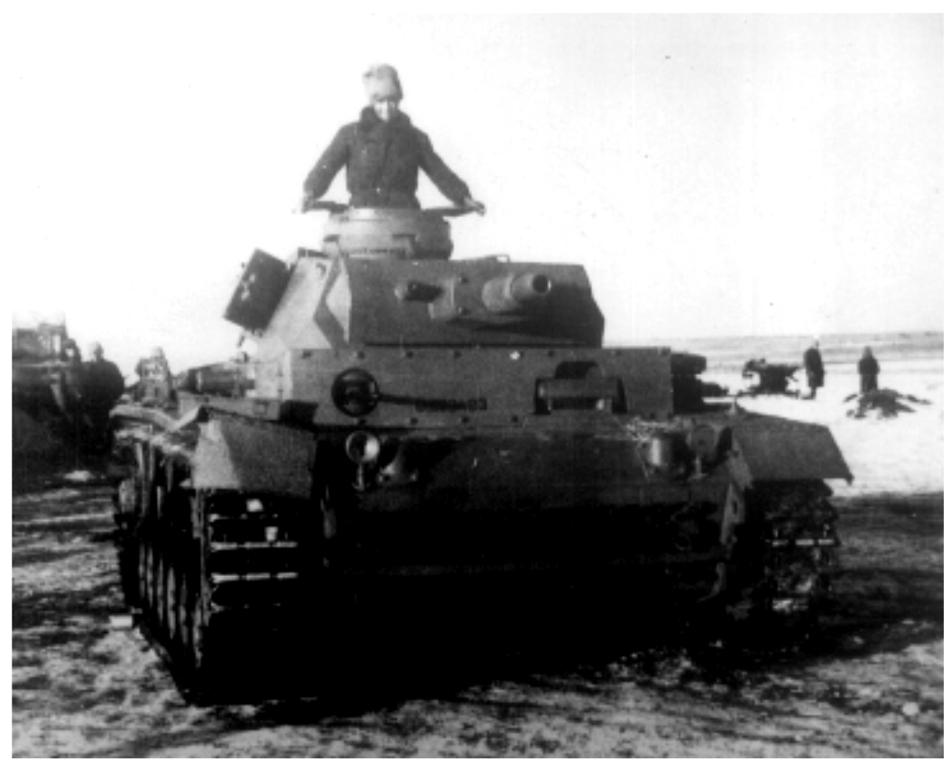
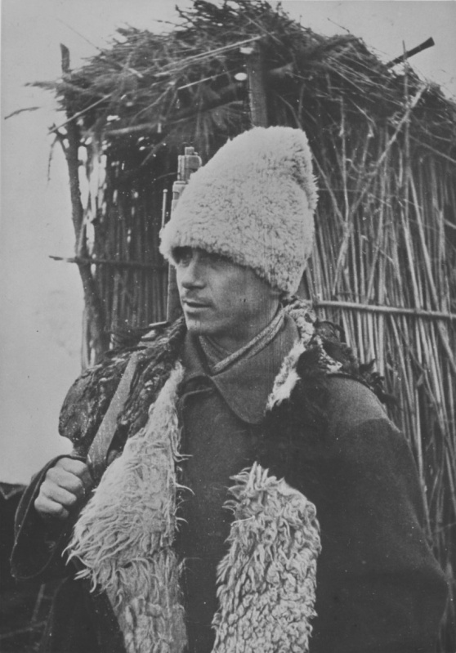
A Romanian Panzer III (T-3) on the Eastern Front during the winter of 1942-1943: the German Balkenkreuz is clearly visible on the side together with a black silhouette-only Michael’s Cross on the front of the side armour plate; military registration number in black on the front glacis, with no white plate painted behind it, reading U-039483; spare track links only on the lower front armour plate; note that the vehicle does not wear a whitewash and the overall colour appears to be too dark to be Field Grey (Feldgrau), suggesting either a darker shade of grey or olive/khaki green; note the tank commander’s fur hat - “cusma” (kushma) - a traditional Romanian hat made of sheepskin, very warm and soft and worn in cold winter weather (corner: Romanian infantryman at Stalingrad, wearing the same type of hat).

Painting and Markings of Romanian T-3 Tanks

As was the norm, vehicles to enter Romanian military service were painted overall olive green (khaki green) and the T-3s were painted this colour over the (most probable) German Field Grey (Feldgrau/Dunkelgrau) that they were received in. It is interesting to note that the German Balkenkreuz (the full version: black cross with white outlines, that German vehicles wore for identification) was kept (or re-painted after painting the vehicles were painted in olive/khaki green) and the Romanian Michael’s Cross was added as well as military registration plates; Michael’s Cross was either a white or black silhouette-only and the registration numbers were applied either on white painted plates or directly painted in black on the front glacis and, possibly, on the rear armour plate, just above the muffler. It is believed that during the 1942-1943 winter the vehicles had a water-based whitewash applied, as it was the case with the R-2 tanks, but unfortunately, there is no photographic evidence of this.
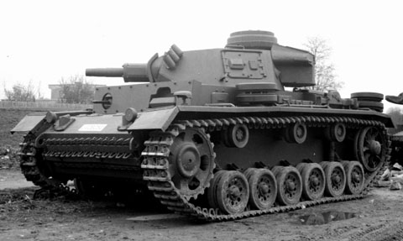

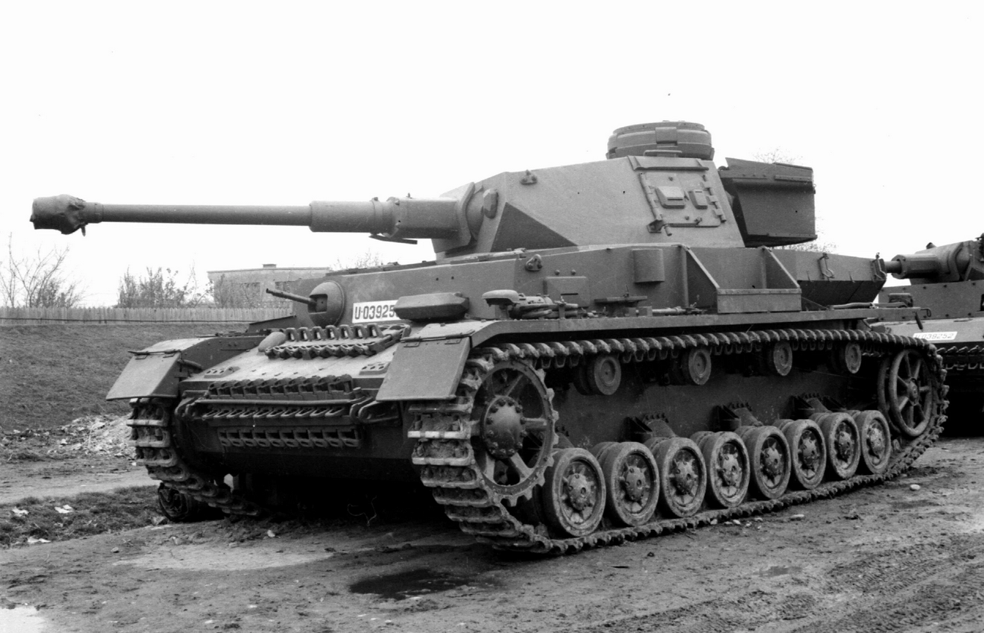
A Romanian Panzer III (T-3): this vehicle has military registration plates and no other national or divisional markings or emblems; it appears that the gun recoil sleeve is removed.

A Romanian Panzer IV Ausf. G (T-4) and a T-3 in the background, behind the T-4 – we can clearly see military number plates on both tanks, on the sloped front armour on the T-3 and on the front glacis on the T-4. The T-4’s registration number is U-039253 and the T-3’s number is U-039252; it seems that the T-3 recoil sleeve was removed. The tanks belong to the same unit, most probably the 1st Regiment of the 1st Armoured Division. Given the surrounding settings and T-3’s missing gun sleeve, it is almost certain that this tank is the same as the one in the photo above. It is believed that these tanks were survivors of the Battle of Stalingrad (the last of each type that survived the onslaught), and are pictured here after the battle.

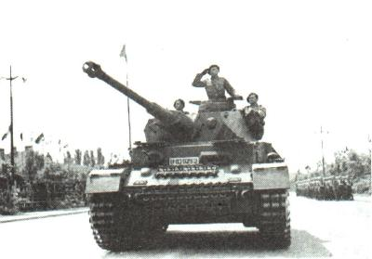
(left) Same T-4 with registration U-039253 at King’s Day Parade on May 10, 1943, in Bucharest, Romania; multiple sources mention this machine as the last surviving Romanian Panzer IV Ausf. G (T-4) from the Eastern Front in 1942-1943, before a new batch of Panzer IV’s were delivered by the Germans, later in 1943 (Ausf. H and J).

Romanian T-3 for modellers

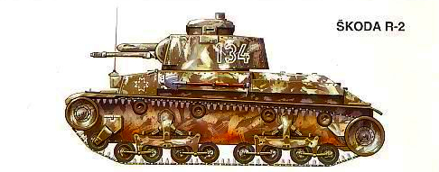

There are a number of 1/35, 1/48 and 1/72 scales model kits of Panzer III Ausf. N, but to our best knowledge, none of them contains markings to build a Romanian T-3. Since the tanks did not suffer any alterations while in Romanian service, it is easy to build a Romanian T-3 just by using the available kits and adding Romanian markings. Note, however, that the Romanian T-3 tanks did not have side skirts (“Schurtzen”), so we don’t recommend using them even if they are supplied in the kit, for historical accuracy. As for after-market decals, Star Decals have released a 1/35 scale decal sheet (product code 35-C 1163) for models of Romanian tanks during WW2. The decal sheet presents the modeller with two options for Romanian T-3’s: U-039483 in an overall Dunkelgelb or Gelbbraun and U-039493 in an overall Feldgrau or Dunkelgrau, both tanks belonging to the 1st Armoured Division on the Don Front, winter 1942-1943; their interpretation of the colours for the T-3 is probably wrong (definitely wrong about the Dunkelgelb/Gelbbraun scheme – German vehicles would be factory painted in Dunkelgelb only from February 1943; there is, however, an explanation for their choice in Dunkelgelb/Gelbbraun – it is thought that the Panzer III tanks destined for the Romanian Army on the Don Front were initially destined for North Africa, but the few photographs of the T-3 suggest a much darker colour instead, unless, of course, the ones in photographs had already been overpainted in olive/khaki by the Romanians); the set is also probably wrong about the dark grey scheme as well, since the Romanians would have painted the T-3 tanks olive/khaki green upon receiving them. U-039483 is present in their decal sheet, as seen in the photograph above and is shown with the correct application of the numbers, as black letter and numbers directly on the hull, with no white plate behind them; it is possible that these numbers, together with Michael’s Cross contour in black, were applied in a hurry, upon receiving the tanks, and the original German paint and markings (Balkenkreuz on the sides and rear) were kept; it is also possible that, later on, the Romanians would have painted the vehicles in olive/khaki green and would have applied the correct registration with black characters on white number plates. As for the winter whitewash, it is very probable that the Romanian vehicles would have worn it, and as it was the case with the R-2 tanks, it would have gradually dissolved and left patches of green paint visible, but unfortunately there is no photographic evidence of it on T-3 tanks, instead, for reference, we show an artist’s impression of an R-2 with patchy winter camouflage.

