Painting and markings of Romanian vehicles during World War 2

Romanian vehicles during World War 2 had a varied provenence, with a lot of them being purchased from abroad (France, Czechoslovakia, Germany), others being locally produced (either under licence or locally developed) and some being captured from the enemy (mostly from the Red Army). Their painting and marking schemes varied during their operational life, but despite the varied provenence, we can identify some degree of standardization, mostly applicable during the first part of Romania’s contribution to the war (1941-1943); during the latter stages of the conflagration (1943-1945) we notice a much higher degree of variability when it comes to painting and markings.

Painting was done in the factory for the locally produced vehicles and in the Ministry of Defense workshops for the vehicles purchased from abroad. The locally-produced vehicles were factory-painted in overall olive green; this shade of green is very close to the contemporary US Army olive green (if at all a slightly warmer shade of olive, with a richer contents of yellow in the black-yellow mix), and very different from the Russian or German green used on the period vehicles. A number of widely-available sources mention that Romanian vehicles that were purchased from other countries were kept in their original colours (e.g. Feldgrau/field grey for German vehicles before 1943 or French Army green for the vehicles purchased before the war) – whereas this may be true for a short period of time between their arrival to the Romanian units (some vehicles were delivered straight to their units on the front) and and the time of re-painting, it is not true in the general sense of the statement. Romanians re-painted these vehicles in olive green, this being a priority task together with other maintenance tasks. Numerous logistics reports mention the need to re-paint these vehicles as a priority task, altogether with repair works and general maintenance. Of interest is the case of German tanks delivered to the Romanian Army between late 1942 and 1944 – albeit a lot of them were delivered straight to the front, a high proportion of these vehicles were not delivered in working condition, consequently being passed on to the field workshops to be repaired, and, since the standards dictated re-painting after repairs, they were all re-painted in olive green before being transferred back to their operational units. The vehicles that were in working order and did not need repairs upon arrival from the Germans may have operated in their original German colours until they themselves needed repairs or were subject to re-deployment (if they survived the front).

There is no documented proof of the Romanians camouflaging their vehicles with splinter or mottled patterns (unlike the Royal Romanian Air Force that used very similar patterns to Luftwaffe, and used a high variety of splintler/mottling camouflage schemes); the only exception being winter whitewashes that were applied frequently to tanks and other vehicles on the Eastern Front. These water-based white washes were applied by hand, with a brush, and following different patterns: overall whitewashing (avoiding overpainting of national and divisional insignia), stripes or uniformly distributed splotches. The whitewash would degrade easily under the influence of elements and would leave a patchy aspect of the vehicle, with large areas of the olive base colour being exposed. Dust and mud would oftentimes contribute to a natural camouflage scheme, and in summer, tree branches would be used for camouflage, just like the Germans did too.

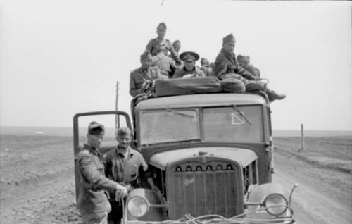
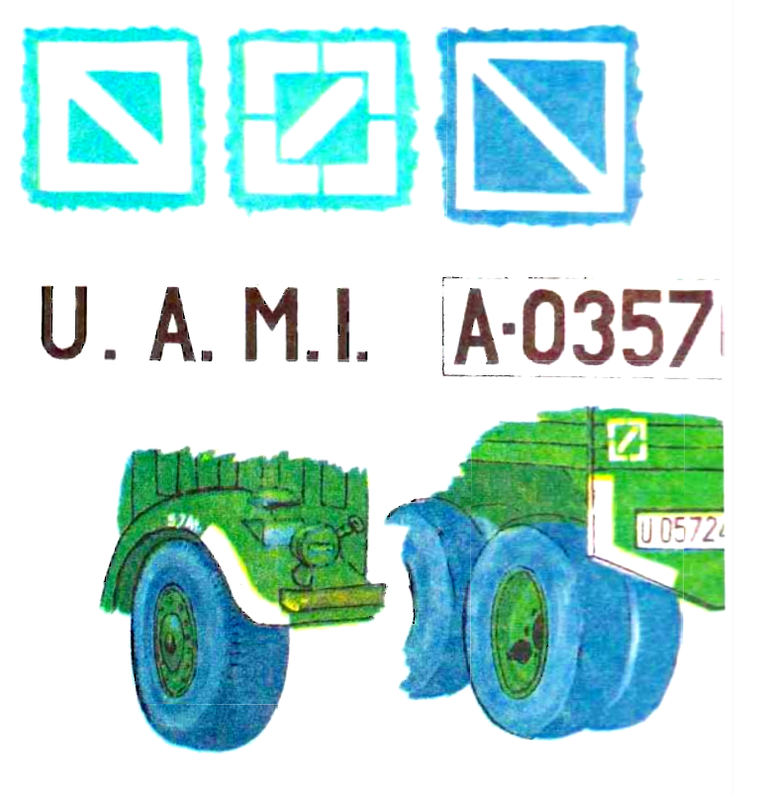

Examples of markings for Romanian military vehicles: white-edged fenders, nominal tire pressure on the fender, registration plates for different military branches (“U” for Army (“Uscat” in Romanian, meaning Land Forces), “A” for Air Force, “M” for Navy “Marina”, meaning Navy in Romanian) and “I” for the Logistics braches (“Inzestrare” meaning Logistics and Supply in Romanian)), white square with diagonal line (image from Modelism Magazine, No. 3-4, 1990, Editura Modelism, Romania).

In terms of markings, Romanian vehicles adhered to a set of regulations put forward by the Ministry of Defense (“Ministerul de Razboi” or the War Ministry), and compiled by the Logistics and Mechanization branch; these regulations were mandatory for all vehicles that were to be deployed in the field. They included painting the edges of fenders in white (just like the German vehicles), having the nominal tire pressure written in white on the fender or hull, right above the tire, carrying registration plates in front and at the rear, and having the nominal and maximum weights of the vehicle written in white on the driver’s door or on the left side of the hull. Registration plates were normally manufactured out of tin, painted white with black letters and numbers (character height of 8cm and 12mm thick) and were stamped and perforated by the Logistics and Mechanization branch representative with the front line unit. These registration plates started with a letter: “U” for Army, “A” for Air Force, “M” for Navy and “I” for the Logistics braches; they also carried a string of digits (4- or 6-digit strings) that would always start with “0” - an identifier for the military purpose of the vehicle. It is believed that the white registration plates, with black lettering, were used only inside the country, and black-only lettering registration numbers were used abroad. A pecularity of Romanian markings is represented by a white square with a diagonal line, mandatory to all wheeled vehicles and placed both in front (on the right hand side of the windshield, opposite to the driver’s position) and at the rear; shapes and dimensions varied, a few examples are shown in the profile colour, from Modelism Magazine, No. 3-4, 1990, Editura Modelism, Romania.
Romanian tank markings varied throughout the war and are not as standardized as the German markings, but followed, in principle, the German standards when it comes to turret numbers namely three-digit numbers (first digit representing the batallion, second the company and third the tank number in that company); other variations of turret numbers included Roman numerals (probably representing the company denominator e.g. Roman numeral “I” representing the 51st company of the T-38 Tank Batallion) accompanied by a digit reprsenting the tank number in that company; a lot of the tanks after 1942 don’t wear any numbers at all on the turret; some tanks carry military registration plates, standardized as we desribed above. But this doesn’t seem to have been the norm with all tanks.

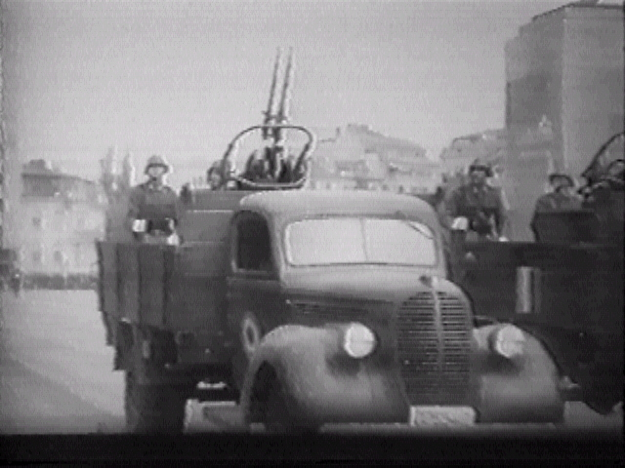
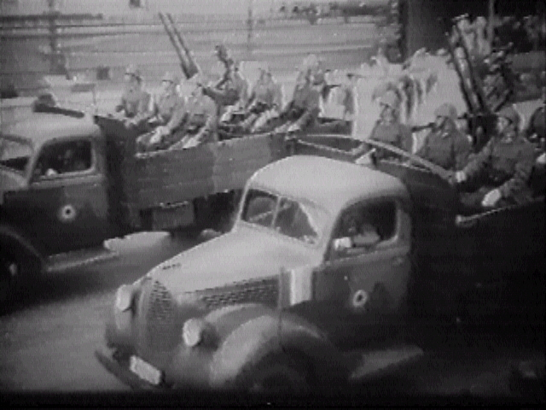

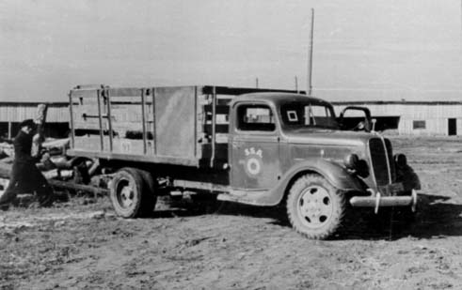
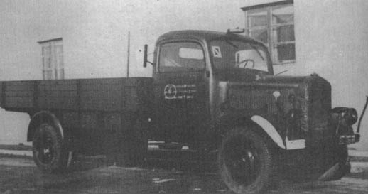

(1 to 3) Romanian Ford trucks (last: Royal Romanian Air Force); (4) Romanian Mercedes-Benz L3000S.

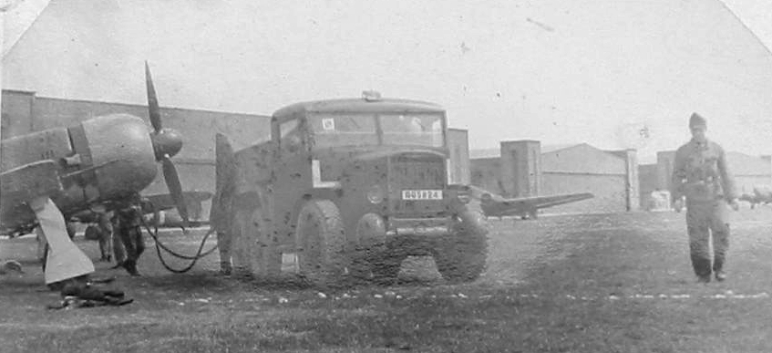
French Latill truck (fuel bowser) in service with the Royal Romanian Air Force.

