German Panzers in Romanian service 1942-1943

Romania joined the Axis and started conducting military operations against the USSR at the onset of Operation Barbarossa, in June 1941, and, albeit fielding a numerically large force, the hardware used, especially when it came to armoured vehicles, was inferior to the German ally, and more alarmingly, inferior to the Soviet enemy. The Romanian tank force was an eclectic mix of French and Czech-built vehicles, reflecting the inter-war rearmament efforts conducted by the government in Buchararest (France – the traditional ally and Czechoslovakia – a conveneint partner for cheaper but still modern vehicles produced by companies like Skoda, Tatra and Praga). It contained, among other vehicles, the French Renault R35 (known as R-35 or T-35 in the Romanian Army) and Czechoslovak Skoda Lt. Vz. 35 (known as R-2 in the Romanian Army) light tanks – the main battle tanks of the 3rd and 4th Romanian Armies during operations in 1941 and most of 1942. Given that the Soviets were not well organized and their superior T-34s and KV-1s were poorly distributed, these light tanks performed well and were valiantly manned by their Romanian crews, hence the Romanian victories during 1941. Still, the battle for Odessa in the fall of 1941, inflicted massive casulaties and materiel losses in the Romanian Army; by the end of that year Romanians had almost no tanks left. This was sought to be remedied by Field Marshall Antonescu’s regime by means of approaching the German ally – a continuous need for hardware during the massive operations the German Army was conducting on the Eastern Front and the miser attitude from Berlin contributed to this effort proving largely fruitless until the end of 1942. This will change slightly with the large operations in and around Stalingrad in the fall of 1942, and with the Romanian Army given the key role to protect German 6th Army’s northern and southern flanks. The lack of available armor in the Romanian camp proved to be a red flag for the Germans and they finally decided to re-supply their ally, albeit in very small numbers.

On September 17, 1942 - the head of the German Military Mission in Romania, Major General Arthur Hauffe, announced the Romanian General Staff that, following the meeting between General Ilie Steflea and Col. Krammer, from 16 September, under the German Fuhrer’s special directive, the Romanian 1st Armored Division will receive, among other vehicles, 11 medium tanks Sd. Kfz. 141 Panzerkampfwagen III Ausfuhrung (Ausf.) N equipped with the KwK 37 75mm/L24 short barrel gun (the last type iteration of the Panzer III before production completely switched to the Sturmgeschutz III), and 11 medium tanks Sd.Kfz. 161 Panzerkampfwagen IV Ausfuhrung G equipped with the KwK 40 L/48 long barrel gun. This materiel was supposed to be sent on September 21, 1942, together with the training Romanian detachment from Wunsdorf, Germany, directly to the Divisional headquarters on the front line, and was planned to be taken over by the Division at the railway station for immediate deployment. Instead, delivery was made on October 17, just a month before the start of the Soviet offensive at Stalingrad (Operation Uranus), and immediately 10 Panzer III tanks (redesignated by the Romanians as T-3, the T initial standing for “tanc” or “tank” in Romanian) and 10 Panzer IV tanks (redesignated by the Romanians as T-4) were incorporated in the 1st Armoured Division, 1st Tank Regiment (under the command of Col. Emilian Popescu), that was operating in the Don Bend area part of the Don Front. Before the delivery date, on October 9th, 1942, two new companies were created part of the 1st Tank Regiment, to hold and operate the two new tank types. One T-3 and one T-4 were each delivered to the 2nd Tank Regiment based at Tirgoviste, Romania, for training purposes. These 10 frontline T-3 tanks, together with the 10 T-4s, albeit a minuscule force, proved to be a sizeable improvement to the existing Romanian force, comprised of well used and obsolete R-2 light tanks, and they immediately started operations; in support of this statement were the extensive firing tests the Romanians had performed during late summer 1942, when there was a lull in operations, tests performed using a captured Soviet T-34 tank – results leading to the conclusion that the 37.2mm gun on the R-2 tank was completely ineffective against the Soviet tank’s sloped thick armor. Around the same time (October-November 1942) the 1st Regiment also received two captured T-26 tanks from the Soviets, that were repaired and repainted in the frontline workshops, together with 4 armoured cars, to be used for recconnaissance by he Romanian Recon Group (“Grupul de Cercetare”) - probably Sd. Kfz. 222 or 223.

On November 10, 1942, under the orders of the German Army Group B command, Army Corps XLVIII (XXXXVIII) was consititured, comprised of the Romanian 1st Armoured Division and the German 22nd Panzer Division, with command given to the German General Ferdinand Heim. The Romanian division was in a relatively good position in terms of tank numbers: 20 T-3 and T-4 heavy (by Romanian designation, in reality - medium) tanks and 109 R-2 light tanks, but in reality it was massively outnumbered and outgunned by the Soviets. At the start of the Soviet offensive codenamed Operation Uranus, on November 19th 1942, the Romanian armoured division was facing the superior (both in numbers and in armour) tanks of the Soviet 5th Tank Army; three days later, the Romanians had lost 50% of their tanks, although the T-3 and T-4 tanks were all still in service. On November 25th the division crossed the river Chir in order to regroup but the recoup time was short since the next day, on November 26th it was ordered to relieve the German 22nd Divsion from the Soviet encirclement, which proved to be a succesful endeavour against all odds. By the first week of December 1942 the 1st Division practically ceased to exist. Out of more than 100 tanks and 12,000 men it started the battle with, 2 tanks and 944 men were left by December 2nd 1942. Practically all the vehicle losses were unsalvageable, a high proportion of them being abandonments due to lack of fuel and break-downs, and most of them were captured by the Soviets. On December 4th 1942, the remnants of the division were hastily regrouped into a detachment-size unit, Colonel Nistor Detachement (“Detasamentul Colonel Nistor”), which recieved 4 more tanks and 700 men on short notice, along with some German light armored cars and halftracks (the armoured cars included German Sd.Kfz. 222 and 223, and, according to some sources, Italian Autoblinda AB41); this detachement was similar in purpose to the German Kampfgruppe units, but smaller since the Kampfgruppe units were of brigade size; it continued to fight on river Chir, keeping the Soviets from crossing the river, but eventually lost all its tanks in fights with 22nd Guards Motorized Brigade. By January 1943, the depleted Romanian units were ordered home, reaching Romania in March 1943. Out of all the tanks the division had, only 40 were salvaged for repairs - mostly those R-2's that were located behind the lines in repair shops or in Romania.

The Romanian armored force was largely destroyed in the 1942 fighting that culminated in the disastrous Stalingrad campaign - at the beginning of 1943, only three T-3 and T-4 tanks were left out of the initial 22 delivered by Germany in the fall of 1942 (two T-3 tanks, including the T-3 tank used for training, and a single T-4, the training one). In a report dated April 15th , 1943, it is said that the Romanian armed forces were equipped with a total of 149 tanks (vast majority R-2 light tanks), which is on its own a very small figure compared to the thousands of tanks in German or Soviet service at the same time. Another contemporary report tells us that the 1942-1943 winter campaign was responsible for the loss of 64% of the entire Romanian tank force. The requirements at the start of 1943, as evaluated by the Romanian strategists, were listing a minimum of 450 armoured vehicles and, given the superiority in firepower and armour protection of the Soviet T-34/76, which was already in widespread use with the Red Army, it was necessary that the Romanian vehicles be armed with 75mm high-velocity guns. This was far from the reality of a worn-out, poorly equipped force that was still operating the lightly armed and armoured R-2 tank as its mainstay type. Another pressing issue was the poor mechanical state in which the remaining tanks were at the time; it was estimated that 77% of the then current inventory needed at least light repairs, if not major overhauls. As a result, it was decided that a unit-level reorganization was need and new vehicles were to be purchased from abroad to complete the decimated units; it was also decided to incorporate at least one Anti-tank (AT) company (fielding the German Flak 36/37 88mm AT gun) and, ideally, one company of T-4 (Panzer IV) tanks. This will result in a mixed nature of Romanian tank units, a result drawn from necessity and lack of vehicles, but that proved to be tactically useful in the future. Among the newer types that Romania purchased from Germany were a handful of Panzer 38(t) tanks (redesignated T-38 by the Romanians).
With the 20 T-3s and T-4s, the 1st Tank Regiment organized the 4th and 8th Companies, each with a platoon of five T-3 and five T-4 respectively. In the eve of the battle for the Don's Bend, the Romanian tank crews were not yet familliar with the new tanks, as the first exercise had taken place only three days before. As a consequence, besides massive losses in R-2 tanks, nine of the ten T-3 tanks were lost in battle (only four were lost as a result of enemy fire, the rest were lost due to a combination of mechanical failures and crew abandonment due to lack of fuel) and all ten T-4 were lost. In early 1943 the 1st Armoured Division was withdrawn back to Romania. In a review dated 15 April 1943, the Romanian Army had a total of 149 tanks, a mix of R-2, R-35, T-3 and T-4, but only a small fraction were operational: 15 R-2’s , 54 R-35’s, a single T-3 and a single T-4. At the beginning of 1944 the two remaining T-3 tanks were incorporated into the “Dimitrie Cantemir” Mixed Armoured Group that was sent to the front in February. The Group operated 55km south of Vinnitsa during the offensive conducted be the Red Army’s 2nd Ukrainan Front (led by Marshall Konev) that achieved a major breakthrough and overran Northern Bucovina. Unfortunately both T-3 tanks were lost during this operation. No other Panzer III tanks are known to have been transferred to the Romanian Army by the Germans, and with the type’s frontline withdrawl in 1943, the Romanian Army could not have captured any others during the operations in Transylvania and Hungary in late 1944-1945, after Romania had already switched to the Allied side.
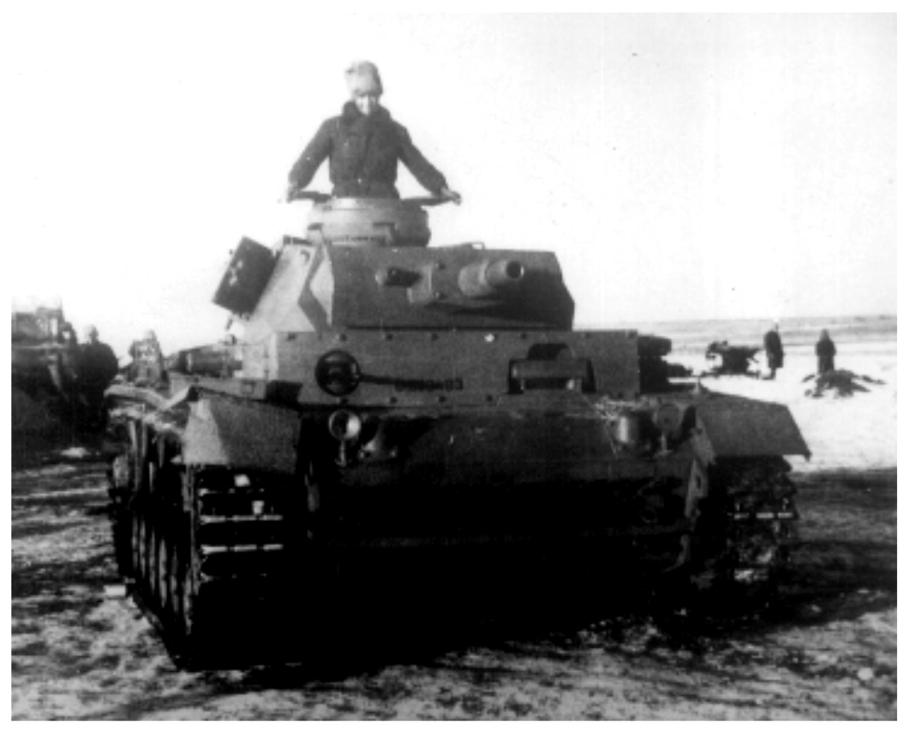
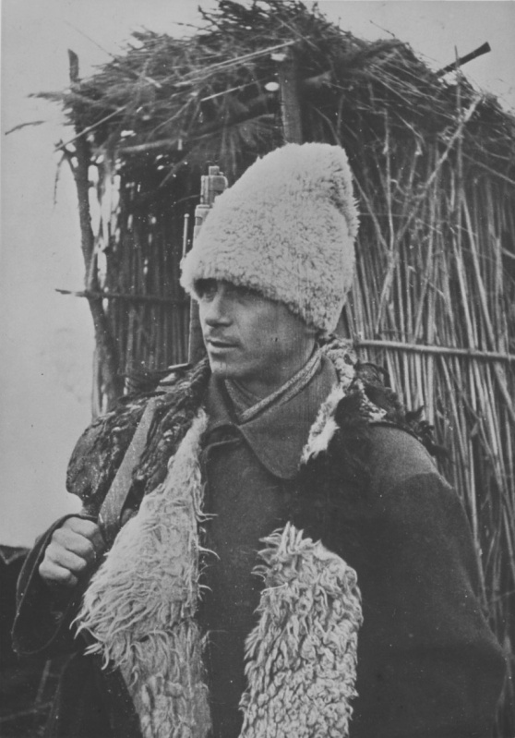
A Romanian Panzer III (T-3) on the Eastern Front during the winter of 1942-1943: the German Balkenkreuz is clearly visible on the side together with a black silhouette-only (stencil) of Michael’s Cross on the front of the side armour plate; military registration number in black on the front glacis, with no white plate painted behind it, reading U-039493 (the letter “U” denotes land forces, from the Romanian word “uscat”, meaning “land”); spare track links only on the lower front armour plate; note that the vehicle does not wear a whitewash (yet?) and the overall colour appears to be too dark to be Dunkelgelb, as suggested in some sources, but rather, possibly, Field Grey (Feldgrau), or a darker shade of grey, or olive/khaki green (Romanian tanks were painted as standard in olive/khaki green, but since these Panzer III’s were delivered straight to the front line, there might have been no time to paint them green); note the tank commander’s fur hat - “cusma” (kushma) - a traditional Romanian hat made of sheepskin, very warm and soft and worn in cold winter weather (corner: Romanian infantryman at Stalingrad, wearing the same type of hat).

In the last week of April, 1943, the Germans triggered the Birnbaum Program, aimed at a modicum of resupply towards their Romanian ally; that resulted in the transfer of a total of 164 vehicles, including 50 Panzer 38(t) Ausf. B from existing German units directly to the Romanian units that would use them in Russia (contrary to the Romanian logical request to be delivered in Romania for examination and training prior to frontline deployment). In the case of the Panzer 38(t) tanks, or T-38 tanks as they appear in Romanian documents, they were mostly old used tanks from the 22nd Panzer Division and its successor units, displaying heavy wear from the previous winter’s operations. They formed an independent tank battalion (“Batalionul Carelor de Lupta T-38”, T-38 Tank Batallion) but less than half of the tanks were functional (sources state only 17 out of the delivered 50 were in running order) and it took time for the Romanian mechanics to repair the remainder. The poor overall condition in which the tanks reached the Romanian beneficiary was not well received by the Romanians, moreover since these tanks had been deliveried straight to the Romanian units engaged in battle in the Kuban and Kerch, and were supposed to perform operational duties immediately, the crews had little training, a similar situation as with the Panzer III’s and IV’s delivered the previous autumn.

Leaving aside their poor condition that led to an actual Romanian-German row, the tanks were not much supperior to the R-2 and R-35 and were still vulnerable to all Soviet anti-tank guns and rifles, but they were badly needed by the Romanian units nonetheless. By June 1943 they were fully operational and integrated in the T-38 Tank Battalion of the 2nd Tank Regiment, with the 51st, 52nd and 53rd tank companies of fifteen T-38’s each. There was also a 54th tank company, allegedly formed much later in the winter of 1943/1944, with five T-38’s of the battalion's HQ; other sources mention the remainder of five T-38’s were kept in reserve.

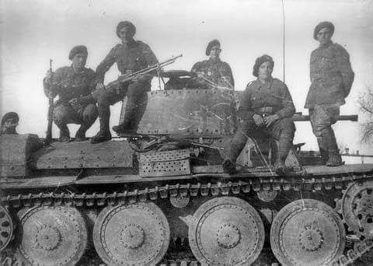
A Romanian Panzer 38(t) Ausf. E/F (T-38 in Romanian documents) and soldiers of the 1st Mountain Rifles Division (“Vanatori de Munte”) on the Eastern Front, during the battles in Kuban/Kerch Peninsula. Note the Romanian Michael’s Cross in white contour only on the turret, with no other unit markings. Also to note the heavy wear on the tank’s turret around the bolts. The light machine-gun is the licence-built Czechoslovak ZB vz 30 7.92mm (licence-produced in Britain as the Bren gun), fitted with a bipod and missing the magazine case. To note the (khaki) Chasseur Alpin-style plain berets of the Mountain Rifles. It appears that the soldier sat on the tank hull (second from right) is a junior officer since he’s the only one to wear the oval pine cluster on his beret (regular soldiers and NCO’s were wearing plain berets).

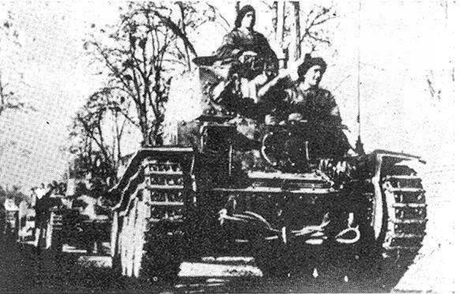
The T-38 Tank Batallion took part in the defensive battles of Kuban and Crimea, in support of the Cavalry Corps and the Mountain Division (“Vantori de Munte”, the equivalent to the German Gebirgsjaeger Division). Heavy fighting in Kuban, the Azov Sea and Kerch Peninsula, towards the Perekop Peninsula leading into Crimea saw heavy losses; starting from November 1943 the few ramaining T-38’s of the 51st and 52nd companies were evacuated to Romania. However, in April 1944 there were still ten T-38’s of the 53rd Tank Company in support of the 10th Infantry Division in Crimea. Due to vehicle losses in these operations, in August 1944 the 2nd Tank Regiment could hardly set up a company of nine T-38 tanks. They participated in the fights around Bucharest and at Ploiesti oil fields, and from March 1945 in the forcing of rivers Hron, Nitra, Vah, Morava in Czechoslovakia and then into Austria. By 22 April 1945 the regiment still possessed five badly worn T-38 tanks, then by May they had lost three, so the last two T-38’s were seized by the Soviets when hostilities ended, putting an end to the type’s presence in the Romanian Army.

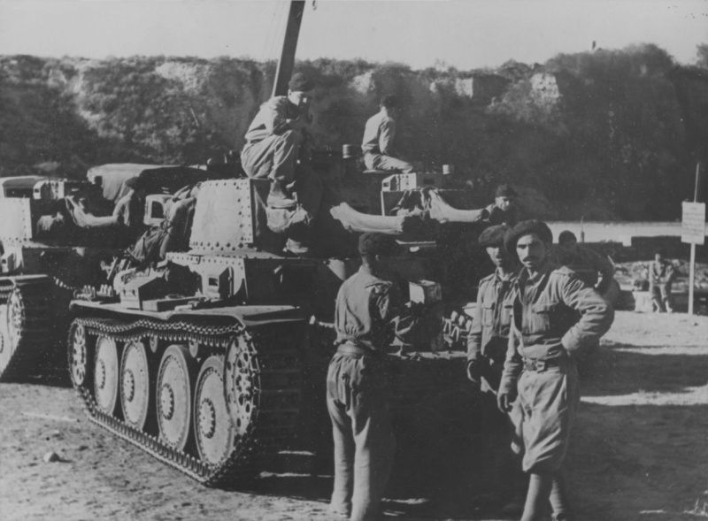

Romanian T-38’s on the Eastern Front, summer 1943. To note the Romanian tanker’s uniform: black beret, the same pattern as the Mountain Rifle Division (only black, with no insignia) and regular khakis, M1941 pattern. Also to note the canvas cover over the gun and spare track links (probably ad-hoc up-armour) on the driver’s side of the hull and at the rear; the grouser box is located towards the middle of the right side.

Painting and Markings of Romanian Panzers 1942-1943

As was the norm, vehicles to enter Romanian military service were painted overall olive green (khaki green) and the Romanian T-3 and T-4 tanks should have been painted this colour over the (most probable) German Field Grey (Feldgrau/Dunkelgrau) that they were received in. It is interesting to note that the German Balkenkreuz (the full version: black cross with white outlines, that German vehicles wore for identification) was kept (or re-painted after painting the vehicles were painted in olive/khaki green?) and the Romanian Michael’s Cross was added as well as military registration plates; Michael’s Cross was either a white or black silhouette-only (stencil) and the registration numbers were applied either on white painted plates (for vehicles inside Romania) or directly painted in black on the front glacis (for vehicles based abroad) and, possibly, on the rear armour plate, just above the muffler. It is believed that during the 1942-1943 winter the vehicles had a water-based whitewash applied, as it was the case with the R-2 tanks, but unfortunately, there is no photographic evidence of this for the T-3 and T-4 tanks.
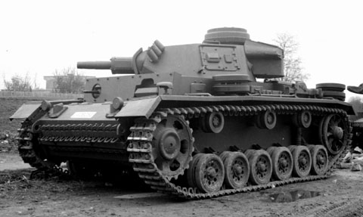

A Romanian Panzer III (T-3) at the Mechanized Troops Training Center (Centrul Instructie al Motomecanizarii) at Tirgoviste, Dimbovita County, spring 1943. This vehicle has military registration plates and no other national or divisional markings or emblems (registration number is U-039252); it appears that the gun recoil sleeve is removed. As for paining, it is most probably painted in overall olive/khaki green, as was standard with Romanian vehicles that were not delivered straight to the front line.
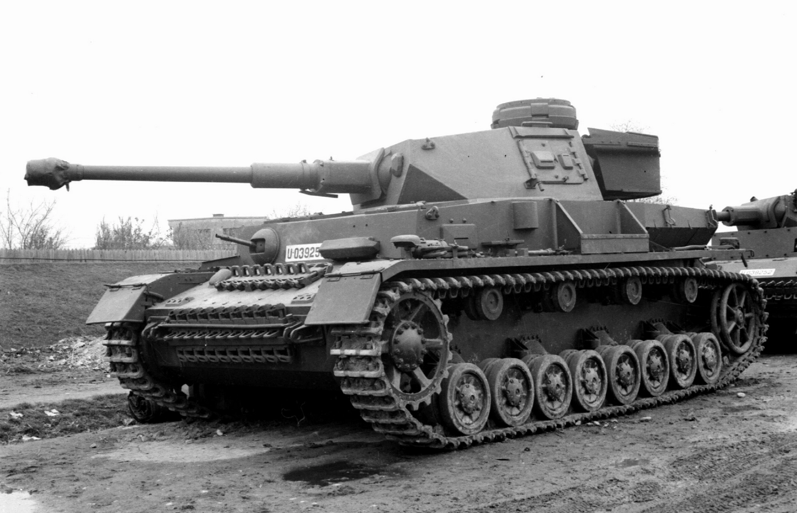

A Romanian Panzer IV Ausf. G (T-4) and a T-3 in the background, behind the T-4 – we can clearly see military number plates on both tanks, on the sloped front armour on the T-3 and on the front glacis on the T-4. The T-4’s registration number is U-039253 and the T-3’s number is U-039252; it seems that the T-3 recoil sleeve was removed. The tanks belong to the same unit, the 2st Regiment of the 1st Armoured Division. Given the surrounding settings and T-3’s missing gun sleeve. It is believed that these tanks survived the Battle of Stalingrad (one T-3 and one T-4 survived the onslaught, out of the original 22), since they have been left behind in Romania, at the Mechanized Troops Training Center (Centrul Instructie al Motomecanizarii) at Tirgoviste, Dimbovita County. White registration plates with black lettering, as seen on both tanks, were used only inside the country, another clue to the fact that the tanks are not pictured abroad.

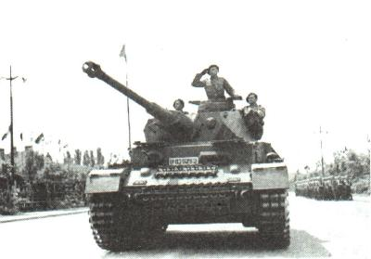

Same T-4 with registration U-039253 at King’s Day Parade on May 10, 1943, in Bucharest, Romania; multiple sources mention this machine as the last surviving Romanian Panzer IV Ausf. G (T-4) from the Eastern Front in 1942-1943, before a new batch of Panzer IV’s were delivered by the Germans, later in 1943 (Ausf. H and J).

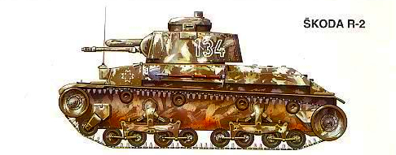
Romanian R-2 (Skoda Lt. Vz. 35/Panzer 35(t)) on the Eastern Front, winter 1942-1943; this colour profile shows the whitewash applied to some Romanian vehicles during winter operations, and its degradation with time (image from Charles K. Francev Vladimir Kliment, Skoda Lt. Vz. 35, MBI Publishing 1995, ISBN8090126383).

There are a large number of 1/35, 1/48 and 1/72 scales model kits of Panzer III Ausf. N and Panzer IV Ausf. G, but to our best knowledge, none of them contains markings to build a Romanian T-3 nor a T-4. Since the tanks did not suffer any alterations while in Romanian service, it is easy to build a Romanian T-3 or T-4 just by using the available kits and adding Romanian markings. Note, however, that the Romanian T-3 tanks did not have side skirts (“Schurtzen”), so we don’t recommend using them even if they are supplied in the kit, for historical accuracy. As for after-market decals, Star Decals have released a 1/35 scale decal sheet (product code 35-C 1163) for models of Romanian tanks during WW2. The decal sheet presents the modeller with two options for Romanian T-3’s: U-039483 in an overall Dunkelgelb or Gelbbraun and U-039493 in an overall Feldgrau or Dunkelgrau, both tanks belonging to the 1st Armoured Division on the Don Front, winter 1942-1943; their interpretation of the colours for the T-3 is probably wrong (definitely wrong about the Dunkelgelb/Gelbbraun scheme – German vehicles would be factory painted in Dunkelgelb only from February 1943; there is, however, an explanation for their choice in Dunkelgelb/Gelbbraun – some sources suggest that the Panzer III tanks destined for the Romanian Army on the Don Front were initially slated for Rommel in North Africa, but the few photographs of the T-3 suggest a darker colour instead, unless, of course, the ones in photographs had already been overpainted in olive/khaki green by the Romanians); the set is also probably wrong about the dark grey scheme as well, since the Romanians would have painted the T-3 tanks olive/khaki green upon receiving them – but, given that these tanks were immediately pressed in action, there may have been little time, if any, for painting them green! U-039493 is present in their decal sheet, as seen in the photograph above and is shown with the correct application of the numbers, as black letter “U” and six-digit number directly on the hull, with no white plate behind them; it is possible that these numbers, together with Michael’s Cross contour in black, were applied in a hurry, upon receiving the tanks, and the original German paint and markings (Balkenkreuz on the sides and rear) were kept; it is also possible that, later on, the Romanians would have painted the vehicles in olive/khaki green and would have applied the correct registration with black characters on white number plates for vehicles inside Romania, for the two surviving T-3s that returned to Romania in March 1943. As for the winter whitewash, it is very probable that the Romanian vehicles would have worn it, and as it was the case with the R-2 tanks, it would have gradually dissolved and left patches of green paint visible, but unfortunately there is no photographic evidence of it on T-3 tanks, instead, for reference, we show an artist’s impression of an R-2 with patchy winter camouflage.

The Romanian T-38 tanks were painted in overall olive/khaki green, like all other Romanian vehicles of the period. In terms of national markings, they wore Michael’s Cross in white stencils (contour only) on the front sides of the hull, with some vehicles wearing it on the turret sides, and other vehicles wearing it on both hull and turret sides. Vehicles of the 51st company wore large Roman “I” numerals and smaller tank numbers (both possibly in red), on the turret sides. No military registration plates or numbers are seen in any of the available photographs. Standardization of Romanian markings is not present after 1942-1943, so it is difficult to extrapolate the markings for other T-38 units based only on the existing photographs. We provide a set of colour profiles, courtesy of http://www.wardrawings.be/ representing the 4th vehicle of the 51st company of the T-38 Tank Batallion (Batalionul Carelor de Lupta T-38), from summer 1943. In 1943 full colour Michael Cross could still be applied on the engine deck, provided that its main reason was for air recognition, and Axis air superiority was still more or less present on the southern flank of the Eastern Front, the main operational area of the Romanian T-38 tank units.

Some vehicles might have preserved the German paint and turret numbers: at least one photograph shows a Romanian T-38 with what appears to be German number and an overpainted Balkenkreuz on the turret, with a light olive Michael Cross painted over the white outlines of the Balkenkreuz. It is possible that the few vehicles that were battle-ready upon arrival from the Germans were not painted green and were used as they came, in Feldgrau/Dunkelgrau and with very minor modifications from the Romanian crews (like overpainting the German Balkenkreuz with whatever paint they had available at the unit).
Romanian T-38 tank and its crew in the Kuban, on the way to the front, spring-summer 1943. The tow cable is stowed on the front armour plate, with spare track links on both sides of the front.
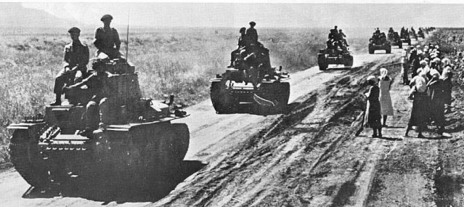

A Romanian T-38 tank column near Poltava, central Ukraine, in the summer of 1943, it appears this is the full complement of a company.

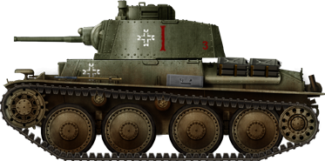

Colour profile of a T-38, in overall olive/khaki green, belonging to the 51st company (3rd tank).

A note on the type of Panzer 38(t) that was transferred to the Romanian Army: the tanks came from the 22nd Panzer Division (known as the last Panzer Division to receive the Panzer 38(t) as main battle tank, and also known as the shortest lived Panzer Division) and albeit Romanian records don’t mention it explicitly, since the German division had Ausf. E/F types in its inventory in March 1943, we believe the Romanian T-38’s were of the same type. We also know that the 22nd Panzer Division was heavily involved in battles in and around Crimea until its disbandonment in March 1943 so it is only fair to assume the level of mechanical fatigue their tanks were at and how much work the Romanian mechanics had laid in front of them when they had had received the German tanks. Some sources mention the Romanian T-38 tanks were in fact very old Panzer 38(t) Ausf. A/B/C up-armoured to E/F standards, process that was not finished when the Romanians received them, and that continued in Romanian workshops.

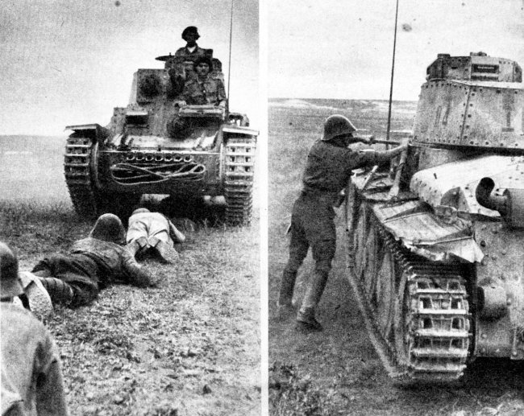

Romanian T-38 tanks in training. (left) to note the towing cable stowed on top of spare track links on the front hull; (right) to note the markings of the 4th tank of the 51st Company, T-38 Tank Batallion. Training was very limited for the Romanian crews since the Germans delivered the 50 Panzer 38(t) tanks straight to the frontline batallion and a large proportion of these tanks was necessitated lengthy repairs.

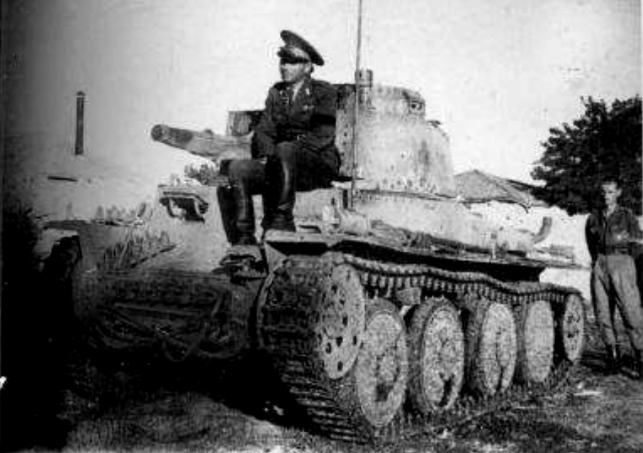

Romanian T-38 from an unknown unit.

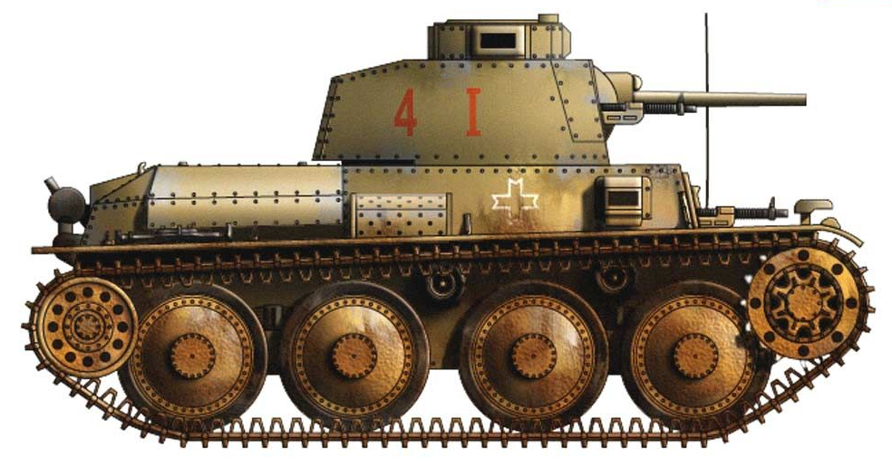

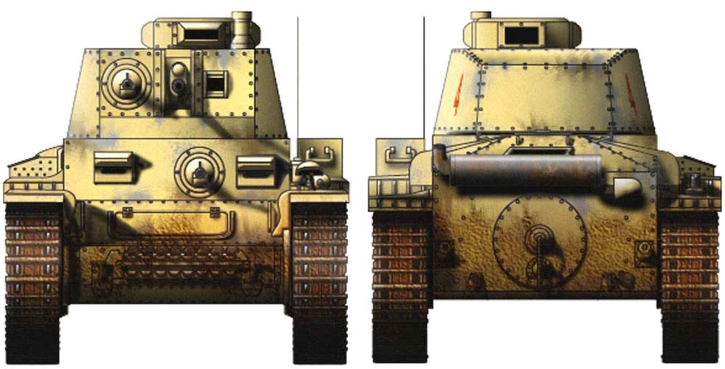
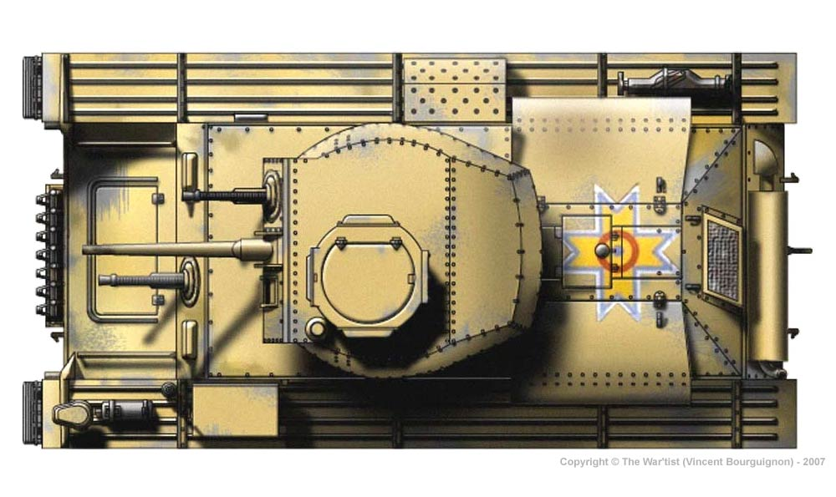

Color profile of a Romanian T-38, possibly belonging to the 51st company, T-38 Tank Batallion, Kuban, summer 1943. The tank was painted overall khaki/olive (on top of the German Feldgrau in which the tanks were received from the Germans), with Michael Crosses stencilled in white on hull sides, and possibly painted in full colour on the engine deck; the unit markings were applied on the turret in red and consisted of the large Roman numeral “I” denoting the unit the tank belonged to, and a smaller number, probably denoting the tank’s number in the unit. The position of the grouser box on the right sponson is seen in a number of photographs, with the larger stowage bins specific to the German Panzer 38(t)’s not present. Colour profile by Vincent Bourguignon and courtesy of http://www.wardrawings.be

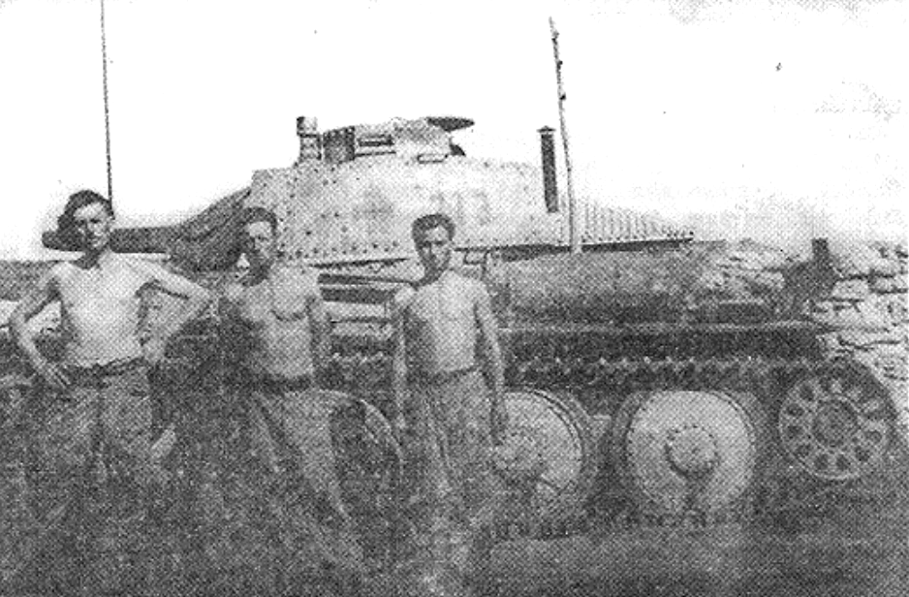

Romanian T-38 summer 1943: it is interesting to note that Michael’s Cross is painted on the turret over what appears to have been a German Balkenkreuz (Michael Cross in light olive, filled with black); the turret number ”213” adheres to German standards, painted in yellow; this tank appears to be used straight as it was received from the Germans, probably painted overall Feldgrau/Dunkelgrau.

