T-72 in Romanian Service

Romania (the Socialist Republic of Romania) ordered 30 T-72M tanks from Soviet Union in 1977, and in 1978 these tanks were delivered to the 1st Tank Regiment “Vlad Tepes” based at Tirgoviste, Dimbovita County. These tanks were not brand new, but rather, accumulated various degrees of mileage and both unused ammunition and empty shell cases were found inside them. It is assumed that these tanks, although manufactured in 1978, the same year they were delivered, were sent from the Russian testing grounds rather than straight from the factory; their spare parts sets being in a used state as well. Immediately upon arrival in Romania, these tanks were integrated in a separate unit, of battalion-size, and accomodated in a purpose-built compund, fitted with air conditioning systems that allowed engine running in closed quarters. This is a consequence of the thick shroud of secrecy that the Romanian military command wanted to cover these new machines with, a common attitude directed from the highest Communist echelons when it came to any new weapons systems that were to be integrated in the Romanian Army or Air Force (e.g. the same secrecy surrounded the operational integration of MiG-23 and MiG-29 jet fighters). The fact that Romania had operational T-72 tanks was not known by the majority of Romanian tankers, with some exceptions – those that had security clearance, obtained from the Securitate (the Romanian political police), and showing both dedication towards the Romanian Communist Party (Partidul Comunist Roman, PCR) and were deployed with higher-grade units, operating higher-grade weapons, like the new TR-85 tank; the majority of Romanian tankers were still using the Soviet T-55A and most of them had no security clearance though. The T-72M was kept in very high regard by the Romanian crews operating it, and much preferred to the other tanks in service, like the TR-77 or even the T-55. Training with the new tanks was done remotely and separately from other tank units and the utmost care was taken when transporting the T-72s, thoroughly covering them while on tractor-trailers.

The shroud of secrecy surrounding the T-72 in operational use proved to be short of a disaster, as this episode from the Romanian Revolution from December, 1989 shows it: the events of the 1989 Revolution escalated rapidly and by 21-22 December the revolt reached Bucharest, with fears that the country was being invaded by foreign powers (including the so-called “terrorists”, thought to be foreign mercenaries sent by the Soviet Union to crush the revolt); the Romanian Army was called up for defense duties and was deployed to major cities across the contry; the 1st Tank Regiment “Vlad Tepes”, together with its T-72 tanks, was deployed from Tirgoviste to Bucharest, with the peculiar situation that the T-72s did not have any main gun ammunition on board. A number of other tank units were deployed on the streets of Bucharest, including the 68th Tank Regiment from Caracal, Olt County, equipped with T-55 and TR-85 tanks, and unlike the T-72s, these tanks were loaded with AP and HE ammunition. The Caracal Regiment, upon arrival downtown Bucharset, met the Tirgoviste T-72 tanks and, due to the crews not recognizing the tank and the communication channels being overloaded with false information and conter-information, they assumed it to be a foreign tank; other Romanian tank units were told the T-72s were captured by the so-called “terrorists”, the overall result being that the T-72s were identified as hostile and immediately engaged. One T-72 was badly damaged when four AP and HE shells were shot at it from TR-85s from the Caracal Regiment, fortunately the crew managing to bail out and escape with their lives. Not being able to return fire due to lack of ammunition, the T-72 was forced to flee and that’s when the shells hit the back of the tank, penetrating the engine compartment; reports say that the on-board fire extingisher worked well and there was no fire, the crew managing to escape. This incident marks the first tank-on-tank battle of the Romanian Army since the Second World War, and to the day, the last such battle, a tragic friendly fire incident that could have resulted in fatalities. The tank was later on repaired and re-entered service.

The Romanian communist government asked the Soviet Union for a license to build the T-72 locally, but were rejected, and as a consequence, they decided to reverse-engineer the T-72 tank. As a result, the TR-125 tank was developed as a derived copy of the T-72, developed from 1984 to 1991. The turret and the loading mechanism were developed by ICSITEM Research Institute in Bucharest, while the hull was designed and developed by ACSIT–P 124 from the F.M.G.S. (FMGS stands for "Fabrica de Mașini Grele Speciale" – Specialized Heavy Machinery Plant), a division of the "23 August" Heavy Machinery Plant (now known as FAUR). Between five and ten prototypes were made between 1987 and 1988 and tested until 1991. An order from the Romanian Army did not come however, and the project was later cancelled. The prototypes are currently mothballed, awaiting dismantling.
The initial 30 T-72M were never modernized, and since the new military doctrine from the mid-90s onwards, required Romania to align its weapons systems to NATO standards, the T-72 tanks became obsolete. They were decommissioned in early 2005, their subsequent fate being uncertain (it is alleged some were sold off, but there is no actual proof to this).

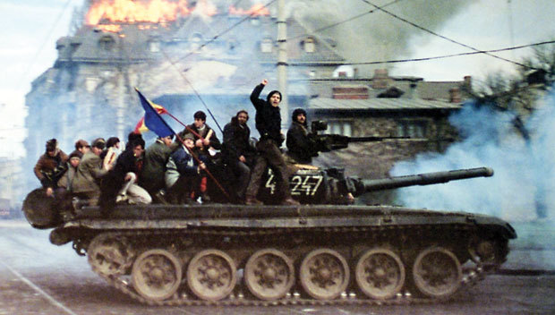

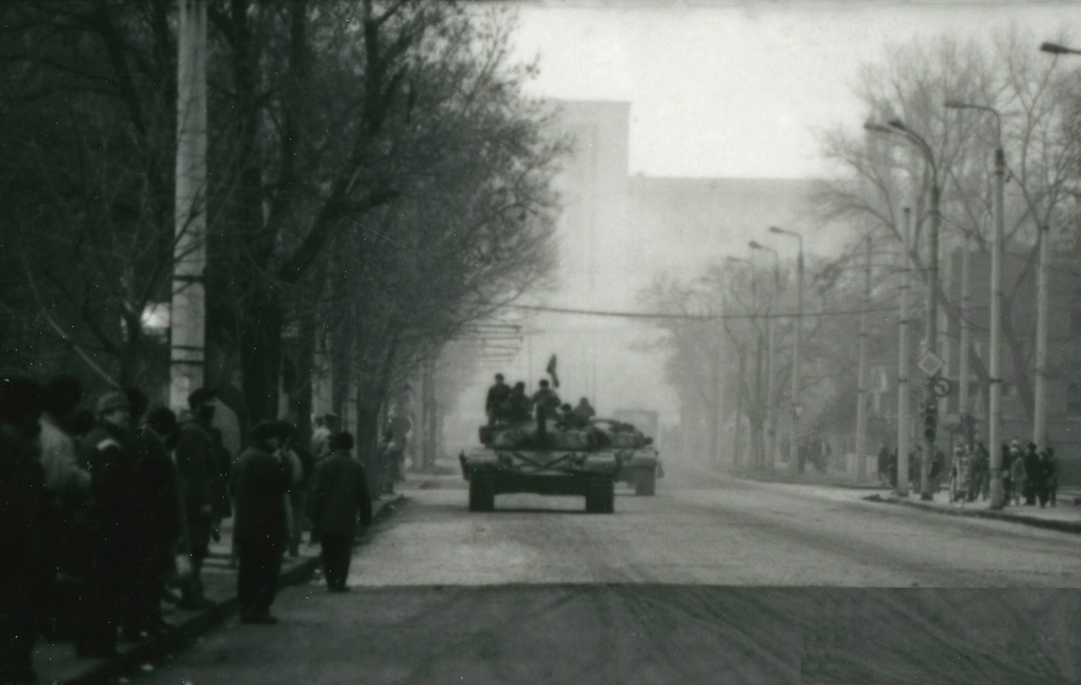

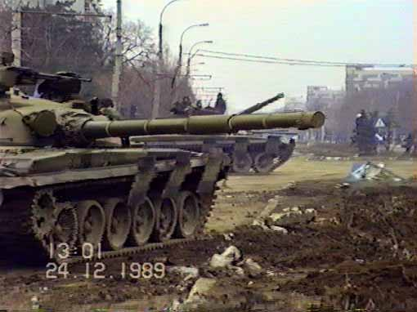
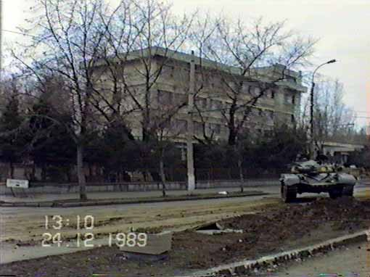

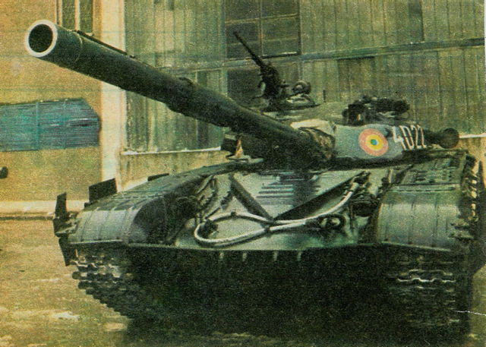
Romanian T-72M tanks participating in the Anti-Communist Revolution of December 1989, as seen in stills and video frames around central Bucharest. They belong to the 1st Tank Regiment “Vlad Tepes” based at Tirgoviste, Dimbovita County; they are painted in overall olive green, as it was the standard for the Romanian Army at the time, and are wearing the Romanian roundels on the turret sides; turret numbers, painted on both turret sides, indicate the unit – the letter “D” being used by the Tirgoviste regiment (4D2xx); note that the combination roundel (left) + turret number (right) is kept on both sides of the turret.
