The tanks that triggered the Romanian Revolution of 1989
Timisoara, Romania, 17 December 1989

The spark that ignited the Romanian Revolution of December 1989 was lit in Timisoara, a city in Western Romania; the Revolution spread across the country and resulted in the overthrowing of the Communist regime led by Nicolae Ceausescu and the Romanian Communist Party (Partidul Comunist Roman, PCR). The first protests started in the streets of Timisoara, on 16-17 December 1989 and were triggered by a decision of the communist authorities to evict Laszlo Tokes, a local Protestant pastor. Mr Tokes was a popular figure, and the decision, on obvious political grounds, was not received well by the community. The people of Timisoara, fed up with the daily hardships endured in a failed communist economy, took to the streets, triggered by this event - the proverbial straw that broke the camel’s back.

17 December 1989 saw largely peaceful street protests, but the local communist authorities were growing alarmed, notwithstanding because Romania of December 1989 was the last country in the Eastern Bloc not to have overthrown their communist government and allow for a democratically-elected leadership. Therefore, the Communist leaders decided to organize a military parade, something of a deterrent and show of force, that was hoped to frighten the protesters and send them back to their homes. Several military units from garrisons based at Timisoara, Lugoj, Dej and even Arad took part in the parade, all these units being infantry or mechanized infantry (no tanks or any other armoured vehicles took part in the first stage); the protesters welcomed the marching soldiers, at the same time the deterrent effect was not achieved, their numbers actually growing. As a result, the military commanders, under direct orders from Bucharest, where the peaceful revolt was already being labelled as insurgency, and protesters identified as hooligans and delinquents, decided to send a number of tanks. These were T-55A tanks from from an Army training unit, and were not equipped with any ammunition on board, neither for the 100mm main gun, nor for any of the two machine guns. The presence of these tanks in the city streets was not received well by the protesters, and the message was clear: the tanks were there to crush the revolt! These tanks triggered a first violent response: people started throwing stones, bottles, chunks of pavement etc. at the tanks. Stopping the tanks became a common effort that united the protesters in a cohesive counter-attack. The situation escalated quickly, and in the afternoon of the 17th of December, the military command sent five more tanks, from the 44th Tank Regiment (Regimentul 44 Tancuri) based nearby Timisoara. These tanks had main gun and machine gun ammunition on board; they were not training tanks, but rather main battle tanks, and their ammunition was sealed in containers on board each tank, most of it dating from 1968 when they had initially entered service. By then, the protesters were starting to mount an organized barrage, erecting makeshift barricades, made of trucks, trolleybuses and street cars bundled together, with the aim of slowing down the tanks, in order to pick them up individually, once stationary. Some of them knew exactly how to disable a tank – either by covering the vision ports with paint, throwing rags dosed in oil and set on fire inside the crew compartment, or by jamming crowbars in the tank’s drive sprocket; these individuals were a minority though, the vast majority of the protesters were trying various methods that were not causing any harm to the machines, but rather, harming themselves (an eye-witness account mentions one young man being thrown a great distance away from a tank, when he tried inserting a metal rod in a tank’s drive sprocket, action that backfired and sent the protester in a spin and swiftly threw him into a bus used as barricade). There were a few cases when the tanks’ external fuel drums were ruptured and set ablaze – this proving to be extremely hazardous since it may have had produced a fire that could have ignited the on-board HE (high explosive) ammunition. The military units, under the command of Major Vasile Paul, instead of using rubber bullets or blanks, shot at the protesters using live ammunition, killing dozens of unarmed civilians (59 confirmed dead, hundreds more wounded). Maj. Paul was subsequently promoted to the rank of General, after 1990.

Violent clashes between the military and the protesters continued all through the 17th to the 19th December, with numerous casualties, most notable the bloodshed on Giroc Way cross Lidia Street, a main road leading to Timisoara’s town centre. On 20th December, the 44th Tank Regiment (Regimentul 44 Tc Timisoara) receives the order to block protesters' advance towards Buzias Way (Calea Buziasului), and the town centre, a few of its tanks holding station in front of the Opera House. At midday, due to overwhelming pressure from the protesters, the Security forces retreat back to their quarters; the Army is now wholly siding with the protesters. The military finally siding with the protesters on 20th December virtually ended all hostilities, but not the bloodshed since the Security forces, still loyal to the communist regime, continued killing civilians.

It was the T-55A tanks that were sent in the streets of Timisoara that angered the protesters and made them switch from a peaceful march to a violent uprising, that, in turn, triggered the bloodshed at the hands of the Security forces and the military, that again, made the cry of help and the call to overthrow the communist regime be heard from Timisoara to Bucharest. This chain of events was the catalyst for the Romanian Revolution of December 1989, but regrettably, the nationwide civilian bloodshed had only begun.

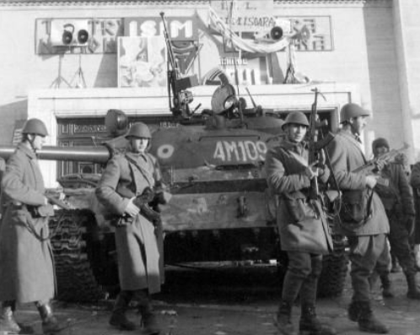
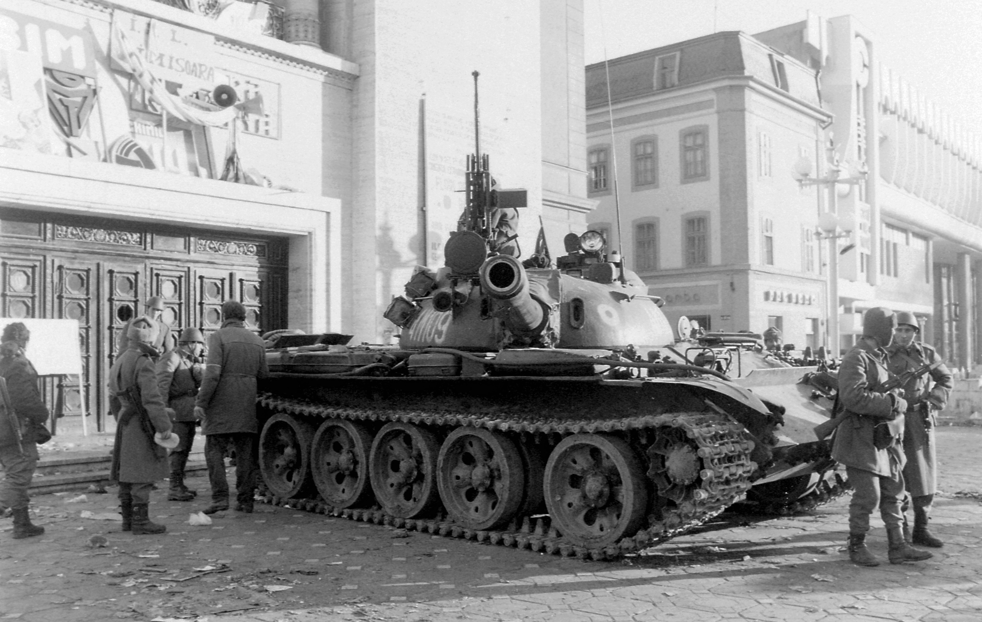
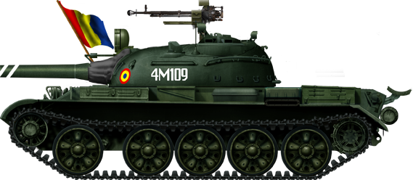

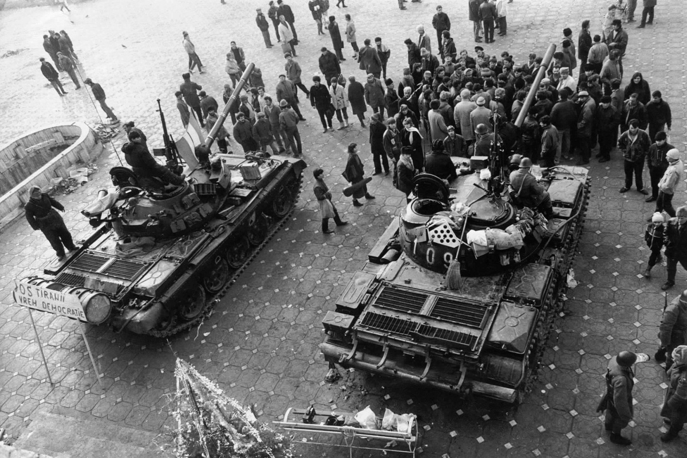
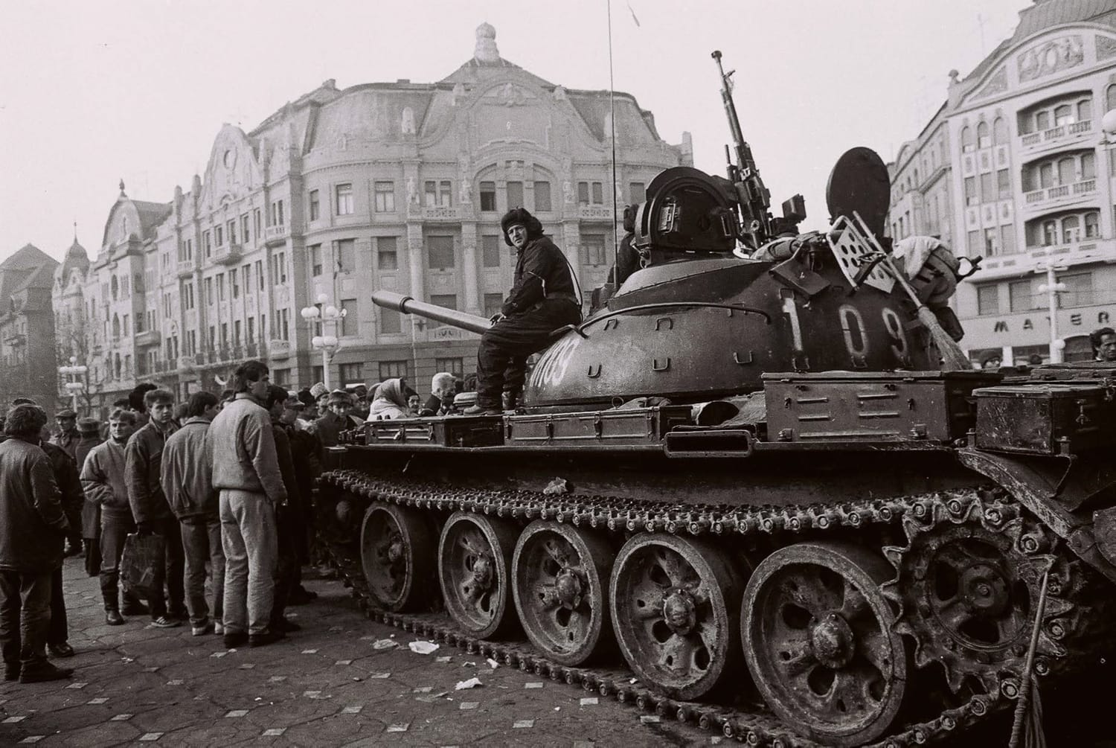

T-55/100 serial number 4M109 from the 1st Platoon, 1st Company, 44th Tank Regiment, Timisoara, Romania, 17-20 December 1989 (photos by Mr. Urban Tamas); location: Opera Square (20 December 1989), other tanks from the same unit, at the same location: 4M107, 4M111 (5 tanks in total). The Romanian Army units present in the streets of Timisoara faced stiff opposition from the revolutionary crowds between 17 and 20 December, with the military shooting live ammunition in response, triggering an unprecedented bloodshed in which 59 civilians were killed.

