ReCAPTCHA

Steps to create ReCaptcha Public key and Private Key

- Go to http://www.recaptcha.net and click “My Account” link

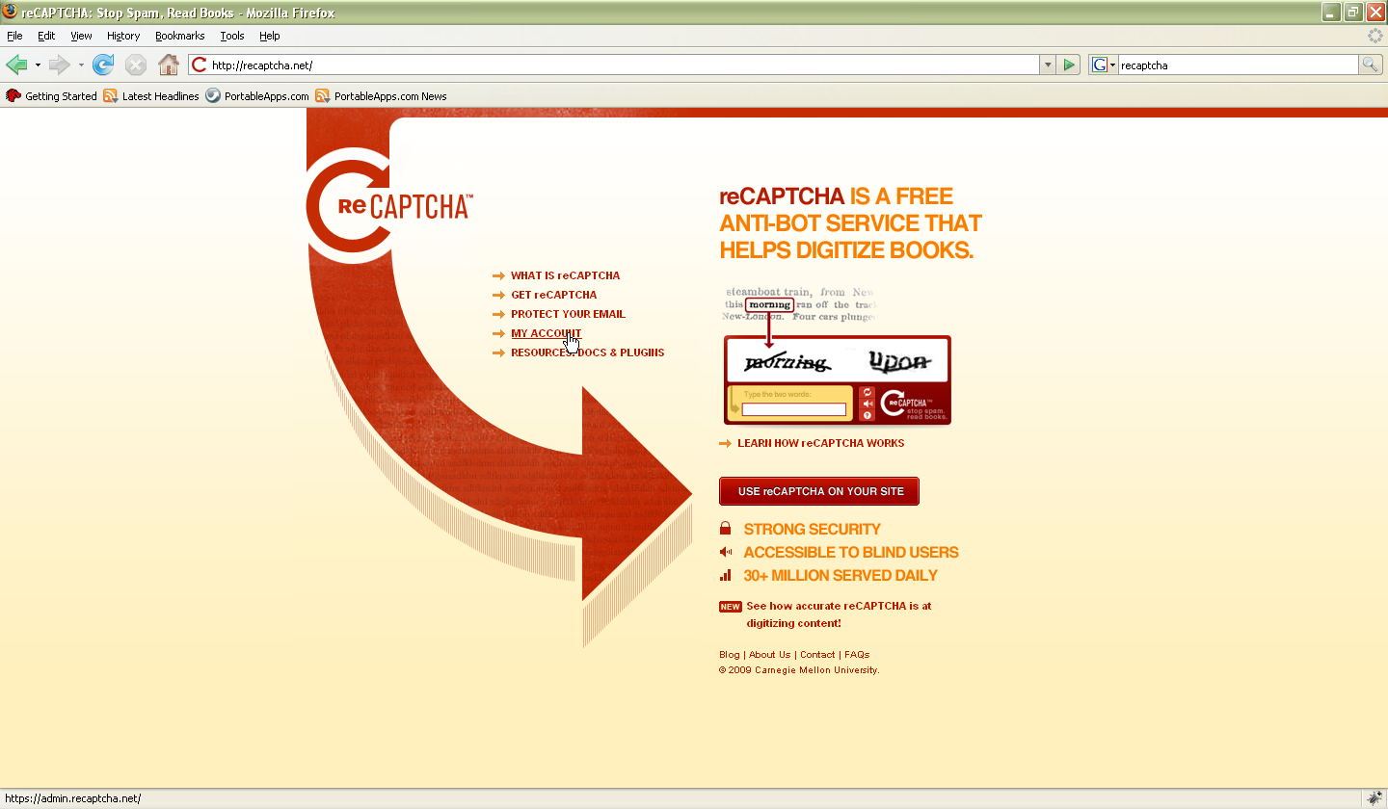

- My Account page

If you have an account in Recaptcha.net login using that else click “Signup” link to create an account in Recaptcha.net. After creating an account login to Recaptcha.net
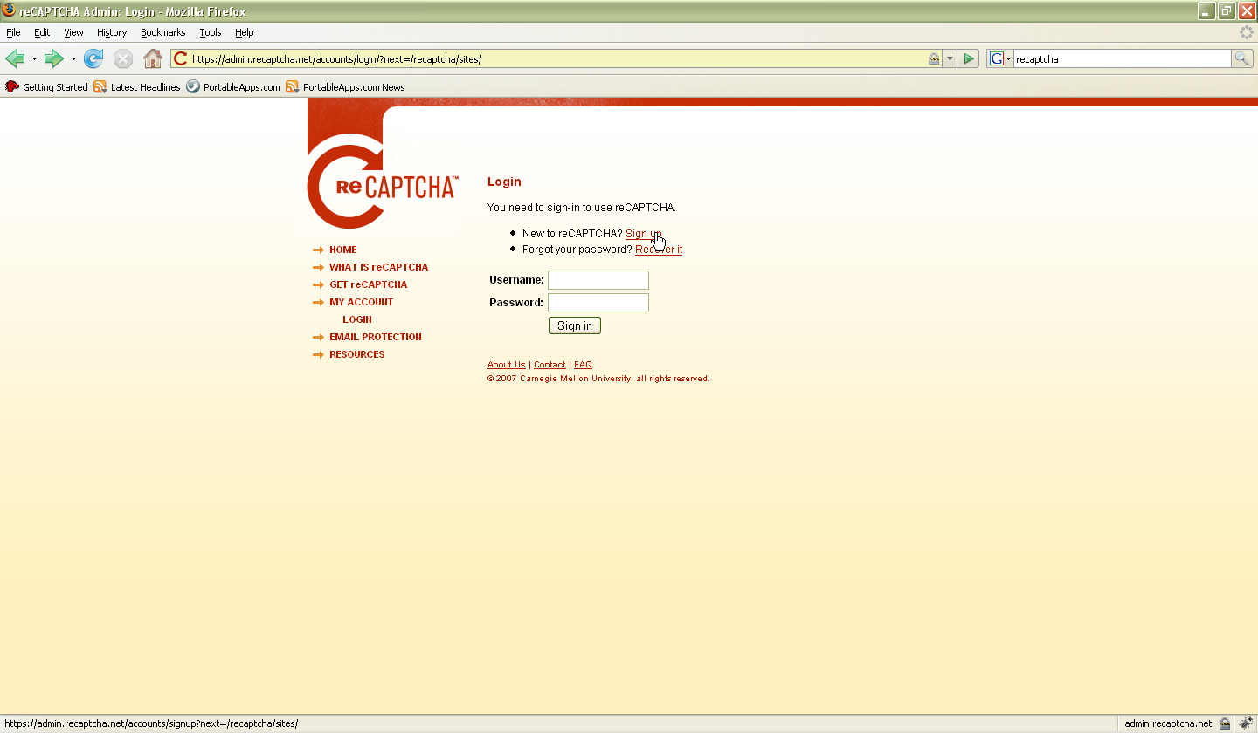

- Create a ReCAPTCHA Key

Enter your domain name and click “Create Key” button
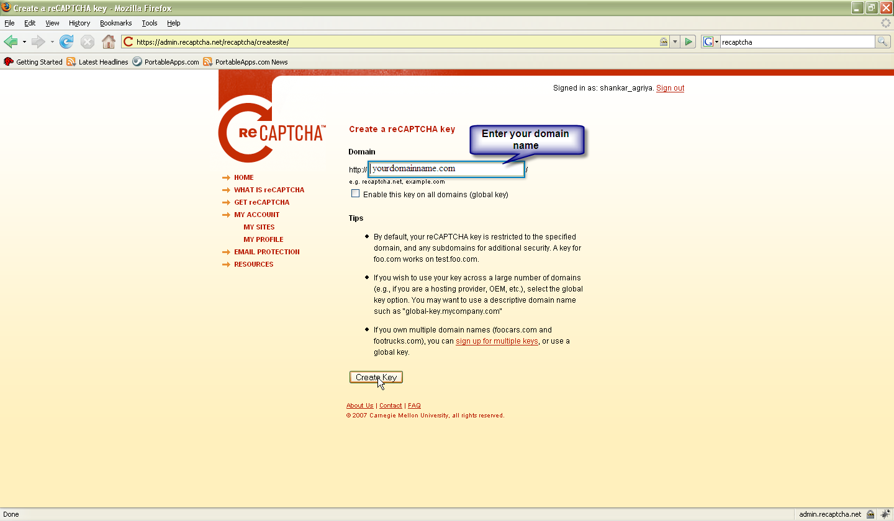

- ReCAPTCHA key creation completed

Copy the Public Key and Private Key
Go to http://www.yourdomainname.com/admin/editConfig.php?config_file_name=config_recaptcha
Paste the Public Key and Private Key in the corresponding fields and click “Update” button.

