***Initial Design - Code Templates, Photos of the Setup, Data Processing through Blynk***

The core of a project is ***Arduino Uno R4 Wi-Fi*** which controls the sensors and communicates with the Blynk platform for real-time data processing and output.

***Jopto TSW-30 & SEN0189 Turbidity Sensors***: These sensors measure the turbidity (cloudiness) of the water. The turbidity sensor outputs a value proportional to how clear or polluted the water is.

***DS18B20 Waterproof Temperature Sensor:*** This sensor is used to measure the water's temperature, which is essential for assessing water quality.

The Turbidity sensor and temperature sensor can be connected to the analog or digital pins of the Arduino. The Arduino sends data to Blynk via Wi-Fi, where users can monitor it on a smartphone in real-time.

***Data Processing through Blynk***

Blynk API gives us a real-time communication between the Arduino device and the app. Фдыщ The app displays:

**Turbidity level:** Real-time water clarity reading.

**Temperature:** Real-time water temperature reading.

**Safety status:** A message like "Safe to Drink" or "Unsafe to Drink"

The app visualizes this data through widgets like Value Display for temperature and turbidity, and Label for the safety status.

***Code Templates***

*Code for Turbidity sensors*

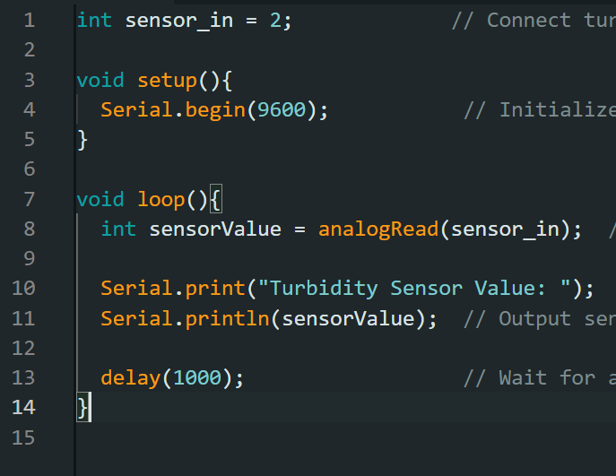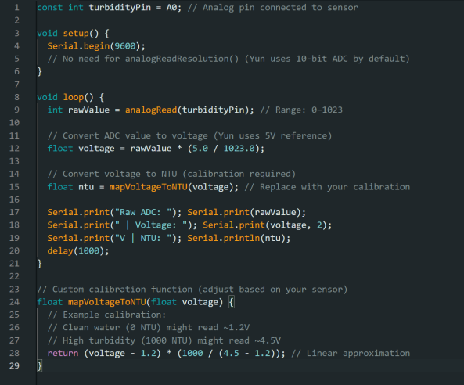

*Code for Blynk*

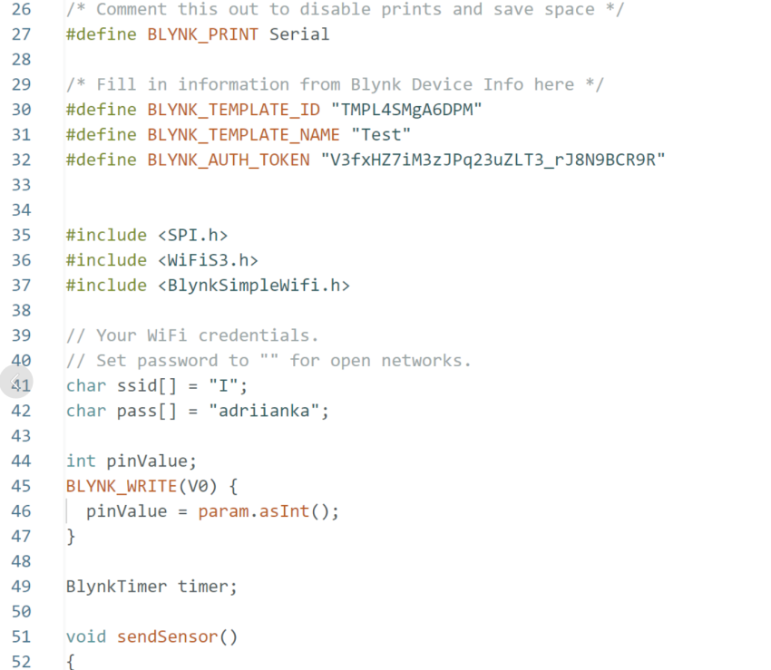

*Code for Temperature sensor*

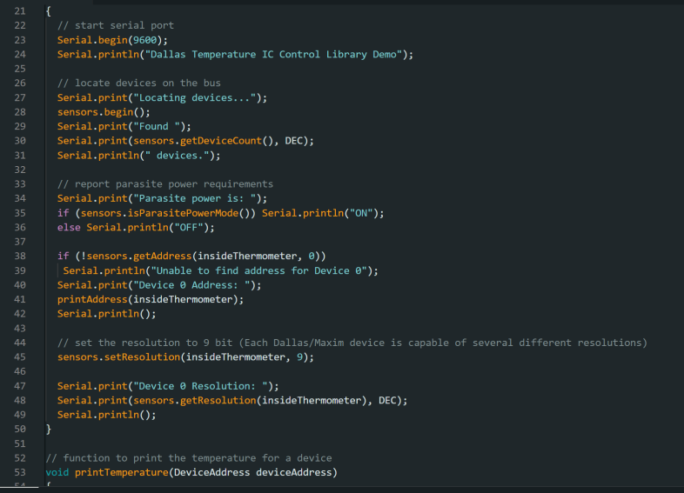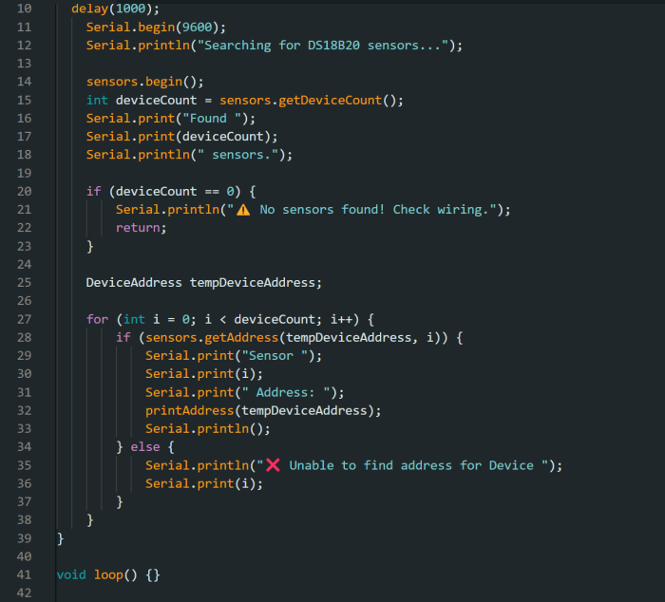

***Setup photos***

*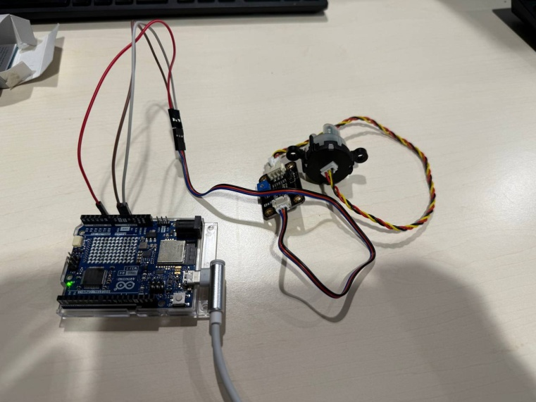(Arduino and SEN0189)*

*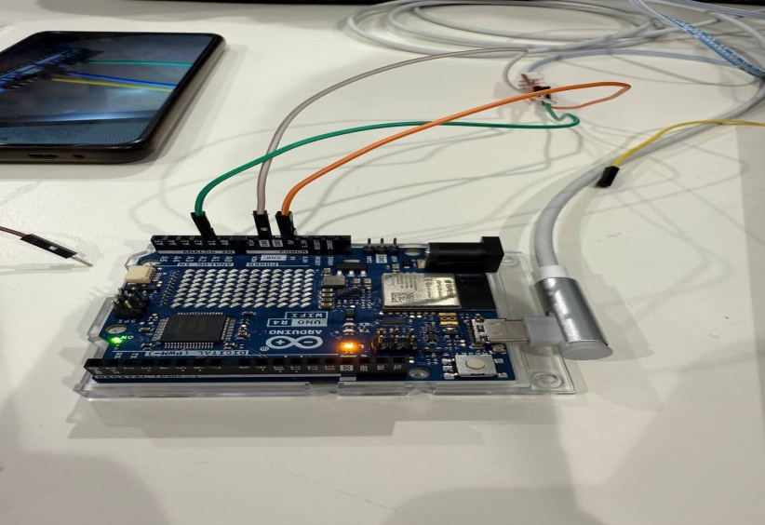( Arduino and Jopto TSW-30)*

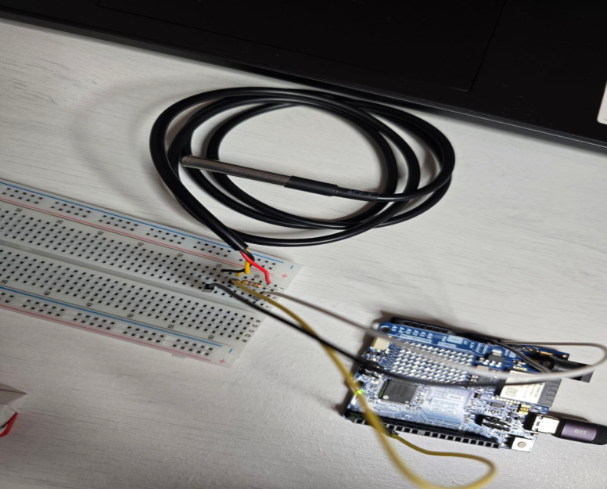 *( Arduino and DS18B20 connected via Breadboard)*

***Description of Data Generated***

The main data generated by the system includes:

***Turbidity Level:*** A numeric value that represents the clarity of the water (higher values indicate murkier water).

Measurement: Analog reading from the turbidity sensor.

***Temperature:*** A floating-point value that represents the water's temperature in °C.

Measurement: DS18B20 sensor provides temperature readings.

***Safety Status:*** A message that indicates whether the water is "Safe to Drink" or "Unsafe to Drink" based on turbidity and temperature readings.

***Datasets or APIs Used***

***Blynk API:*** For real-time data transfer between the sensors and the app. It helps visualize the sensor values and allows for status updates.

***Blynk Cloud:*** Data will be stored and processed in the cloud, ensuring it's always accessible from the Blynk app.

***Arduino Data Processing:*** Local data processing on the Arduino involves reading sensor values and sending them to Blynk for further analysis.