Nombre del alumno: _Garibay Huerta Valery Viridiana__ Profesora: Leticia Henestrosa Carrasco

Asignatura: Administración de servicios en Red Academia: Sistemas Distribuidos

# PRACTICE: ROUTING ON A MULTILAYER SWITCH

In this practice, you will learn how to configure a SVI (switch Virtual Interface), routed ports, and routing on a multilayer switch.

The ports on SW1 must be configured to have PC1 in VLAN 10 and PC2 in VLAN 20. The link between SW1 and DSW1 is configured as a trunk link. PC1 and PC2 are configured with addresses. R1 is configured with IP addresses and EIGRP. You will configure DSW1 to route between PC1 and PC2.

## TOPOLOGY

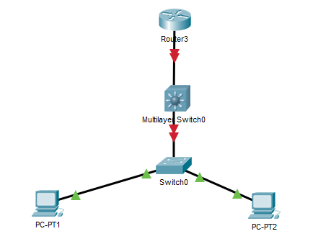

|  |  |  |
| --- | --- | --- |
| **DEVICE** | **INTERFACE** | **IP ADDRESS** |
| PC1 | FA0/0 | 10.0.10.100/24 |
| PC2 | FA0/0 | 10.0.20.100/24 |
| DSW1 | VLAN 10 | 10.0.10.1/24 |
| DSW1 | VLAN 20 | 10.0.20.1/24 |
| DSW1 | G1/0/2 | 10.0.99.1/24 |
| R1 | FA0/0 | 10.0.99.2/24 |

