

Consumer Credit and Criminal Record Search
Please print clearly.

Name: ______________________________________________________________________________
Last First Middle Maiden

Address: _____________________________________________________________________________

______________________________________________________________________________________

Date of Birth (mm/dd/yy): _________________ Social Security Number:__________________________
(If off-shore, passport # can be used if SS# not available)

Have you ever been convicted of a crime? US Visa Type: ____________________________

Yes No If so, Felony Misdemeanor

If yes: Date: ___________ County/City _____________ State: _____________

Crime: __________ Disposition: ______________

Release
I authorize all credit agencies to release information they may have about me to Citigroup or their agent Joe Wyllie & Associates and release them from liability or responsibility from doing so; further I authorize the procurement of an investigative a consumer report and I understand that such a report may contain information about my background, character, and personal reputation. If I am convicted of a crime during the period of time I am assigned to provide services for Citigroup or any of its affiliates, then I shall immediately provide Citigroup with the relevant information as requested above.

________________________________ __________________________________
Print Name Date of Birth (mm/dd/yy)

________________________________ __________________________________
Signature Social Security Number (If off-shore, passport # can be used in place of SS#)

________________________________
Date of Signature

Please Email to Jennifer.Fontanetta@citigroup.com when completed.
Vendors please complete ALL of the following:
Vendor: ___SANS CONSULTING________

__LEO KOGAN___________ _(212) 616-4800_________ _LeoK@sans.com_____________________

Contact Name Telephone Number E-Mail

Project Manager: P&L Number:
Senior Manager:
Transfer: If yes, location transferring from and to(ex: US to India – India to US).
Replacement: If yes, name of consultant being replaced.
Fixed Price OR Time and Material OR Capped T&M
Consultant Location:(Country/State)
Does consultant already have a SOE/TRS ID? If so, please provide:
EXHIBIT 1
NON-DISCLOSURE AND WORK PRODUCT ASSIGNMENT AGREEMENT

I, THE UNDERSIGNED, DO HEREBY ACKNOWLEDGE that __SANS CONSULTING __________ (“Contractor”) and Citigroup Global Markets Inc. or one of its affiliates (“Client”) have entered into a Master Professional Services Agreement (the “Agreement”).

I HAVE BEEN ADVISED BY CONTRACTOR that under the Agreement, Contractor has, inter alia, agreed to treat certain information and materials received or otherwise obtained from Client as confidential, and to exercise at least the same degree of care with respect to the Client’s Confidential Information that Contractor exercises to protect its own confidential information from unauthorized disclosure or use. I agree that for purposes of this Non-Disclosure and Work Product Assignment Agreement, “Confidential Information” shall mean and include all tangible or intangible information and materials, in any form or medium (and without regard to whether the information is owned by Client or by a third party), that is furnished or disclosed to Contractor or any of its personnel by Client, or otherwise obtained or accessed by Contractor or any of its personnel from Client. I am aware that the Agreement provides for the exclusion of certain types of information and materials from the definition of Client’s “Confidential Information”; however, I agree to treat as confidential all information that would otherwise qualify as “Confidential Information”, except for information that a Managing Director of Client specifically declares in writing to be subject to one of the exclusions. I have been further advised by Contractor that as a condition to my performing any services for Client, I must agree, and I do hereby agree, to abide by the obligations of confidentiality assumed by Contractor, which include the following:

- not to disclose Client’s Confidential Information, except to other employees of Contractor on a “need to know” basis and only to the extent necessary to fulfill Contractor’s obligations under the Agreement;
- not to reproduce Client’s Confidential Information in any media without the express written approval of Client;
- not to remove or transmit Client’s Confidential Information from Client's premises without Client’s express prior written consent;
- not to remove any copyright or other proprietary notice or indication of confidentiality contained on or included in any item of Client’s Confidential Information; and,
- to reproduce any copyright or other proprietary notice or indication of confidentiality on any reproduction, modification or translation of such Confidential Information.

I HAVE BEEN FURTHER ADVISED BY CONTRACTOR that under the Agreement, Contractor has, inter alia, agreed to treat as Client’s “Work Product”, all ideas, concepts, know-how, techniques, inventions, discoveries, improvements, specifications, designs, methods, devices, systems, reports, studies, computer software (in object or source code), programming and other documentation, flow charts, diagrams and all other information or tangible material of any nature whatsoever (in any medium and in any stage of development or completion) relating to the subject matter of the Agreement or any applicable Project Schedule, that are conceived, designed, practiced, prepared, produced or developed by me: (i) during the course of my Service for Client; (ii) based upon knowledge or information learned or gained from Client; or, (iii) resulting from the use of Client’s facilities, personnel, or materials. I understand that as a condition to my performing any services for Client, I must agree, and I do hereby agree, to the following:

I acknowledge and agree that, as between Client and me, to the fullest extent permitted under law, all Work Product shall be the property of Client and shall be deemed to be a “work made for hire” (as defined in Section 101 of Title 17 of the United States Code).

To the extent any Work Product is determined not to be “work made for hire”, I hereby irrevocably and exclusively assign, transfer and convey to Client all rights, title and interest of any kind, in and to any and all Work Product; and I acknowledge that I will not retain any proprietary right or interest in the Work Product.

I will promptly make full written disclosure to Client, will hold in trust for the sole right and benefit of Client, and hereby assign and agree to assign in future to Client, all my right, title, and interest in and to any and all Work Product.

I will keep and maintain adequate and current written records of all Work Products made by me (solely or jointly with others). The records will be in the form of notes, sketches, drawings, and any other format that may be specified by Client. The records will be available to and remain the sole property of Client at all times.

I will hereafter do all acts and sign all writing as may be required to transfer or vest the ownership of the Work Product to or in Client, and otherwise assist Client, or its designee, in every proper way to secure Client's rights in the Work Product and any copyrights, patents, mask work rights or other intellectual property rights relating thereto in any and all countries, including the disclosure to Client of all pertinent information and data with respect thereto, the execution of all applications, specifications, oaths, assignments and all other instruments which Client shall deem necessary in order to apply for and obtain such rights and in order to assign and convey to Client, its successors, assigns, and nominees the sole and exclusive rights, title and interest in and to the Work Product, and any copyrights, patents, mask work rights or other intellectual property rights relating thereto.

I specifically agree that I shall not modify, adapt, translate, prepare derivative works from, decompile, reverse engineer, disassemble or otherwise attempt to derive source code from any Work Product without the express written consent of Client, which consent Client may withhold in its sole discretion.

I shall not in any non-transitory manner store or cache information about the Work Product.

I ACKNOWLEDGE AND AGREE that the terms of this Non-Disclosure and Work Product Assignment Agreement shall be binding upon me during my term of employment with Contractor and shall also continue to bind me thereafter.

I ACKNOWLEDGE AND AGREE that Client and its affiliates are third party beneficiaries under this Agreement. Except as specifically set forth or referred to herein, nothing contained or implied herein is intended or shall be construed to convey upon any person or entity other than the parties hereto and Client and its affiliates, any rights or remedies under or by reason of this Agreement.

I INTEND, by signing this Non-Disclosure and Work Product Assignment Agreement, for both Contractor and Client to rely upon my adherence to the obligation of confidentiality and other obligations set forth in this Agreement in permitting me to work on the Project contemplated by the Master Professional Services Agreement.

Signature:
Name:  (type or print) |  | Witness:
SS#or Passport# |  | Name:
Date:

EXHIBIT 2A
ASSURANCE OF COMPLIANCE
WITH EXPORT LAW AND REGULATIONS
(CONTRACTOR’S PERSONNEL, US RESIDENT)

Citigroup Global Markets Inc.
388 Greenwich Street
New York, NY 10013

To whom it may concern:

I hereby certify that, unless the permission of the U.S. Departments of Commerce, Treasury, or State, as applicable, is obtained, either in writing or in accordance with applicable regulations; I will not export, reexport or otherwise disclose, directly or indirectly, any proprietary software or technical data received from Citigroup or any of its direct or indirect subsidiaries or affiliates (collectively, “Citigroup”), or the direct product of any such software or technical data, to any of the following nations or nationals thereof:

- Country Group E:2 (currently Cuba and Libya) or any other embargoed destinations (currently Iran, Iraq, Sudan, Syria, or the Taliban controlled areas of Afghanistan).

- Non-civil (i.e., military) end-users or for any non-civil (i.e., military) end uses in Country Groups D:1 (currently Albania, Armenia, Azerbaijan, Belarus, Bulgaria, China (PRC), Cambodia, Estonia, Georgia, Kazakhstan, North Korea, Kyrgystan, Laos, Latvia, Lithuania, Macau, Moldova, Mongolia, Romania, Russia, Tajikistan, Turkmenistan, Ukraine, Uzbekistan, and Vietnam).

I agree to be bound by any future modifications of the foregoing list of restricted destinations by amendments to the U.S. Export Administration Regulations or other U.S. Government agencies.

I understand that prior approval of the U.S. Department of Commerce or other appropriate agencies can be provided by regulations authorizing certain exports or by licenses or other authorizations obtained after prior application to the agency.

Additionally, I understand that countries other than the U.S. may restrict exports and may also restrict the import or use of strong encryption products and agree that we shall be solely responsible for compliance with any such export, import or use restrictions.

Further, I understand that failure to comply with the U.S. export regulations exposes Citigroup (and individuals providing services to Citigroup) to severe criminal and administrative penalties and sanctions, as well as adverse publicity, and that violation of this Assurance can result in the termination of my service assignment.

Sincerely,

________________________________
(Signature)

____________________________________
(Name---type or print)

____________________________________
(Date)

Name of Contractor (employer of signatory): _SANS Consulting_______________________
EXHIBIT 2B

ASSURANCE OF COMPLIANCE
WITH EXPORT LAW AND REGULATIONS

(CONTRACTOR’S PERSONNEL, FOREIGN NATIONAL)

Citigroup Global Markets Inc.
388 Greenwich Street
New York, NY 10013

To whom it may concern:

During my engagement with any direct or indirect subsidiary or affiliate of Citigroup (collectively “Citigroup”), I may have access to proprietary technical data and computer software. As a foreign national (non-U.S. citizen without U.S. permanent residency status), I understand that this access constitutes an export of technical data/software from the United States and is therefore governed by the provisions of the U.S. Export Administration Regulations ("EAR").

Consequently, I agree to comply with U.S. Export Administration Regulations as they pertain to any technical data or computer software to which I have access. I hereby certify that, unless prior written authorization is received from the U.S. Department of Commerce or other appropriate agencies, I shall not knowingly reexport, directly or indirectly, this technical data/computer software without full compliance with U.S. export control laws, and in particular I will not export it to any of the following nations or nationals thereof:

- Country Group E:2 (currently Cuba and Libya) or any other generally embargoed destinations (currently Iran, Iraq, Sudan, Syria, or the Taliban controlled areas of Afghanistan), or

- Non-civil (i.e., military) end-users or for any non-civil (i.e., military) end uses in Country Groups D:1 (currently Albania, Armenia, Azerbaijan, Belarus, Bulgaria, China, Cambodia, Estonia, Georgia, Kazakhstan, North Korea, Kyrgystan, Laos, Latvia, Lithuania, Macau, Moldova, Mongolia, Romania, Russia, Tajikistan, Turkmenistan, Ukraine, Uzbekistan, and Vietnam.

I agree to be bound by any future modifications of the foregoing list of restricted destinations by amendments to the U.S. Export Administration Regulations or other U.S. Government agencies.

I also agree that, without the prior approval of the U.S. Department of Commerce or other appropriate agencies, I shall not knowingly export to any of the above nations, directly or indirectly, any product (or any part thereof), process or service which is the direct product of this technical data/computer software.

I understand that prior approval of the U.S. Department of Commerce or other appropriate agencies can be provided by regulations authorizing certain exports or by licenses or other authorizations obtained after prior application to the agency, and that prior regulatory approvals are more likely to be available for exports to the second group of countries.

Additionally, I understand that countries other than the U.S. may restrict the import or use of strong encryption products and export of any products, and I agree that I will accept responsibility for compliance with any such restrictions.

I certify that I understand that this assurance I am providing is a condition to my having access to such data or software and applies in addition to any commercial nondisclosure agreements to which I am now or may be a party. Failure to comply exposes Citigroup (and individuals providing services to Citigroup) to severe criminal and administrative penalties and sanctions, as well as adverse publicity. Additional personal liability can result, including disciplinary action up to and including termination and/or problems under U.S. immigration laws.

Sincerely,

_____________________________ __SANS Consulting_________________________
(Signature) Name of Contractor (employer of signatory)

_____________________________
(Name---type or print)

_____________________________
(Date)

Telephonic and Electronic Communications, Electronic Mail and Voice Mail Systems Policy and Acknowledgement

Electronic communications equipment and services provided by the “client”, including telephone, voice mail, Bloomberg Mail, Internet and other external electronic communication links, whether they are on-site, mobile or remote, are provided for the conduct of the “client’s” business. This means that the use of such equipment and services is only for the performance of tasks related to your job with an exception for minimal personal use.

There is no personal privacy when you use the “client’s” equipment and services. All information, data or files you create or use while employed by the “client” are the “client’s” property. The “client” may monitor, copy, access or disclose any information or files that you store, process or transmit using the “client’s” equipment and services. This monitoring, etc., may be done for the following purposes: to verify for performance or quality; to assure compliance with the “client’s” policies; to investigate conduct that may be illegal or adversely affect the Firm or its employees; and, to prevent inappropriate or excessive personal use of Firm property. Monitoring may be periodic, random or continuous.

Any use of equipment or services that is inconsistent with the “client’s” ownership interests may be investigated. Improper use may subject you to disciplinary action, including removal from the project and/or assignment, civil litigation and/or criminal prosecution. Improper use includes any use of such equipment or services for the transmission or communication of images or text consisting of ethnic slurs, racial epithets, sexually explicit material, obscenities or anything else that may be construed as illegally harassing or offensive to others based on an individual’s race, national origin, religion, sex, sexual orientation, color, martial status, veteran’s status, age or disability. In addition, accessing sites and “chat rooms” that feature pornography, off-color jokes, hate speech and the like is strictly prohibited and may result in immediate removal from the project and/or assignment.

I have read and understand the policy.

Signature__________________________________Date______________________

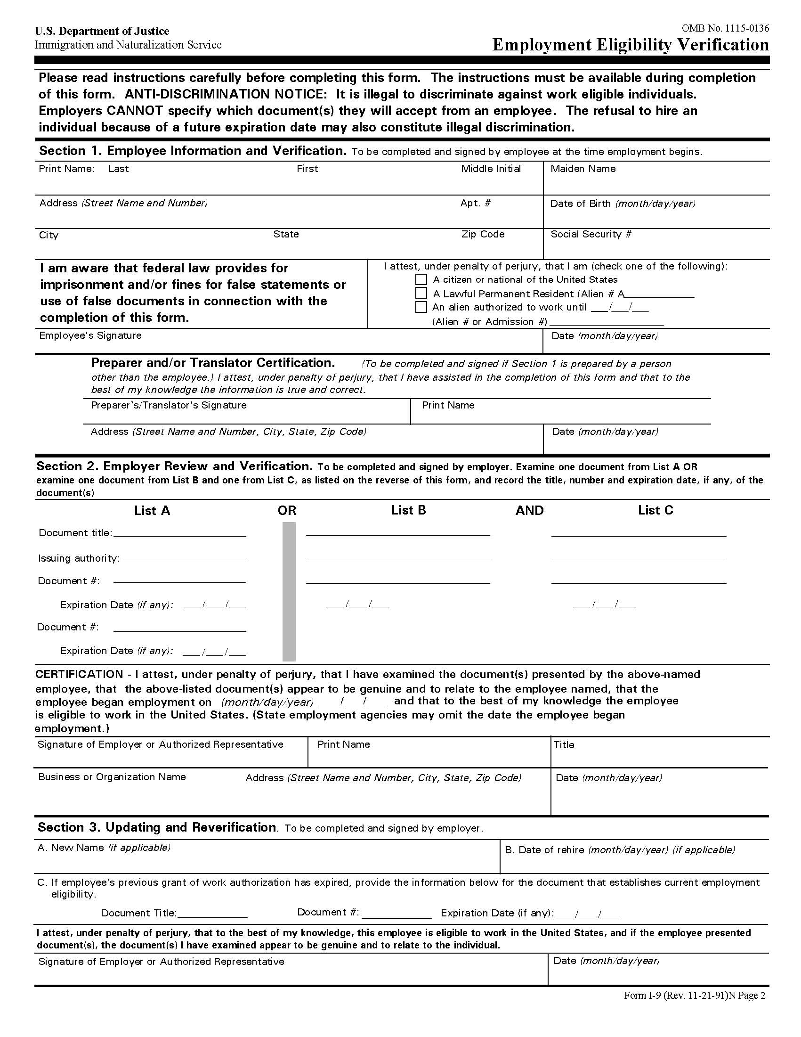
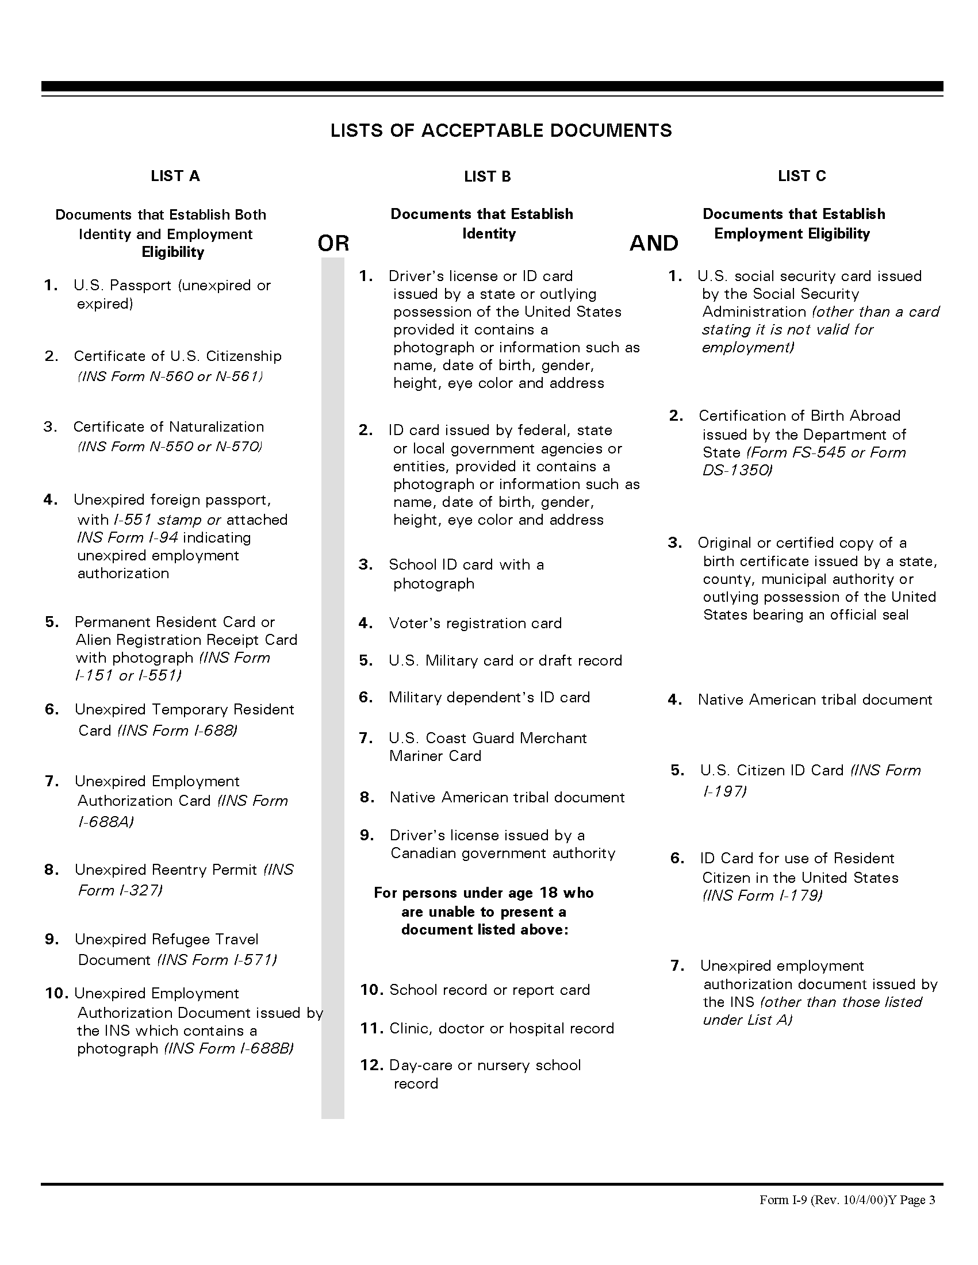
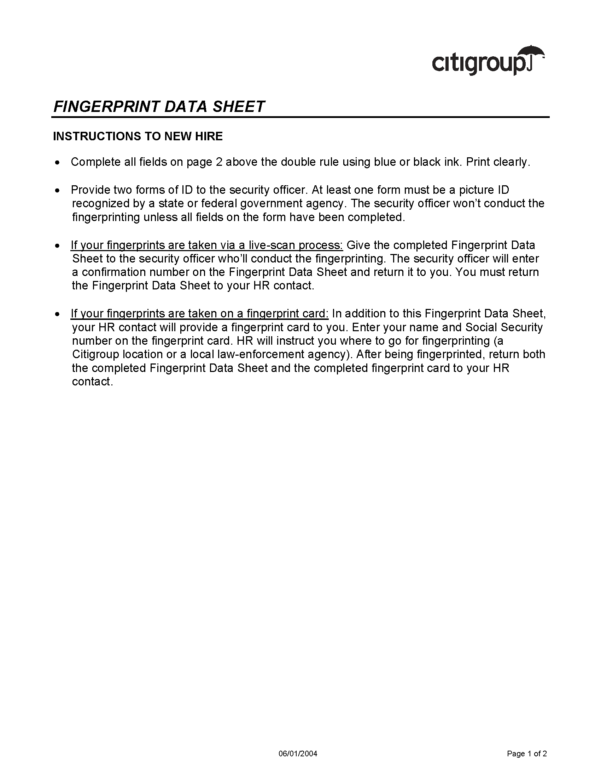
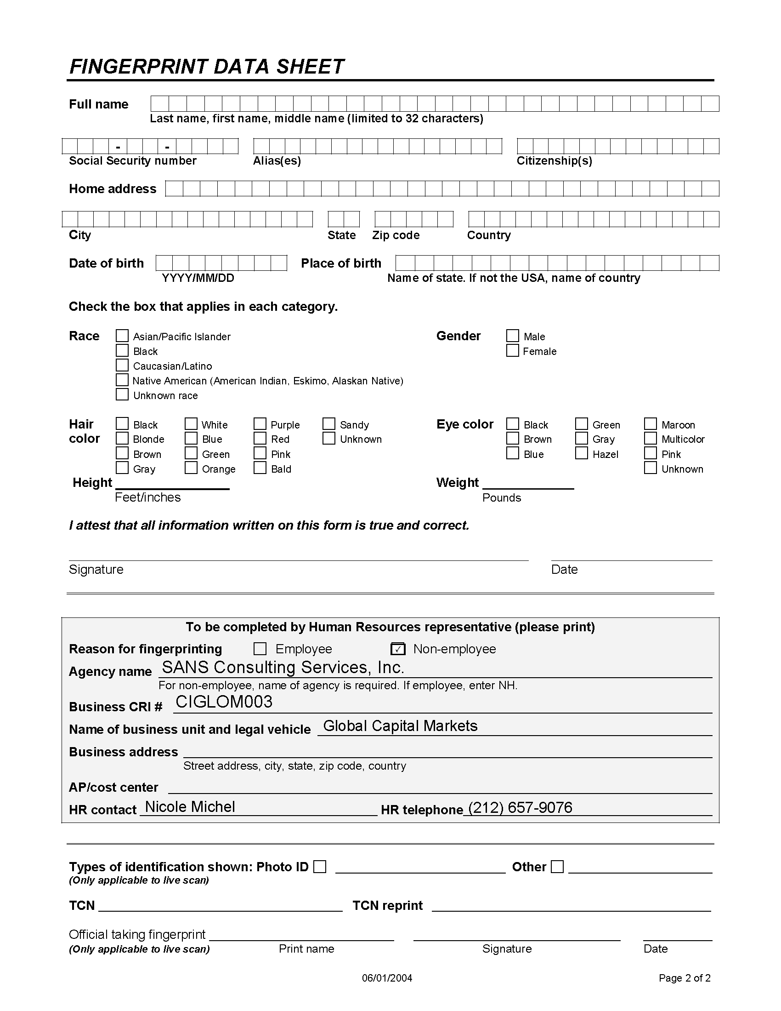
Finger Printing & Drug Test Schedule

CitiGroup requires Finger Printing and Drug Testing be done at their facilities in lower Manhattan.

Both are done on the same day, and generally are done between 9AM and 1PM. The preferred day for this to be done is within 1-2 days of your NHP submittal to us.

Please put down the next 1-2 availability dates for you to be able to do this.

1.______________________________________

2.______________________________________

Thank you.

