ΣΧΕΔΙΑΣΗ ΨΗΦΙΑΚΩΝ ΣΥΣΤΗΜΑΤΩΝ
ΕΡΓΑΣΤΗΡΙΑΚΗ ΑΣΚΗΣΗ

ΚΑΘ. ΑΝΤΩΝΗΣ ΠΑΣΧΑΛΗΣ

ΥΛΟΠΟΙΗΣΗ RISC ΕΠΕΞΕΡΓΑΣΤΗ ΑΡΧΙΤΕΚΤΟΝΙΚΗΣ MIPS R2000
ME BAΣΗ ΣΥΓΚΕΚΡΙΜΕΝΟ ΥΠΟΣΥΝΟΛΟ ΕΝΤΟΛΩΝ

Α.Μ.: 1115201400026
ΕΠΩΝΥΜΟ: Γεωργάρα
ΟΝΟΜΑ: Βασιλική

Περιεχόμενα
1. ΥΠΟΣΥΝΟΛΟ ΕΝΤΟΛΩΝ 3
2. ΣΧΕΔΙΑΣΤΙΚΕΣ ΕΠΙΛΟΓΕΣ 3
3. ΣΧΟΛΙΑΣΜΟΣ ΓΙΑ ΤΗΝ ΔΟΜΗ ΚΑΙ ΤΗΝ ΛΕΙΤΟΥΡΓΙΑ ΚΑΘΕ ΒΑΣΙΚΟΥ ΚΥΚΛΩΜΑΤΟΣ ΤΟΥ ΕΠΕΞΕΡΓΑΣΤΗ 4
4. ΕΠΑΛΗΘΕΥΣΗ ΟΡΘΗΣ ΣΧΕΔΙΑΣΗΣ ΚΑΘΕ ΒΑΣΙΚΟΥ ΚΥΚΛΩΜΑΤΟΣ ΤΟΥ ΕΠΕΞΕΡΓΑΣΤΗ 6
5. ΕΠΑΛΗΘΕΥΣΗ ΟΡΘΗΣ ΣΧΕΔΙΑΣΗΣ ΕΠΕΞΕΡΓΑΣΤΗ 8
6. ΑΠΟΤΕΛΕΣΜΑΤΑ ΤΗΣ ΣΥΝΘΕΣΗΣ ΚΑΙ ΥΛΟΠΟΙΗΣΗΣ ΤΟΥ ΕΠΕΞΕΡΓΑΣΤΗ 11

- ΥΠΟΣΥΝΟΛΟ ΕΝΤΟΛΩΝ
Το σύνολο εντολών που υποστηρίζει ο επεξεργαστής που μου ανατέθηκε να υλοποιήσω σύμφωνα με τον ΑΜ μου ( 1115201400026) είναι:

- LW $r1, 100($r2) - Load word
- SW $r1, 100($r2) - Store word
- JR $r1 - Jump register
- JALR $r1 - Jump and link register
- ΑDDU $r1,$r1,$r3 - Add --
- SUBU $r1,$r2,$r3 - Subtract --
- ANDI $r1,$r2,3 - Bitwise Imm AND -
- SRL $r1, $r2, 3 - Shift right logical --
- BEQ $r1, $r2, L - Branch on equal
- SLT $r3, $r2, $r1 - Set less than

- ΣΧΕΔΙΑΣΤΙΚΕΣ ΕΠΙΛΟΓΕΣ
…………………………………………………………………………………………………
…………………………………………………………………………………………………
…………………………………………………………………………………………………
Τα τμήματα που αφαιρέθηκαν ή τροποποιήθηκαν για την προσαρμογή της διόδου δεδομένων της θεωρίας σε σχέση με την υπό υλοποίηση δίοδο δεδομένων είναι:
  - Αφαιρέθηκε ο πολυπλέκτης για την είσοδο shamt (shamt_in <= shamt;)και οι έξοδοι Ne και ov και η είσοδος sv διαγράφηκαν καθώς ήταν περιττοί. Στον ολισθητή επίσης, αφαιρέθηκε το bus για το signed και οι 2 επιλογές του πολυπλέκτη.
  - Στη μονάδα ADDSUBSLT κράτησα μόνο τις εντολές που αφορούν τα unsigned. Επίσης αφαιρέθηκε ο έλεγχος για signed overflow.
  - H λογική μονάδα έχει μόνο μία πύλη η οποία υλοποιεί τις ανάγκες της εντολής που δόθηκε (Συγκεκριμένα η and).

Παραδίδεται στο πρώτο σημείο ελέγχου.
- ΣΧΟΛΙΑΣΜΟΣ ΓΙΑ ΤΗΝ ΔΟΜΗ ΚΑΙ ΤΗΝ ΛΕΙΤΟΥΡΓΙΑ ΚΑΘΕ ΒΑΣΙΚΟΥ ΚΥΚΛΩΜΑΤΟΣ ΤΟΥ ΕΠΕΞΕΡΓΑΣΤΗ
  - ΕΠΙΠΕΔΟ ΔΙΟΔΟΥ ΔΕΔΟΜΕΝΩΝ (DATAPATH)
    - Συνολική Περιγραφή
Να δοθεί και να σχολιασθεί το σχηματικό διάγραμμα της διόδου δεδομένων.
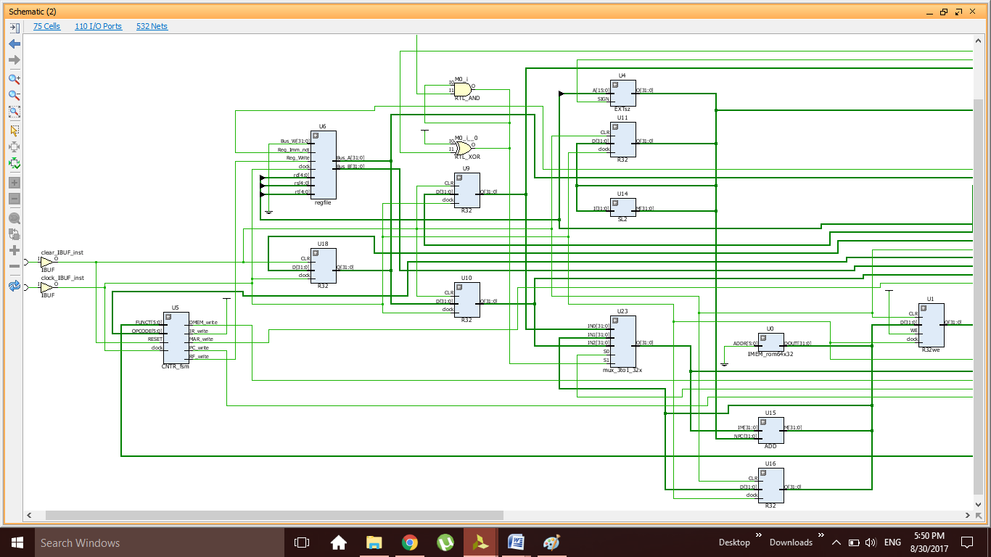
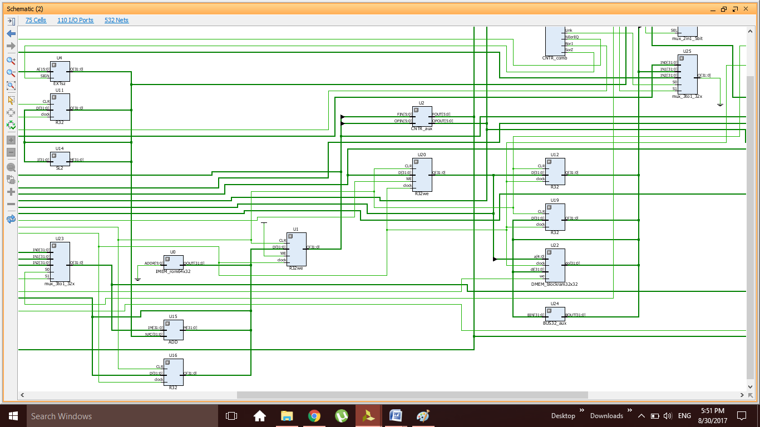
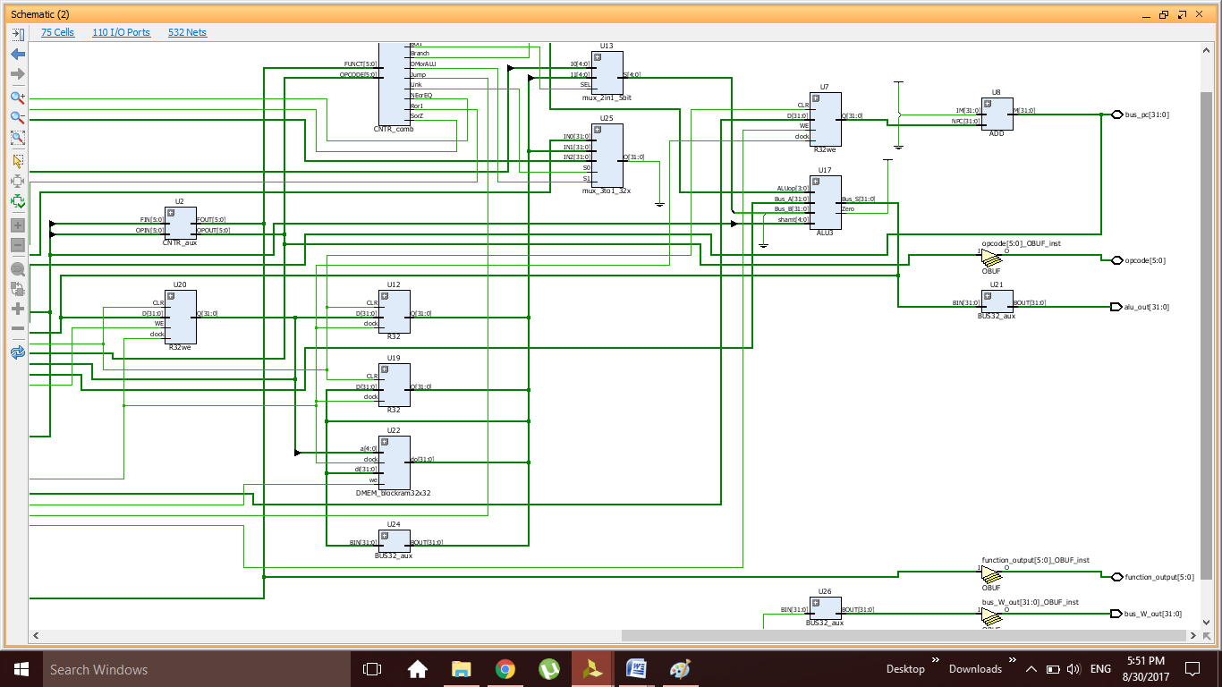
    - Αριθμητική και Λογική Μονάδα (ALU)
Να δοθούν σχηματικά διαγράμματα και κώδικας όλων των πηγαίων αρχείων (σχηματικών ή VHDL) που χρησιμοποιήθηκαν για την υλοποίηση της ALU
και να σχολιασθούν ανάλογα.
----------------------------------------------------------------------------------
--
----------------------------------------------------------------------------------
library IEEE;
use IEEE.STD_LOGIC_1164.ALL;

-- Uncomment the following library declaration if using
-- arithmetic functions with Signed or Unsigned values
use IEEE.NUMERIC_STD.ALL;

-- Uncomment the following library declaration if instantiating
-- any Xilinx primitives in this code.
--library UNISIM;
--use UNISIM.VComponents.all;

entity ALU3 is
Port ( --sv : in STD_LOGIC;
ALUop : in STD_LOGIC_VECTOR (3 downto 0);
shamt : in STD_LOGIC_VECTOR (4 downto 0);
Bus_A : in STD_LOGIC_VECTOR (31 downto 0);
Bus_B : in STD_LOGIC_VECTOR (31 downto 0);
Bus_S : out STD_LOGIC_VECTOR (31 downto 0);
Zero : out STD_LOGIC);
-- Ne : out STD_LOGIC;
--ov : out STD_LOGIC);
end ALU3;

architecture Behavioral of ALU3 is

signal L_out, A_out, Sh_out, SLT_out, MUX_out: std_logic_vector(31 downto 0);
signal shamt_in: std_logic_vector(4 downto 0);

begin

-- mux: process (shamt, Bus_A(4 downto 0), sv)
-- begin
-- if (sv = '1')
-- then shamt_in <= Bus_A(4 downto 0);
-- else
shamt_in <= shamt; --gia variable
-- end if;
-- end process;

SHIFTER: process (shamt_in, Bus_B, ALUop(1 downto 0))
variable shamt_n : natural range 0 to 31;
variable Bus_B_s : signed (31 downto 0);
variable Bus_B_u : unsigned (31 downto 0);
begin
--Bus_B_s := signed(Bus_B);
Bus_B_u := unsigned(Bus_B);
shamt_n := to_integer(unsigned(shamt_in));
case ALUop(1 downto 0) is
--when "00" => sh_out <= std_logic_vector(SHIFT_LEFT (Bus_B_u, shamt_n));
when "10" => sh_out <= std_logic_vector(SHIFT_RIGHT(Bus_B_u, shamt_n));
--when "11" => sh_out <= std_logic_vector(SHIFT_RIGHT(Bus_B_s, shamt_n));
when others => sh_out <= Bus_B;
end case;
end process;

ADDSUB_SLTUNT: process(Bus_A,Bus_B,ALUop)
variable Bus_A_s, Bus_B_s, A_out_s: SIGNED(32 downto 0);
variable Ext_A, Ext_B: STD_LOGIC;
begin
-- initial values to avoid unexpected latches
--ov <= '0';
SLT_out <= (others=>'0');
A_out <= (others=>'0');

--if (ALUop(0) = '0')
--then Ext_A := Bus_A(31); Ext_B := Bus_B(31); -- signed
--else
Ext_A := '0'; Ext_B := '0'; -- unsigned
--end if;

Bus_A_s := signed(Ext_A & Bus_A);
Bus_B_s := signed(Ext_B & Bus_B);

if (ALUop(1) = '0')
then A_out_s := signed(Bus_A_s + Bus_B_s); -- ADDU
else A_out_s := signed(Bus_A_s - Bus_B_s); -- SUBU
end if;

A_out <= std_logic_vector(A_out_s(31 downto 0));

--if (ALUop(0) = '0')
--then ov <= (A_out_s(32) xor A_out_s(31)); -- signed overflow
--else null;
--end if;

SLT_out <= "000" & X"0000000" & A_out_s(32); -- It is always right independently of overflow

--Ne <= A_out_s(32); den to xreiazomaste me ta proshma

end process;

LOGICU: process(Bus_A,Bus_B,ALUop)
begin
-- initial values to avoid unexpected latches
L_out <= (others=>'0');
case ALUop(1 downto 0) is
when "00" =>
L_out <= Bus_A and Bus_B;
--when "01" =>
--L_out <= Bus_A or Bus_B;
--when "10" =>
--L_out <= Bus_A xor Bus_B;
--when "11" =>
--L_out <= Bus_A nor Bus_B;
when others =>
null;
end case;
end process;

MUX4to1: process(Sh_out,SLT_out,A_out,L_out,ALUop(3 downto 2))
begin
-- initial values to avoid unexpected latches
MUX_out <= (others=>'0');
case ALUop(3 downto 2) is
when "00" => -- Shift
MUX_out <= Sh_out;
when "01" => -- SLT
MUX_out <= SLT_out;
when "10" => -- Arithmetic
MUX_out <= A_out;
when "11" => -- Logical
MUX_out <= L_out;
when others =>
null;
end case;
end process;

ORtree: process (A_out)
begin
if (A_out = X"00000000")
then Zero <= '1';
else Zero <= '0';
end if;
end process;

Bus_S <= MUX_out;

end Behavioral;

Και το σχηματικό της ALU:
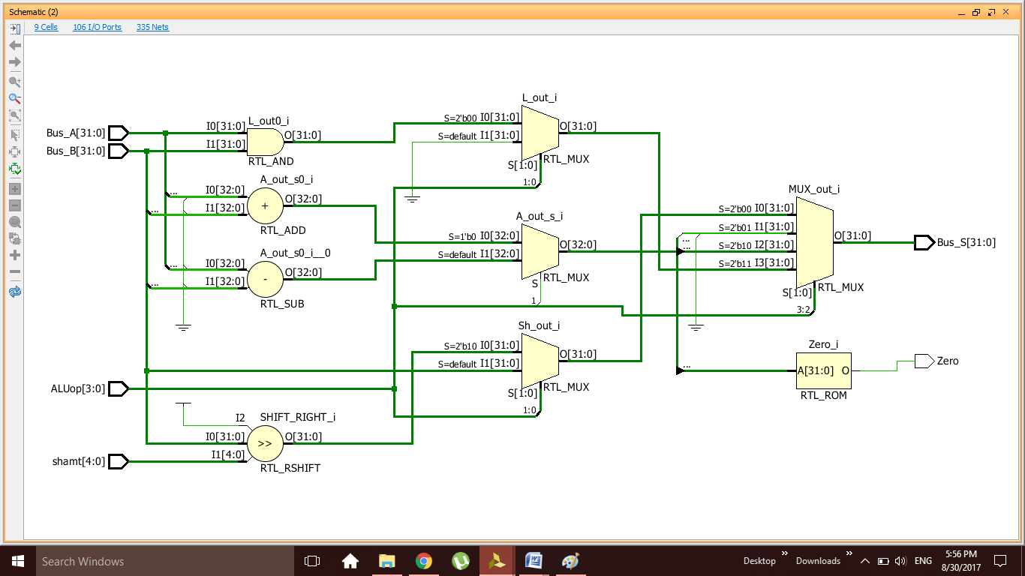

    - Αρχείο Καταχωρητών (RF)
Να δοθούν σχηματικά διαγράμματα και κώδικας όλων των πηγαίων αρχείων (σχηματικών ή VHDL) που χρησιμοποιήθηκαν για την υλοποίηση του RF
και να σχολιασθούν ανάλογα. (Μόνο το πιο πάνω ιεραρχικό επίπεδο του
αρχείου καταχωρητών, που σχεδιάσατε μόνοι σας).

library ieee;
use ieee.std_logic_1164.all;
use ieee.numeric_std.all;

entity regfile is
port (
clock : in std_logic;
Reg_Write : in std_logic;
Reg_Imm_not : in std_logic;
rs : in std_logic_vector(4 downto 0);
rt : in std_logic_vector(4 downto 0);
rd : in std_logic_vector(4 downto 0);
Bus_W : in std_logic_vector(31 downto 0);
Bus_A : out std_logic_vector(31 downto 0);
Bus_B : out std_logic_vector(31 downto 0)
);
end regfile;

architecture RTL of regfile is
type ram_type is array (31 downto 0) of std_logic_vector (31 downto 0);
signal RAM: ram_type := ((others=> (others=>'0')));
signal addr_in : std_logic_vector(4 downto 0);
begin

-- Write Address MUX
--addr_in <= rd WHEN Reg_Imm_Not ='1' ELSE rt;
process ( Reg_Imm_Not, rd, rt )
begin
if (Reg_Imm_Not ='1') then
addr_in <= rd;
else
addr_in <= rt;
end if;
end process;

addr_in <= rd WHEN Reg_Imm_Not ='1' ELSE rt;
-- Register file RAM
process (clock)
begin
if (clock'event and clock = '1') then
if (Reg_Write = '1' and Addr_in /= "00000") then
RAM(to_integer(unsigned(addr_in))) <= Bus_W;
end if;
Bus_A <= RAM(to_integer(unsigned(rs))) ; -- Synchronous READ -> BRAM
Bus_B <= RAM(to_integer(unsigned(rt))) ; -- Synchronous READ -> BRAM
end if;
--Bus_A <= RAM(to_integer(unsigned(rs))) ; -- Asynchronous READ -> Distributed RAM
--Bus_B <= RAM(to_integer(unsigned(rt))) ; -- Asynchronous READ -> Distributed RAM
end process;

end RTL;

Και το σχηματικό Regfile:
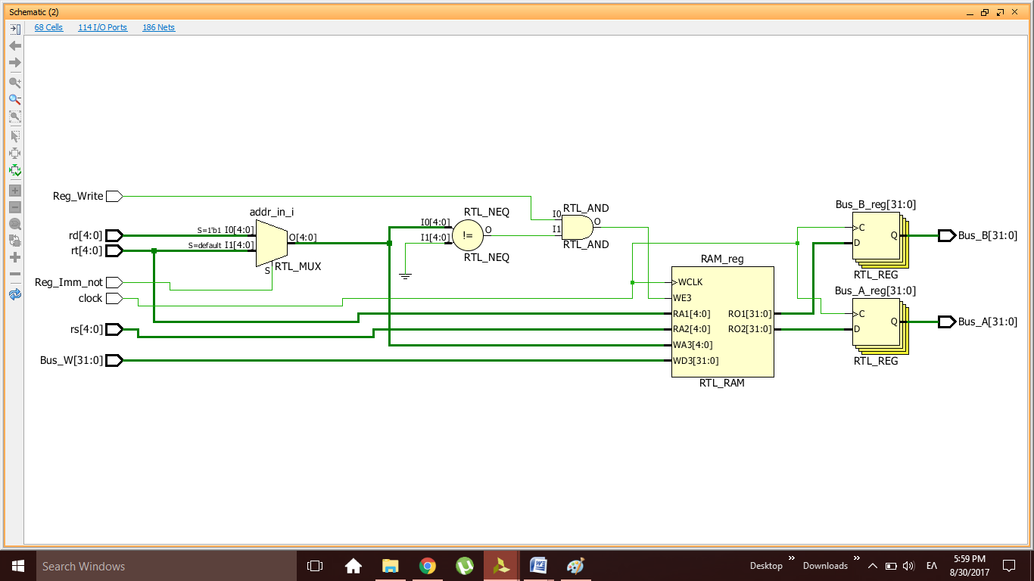

Παραδίδεται στο πρώτο σημείο ελέγχου.
  - ΕΠΙΠΕΔΟ ΕΠΕΞΕΡΓΑΣΤΗ (PROCESSOR – TOP LEVEL)
    - Συνολική Περιγραφή
Να δοθεί και να σχολιασθεί το σχηματικό διάγραμμα του επεξεργαστή.
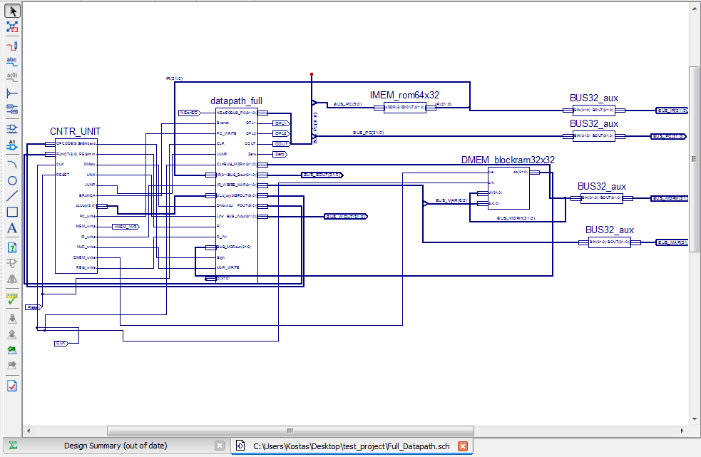
    - Συνδυαστική Μονάδα Ελέγχου
Να δοθεί πίνακας αλήθειας για όλα τα σήματα που παραμένουν σταθερά κατά την εκτέλεση της εντολής. Να δοθεί ο κώδικας σε VHDL με ανάλογα σχόλια.
----------------------------------------------------------------------------------
--
----------------------------------------------------------------------------------
library IEEE;
use IEEE.STD_LOGIC_1164.ALL;

-- Uncomment the following library declaration if using
-- arithmetic functions with Signed or Unsigned values
--use IEEE.NUMERIC_STD.ALL;

-- Uncomment the following library declaration if instantiating
-- any Xilinx primitives in this code.
--library UNISIM;
--use UNISIM.VComponents.all;

entity CNTR_comb is
Port ( OPCODE : in STD_LOGIC_VECTOR (5 downto 0);
FUNCT : in STD_LOGIC_VECTOR (5 downto 0);
SorZ : out STD_LOGIC;
BorI : out STD_LOGIC;
ALUop : out STD_LOGIC_VECTOR (3 downto 0);
DMorALU : out STD_LOGIC;
Link : out STD_LOGIC;
RorI : out STD_LOGIC;
Branch : out STD_LOGIC;
NEorEQ : out STD_LOGIC;
Jump : out STD_LOGIC);
end CNTR_comb;

architecture Behavioral of CNTR_comb is
-- OPCODE definition as constants
constant RTYPE : std_logic_vector (5 downto 0) := "000000"; -- 0x00
constant LW : std_logic_vector (5 downto 0) := "100011"; -- 0x23
constant SW : std_logic_vector (5 downto 0) := "101011"; -- 0x2B
constant ANDI : std_logic_vector (5 downto 0) := "001100"; -- 0x0C
constant BEQ : std_logic_vector (5 downto 0) := "000100"; -- 0x04

-- FUNCT definition as constants
constant ADDRU : std_logic_vector (5 downto 0) := "100001"; -- 0x21
constant SUBRU : std_logic_vector (5 downto 0) := "100011"; -- 0x23
constant SLTR : std_logic_vector (5 downto 0) := "101010"; -- 0x2A
constant SRLR : std_logic_vector (5 downto 0) := "000010"; -- 0x02
constant JR : std_logic_vector (5 downto 0) := "001000"; -- 0x08
constant JALR : std_logic_vector (5 downto 0) := "001001"; -- 0x09

begin

CNTR_COMB: process (OPCODE, FUNCT)
begin
-- OUTPUT initialization
SorZ <= '0';
BorI <= '0';
ALUop <= "0000";
DMorALU <= '0';
Link <= '0';
RorI <= '0';
Branch <= '0';
NEorEQ <= '0';
Jump <= '0';
case OPCODE is
when LW =>
SorZ <= '1';
BorI <= '0';
ALUop <= "1001";
DMorALU <= '1';
Link <= '0';
RorI <= '0';
Branch <= '0';
NEorEQ <= '-';
Jump <= '0';

when SW =>
SorZ <= '1';
BorI <= '-';
ALUop <= "1001";
DMorALU <= '-';
Link <= '-';
RorI <= '0';
Branch <= '0';
NEorEQ <= '-';
Jump <= '0';

when ANDI =>
SorZ <= '0';
BorI <= '0';
ALUop <= "1100";
DMorALU <= '0';
Link <= '0';
RorI <= '0';
Branch <= '0';
NEorEQ <= '-';
Jump <= '0';

when BEQ =>
SorZ <= '1';
BorI <= '-';
ALUop <= "1011";
DMorALU <= '-';
Link <= '0';
RorI <= '1';
Branch <= '1';
NEorEQ <= '0';
Jump <= '0';

when RTYPE =>

case FUNCT is
when ADDRU =>
SorZ <= '-';
BorI <= '1';
ALUop <= "1001";
DMorALU <= '0';
Link <= '0';
RorI <= '1';
Branch <= '0';
NEorEQ <= '-';
Jump <= '0';

when SUBRU =>
SorZ <= '-';
BorI <= '1';
ALUop <= "1011";
DMorALU <= '0';
Link <= '0';
RorI <= '1';
Branch <= '0';
NEorEQ <= '-';
Jump <= '0';

when SLTR =>
SorZ <= '1';
BorI <= '0';
ALUop <= "0110";
DMorALU <= '0';
Link <= '0';
RorI <= '0';
Branch <= '0';
NEorEQ <= '-';
Jump <= '0';

when SRLR =>
SorZ <= '-';
BorI <= '1';
ALUop <= "0010";
DMorALU <= '0';
Link <= '0';
RorI <= '1';
Branch <= '0';
NEorEQ <= '-';
Jump <= '0';

when JR =>
SorZ <= '-';
BorI <= '-';
ALUop <= "----";
DMorALU <= '-';
Link <= '-';
RorI <= '-';
Branch <= '-';
NEorEQ <= '-';
Jump <= '1';

when JALR =>
SorZ <= '-';
BorI <= '1';
ALUop <= "----";
DMorALU <= '-';
Link <= '1';
RorI <= '-';
Branch <= '-';
NEorEQ <= '-';
Jump <= '1';

when others =>
SorZ <= '-';

end case;
when others =>
SorZ <= '-';

end case;
end process;
end Behavioral;

instruction | Opcode | funct | SorZ | BorI | AluOp | Sv | DMorALU | link | RorI | branch | NEorEQ | Jump
LW | 100011 | - | 1 | 0 | 1001 |  | 1 | 0 | 0 | 0 |  | 0
SW | 101011 | - | 1 | 0 | 1001 |  |  |  |  | 0 |  | 0
JR | 000000 | 001000 |  |  |  |  |  |  |  |  |  | 1
JALR | 000000 | 001001 |  |  |  |  |  | 1 | 1 |  |  | 1
ADDU | 000000 | 100001 |  | 1 | 1001 |  | 0 | 0 | 1 | 0 |  | 0
SUBU | 000000 | 100011 |  | 1 | 1011 |  | 0 | 0 | 1 | 0 |  | 0
ANDI | 001100 | - | 0 | 0 | 1100 |  | 0 | 0 | 0 | 0 |  | 0
SRL | 000000 | 000010 |  | 1 | 0010 | 0 | 0 | 0 | 1 | 0 |  | 0
BEQ | 000100 | - | 1 | 1 | 1011 |  | 0 |  |  | 1 | 0 | 0
SLT | 000000 | 101010 |  | 1 | 0110 |  | 0 | 0 | 1 | 0 |  | 0
    - Ακολουθιακή Μονάδα Ελέγχου
Να δοθεί το διάγραμμα καταστάσεων για όλα τα σήματα ενεργοποίησης εγγραφής. Να δοθεί ο κώδικας σε VHDL με ανάλογα σχόλια.
----------------------------------------------------------------------------------
--
----------------------------------------------------------------------------------
library IEEE;
use IEEE.STD_LOGIC_1164.ALL;

-- Uncomment the following library declaration if using
-- arithmetic functions with Signed or Unsigned values
--use IEEE.NUMERIC_STD.ALL;

-- Uncomment the following library declaration if instantiating
-- any Xilinx primitives in this code.
--library UNISIM;
--use UNISIM.VComponents.all;

entity CNTR_fsm is
Port (
OPCODE : in STD_LOGIC_VECTOR (5 downto 0);
FUNCT : in STD_LOGIC_VECTOR (5 downto 0);
RESET : in STD_LOGIC;
clock : in STD_LOGIC;
PC_write : out STD_LOGIC;
IR_write : out STD_LOGIC;
MAR_write : out STD_LOGIC;
DMEM_write : out STD_LOGIC;
IMEM_write : out STD_LOGIC;
RF_write : out STD_LOGIC);
end CNTR_fsm;

architecture Behavioral of CNTR_fsm is

-- state definition
type control_states is
(S0, S1, S2A, S2B, S3, S4A, S4B, S4C);
signal current_state, next_state : control_states;

-- OPCODE definition as constants
constant RTYPE : std_logic_vector (5 downto 0) := "000000"; -- 0x00
constant LW : std_logic_vector (5 downto 0) := "100011"; -- 0x23
constant SW : std_logic_vector (5 downto 0) := "101011"; -- 0x2B
constant ANDI : std_logic_vector (5 downto 0) := "001100"; -- 0x0C
constant BEQ : std_logic_vector (5 downto 0) := "000100"; -- 0x04

-- FUNCT definition as constants
constant ADDRU : std_logic_vector (5 downto 0) := "100001"; -- 0x21
constant SUBRU : std_logic_vector (5 downto 0) := "100011"; -- 0x23
constant SLTR : std_logic_vector (5 downto 0) := "101010"; -- 0x2A
constant SRLR : std_logic_vector (5 downto 0) := "000010"; -- 0x02
constant JR : std_logic_vector (5 downto 0) := "001000"; -- 0x08
constant JALR : std_logic_vector (5 downto 0) := "001001"; -- 0x09

begin

-- common synchronous process for all FSMs
SYNCHR: process (clock, RESET)
begin
if (RESET = '1') then
current_state <= S0; -- initial state
elsif (clock'event and clock = '1') then
current_state <= next_state;
end if;
end process;

-- asynchronous process to create output logic and next state logic

ASYNCHR: process (current_state, OPCODE, FUNCT)
begin
-- next state and output initialization
next_state <= S0; -- initial state
IR_write <= '0';
MAR_write <= '0';
DMEM_write <= '0';
RF_write <= '0';
PC_write <= '0';
IMEM_write <= '0';

case current_state is
when S0 => next_state <= S1;
IR_write <= '1';

when S1 =>
case OPCODE is
when LW => next_state <= S2A;
when SW => next_state <= S2A;
when ANDI => next_state <= S2B;
when BEQ => next_state <= S2B;
when RTYPE =>
case FUNCT is
when ADDRU => next_state <= S2B;
when SUBRU => next_state <= S2B;
when SLTR => next_state <= S2B;
when SRLR => next_state <= S2B;
when JR => next_state <= S2B;
when JALR => next_state <= S2B;
when others => null;
end case;
when others => null;
end case;

when S2A => MAR_write <= '1';
case OPCODE is
when LW => next_state <= S3;
when SW => next_state <= S4C;
when others => null;
end case;

when S2B => MAR_write <= '0';
case OPCODE is
when ANDI => next_state <= S3;
when BEQ => next_state <= S3;
when RTYPE =>
case FUNCT is
when ADDRU => next_state <= S3;
when SUBRU => next_state <= S3;
when SLTR => next_state <= S3;
when SRLR => next_state <= S3;
when JR => next_state <= S3;
when JALR => next_state <= S3;
when others => null;
end case;
when others => null;
end case;

when S3 => DMEM_write <= '0';
case OPCODE is
when LW => next_state <= S4A;
when ANDI => next_state <= S4A;
when BEQ => next_state <= S4B;
when RTYPE =>
case FUNCT is
when ADDRU => next_state <= S4A;
when SUBRU => next_state <= S4A;
when SLTR => next_state <= S4A;
when SRLR => next_state <= S4A;
when JR => next_state <= S4B;
when JALR => next_state <= S4A;
when others => null;
end case;
when others => null;
end case;

when S4A => DMEM_write <= '0';
RF_write <= '1';
PC_write <= '1';
next_state <= S0;

when S4B => DMEM_write <= '0';
RF_write <= '0';
PC_write <= '1';
next_state <= S0;

when S4C => DMEM_write <= '1';
RF_write <= '0';
PC_write <= '1';
next_state <= S0;

when others => null;
end case;
end process;
end Behavioral;

S0 | S1 | S2a | S2b | S3 | S4a | S4b | S4c
Reset = 1  Imem_write = 0  IR_write = 1 |  | MAR_write = 1 | MAR_write = 0 | Dmem_write = 0 | Dmem_write = 0  Reg_write = 1  PC_write = 1 | Dmem_write = 0  Reg_write = 0  PC_write = 1 | Dmem_write = 1  Reg_write = 0  PC_write = 1
Και ένα σχήμα που δείχνει τη διαδρομή:
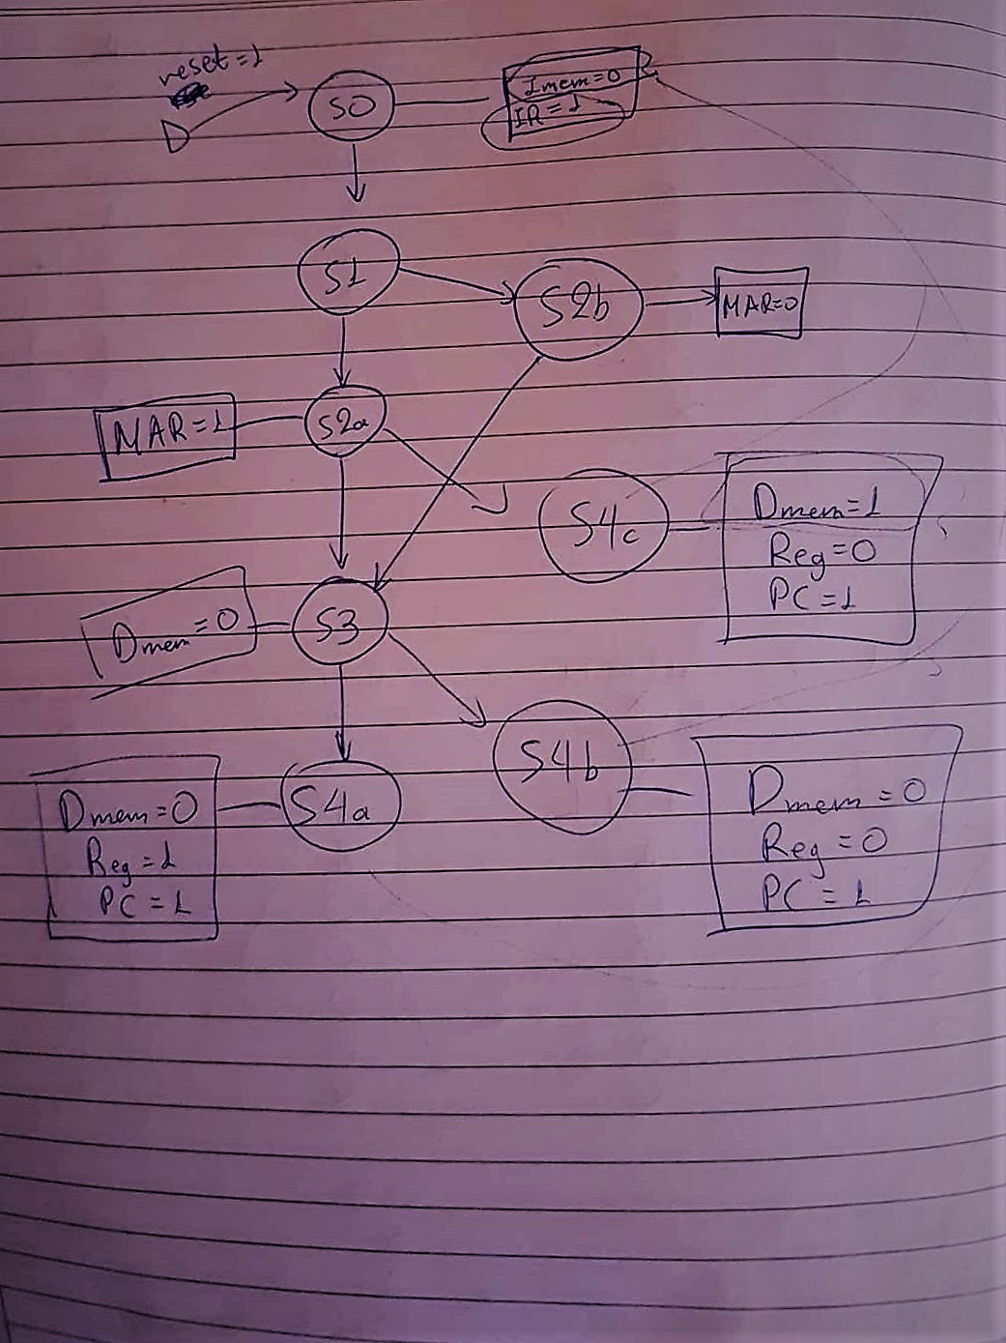

Παραδίδεται στο δεύτερο σημείο ελέγχου.
- ΕΠΑΛΗΘΕΥΣΗ ΟΡΘΗΣ ΣΧΕΔΙΑΣΗΣ ΚΑΘΕ ΒΑΣΙΚΟΥ ΚΥΚΛΩΜΑΤΟΣ ΤΟΥ ΕΠΕΞΕΡΓΑΣΤΗ
  - ΕΠΙΠΕΔΟ ΔΙΟΔΟΥ ΔΕΔΟΜΕΝΩΝ (DATAPATH)
    - Αριθμητική και Λογική Μονάδα (ALU)
Να δοθεί το κατάλληλο VHDL test bench καθώς και τα αποτελέσματα των προσομοιώσεων (behavioral και post-route) με τον απαραίτητο σχολιασμό αυτών. Επίσης να δειχθεί η μεγαλύτερη καθυστέρηση διάδοσης και να συγκριθεί με τα αντίστοιχα αποτελέσματα των Post, Place and Route Static Timing Reports.
(Μόνο για το πιο πάνω ιεραρχικό επίπεδο της ALU). Να δώσετε τα απαραίτητα screenshots.
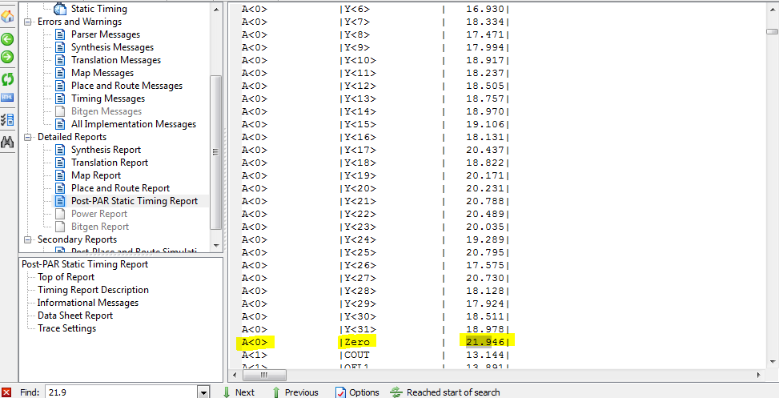
παρατηρούμε την πιο μεγάλη καθυστέρηση διάδοσης (~=21.946 ns ).
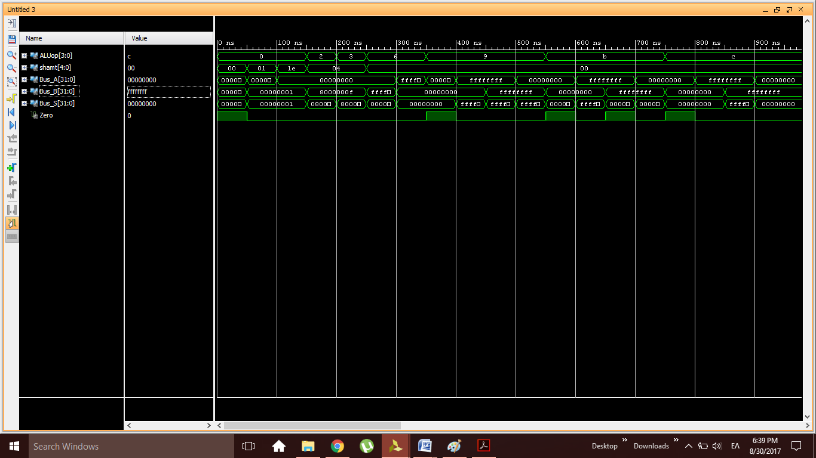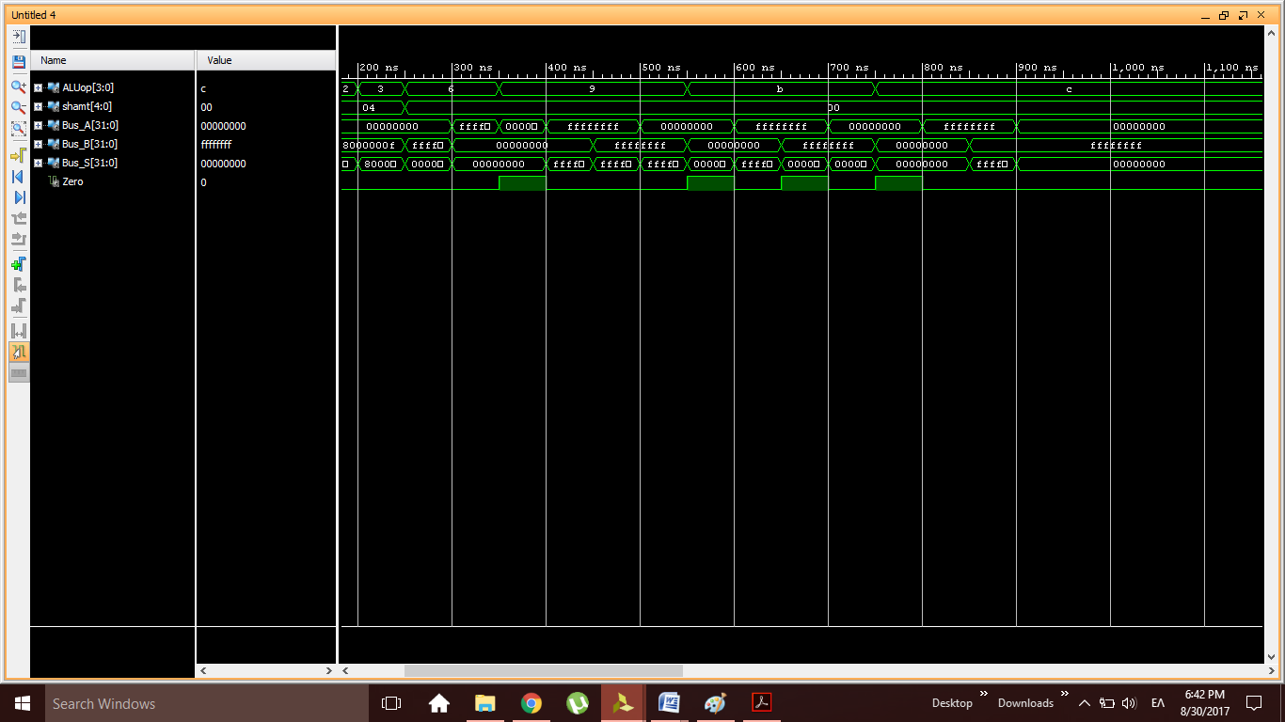

--------------------------------------------------------------------------------
--
-- Notes:
-- This testbench has been automatically generated using types std_logic and
-- std_logic_vector for the ports of the unit under test. Xilinx recommends
-- that these types always be used for the top-level I/O of a design in order
-- to guarantee that the testbench will bind correctly to the post-implementation
-- simulation model.
--------------------------------------------------------------------------------
LIBRARY ieee;
USE ieee.std_logic_1164.ALL;

-- Uncomment the following library declaration if using
-- arithmetic functions with Signed or Unsigned values
USE ieee.numeric_std.ALL;

ENTITY ALU3_TB IS
END ALU3_TB;

ARCHITECTURE behavior OF ALU3_TB IS

-- Component Declaration for the Unit Under Test (UUT)

COMPONENT ALU3
PORT(
ALUop : IN std_logic_vector(3 downto 0);
shamt : IN std_logic_vector(4 downto 0);
Bus_A : IN std_logic_vector(31 downto 0);
Bus_B : IN std_logic_vector(31 downto 0);
Bus_S : OUT std_logic_vector(31 downto 0);
Zero : OUT std_logic
);
END COMPONENT;

--Inputs
signal ALUop : std_logic_vector(3 downto 0) := (others => '0');
signal shamt : std_logic_vector(4 downto 0) := (others => '0');
signal Bus_A : std_logic_vector(31 downto 0) := (others => '0');
signal Bus_B : std_logic_vector(31 downto 0) := (others => '0');

--Outputs
signal Bus_S : std_logic_vector(31 downto 0);
signal Zero : std_logic;
-- No clocks detected in port list. Replace <clock> below with
-- appropriate port name

BEGIN

-- Instantiate the Unit Under Test (UUT)
uut: ALU3 PORT MAP (
ALUop => ALUop,
shamt => shamt,
Bus_A => Bus_A,
Bus_B => Bus_B,
Bus_S => Bus_S,
Zero => Zero
);

-- Stimulus process
stim_proc: process
begin
-- hold reset state for 100 ns.
wait for 50 ns;

-- insert stimulus here

-- SHIFTER-mux tests
ALUop <= "0000"; shamt <= "00001"; Bus_A <= X"0000001F"; Bus_B <= X"00000001";
wait for 50 ns;
ALUop <= "0000"; shamt <= "11110"; Bus_A <= X"00000000"; Bus_B <= X"00000001";
wait for 50 ns;
ALUop <= "0010"; shamt <= "00100"; Bus_A <= X"00000000"; Bus_B <= X"8000000F";
wait for 50 ns;
ALUop <= "0011"; shamt <= "00100"; Bus_A <= X"00000000"; Bus_B <= X"8000000F";
wait for 50 ns;

-- SLT tests
ALUop <= "0110"; shamt <= "00000"; Bus_A <= X"00000000"; Bus_B <= X"FFFFFFFF";
wait for 50 ns;
ALUop <= "0110"; shamt <= "00000"; Bus_A <= X"FFFFFFFF"; Bus_B <= X"00000000";
wait for 50 ns;

-- ADDSUB tests
ALUop <= "1001"; shamt <= "00000"; Bus_A <= X"00000000"; Bus_B <= X"00000000";
wait for 50 ns;
ALUop <= "1001"; shamt <= "00000"; Bus_A <= X"FFFFFFFF"; Bus_B <= X"00000000";
wait for 50 ns;
ALUop <= "1001"; shamt <= "00000"; Bus_A <= X"FFFFFFFF"; Bus_B <= X"FFFFFFFF";
wait for 50 ns;
ALUop <= "1001"; shamt <= "00000"; Bus_A <= X"00000000"; Bus_B <= X"FFFFFFFF";
wait for 50 ns;

ALUop <= "1011"; shamt <= "00000"; Bus_A <= X"00000000"; Bus_B <= X"00000000";
wait for 50 ns;
ALUop <= "1011"; shamt <= "00000"; Bus_A <= X"FFFFFFFF"; Bus_B <= X"00000000";
wait for 50 ns;
ALUop <= "1011"; shamt <= "00000"; Bus_A <= X"FFFFFFFF"; Bus_B <= X"FFFFFFFF";
wait for 50 ns;
ALUop <= "1011"; shamt <= "00000"; Bus_A <= X"00000000"; Bus_B <= X"FFFFFFFF";
wait for 50 ns;

-- LOGICU tests
ALUop <= "1100"; shamt <= "00000"; Bus_A <= X"00000000"; Bus_B <= X"00000000";
wait for 50 ns;
ALUop <= "1100"; shamt <= "00000"; Bus_A <= X"FFFFFFFF"; Bus_B <= X"00000000";
wait for 50 ns;
ALUop <= "1100"; shamt <= "00000"; Bus_A <= X"FFFFFFFF"; Bus_B <= X"FFFFFFFF";
wait for 50 ns;
ALUop <= "1100"; shamt <= "00000"; Bus_A <= X"00000000"; Bus_B <= X"FFFFFFFF";
wait for 50 ns;
wait;
end process;

END;

    - Αρχείο Καταχωρητών (RF)
Να δοθεί το κατάλληλο VHDL test bench καθώς και τα αποτελέσματα των προσομοιώσεων (behavioral και post-route) με τον απαραίτητο σχολιασμό αυτών. Επίσης να δειχθεί η μεγαλύτερη καθυστέρηση διάδοσης και να συγκριθεί με τα αντίστοιχα αποτελέσματα των Post, Place and Route Static Timing Reports.
(Μόνο για το πιο πάνω ιεραρχικό επίπεδο του RF). Να δώσετε τα απαραίτητα screenshots.

LIBRARY ieee;
USE ieee.std_logic_1164.ALL;
USE ieee.numeric_std.ALL;
USE std.env.all;

ENTITY tb_regfile IS
END tb_regfile;

ARCHITECTURE behavior OF tb_regfile IS

-- Component Declaration for the Unit Under Test (UUT)

COMPONENT regfile
PORT(
clock : in std_logic;
Reg_Write : in std_logic;
Reg_Imm_not : in std_logic;
rs : in std_logic_vector(4 downto 0);
rt : in std_logic_vector(4 downto 0);
rd : in std_logic_vector(4 downto 0);
Bus_W : in std_logic_vector(31 downto 0);
Bus_A : out std_logic_vector(31 downto 0);
Bus_B : out std_logic_vector(31 downto 0)
);
END COMPONENT;

--Inputs
signal clock : std_logic := '0';
signal Reg_Write : std_logic := '0';
signal Reg_Imm_not : std_logic := '0';
signal rs : std_logic_vector(4 downto 0) := (others => '0');
signal rt : std_logic_vector(4 downto 0) := (others => '0');
signal rd : std_logic_vector(4 downto 0) := (others => '0');
signal Bus_W : std_logic_vector(31 downto 0) := (others => '0');

--Outputs
signal Bus_A : std_logic_vector(31 downto 0);
signal Bus_B : std_logic_vector(31 downto 0);

-- Clock period definitions
constant clk_period : time := 50 ns;

BEGIN

-- Instantiate the Unit Under Test (UUT)
uut: regfile PORT MAP (
clock => clock,
Reg_Write => Reg_Write,
Reg_Imm_not => Reg_Imm_not,
rs => rs,
rt => rt,
rd => rd,
Bus_W => Bus_W,
Bus_A => Bus_A,
Bus_B => Bus_B
);

-- Clock process definitions
CLK_process :process
begin
clock <= '0';
wait for clk_period/2;
clock <= '1';
wait for clk_period/2;
end process;

-- Stimulus process
stim_proc: process
begin
wait for 100*clk_period;

-- The following loop writes to all registers R(i)<=i+100
-- Write register = rd (Reg_Imm_not=1)
for i in 0 to 31 loop
rs <=std_logic_vector(to_unsigned(i,rs'length));
rt <=std_logic_vector(to_unsigned(i,rt'length));
rd <=std_logic_vector(to_unsigned(i,rd'length));
Bus_W <=std_logic_vector(to_unsigned(i+100,Bus_W'length));
Reg_Write <='1';
Reg_Imm_not <='1';
wait for CLK_period;
Reg_Write <='0';
wait for CLK_period;
wait for CLK_period;
end loop;

Reg_Write <='0';
wait for CLK_period*10;

-- The following loop reads all registers R(i) through rs and rt ports
for i in 0 to 31 loop
rs <=std_logic_vector(to_unsigned(i,rs'length));
rt <=std_logic_vector(to_unsigned(i,rt'length));
rd <=(others => 'X');
Bus_W <=(others => 'X');
Reg_Write <='0';
Reg_Imm_not <='1';
wait for CLK_period;
end loop;

wait for CLK_period*10;

-- The following loop writes to all registers R(i)<=i+200
-- Write register = rt (Reg_Imm_not=1)
for i in 0 to 31 loop
rs <=std_logic_vector(to_unsigned(i,rs'length));
rt <=std_logic_vector(to_unsigned(i,rt'length));
rd <=(others => 'X');
Bus_W <=std_logic_vector(to_unsigned(i+200,Bus_W'length));
Reg_Write <='1';
Reg_Imm_not <='0';
wait for CLK_period;
Reg_Write <='0';
wait for CLK_period;
wait for CLK_period;
end loop;

Reg_Write <='0';
wait for CLK_period*10;

-- The following loop reads all registers R(i) through rs and rt ports
for i in 0 to 31 loop
rs <=std_logic_vector(to_unsigned(i,rs'length));
rt <=std_logic_vector(to_unsigned(i,rt'length));
rd <=(others => 'X');
Bus_W <=(others => 'X');
Reg_Write <='0';
Reg_Imm_not <='1';
wait for CLK_period;
end loop;

wait for CLK_period*10;
report "All patterns applied";
report "Simulation finished";

--finish(2);
stop(2);
wait;
end process;

END;

Τέλος εδώ επιβεβαιώνετε το Post route (Post Place and Route Model) με την πιο μεγάλη καθυστέρηση διάδοσης (~=22.940 ns )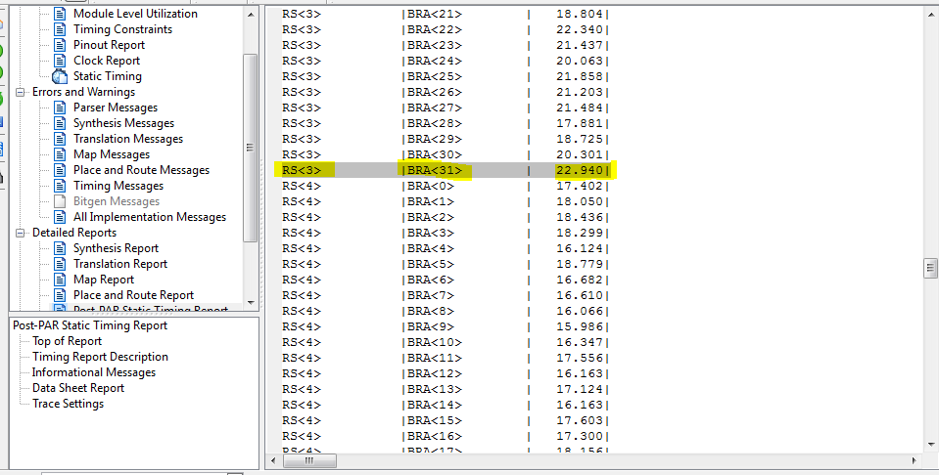

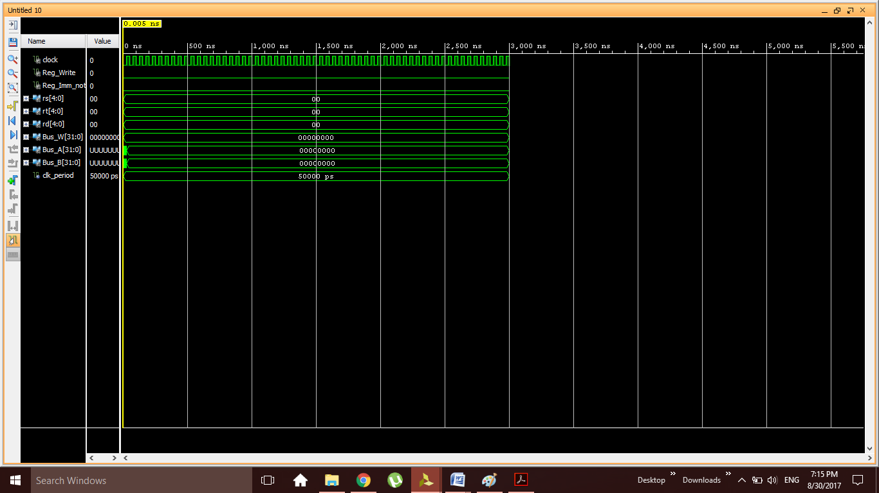

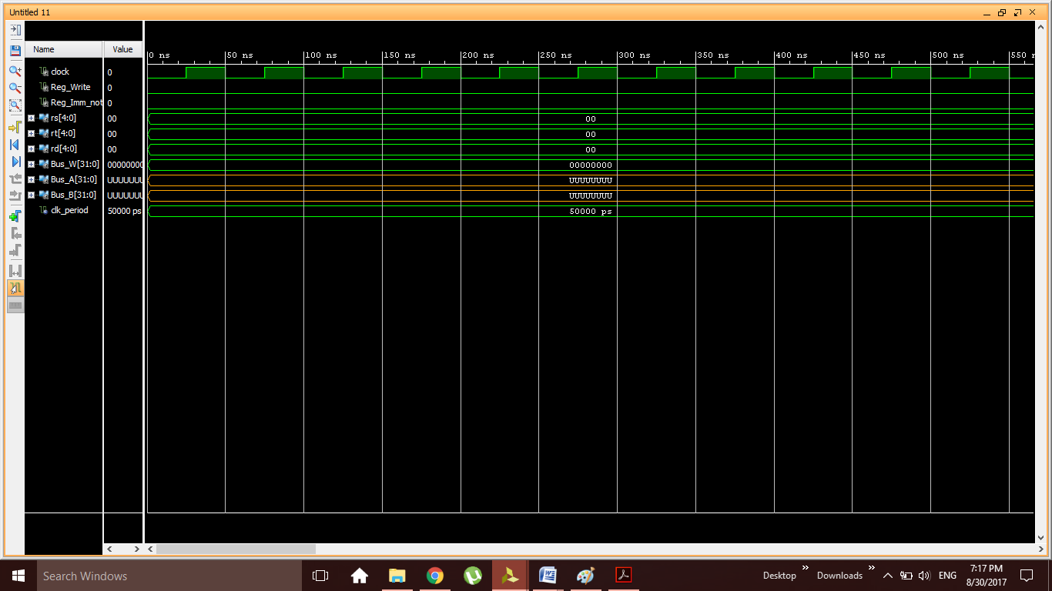
Παραδίδεται στο πρώτο σημείο ελέγχου.
  - ΕΠΙΠΕΔΟ ΕΠΕΞΕΡΓΑΣΤΗ (PROCESSOR – TOP LEVEL)
    - Συνδυαστική Μονάδα Ελέγχου
Να δοθεί το κατάλληλο VHDL test bench καθώς και τα αποτελέσματα των προσομοιώσεων (behavioral και post-route) με τον απαραίτητο σχολιασμό αυτών. Επίσης να δειχθεί η μεγαλύτερη καθυστέρηση διάδοσης και να συγκριθεί με τα αντίστοιχα αποτελέσματα του Post, Place and Route Static Timing Report. Να δώσετε τα απαραίτητα screenshots.
Το πιο αργο μονοπατι είναι αυτό του ALU_op και είναι ισο με 11.973.
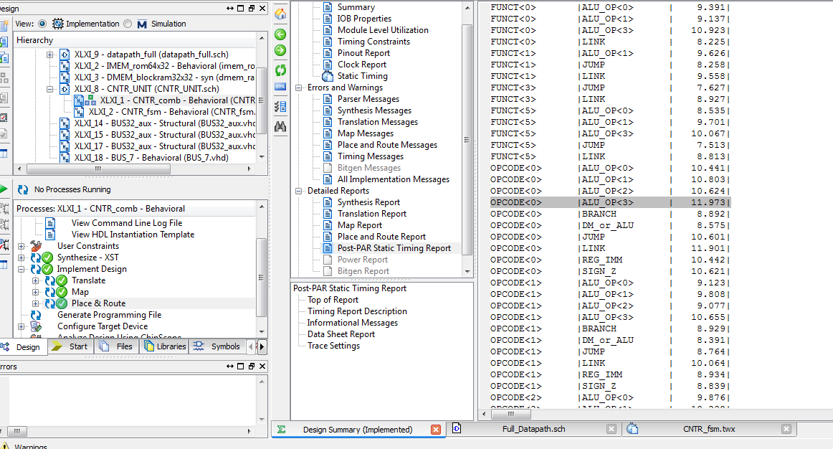

--------------------------------------------------------------------------------
--
-- Notes:
-- This testbench has been automatically generated using types std_logic and
-- std_logic_vector for the ports of the unit under test. Xilinx recommends
-- that these types always be used for the top-level I/O of a design in order
-- to guarantee that the testbench will bind correctly to the post-implementation
-- simulation model.
--------------------------------------------------------------------------------
LIBRARY ieee;
USE ieee.std_logic_1164.ALL;

-- Uncomment the following library declaration if using
-- arithmetic functions with Signed or Unsigned values
--USE ieee.numeric_std.ALL;

ENTITY CNTR_comb_tb IS
END CNTR_comb_tb;

ARCHITECTURE behavior OF CNTR_comb_tb IS

-- Component Declaration for the Unit Under Test (UUT)

COMPONENT CNTR_comb
PORT(
OPCODE : in STD_LOGIC_VECTOR (5 downto 0);
FUNCT : in STD_LOGIC_VECTOR (5 downto 0);
SorZ : out STD_LOGIC;
BorI : out STD_LOGIC;
ALUop : out STD_LOGIC_VECTOR (3 downto 0);
DMorALU : out STD_LOGIC;
Link : out STD_LOGIC;
RorI : out STD_LOGIC;
Branch : out STD_LOGIC;
NEorEQ : out STD_LOGIC;
Jump : out STD_LOGIC);

END COMPONENT;

--Inputs
signal OPCODE : std_logic_vector(5 downto 0) := (others => '0');
signal FUNCT : std_logic_vector(5 downto 0) := (others => '0');

--Outputs
signal SorZ : std_logic;
signal ALUop : std_logic_vector(3 downto 0);
signal RorI : std_logic;
signal BorI : std_logic;
signal DMorALU : std_logic;
signal NEorEQ : std_logic;
signal Link : std_logic;
signal Jump : std_logic;
signal Branch : std_logic;

-- No clocks detected in port list. Replace <clock> below with
-- appropriate port name

BEGIN

-- Instantiate the Unit Under Test (UUT)
uut: CNTR_comb PORT MAP (
OPCODE => OPCODE,
FUNCT => FUNCT,
SorZ => SorZ,
ALUop => ALUop,
RorI => RorI,
BorI => BorI,
DMorALU => DMorALU,
Link => Link,
Jump => Jump,
Branch => Branch,
NEorEQ => NEorEQ
);
-- *** Test Bench - User Defined Section ***
tb : PROCESS
BEGIN

OPCODE <= "100011"; --LW
WAIT FOR 100 NS;

OPCODE <= "101011"; --SW
WAIT FOR 100 NS;

OPCODE <= "001100"; --ANDI
WAIT FOR 100 NS;

OPCODE <= "000100"; --BEQ
WAIT FOR 100 NS;

-----------------------------------------------------------------------
OPCODE <= "000000"; --RTYPE
FUNCT <= "100001"; --ADDU
WAIT FOR 100 NS;

OPCODE <= "000000"; --RTYPE
FUNCT <= "100011"; --SUBU
WAIT FOR 100 NS;

OPCODE <= "000000"; --RTYPE
FUNCT <= "000010"; --SRLR
WAIT FOR 100 NS;

OPCODE <= "000000"; --RTYPE
FUNCT <= "101010"; --SLTR
WAIT FOR 100 NS;

OPCODE <= "000000"; --RTYPE
FUNCT <= "001000"; --JR
WAIT FOR 100 NS;

OPCODE <= "000000"; --RTYPE
FUNCT <= "001001"; --JALR
WAIT FOR 100 NS;

OPCODE <= "111111"; --FAULT
WAIT FOR 100 NS;

end process;

END;
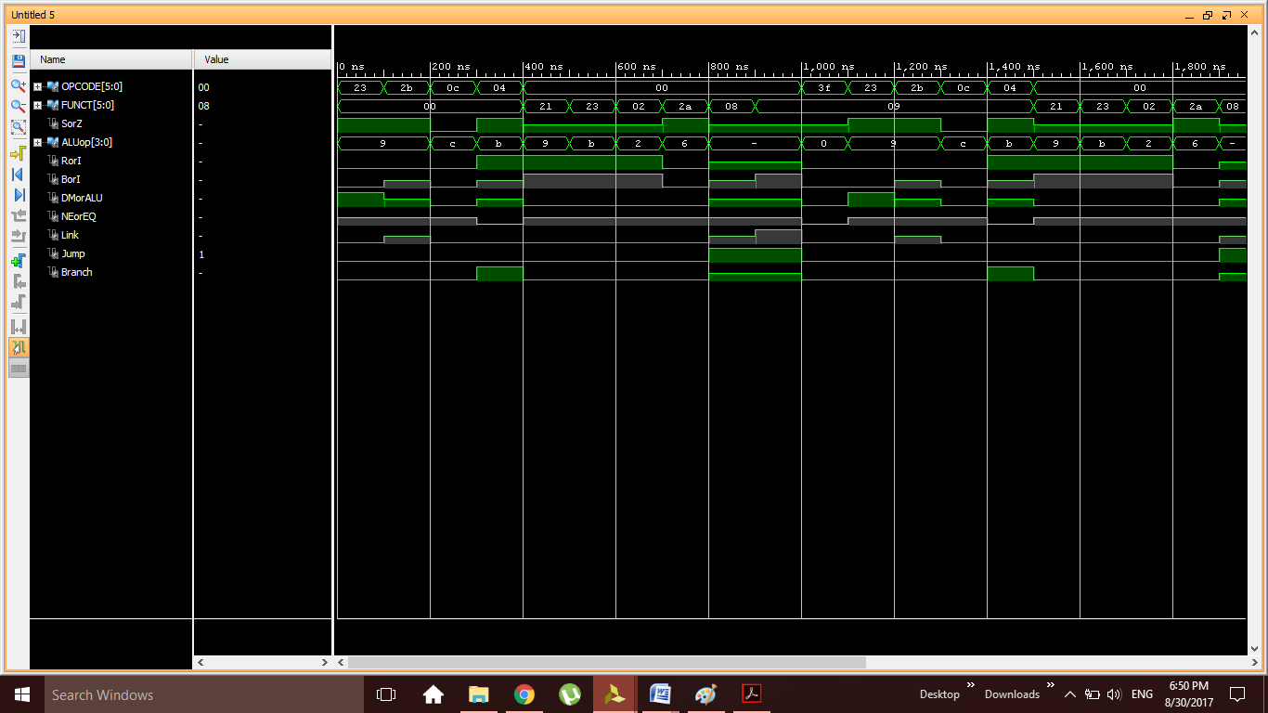

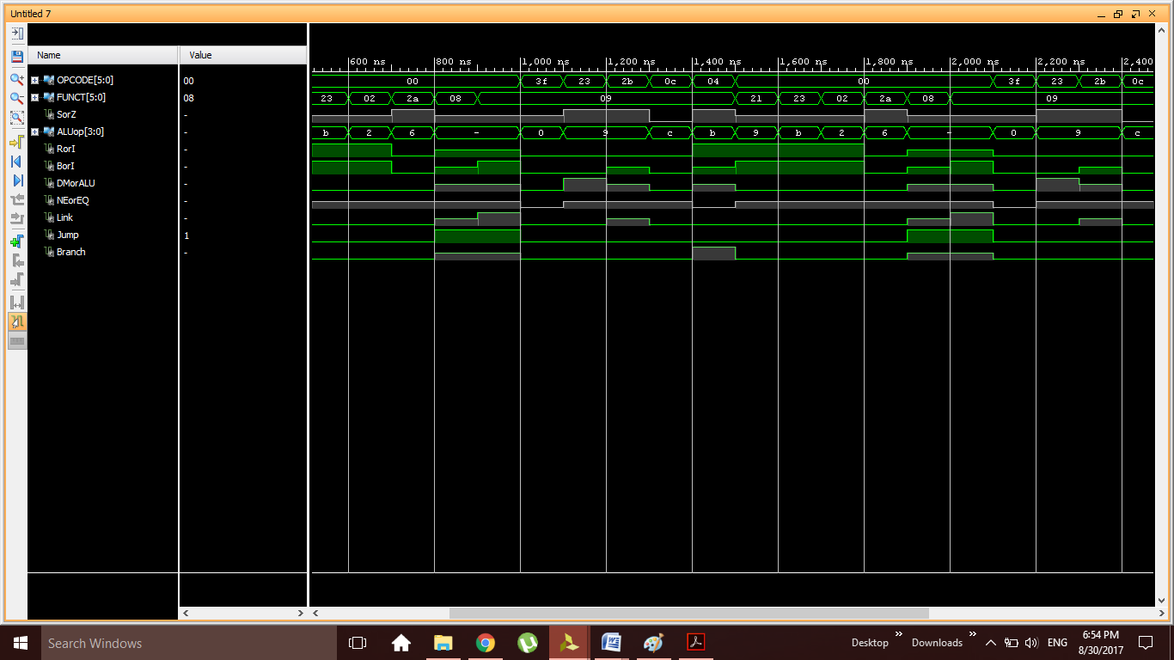
    - Ακολουθιακή Μονάδα Ελέγχου
Να δοθεί το κατάλληλο VHDL test bench καθώς και τα αποτελέσματα των προσομοιώσεων (behavioral και post-route) με τον απαραίτητο σχολιασμό αυτών. Επίσης να δειχθεί η μεγαλύτερη καθυστέρηση διάδοσης και να συγκριθεί με τα αντίστοιχα αποτελέσματα του Post, Place and Route Static Timing Report. Να δώσετε τα απαραίτητα screenshots.
Το πιο αργο μονοπατι είναι αυτό του IRWrite και είναι ισο με 10.377.
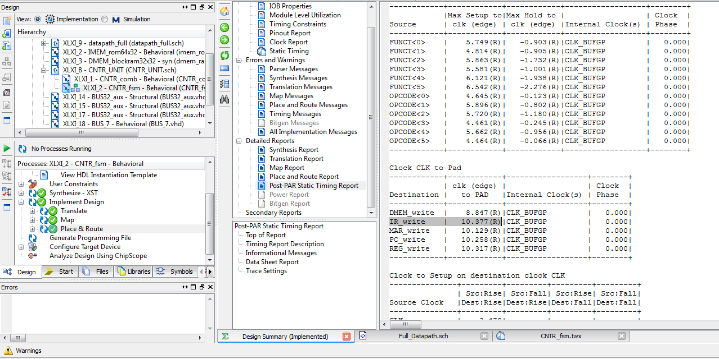
--------------------------------------------------------------------------------
--
-- Notes:
-- This testbench has been automatically generated using types std_logic and
-- std_logic_vector for the ports of the unit under test. Xilinx recommends
-- that these types always be used for the top-level I/O of a design in order
-- to guarantee that the testbench will bind correctly to the post-implementation
-- simulation model.
--------------------------------------------------------------------------------
LIBRARY ieee;
USE ieee.std_logic_1164.ALL;
USE ieee.numeric_std.ALL;
LIBRARY UNISIM;
USE UNISIM.Vcomponents.ALL;
ENTITY CNTR_fsm_tb IS
END CNTR_fsm_tb;

ARCHITECTURE behavior OF CNTR_fsm_tb IS

-- Component Declaration for the Unit Under Test (UUT)

COMPONENT CNTR_fsm
PORT(
OPCODE : in STD_LOGIC_VECTOR (5 downto 0);
FUNCT : in STD_LOGIC_VECTOR (5 downto 0);
RESET : in STD_LOGIC;
CLK : in STD_LOGIC;
PC_write : out STD_LOGIC;
IR_write : out STD_LOGIC;
MAR_write : out STD_LOGIC;
DMEM_write : out STD_LOGIC;
IMEM_write : out STD_LOGIC;
RF_write : out STD_LOGIC);

END COMPONENT;

--Inputs
signal CLK : std_logic := '0';
signal RESET : std_logic := '0';
signal OPCODE : std_logic_vector(5 downto 0) := (others => '0');
signal FUNCT : std_logic_vector(5 downto 0) := (others => '0');

--Outputs
signal PC_write : std_logic;
signal IMEM_write : std_logic;
signal IR_write : std_logic;
signal MAR_write : std_logic;
signal DMEM_write : std_logic;
signal RF_write : std_logic;

CONSTANT CLK_period : time := 100 ns;

BEGIN

-- Instantiate the Unit Under Test (UUT)
uut: CNTR_fsm PORT MAP (
CLK => CLK,
RESET => RESET,
OPCODE => OPCODE,
FUNCT => FUNCT,
PC_write => PC_write,
IMEM_write => IMEM_write,
IR_write => IR_write,
MAR_write => MAR_write,
DMEM_write => DMEM_write,
RF_write => RF_write
);

-- *** Independent clock generation ***
CLK_gen: PROCESS
BEGIN
CLK <= '1'; WAIT FOR CLK_period / 2;
CLK <= '0'; WAIT FOR CLK_period - CLK_period / 2;
END PROCESS;

-- *** Independent reset generation ***
Reset <= '1', '0' after CLK_period / 2;

-- *** Test Bench - User Defined Section ***
test_patterns : PROCESS
BEGIN
WAIT UNTIL (CLK'event AND CLK = '1');
WAIT FOR CLK_period / 10; -- the test patterns change after clock edge
RESET <= '1';
OPCODE <= "000000";
FUNCT <= "000000"; --START

WAIT UNTIL (CLK'event AND CLK = '1');
WAIT FOR CLK_period / 10; -- the test patterns change after clock edge
RESET <= '0';
OPCODE <= "100011"; -- LW

WAIT UNTIL (CLK'event AND CLK = '1');
WAIT FOR CLK_period / 10; -- the test patterns change after clock edge
RESET <= '0';
OPCODE <= "101011"; --SW

WAIT UNTIL (CLK'event AND CLK = '1');
WAIT FOR CLK_period / 10; -- the test patterns change after clock edge
RESET <= '0';
OPCODE <= "000000";
FUNCT <= "001000"; --JR

WAIT UNTIL (CLK'event AND CLK = '1');
WAIT FOR CLK_period / 10; -- the test patterns change after clock edge
RESET <= '0';
OPCODE <= "000000";
FUNCT <= "001001"; --JALR

WAIT UNTIL (CLK'event AND CLK = '1');
WAIT FOR CLK_period / 10; -- the test patterns change after clock edge
RESET <= '0';
OPCODE <= "000000";
FUNCT <= "100001"; --ADDRU

WAIT UNTIL (CLK'event AND CLK = '1');
WAIT FOR CLK_period / 10; -- the test patterns change after clock edge
RESET <= '0';
OPCODE <= "000000";
FUNCT <= "100011"; --SUBU

WAIT UNTIL (CLK'event AND CLK = '1');
WAIT FOR CLK_period / 10; -- the test patterns change after clock edge
RESET <= '0';
OPCODE <= "001100"; --ANDI

WAIT UNTIL (CLK'event AND CLK = '1');
WAIT FOR CLK_period / 10; -- the test patterns change after clock edge
RESET <= '0';
OPCODE <= "000000";
FUNCT <= "000010"; --SRLR

WAIT UNTIL (CLK'event AND CLK = '1');
WAIT FOR CLK_period / 10; -- the test patterns change after clock edge
RESET <= '0';
OPCODE <= "000100"; --BEQ

WAIT UNTIL (CLK'event AND CLK = '1');
WAIT FOR CLK_period / 10; -- the test patterns change after clock edge
RESET <= '0';
OPCODE <= "001010";
FUNCT <= "101010"; --SLT

WAIT UNTIL (CLK'event AND CLK = '1');
WAIT FOR CLK_period / 10; -- the test patterns change after clock edge
RESET <= '0';
OPCODE <= "101010"; --CHECK FOR FAULT-SAFE FUNCTION

WAIT UNTIL (CLK'event AND CLK = '1');
WAIT FOR CLK_period / 10; -- the test patterns change after clock edge
RESET <= '0';
OPCODE <= "001111"; --CHECK FOR FAULT-SAFE FUNCTION

WAIT UNTIL (CLK'event AND CLK = '1');
WAIT FOR CLK_period / 10; -- the test patterns change after clock edge
RESET <= '0';
OPCODE <= "000000"; --CHECK FOR FAULT-SAFE FUNCTION
FUNCT <= "111111";

WAIT UNTIL (CLK'event AND CLK = '1');
WAIT FOR CLK_period / 10; -- the test patterns change after clock edge
RESET <= '0';
OPCODE <= "000000"; --CHECK FOR FAULT-SAFE FUNCTION
FUNCT <= "110001";

WAIT FOR CLK_period;

end process;

END;

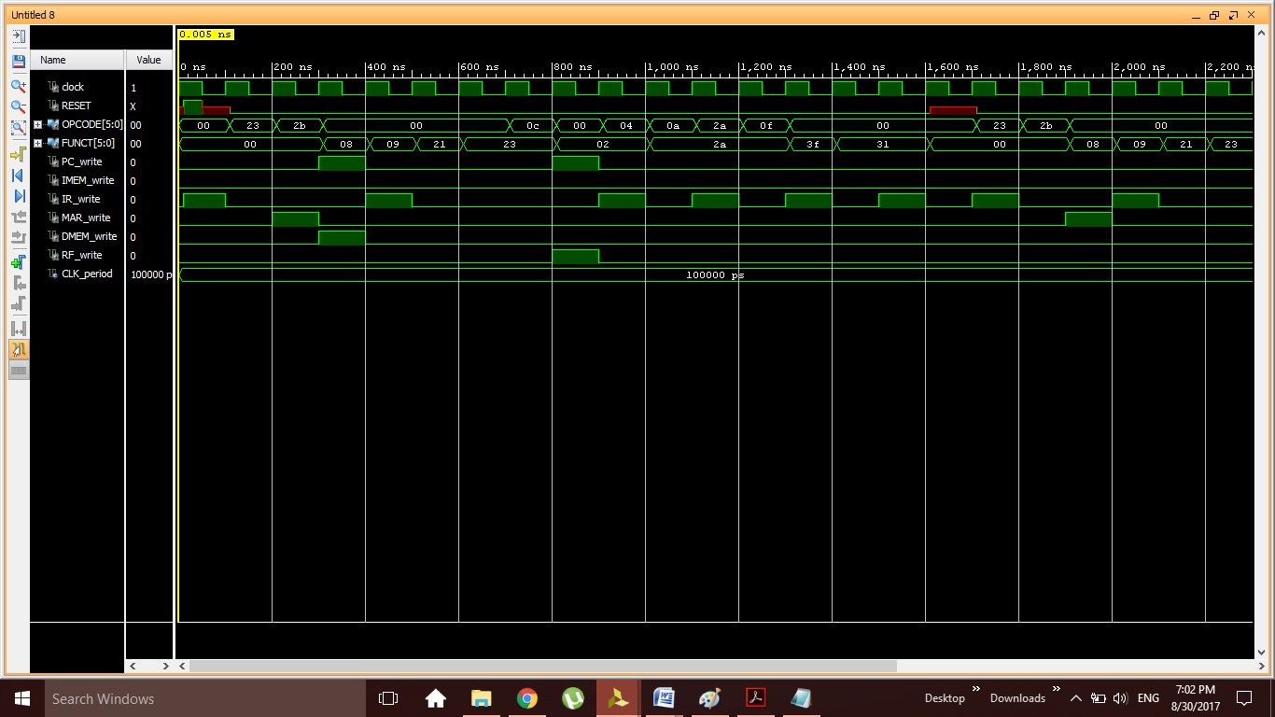

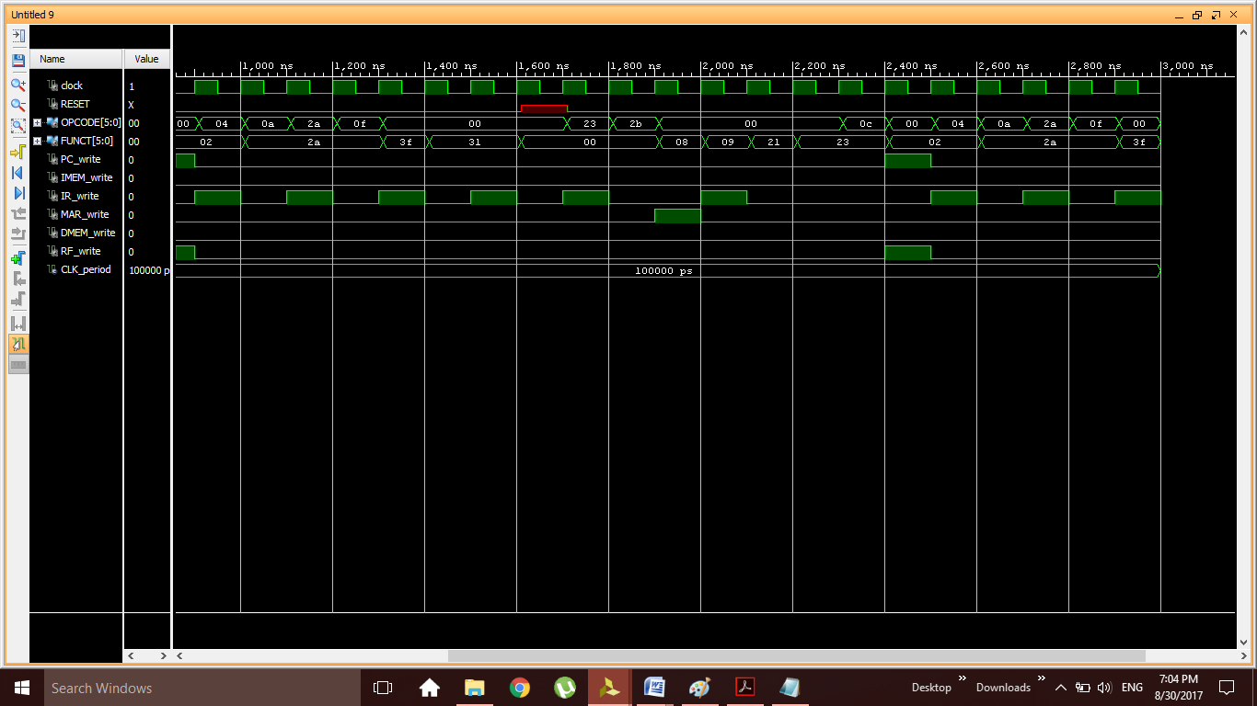

Παραδίδεται στο δεύτερο σημείο ελέγχου.
- ΕΠΑΛΗΘΕΥΣΗ ΟΡΘΗΣ ΣΧΕΔΙΑΣΗΣ ΕΠΕΞΕΡΓΑΣΤΗ
- Πρόγραμμα σε γλώσσα Assembly
Το πρόγραμμα σε assembly που χρησιμοποίησα είναι το ακόλουθο:
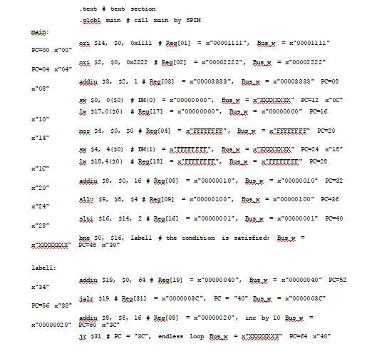
Το προκύπτον μετά τη μεταγλώττιση αρχείο DISASM είναι το ακόλουθο:
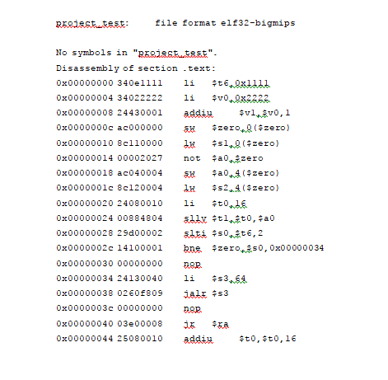
Οι απαιτούμενες αλλαγές στο αρχείο DISASM είναι οι ακόλουθες:
►Βγάζω τις nop από το αρχειο DISASM.
►H jr εντολή πρέπει να μπει στο τέλος του προγράμματος, καθώς o μεταγλωττιστής είναι ρυθμισμένος για MIPS επεξεργαστές που υλοποιούν το delay slot, δηλαδή με μία εντολή διακλάδωσης (beq, bne) ή μεταπήδησης (jalr, jr) να εκτελείται πάντα και η αμέσως επόμενη εντολή.
►Βάζω στο bne στο label την τιμη 0x00000030 έτσι ώστε όταν χρειαστεί να μεταπηδά στο τέλος του προγράμματος.
►Τροποποιώ την αρίθμηση στο κείμενο από εντολή σε εντολή.

Ο κώδικας VHDLτης μνήμης εντολών είναι ο ακόλουθος:
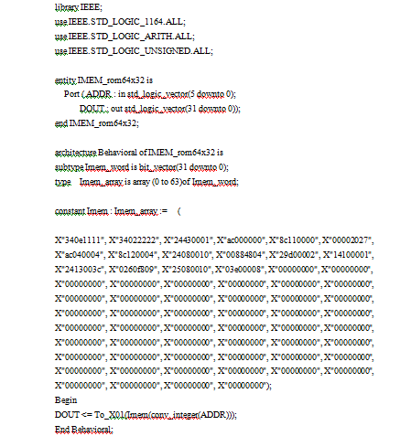
Ο πίνακας ελέγχου είναι ο ακόλουθος:
Εντολη | Clk | Pc | Ir | Aluout | Zero | Mar | Mdrin | W
Lw | 400 | 0x00000010 | 8c110000
 | 500
 | 600 |  |  | 00000000 | 1
 | 700 |  |  |  |  | 00000000
 | 800
Sw | 900 | 0x0000000c | ac000000
 | 1000
 | 1100 |  |  | 00000000 | 1 | 00000000
 | 1200 |  |  |  |  |  | 00000000
addiu | 1300 | 000008 | 24430001
 | 1400
 | 1500 |  |  | 00000000 | 1
 | 1600
Subu | 1700 | 0x00000014 | 00002027
 | 1800
 | 1900 |  |  | 00000000 | 1
 | 2000
or | 2100 | 0x00000000 | 340e1111
 | 2200
 | 2300 |  |  | 00001000 | 0
 | 2400
Sra | 2500 | 0x00000024 | 00884804
 | 2600
 | 2700 |  |  | 00000001 | 0
 | 2800
slti | 2900 | 0x00000028 | 29d00002
 | 3000
 | 3100 |  |  | 00000001 | 0
 | 3200
beq | 3300 | 0x0000002c | 14100001
 | 3400
 | 3500 |  |  | 00000001 | 0
 | 3600
or | 3700 | 000020 | 2408fff0
 | 3800
 | 3900 |  |  | 00000000 | 1
 | 4000
jalr | 4100 | 0x00000034 | 24130040
 | 4200
 | 4300
Jr | 4400 | 0x0000003c | 03e00008
 | 4500
 | 4600

Παραδίδεται στο δεύτερο σημείο ελέγχου.
- Αποτελέσματα προσομοιώσεων στο επίπεδο του επεξεργαστή
    - Behavioral Simulation
Να επαληθεύσετε τον πίνακα ελέγχου. Να δώσετε κάποια ενδεικτικά screenshots.
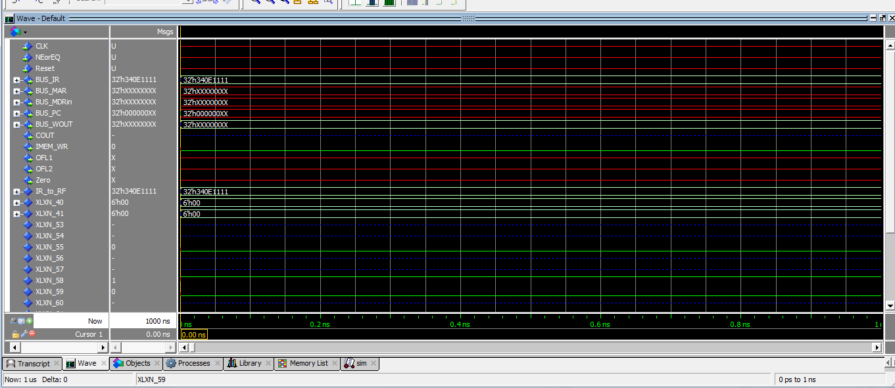
    - Post-Route Simulation
Ποια είναι η συχνότητα λειτουργίας του επεξεργαστή;
Η συχνοτητα λειτουργιας του επεξεργαστη είναι 1/ 19.917 ns=50.2084 Hz.
Το ρολοι του επεξεργαστη μετα από τη διαδικασια Implement Top Module είναι ισο με 13.126.

Παραδίδεται στο δεύτερο σημείο ελέγχου.
- ΑΠΟΤΕΛΕΣΜΑΤΑ ΤΗΣ ΣΥΝΘΕΣΗΣ ΚΑΙ ΥΛΟΠΟΙΗΣΗΣ ΤΟΥ ΕΠΕΞΕΡΓΑΣΤΗ
- Design Summary
Όπως στο υπόδειγμα προσομοίωσης.
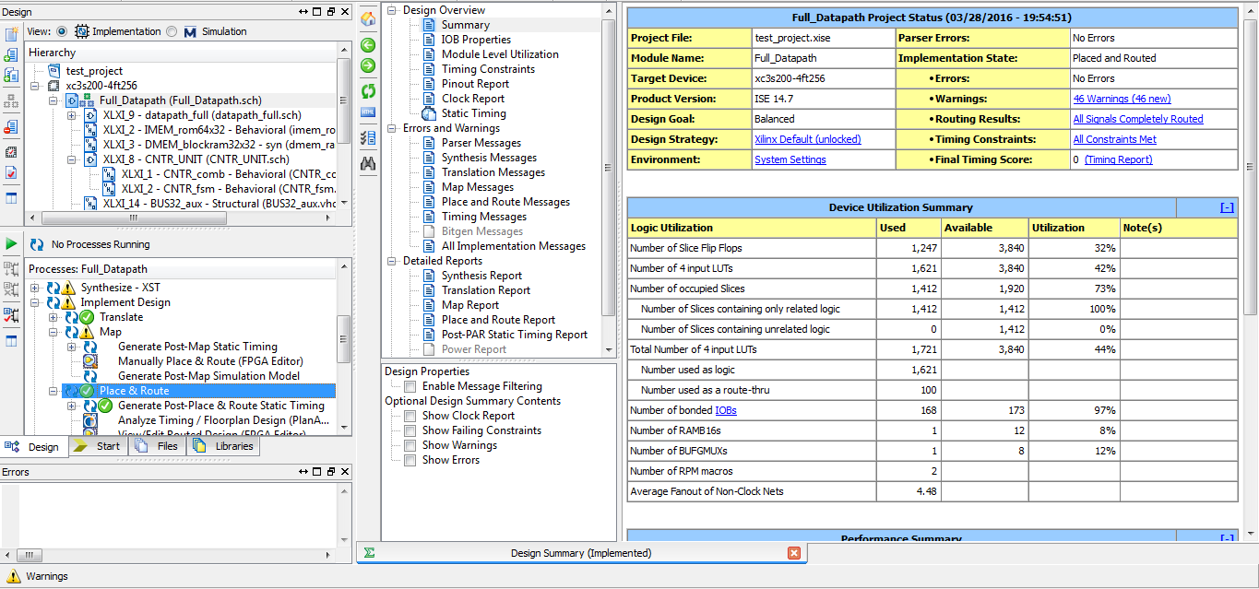
- Post, Place and Route Static Timing Report
Όπως στο υπόδειγμα προσομοίωσης.
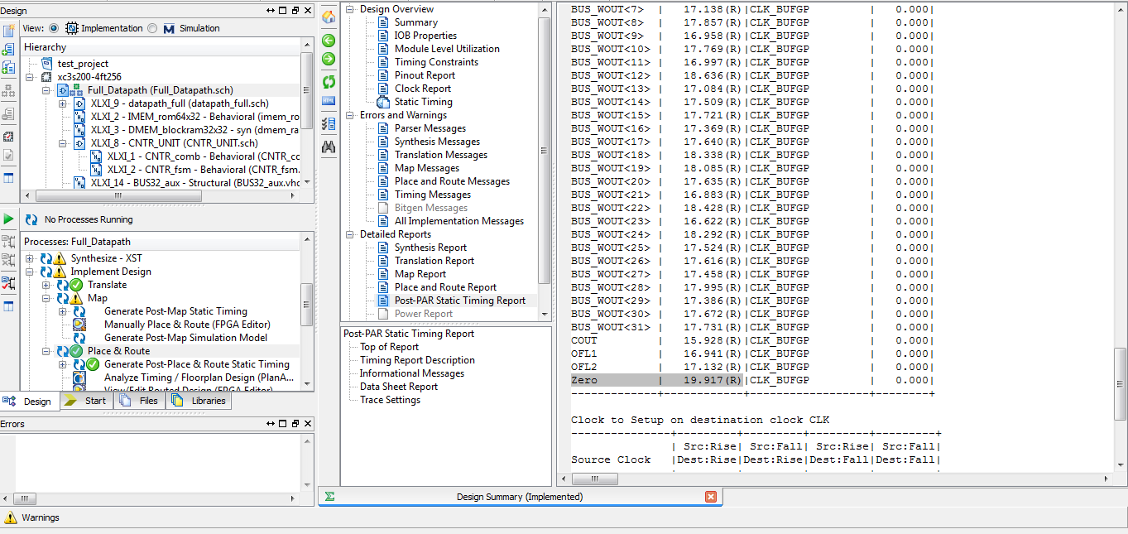

- Σχολιασμός των αποτελεσμάτων
Σύμφωνα με τα αποτελέσματα ο επεξεργαστής έχει ως ελαχιστη περίοδο τα 19.917 ns. Το πιο αργό μονοπάτι είναι αυτό της εξοδου Zero, δηλαδή του στοιχείου εκείνου που ελέγχει αν η έξοδος της ALU εχει όλα τα στοιχεια ισα με μηδεν. Αυτό είναι φυσιολογικο επειδη στο μονοπατι αυτό η πληροφορία περνάει μέσα από τις περισσότερες πύλες.
…………………………………………………………………………………………
…………………………………………………………………………………………
…………………………………………………………………………………………
…………………………………………………………………………………………
…………………………………………………………………………………………
…………………………………………………………………………………………

Παραδίδεται στο δεύτερο σημείο ελέγχου.

