Lisa Bourlier

ID : 5999222005

Laravel bootcamp

First, installing laravel and Laravel breeze and registering.

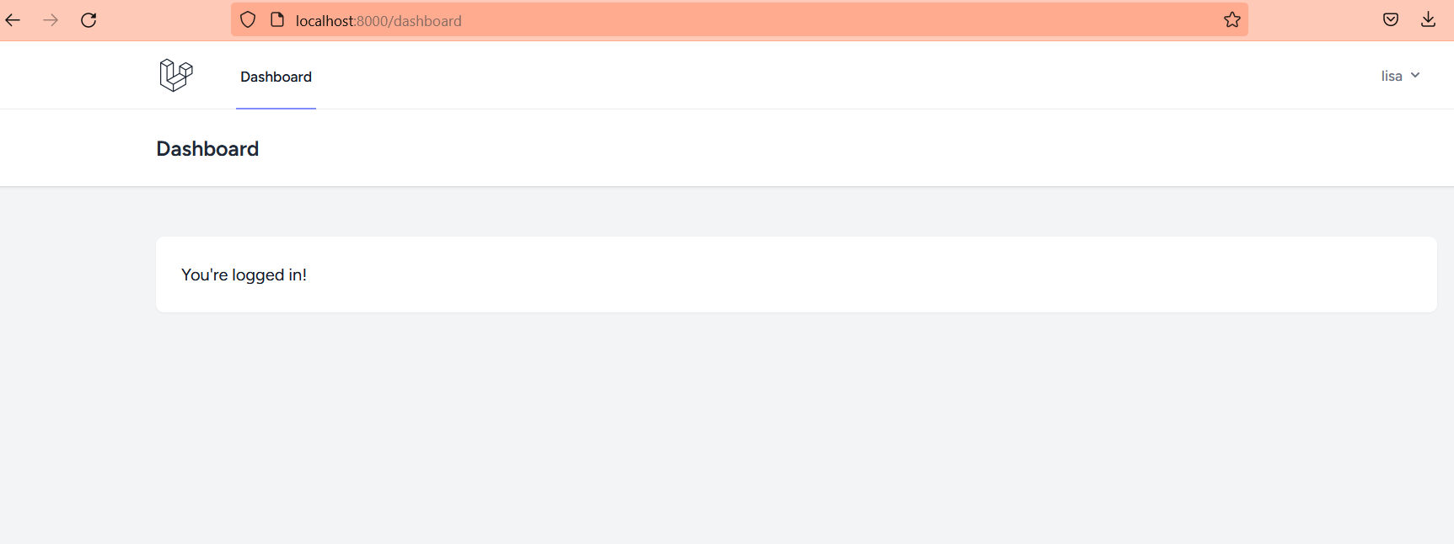

I had some difficulties to run Laravel and register because the database was not working. So, I changed it to sqlite in the .env file.

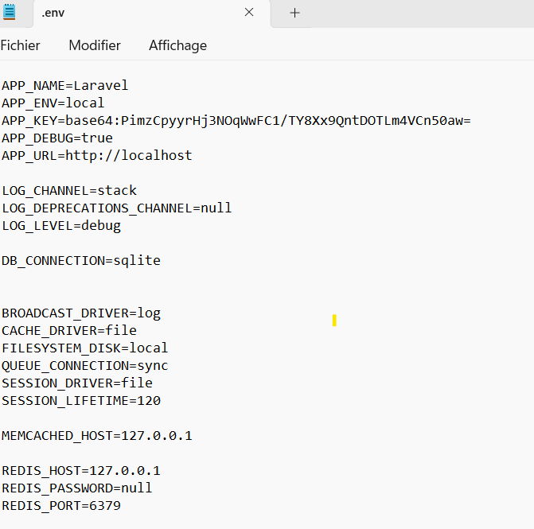

When it finally worked, I started creating the first chirp and you can see a message appear in the dialog box

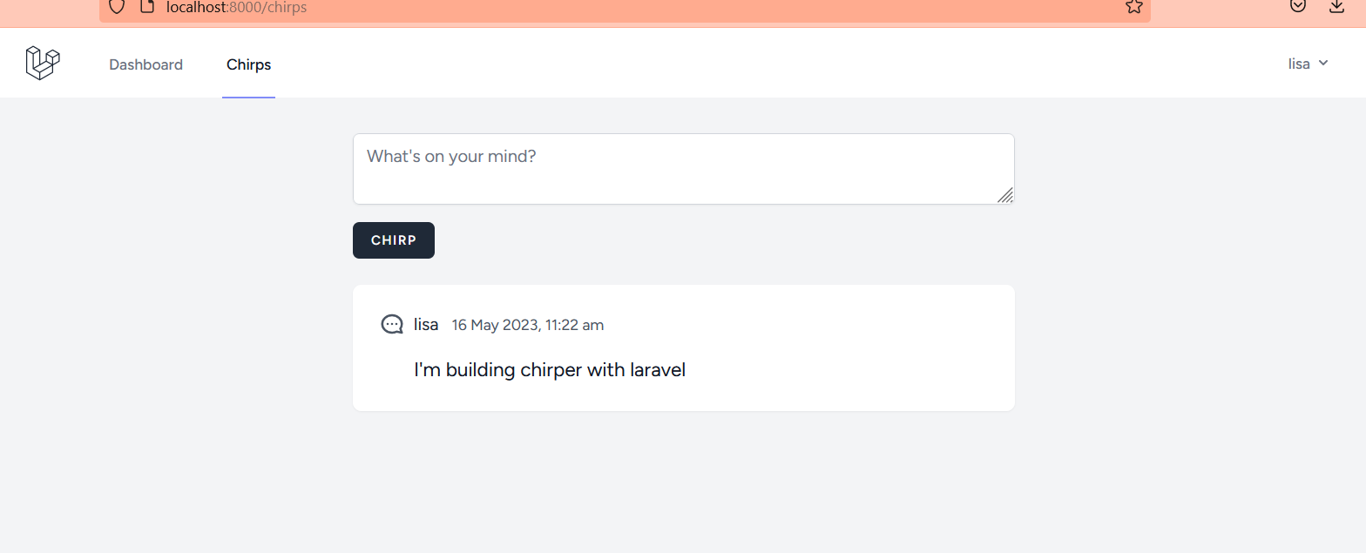

Here are some exemples of chirpers I send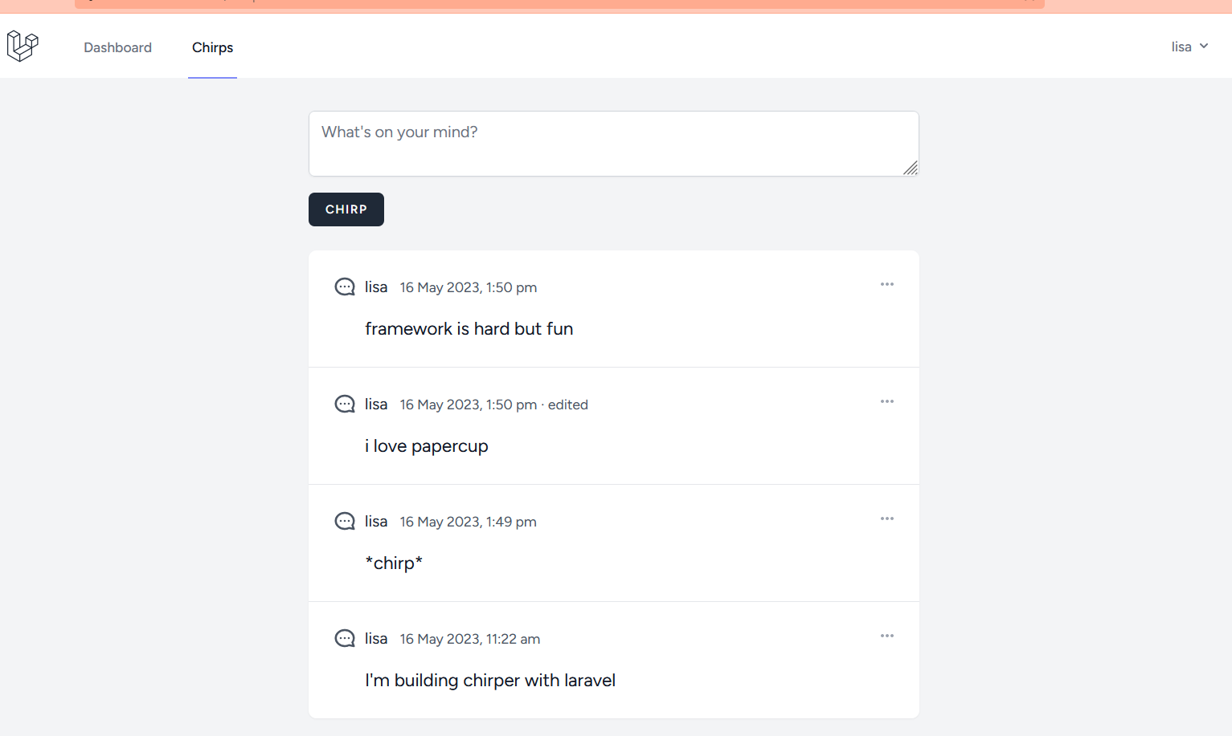

Then I implemented the menu with edit and delete

