Lisa BOURLIER

ID : 5999222005

Framework programming assignment 1

I have encountered a lot of problems with my github, to push some of my work and to put the images into the readme. So I will be putting the images in this document as well.

**exercise 1:**

1. create the flyouts

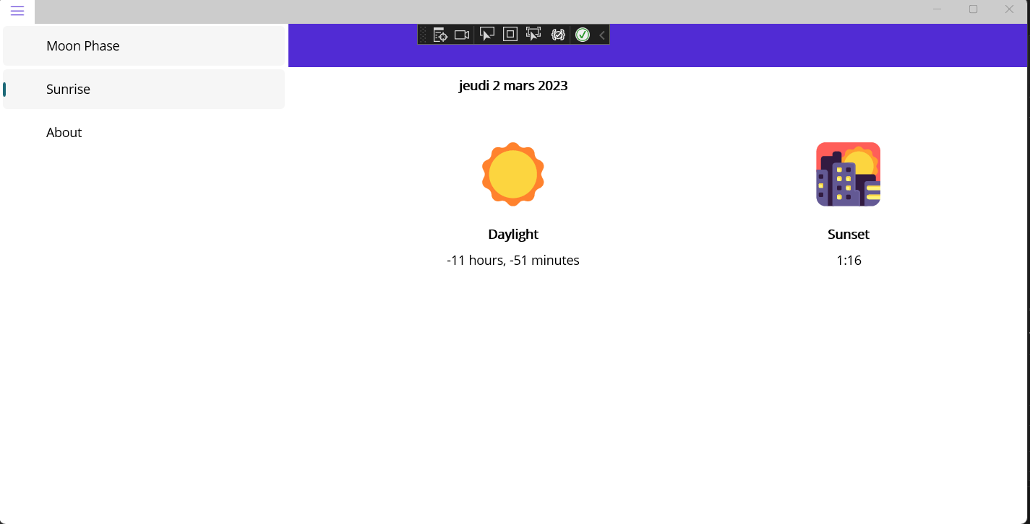

2) adding icons

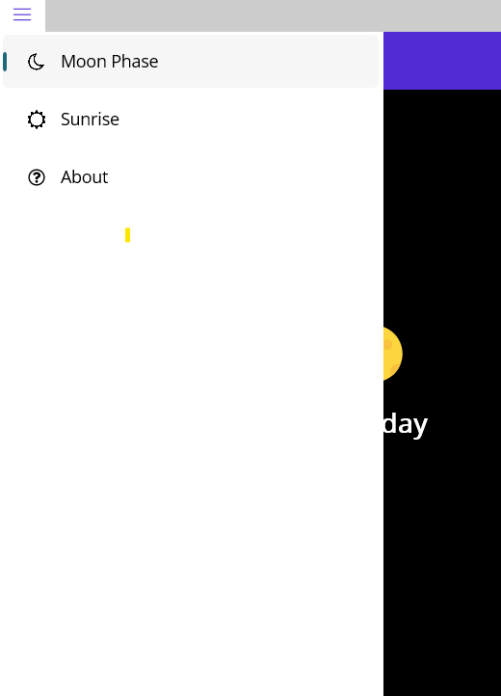

3) adding flyout header

4) adding author page

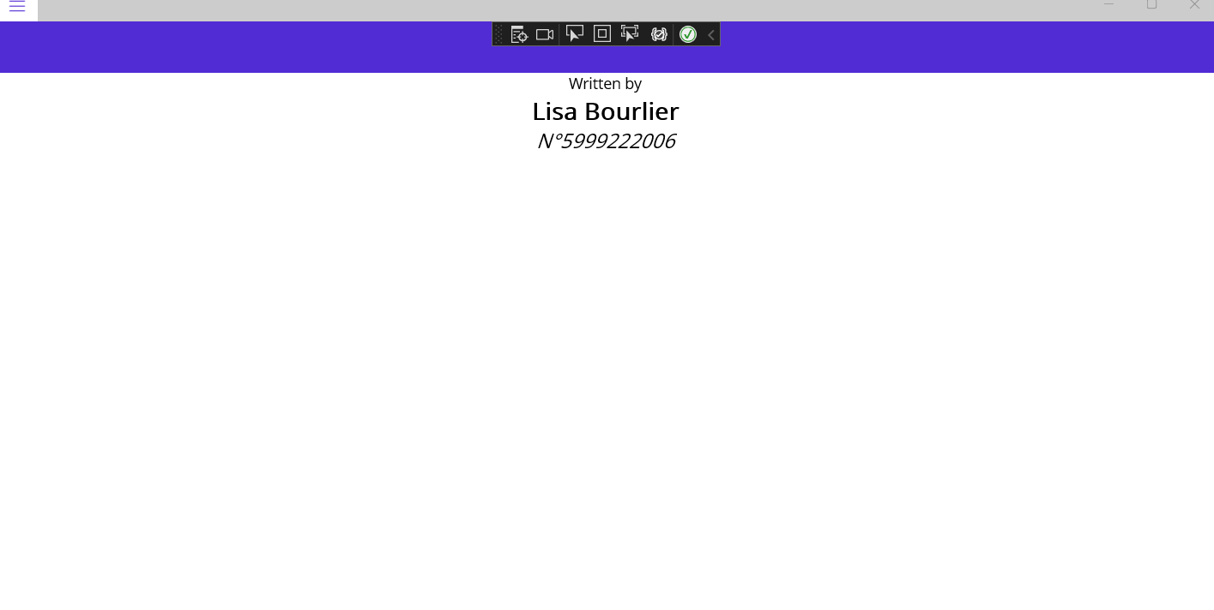

**exercise 2:**

1) create tabs

1. add flyout 'About'

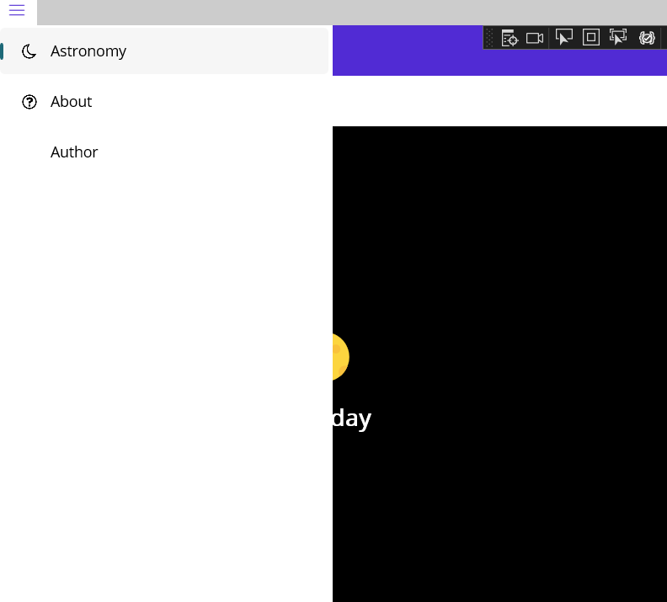

1. add author page

**exercise 3:**

1. author page

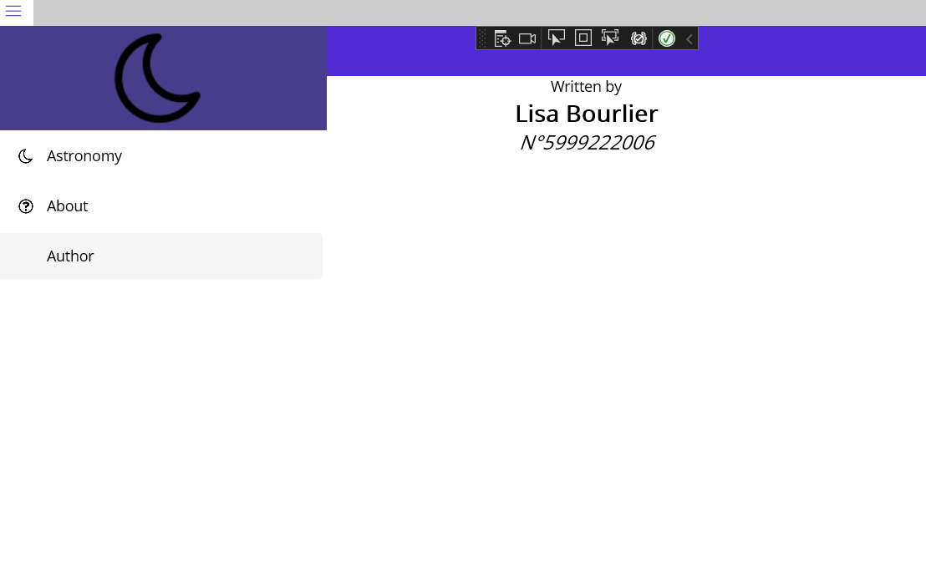

2) bodies page

3)astronomical body page

WARNING

I could not commit and push my work on the exercises 2 and 3 because their directories appeared as empty on my cmd. However, you can see what I did on the photos.