Lisa BOURLIER

ID : 5999222005

Framework programming Databinding and MVVM

Exercise 1 – Data binding and MVVM :

1. Simple MVVM

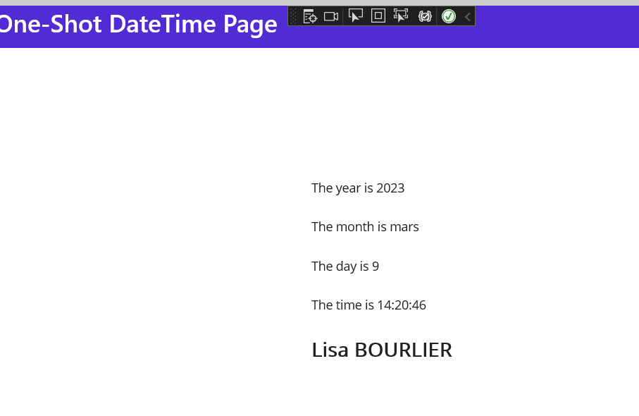

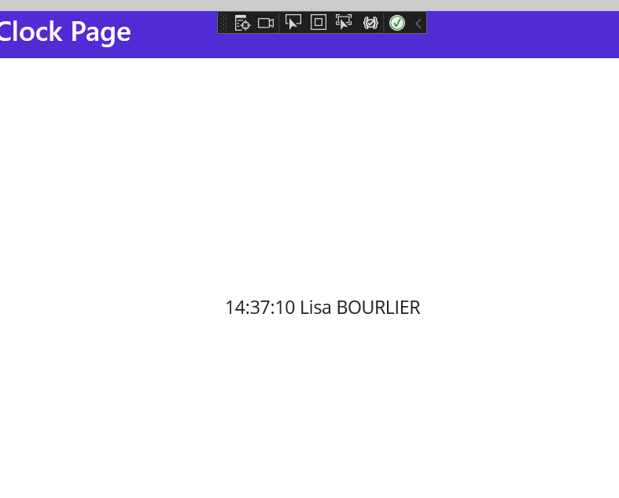

1. Interactive MVVM



1. Commanding MVVM

