Lisa Bourlier

Id : 5999222005

Framework programming assignement2

Exercise 1

1. Getting the sand box and cloning the parts rest web service

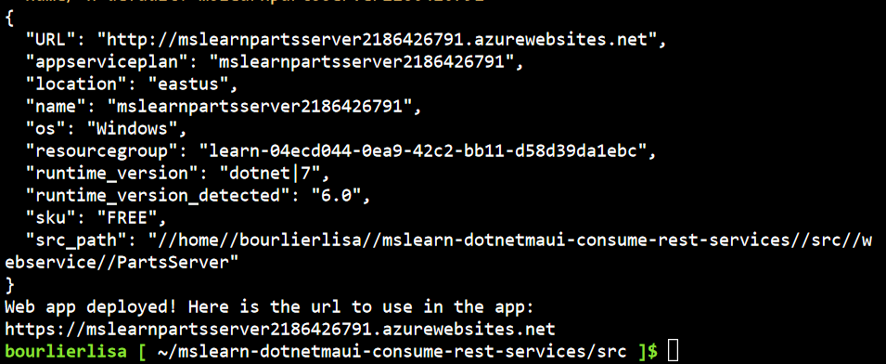

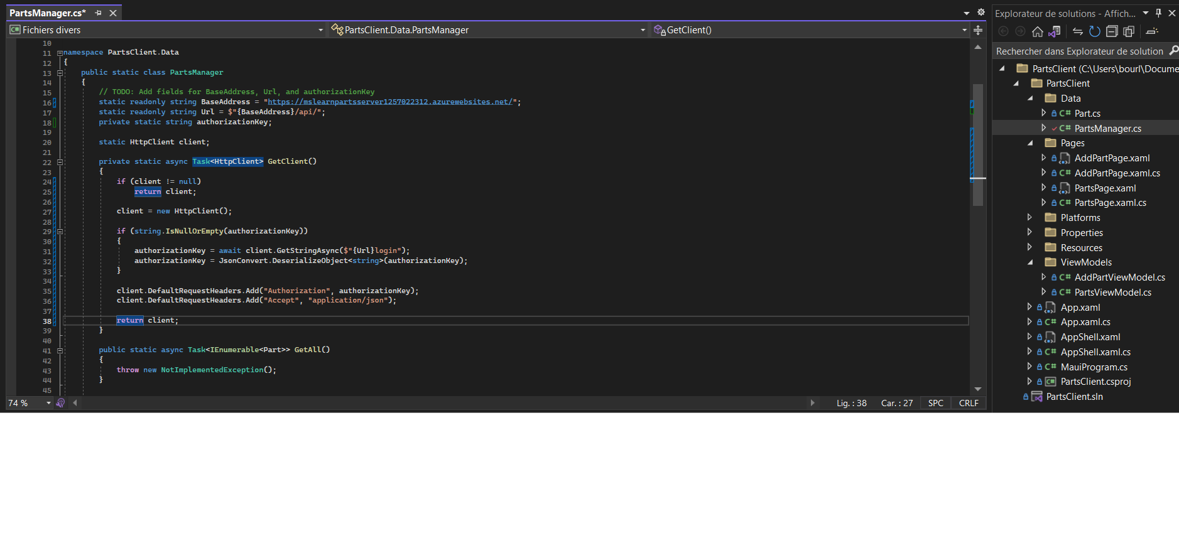

1. Retrieve information for Parts

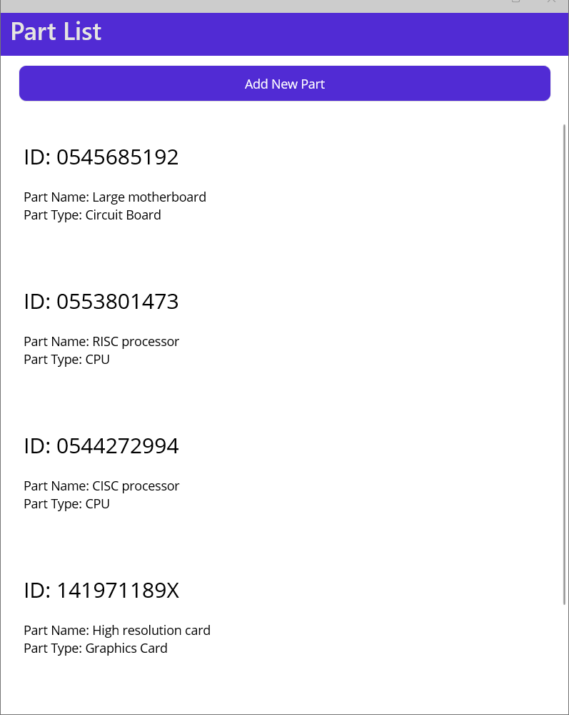

1. Add information (at the end)

1. Update the information in Parts

1. Delete information in Parts



