Lisa Bourlier

Id : 5999222005

Framework programming assignment 2

Exercise 2

1. Use SQLite synchronously

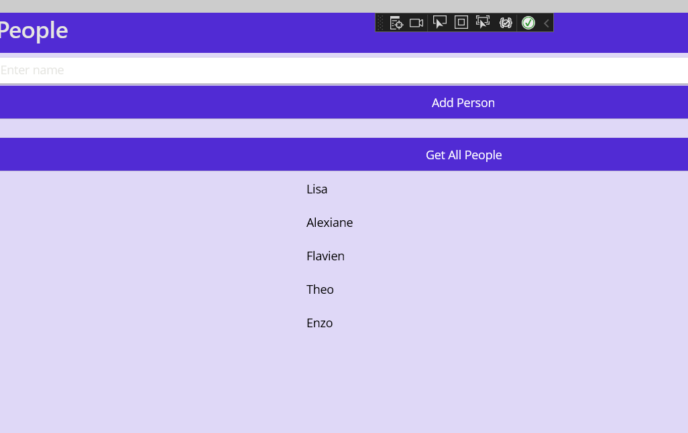

1. Use SQLite asynchronously

