Create proper and effective Test Data sets for Application Development!
If the test data is not proper, it will lead into many problems in application and systems development:
- You might think something is wrong (false positive), but in fact the problem is in the test data that is not logical, or even has mistakes.
- You might also think some feature works (false negative), as the test data is missing such variation that would reveal that the feature does not work in all situations.
- Or it might be hard to track a problem in our code or application as test data doesn’t allow for versatile revealing tests that would test the system from many angles and with variety of business cases.
- While programming – First technical testing
Use at least 5 objects/items/rows of each.
Reason1: After that you have the first item (1.), the item after first item (2.), the last item (5.), the item before the last item (4.) and one neutral item which is not at those special places (3.).
Reason2: If you code does not work with 5 items, it won’t work with million. (Not proof the other way)
- Real smoke testing of features in a larger application proto
To ensure that some feature really works (technically speaking) in all special cases, you’ll need at least 5 rows in some far-end table and more in the other tables. E.g. 5 – 10 – 30 – 20 – 10
Reasons: You’ll need variation in the test data = variation to possibilities for defining test cases. In short, remember these numbers: You’ll need items that have the following relationships to other tables/types:
0 children
1 child
5 children (many children)
And here is a picture of the principle for adding variation to test data. Above typical beginner test data of 1-1-1-1 -nature. Below the good one with parents with no children, parents with 1, and parents with many children:
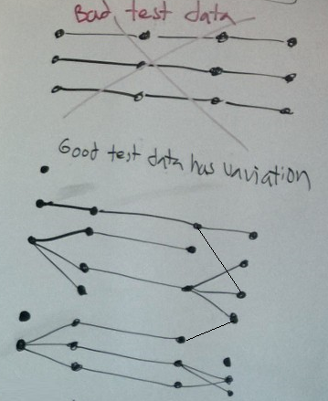
1. b “Empty” test data (an additional set of insert statements) for testing how the app works, looks, and behaves with empty lists = empty database (or empty data tables with only codes in code tables, e.g. colors in Color table)
- (In system testing) To ensure that empty lists of any kind won’t cause anomalies in technical ways NOR in user experience (UX) or in graphics. This is something many developers often forget.
- (While in technical tests like module / unit tests) In addition to empty test data, programmers often forget to test their modules, methods, and API interfaces with special values like nulls or empty objects or empty strings etc.:
e.g. the following: last accepted and first unallowed boundary values, 0, -1, negative values, null references, database NULL, database searches that return an empty result set, empty String “”, emptyish Strings with white space or punctuation “ “, “.”, “\t” =tabulator, “\n”,
- Usability testing
200-500 rows per those tables that naturally have more than just a few lines. Natural number to those who do have such, e.g. list of countries. Some lists naturally short, like “Product Owner, Developer, Scrum Master”.
Reasons: You’ll realize the possible need for e.g. search / filtering / paginating / visualizing scroll / memory aids /…
- Performance testing
From 100 000 to millions of rows depending on the business case, technology, platform, networking, scalability of the solution, the nature and length of the data on each row …
Reasons: to test network bottlenecks, memory, processing power, concurrency locks between database items …
Remark, while using auto-incremented ids!!! (AUTO_INCREMENT, Identity, SEQUENCE, …product terms vary…)
- If you are using SQL DML INSERT statements to reset your database to the initial test data ‘snapshot’: You’ll have to count how many rows the previous table insert did enter => use those in next table statements as foreign keys. (And yes, we could also use database snapshot and recovery tools to simply write the test database tables to a certain situation, but we still need editable insert statements to create the snapshot in the first place.)
- In the case of external system relationships (e.g. to another REST API) make sure there is a fixed list of allowed values for the external ids and use only them. Otherwise, your test cases won’t work consistently! = regression testing impossible, and any testing needs manual fixing.)
- Deleting all data rows of a table doesn’t usually reset the automatically incremented ids. You’ll need to fully DROP TABLEs to reset the counter(s). (((Or run some other commands to reset the counter (e.g. ALTER TABLE ….)))
- If you remove individual rows, a hole is often left in the id chain. Thus, running through ids is never correct way to handle sets of rows that have auto-increment keys=ids. Well, never in other cases either. Better just always give nothing/null for insertion.
- Make each table’s ids look different. 1->, 101->,201->,1001->,2001->, 10001->, Helps a lot in debugging while developing features and code logic.
- Professional frameworks have ways to get back the inserted item/s’ id/s (that the database creates, and front end did not yet know).

