Name: Shweta Rawat

Employee ID: 902483

Batch: INTCDB21DW002

1. ls -l --sort=time | head -n 11 | tail

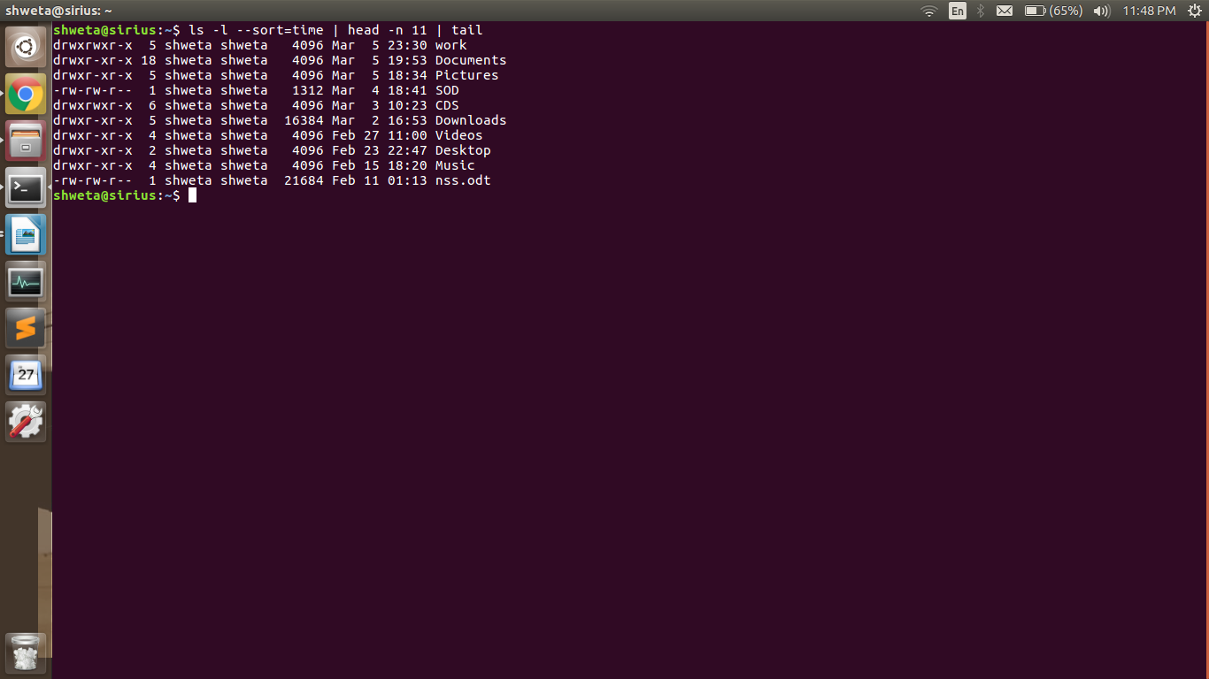

2. find -mtime -10 -exec ls -rtdl {} \;

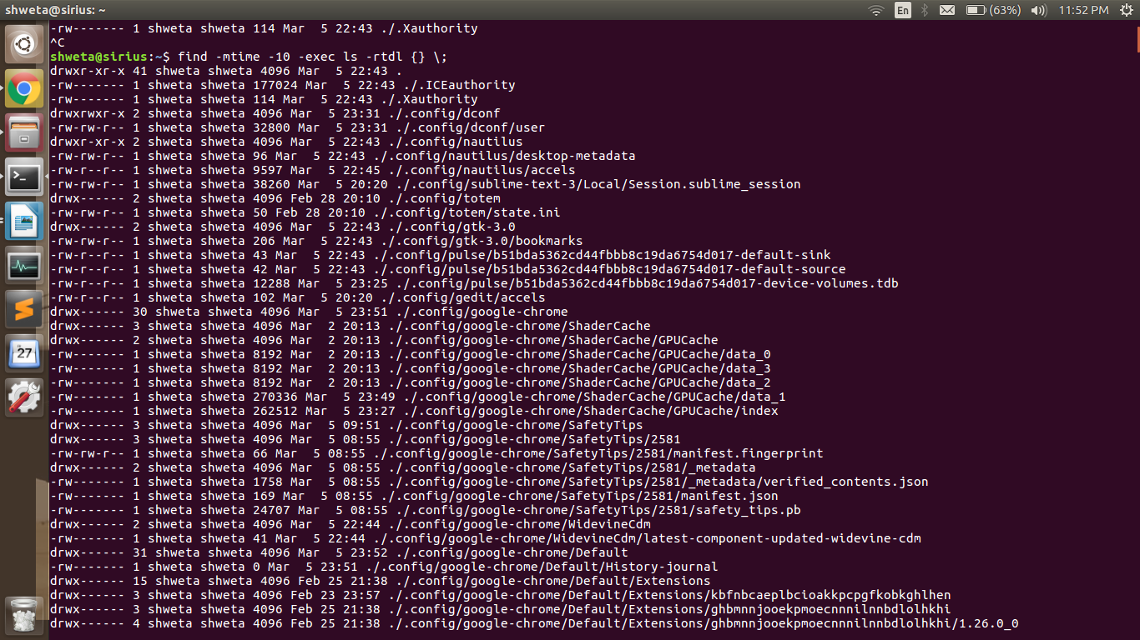

3. find ~ -type d -empty

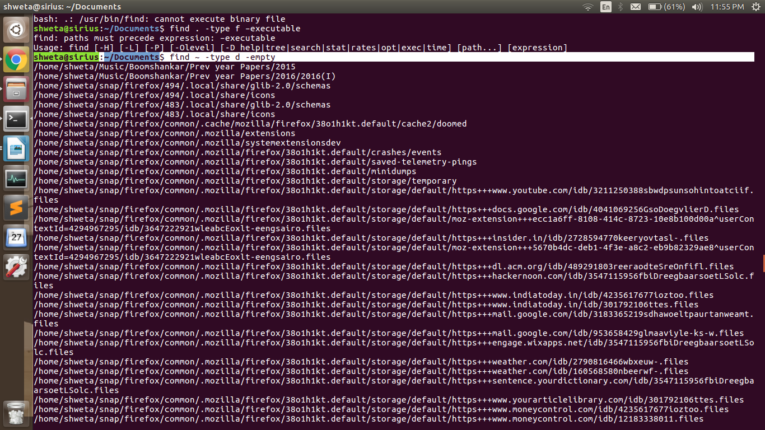

4. find . -type f -executable -print

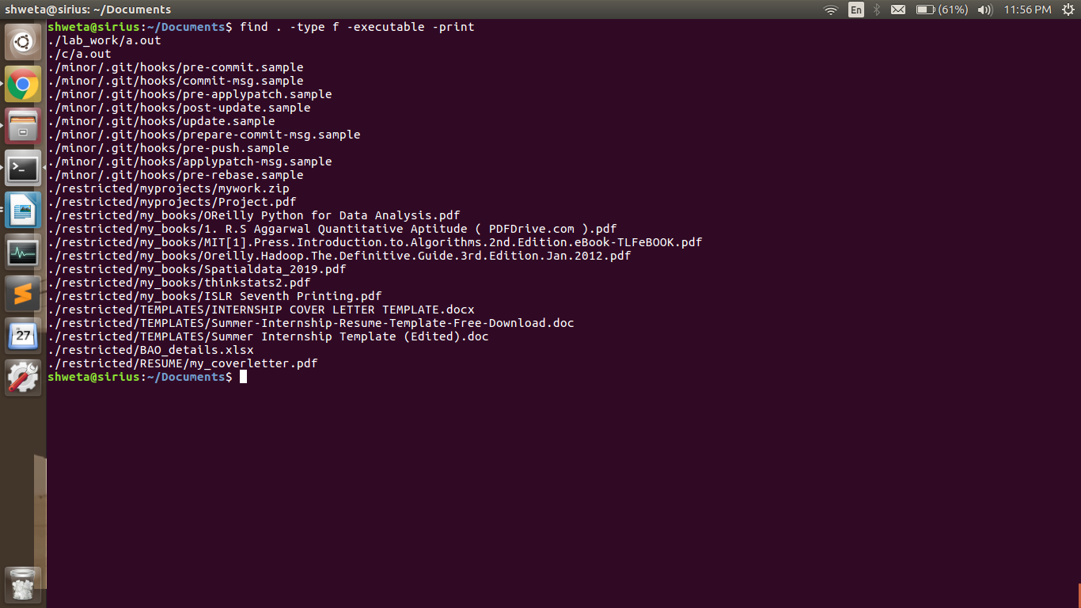

5. find / -perm /4000

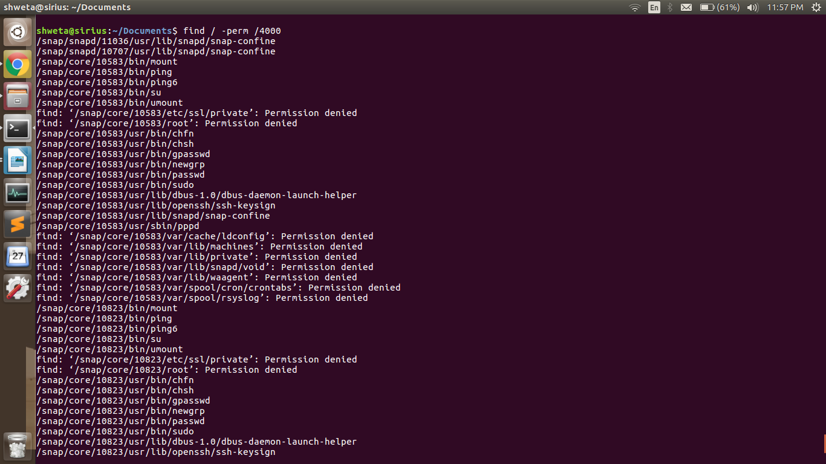

6. **vi a.txt**

to insert press **i** and write required lines

To exit, press **ecs and :wq**

