TAX CALCULATOR

By

KMPS PRIVATE LIMITED

*Submitted By*

**Manas Sati(902216)**

**Prapti Hazra(901468)**

**Shweta Rawat(902483)**

**Achalla Keerthana(902224)**

*Under the Guidance of*

**Deepa Thangaraj**



MARCH 2021

***Certificate of Approval***

This is to certify that this report of the project, entitled **“Tax Calculator”** is a record of bona-fide work, carried out by **Achalla Keerthana,** **Manas Sati**, **Prapti Hazra, Shweta Rawat** under my supervision and guidance.

In my opinion, the report in its present form is in partial fulfilment of all the requirements, as specified by the ***Cognizant Technology Solutions***. In fact, it has attained the standard, necessary for submission. To the best of my knowledge, the results embodied in this report, are original in nature and worthy of incorporation in the present version of the report.

It is understood that by this approval the undersigned does not necessarily endorse or approve any statement made, opinion expressed or conclusion drawn therein, but approve this thesis for the purpose for which it is submitted.

**Guide / Supervisor**

**__________________________**

**Deepa Thangaraj**

__________________

**Examiner(s)**

**ACKNOWLEDGEMENT**

We would like to express our gratitude for Our mentor and guide, **Mrs. Deepa Thangaraj** for her continuous guidance and support. This work would not have been possible without her guidance valuable suggestions.

We would like to thank all our friends for their help and constructive criticism during our project work. Finally we have no words to express our sincere gratitude to our parents who have shown us this world and for every support they have given us.

**PROBLEM STATEMENT**

To Develop a simple java application to calculate the tax for a particular employee based on his salary by creating a class named “**TaxCalculator”** with a method named **calculateTax**with some parameters and various other classes and models as needed.

The program should be able to validate the data entered by the user and calculate the tax as per his salary and store his details into the database.

**ABSTRACT**

Tax calculator is an online tool, which is specifically designed to help the taxpayers with their basic tax calculations. With the help of tax calculator an individual can calculate their tax liability in a contemporary and convenient way. There are various insurance aggregators and financial institutions that provide tax calculators on their website. One can use these tax calculators for free in order to determine their income tax.

So, in this project, we have created a class named **tax calculator** and performed validations like - whether the employee is Indian, whether he/she has a digit in his/her name and whether they need to pay tax according to their salary and then calculated tax accordingly.

In the end, we have used JDBC to successfully store the employee data into the MySQL database.

**REQUIREMENTS:**

* Eclipse
* MySQL workbench
* Laptop
* Min. 4GB RAM

**ESTIMATED DURATION**

The estimated duration for this project is two weeks.

**METHODOLOGY**

**Step 1.** Create a class **taxCalculator** and its constructor, define get, set methods and other variables.

**Step 2.** Add **calculateTax** function and define the logic to calculate tax

**Step 3.** Create a class **CalculatorSimulator** and take input from user

**Step 4.**  Create objects o**f taxCalculator** and calculate tax

**Step 5.** Perform necessary validations

**Step 6. Throw exceptions, wherever necessary**

**Step 7.** Register the driver class and create connection

**Step 8.** Create a table

**Step 9.** Input values into the database using **preparedStatement**

**CODE**

**TaxCalculator class:**

*class TaxCalculator {*

*private String EmployeeNationality;*

*private String Name;*

*private int Salary;*

*public TaxCalculator(String id, String name,int salary) {*

*this.EmployeeNationality= id;*

*this.Name = name;*

*this.Salary=salary;*

*}*

*public void setDetails(String id, String name,int salary) {*

*this.EmployeeNationality= id;*

*this.Name = name;*

*this.Salary=salary;*

*}*

*public String getID() {*

*return this.EmployeeNationality;*

*}*

*public String getName() {*

*return this.Name;*

*}*

*public int getSalary() {*

*return this.Salary;*

*}*

*public static boolean isNumeric(final String str) {*

*// null or empty*

*if (str == null || str.length() == 0) {*

*return false;*

*}*

*return true;*

*}*

*public static boolean num(final int n) {*

*// null or empty*

*if ( n <= 0) {*

*return false;*

*}*

*return true;*

*}*

*public static boolean*

*onlyDigits(String str)*

*{*

*int n=str.length();*

*// Traverse the string from*

*// start to end*

*for (int i = 0; i < n; i++) {*

*// Check if character is*

*// digit from 0-9*

*// then return true*

*// else false*

*if (str.charAt(i) >= '0'*

*&& str.charAt(i) <= '9') {*

*return true;*

*}*

*else {*

*return false;*

*}*

*}*

*return false;*

*}*

*public static boolean*

*m(String str) {*

*String sample = str;*

*char[] chars = sample.toCharArray();*

*StringBuilder sb = new StringBuilder();*

*for(char c : chars){*

*if(Character.isDigit(c)){*

*return true;*

*}*

*}*

*return false;*

*}*

*public double calculateTax() {*

*double taxAmount = 0.0;*

*//---------------------EmployeeNationality*

*if(!"Indian".equals(EmployeeNationality)||isNumeric(EmployeeNationality)==false) {*

*System.out.println("CountryNotValidException"+" "+"The employee should be an Indian citizen for calculating tax.");*

*System.exit(0);*

*}*

*else*

*{*

*System.out.println(this.EmployeeNationality + " " + " "+"Valid");*

*}*

*//------------------------Name*

*if(isNumeric(Name)==false||onlyDigits(Name)==true||m(Name)==true) {*

*System.out.println("EmployeeNameInvalidException"+" "+"The employee name cannot be empty or null or numeric");*

*System.exit(0);*

*}*

*else*

*System.out.println(this.Name + " " + " "+"Valid");*

*//------------------------Salary*

*if(num(Salary)==false) {*

*System.out.println("ValidationFailedException"+" "+" ");*

*System.exit(0);*

*}*

*else*

*{*

*int p=0,r,cess;*

*int a=12500,b=25000,c=37500,d=50000,e=62500,f=177600;*

*if(Salary<250000) {*

*taxAmount = 0;*

*System.out.println("The employee does not need to pay tax "+" "+"Your Tax amount is"+" "+"0");*

*}*

*else if(Salary>250000 && Salary<=500000) {*

*r=Salary-250000;*

*p=p+(r*5)/100;*

*cess=(p*4)/100;*

*taxAmount = cess+p;*

*}*

*else if(Salary> 500000 && Salary<=750000) {*

*r=Salary-500000;*

*p=p+a+(r*10/100);*

*cess=(p*4)/100;*

*taxAmount = cess+p;*

*}*

*else if(Salary>750000 && Salary<=1000000) {*

*r=Salary-750000;*

*p=p+a+b+(r*15)/100;*

*cess=(p*4)/100;*

*taxAmount = cess+p;*

*}*

*else if(Salary>1000000 && Salary<=1250000) {*

*r=Salary-1000000;*

*p=p+a+b+c+((r*20)/100);*

*cess=(p*4)/100;*

*taxAmount = cess+p;*

*}*

*else if(Salary>1250000 && Salary<=1500000) {*

*r=Salary-1250000;*

*p=p+a+b+c+d+(r*25)/100;*

*cess=(p*4)/100;*

*taxAmount = cess+p;*

*}*

*else if(Salary>1500000) {*

*r= Salary-1500000;*

*p=p+a+b+c+d+e+(r*30)/100;*

*cess=(p*4)/100;*

*taxAmount = cess+p;*

*}*

*}*

*return taxAmount;*

*}*

*}*

**CalculatorSimulator class:**

*public class CalculatorSimulator { // main class*

*public static void main(String[] args) throws Exception {*

*@SuppressWarnings("resource")*

*double tax = 0;*

*Scanner scnr = new Scanner(System.in);*

*System.out.println("Enter the number of Employees");*

*int num = scnr.nextInt();*

*scnr.nextLine();*

*TaxCalculator[] myarr = new TaxCalculator[num];*

*for(int i = 0; i < num; i++) {*

*System.out.println("Enter Your Nationality");*

*String id = scnr.nextLine();*

*System.out.println("Enter Your Name");*

*String name = scnr.nextLine();*

*System.out.println("Enter Your Salary");*

*int salary = scnr.nextInt();*

*myarr[i] = new TaxCalculator(id, name,salary);*

*}*

*for(int j = 0; j < myarr.length; j++) {*

*tax = myarr[j].calculateTax();*

*System.out.println("YOUR TOTAL TAX :"+" "+tax);*

*System.out.println("Thankyou for visiting KMPS");*

*}*

**JDBC:**

*String url = "jdbc:mysql://localhost:3306/manas";*

*String uname = "root";*

*String pass = "12345";*

*try{*

*String query = "insert into employee values (?,?,?,?)";*

*Class.forName("com.mysql.jdbc.Driver");*

*Connection con = DriverManager.getConnection(url,uname,pass);*

*PreparedStatement st = con.prepareStatement(query);*

*st.setString(1,myarr[0].getName());*

*st.setString(2,myarr[0].getID());*

*st.setInt(3, myarr[0].getSalary());*

*st.setInt(4,tax);*

*int count = st.executeUpdate();*

*System.out.println("Data inserted successfully");*

*//System.out.println("Data has been inserted into the database!!! ---->"+count+" rows effected");*

*}*

*catch{*

*System.out.println("Error in inserting data");*

*}*

*finally{*

*st.close();*

*con.close();*

*}*

*}*

**OUTPUT**

1.

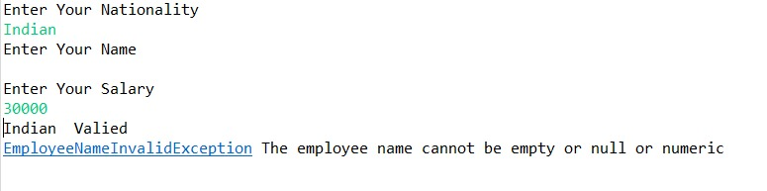

2.

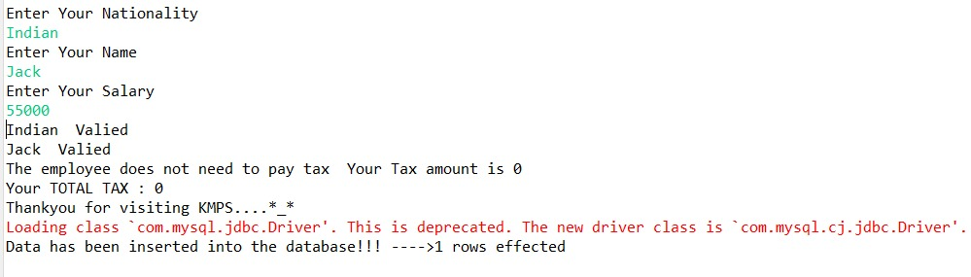

3.

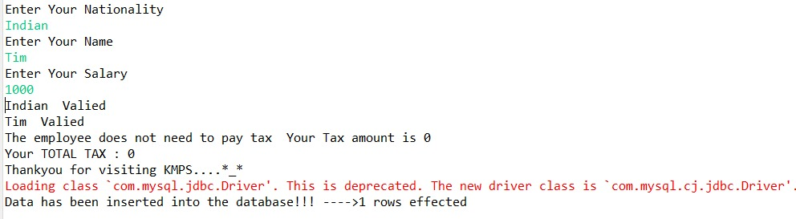

4.

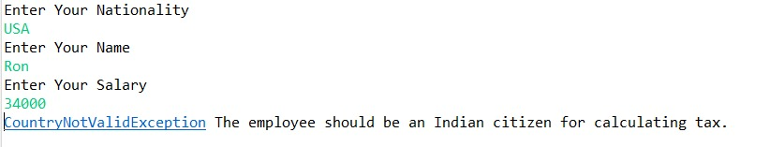

**5. Data saved into the database**

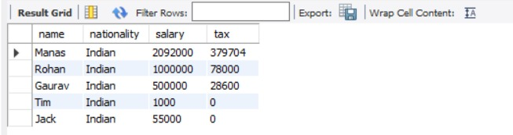

**FUTURE SCOPE**

While developing the system a conscious effort has been made to create and develop a software package, making use of available tools, techniques and resources – that would generate a proper system for TAX CALCULATOR. While making the system, an eye has been kept on making it as user-friendly.

As such one may hope that the system will be acceptable to any user and will adequately meet his/her needs. As in case of any system development process where there are a number of short comings, there have been some shortcomings in the development of this system also. There are some of the areas of improvement which couldn’t be implemented due to time constraints. We couldn’t implement the bonus part.