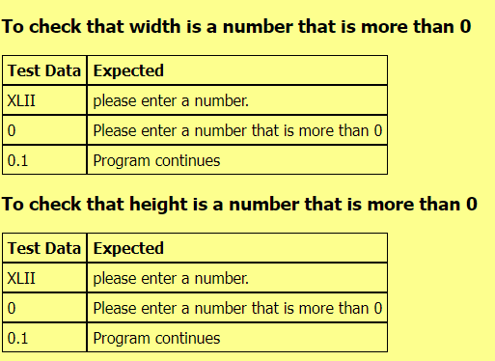

|  |  |
| --- | --- |
| **Test Case** | **Expected Values** |
| Width: 3Height: 4 | Area; 12 square unitsPerimeter: 14 units |

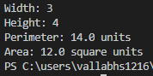

Code works