**Check-In 5.1**

For this activity, I selected a non-responsive and non-mobile webpage: http://www.gossip.com.co/en/HairCare. Gossip is a Bogotá salon owned by Ronald Matthaei a Dutch-born and trained hair stylist. The salon caters to Dutch, German, and English-speaking expats.

**Desktop:**

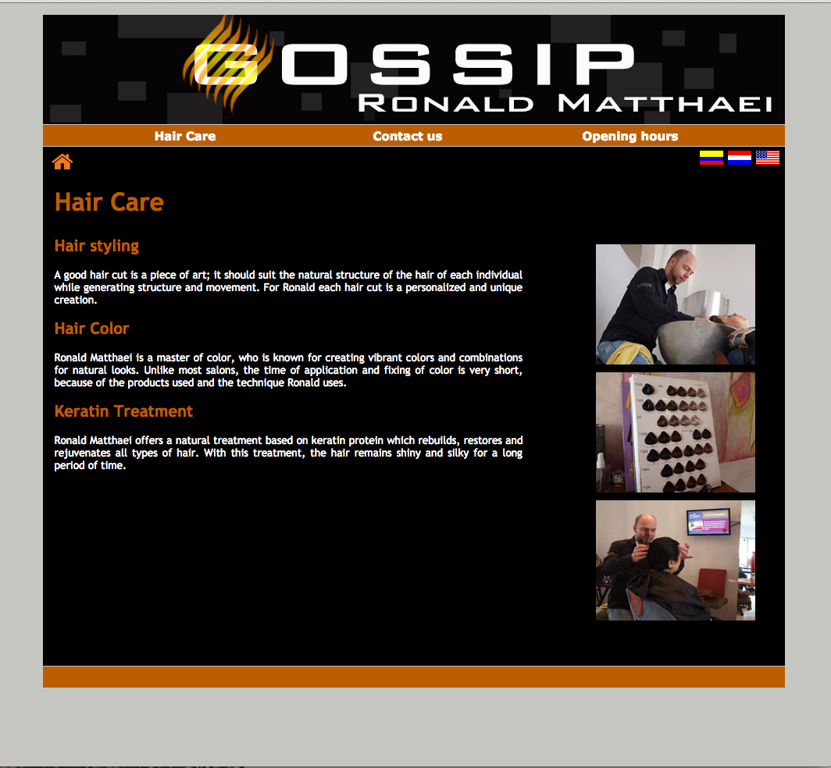

**Resizing desktop window:**

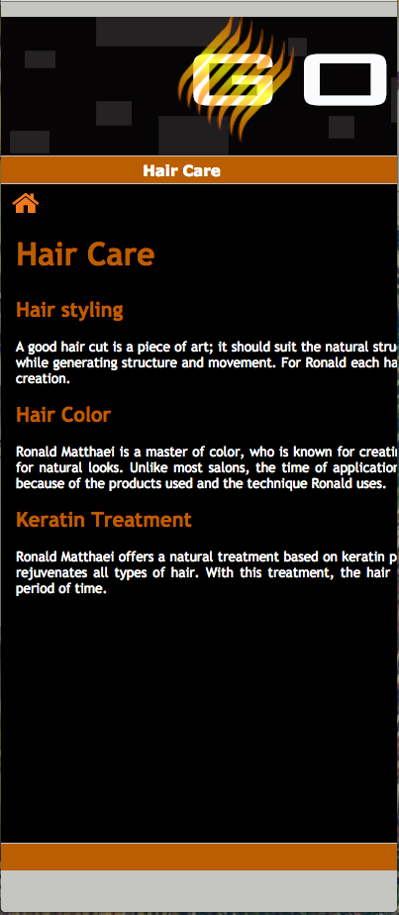

**Moblie:  
  
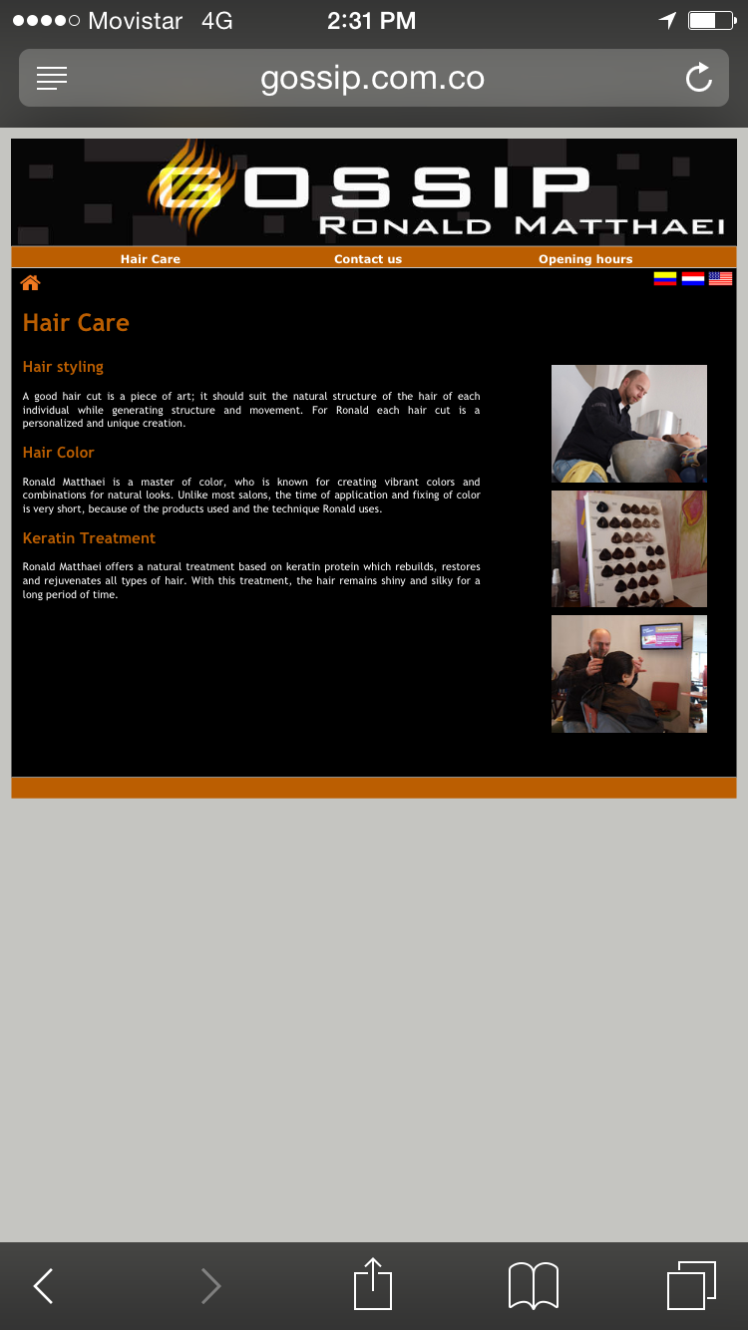**

**Organization**:   
For organization of a mobile version of this webpage, I’d modify the content to focus on the three critical mobile behaviors:

1. Edit/Create (urgent change/micro-tasking)
   * Book an appointment
   * Call us
2. Check In/Status (repeat/micro-tasking)

* Change appointment
* Get directions

3. Explore/Play (bored, local)

* Links to instagram, facebook, foursquare, and website

**Actions**:

In terms of actions, I’d utilize the following basic gestures for touch commands:

* Basic actions
* Object-related actions
* Navigating actions

I’d make sure to follow touch-target sizing recommendations, for padding or margins, around interface elements.

Also, I’d build the mobile version of this page without hovers.

**Inputs**:

For booking an appointment, I’d use input types, attributes, masks with smart defaults to make mobile input easy.   
  
For choosing an appointment date, the interface would allow the user to select a day or month by touching a calendar with an index or thumb finger. The date input element would be non-scrolling.

**Layout**:

For layout, I’d:

* Set meta viewport to device width to optimize for different devices
* Create resolution break points for different layouts: desktop, tablet, and mobile.
* Reduce content to essentials for smaller devices.
* Account for difference in screen density and include high-resolution images for devices that support them.