**COURSE : ARTIFICIAL INTELLIGENCE**

**TITLE: CREATE A CHATBOT IN PYTHON**

**PHASE 1 SUBMISSION**

**TEAM MEMBERS:**

**SRIVALSAN. S (au 311521106098)**

**VALLARASU . S (au 3115211060107)**

**PROBLEM DEFINITION:**

Create a chatbot in Python that can engage in textbased conversations with users on various topics, answer questions, provide information, and offer assistance in a natural and interactive manner.

**DESIGN THINKING:**

**Empathize:**

Understand the perspective of the endusers or stakeholders by actively listening, observing, and engaging with them.

Develop empathy by conducting interviews, surveys, and observations to uncover their needs, desires, pain points, and challenges.

**Define:**

Clearly articulate and define the problem or challenge based on the insights gained during the empathize stage.

Create a problem statement or a usercentered point of view (POV) that frames the issue and provides a focus for the rest of the design process.

**Ideate:**

Encourage creative brainstorming sessions to generate a wide range of potential solutions without judgment.

Explore various ideas, concepts, and approaches to address the defined problem.

Use techniques like mind mapping, brainstorming, and ideation workshops to foster creativity.

**Prototype:**

Build lowfidelity prototypes or mockups of the proposed solutions. These can be sketches, paper prototypes, digital wireframes, or physical models.

Prototyping helps to visualize and communicate ideas and concepts, making them more tangible for evaluation and feedback.

**Test:**

Put the prototypes in front of users or stakeholders to gather feedback and insights.

Observe how users interact with the prototypes and note their reactions, preferences, and pain points.

Use feedback to refine and iterate on the prototypes, making improvements based on user input.

**Implement (or Scale):**

Once a viable solution has been identified and refined through testing, move forward with implementation.

Develop a plan for scaling and launching the solution, considering factors like technology, resources, and user adoption.

Continuously gather feedback and make adjustments as needed after implementation.

**DATA SET LINK:**[**https://www.kaggle.com/datasets/grafstor/simple-dialogs-for-chatbot**](https://www.kaggle.com/datasets/grafstor/simple-dialogs-for-chatbot)

**DATA SET:**

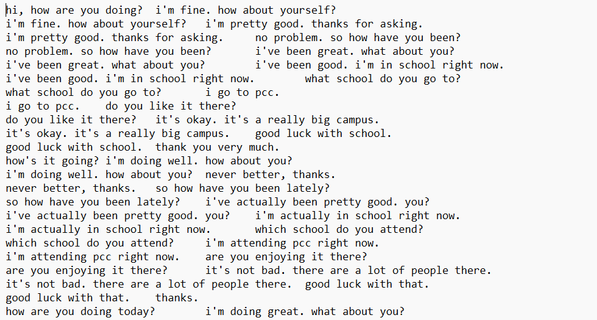

PROGRAM:

import numpy as np

import string

from nltk.corpus import stopwords

import pandas as pd

from sklearn.feature_extraction.text import CountVectorizer

from sklearn.tree import DecisionTreeClassifier

from sklearn.feature_extraction.text import TfidfTransformer,TfidfVectorizer

from sklearn.pipeline import Pipeline

df pd.read_csv('../input/simple-dialogs-for-chatbot/dialogs.txt',sep='**\t**')

a = pd.Series(df.columns)

df

a = a.rename({0: df.columns[0],1: df.columns[1]})

b = {'Questions':'Hi','Answers':'hello'}

c = {'Questions':'Hello','Answers':'hi'}

d= {'Questions':'how are you','Answers':"i'm fine. how about yourself?"}

e= {'Questions':'how are you doing','Answers':"i'm fine. how about yourself?"}

df = df.append(a,ignore_index=True)

df.columns=['Questions','Answers']

df = df.append([b,c,d,e],ignore_index=True)

Df

df = df.append(c,ignore_index=True)

df = df.append(d,ignore_index=True)

df

def cleaner(x):

    return [a for a **in** (''.join([a for a **in** x if a **not** **in** string.punctuation])).lower().split()]

Pipe = Pipeline([

    ('bow',CountVectorizer(analyzer=cleaner)),

    ('tfidf',TfidfTransformer()),

    ('classifier',DecisionTreeClassifier())

])

Pipe.fit(df['Questions'],df['Answers'])

Pipe.fit(df['Questions'],df['Answers'])

Pipe.predict(['how are you'])[0]

Pipe.predict(['great'])[0]

Pipe.predict(['What are you doing'])[0]

**OUTPUT:**

Pipeline(steps=[('bow',

                 CountVectorizer(analyzer=<function cleaner at 0x7f5cfaae40e0>)),

                ('tfidf', TfidfTransformer()),

                ('classifier', DecisionTree

'hello'

"i'm fine. how about yourself?"

'i appreciate that.'

"i'm going to change the light bulb. it burnt