**COURSE : ARTIFICIAL INTELLIGENCE**

**TITLE: CREATE A CHATBOT IN PYTHON**

**PHASE 3 SUBMISSION : DEVELOPMENT PART 1**

**TEAM MEMBERS:**

**SRIVALSAN. S (au311521106098)**

**VALLARASU . S (au3115211060107)**

**INTODUCTION:**

In an increasingly digital world, the demand for intelligent and interactive conversational agents has surged. Chatbots, driven by the power of natural language processing and artificial intelligence, have become indispensable tools for businesses and individuals alike. This project aims to address this growing need by developing a Python-based chatbot capable of engaging users in text-based conversations on a wide array of topics. This chatbot is designed to provide information, answer questions, and offer assistance in a manner that mimics human interaction, making it a valuable asset for customer support, information retrieval, and general conversational purposes. By harnessing the capabilities of modern AI and natural language understanding, this chatbot will not only streamline communication but also enhance the user experience, ultimately becoming a valuable addition to any platform or service.

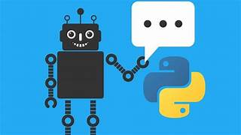

**DATA SET LINK:**[**https://www.kaggle.com/datasets/grafstor/simple-dialogs-for-chatbot**](https://www.kaggle.com/datasets/grafstor/simple-dialogs-for-chatbot)

**DATA SET:**

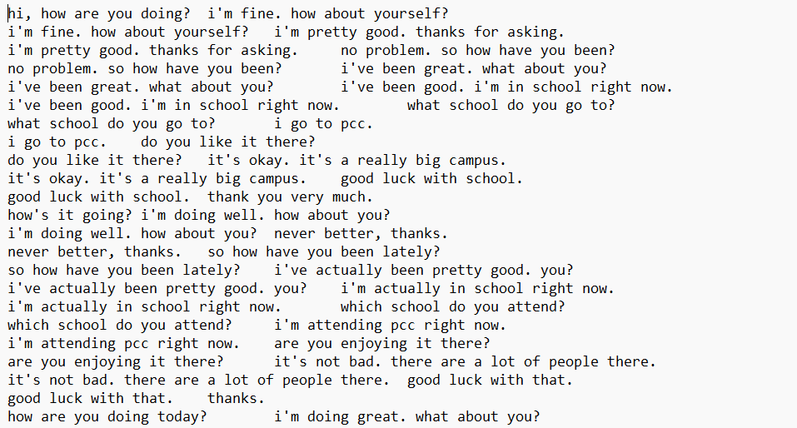

**DATA PRE-PROCESSING:**

Data preprocessing for a chatbot typically involves several steps to clean, format, and structure the data to make it suitable for training a chatbot model. Here's a general outline of the data preprocessing steps using Python:

1. Data Collection:

- Collect the chatbot training data from various sources, such as chat logs, user interactions, or existing datasets.

2. Text Lowercasing:

- Convert all text to lowercase to ensure consistency in the data. This helps the model generalize better.

3. Tokenization:

- Tokenize the text into words or subword tokens. Common libraries for this include NLTK, spaCy, or the Hugging Face Transformers library for BERT-based tokenization.

4. Remove Special Characters:

- Remove unnecessary special characters, punctuation, and symbols that don't convey meaningful information for the chatbot.

5. Handle Contractions:

- Expand contractions to standardize the language (e.g., converting "can't" to "cannot").

6. Remove Stop Words:

- Remove common stop words (e.g., "the," "and," "is") to reduce noise in the data.

7. Spelling Correction (optional):

- Correct common spelling errors using libraries like TextBlob or autocorrect.

8. Remove Duplicates:

- Eliminate duplicate or highly similar dialogues or responses to avoid bias in the training data.

9. Data Splitting:

- Split the data into training, validation, and test sets to evaluate the chatbot's performance.

10. Text Encoding:

- Convert the text into numerical representations that machine learning models can process. For instance, you can use word embeddings like Word2Vec, GloVe, or pre-trained models like BERT for contextual embeddings.

11. Padding and Truncating:

- Ensure that all input sequences are of the same length by padding or truncating as necessary. This is important for batching during training.

12. Handling Out-of-Vocabulary (OOV) Words:

- Implement an OOV strategy for words that are not in the vocabulary of your pre-trained embeddings, such as using a special token for OOV words.

13. Data Formatting:

- Format the data into a format that your chatbot model can accept. This often involves creating input-output pairs for a seq2seq model or arranging data into a suitable format for a retrieval-based model.

14. Save Processed Data:

- Save the preprocessed data in a format that's easy to load for model training and evaluation. This might involve saving it as CSV, JSON, or in a database.

15. Exploratory Data Analysis (EDA):

- Perform some EDA to gain insights into your data. This can help you identify patterns, check for class imbalances, and make informed decisions about data augmentation or model selection.

**DATA CLEANING:**

Data cleaning is an essential part of preparing your data for a chatbot project. Cleaning the data ensures that it is free from noise, inconsistencies, and errors, which can impact the performance of your chatbot. Here are some common data cleaning steps using Python:

1. Removing Duplicates:

- Remove duplicate records or conversations from your dataset to avoid bias in training your chatbot. You can use Python's `pandas` library to identify and remove duplicates:

import pandas as pd

df = pd.read_csv("chatbot_data.csv")

df = df.drop_duplicates()

2. Handling Missing Values:

- Check for and handle missing values in your dataset. Depending on the nature of your data, you can either remove rows with missing values or fill them in with appropriate data:

# Remove rows with missing values

df.dropna(inplace=True)

# Fill in missing values with a placeholder

df.fillna("N/A", inplace=True)

3. Removing Irrelevant Data:

- Remove columns or features that are irrelevant for your chatbot project. This can help reduce the dimensionality of your data and improve model training:

df = df.drop(columns=["unwanted_column"])

4. Handling Noise and Outliers:

- Identify and remove noisy data or outliers that don't contribute meaningfully to your chatbot's training. You can use statistical methods to detect outliers:

from scipy import stats

z_scores = stats.zscore(df["numeric_column"])

df = df[(z_scores < 3)]

5. Standardizing Text:

- Standardize text data by converting it to lowercase, removing extra whitespaces, and ensuring consistent formatting. This is important for text-based chatbot projects:

df["text_column"] = df["text_column"].str.lower()

df["text_column"] = df["text_column"].str.strip()

6. Handling Special Characters:

- Remove or replace special characters and symbols that may not be relevant to your chatbot:

import re

df["text_column"] = df["text_column"].apply(lambda x: re.sub(r'[^a-zA-Z0-9\s]', '', x))

7. Spelling Correction (optional):

- If your text data has common spelling errors, you can use libraries like `TextBlob` for spell checking and correction:

from textblob import TextBlob

df["text_column"] = df["text_column"].apply(lambda x: str(TextBlob(x).correct()))

8. Text Tokenization and Lemmatization (optional):

- Tokenize and lemmatize the text data to reduce inflected words to their base form. This can help improve text analysis:

from nltk.stem import WordNetLemmatizer

from nltk.tokenize import word_tokenize

lemmatizer = WordNetLemmatizer()

df["text_column"] = df["text_column"].apply(lambda x: ' '.join([lemmatizer.lemmatize(word) for word in word_tokenize(x)]))

9. Save Cleaned Data:

- Save the cleaned data to a new file for further processing and model training:

df.to_csv("cleaned_chatbot_data.csv", index=False)

These data cleaning steps should be adapted to your specific dataset and chatbot project requirements. Data cleaning is a crucial step to ensure that your chatbot model is trained on high-quality and reliable data.

**DATA INTEGRATION:**

Data integration in a chatbot project involves collecting, processing, and combining data from various sources to create a unified dataset that the chatbot can use for training or improving its responses. Here's a step-by-step guide on how to perform data integration for a chatbot project using Python:

1. Identify Data Sources:

Determine the sources of data that you want to integrate. These sources can include:

- Existing chat logs

- FAQs or knowledge bases

- Databases

- Web services and APIs

- Social media feeds

- Custom data sources specific to your project

2. Data Collection:

Collect data from each source. Use Python libraries such as `requests` for web scraping, database connectors like `SQLAlchemy` or database-specific libraries, and API wrappers to fetch data from external services.

3. Data Preprocessing:

Before integrating the data, clean and preprocess each data source individually. This includes steps like text normalization, tokenization, and removing unnecessary characters, as mentioned in the data preprocessing steps provided earlier.

4. Data Transformation:

Convert the data from various sources into a common format that the chatbot can understand. This often involves converting data into text or structured formats like JSON.

5. Data Deduplication:

Remove duplicate data entries within each source to avoid redundancy.

6. Data Integration:

Merge or combine the data from different sources into a single dataset. You can use Python libraries like `pandas` to handle this task effectively.

import pandas as pd

# Merge data from multiple sources

merged_data = pd.concat([data_source1, data_source2], axis=0)

7. Handling Data Conflicts:

Address any conflicts that arise when integrating data from multiple sources. This may involve standardizing column names or dealing with data structure inconsistencies.

8. Data Enrichment:

Enhance your chatbot's dataset by adding additional information from external sources. You can use Python to retrieve data from external APIs, databases, or web scraping. Libraries like `requests` and `beautifulsoup` can be helpful for this.

9. Data Validation:

Check the quality and consistency of the integrated data. Look for missing values, outliers, and other data anomalies.

10. Data Storage:

Save the integrated and processed data in a suitable format. Common choices include CSV, JSON, SQL databases (e.g., SQLite or PostgreSQL), or NoSQL databases (e.g., MongoDB). Python libraries like `pandas` and `SQLAlchemy` can help with data storage.

11. Version Control:

Consider using version control systems like Git to keep track of changes in your data integration process, especially if multiple team members are working on the project.

12. Data Backup and Recovery:

Ensure you have a backup of your integrated data in case of accidental data loss or corruption.

**DATA TRANSFORMATION:**

Data transformation in a chatbot project using Python involves converting and preparing data to be in a suitable format for training or interaction with the chatbot. Here are the steps for data transformation:

1. Data Collection and Preprocessing:

Start with clean and preprocessed data. If you haven't already, follow the data preprocessing steps to clean, tokenize, and normalize the text data.

2. Tokenization:

Tokenize the text data into words or subword tokens. You can use libraries like NLTK, spaCy, or the Hugging Face Transformers library for BERT-based tokenization.

3. Text Vectorization:

Convert the tokenized text into numerical representations that can be processed by machine learning models. There are several methods for text vectorization:

a. Bag of Words (BoW):

- Use the `CountVectorizer` or `TfidfVectorizer` from scikit-learn to represent text as a matrix of word counts or TF-IDF values.

b. Word Embeddings:

- Use pre-trained word embeddings like Word2Vec, GloVe, or FastText to obtain dense vector representations of words.

c. Transformer Models:

- Utilize pre-trained transformer models like BERT, GPT-2, or RoBERTa to obtain contextual embeddings for text. The Hugging Face Transformers library provides easy access to these models.

4. Sequence Padding:

If you are using sequences of variable lengths, such as for sequence-to-sequence models, pad or truncate sequences to ensure uniform length. This is important for batch processing during training.

5. Special Tokens and Attention Masks:

If using transformer models, add special tokens (e.g., `[CLS]`, `[SEP]`) and attention masks to the data for compatibility with these models.

6. Data Splitting:

Split the data into training, validation, and test sets. Typically, the data is divided into these sets to train, validate, and evaluate the chatbot model's performance.

7. Formatting for Model Input:

Depending on the type of chatbot model you're using (e.g., retrieval-based, generative, or a combination), you may need to format the data as input-output pairs, context-response pairs, or any other suitable format for training.

8. Handling Out-of-Vocabulary (OOV) Words:

Implement a strategy for dealing with out-of-vocabulary words, which may arise during inference. Using a special token for OOV words or generating a suitable response is common.

9. Saving Processed Data:

Save the transformed data in a format that's easy to load for model training and evaluation. Common choices include saving it as CSV, JSON, or in a database.

10. Data Augmentation (Optional):

Depending on the quantity of data available, you may consider data augmentation techniques to increase the diversity of your training data.

11. Data Serialization:

Serialize your processed data into a suitable format for your chatbot model training framework. Many models accept data in serialized formats like Pickle, TFRecord, or HDF5.

12. Data Feeding:

Finally, prepare your data to be fed into your chatbot model during training or inference. The format and method for feeding data will depend on the specific library or framework you're using for the chatbot model.

**DATA REDUCTION:**

Data reduction in the context of a chatbot project typically involves techniques to reduce the complexity and size of the data without significantly compromising the quality of the chatbot's responses. Reducing data can be beneficial in cases where the dataset is large, and you want to improve efficiency and model training speed. Here are some common data reduction techniques for a chatbot project using Python:

1. Sample Selection:

If your dataset is extensive, you can randomly sample a subset of the data for model training and testing. Python's libraries, such as `pandas`, can help with random sampling from datasets.

import pandas as pd

# Randomly sample 10% of the data

sample = data.sample(frac=0.1, random_state=42)

2. Data Cleaning and Filtering:

Remove low-quality or irrelevant data, including data entries with low user engagement or poor quality responses. This can help to improve the quality of the chatbot's training data.

3. Frequency-Based Pruning:

Consider removing words, tokens, or phrases that occur very infrequently in the dataset, as they may not contribute significantly to the chatbot's learning. Python's `collections` library can be used to count word frequencies.

from collections import Counter

# Count word frequencies

word_counts = Counter(tokenized_data)

4. Data Aggregation:

For retrieval-based chatbots, you can group similar responses together to reduce the number of unique responses in the training data. This can help in simplifying the model's training.

5. Dimensionality Reduction:

If your dataset includes high-dimensional features, consider using dimensionality reduction techniques like Principal Component Analysis (PCA) to reduce the feature space's dimensionality while retaining most of the variance.

from sklearn.decomposition import PCA

pca = PCA(n_components=2)

reduced_data = pca.fit_transform(data)

6. Text Summarization:

For chatbots that generate long or detailed responses, consider using text summarization techniques to condense responses while retaining essential information. Python libraries like Gensim or the Hugging Face Transformers library can be helpful for this.

7. Feature Selection:

If your chatbot project involves feature-based models, use feature selection methods to choose the most relevant features and eliminate less informative ones. Libraries like scikit-learn offer various feature selection techniques.

from sklearn.feature_selection import SelectKBest

selector = SelectKBest(k=10)

selected_features = selector.fit_transform(X, y)

8. Data Augmentation (Selective):

Rather than increasing the dataset size, you can selectively augment the data by generating additional samples for specific classes or topics that are underrepresented in your dataset.

9. Data Compression:

Use data compression techniques to reduce the storage space required for the dataset. Python provides modules like `gzip` and `zlib` for compression.

10. Use of Pre-trained Models:

Instead of using the entire dataset, you can leverage pre-trained language models like GPT-3 or BERT for chatbot responses, which are based on massive amounts of text data. This approach reduces the need for a large custom dataset.

11. Domain Specialization:

Narrow down the scope of your chatbot to focus on specific domains or topics, which can reduce the amount of training data needed.

12. Leverage Transfer Learning:

Utilize transfer learning by fine-tuning pre-trained chatbot models with a smaller amount of custom data, which can be an efficient way to reduce data requirements.