DrawObjectsExtended Design Document

Contents
License 1
DrawObjectsExtended Design Overview 1
Use Cases 2
Main use cases 2
Screen copies 3
UML Design 4
Overall Structure 4
Main Classes 6
The drawing behaviour 7

License
DrawObjectsExtended is published under Mozilla License 1.1.
The original contributor of DrawObjects is Angus Johnson.
DrawObjectsExtended is contributed by Thierry Coq.

DrawObjectsExtended Design Overview
This document describes the design and use of the DrawObjectsExtended Component.
This component is designed for use with FPC 2.3.1 and Lazarus 0.9.29 on the Windows platform, and has been ported from Delphi. The final target is to be portable to Linux.
It allows users to make structured graphics, such as boxes and arrows linked together.

Use Cases

Main use cases

Screen copies
A few screen copies are presented below:
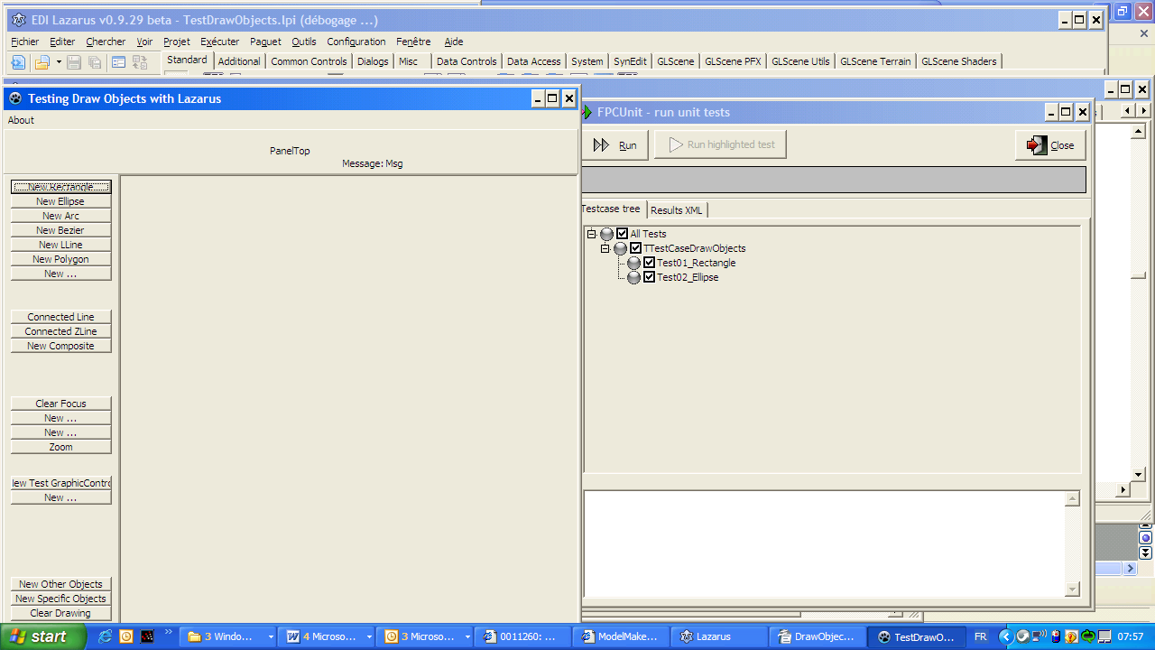
the DrawObjectsExtended test form running under Lazarus 0.9.29beta, in windows
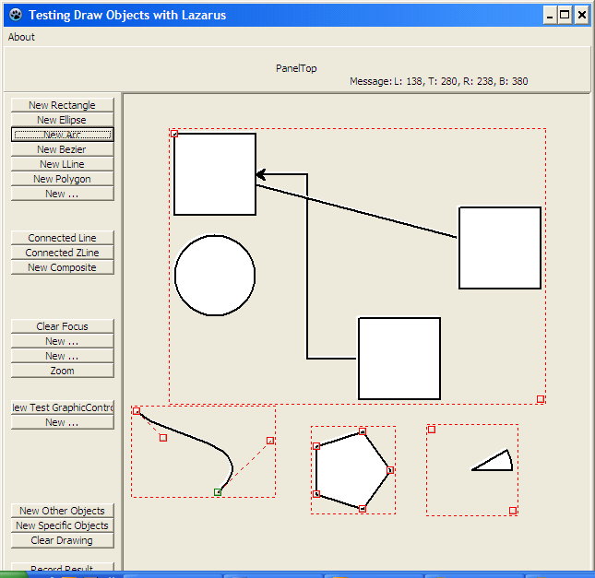
Some drawobjects, including the Composite DrawObject.

UML Design
The UML Model is implemented using ModelMaker's UML tool, version 9.

Overall Structure
The first diagram shows the relationships between the various units, the classes and operations provided by each unit.

Main Classes
The second diagram shows the inheritance relationships to identify where to add additional classes, if needed.

The drawing behaviour

