**1. Task**

**1.1 Description**

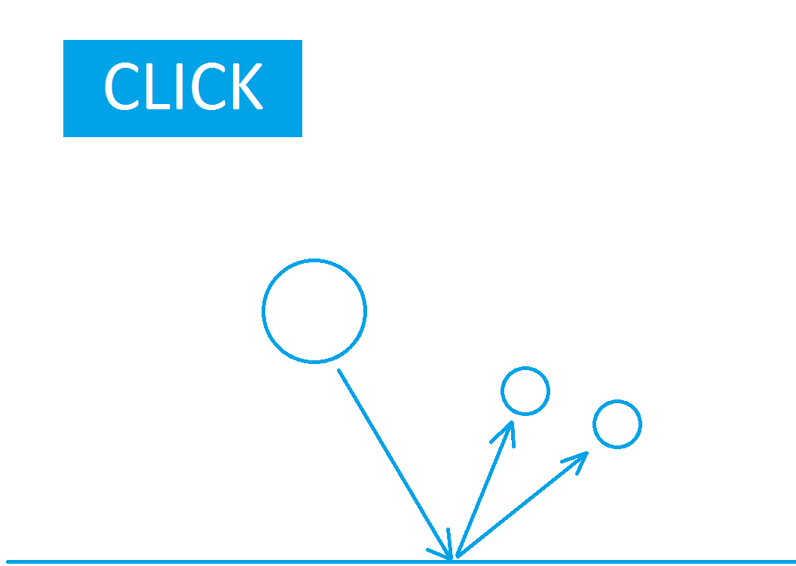

Each time when you click the button “drop ball” ball is drop. When the ball hit the ground it

brakes in to two balls. In the box on the right you count braked balls. Speed of each drop ball

is random.

**1.2. Requirements**

Graphics is not important. The main requirement is the game to be playable.

**1.3. Technical**

Source code should be object oriented and understandable.