#1 BAR CHART

import matplotlib.pyplot as plt
courses = ["Python", "Java", "ML", "Web Dev", "Data Science"]
students = [45, 30, 60, 25, 50]
colors = ["blue", "green", "red", "orange", "purple"]
plt.bar(courses, students, color=colors)
plt.xlabel("Courses")
plt.ylabel("Number of Students")
plt.title("Number of Students Enrolled in Different Courses")
for i in range(len(courses)):
plt.text(i, students[i] + 1, str(students[i]), ha='center')
plt.show()
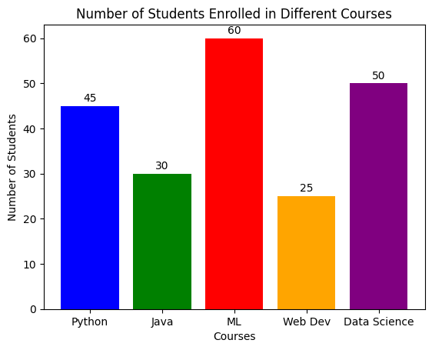

#2 Line chart

import matplotlib.pyplot as plt
months = ["Jan", "Feb", "Mar", "Apr", "May", "Jun"]
scores = [55, 62, 70, 68, 78, 85]
plt.plot(months, scores, marker='o', linestyle='--')
plt.xlabel("Months")
plt.ylabel("Test Scores")
plt.title("Student's Monthly Test Scores")
for i in range(len(months)):
plt.text(months[i], scores[i] + 1, str(scores[i]), ha='center')
plt.grid(True)
plt.show()

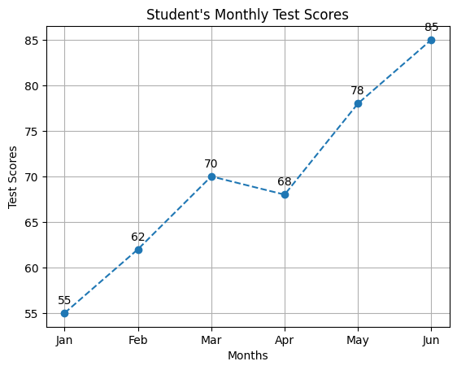

#3 PIE CHART

import matplotlib.pyplot as plt
brands = ["Samsung", "Apple", "OnePlus", "Xiaomi", "Others"]
sales = [35, 28, 15, 12, 10]
explode = (0.1, 0, 0, 0, 0)
colors = ["gold", "lightblue", "lightgreen", "orange", "pink"]
plt.pie(
sales,
labels=brands,
colors=colors,
explode=explode,
autopct='%1.1f%%',
startangle=90
)
plt.title("Mobile Phone Sales Distribution")
plt.axis('equal')
plt.show()
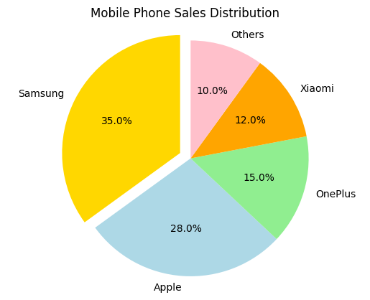
#4 HISTOGRAM

import numpy as np
import matplotlib.pyplot as plt
scores = np.random.normal(loc=65, scale=10, size=200)
mean_score = np.mean(scores)
plt.hist(scores, bins=15, color="skyblue", edgecolor="black")
plt.axvline(mean_score, color="red", linestyle="--", linewidth=2,
label=f"Mean = {mean_score:.2f}")
plt.xlabel("Exam Scores")
plt.ylabel("Frequency")
plt.title("Distribution of Exam Scores")
plt.legend()
plt.show()
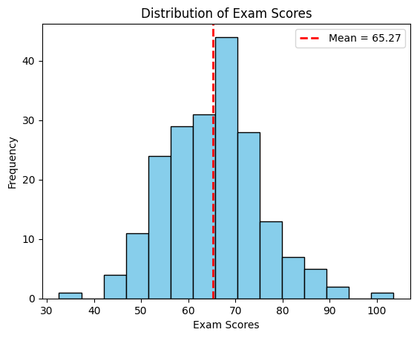
#5 SCATTER PLOT

import matplotlib.pyplot as plt
hours = [1, 2, 3, 4, 5, 6, 7, 8, 9, 10]
marks = [20, 35, 40, 45, 50, 55, 60, 70, 80, 90]
pass_hours = []
pass_marks = []
fail_hours = []
fail_marks = []
for i in range(len(hours)):
if marks[i] >= 40:
pass_hours.append(hours[i])
pass_marks.append(marks[i])
else:
fail_hours.append(hours[i])
fail_marks.append(marks[i])

plt.scatter(pass_hours, pass_marks, color='green', label='Passed')
plt.scatter(fail_hours, fail_marks, color='red', label='Failed')
plt.xlabel("Hours Studied")
plt.ylabel("Marks Obtained")
plt.title("Hours Studied vs Marks Obtained")
plt.legend()
plt.grid(True)
plt.show()
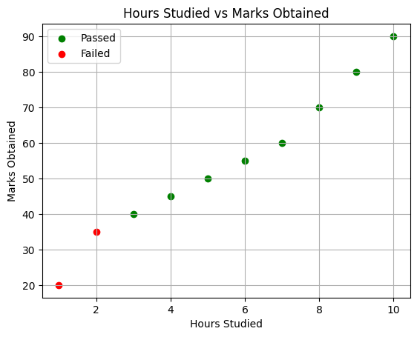

#6 HORIZONTAL BAR CHART

import matplotlib.pyplot as plt
countries = ["China", "India", "USA", "Brazil", "Indonesia"]
internet_users = [1050, 750, 310, 165, 155]
plt.barh(countries, internet_users,
color=["red", "orange", "blue", "green", "purple"])
plt.xlabel("Internet Users (in Millions)")
plt.ylabel("Countries")
plt.title("Top 5 Countries by Internet Users")
for i in range(len(countries)):
plt.text(internet_users[i] + 10, i, str(internet_users[i]), va='center')
plt.gca().invert_yaxis()
plt.show()

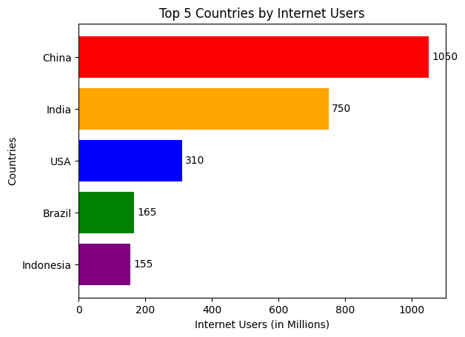

#7 STACKED BAR CHART

import matplotlib.pyplot as plt
quarters = ["Q1", "Q2", "Q3", "Q4"]
HR = [20, 25, 22, 24]
IT = [35, 40, 38, 42]
Finance = [15, 18, 20, 17]
plt.bar(quarters, HR, color="skyblue", label="HR")
plt.bar(quarters, IT, bottom=HR, color="orange", label="IT")
bottom_finance = [HR[i] + IT[i] for i in range(len(HR))]
plt.bar(quarters, Finance, bottom=bottom_finance, color="green", label="Finance")
plt.xlabel("Quarters")
plt.ylabel("Expenses (in Thousands)")
plt.title("Quarterly Department Expenses")
plt.legend()
plt.show()
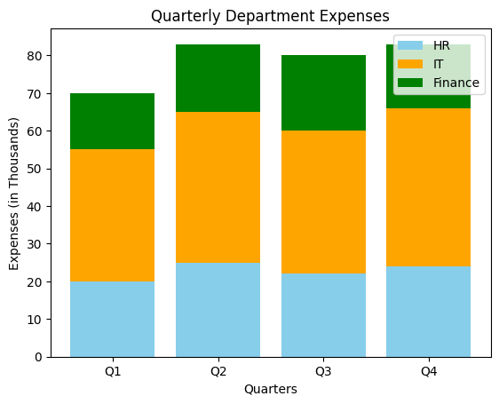
#8 BOX PLOT

import numpy as np
import matplotlib.pyplot as plt
np.random.seed(42)
class_A = np.random.normal(loc=60, scale=8, size=30)
class_B = np.random.normal(loc=70, scale=7, size=30)
class_C = np.random.normal(loc=80, scale=6, size=30)
plt.boxplot([class_A, class_B, class_C],
labels=["Class A", "Class B", "Class C"])
plt.xlabel("Classes")
plt.ylabel("Test Scores")
plt.title("Comparison of Test Score Distributions")
plt.grid(True)
plt.show()
/tmp/ipykernel_2366/2134900978.py:12: MatplotlibDeprecationWarning: The 'labels' parameter of boxplot() has been renamed 'tick_labels' since Matplotlib 3.9; support for the old name will be dropped in 3.11.
plt.boxplot([class_A, class_B, class_C],
