1) Write a program to create bar plot for sample data using matplotlib.

import matplotlib.pyplot as plt

x = ["A", "B", "C", "D"]
y = [10, 20, 15, 25]

plt.bar(x, y)
plt.title("Bar Plot")
plt.show()

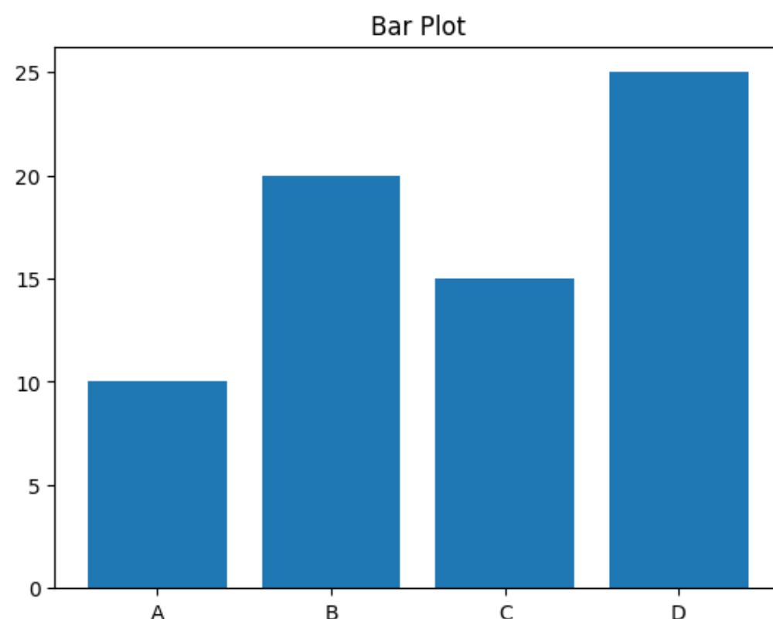

2) Write a program to create stacked-bar plot for sample data using matplotlib.

import matplotlib.pyplot as plt

x = ["A", "B", "C"]
y1 = [10, 15, 20]
y2 = [5, 8, 10]

plt.bar(x, y1)
plt.bar(x, y2, bottom=y1)

plt.title("Stacked Bar Plot")
plt.show()

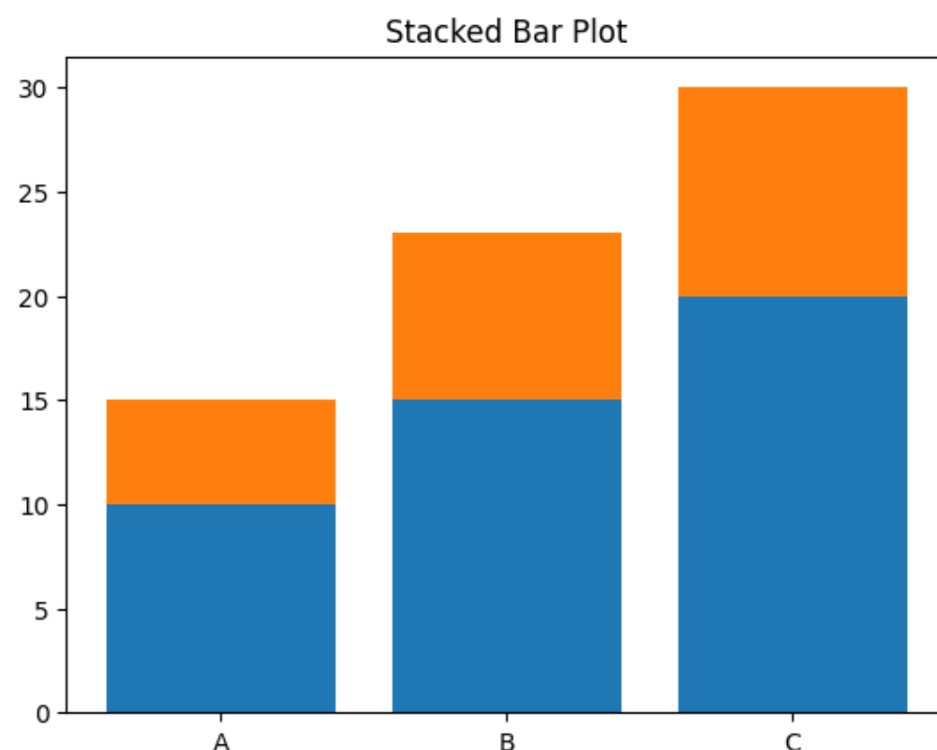

3) Write a program to create pie plot for sample data using matplotlib.

import matplotlib.pyplot as plt

data = [30, 40, 20, 10]
label = ["A", "B", "C", "D"]

plt.pie(data, labels=label)
plt.title("Pie Chart")
plt.show()

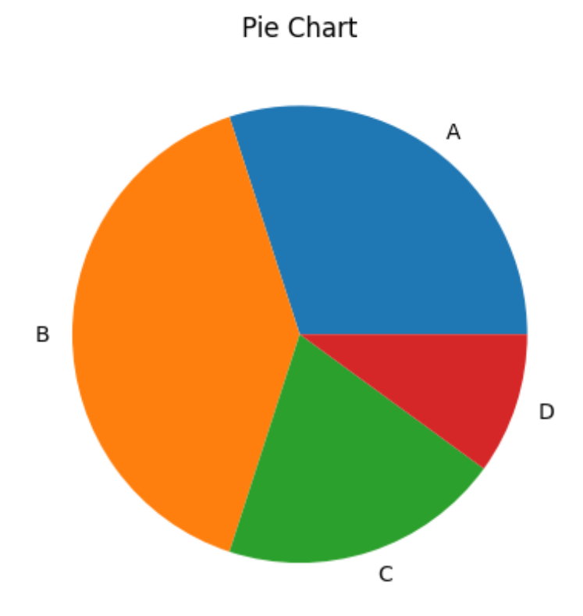

4) Write a program to create pie plot using explode parameter for sample

import matplotlib.pyplot as plt

data = [25, 35, 20, 20]
label = ["A", "B", "C", "D"]
exp = [0, 0.2, 0, 0]

plt.pie(data, labels=label, explode=exp)
plt.title("Pie Chart with Explode")
plt.show()
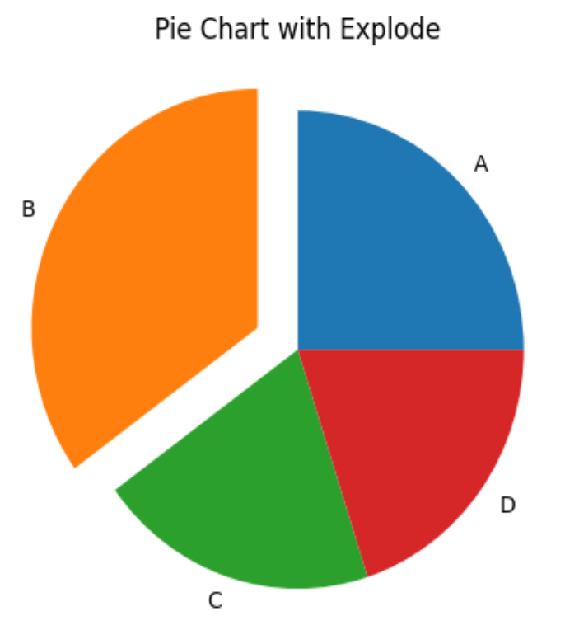

5) Write a program to create scatter plot for sample data using matplotlib.

import matplotlib.pyplot as plt

x = [1, 2, 3, 4, 5]
y = [10, 20, 15, 25, 30]

plt.scatter(x, y)
plt.title("Scatter Plot")
plt.show()

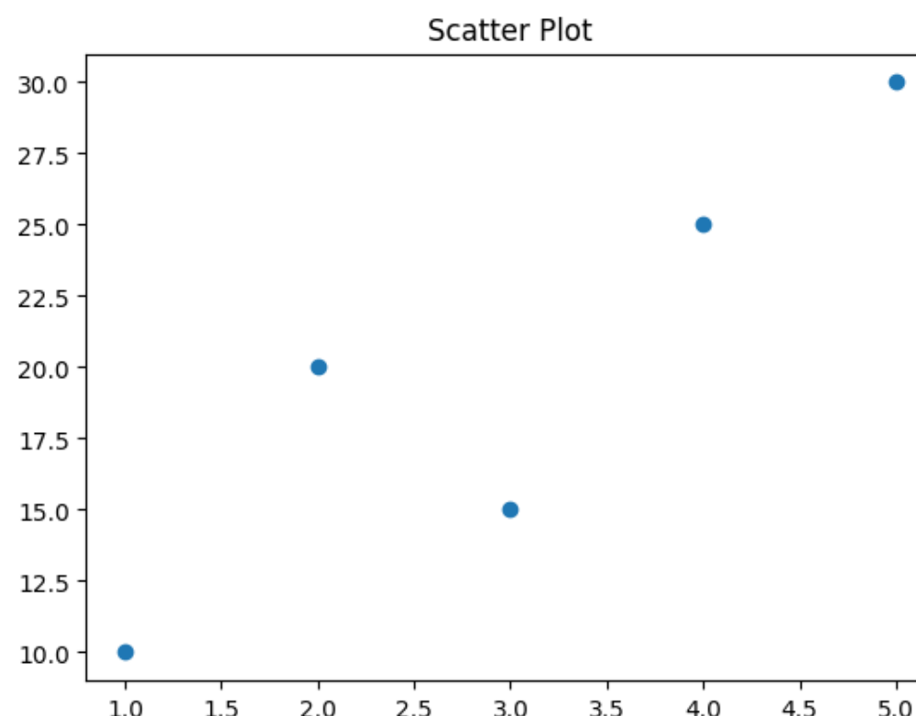

6) Write a program to create line plot for sample data using matplotlib

import matplotlib.pyplot as plt

x = [1, 2, 3, 4, 5]
y = [2, 4, 6, 8, 10]

plt.plot(x, y)
plt.title("Line Plot")
plt.show()

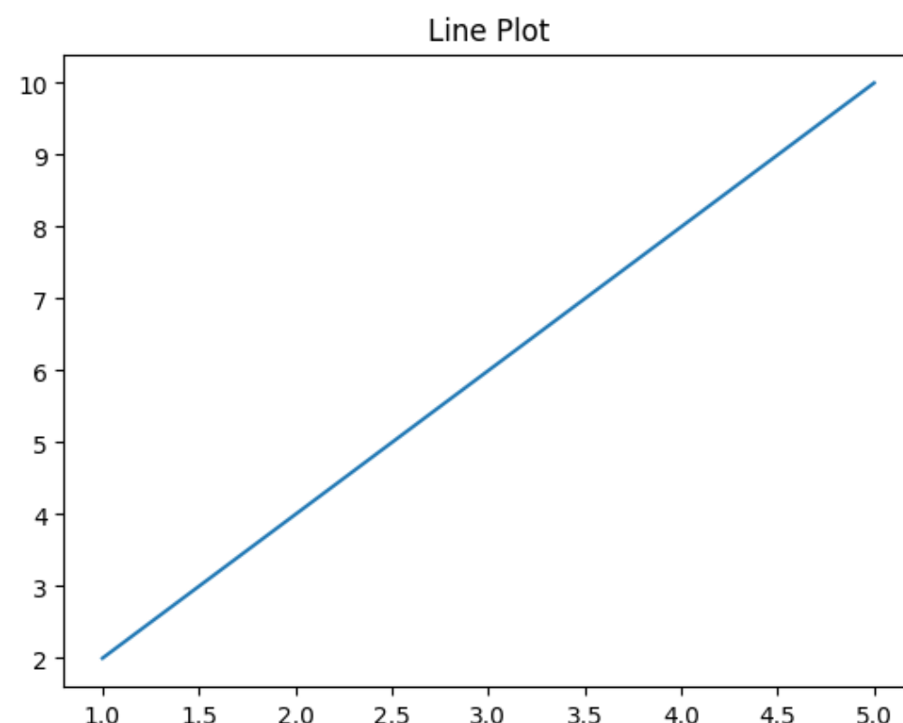

7) Write a program to create Multi-line plot for sample data using matplotlib.

import matplotlib.pyplot as plt

x = [1, 2, 3, 4]

y1 = [2, 4, 6, 8]
y2 = [1, 3, 5, 7]

plt.plot(x, y1)
plt.plot(x, y2)

plt.title("Multi Line Plot")
plt.show()

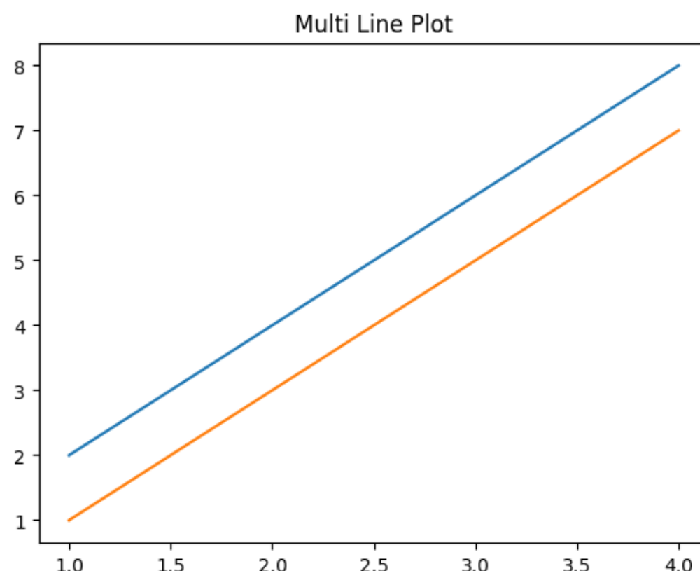

8) Write a program to create Histogram for sample data using matplotlib.

import matplotlib.pyplot as plt

data = [10, 20, 20, 30, 30, 30, 40, 50]

plt.hist(data)
plt.title("Histogram")
plt.show()

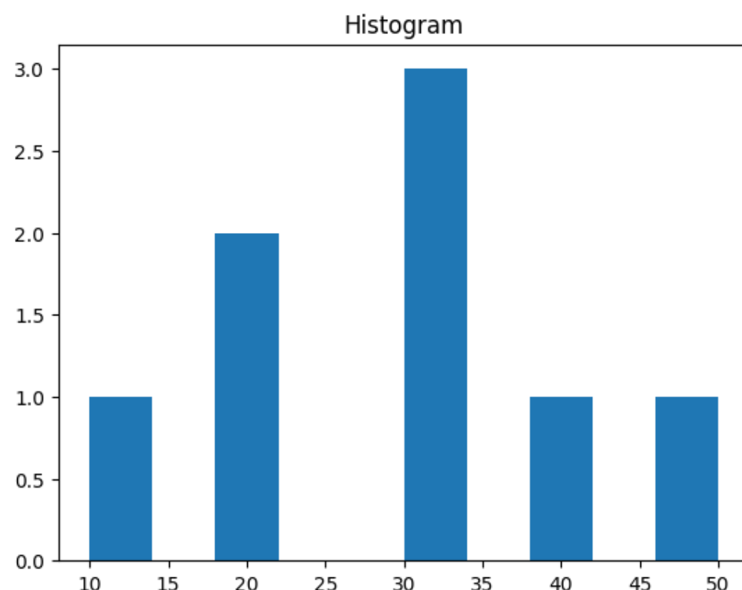

9) Write a program to create box plot for sample data using matplotlib .

import matplotlib.pyplot as plt

data = [10, 12, 14, 18, 20, 22, 25]

plt.boxplot(data)
plt.title("Box Plot")
plt.show()

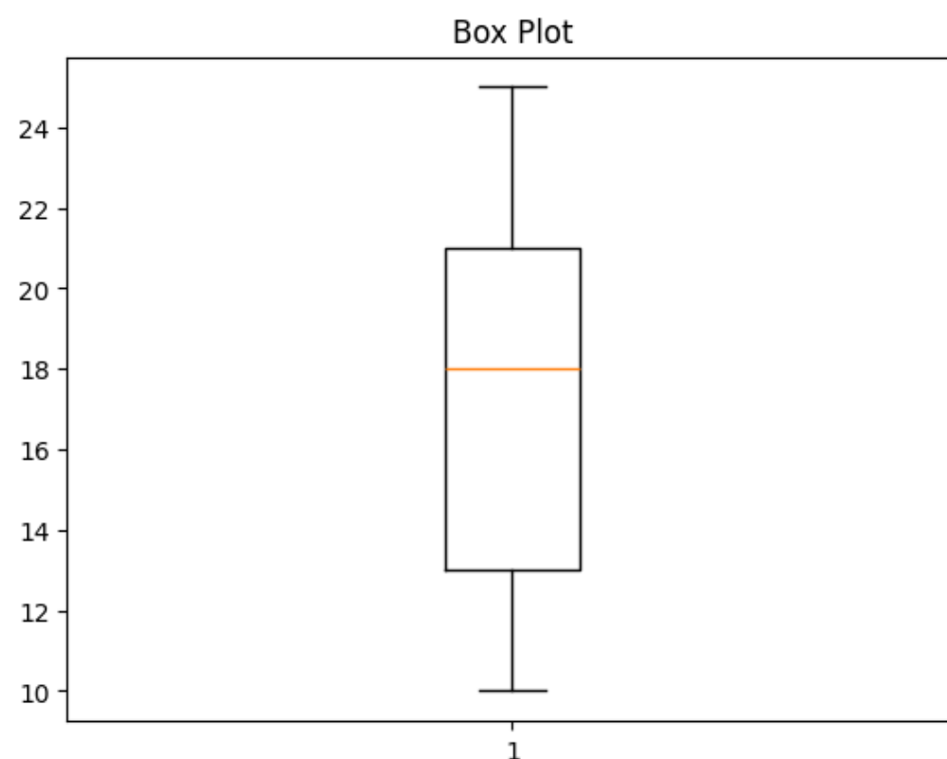

10)Write a program to create 3D plot for sample data using matplotlib.

import matplotlib.pyplot as plt
from mpl_toolkits.mplot3d import Axes3D

fig = plt.figure()

ax = fig.add_subplot(111, projection='3d')

x = [1, 2, 3, 4]
y = [2, 4, 6, 8]
z = [1, 3, 5, 7]

ax.plot(x, y, z)

plt.title("3D Plot")
plt.show()

