
MSc Data Science Project
7PAM2002
Department of Physics, Astronomy and Mathematics
Data Science FINAL PROJECT REPORT
Project Title:
Machine Learning Based Analysis of Study Behaviour Patterns for Student Performance Prediction
Student Name and SRN:
Gnana Theja Valleri, 23102882
Supervisor: Aoife Simpson
Date Submitted: 20th November 2026
Word Count: 4922
GitHub:

DECLARATION STATEMENT
This report is submitted in partial fulfilment of the requirement for the degree of Master of Science in Data Science at the University of Hertfordshire.
I have read the detailed guidance to students on academic integrity, misconduct and plagiarism information at Assessment Offences and Academic Misconduct and understand the University process of dealing with suspected cases of academic misconduct and the possible penalties, which could include failing the project or course.
I certify that the work submitted is my own and that any material derived or quoted from published or unpublished work of other persons has been duly acknowledged. (Ref. UPR AS/C/6.1, section 7 and UPR AS/C/5, section 3.6)
I did not use human participants in my MSc Project.
I hereby give permission for the report to be made available on module websites provided the source is acknowledged.
Student Name printed: Gnana Theja Valleri
Student Name signature: Gnana Theja Valleri
Student SRN number: 23102882
UNIVERSITY OF HERTFORDSHIRE
SCHOOL OF PHYSICS, ENGINEERING AND COMPUTER SCIENCE

Abstract
This project asks how far a student's final grade band can be predicted from study behaviour, engagement, learning preferences and demographics when the exam score is withheld. The data are a public merged file of 14,004 records and 16 variables published on Zenodo in 2025; after removing 1,534 exact duplicates, 12,469 rows remained. The grade coding was reversed so that higher means better, and ExamScore was excluded because the four grade bands are non overlapping ranges of it. Logistic Regression, Random Forest and Gradient Boosting were compared on a stratified 80:20 split with five fold cross validation and tuned with GridSearchCV. On the row level split the tuned Random Forest reached 90.0% test accuracy and 0.900 weighted F1, Gradient Boosting 88.8% and Logistic Regression 26.7%, roughly chance for four balanced classes, with AssignmentCompletion, Attendance, OnlineCourses, Age and StudyHours as the leading features. Tracing the dataset's construction then showed that it is an inner join of two Kaggle files, one declared synthetic, so the rows carry only 4,200 distinct grade records, each repeated with different attributes attached. When the split was made by grade record so that none appeared on both sides, every model fell to about 25%. The high accuracy was memorisation of repeated records, not a relationship between behaviour and grade. These variables do not predict grade in this dataset, and provenance checks with record level validation should precede any claim about educational prediction.

Contents
1. Introduction
1.1 Aim, research question and objectives
2. Background
2.1 Literature selection
2.2 Overview
2.3 Critical analysis of key papers
2.4 Technical background
3. Dataset
3.1 Source and construction
3.2 Why this dataset
3.3 Variables
3.4 Data quality and preprocessing
3.5 Exploratory data analysis
4. Ethical Issues
5. Methodology
5.1 Design and tools
5.2 Features and split
5.3 Models
5.4 Metrics
5.5 Cross validation and tuning
5.6 Importance, error analysis and leakage check
6. Results
6.1 Initial models and cross validation
6.2 Hyperparameter tuning
6.3 Feature importance
6.4 Record level leakage and grouped validation
7. Analysis and Discussion
7.1 Answer to the research question
7.2 Why the models behaved as they did
7.3 Comparison with the literature
7.4 Limitations
7.5 Evidence that the objectives were met
7.6 Practical implications
8. Conclusion and Future Work
References
Appendix A. Additional figures and tables
Appendix B. Dataset provenance evidence
Appendix C. Code

1. Introduction
Educational data mining applies machine learning to data about students to understand and improve learning (Romero and Ventura, 2020); predicting performance is its most studied task (Namoun and Alshanqiti, 2021; Balaji et al., 2021). The motivation is early intervention (Cagliero et al., 2021; Nieto-Reyes, Duque and Francisci, 2021), and universities increasingly build early warning dashboards from attendance and platform logs, so which signals carry information is a live question.
Many published models use prior marks as inputs (Yağcı, 2022), which is accurate but circular. The more useful question is whether behaviour and engagement alone carry a signal. The dataset used here contains an ExamScore column from which FinalGrade is derived directly, so the project withholds it: a predictor that contains the answer is target leakage (Kaufman et al., 2012) and must be removed before the question is meaningful.

1.1 Aim, research question and objectives
Aim and research question: to evaluate how well machine learning predicts a student's grade band from behavioural, engagement, demographic and learning related variables. To what extent can machine learning models predict students' FinalGrade from behavioural, engagement, demographic and learning related variables when ExamScore is excluded from the predictor set?
The objectives are to:
- document the dataset's origin and construction, check its quality and remove duplicates;
- correct the direction of the FinalGrade coding without changing any class membership;
- explore the sample and test whether any single variable separates the grade bands;
- compare Logistic Regression, Random Forest and Gradient Boosting on a held out set and with cross validation, tuning each with GridSearchCV;
- interpret which variables the best model relies on using two importance measures;
- critically assess whether the data allow the result to be believed.
The task is four class classification on tabular data; tree ensembles rather than deep learning are the established choice at this size (Hastie, Tibshirani and Friedman, 2009). All code is in one notebook on GitHub and every number here is regenerated by it with a fixed seed.

2. Background

2.1 Literature selection
Papers were found by searching Scopus and Google Scholar for peer reviewed work since 2020 on student performance prediction, favouring systematic reviews for the overview and primary studies using behavioural features and tree ensembles, since those match this project. Four primary studies are analysed in detail.

2.2 Overview
Rastrollo-Guerrero, Gómez-Pulido and Durán-Domínguez (2020) reviewed seventy studies and found feature selection matters as much as the algorithm. Albreiki, Zaki and Alashwal (2021) concluded that no single classifier wins across datasets, so several should be compared on the data at hand. Zhang et al. (2021) warn that weak target definition and leakage mislead long before a model is trained, and Ersozlu, Taheri and Koch (2024) note that Logistic Regression remains the standard interpretable baseline. These shaped the design: three models, a linear baseline, and leakage treated as a first order concern.

2.3 Critical analysis of key papers
Yağcı (2022) predicted the final grades of 1,854 Turkish university students on one course from midterm marks, faculty and department with six classifiers including Random Forest and Logistic Regression, reporting 70 to 75% accuracy. The strength is a real cohort; the limitation is that the midterm mark does most of the work, so the model projects an existing score forward, the leakage this project avoids. His figure is the realistic benchmark for real data, and why 90% here was treated with suspicion.
Wang and Yu (2025) used online platform logs and found learning duration the strongest predictor, with tree models beating linear ones. Logged behavioural traces rather than self report are a strength; a self selected population and no test of transfer to another course are the weaknesses. It supports using StudyHours and OnlineCourses here.
Su, Lin and Liu (2022) applied several classifiers to a Taiwanese university dataset and found study time, attendance and assignment submission carried most of the predictive weight. The same three variables are in this dataset. Its limitations are a single institution, a small sample and no reported variance. Its ranking matches the row level importance found here, which made the later discovery that the ranking was an artefact more instructive.
Abuzinadah et al. (2023) extracted features from Moodle logs and found boosted ensembles performed best and that feature representation mattered more than the choice of ensemble. The comparison is careful, but the authors do not discuss whether repeated students or sessions could appear in both training and test folds, which is exactly the problem uncovered here. Their conclusion fits the finding that Random Forest and Gradient Boosting were indistinguishable.
Lu et al. (2024) and Wang et al. (2022) found that stress and motivation contribute alongside attendance, which justified keeping those variables. Doz, Cotič and Felda (2023) and Siddique et al. (2021) report strong ensemble results, and Ahmed (2024) found modest grids around the defaults improved student classifiers, which guided the tuning. Ramaswami, Susnjak and Mathrani (2022) argue that models affecting students must be explainable, hence two importance measures.

2.4 Technical background
Random Forest (Breiman, 2001) grows many decision trees, each on a bootstrap sample of rows with a random subset of features at each split, and takes a majority vote; because the trees differ their errors partly cancel (bagging). Gradient Boosting (Friedman, 2001) grows trees sequentially, each fitted to the residual errors so far, with shallow trees and a learning rate limiting each contribution; XGBoost is an optimised implementation of the same idea. Impurity importance favours features with many distinct values (Strobl et al., 2007), so permutation importance is used as a check. Cross validation is more stable than one split (Kohavi, 1995) only if folds are independent; when a record appears in several rows, grouped splitting is required (Kaufman et al., 2012). Per class precision, recall and F1 complement accuracy (Sokolova and Lapalme, 2009; Borna et al., 2024).

3. Dataset

3.1 Source and construction
The data are the Student Performance and Learning Behavior Dataset for Educational Analytics (Najem, Ziti and Zaoui Seghroucheni, 2025), published on Zenodo on 26 July 2025 under a Creative Commons Attribution 4.0 licence by researchers at Mohammed V University, Rabat, Morocco, and mirrored on Kaggle as student_performance.csv (Shamim, 2025), where I downloaded it. Both pages state that it merges two public Kaggle datasets into 14,004 anonymised records with 16 attributes, and the Zenodo record includes the authors' notebook, which shows the construction exactly. It was built for a clustering study of learning styles, not grade prediction.
Source A is Student Performance Factors (Nguyen, 2025), 6,607 rows under CC0, from which seven columns were kept (study hours, attendance, resources, extracurricular, motivation, internet, gender). Source B is version 1 of the Kaggle dataset by Shamim (2024), 10,000 rows, from which twelve were kept including age, learning style, online courses, assignment completion, exam score, stress level and final grade. The Source B page states that the data are "a synthetic representation based on true trends in education and career outcomes" (Appendix B). Source A does not say how its data were collected, and neither gives a date or country.
The two were combined with an inner join on gender, study hours and attendance, which pairs every Source A row with every Source B row sharing those three values. The 14,004 rows are therefore pairings, not students: each takes Resources, Extracurricular, Motivation and Internet from one Source A record and everything else, including the grade, from one Source B record. Section 6.4 shows the consequence. The first version of this report called the data artificial without evidence; the evidence is now given and applies to Source B.

3.2 Why this dataset
It was chosen because it holds the behavioural, engagement and psychological variables the question needs with a grade outcome, is large enough for ensembles and cross validation, is openly licensed, and is numeric with no missing values. The provenance problems were discovered only during this resubmission; a single source institutional dataset would have been preferable and is the first recommendation for future work.

3.3 Variables
Table A1 in Appendix A lists the sixteen variables with their source file, type, observed range and meaning, combining the Zenodo grouping, the Kaggle column notes and inspection of the file. Three variables (StudyHours, Attendance, Gender) are the join keys; Resources, Extracurricular, Motivation and Internet come from Source A; the other nine, including FinalGrade, come from Source B. For the ordinal scales I checked the direction against the data: mean grade rises with Motivation and Resources and falls with StressLevel, supporting low, medium, high.

3.4 Data quality and preprocessing
No cell was missing, every column was integer typed and every value lay inside the ranges in Table A1. I removed the 1,534 rows that were exact copies across all 16 columns, keeping the first, because a duplicate in both training and test sets lets a model score by memory; the cleaned file has 12,469 rows, used throughout. Section 6.4 shows this was not sufficient. In the raw file the best students had the lowest grade code (mean ExamScore 92.6 for code 0, 46.8 for code 3), a correlation of -0.968. I recoded FinalGrade as 3 minus the original so that higher means better; a cross tabulation confirms no row changes band and the correlation becomes +0.968. The original column was kept for audit. No other transformation was needed.

3.5 Exploratory data analysis
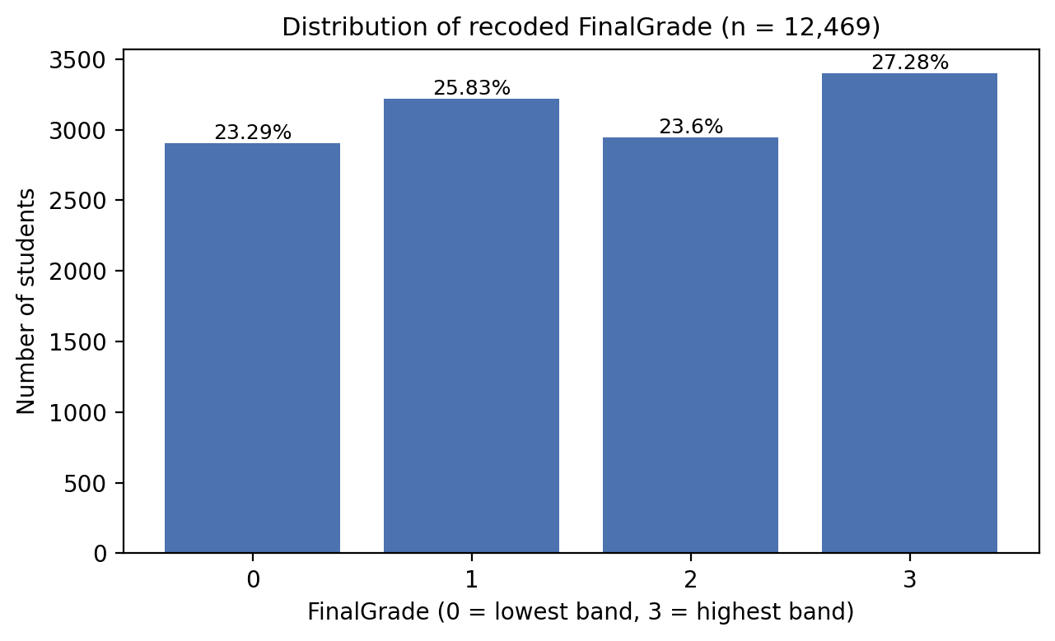
Figure 1. Rows and percentage in each recoded FinalGrade band after de duplication (n = 12,469); band 3 is the highest grade.
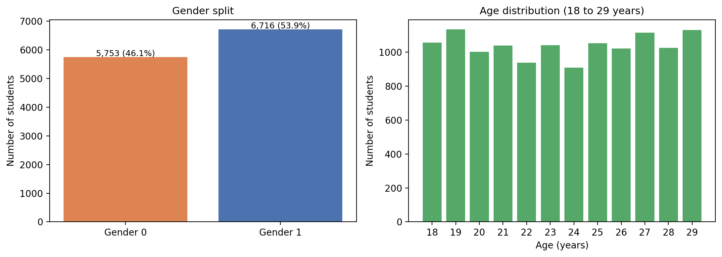
Figure 2. Left: rows by Gender code (the data do not say which code is which). Right: rows at each age, 18 to 29 (n = 12,469).
Figure 1 shows the target bands range from 23.3% to 27.3%, so accuracy is a fair headline metric and no resampling is needed. Figure 2 shows gender at 53.9% code 1 and age spread almost evenly across twelve years; a real cohort would cluster around 18 to 22, the first sign the file was not a natural sample.
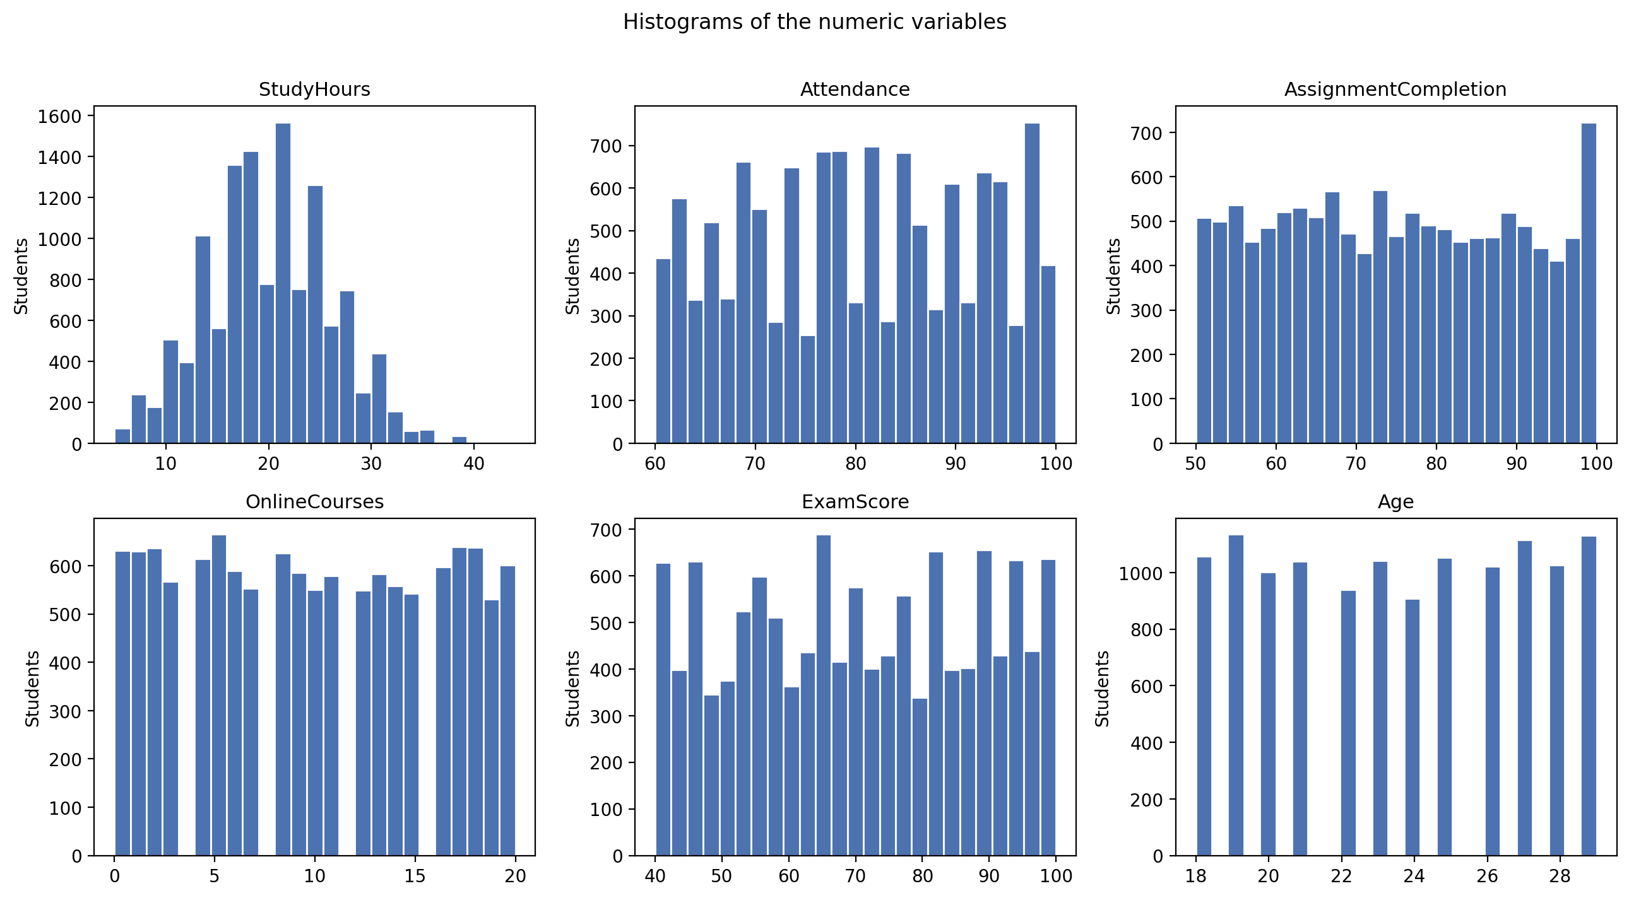
Figure 3. Histograms of the six numeric variables (n = 12,469).
Figure 3 shows the numeric variables; none has outliers. Among the coded variables (Appendix A, Figure A1) Internet is 93% ones and 57% of rows report high stress.
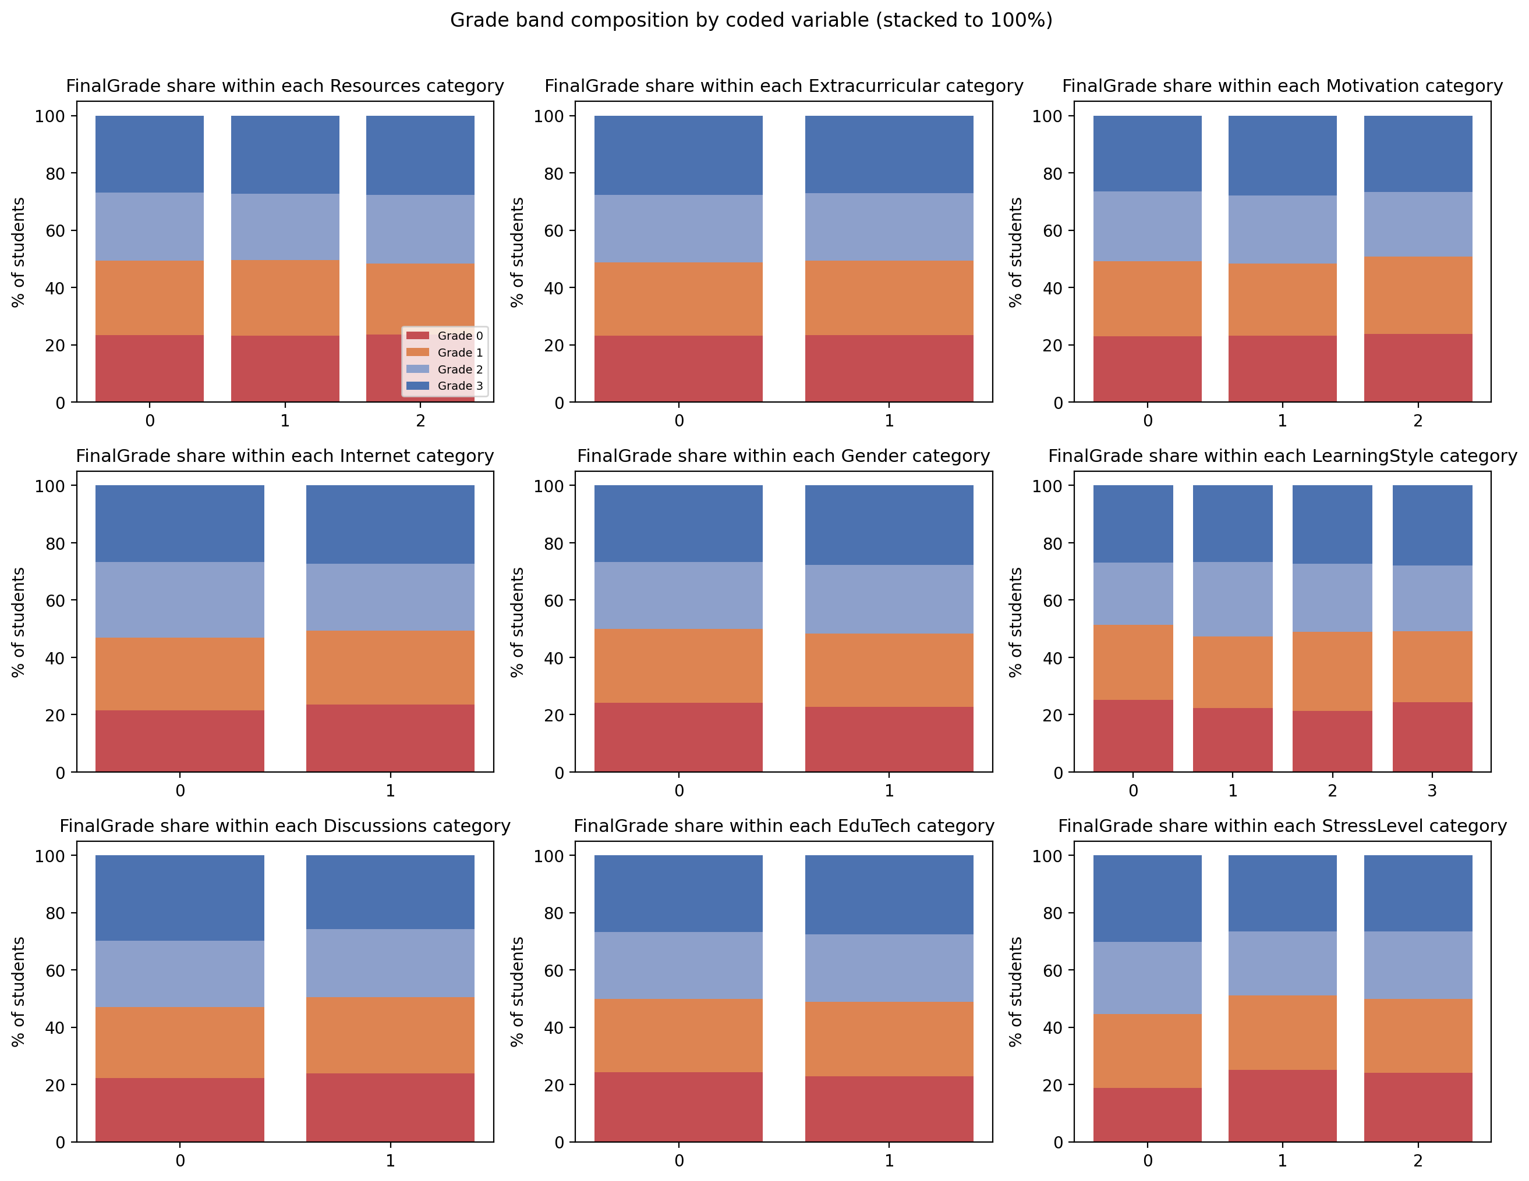
Figure 4. Percentage of rows in each grade band within each code of the nine coded variables, stacked to 100% (n = 12,469). A variable that separated the grades would show the band shares shifting between codes.
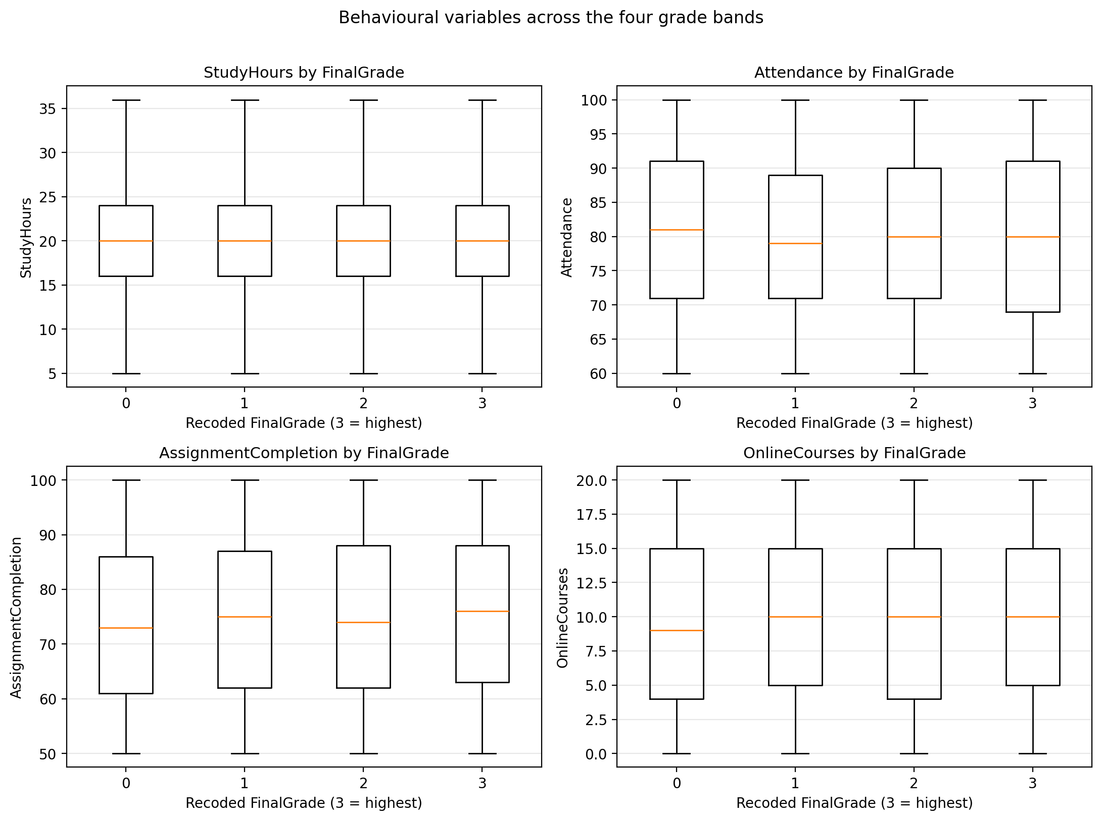
Figure 5. Boxplots of the four main behavioural variables by recoded grade band (box = middle 50%, line = median, whiskers = typical range, outliers hidden).
Figures 4 and 5 test whether any variable separates the grades on its own. None does. The largest shift among coded variables is StressLevel, where mean recoded grade falls from 1.67 at low stress to 1.51 at medium; Motivation and Resources move it by under 0.03 of a band. Mean StudyHours runs from 19.96 in band 0 to 20.12 in band 3 and Attendance from 80.76 to 80.11, far inside the within band spread. If the information is not in any single variable, only a model representing combinations could succeed, and the question becomes whether such combinations are real.
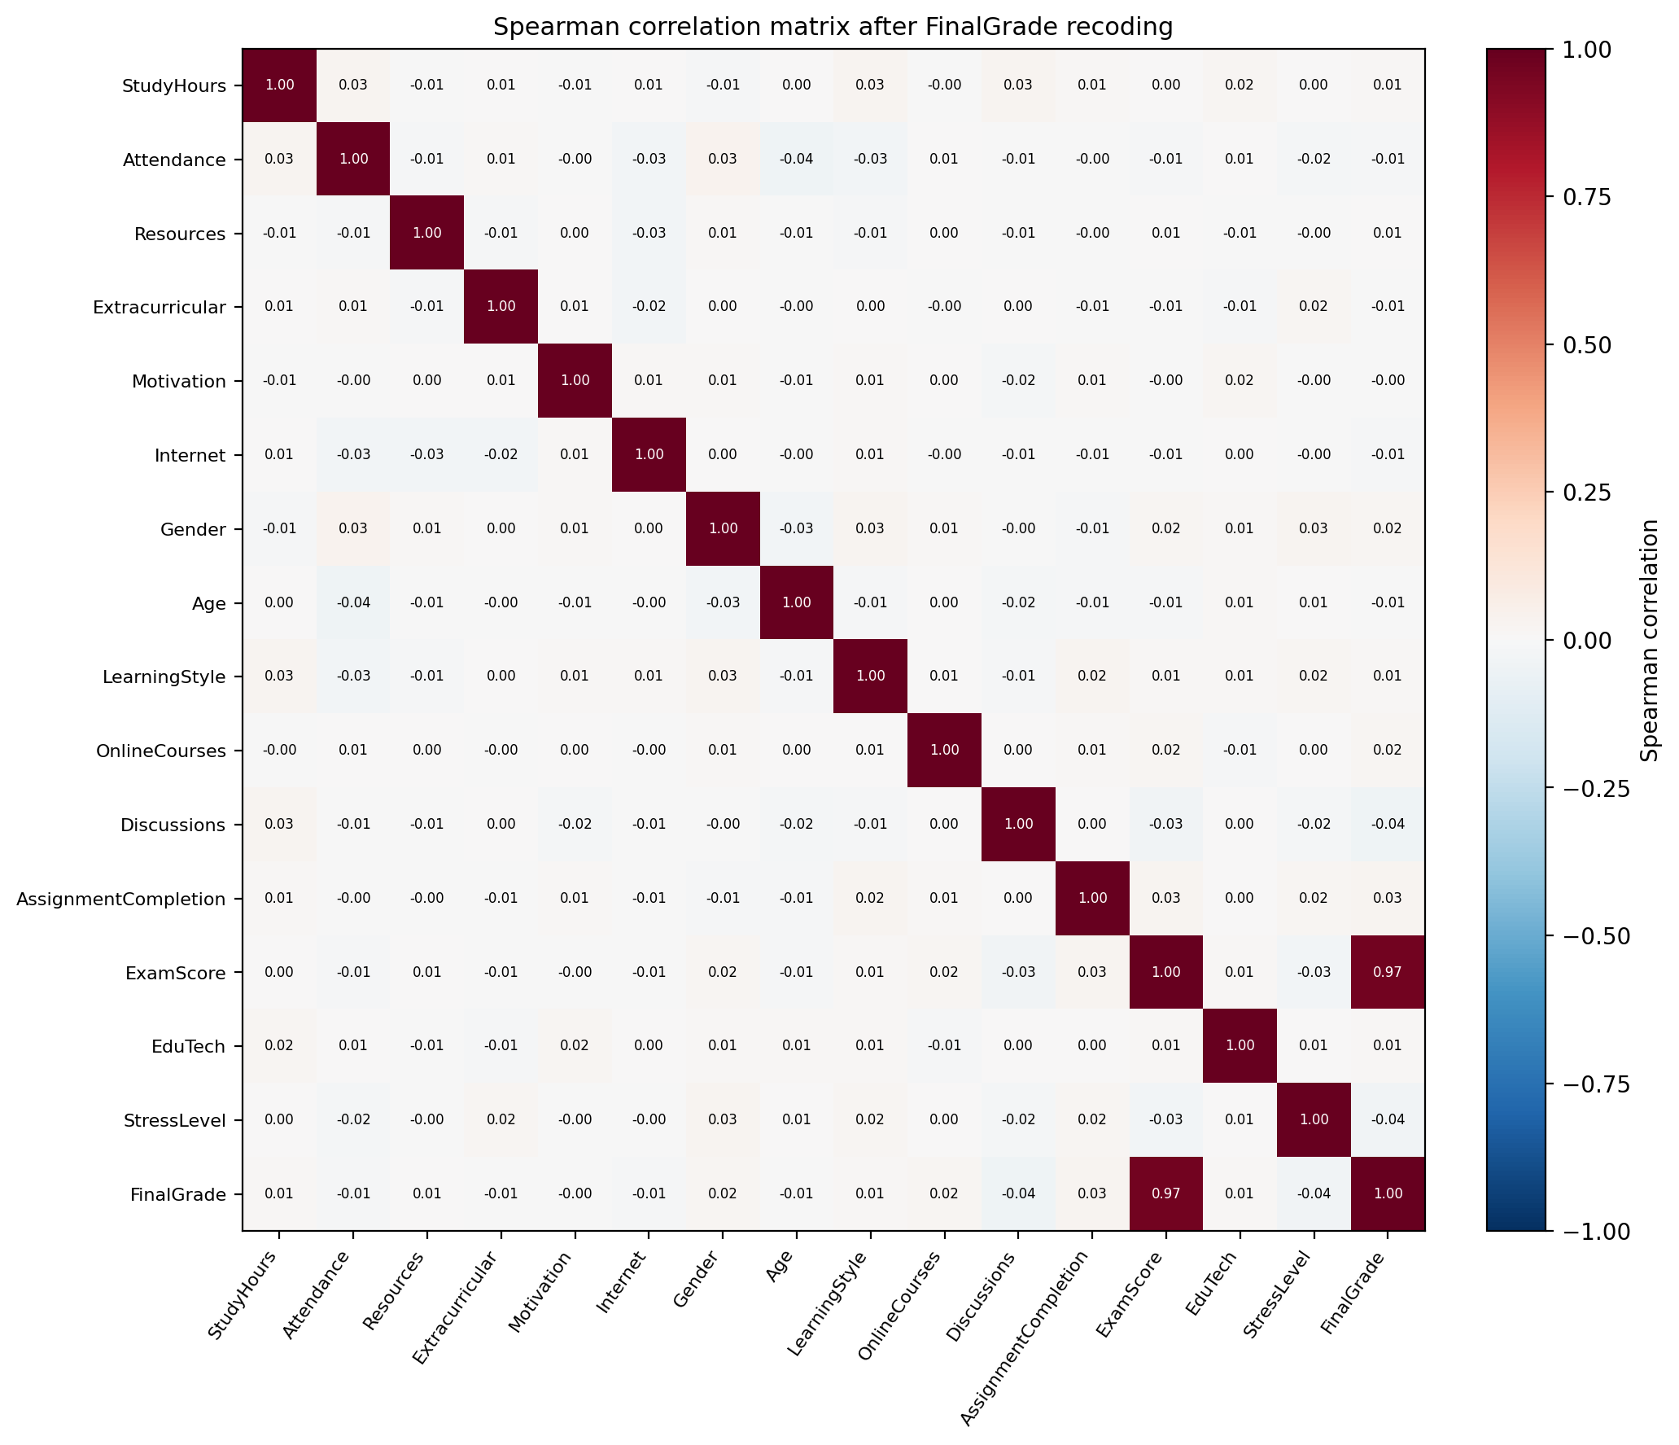
Figure 6. Spearman rank correlation between every pair of variables after recoding (n = 12,469); red positive, blue negative, white zero, values annotated.
Figure 6 shows the Spearman correlation matrix (used because most variables are ordinal or binary). In the FinalGrade row ExamScore is +0.97 and nothing else exceeds 0.04; predictors are also uncorrelated with each other. I removed no feature on this basis: low linear correlation is not grounds for removal before a nonlinear model, and no pair was redundant.
Table 1. ExamScore summary by recoded grade band (n = 12,469); the minimum and maximum show the bands do not overlap.
Recoded FinalGrade | Rows | Mean ExamScore | Median | Minimum | Maximum
0 (lowest) | 2,904 | 46.75 | 47 | 40 | 54
1 | 3,221 | 61.88 | 62 | 55 | 69
2 | 2,943 | 77.07 | 77 | 70 | 84
3 (highest) | 3,401 | 92.57 | 93 | 85 | 100

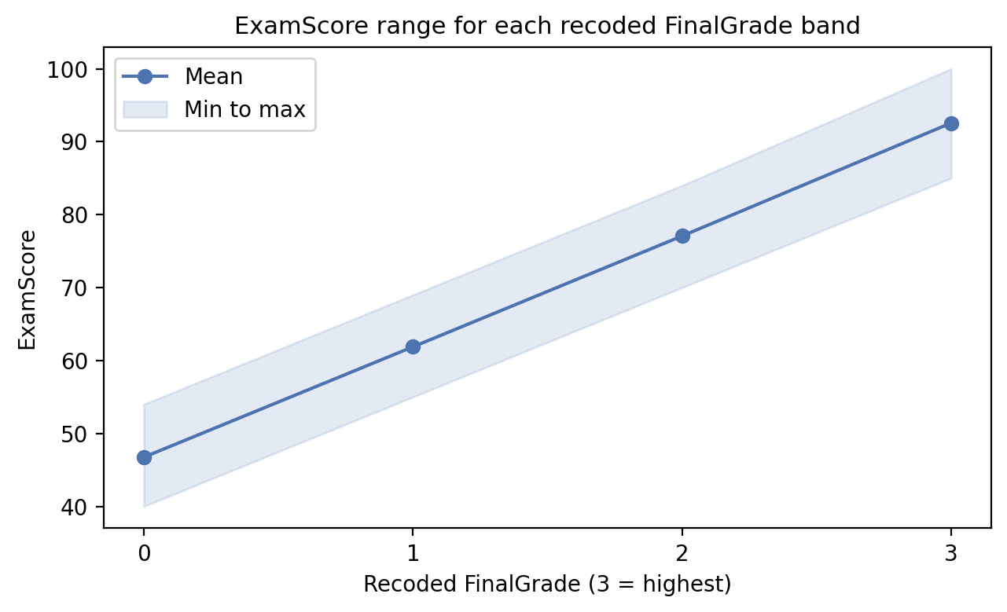
Figure 7. Mean ExamScore (line) and minimum to maximum range (shaded) for each recoded grade band; the ranges do not overlap.
Table 1 and Figure 7 show that band 0 is exactly ExamScore 40 to 54, band 1 is 55 to 69, band 2 is 70 to 84 and band 3 is 85 to 100, with no overlap, matching the Source B description of the grade as "assigned based on exam score". A model given ExamScore would learn four thresholds and score near 100% while saying nothing about behaviour, so it was withheld.

4. Ethical Issues
The dataset contains no names, identifiers, contact details or free text, so no personal data in the GDPR sense is present and UH ethical approval was not required. Permission is explicit: the Zenodo record carries a CC BY 4.0 licence (Figure 8), Source A is CC0 and the Kaggle mirror repeats the CC BY 4.0 terms; attribution is given in the references.
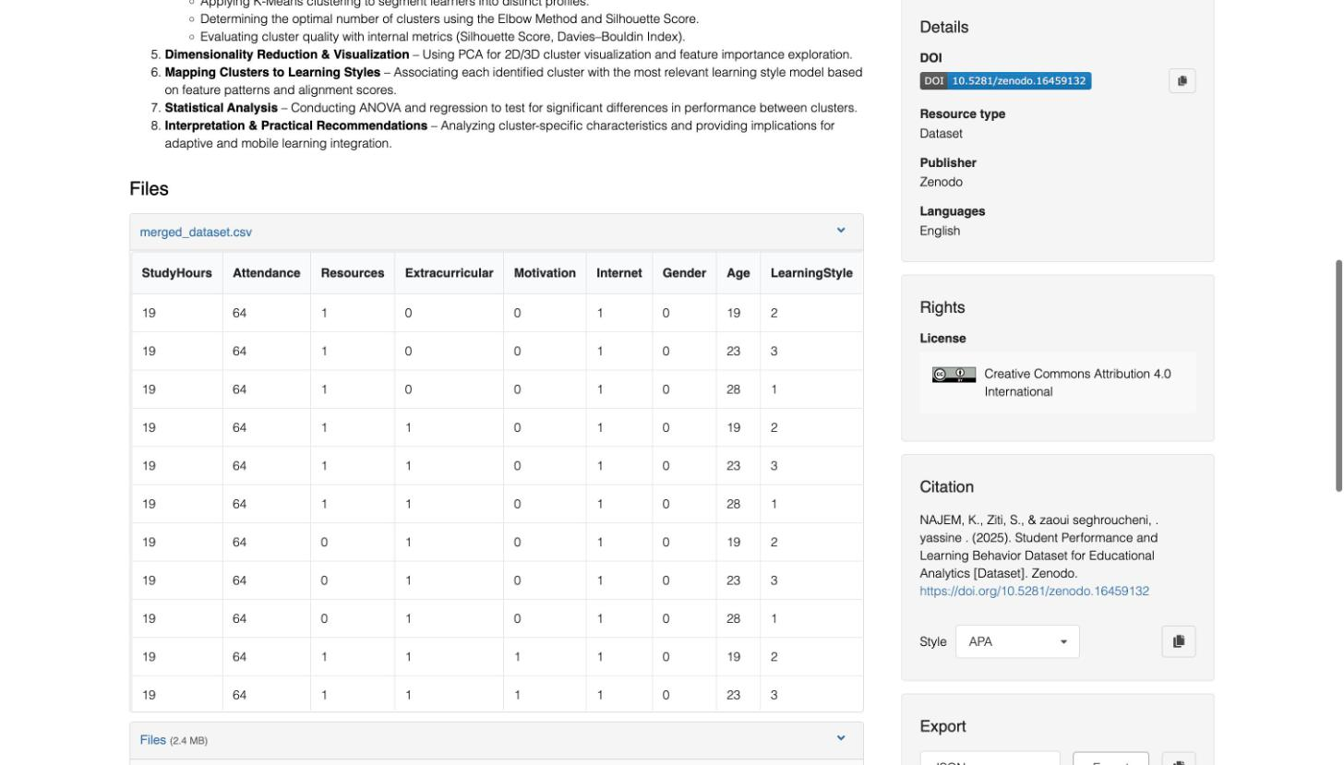
Figure 8. Zenodo record for the dataset (DOI 10.5281/zenodo.16459132), accessed 6 October 2026, showing the CC BY 4.0 licence and citation.
Ethical collection does not quite apply: Source B is synthetic and Source A, though undocumented, contains no identifiers and is public domain. The risk lies in use. Zhang et al. (2021) and Ramaswami, Susnjak and Mathrani (2022) warn that performance predictions can label students and change how staff treat them; a model built on these data would carry that risk with no compensating validity, since Section 6.4 shows it does not generalise. Gender and Age are predictors, so any operational model would also need a fairness audit, and the headline accuracy must not justify any intervention.

5. Methodology

5.1 Design and tools
I used a quantitative predictive design on secondary data: quality checks, recoding, duplicate removal, exploratory analysis, stratified split, three models, five fold cross validation, GridSearchCV tuning of all three, two importance measures, an ordinal error analysis, and a record level leakage check with grouped validation. I wrote the code in Python 3.12 with pandas, matplotlib and scikit-learn 1.8 (Pedregosa et al., 2011), fixed the seed at 42, and the notebook saves every figure and table used here.

5.2 Features and split
The fourteen predictors are every column except FinalGrade, FinalGrade_Original and ExamScore. I used train_test_split with test_size 0.20, shuffle and stratify on the grade, giving 9,975 training and 2,494 test rows with the same 23.3, 25.8, 23.6 and 27.3% band shares in each. The test set was used once per fitted model.

5.3 Models
Logistic Regression fits one linear boundary per class and picks the most probable class. I placed a StandardScaler inside a Pipeline so it is fitted on training folds only. It is the baseline: if it fails while tree models succeed, the structure is nonlinear.
Random Forest was chosen because Section 2 shows it performing well on such data, it captures interactions without feature engineering, and it provides importance measures. The initial model used 100 unlimited depth trees.
Gradient Boosting was included as a sequential ensemble to check the forest against a different way of combining trees; initially 200 trees, learning rate 0.15, depth 6.

5.4 Metrics
Accuracy is the share of test rows placed in the correct band, a fair headline because the bands are balanced. Precision for a class is TP/(TP+FP), the share of rows predicted in that band that belong there; recall is TP/(TP+FN), the share of rows in that band that were found; F1 is their harmonic mean 2PR/(P+R), high only when both are. Weighted F1 averages the class F1 scores by class size and is the second headline metric. Confusion matrices show where errors fall; because the grade is ordinal I also report adjacent accuracy and mean absolute error in bands, and per class precision and recall for the tuned ensembles.

5.5 Cross validation and tuning
I used StratifiedKFold with five shuffled folds on all 12,469 rows for the initial models, and GridSearchCV with the same scheme inside the training set only for tuning. I tuned all three models so the comparison is between models at their best. Grids were centred on the scikit-learn defaults and widened both ways, the usual start without a prior study on the same data (Ahmed, 2024). Logistic Regression: C in {0.01, 0.1, 1, 10}. Random Forest: trees {100, 200, 300}, max depth {10, 15, 25, none}, min samples per leaf {1, 2, 4}, 36 combinations. Gradient Boosting: trees {100, 200}, learning rate {0.05, 0.15}, depth {3, 6}, 8 combinations. In all 44 settings and 220 fits.

5.6 Importance, error analysis and leakage check
I report impurity importance from the tuned forest and permutation importance on the test set with ten repeats. For the leakage check I reconstructed each row's Source B identity from its twelve Source B columns, measured the share of test rows sharing a record with training, compared accuracy on shared and unshared rows, then repeated the modelling with GroupShuffleSplit and five fold GroupKFold, which keep all rows of a record on one side of every split.

6. Results

6.1 Initial models and cross validation
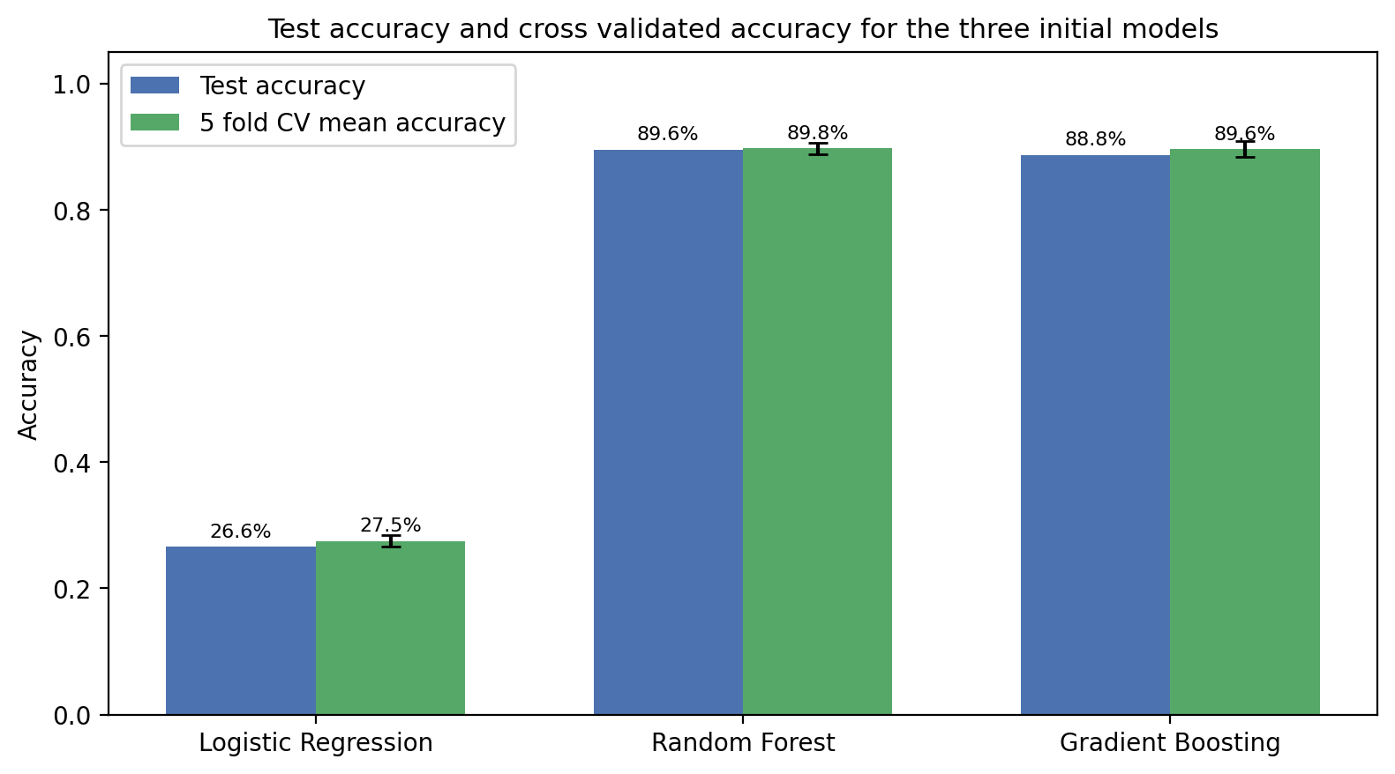
Figure 9. Test accuracy (blue) and five fold cross validated accuracy with one standard deviation bars (green) for the three initial models, row level split.
Figure 9 gives the row level results. Logistic Regression scored 0.266 accuracy and 0.228 weighted F1, collapsing towards one class (recall 0.03 for band 2, 0.57 for band 3; Appendix A, Figure A2), where a random guess scores 0.25. Random Forest scored 0.896 and Gradient Boosting 0.888 on both metrics, evenly across bands; five fold cross validation gave 0.275, 0.898 and 0.896 with standard deviations of 0.009 to 0.013. The gap between the ensembles is smaller than the fold to fold variation, so they are equivalent on this evidence.

6.2 Hyperparameter tuning
Table 2. GridSearchCV on the 9,975 training rows: best Logistic Regression setting, four of eight Gradient Boosting settings and the three best of 36 Random Forest settings (full grids in Appendix A). CV accuracy is on training folds of about 8,000 rows, so lower than Section 6.1.
Model | Setting | Training accuracy | CV accuracy | CV std
Logistic Regression | C = 0.01 (best of 4; all within 0.001) | 0.290 | 0.277 | 0.005
Gradient Boosting | lr 0.15, depth 6, 200 trees | 0.9999 | 0.8652 | 0.0093
Gradient Boosting | lr 0.15, depth 6, 100 trees | 0.9863 | 0.8202 | 0.0112
Gradient Boosting | lr 0.05, depth 6, 200 trees | 0.9564 | 0.7677 | 0.0195
Gradient Boosting | lr 0.15, depth 3, 200 trees | 0.6695 | 0.5151 | 0.0079
Random Forest | depth 25, leaf 1, 200 trees | 1.0 | 0.8649 | 0.0059
Random Forest | depth none, leaf 1, 200 trees | 1.0 | 0.8636 | 0.0069
Random Forest | depth none, leaf 1, 300 trees | 1.0 | 0.8625 | 0.0084

Table 2 records the trials. Logistic Regression did not move with C: no regularisation helps boundaries of the wrong shape. Gradient Boosting was highly sensitive: depth 3 trees scored 0.38 to 0.52 and only depth 6 with the higher learning rate reached 0.865. Random Forest was insensitive: all 36 settings lay within a few points and the best (200 trees, depth 25, one row per leaf) scored 0.865. Training accuracy near 1.0 shows each tree memorises its folds.
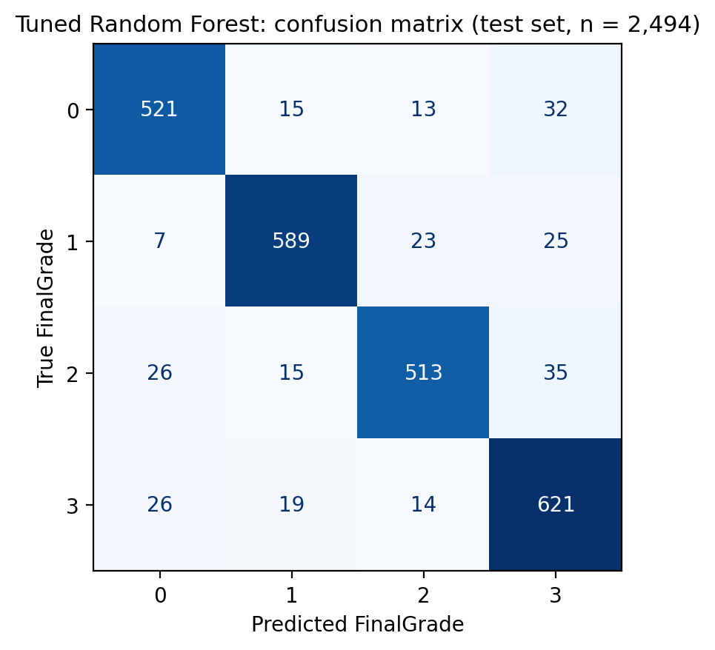
Figure 10. Tuned Random Forest confusion matrix on the row level test set (n = 2,494): rows true band, columns predicted band.
Refitted on the full training set, the tuned Random Forest scored 0.900 on both metrics, up 0.4 points; tuned Gradient Boosting stayed at 0.888 and Logistic Regression at 0.267. Per class precision and recall (Appendix A, Table A2) lie between 0.87 and 0.92 for every band of both ensembles, so no weak class hides behind the headline, though band 2 has the lowest recall. Figure 10 shows the 250 errors: 109 one band out, 83 two and 58 three, giving adjacent accuracy 0.944 and mean absolute error 0.18 bands; over half the errors are not near misses.

6.3 Feature importance
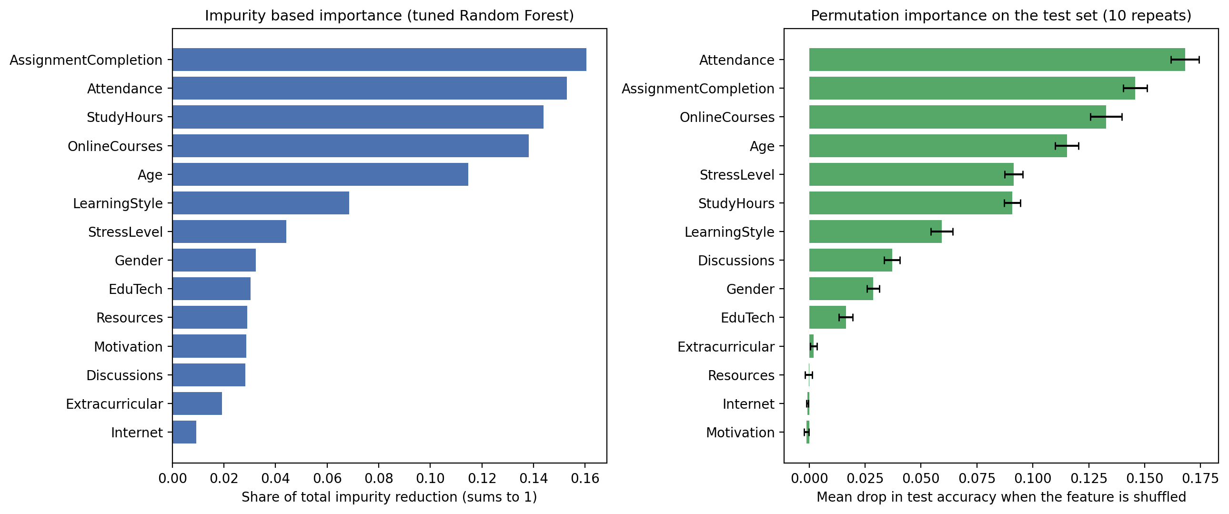
Figure 11. Left: impurity importance in the tuned Random Forest (share of total impurity reduction). Right: permutation importance on the row level test set (mean accuracy drop when shuffled, ten repeats).
Figure 11 shows both importance measures. They agree on AssignmentCompletion, Attendance, OnlineCourses, Age and StudyHours, each costing 9 to 17 points of accuracy when shuffled, and disagree on StressLevel (impurity seventh, permutation fifth), the bias Strobl et al. (2007) describe for a three valued variable. The striking result is that Resources, Motivation, Internet and Extracurricular have permutation importance of zero. Those are exactly the four Source A variables: the model ignores them, as expected if the join paired them with the grade arbitrarily rather than measuring them on the same student.

6.4 Record level leakage and grouped validation
Reconstructing each row's Source B identity showed that the 12,469 rows contain only 4,200 distinct grade records, each appearing about three times (up to ten) with different Source A attributes. In the row level split, 86.4% of test rows had a grade record also present in training; on those the tuned forest scored 99.6%, and on the 339 rows whose record it had never seen it scored 28.6%.
Table 3. Tuned models when the split is made by grade record (GroupShuffleSplit, 20% of records held out; five fold GroupKFold), so no record appears on both sides.
Model | Grouped test accuracy | Grouped weighted F1 | GroupKFold accuracy | GroupKFold std
Logistic Regression | 0.271 | 0.226 | 0.268 | 0.016
Random Forest | 0.244 | 0.240 | 0.238 | 0.014
Gradient Boosting | 0.238 | 0.236 | 0.251 | 0.015

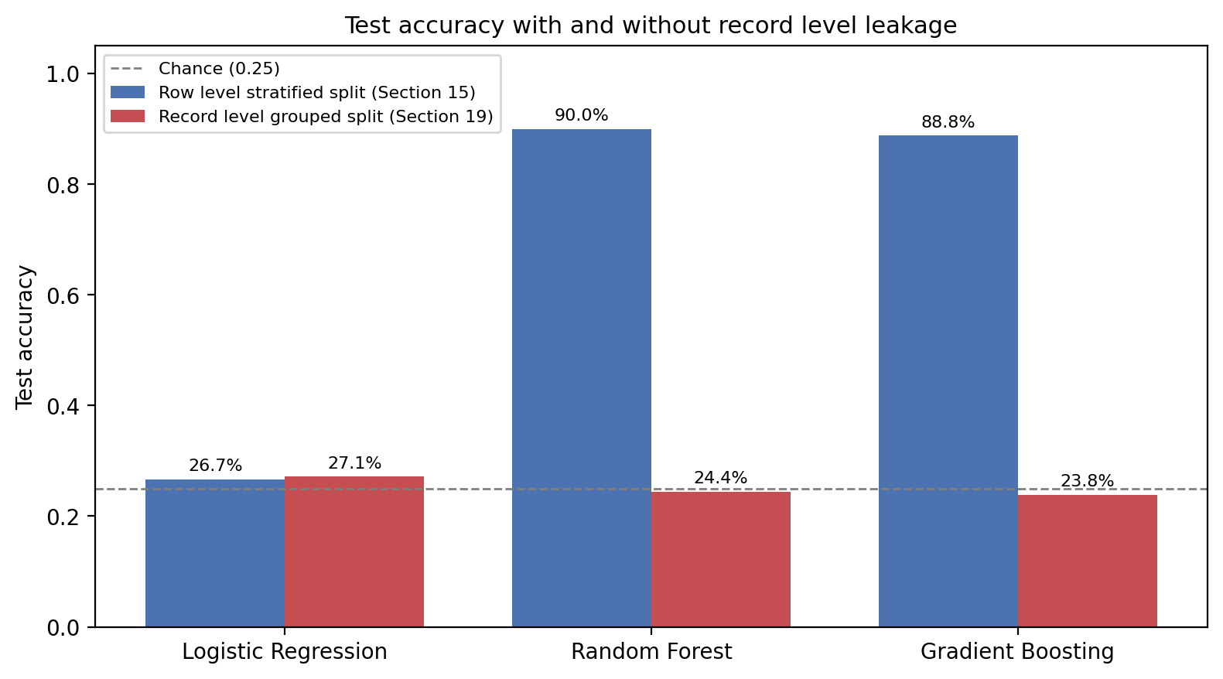
Figure 12. Test accuracy of the tuned models on the row level split (blue) and the record level grouped split (red); dashed line is chance.
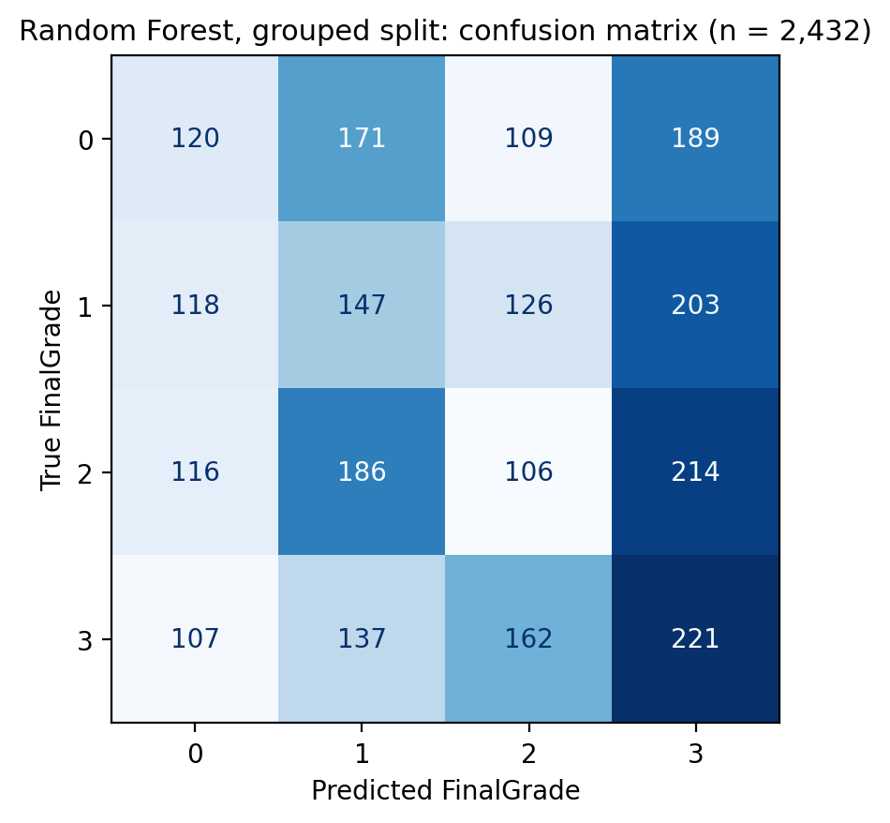
Figure 13. Random Forest confusion matrix on the record level grouped split (n = 2,432): predictions spread across all bands regardless of the true band.
Table 3 and Figures 12 and 13 give the grouped results. With no record on both sides, Random Forest scored 0.244 on the grouped test set and 0.238 in GroupKFold, Gradient Boosting 0.238 and 0.251, and Logistic Regression 0.271 and 0.268. All three are at the 0.25 of random guessing. The notebook's nine validation assertions, including no duplicate rows and no overlap of row indices, all pass; they were correct and not enough.

7. Analysis and Discussion

7.1 Answer to the research question
The row level results say that ensembles predict the grade band with 90% accuracy; the grouped results say they predict nothing, and the second answer is correct. The ensembles reached 90% by memorising the 4,200 grade records and recognising them when they reappeared with different Source A attributes, which they could do because the Source B columns together identify a record almost uniquely. That is why those columns topped the importance ranking and the Source A columns scored zero. Once memorisation is prevented, the fourteen variables carry no usable information. On this dataset, behavioural and contextual variables do not predict the grade at all.

7.2 Why the models behaved as they did
The exploratory analysis agreed with the grouped result all along: no variable separated the bands and no correlation exceeded 0.04, and a real 90% signal would leave some trace in the marginals. The ensembles succeeded only at row level because deep trees can carve out a leaf for each record; that Gradient Boosting collapsed to 0.38 to 0.52 with depth 3 trees and Random Forest needed depth 25 with single row leaves is the signature of memorisation, and training accuracy of 1.0 pointed the same way.

7.3 Comparison with the literature
The row level importance ranking matched Su, Lin and Liu (2022) and Wang and Yu (2025) closely, which is itself a caution: agreement with the literature made a spurious result look plausible. Yağcı (2022) reached 70 to 75% with prior marks on a real cohort and nobody reviewed reports 90% from behaviour alone; that discrepancy should have prompted the provenance check earlier. The grouped result is below every reviewed study, but those measured behaviour and grade on the same real person; Source B is synthetic with no indication that its behavioural columns depend on grade, so a null result is what its construction implies. Kaufman et al. (2012) describe repeated entity leakage as common and hard to spot.

7.4 Limitations
The dataset is the central limitation: one source synthetic, the other undocumented, no population or dates, and a join that manufactures rows, so nothing can be said about real students. The grids were modest and Gradient Boosting at depth 6 sat at the edge of its grid, though wider search cannot create signal that is not there. SHAP values (Wang and Luo, 2024) were not computed; given the grouped result they would have explained a memorisation pattern. The grouped validation relies on reconstructing record identity from twelve Source B columns, an inference from the published notebook rather than a key supplied with the data.

7.5 Evidence that the objectives were met
Objective 1: construction traced to its sources and join, 1,534 duplicates removed (Sections 3.1, 3.4). Objective 2: FinalGrade reversed with a cross tabulation proving no row changed band (3.4). Objective 3: Figures 1 to 7 show no single variable separates the bands (3.5). Objective 4: three models compared on a held out set and with cross validation, all tuned across 44 settings (6.1, 6.2). Objective 5: two importance measures compared and their disagreement explained (6.3). Objective 6 produced the main finding: grouped validation showed the headline accuracy to be an artefact (6.4).

7.6 Practical implications
Nothing from this model should be used to flag students. The useful output is a method: before trusting an accuracy figure on an assembled dataset, trace how it was built, identify the entity that carries the outcome, and validate with splits grouped by that entity. A university building an early warning tool from its own records should group by student in every split, report precision and recall per risk band, audit outcomes by gender and age, and keep a human in the decision.

8. Conclusion and Future Work
This project measured how well behaviour, engagement and context predict a student's grade band without the exam score. On a row level split a tuned Random Forest reached 90.0% accuracy and 0.900 weighted F1 against 26.7% for Logistic Regression. Tracing the dataset's construction showed it to be an inner join of two Kaggle files, one declared synthetic, in which 12,469 rows carry only 4,200 distinct grade records, and when the split was grouped by record every model fell to chance. The justified conclusion is that these variables do not predict FinalGrade here and that the 90% figure, which the first submission reported as a result, was leakage produced by the merge. The contribution is to document that failure mode and to show that duplicate removal, stratified splitting and cross validation, all correctly applied, did not catch it.
Future work should begin with data: a single institutional dataset with known dates and one row per student, where behaviour only prediction is an open question and 70 to 75% with prior marks is realistic (Yağcı, 2022). Grouped validation should be the default whenever an entity can repeat, SHAP should check that any signal has a plausible direction, and calibration and a fairness audit across gender and age should precede any use that touches a student.

References
Abuzinadah, N., Umer, M., Ishaq, A., Al Hejaili, A., Alsubai, S., Eshmawi, A.A., Mohamed, A. and Ashraf, I. (2023) 'Role of convolutional features and machine learning for predicting student academic performance from MOODLE data', PLOS ONE, 18(11), e0293061. Available at: https://doi.org/10.1371/journal.pone.0293061
Ahmed, E. (2024) 'Student performance prediction using machine learning algorithms', Applied Computational Intelligence and Soft Computing, 2024, 4067721. Available at: https://doi.org/10.1155/2024/4067721
Albreiki, B., Zaki, N. and Alashwal, H. (2021) 'A systematic literature review of student performance prediction using machine learning techniques', Education Sciences, 11(9), 552. Available at: https://doi.org/10.3390/educsci11090552
Balaji, P., Alelyani, S., Qahmash, A. and Mohana, M. (2021) 'Contributions of machine learning models towards student academic performance prediction: a systematic review', Applied Sciences, 11(21), 10007. Available at: https://doi.org/10.3390/app112110007
Borna, M.-R., Saadat, H., Hojjati, A.T. and Akbari, E. (2024) 'Analyzing click data with AI: implications for student performance prediction and learning assessment', Frontiers in Education, 9, 1421479. Available at: https://doi.org/10.3389/feduc.2024.1421479
Breiman, L. (2001) 'Random forests', Machine Learning, 45(1), pp. 5-32. Available at: https://doi.org/10.1023/A:1010933404324
Cagliero, L., Canale, L., Farinetti, L., Baralis, E. and Venuto, E. (2021) 'Predicting student academic performance by means of associative classification', Applied Sciences, 11(4), 1420. Available at: https://doi.org/10.3390/app11041420
Doz, D., Cotič, M. and Felda, D. (2023) 'Random forest regression in predicting students' achievements and fuzzy grades', Mathematics, 11(19), 4129. Available at: https://doi.org/10.3390/math11194129
Ersozlu, Z., Taheri, S. and Koch, I. (2024) 'A review of machine learning methods used for educational data', Education and Information Technologies, 29, pp. 22125-22145. Available at: https://doi.org/10.1007/s10639-024-12704-0
Friedman, J.H. (2001) 'Greedy function approximation: a gradient boosting machine', Annals of Statistics, 29(5), pp. 1189-1232. Available at: https://doi.org/10.1214/aos/1013203451
Hastie, T., Tibshirani, R. and Friedman, J. (2009) 'The elements of statistical learning: data mining, inference, and prediction', 2nd edn, Springer. Available at: https://hastie.su.domains/ElemStatLearn/
Kaufman, S., Rosset, S., Perlich, C. and Stitelman, O. (2012) 'Leakage in data mining: formulation, detection, and avoidance', ACM Transactions on Knowledge Discovery from Data, 6(4), 15. Available at: https://doi.org/10.1145/2382577.2382579
Kohavi, R. (1995) 'A study of cross-validation and bootstrap for accuracy estimation and model selection', Proc. 14th Int. Joint Conf. on Artificial Intelligence (IJCAI), Montreal, 2, pp. 1137-1143. Available at: https://www.ijcai.org/Proceedings/95-2/Papers/016.pdf
Lu, J., Liu, Y., Liu, S., Yan, Z., Zhao, X., Zhang, Y., Yang, C., Zhang, H., Su, W. and Zhao, P. (2024) 'Machine learning analysis of factors affecting college students' academic performance', Frontiers in Psychology, 15, 1447825. Available at: https://doi.org/10.3389/fpsyg.2024.1447825
Najem, K., Ziti, S. and Zaoui Seghroucheni, Y. (2025) 'Student performance and learning behavior dataset for educational analytics' [Dataset], Zenodo. Available at: https://doi.org/10.5281/zenodo.16459132 (Accessed: 6 October 2026)
Namoun, A. and Alshanqiti, A. (2021) 'Predicting student performance using data mining and learning analytics techniques: a systematic literature review', Applied Sciences, 11(1), 237. Available at: https://doi.org/10.3390/app11010237
Nguyen, L. (2025) 'Student performance factors' [Dataset], Kaggle. Available at: https://www.kaggle.com/datasets/lainguyn123/student-performance-factors (Accessed: 6 October 2026)
Nieto-Reyes, A., Duque, R. and Francisci, G. (2021) 'A method to automate the prediction of student academic performance from early stages of the course', Mathematics, 9(21), 2677. Available at: https://doi.org/10.3390/math9212677
Pedregosa, F., Varoquaux, G., Gramfort, A., Michel, V., Thirion, B., Grisel, O., Blondel, M., Prettenhofer, P., Weiss, R., Dubourg, V., Vanderplas, J., Passos, A., Cournapeau, D., Brucher, M., Perrot, M. and Duchesnay, É. (2011) 'Scikit-learn: machine learning in Python', Journal of Machine Learning Research, 12, pp. 2825-2830. Available at: https://jmlr.org/papers/v12/pedregosa11a.html
Ramaswami, G., Susnjak, T. and Mathrani, A. (2022) 'Supporting students' academic performance using explainable machine learning with automated prescriptive analytics', Big Data and Cognitive Computing, 6(4), 105. Available at: https://doi.org/10.3390/bdcc6040105
Rastrollo-Guerrero, J.L., Gómez-Pulido, J.A. and Durán-Domínguez, A. (2020) 'Analyzing and predicting students' performance by means of machine learning: a review', Applied Sciences, 10(3), 1042. Available at: https://doi.org/10.3390/app10031042
Romero, C. and Ventura, S. (2020) 'Educational data mining and learning analytics: an updated survey', WIREs Data Mining and Knowledge Discovery, 10(3), e1355. Available at: https://doi.org/10.1002/widm.1355
Shamim, A. (2024) 'Student performance and learning behavior dataset', version 1 [Dataset], Kaggle. Available at: https://www.kaggle.com/datasets/adilshamim8/student-performance-and-learning-style/versions/1 (Accessed: 6 October 2026)
Shamim, A. (2025) 'Student performance and learning behavior dataset', version 3 [Dataset], Kaggle. Available at: https://www.kaggle.com/datasets/adilshamim8/student-performance-and-learning-style (Accessed: 6 October 2026)
Siddique, A., Jan, A., Majeed, F., Qahmash, A.I., Quadri, N.N. and Abdul Wahab, M.O. (2021) 'Predicting academic performance using an efficient model based on fusion of classifiers', Applied Sciences, 11(24), 11845. Available at: https://doi.org/10.3390/app112411845
Sokolova, M. and Lapalme, G. (2009) 'A systematic analysis of performance measures for classification tasks', Information Processing and Management, 45(4), pp. 427-437. Available at: https://doi.org/10.1016/j.ipm.2009.03.002
Strobl, C., Boulesteix, A.-L., Zeileis, A. and Hothorn, T. (2007) 'Bias in random forest variable importance measures: illustrations, sources and a solution', BMC Bioinformatics, 8, 25. Available at: https://doi.org/10.1186/1471-2105-8-25
Su, Y.-S., Lin, Y.-D. and Liu, T.-Q. (2022) 'Applying machine learning technologies to explore students' learning features and performance prediction', Frontiers in Neuroscience, 16, 1018005. Available at: https://doi.org/10.3389/fnins.2022.1018005
Wang, D., Lian, D., Xing, Y., Dong, S., Sun, X. and Yu, J. (2022) 'Analysis and prediction of influencing factors of college student achievement based on machine learning', Frontiers in Psychology, 13, 881859. Available at: https://doi.org/10.3389/fpsyg.2022.881859
Wang, J. and Yu, Y. (2025) 'Machine learning approach to student performance prediction of online learning', PLOS ONE, 20(1), e0299018. Available at: https://doi.org/10.1371/journal.pone.0299018
Wang, S. and Luo, B. (2024) 'Academic achievement prediction in higher education through interpretable modeling', PLOS ONE, 19(9), e0309838. Available at: https://doi.org/10.1371/journal.pone.0309838
Yağcı, M. (2022) 'Educational data mining: prediction of students' academic performance using machine learning algorithms', Smart Learning Environments, 9, 11. Available at: https://doi.org/10.1186/s40561-022-00192-z
Zhang, Y., Yun, Y., An, R., Cui, J., Dai, H. and Shang, X. (2021) 'Educational data mining techniques for student performance prediction: method review and comparison analysis', Frontiers in Psychology, 12, 698490. Available at: https://doi.org/10.3389/fpsyg.2021.698490

Appendix A. Additional figures and tables
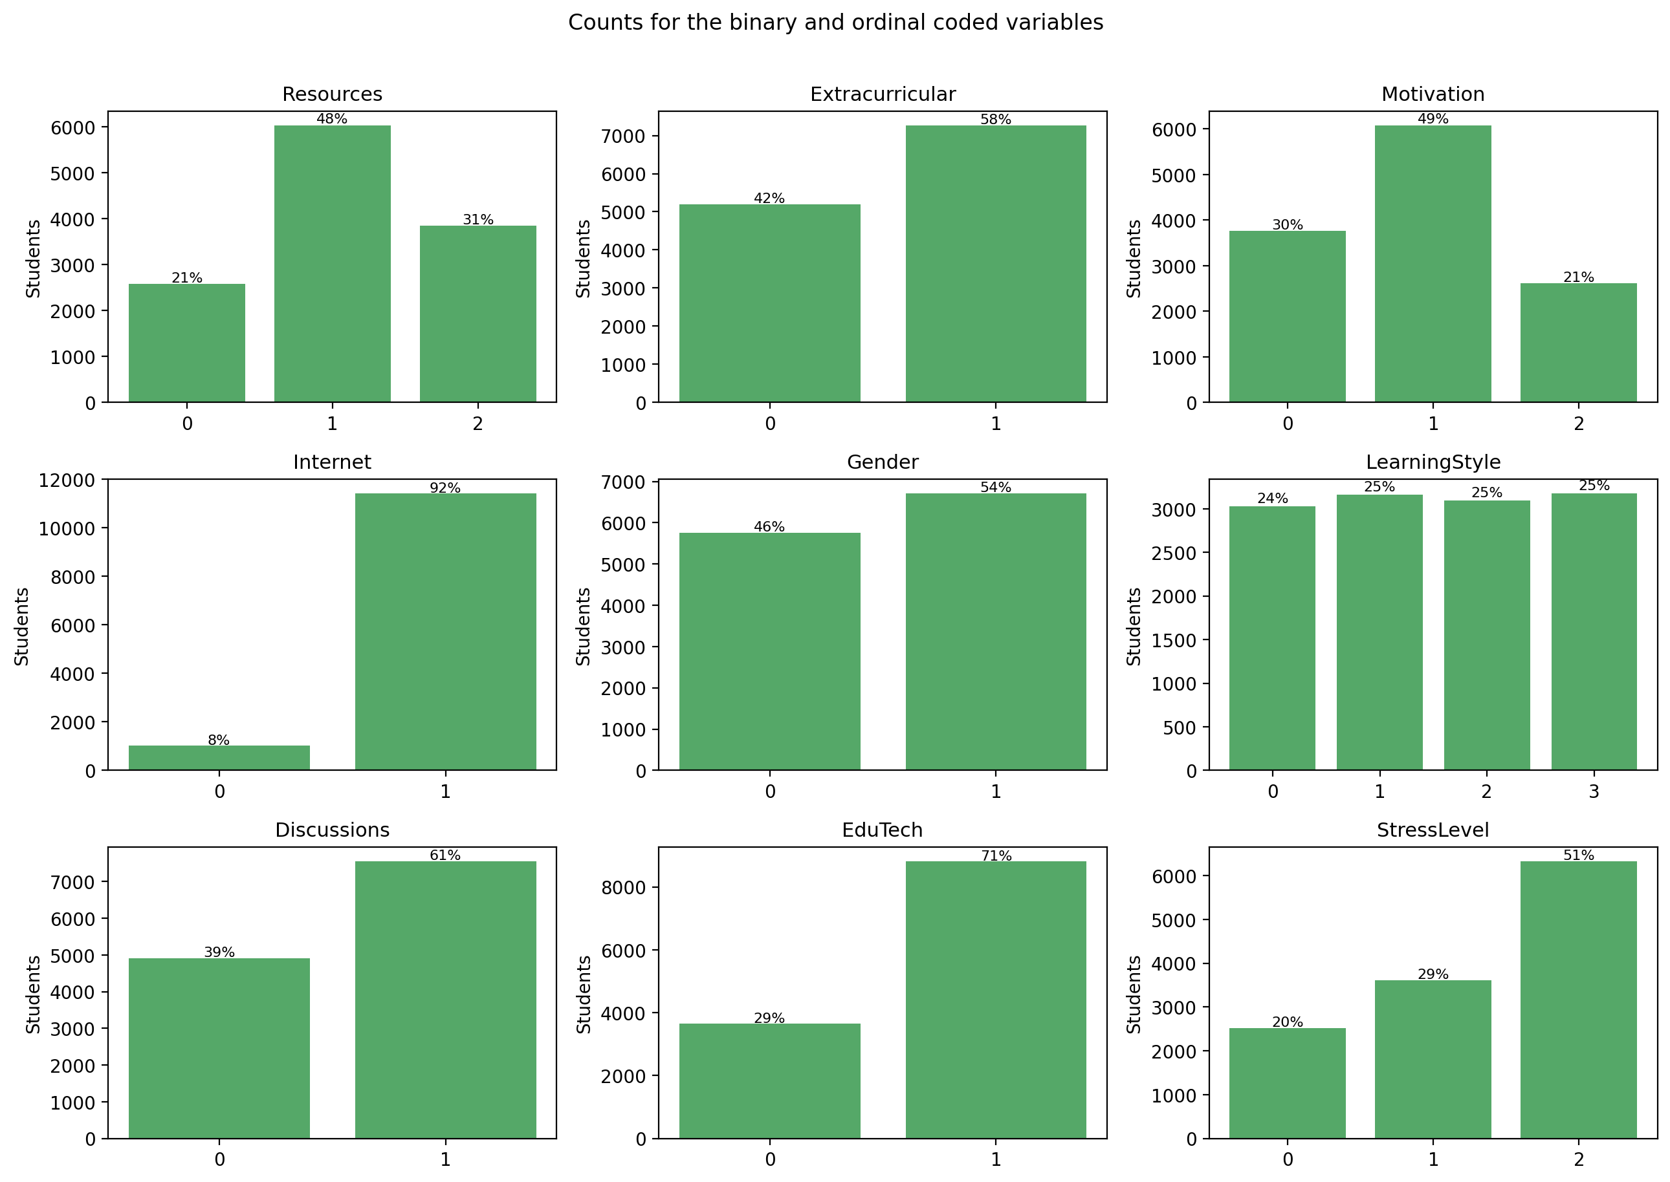
Figure A1. Number of rows in each code of the nine binary and ordinal variables, with the percentage above each bar (n = 12,469).
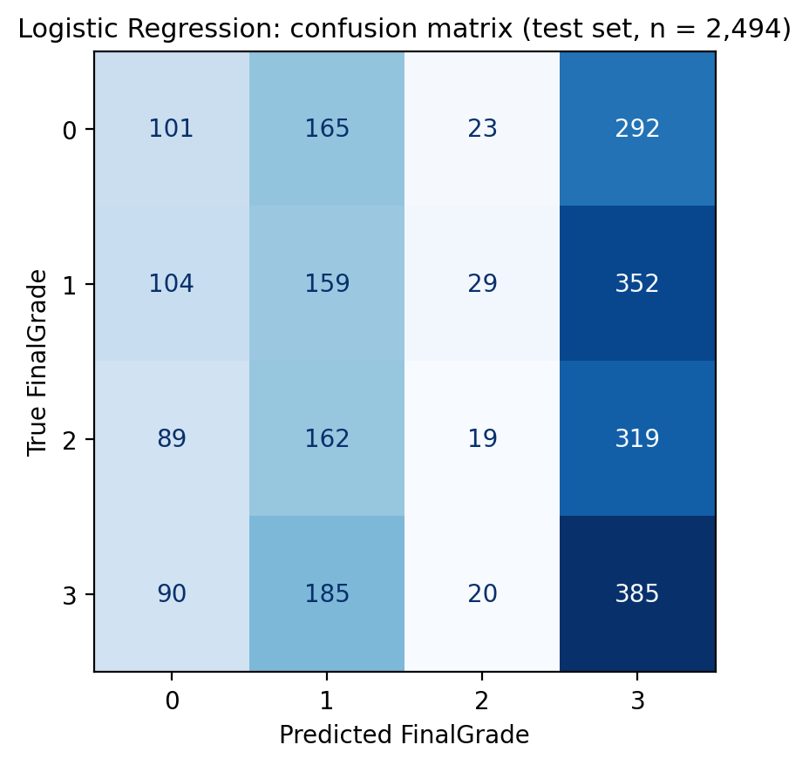
Figure A2. Confusion matrix for Logistic Regression on the row level test set (n = 2,494). The model predicts band 3 for most rows and band 2 for only 17 of the 589 rows that belong there.
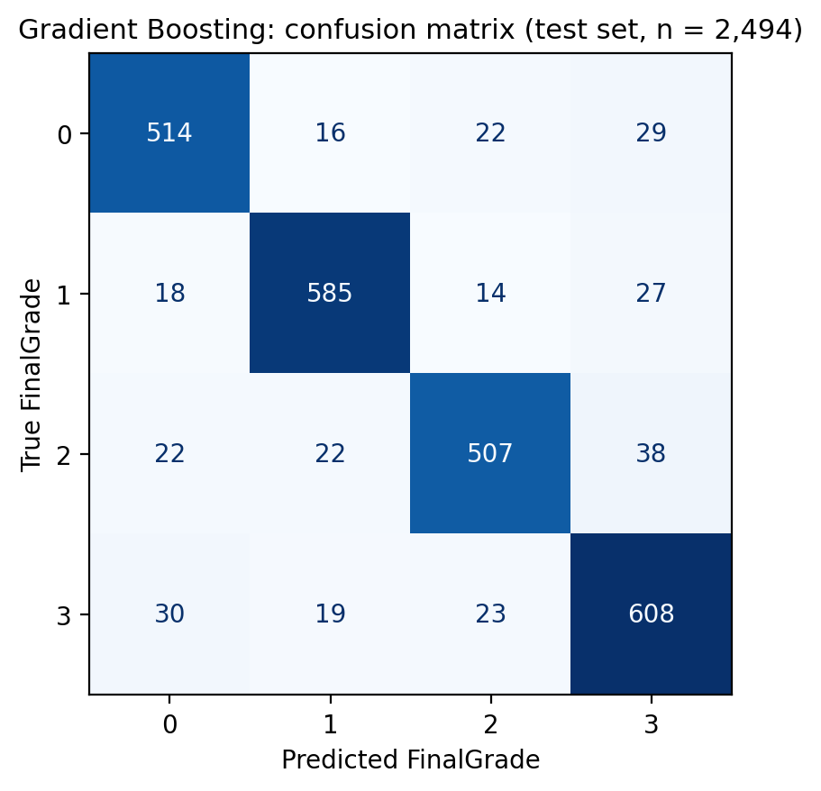
Figure A3. Confusion matrix for the initial Gradient Boosting model on the row level test set (n = 2,494).
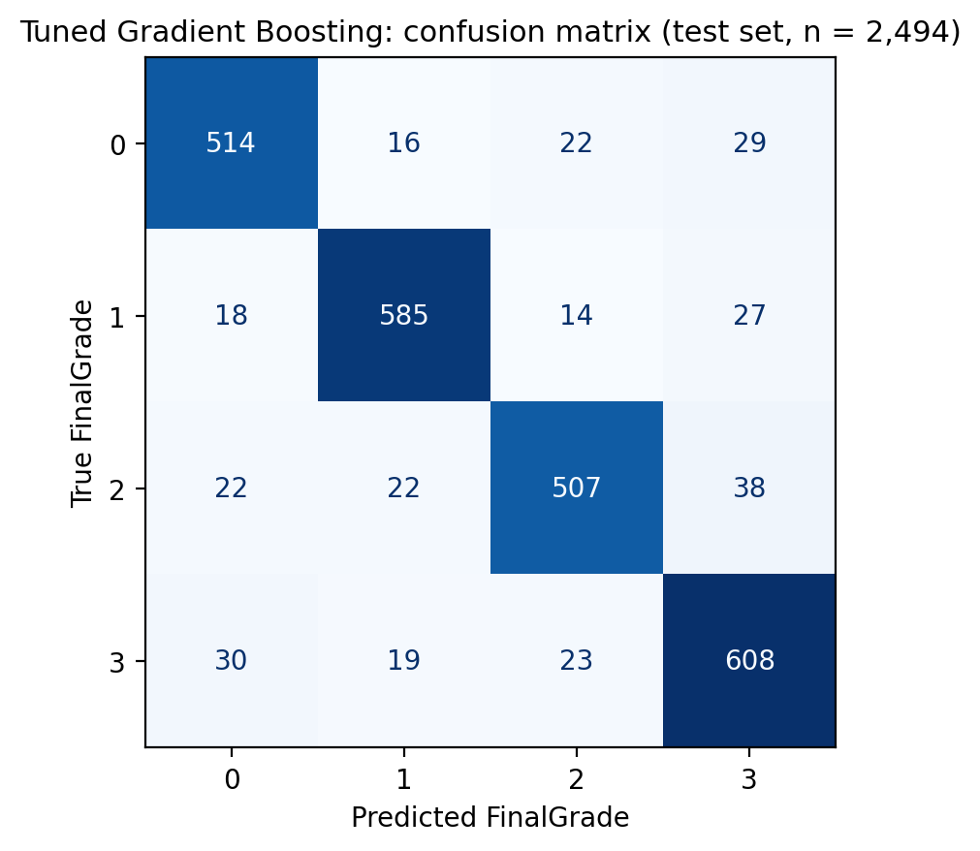
Figure A4. Confusion matrix for the tuned Gradient Boosting model on the row level test set (n = 2,494).
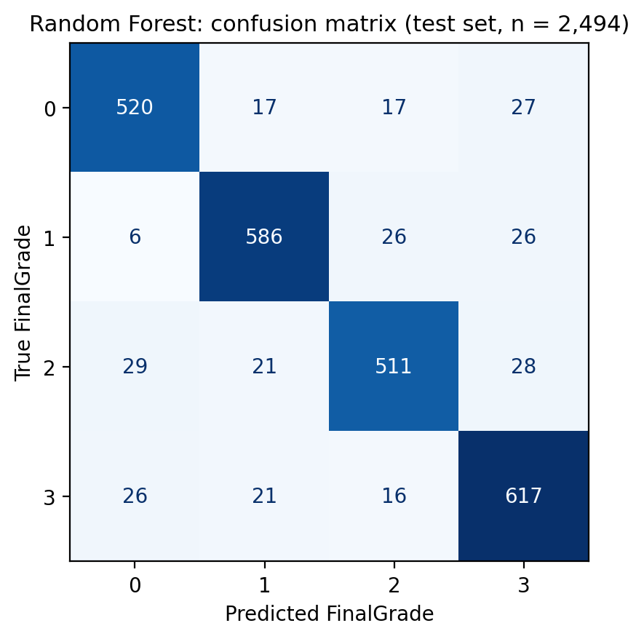
Figure A5. Confusion matrix for the initial 100 tree Random Forest on the row level test set (n = 2,494).
Table A1. The sixteen variables: source file (key = join column present in both sources), type, observed range and meaning.
Variable | From | Type | Values | Meaning
StudyHours | key | numeric | 5 to 44 | Weekly hours of study
Attendance | key | numeric | 60 to 100 | Percentage of classes attended
Gender | key | binary | 0, 1 | Gender; code mapping not stated
Resources | A | ordinal | 0, 1, 2 | Access to resources: low, medium, high
Extracurricular | A | binary | 0, 1 | Extracurricular activities
Motivation | A | ordinal | 0, 1, 2 | Motivation: low, medium, high
Internet | A | binary | 0, 1 | Internet access
Age | B | numeric | 18 to 29 | Age in years
LearningStyle | B | nominal | 0 to 3 | Visual, auditory, reading/writing, kinaesthetic
OnlineCourses | B | numeric | 0 to 20 | Online courses completed
Discussions | B | binary | 0, 1 | Takes part in discussions
AssignmentCompletion | B | numeric | 50 to 100 | Percentage of assignments completed
ExamScore | B | numeric | 40 to 100 | Exam score; descriptive only
EduTech | B | binary | 0, 1 | Uses educational technology
StressLevel | B | ordinal | 0, 1, 2 | Stress: low, medium, high
FinalGrade | B | ordinal | 0 to 3 | Grade band from ExamScore; target, recoded so 3 is highest

Table A2. Per class precision, recall and F1 for the tuned Random Forest and tuned Gradient Boosting on the 2,494 row level test rows.
Model | Grade | Precision | Recall | F1 | Test rows
Random Forest | 0 | 0.898 | 0.897 | 0.898 | 581
Random Forest | 1 | 0.923 | 0.915 | 0.919 | 644
Random Forest | 2 | 0.911 | 0.871 | 0.891 | 589
Random Forest | 3 | 0.871 | 0.913 | 0.892 | 680
Gradient Boosting | 0 | 0.88 | 0.885 | 0.882 | 581
Gradient Boosting | 1 | 0.911 | 0.908 | 0.91 | 644
Gradient Boosting | 2 | 0.896 | 0.861 | 0.878 | 589
Gradient Boosting | 3 | 0.866 | 0.894 | 0.88 | 680

Table A3. All 36 Random Forest settings tried by GridSearchCV on the 9,975 training rows, sorted by cross validated accuracy; depth none means trees grow until pure. Logistic Regression C in {0.01, 0.1, 1, 10} gave CV accuracy 0.276 to 0.277; the four Gradient Boosting settings omitted from Table 2 (depth 3) scored 0.379, 0.419, 0.450 and 0.515.
Max depth | Min samples leaf | Trees | Training accuracy | CV accuracy
25 | 1 | 200 | 1.0 | 0.8649
none | 1 | 200 | 1.0 | 0.8636
none | 1 | 300 | 1.0 | 0.8625
25 | 1 | 100 | 1.0 | 0.8625
25 | 1 | 300 | 1.0 | 0.8622
none | 1 | 100 | 1.0 | 0.8608
15 | 1 | 300 | 0.9999 | 0.8575
15 | 1 | 200 | 0.9999 | 0.8572
15 | 1 | 100 | 0.9999 | 0.8529
none | 2 | 300 | 0.9999 | 0.8455
25 | 2 | 300 | 0.9999 | 0.845
25 | 2 | 200 | 0.9999 | 0.8431
none | 2 | 200 | 0.9999 | 0.8425
none | 2 | 100 | 0.9998 | 0.8394
25 | 2 | 100 | 0.9998 | 0.8377
15 | 2 | 200 | 0.9995 | 0.8349
15 | 2 | 300 | 0.9995 | 0.8345
15 | 2 | 100 | 0.9989 | 0.8333
none | 4 | 300 | 0.9944 | 0.814
25 | 4 | 300 | 0.9944 | 0.8137
25 | 4 | 200 | 0.9939 | 0.8091
none | 4 | 200 | 0.9939 | 0.8089
none | 4 | 100 | 0.9911 | 0.8047
25 | 4 | 100 | 0.9912 | 0.8037
15 | 4 | 300 | 0.9918 | 0.8033
15 | 4 | 200 | 0.9907 | 0.7997
15 | 4 | 100 | 0.9872 | 0.7893
10 | 1 | 300 | 0.9699 | 0.7633
10 | 1 | 200 | 0.9668 | 0.7588
10 | 1 | 100 | 0.9575 | 0.7432
10 | 2 | 300 | 0.9594 | 0.7413
10 | 2 | 200 | 0.9562 | 0.7358
10 | 2 | 100 | 0.9443 | 0.727
10 | 4 | 300 | 0.9371 | 0.7116
10 | 4 | 200 | 0.932 | 0.7015
10 | 4 | 100 | 0.9228 | 0.6945

Appendix B. Dataset provenance evidence
Screenshots taken on 6 October 2026 of the two Kaggle source datasets identified from the Zenodo authors' notebook (Project.ipynb, cell 6 reads Dataset_J7.csv and student_performance_large_dataset.csv; cell 14 maps their column names; cells 21 and 25 define the join keys and perform pd.merge with how='inner').

Figure B1. Source A: Student Performance Factors (Nguyen, 2025), 6,607 rows, CC0 licence. The page describes the columns but not how or where the data were collected.

Figure B2. Source B: version 1 of Student Performance and Learning Behavior Dataset (Shamim, 2024), 10,000 rows. The first line of the description states that the dataset is a synthetic representation based on true trends and should not be taken seriously.

Appendix C. Code
The complete notebook (Student_Performance_Resubmission.ipynb) is on GitHub at https://github.com/vallerignanatheja23102882/student-performance-ml-prediction together with the dataset, a README, the figures folder and a models folder holding the three tuned models saved with joblib (random_forest_tuned.joblib, gradient_boosting_tuned.joblib, logistic_regression_tuned.joblib) and tuned_models.json with their hyperparameters and scores. The code cells are reproduced below in order; the explanatory markdown between them is in the notebook. All code is my own, written with pandas, matplotlib and scikit-learn (Pedregosa et al., 2011). To reproduce: install pandas, numpy, matplotlib, scikit-learn and jupyter, place student_performance.csv beside the notebook and run all cells; with RANDOM_STATE = 42 every number in this report is regenerated.
1. Libraries and settings
Cell 1
import warnings
from pathlib import Path

import numpy as np
import pandas as pd
import matplotlib.pyplot as plt

from sklearn.model_selection import train_test_split, StratifiedKFold, cross_val_score, GridSearchCV
from sklearn.preprocessing import StandardScaler
from sklearn.pipeline import Pipeline
from sklearn.linear_model import LogisticRegression
from sklearn.ensemble import RandomForestClassifier, GradientBoostingClassifier
from sklearn.inspection import permutation_importance
from sklearn.metrics import (accuracy_score, f1_score, precision_score, recall_score,
classification_report, confusion_matrix, ConfusionMatrixDisplay,
mean_absolute_error)

warnings.filterwarnings("ignore")
RANDOM_STATE = 42
FIG_DIR = Path("figures")
FIG_DIR.mkdir(exist_ok=True)

plt.rcParams.update({"figure.dpi": 110, "savefig.dpi": 200, "axes.titlesize": 11, "axes.labelsize": 10})

def save_fig(name):
"""Save the current matplotlib figure to figures/<name>.png and show it."""
plt.tight_layout()
plt.savefig(FIG_DIR / f"{name}.png", bbox_inches="tight")
plt.show()

print("Libraries loaded. Random state:", RANDOM_STATE)
2. Dataset documentation
3. Loading and data quality checks
Cell 2
df = pd.read_csv("student_performance.csv")
print(f"Shape: {df.shape[0]:,} rows x {df.shape[1]} columns")
df.head()
Cell 3
print("Missing values per column:")
print(df.isna().sum())
print(f"\nExact duplicate rows: {df.duplicated().sum():,}")
print(f"Data types: {df.dtypes.unique().tolist()}")
Cell 4
summary = df.describe().T[["count", "mean", "std", "min", "50%", "max"]].round(2)
summary["unique"] = df.nunique()
summary
4. Recoding the FinalGrade direction
Cell 5
df["FinalGrade_Original"] = df["FinalGrade"].copy()
grade_min, grade_max = df["FinalGrade_Original"].min(), df["FinalGrade_Original"].max()
df["FinalGrade"] = grade_max + grade_min - df["FinalGrade_Original"]

original_corr = df[["ExamScore", "FinalGrade_Original"]].corr().iloc[0, 1]
recoded_corr = df[["ExamScore", "FinalGrade"]].corr().iloc[0, 1]
print(f"Correlation ExamScore vs original FinalGrade: {original_corr:+.3f}")
print(f"Correlation ExamScore vs recoded FinalGrade: {recoded_corr:+.3f}")

pd.crosstab(df["FinalGrade_Original"], df["FinalGrade"], rownames=["Original code"], colnames=["Recoded"])
5. Removing duplicates
Cell 6
rows_before = len(df)
df = df.drop_duplicates().reset_index(drop=True)
print(f"Rows before: {rows_before:,}")
print(f"Rows after: {len(df):,}")
print(f"Removed: {rows_before - len(df):,}")
N = len(df)
6. Exploratory data analysis
Cell 7
grade_counts = df["FinalGrade"].value_counts().sort_index()
grade_pct = (grade_counts / N * 100).round(2)

plt.figure(figsize=(6.5, 4))
bars = plt.bar(grade_counts.index.astype(str), grade_counts.values, color="#4C72B0")
for b, p in zip(bars, grade_pct):
plt.text(b.get_x() + b.get_width() / 2, b.get_height() + 30, f"{p}%", ha="center", fontsize=9)
plt.title("Distribution of recoded FinalGrade (n = 12,469)")
plt.xlabel("FinalGrade (0 = lowest band, 3 = highest band)")
plt.ylabel("Number of students")
save_fig("fig02_grade_distribution")
print(pd.DataFrame({"count": grade_counts, "percent": grade_pct}))
Cell 8
fig, axes = plt.subplots(1, 2, figsize=(11, 4))

gender_counts = df["Gender"].value_counts().sort_index()
gender_pct = (gender_counts / N * 100).round(1)
axes[0].bar(["Gender 0", "Gender 1"], gender_counts.values, color=["#DD8452", "#4C72B0"])
for i, (c, p) in enumerate(zip(gender_counts.values, gender_pct.values)):
axes[0].text(i, c + 40, f"{c:,} ({p}%)", ha="center", fontsize=9)
axes[0].set_title("Gender split")
axes[0].set_ylabel("Number of students")

age_counts = df["Age"].value_counts().sort_index()
axes[1].bar(age_counts.index.astype(str), age_counts.values, color="#55A868")
axes[1].set_title("Age distribution (18 to 29 years)")
axes[1].set_xlabel("Age (years)")
axes[1].set_ylabel("Number of students")
save_fig("fig03_gender_age")
print("Gender split (%):", gender_pct.to_dict())
print("Age: min", df.Age.min(), "max", df.Age.max(), "mean", round(df.Age.mean(), 1))
Cell 9
numeric_vars = ["StudyHours", "Attendance", "AssignmentCompletion", "OnlineCourses", "ExamScore", "Age"]
coded_vars = ["Resources", "Extracurricular", "Motivation", "Internet", "Gender",
"LearningStyle", "Discussions", "EduTech", "StressLevel"]

fig, axes = plt.subplots(2, 3, figsize=(13, 7))
for ax, v in zip(axes.flat, numeric_vars):
ax.hist(df[v], bins=25, color="#4C72B0", edgecolor="white")
ax.set_title(v)
ax.set_ylabel("Students")
fig.suptitle("Histograms of the numeric variables", y=1.01)
save_fig("fig04_numeric_histograms")
Cell 10
fig, axes = plt.subplots(3, 3, figsize=(13, 9))
for ax, v in zip(axes.flat, coded_vars):
counts = df[v].value_counts().sort_index()
ax.bar(counts.index.astype(str), counts.values, color="#55A868")
for i, c in enumerate(counts.values):
ax.text(i, c + 40, f"{c / N * 100:.0f}%", ha="center", fontsize=8)
ax.set_title(v)
ax.set_ylabel("Students")
fig.suptitle("Counts for the binary and ordinal coded variables", y=1.01)
save_fig("fig05_coded_bars")
Cell 11
fig, axes = plt.subplots(3, 3, figsize=(13, 10))
colours = ["#C44E52", "#DD8452", "#8DA0CB", "#4C72B0"]
for ax, v in zip(axes.flat, coded_vars):
ct = pd.crosstab(df[v], df["FinalGrade"], normalize="index") * 100
bottom = np.zeros(len(ct))
for g, col in zip(ct.columns, colours):
ax.bar(ct.index.astype(str), ct[g], bottom=bottom, color=col, label=f"Grade {g}")
bottom += ct[g].values
ax.set_title(f"FinalGrade share within each {v} category")
ax.set_ylabel("% of students")
axes[0, 0].legend(fontsize=7, loc="lower right")
fig.suptitle("Grade band composition by coded variable (stacked to 100%)", y=1.01)
save_fig("fig06_coded_vs_grade")
Cell 12
# Mean recoded grade per category, to read the direction of each ordinal variable
direction = pd.DataFrame({v: df.groupby(v)["FinalGrade"].mean().round(3) for v in coded_vars}).T
direction.columns = [f"code {c}" for c in direction.columns]
direction
Cell 13
behav = ["StudyHours", "Attendance", "AssignmentCompletion", "OnlineCourses"]
fig, axes = plt.subplots(2, 2, figsize=(11, 8))
for ax, v in zip(axes.flat, behav):
groups = [df.loc[df["FinalGrade"] == g, v].values for g in range(4)]
ax.boxplot(groups, tick_labels=["0", "1", "2", "3"], showfliers=False)
ax.set_title(f"{v} by FinalGrade")
ax.set_xlabel("Recoded FinalGrade (3 = highest)")
ax.set_ylabel(v)
ax.grid(axis="y", alpha=0.3)
fig.suptitle("Behavioural variables across the four grade bands", y=1.01)
save_fig("fig07_behavioural_boxplots")
df.groupby("FinalGrade")[behav].mean().round(2)
Cell 14
corr_cols = [c for c in df.columns if c != "FinalGrade_Original"]
corr = df[corr_cols].corr(method="spearman")

fig, ax = plt.subplots(figsize=(11, 9))
im = ax.imshow(corr, cmap="RdBu_r", vmin=-1, vmax=1)
ax.set_xticks(range(len(corr_cols))); ax.set_yticks(range(len(corr_cols)))
ax.set_xticklabels(corr_cols, rotation=55, ha="right", fontsize=8)
ax.set_yticklabels(corr_cols, fontsize=8)
for i in range(len(corr_cols)):
for j in range(len(corr_cols)):
val = corr.iloc[i, j]
ax.text(j, i, f"{val:.2f}", ha="center", va="center", fontsize=6,
color="white" if abs(val) > 0.55 else "black")
plt.colorbar(im, ax=ax, fraction=0.046, pad=0.04, label="Spearman correlation")
ax.set_title("Spearman correlation matrix after FinalGrade recoding")
save_fig("fig08_correlation_heatmap")

print("Correlation of each predictor with FinalGrade:")
print(corr["FinalGrade"].drop(["FinalGrade", "ExamScore"]).sort_values(ascending=False).round(3))
7. Why ExamScore is excluded (target leakage)
Cell 15
exam_by_grade = df.groupby("FinalGrade")["ExamScore"].agg(["count", "mean", "median", "min", "max"]).round(2)
print(exam_by_grade)

plt.figure(figsize=(6.5, 4))
plt.plot(exam_by_grade.index, exam_by_grade["mean"], marker="o", color="#4C72B0", label="Mean")
plt.fill_between(exam_by_grade.index, exam_by_grade["min"], exam_by_grade["max"], alpha=0.15, color="#4C72B0", label="Min to max")
plt.title("ExamScore range for each recoded FinalGrade band")
plt.xlabel("Recoded FinalGrade (3 = highest)")
plt.ylabel("ExamScore")
plt.xticks(exam_by_grade.index)
plt.legend()
save_fig("fig01_examscore_by_grade")
8. Features, target and train/test split
Cell 16
TARGET = "FinalGrade"
EXCLUDED = ["FinalGrade", "FinalGrade_Original", "ExamScore"]
FEATURES = [c for c in df.columns if c not in EXCLUDED]
X, y = df[FEATURES].copy(), df[TARGET].copy()

X_train, X_test, y_train, y_test = train_test_split(
X, y, test_size=0.20, random_state=RANDOM_STATE, stratify=y, shuffle=True)

print(f"Features ({len(FEATURES)}): {FEATURES}")
print(f"Training rows: {len(X_train):,} Test rows: {len(X_test):,}")
print("\nGrade share (%) in train vs test:")
print(pd.DataFrame({"train": y_train.value_counts(normalize=True).sort_index() * 100,
"test": y_test.value_counts(normalize=True).sort_index() * 100}).round(2))
9. Evaluation metrics explained
Cell 17
results = {}

def evaluate(name, model, X_te=X_test, y_te=y_test, fig_name=None):
"""Fit is done outside; this reports test metrics and draws the confusion matrix."""
y_pred = model.predict(X_te)
acc = accuracy_score(y_te, y_pred)
f1w = f1_score(y_te, y_pred, average="weighted")
results[name] = {"Test accuracy": acc, "Weighted F1": f1w,
"Macro precision": precision_score(y_te, y_pred, average="macro"),
"Macro recall": recall_score(y_te, y_pred, average="macro")}
print(f"{name}\n Accuracy: {acc:.4f} Weighted F1: {f1w:.4f}\n")
print(classification_report(y_te, y_pred, digits=3))
fig, ax = plt.subplots(figsize=(5, 4.5))
ConfusionMatrixDisplay.from_predictions(y_te, y_pred, cmap="Blues", ax=ax, colorbar=False)
ax.set_title(f"{name}: confusion matrix (test set, n = {len(y_te):,})")
ax.set_xlabel("Predicted FinalGrade"); ax.set_ylabel("True FinalGrade")
if fig_name:
save_fig(fig_name)
else:
plt.tight_layout(); plt.show()
return y_pred
10. Logistic Regression (linear baseline)
Cell 18
logistic_model = Pipeline([
("scaler", StandardScaler()),
("model", LogisticRegression(max_iter=1000, random_state=RANDOM_STATE))
])
logistic_model.fit(X_train, y_train)
y_pred_lr = evaluate("Logistic Regression", logistic_model, fig_name="fig09_cm_logistic")
11. Random Forest
Cell 19
rf_model = RandomForestClassifier(n_estimators=100, random_state=RANDOM_STATE, n_jobs=1)
rf_model.fit(X_train, y_train)
y_pred_rf = evaluate("Random Forest", rf_model, fig_name="fig10_cm_random_forest")
12. Gradient Boosting
Cell 20
gb_model = GradientBoostingClassifier(n_estimators=200, learning_rate=0.15, max_depth=6, random_state=RANDOM_STATE)
gb_model.fit(X_train, y_train)
y_pred_gb = evaluate("Gradient Boosting", gb_model, fig_name="fig11_cm_gradient_boosting")
13. Five fold cross validation
Cell 21
cv = StratifiedKFold(n_splits=5, shuffle=True, random_state=RANDOM_STATE)

cv_scores = {
"Logistic Regression": cross_val_score(logistic_model, X, y, cv=cv, scoring="accuracy"),
"Random Forest": cross_val_score(RandomForestClassifier(n_estimators=100, random_state=RANDOM_STATE, n_jobs=1), X, y, cv=cv, scoring="accuracy"),
"Gradient Boosting": cross_val_score(GradientBoostingClassifier(n_estimators=200, learning_rate=0.15, max_depth=6, random_state=RANDOM_STATE), X, y, cv=cv, scoring="accuracy"),
}
for name, s in cv_scores.items():
results[name]["CV mean accuracy"] = s.mean()
results[name]["CV std"] = s.std()
print(f"{name:20s} folds: {np.round(s, 4)} mean {s.mean():.4f} +/- {s.std():.4f}")
14. Model comparison
Cell 22
comparison = pd.DataFrame(results).T.round(4)
comparison
Cell 23
fig, ax = plt.subplots(figsize=(8, 4.5))
names = list(comparison.index)
x = np.arange(len(names)); w = 0.35
b1 = ax.bar(x - w/2, comparison["Test accuracy"], w, label="Test accuracy", color="#4C72B0")
b2 = ax.bar(x + w/2, comparison["CV mean accuracy"], w, label="5 fold CV mean accuracy", color="#55A868",
yerr=comparison["CV std"], capsize=4)
for bars in (b1, b2):
for b in bars:
ax.text(b.get_x() + b.get_width()/2, b.get_height() + 0.015, f"{b.get_height():.1%}", ha="center", fontsize=8)
ax.set_xticks(x); ax.set_xticklabels(names)
ax.set_ylim(0, 1.05); ax.set_ylabel("Accuracy")
ax.set_title("Test accuracy and cross validated accuracy for the three initial models")
ax.legend(loc="upper left")
save_fig("fig12_model_comparison")
15. Hyperparameter tuning with GridSearchCV
Cell 24
grids = {
"Logistic Regression": (
Pipeline([("scaler", StandardScaler()), ("model", LogisticRegression(max_iter=2000, random_state=RANDOM_STATE))]),
{"model__C": [0.01, 0.1, 1, 10]}),
"Random Forest": (
RandomForestClassifier(random_state=RANDOM_STATE, n_jobs=-1),
{"n_estimators": [100, 200, 300], "max_depth": [10, 15, 25, None], "min_samples_leaf": [1, 2, 4]}),
"Gradient Boosting": (
GradientBoostingClassifier(random_state=RANDOM_STATE),
{"n_estimators": [100, 200], "learning_rate": [0.05, 0.15], "max_depth": [3, 6]}),
}

searches = {}
for name, (estimator, grid) in grids.items():
gs = GridSearchCV(estimator, param_grid=grid, cv=cv, scoring="accuracy", n_jobs=1, return_train_score=True)
gs.fit(X_train, y_train)
searches[name] = gs
print(f"{name}: best {gs.best_params_} CV accuracy {gs.best_score_:.4f}")
Cell 25
def grid_table(name):
gs = searches[name]
cols = [c for c in gs.cv_results_ if c.startswith("param_")]
t = pd.DataFrame(gs.cv_results_)[cols + ["mean_train_score", "mean_test_score", "std_test_score"]]
t.columns = [c.replace("param_", "").replace("model__", "") for c in cols] + ["train_acc", "cv_acc", "cv_std"]
return t.sort_values("cv_acc", ascending=False).round(4).reset_index(drop=True)

for name in grids:
grid_table(name).to_csv(FIG_DIR / f"grid_{name.split()[0].lower()}.csv", index=False)

print("Logistic Regression grid:"); display(grid_table("Logistic Regression"))
print("Gradient Boosting grid:"); display(grid_table("Gradient Boosting"))
print("Random Forest grid (top 10 of 36):"); display(grid_table("Random Forest").head(10))
Cell 26
best_lr = searches["Logistic Regression"].best_estimator_
best_rf = searches["Random Forest"].best_estimator_
best_gb = searches["Gradient Boosting"].best_estimator_

y_pred_tuned_lr = evaluate("Tuned Logistic Regression", best_lr)
y_pred_tuned_gb = evaluate("Tuned Gradient Boosting", best_gb, fig_name="fig15_cm_tuned_gb")
y_pred_tuned = evaluate("Tuned Random Forest", best_rf, fig_name="fig13_cm_tuned_rf")
for name in grids:
gs = searches[name]
results["Tuned " + name]["CV mean accuracy"] = gs.best_score_
results["Tuned " + name]["CV std"] = gs.cv_results_["std_test_score"][gs.best_index_]
Cell 27
# Per class precision, recall and F1 for the two tuned ensembles
from sklearn.metrics import precision_recall_fscore_support
rows = []
for name, pred in [("Tuned Random Forest", y_pred_tuned), ("Tuned Gradient Boosting", y_pred_tuned_gb)]:
p, r, f, sup = precision_recall_fscore_support(y_test, pred)
for g in range(4):
rows.append({"Model": name, "Grade": g, "Precision": p[g], "Recall": r[g], "F1": f[g], "Support": sup[g]})
per_class = pd.DataFrame(rows).round(3)
per_class.to_csv(FIG_DIR / "per_class.csv", index=False)
per_class
Cell 28
import joblib, json, sklearn
MODEL_DIR = Path("models"); MODEL_DIR.mkdir(exist_ok=True)
saved = {"sklearn_version": sklearn.__version__, "random_state": RANDOM_STATE, "features": FEATURES,
"target": "FinalGrade (recoded, 3 = highest)", "models": {}}
for name, est in [("logistic_regression_tuned", best_lr), ("random_forest_tuned", best_rf), ("gradient_boosting_tuned", best_gb)]:
joblib.dump(est, MODEL_DIR / f"{name}.joblib", compress=("xz", 3))
key = name.split("_tuned")[0].replace("_", " ").title().replace("Logistic Regression", "Logistic Regression")
gs_name = {"logistic": "Logistic Regression", "random": "Random Forest", "gradient": "Gradient Boosting"}[name.split("_")[0]]
saved["models"][name] = {"best_params": searches[gs_name].best_params_,
"grid_cv_accuracy": round(searches[gs_name].best_score_, 4),
"test_accuracy": round(results["Tuned " + gs_name]["Test accuracy"], 4),
"test_weighted_f1": round(results["Tuned " + gs_name]["Weighted F1"], 4)}
json.dump(saved, open(MODEL_DIR / "tuned_models.json", "w"), indent=2)
print("Saved:", sorted(p.name for p in MODEL_DIR.iterdir()))

# Reload check: the saved forest must give the same test accuracy
reloaded = joblib.load(MODEL_DIR / "random_forest_tuned.joblib") # loads compressed file directly
print(f"Reloaded Random Forest test accuracy: {accuracy_score(y_test, reloaded.predict(X_test)):.4f}")
16. Feature importance
Cell 29
imp_impurity = pd.Series(best_rf.feature_importances_, index=FEATURES, name="Impurity importance")

perm = permutation_importance(best_rf, X_test, y_test, n_repeats=10, random_state=RANDOM_STATE, scoring="accuracy", n_jobs=1)
imp_perm = pd.Series(perm.importances_mean, index=FEATURES, name="Permutation importance (accuracy drop)")
imp_perm_std = pd.Series(perm.importances_std, index=FEATURES)

importance = pd.concat([imp_impurity, imp_perm], axis=1).sort_values("Impurity importance", ascending=False).round(4)
importance
Cell 30
fig, axes = plt.subplots(1, 2, figsize=(13, 5.5))
order = imp_impurity.sort_values()
axes[0].barh(order.index, order.values, color="#4C72B0")
axes[0].set_title("Impurity based importance (tuned Random Forest)")
axes[0].set_xlabel("Share of total impurity reduction (sums to 1)")

order_p = imp_perm.sort_values()
axes[1].barh(order_p.index, order_p.values, xerr=imp_perm_std[order_p.index], color="#55A868", capsize=3)
axes[1].set_title("Permutation importance on the test set (10 repeats)")
axes[1].set_xlabel("Mean drop in test accuracy when the feature is shuffled")
save_fig("fig14_feature_importance")
17. Error analysis for an ordinal target
Cell 31
err = pd.DataFrame({"true": y_test.values, "pred": y_pred_tuned})
err["distance"] = (err["true"] - err["pred"]).abs()
dist_counts = err["distance"].value_counts().sort_index()

print(f"Exact accuracy: {accuracy_score(y_test, y_pred_tuned):.4f}")
print(f"Adjacent accuracy: {(err['distance'] <= 1).mean():.4f}")
print(f"MAE in grade bands: {mean_absolute_error(y_test, y_pred_tuned):.4f}")
print("\nHow far off each prediction was (0 = correct):")
print(pd.DataFrame({"count": dist_counts, "percent": (dist_counts / len(err) * 100).round(2)}))
18. Final validation checks
Cell 32
final_checks = pd.Series({
"Dataset rows after cleaning = 12,469": N == 12469,
"No missing values": int(df.isna().sum().sum()) == 0,
"No duplicate rows remain": int(df.duplicated().sum()) == 0,
"Original grade retained for audit": "FinalGrade_Original" in df.columns,
"ExamScore excluded from predictors": "ExamScore" not in X.columns,
"FinalGrade_Original excluded from predictors": "FinalGrade_Original" not in X.columns,
"Exactly 14 predictors": len(FEATURES) == 14,
"Recoded grade correlates positively with ExamScore": recoded_corr > 0,
"Train and test sets do not overlap": len(set(X_train.index) & set(X_test.index)) == 0,
})
print(final_checks.to_string())
print("\nAll checks passed:", bool(final_checks.all()))
19. Record level leakage check and grouped validation
Cell 33
from sklearn.model_selection import GroupShuffleSplit, GroupKFold

B_COLS = ["Gender", "StudyHours", "Attendance", "Age", "LearningStyle", "OnlineCourses", "Discussions",
"AssignmentCompletion", "ExamScore", "EduTech", "StressLevel", "FinalGrade_Original"]
record_id = df.groupby(B_COLS).ngroup()
rep = record_id.value_counts()

print(f"Rows after de duplication: {N:,}")
print(f"Distinct Source B records: {record_id.nunique():,}")
print(f"Mean repetitions per record: {rep.mean():.2f} (max {rep.max()})")
print("\nRows per Source B record:")
print(rep.value_counts().sort_index().rename_axis("repetitions").rename("records").to_string())
Cell 34
# Question 2: overlap between the stratified train and test sets at record level
g_train, g_test = record_id.loc[X_train.index], record_id.loc[X_test.index]
seen = np.isin(g_test, g_train)
pred = y_pred_tuned

print(f"Share of test rows whose Source B record also appears in training: {seen.mean():.3f}")
print(f"Tuned RF accuracy on those rows: {(pred[seen] == y_test.values[seen]).mean():.4f} (n = {seen.sum():,})")
print(f"Tuned RF accuracy on unseen rows: {(pred[~seen] == y_test.values[~seen]).mean():.4f} (n = {(~seen).sum():,})")
Cell 35
gss = GroupShuffleSplit(n_splits=1, test_size=0.20, random_state=RANDOM_STATE)
tr_idx, te_idx = next(gss.split(X, y, groups=record_id))
Xg_train, Xg_test, yg_train, yg_test = X.iloc[tr_idx], X.iloc[te_idx], y.iloc[tr_idx], y.iloc[te_idx]
print(f"Grouped split: {len(tr_idx):,} training rows, {len(te_idx):,} test rows, "
f"records in both sets: {len(set(record_id.iloc[tr_idx]) & set(record_id.iloc[te_idx]))}")

grouped_models = {
"Logistic Regression": Pipeline([("scaler", StandardScaler()), ("model", LogisticRegression(max_iter=2000, C=0.01, random_state=RANDOM_STATE))]),
"Random Forest": RandomForestClassifier(n_estimators=200, max_depth=25, random_state=RANDOM_STATE, n_jobs=-1),
"Gradient Boosting": GradientBoostingClassifier(n_estimators=200, learning_rate=0.15, max_depth=6, random_state=RANDOM_STATE),
}
gkf = GroupKFold(n_splits=5)
grouped_results = {}
for name, model in grouped_models.items():
model.fit(Xg_train, yg_train)
p = model.predict(Xg_test)
cvs = cross_val_score(model, X, y, cv=gkf, groups=record_id, scoring="accuracy")
grouped_results[name] = {"Grouped test accuracy": accuracy_score(yg_test, p),
"Grouped weighted F1": f1_score(yg_test, p, average="weighted"),
"GroupKFold mean accuracy": cvs.mean(), "GroupKFold std": cvs.std()}
if name == "Random Forest":
yg_pred_rf = p
grouped_table = pd.DataFrame(grouped_results).T.round(4)
grouped_table.to_csv(FIG_DIR / "grouped_results.csv")
grouped_table
Cell 36
fig, ax = plt.subplots(figsize=(5, 4.5))
ConfusionMatrixDisplay.from_predictions(yg_test, yg_pred_rf, cmap="Blues", ax=ax, colorbar=False)
ax.set_title(f"Random Forest, grouped split: confusion matrix (n = {len(yg_test):,})")
ax.set_xlabel("Predicted FinalGrade"); ax.set_ylabel("True FinalGrade")
save_fig("fig16_cm_grouped_rf")
Cell 37
fig, ax = plt.subplots(figsize=(8, 4.5))
names = ["Logistic Regression", "Random Forest", "Gradient Boosting"]
x = np.arange(3); w = 0.38
row_acc = [results["Tuned " + n]["Test accuracy"] for n in names]
grp_acc = [grouped_results[n]["Grouped test accuracy"] for n in names]
b1 = ax.bar(x - w/2, row_acc, w, label="Row level stratified split (Section 15)", color="#4C72B0")
b2 = ax.bar(x + w/2, grp_acc, w, label="Record level grouped split (Section 19)", color="#C44E52")
for bars in (b1, b2):
for b in bars:
ax.text(b.get_x() + b.get_width()/2, b.get_height() + 0.015, f"{b.get_height():.1%}", ha="center", fontsize=8)
ax.axhline(0.25, ls="--", color="grey", lw=1, label="Chance (0.25)")
ax.set_xticks(x); ax.set_xticklabels(names); ax.set_ylim(0, 1.05); ax.set_ylabel("Test accuracy")
ax.set_title("Test accuracy with and without record level leakage")
ax.legend(loc="upper left", fontsize=8)
save_fig("fig17_row_vs_grouped")
Cell 38
# Summary table used in the report
final_table = pd.DataFrame(results).T[["Test accuracy", "Weighted F1", "CV mean accuracy", "CV std"]].round(4)
final_table.to_csv(FIG_DIR / "model_results.csv")
importance.to_csv(FIG_DIR / "feature_importance.csv")
final_table

