1. Is the Python Standard Library included with PyInputPlus?

Ans: - No, PyInputPlus is not part of Python Standard Library. It has to be installed and imported as

pip install PyInputPlus

**import** pyinputplus

2. Why is PyInputPlus commonly imported with import pyinputplus as pypi?

Ans: - pypi is just alias. It can be anything. Mainly short names are used to reduce typing making it for flexible reference.

3. How do you distinguish between inputInt() and inputFloat()?

Ans: - inputInt() accepts integer values and returns an integer

inputFloat() accepts floating point values and returns a float

4. Using PyInputPlus, how do you ensure that the user enters a whole number between 0 and 99?

Ans: - pyinputplus.inputInt(min=0, max=99)

5. What is transferred to the keyword arguments allowRegexes and blockRegexes?

Ans: - allowRegexes and blockRegexes keyword arguments takes a list of regular expression strings which is to be allowed and blocked respectively.

6. If a blank input is entered three times, what does inputStr(limit=3) do?

Ans: - Throws RetryLimitException exception as blank values are not allowed.

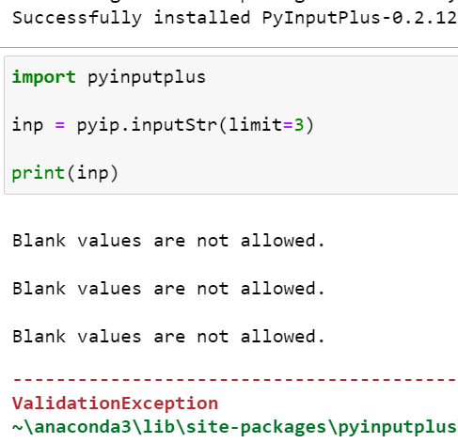 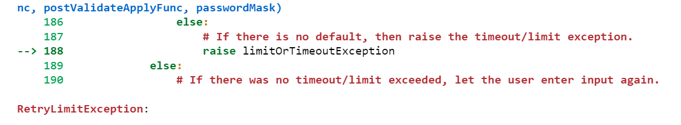

7. If blank input is entered three times, what does inputStr(limit=3, default='hello') do?

Ans: - After user enters blank input for 3 times, default value ‘hello’ will be returned to function without raising any exception.