**Access card swipe simulator**

**Configurations:**

**Raspberry pi-pin out**

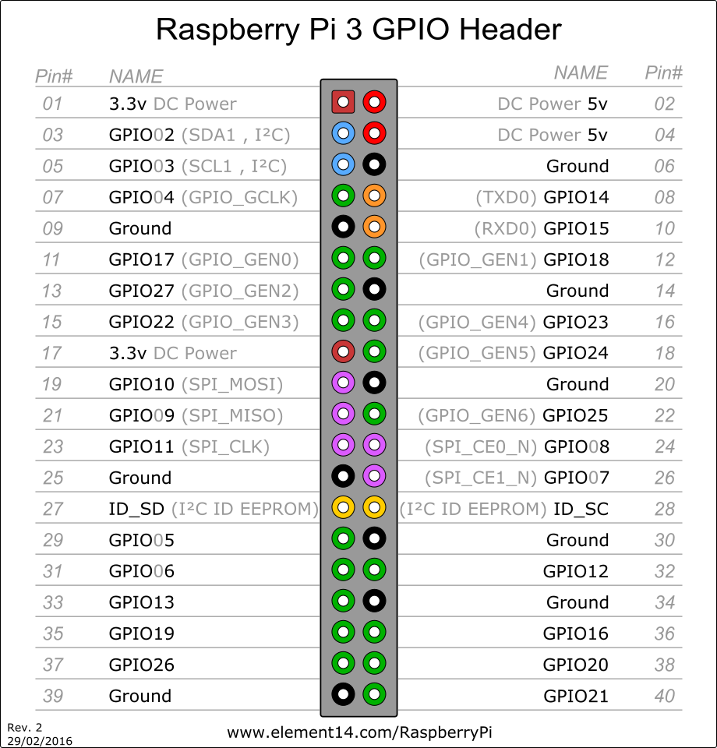

GPIO 17 (6th pin) – D0

GPIO 27(7th Pin) – D1

**For Reader check:**

GPIO 10 and 9 is used

**Programs:**

1. Program which converts hex to binary and triggers GPIO 17 and 27 based on binary value

C Program : wiegand26gen.c

Path: /home/pi

1. Program which receives facility code & Card number from web(main.php) and converts into hexa code and invoke the wiegand26gen file.

Filename: wiegandcalc.py

Path:/home/pi/scripts

1. Program which is used for performance tests

Filename: Performance.py

Path: /home/pi/scripts

1. Card reader program to test the above programs

Filename: wiegand.c

Path: /home/pi/Downloads/wiegand_c

For cardswipe with PIN, use mainwithphp and tempwithphp scripts

Refer below picture for pin inputs. Code refers the wiringpi pinout, Double check the pinout before provide the inputs

