Unit - 1 Foundations of Design
UI vs UX Design- Core Stages of Design Thinking – Divergent and Convergent Thinking – Brain storming and Game Storming – Observational Empathy

What is user interface (UI)?
The user interface (UI) is the point of human-computer interaction and communication in a device. This can include display screens, keyboards,
a mouse and the appearance of a desktop. It is also the way through which a user interacts with an application or a website.
The growing dependence of many businesses on web applications and mobile applications has led many companies to place increased priority on UI in an effort to improve the user's overall experience.

Types of user interfaces
The various types of user interfaces include:
- graphical user interface (GUI)
- command line interface (CLI)
- menu-driven user interface
- touch user interface
- voice user interface (VUI)
- form-based user interface
- natural language user interface

Examples of user interfaces
Some examples of user interfaces include:
- computer mouse
- remote control
- virtual reality
- ATMs
- speedometer
- the old iPod click wheel
Websites such as Airbnb, Dropbox and Virgin America display strong user interface design. Sites like these have created pleasant, easily operable, user- centered designs (UCD) that focus on the user and their needs.

History of UI
In early computers, there was very little user interface except for a few buttons at an operator's console. Many of these early computers used punched cards, prepared using keypunch machines, as the primary method of input for computer programs and data. While punched cards have been essentially obsolete in computing since 2012, some voting machines still use a punched card system.
The user interface evolved with the introduction of the command line interface, which first appeared as a nearly blank display screen with a line for user input. Users relied on a keyboard and a set of commands to navigate exchanges of information with the computer. This command line interface led to one in which menus (lists of choices written in text) predominated.
Finally, the GUI arrived, originating mainly in Xerox's Palo Alto Research Center (PARC), adopted and enhanced by Apple and effectively standardized by Microsoft in its Windows operating systems.

Graphical UIs
Elements of a GUI include such things as windows, pull-down menus, buttons, scroll bars and icons. With the increasing use of multimedia as part of the GUI, sound, voice, motion video and virtual reality are increasingly becoming the GUI for many applications.

Mobile UIs

The emerging popularity of mobile applications has also affected UI, leading to something called mobile UI. Mobile UI is specifically concerned with creating usable, interactive interfaces on the smaller screens of smartphones and tablets and improving special features, like touch controls.
What is User Experience (UX) Design?
User experience (UX) design is the process design teams use to create products that provide meaningful and relevant experiences to users. UX design involves the design of the entire process of acquiring and integrating the product, including aspects of branding, design, usability and function.
Designing an experience includes not only making the software easy to use but also designing the other experiences related to the product, for example, the marketing campaign, the packaging and after-sales support. Most importantly, UX design is concerned with delivering solutions that address pain points and needs.
After all, no one will use a product that serves no purpose.
What UX Designers Do Goes Beyond UI Design
“User Experience Design” is often used interchangeably with terms such as “User Interface Design” and “Usability.” However, while usability and user interface (UI) design are important aspects of UX design, they are subsets of it.
A UX designer is concerned with the entire process of acquiring and integrating a product, including aspects of branding, design, usability and function. It’s a story that begins before the device is even in the user’s hands.
“No product is an island. A product is more than the product. It is a cohesive, integrated set of experiences. Think through all of the stages of a product or service – from initial intentions through final reflections, from the first usage to help, service, and maintenance. Make them all work together seamlessly.”— Don Norman, inventor of the term “User Experience.”
Products that provide a great user experience (e.g., the iPhone) are thus designed with the product’s consumption or use in mind and the entire process of acquiring, owning and even troubleshooting it. Similarly, UX designers don’t just focus on creating usable products; they concentrate on other aspects of the user experience, such as pleasure, efficiency and fun. Consequently, there is no single definition of a good user experience. Instead, a good user experience meets a particular user’s needs in the specific context where they use the product.
A UX designer attempts to answer the question: "How can we make the experience of interacting with a computer, a smartphone, a product, or a service as intuitive, smooth and pleasant as possible?"

UX Design—A Formal Definition
The International Organization for Standardization (ISO) defines user experience as:
“A person's perceptions and responses that result from the use or anticipated use of a product, system or service.”
- ISO 9241-210, Ergonomics of human-system interaction—Part 210: Human- centered design for interactive systems
We can break this definition into two parts:
  - A person’s perceptions and responses.
  - The use of a product, system or service.
In user experience, designers do not have much control over a person’s perceptions and responses—the first part of the definition. For example, they cannot control how someone feels, moves their fingers or controls their eyes as they use a product. However, designers can control how the product, system or service behaves and looks—the second part of the definition.
“One cannot design a user experience, only design for a user experience. In particular, one cannot design a sensual experience, but only create the design features that can evoke it.”
- Jeff Johnson, Assistant Professor in the Computer Science Department of the University of San Francisco
The simplest way to think about user experience design is as a verb and a noun. A UX designer designs (verb)—ideates, plans, changes—the things that affect the user experience (noun)—perceptions and responses to a system or service.
The simplest way to think about user experience design is as a verb and a noun.
For example, when using a physical device, such as a computer mouse, we can control some aspects of the product that influence whether the user enjoys looking at, feeling and holding it:
- The way it fits in their hand. Is it snug? Is it too big and cumbersome?
- The weight. Does it affect their ability to move it as they wish?
- Its ease of use. Can they use it automatically, or do they have to think hard about it to achieve a goal?

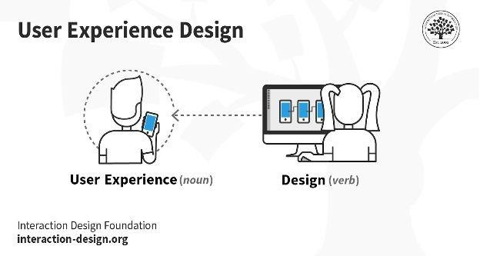

When a person uses a digital product, such as a computer application, a few aspects that we can influence include:
- How intuitively they can navigate through the system.
- The cues that help guide them to their goal.
- The visibility of the essential aspects of a task at the appropriate time.
UX Designers Consider the Why, What, and How of Product Use
As a UX designer, you should consider the Why, What and How of product use. The Why involves the users’ motivations for adopting a product, whether they relate to a task they wish to perform with it or to values and views that users associate with the ownership and use of the product. The What addresses the things people can do with a product—its functionality. Finally, the How relates to the design of functionality in an accessible and aesthetically pleasant way.
UX designers start with the Why before determining the What and then, finally, the How to create products that users can form meaningful experiences with. In software designs, you must ensure the product’s “substance” comes through an existing device and offers a seamless, fluid experience.
UX Design is User-Centered
Since UX design encompasses the entire user journey, it’s a multidisciplinary field–UX designers come from various backgrounds such as visual design, programming, psychology and interaction design. To design for human users also means working with a heightened scope regarding accessibility and
accommodating many potential users’ physical limitations, such as reading small text.
A UX designer’s typical tasks vary but often include user research,
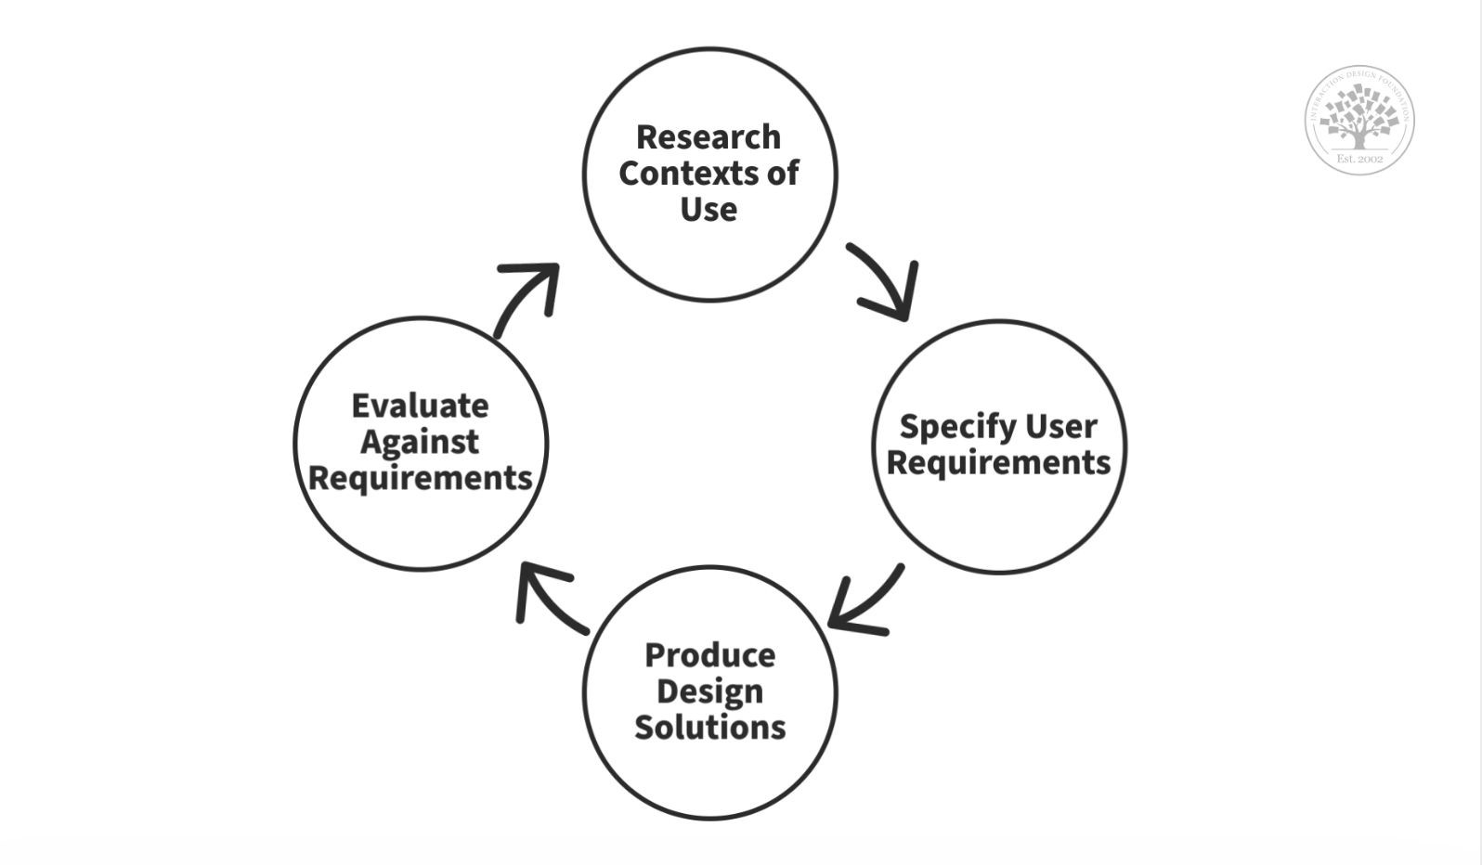
creating personas, designing wireframes and interactive prototypes, and testing designs. These tasks can vary significantly from one organization to the next. Still, they always demand designers to be the users’ advocates and keep their needs at the center of all design and development efforts. That’s also why most UX designers work in some form of user-centered work process and keep channelingtheir best-informed efforts until they address all of the relevant issues and user needs optimally.

© Interaction Design Foundation, CC BY-SA 3.0
User-centered design is an iterative process where you take an understanding of the users and their context as a starting point for all design and development.

UI and UX
The UI is often talked about in conjunction with user experience (UX), which may include the aesthetic appearance of the device, response time and the content that is presented to the user within the context of the user interface. Both terms fall under the concept of human-computer interaction (HCI), which is the field of study focusing on the creation of computer technology and the interaction between humans and all forms of IT design. Specifically, HCI studies areas such as UCD, UI design and UX design.An increasing focus on creating an optimized user experience has led some to carve out careers as UI and UX experts. Certain languages, such as HTML and CSS, have been geared toward making it easier to create a strong user interface and experience.

Difference between UI and UX
Developing a product that people love often requires both good UI and good UX. For example, you could have a messaging app (such as WhatsApp) that looks great and has intuitive navigation (UI). But if the app loads slowly or makes you click through numerous screens to message someone (UX), it doesn’t matter how good it looks. You’re probably not going to want to use it.
On the other hand, a website could be loaded with unique, helpful content organised in a logical and intuitive way. But if it looks dated or you can’t easily figure out how to move between screens or scroll through options, you’re likely to click away from the site.
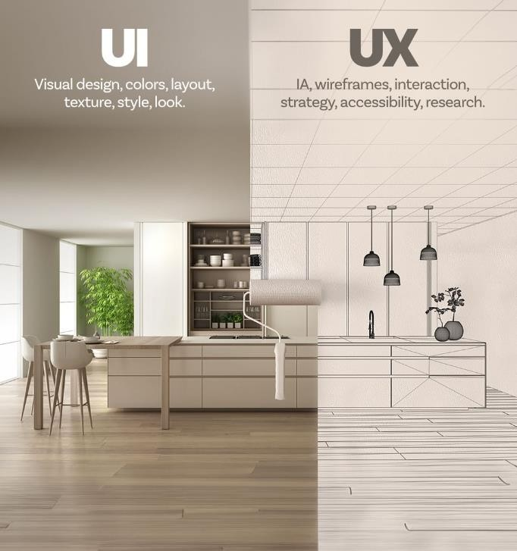

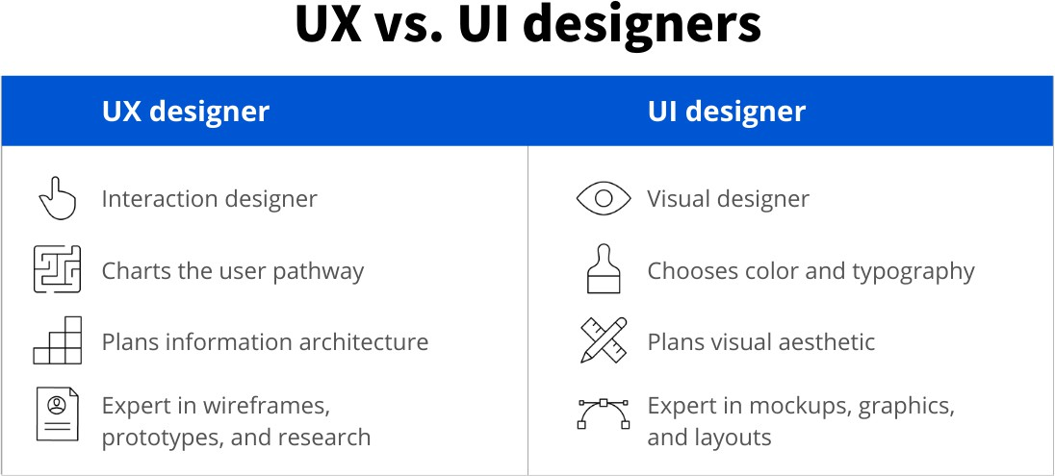
Aspect | User Interface (UI) | User Experience (UX)
Definition | UI focuses on the visual elements users interact with. | UX focuses on the overall experience users have.
Scope | Deals with the layout, design, and presentation. | Encompasses the entire journey of the user.
Purpose | Aims to provide an attractive and usable interface. | Aims to ensure the user's needs are met effectively.
Elements | Involves buttons, icons, menus, and other components. | Involves emotions, perceptions, and interactions.
Goal | Enhances the aesthetic appeal and usability of a product. | Enhances user satisfaction and fulfillment.
Interaction | Deals with how users interact with the interface. | Deals with how users feel during their interactions.
Measurability | Can be measured by visual appeal, consistency, etc. | Measured by user feedback, metrics, and satisfaction.
Medium | Primarily concerned with the visual aspects. | Involves both visual and psychological aspects.
Output | The end result is a visually appealing design. | The end result is a satisfying user experience.
Collaboration | Collaborates with UX to implement design elements. | Collaborates with UI to deliver a cohesive experience.

Design thinking’s value as a world-improving, driving force in business (global heavyweights such as Google, Apple and Airbnb have wielded it to notable effect) matches its status as a popular subject at leading international universities. With design thinking, teams have the freedom to generate ground-breaking solutions. Using it, your team can get behind hard-to-access insights and apply a collection of hands-on methods to help find innovative answers.
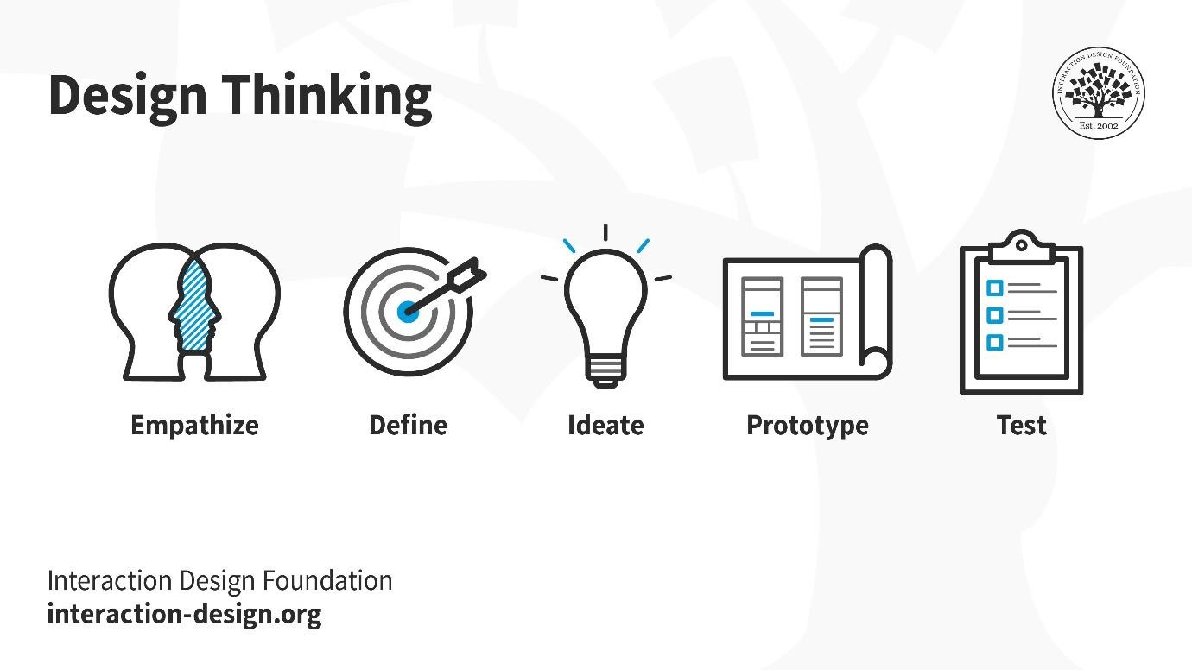

Design thinking is an iterative and non-linear process that contains five phases: 1. Empathize, 2. Define, 3. Ideate, 4. Prototype and 5. Test.
© Interaction Design Foundation, CC BY-SA 3.0
- Stage 1: Empathize—Research Your Users' Needs
Here, you should gain an empathetic understanding of the problem you’re trying to solve, typically through user research. Empathy is crucial to a human-centered
design process such as design thinking because it allows you to set aside your own assumptions about the world and gain real insight into users and their needs.
- Stage 2: Define—State Your Users' Needs and Problems
It’s time to accumulate the information gathered during the Empathize stage. You then analyze your observations and synthesize them to define the core problems you and your team have identified. These definitions are called problem statements. You can create personas to help keep your efforts human-centered before proceeding to ideation.
- Stage 3: Ideate—Challenge Assumptions and Create Ideas
Now, you’re ready to generate ideas. The solid background of knowledge from the first two phases means you can start to “think outside the box”, look for alternative ways to view the problem and identify innovative solutions to the problemstatement you’ve created. Brainstorming is particularly useful here..
- Stage 4: Prototype—Start to Create Solutions
This is an experimental phase. The aim is to identify the best possible solution for each problem found. Your team should produce some inexpensive, scaled-down versions of the product (or specific features found within the product) to
investigate the ideas you’ve generated. This could involve simply paper prototyping.
- Stage 5: Test—Try Your Solutions Out
Evaluators rigorously test the prototypes. Although this is the final phase, design thinking is iterative: Teams often use the results to redefine one or more further problems. So, you can return to previous stages to make further iterations, alterations and refinements – to find or rule out alternative solutions.
Overall, you should understand that these stages are different modes which contribute to the entire design project, rather than sequential steps. Your goal throughout is to gain the deepest understanding of the users and what their ideal solution/product would be.
Why Is Design Thinking so Important?
Design thinking is essential in UX design to adapt to rapid changes in users' behaviors and environments. Since its inception by Herbert A. Simon in 1969, it has evolved and been embraced across various fields. Today, organizations use it to solve complex problems and cater to human needs. Design teams leverage design thinking to tackle challenging issues and prioritize user-centric solutions. It encourages "thinking outside the box," leading to improved UX research, prototyping, and usability testing to meet users' evolving needs effectively.
Divergent Vs Convergent Thinking
Divergence and convergence is a problem-solving method that emphasizes empathy, experimentation, and iteration. It is a human-centered design approach that focuses on understanding people's needs, behaviors, and motivations to design creative solutions that meet those needs effectively.
This problem-solving process cycles between expansive and focused thinking to better understand problems people face and develop a solution. Coined by psychologist J.P.Guilford in the 1950s, these cycles of thinking provide the structure for this iterative design thinking process.In this article we’ll define divergence and convergence, provide examples, walk through each stage, suggest free templates you can use to try it out, and provide tips to help you get the most out of the creative process.
Divergence vs convergence
Divergence and convergence are like the inhale and exhale of the design thinking process. Divergence creates space and possibilities, while convergence brings focus and direction. Designers move back and forth between these two processes throughout the design thinking process, building on the insights and ideas generated during each cycle to refine and improve the solution.
Note: Divergent and convergent phases are non-linear, meaning that when facilitating this process, you may move back and forth as you discover new insights during convergence.
What is divergence?
Divergence is the process of exploring and generating a wide range of ideas and possibilities without any judgment or criticism. Divergent thinking allows designers to expand the possibilities and consider different perspectives, angles, and dimensions of the problem.
What is convergence?
Convergent thinking refers to the process of selecting, evaluating, and refining the most promising ideas from the divergent phase. It involves narrowing down and refining possibilities by selecting the best ideas and combining them to create a coherent and effective solution.
Benefits of divergent and convergent thinking
- Increased creativity and innovation
- Better decision-making
- Human-centered design
- Enhanced problem-solving
- Improved collaboration
What is Brainstorming?
- Brainstorming is a method design teams use to generate ideas to solve clearly defined design problems. In controlled conditions and a free-thinking environment, teams approach a
problem by such means as “How Might We” questions. They produce a vast array of ideas and draw links between them to find potential solutions.
- Resume
- Watch how to get serious, and fun, results with Brainstorming.
- How To Use Brainstorming Best
- Brainstorming is part of design thinking. You use it in the ideation phase. It’s extremely popular for design teams because they can expand in all directions. Although teams have rules and a facilitator to keep them on track, they are free to use out-of-the-box and lateral thinking to seek the most effective solutions to any design problem. By brainstorming, they can take a vast number of approaches—the more, the better—instead of just exploring conventional means and running into the associated obstacles. When teams work in a judgment-freeatmosphere to find the real dimensions of a problem, they’re more likely to produce rough answers which they’ll refine into possible solutions later. Marketing CEO Alex Osborn,brainstorming’s “inventor”, captured the refined elements of creative problem-solving in his 1953 book, Applied Imagination. In brainstorming, we aim squarely at a design problem and produce an arsenal of potential solutions. By not only harvesting our own ideas but also considering and building on colleagues’, we cover the problem from every angle imaginable.
- “It is easier to tone down a wild idea than to think up a new one.”
— Alex Osborn
- Everyone in a design team should have a clear definition of the target problem. They typically gather for a brainstorming session in a room with a large board/wall for pictures/Post-Its. A good mix of participants will expand the experience pool and therefore broaden the idea space.
- 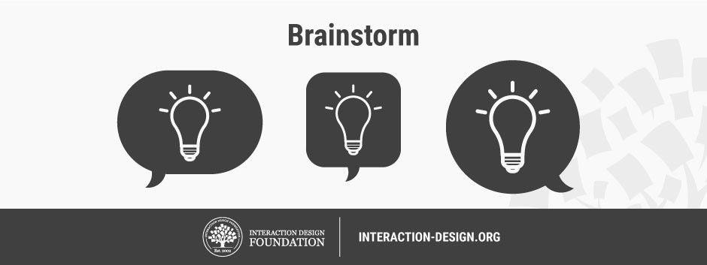
- Brainstorming may seem to lack constraints, but everyone must observe eight house rules and have someone acting as facilitator.
- Set a time limit – Depending on the problem’s complexity, 15–60 minutes is normal.
- Begin with a target problem/brief – Members should approach this sharply defined question, plan or goal and stay on topic.
- Refrain from judgment/criticism – No-one should be negative (including via body language) about any idea.
- Encourage weird and wacky ideas – Further to the ban on killer phrases like “tooexpensive”, keep the floodgates open so everyone feels free to blurt out ideas (provided they’re on topic).
- Aim for quantity – Remember, “quantity breeds quality”. The sifting-and-sorting process comes later.
- Build on others’ ideas – It’s a process of association where members expand on others’
notions and reach new insights, allowing these ideas to trigger their own. Say “and”—rather than discourage with “but”—to get ideas closer to the problem.
Stay visual – Diagrams and Post-Its help bring ideas to life and help others see things in different ways.
Allow one conversation at a time – To arrive at concrete results, it’s essential to keep on track this way and show respect for everyone’s ideas.

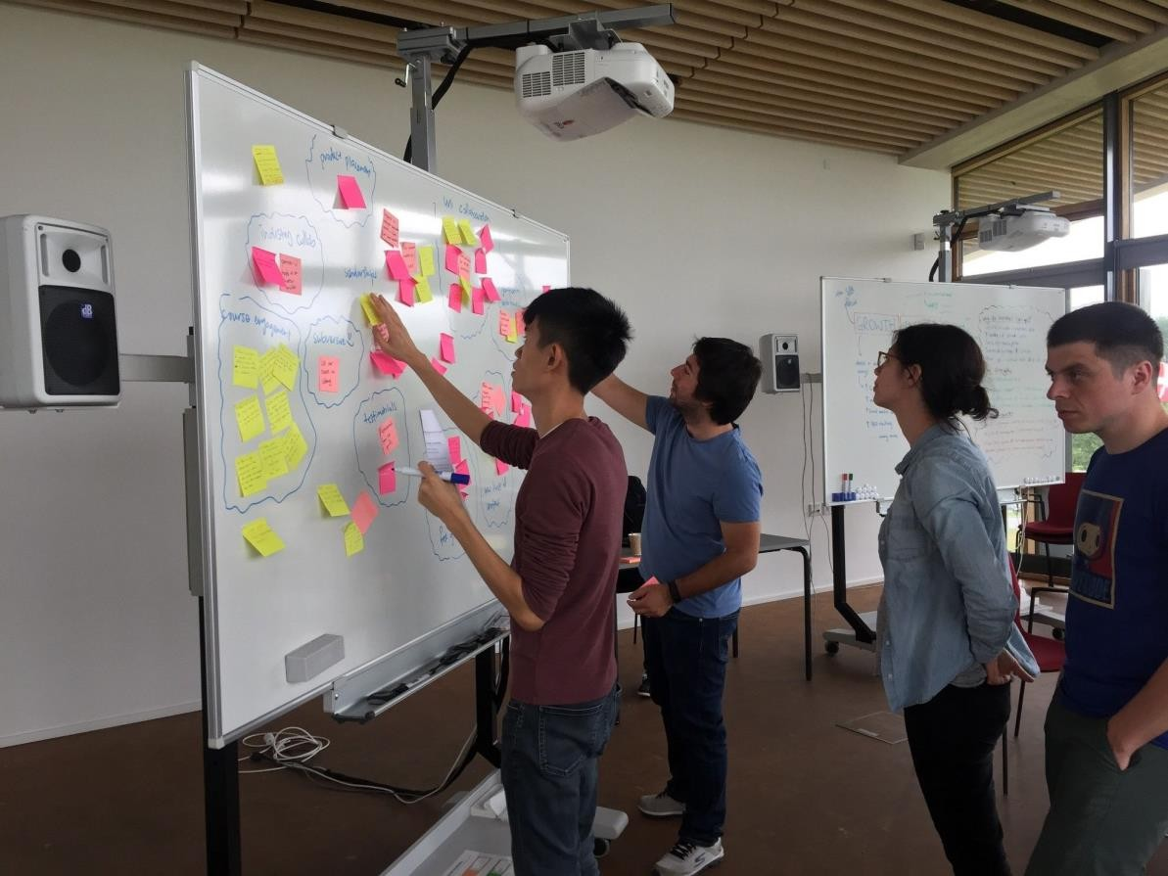
- To capture everyone’s ideas in a brainstorming session, someone must play “scribe” and mark every idea on the board. Alternatively, write down your own ideas as they come, and share these with the group. Often, design problems demand mixed tactics: brainstorming and its sibling approaches – braindumping (for individuals),and brainwriting and brainwalking (for group-and-individual mixes).
- Take Care with Brainstorming
- Brainstorming involves harnessing synergy – we leverage our collective thinking towards a variety of potential solutions. However, it’s challenging to have boundless freedom. In groups, introverts may stay quiet while extroverts dominate. Whoever’s leading the session must “police” the team to ensure a healthy, solution-focused atmosphere where even the shiest participants will speak up. A warm-up activity can cure brainstorming “constipation” – e.g., ask participants to list ways the world would be different if metal were like rubber.
What is gamestorming?

Gamestorming is a form of brainstorming that leverages the use of games.
As we all know, playing games enforces rules, effectively helping to overcome the usual brainstorming limitations. The way brainstorming avoids conflicts is by shifting group and thought dynamics.
To give you a real life example, at Collaboard we need to coordinate employees across multiple locations, and found that gamestorming (especially when facilitated through our app Collaboard) makes it easier to handle collaborative and creative processes.
We started to test it, mainly out of our love for innovation, and played the 3- 12-3 Brainstorm game, ideated by James Macanufo, involving employees in three different locations: Zurich, Munich and Milano. Keep reading to discover this amazing technique.
The 3-12-3 Brainstorming: a new approach to creative collaboration
So, how does this game work? There can be up to 10 players, who must follow these rules:
- First of all, they must choose a two-word topic to focus on.
- After the choice, phase one of the game begins: for 3 minutes, each team member brainstorms on his own and writes down their ideas on sticky notes.
- When everyone’s done brainstorming, the team is divided into sub- teams of 2 people each. This is the beginning of phase 2.
- For 12 minutes, teams pick three random cards and develop a full- fledged concept.
- In phase 3, teams have 3 minutes each to present their ideas to everyone else.
All you need is Collaboard!
So, back to our experiment: we decided to brainstorm some ideas for Christmas Cards. For the sake of simplicity, we split our team into 3 sub- teams according to their physical location: Berlin, Zurich, Munich.



Phase One
This first phase is all about generating ideas. Each team member is on his own and must write on sticky notes whatever idea comes to mind.
This part felt very similar to classic brainstorming, but we quickly noticed two differences:
- Each person was using their own device, so they didn’t fear judgment from their peers, and didn’t forget what they wanted to say/write while waiting for their turn.
- The limited time of 3 minutes meant that there was no space for self- doubt. As sticky notes were being written, they were quickly moved into a grid library.



Phase Two
Once solo brainstorming was completed, each team member selected three random stick notes from the library to start developing concepts around them.
We found this phase a bit more challenging than the first one, as the cards could involve clashing ideas. But this is exactly where collaboration steps in: the team has to work together in order to consolidate the ideas into a final, collaborative project.
With Collaboard by our side, visualizing and working through sketches, images, prototypes and concepts made the process way easier
Phase Three
Finally, we approached the final phase. Using sketches created in phase two, we proceeded to present our final ideas to the team.
The integration with Skype for Business made the remote presentation extremely easy - we ended up with three different proposals (ready to be approved by the marketing manager) in less than 30 minutes, which is hard to imagine with a traditional brainstorming session!
Also, we all could leverage other teams’ ideas, nurturing collaboration and strengthening our connection.
Observational empathy is a crucial aspect of the design thinking process that involves closely observing and understanding the experiences, behaviors, and needs of users by immersing oneself in their environment. It is a method of gaining deep insights into users' lives, thoughts, and emotions, which helps designers create more meaningful and user-centered solutions.
In observational empathy, designers go beyond simply asking users about their preferences or needs. Instead, they spend time directly observing users in their natural context, without interrupting or interfering with their actions. This approach allows designers to understand how users interact with products, services, or environments and how they overcome challenges or frustrations.

Observational empathy
Key aspects of observational empathy include:
- **Active Observation**: Designers keenly observe users' behaviors, gestures, facial expressions, and body language to understand their emotions and reactions.
- **Listening and Note-taking**: They listen attentively to users' conversations and take notes on their experiences, pain points, and unmet needs.
- **Contextual Understanding**: Observational empathy takes place in the real environment where users use the product or service, providing context- rich information for design decisions.
- **Identifying Unspoken Needs**: Through observation, designers can identify needs that users may not explicitly communicate or may not be aware of themselves.
- **Avoiding Assumptions**: Observational empathy helps designers avoid making assumptions about users' preferences or behaviors, as it relies on direct evidence.
By practicing observational empathy, designers can gain a deeper and more holistic understanding of their target audience. This empathetic understanding forms the foundation for creating solutions that truly resonate with users and provide a positive impact on their lives. It is an essential step in the design thinking process, enabling designers to design with empathy and solve real problems effectively.

