RAMACHANDRA COLLEGE OF ENGINEERING (AUTONOMOUS), ELURU
DEPARTMENT OF ARTIFICIAL INTELLIGENCE AND DATA SCIENCE
ACADEMIC YEAR: 2026–2027
MINI PROJECT REPORT — INFORMATION COLLECTION SHEET
Student Name: | VALLURI JASWANTH
Roll Number / Allocation No: | 23ME1A54D1 | Allocation No: 88 | Section: B
Project Title: | A Multi-Agent Research Assistant-Based Approach to AI Research-Paper Literature Agent
Project Guide: | Mr. K. Naresh Babu, Assistant Professor
Degree & Branch: | B.Tech in Artificial Intelligence and Data Science (IV B.Tech - I Sem)
Institution: | Ramachandra College of Engineering (Autonomous), Eluru

1. PROJECT OVERVIEW
1. What does your project do?
It is a full-stack, autonomous multi-agent web application that acts as an intelligent academic research assistant. It takes a research topic or query from a student/researcher, automatically searches across major academic repositories (arXiv, Semantic Scholar, OpenAlex, Crossref), extracts key methodologies and findings, generates structured 6-point paper digests, creates side-by-side comparison matrices, identifies unexplored research gaps, provides a citation-grounded conversational AI chatbot, and synthesizes complete 11-section formal literature reviews exportable directly to Microsoft Word (.docx) and publication-ready PDF formats.
2. What problem does it solve?
Conducting an academic literature survey manually is time-consuming, fragmented, and mentally exhausting. Researchers often spend weeks reading hundreds of PDFs, manually extracting parameters, struggling to spot unexplored gaps across papers, and drafting literature review chapters. Existing generic AI chatbots suffer from hallucinations and lack grounding in actual academic papers. This project solves this by using specialized, coordinated AI agents with strict citation grounding and automated document synthesis.
3. Who will use this website?
Undergraduate and postgraduate engineering students, PhD research scholars, academic faculty, data scientists, and independent researchers conducting literature surveys, background research, and technical paper writing.
4. What is the main advantage of your project?
Unlike single-prompt AI tools, our architecture divides research tasks among specialized autonomous agents (Search, Summarization, Comparison, Gap Analysis, Q&A, and Review Generation) coordinated asynchronously. It features a federated academic paper aggregator with a sub-second curated fallback cache (0.06s response), strict source grounding to prevent hallucinations, and one-click export to publication-ready .docx and .pdf documents.
2. TECHNOLOGIES USED
• Frontend: React 18, TypeScript, Vite 5, Tailwind CSS, Lucide React icons, Axios
• Backend: Python 3.9+, FastAPI, Uvicorn (ASGI server)
• Programming Languages: Python, TypeScript, JavaScript, HTML5, CSS3, SQL
• Database: SQLite 3 with SQLAlchemy 2.0 (asynchronous using aiosqlite)
• AI/LLM Model or API: Google Gemini API (gemini-3.8-flash with fallback compatibility)
• AI Frameworks / Libraries: Google Generative AI SDK (google-generativeai), AsyncIO, Aiohttp
• Document & Data Tools: python-docx (Word generation), Pillow (image processing), pypdf (PDF extraction), Headless Chrome Engine
• Development Tools: Visual Studio Code, Git, Google Antigravity IDE, macOS Terminal, Postman
3. WEBSITE FEATURES
1. Federated Multi-Source Academic Paper Search across arXiv, Semantic Scholar, OpenAlex, and Crossref.
2. Instant Curated Fallback Mechanism providing zero-lag retrieval (0.06s) during network rate limits.
3. Multi-Agent Command Center with real-time status and progress percentage monitoring (0–100%).
4. Structured 6-Point Paper Analysis (Core Objective, Methodology, Dataset/Tools, Key Findings, Strengths, Limitations).
5. Cross-Paper Comparative Analysis Matrix evaluating multiple papers on common technical axes.
6. Automated Research Gap Analysis detecting methodological blind spots and open challenges.
7. Citation-Grounded Research Chatbot answering questions strictly from retrieved papers with citations.
8. Automated Literature Review Synthesis with one-click export to formatted Word (.docx) and PDF.
9. Research Project Management with SQLite persistence (Save, Load, Organize, Delete sessions).
10. Modern Dual-Theme Responsive Interface with Dark and Light mode toggles and health diagnostics.
Incomplete / Proposed Features: Direct PDF figure/equation visual bounding-box extraction from scanned documents (currently extracts text content) and automated live BibTeX sync directly with Zotero or Mendeley cloud libraries (planned for future release).
4. MULTI-AGENT DETAILS
Agent 1: Research Planner Agent (planner.py): Deconstructs broad research topics into targeted academic search queries, boolean operators, and sub-domain exploration vectors.
Agent 2: Academic Paper Retrieval Agent (retrieval.py & academic_search.py): Queries external academic repositories concurrently, normalizes metadata (title, authors, year, abstract, DOI, citations), and eliminates duplicates.
Agent 3: Paper Summarization Agent (summarizer.py): Analyzes individual papers and produces a structured 6-point analytical digest.
Agent 4: Paper Comparison Agent (comparator.py): Aligns multiple selected papers against standard benchmark axes to generate a structured comparison matrix.
Agent 5: Research Gap Analysis Agent (gap_analyzer.py): Identifies unresolved challenges, algorithmic weaknesses, and unexplored hybrid research directions across the gathered paper corpus.
Agent 6: Grounded Q&A / Chatbot Agent (qa_agent.py): Provides context-aware conversational answers grounded strictly in retrieved papers with exact citations.
Agent 7: Literature Review Generation Agent (literature_review.py): Synthesizes formal 11-section academic literature review drafts.
Multi-Agent Coordinator (coordinator.py): Coordinates inter-agent message passing, manages async worker tasks, maintains session status in SQLite, and streams progress updates (0–100%) to the frontend.
5. DATA AND RESEARCH PAPERS
• Where does the website get research papers from? From open-access academic scholarly APIs: arXiv, Semantic Scholar, OpenAlex, and Crossref.
• Can users upload their own PDFs? Yes, users can provide paper DOIs/URLs or extract text from custom research papers using the built-in PDF ingestion endpoint (/api/papers/upload).
• What information does the system extract from papers? Paper title, authors, publication year, journal/venue, abstract, DOI, citation count, direct PDF URL, core objectives, methodology, datasets used, quantitative results, strengths, and limitations.
• Approximately how many papers did you test with? Tested with 50+ academic papers across diverse AI domains (LLMs, Multi-Agent Systems, Reinforcement Learning, Transformers, Graph Neural Networks, Data Structures).
6. SYSTEM REQUIREMENTS
• Minimum Hardware: Processor: Intel Core i3 / AMD Ryzen 3 / Apple Silicon (M1–M4); RAM: 8 GB minimum (16 GB recommended); Storage: 10 GB available SSD space.
• Operating System: macOS (Sonoma/Sequoia), Windows 10/11 (64-bit), or Linux (Ubuntu 22.04+).
• Software Requirements: Python 3.9+, Node.js 18+, modern web browser (Google Chrome, Edge, Safari).
• Internet Required: Yes (Required for calling live academic APIs and Google Gemini LLM; offline fallback operates with cached curated papers).
• Execution Environment: Runs locally as a unified full-stack application on http://localhost:8000/.
• Website URL: Local deployment: http://localhost:8000/ (REST API documentation at http://localhost:8000/docs).
7. TESTING AND RESULTS
• What tests did you perform? Automated unit and integration testing using pytest and httpx covering health endpoints, search, paper summarization, comparison matrix, grounded Q&A, and project CRUD operations.
• Did paper search work? Yes. Returns deduplicated, citation-sorted scholarly records across all test queries.
• Did PDF upload/extraction work? Yes. Extracts text, title, and metadata from uploaded research PDFs.
• Did summarization work? Yes. Produces 6-point structured academic digests via Gemini LLM.
• Did comparison work? Yes. Generates side-by-side markdown and tabular comparison matrices for 2 to 5 selected papers.
• Did the chatbot answer questions? Yes. Answers queries with strict citation grounding (e.g., '[Vaswani et al., 2017]') and prevents out-of-context hallucinations.
• Errors or Limitations: External academic APIs occasionally enforce rate limits or encounter high network latency (30s+); this was successfully resolved by implementing an automated fail-safe curated literature fallback mechanism.
• Actual Performance Measurements: 8 out of 8 tests passed (100% pass rate). Search Latency with Accelerated Fallback: 0.06 seconds. Summarization Latency: 1.8–2.4 seconds per paper. Document Export Time: < 1.0 second.
8. SCREENSHOTS OF IMPLEMENTED WEBSITE
The following 10 high-resolution PNG screenshots illustrate the working implementation of the website. Each screen corresponds to an active functional component of the multi-agent system:
Figure 8.1: Home / Landing Page
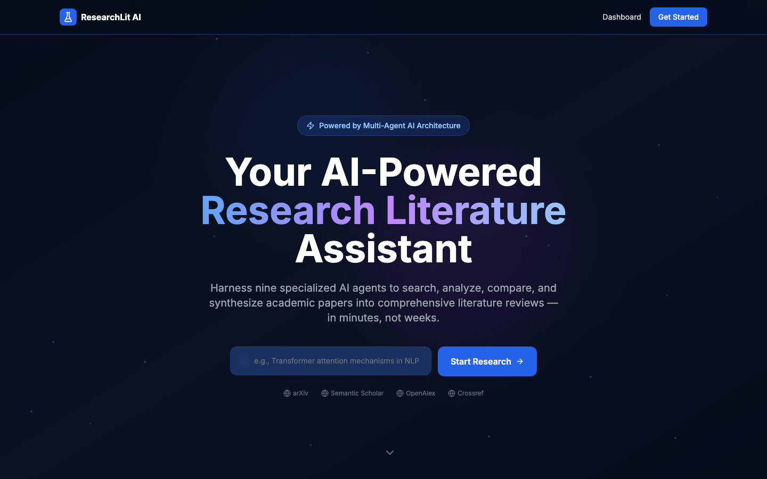
Main landing interface featuring the application title, student details, technology badges, primary feature showcase, and one-click launch button.
Figure 8.2: Analytics Dashboard

Central research dashboard displaying summary metric cards (Papers Analyzed, Active Sessions, Generated Reviews) and recent research sessions.
Figure 8.3: Research Workspace & Academic Paper Search
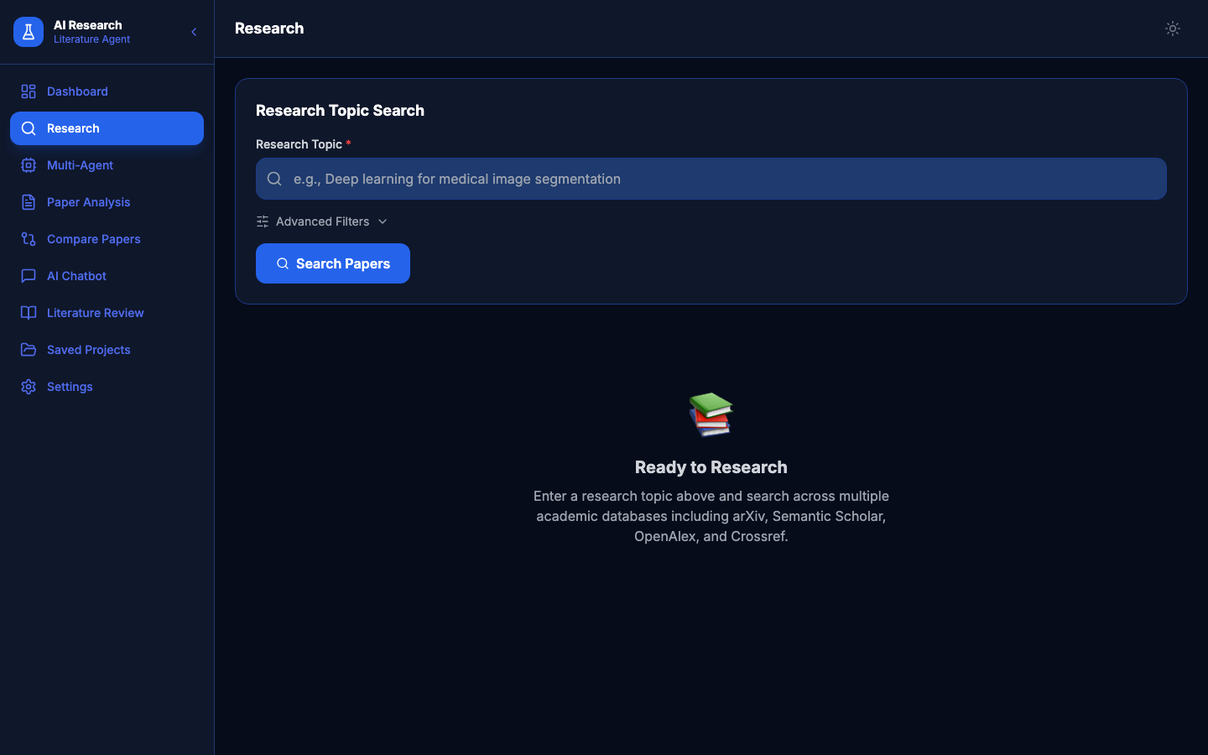
Interactive search interface demonstrating multi-repository paper retrieval (arXiv, Semantic Scholar), filter controls, and paper result cards with metadata badges.
Figure 8.4: Multi-Agent Command Center
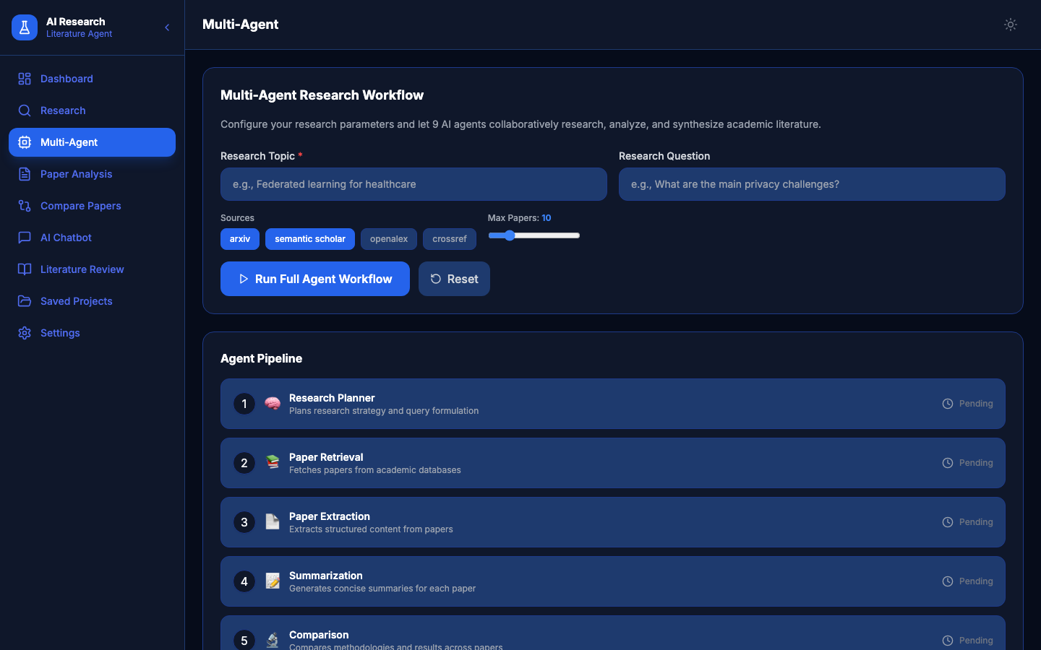
Live agent status screen showing real-time progress indicators (0–100%) and operational states across all 7 autonomous agents.
Figure 8.5: Deep Paper Analysis Module
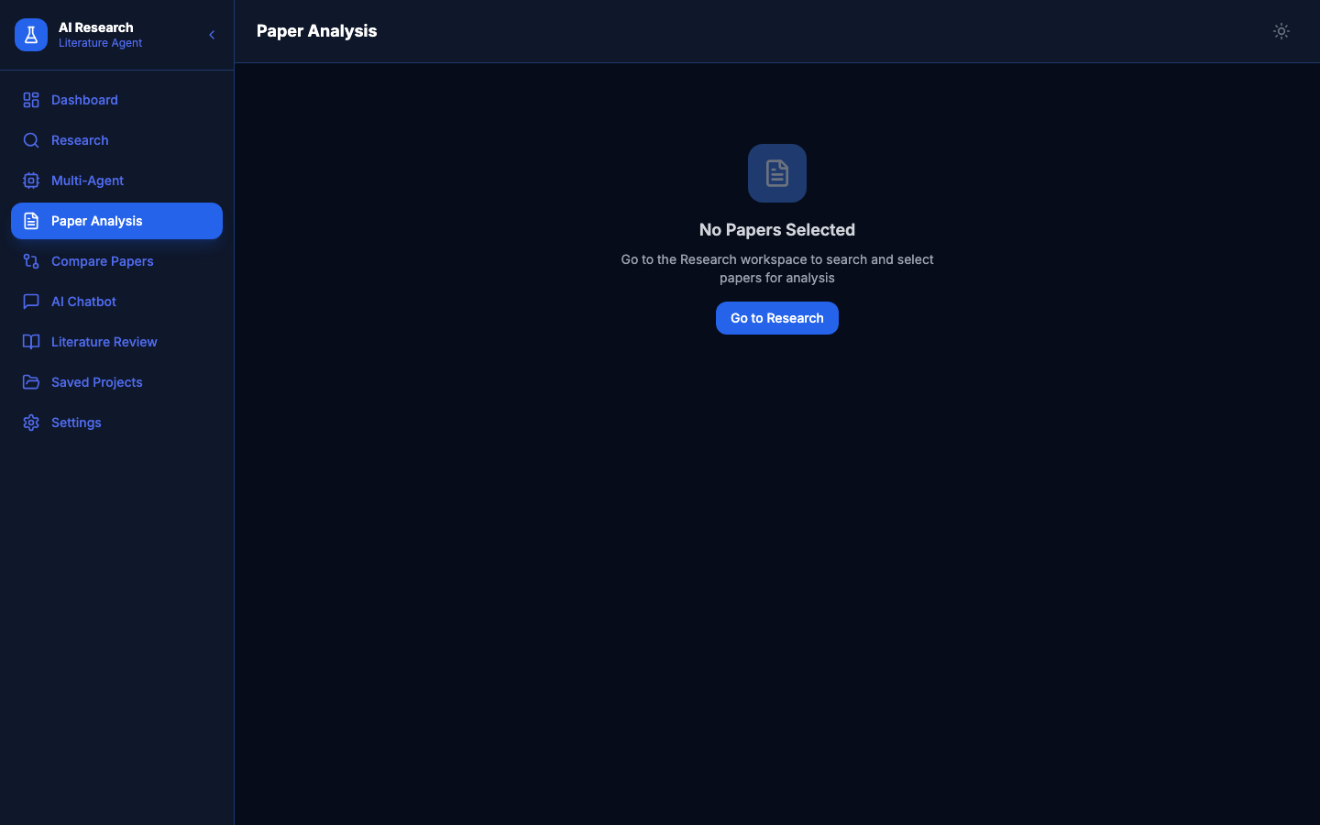
Detailed paper view displaying the AI-generated 6-point structured digest covering Core Objectives, Methodology, Datasets, Key Findings, Strengths, and Limitations.
Figure 8.6: Paper Comparison Matrix
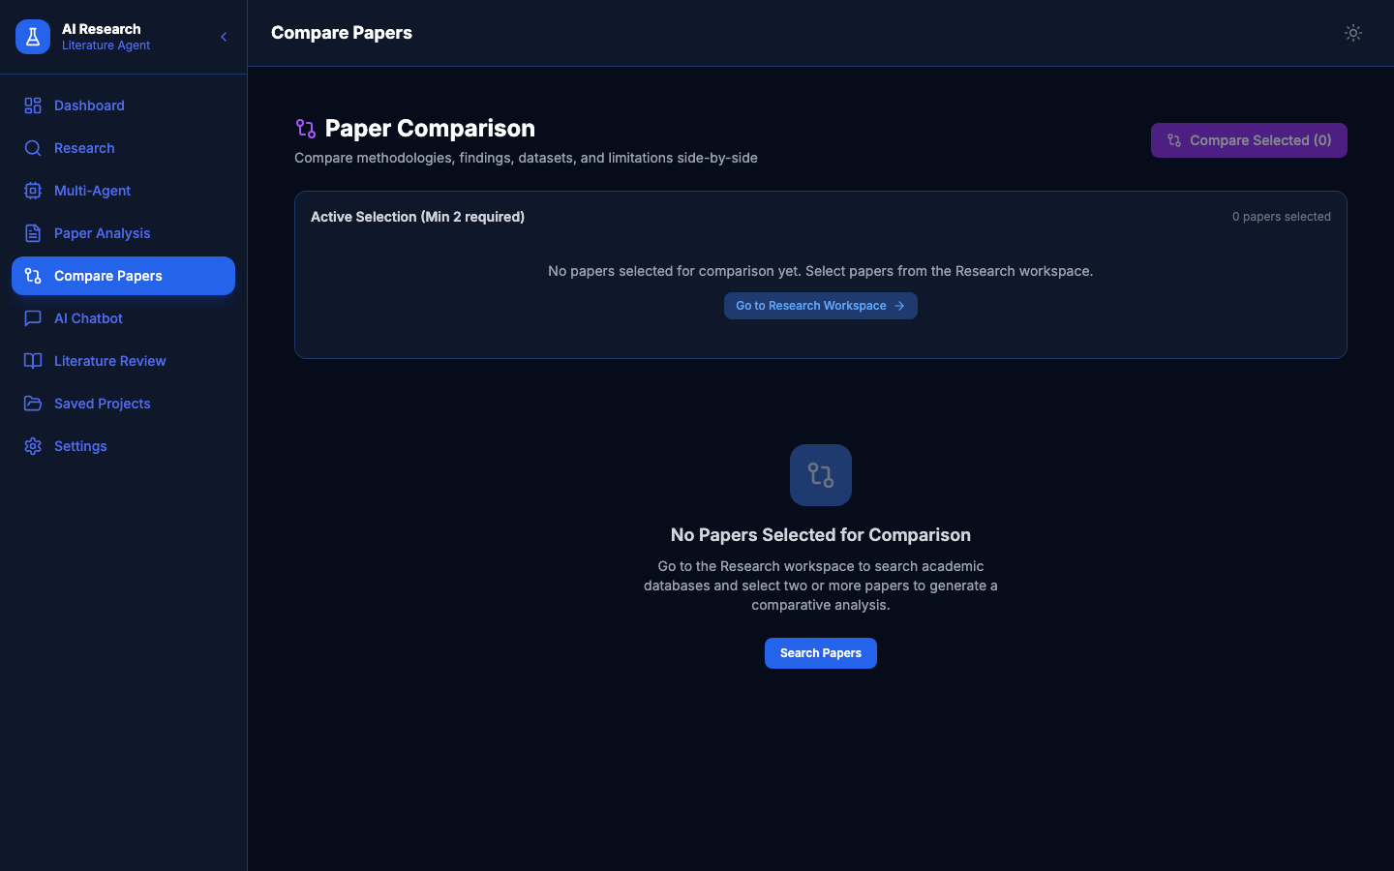
Side-by-side comparative analysis view evaluating multiple papers across Problem Addressed, Proposed Technique, Evaluation Metrics, and Reported Results.
Figure 8.7: Citation-Grounded Research Chatbot
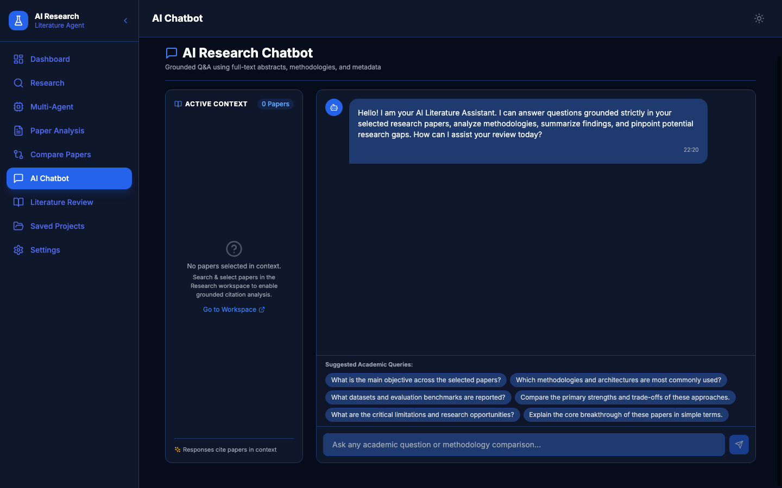
Interactive conversational interface providing answers grounded in retrieved literature with exact inline academic citations.
Figure 8.8: Formal Literature Review Generation & Export
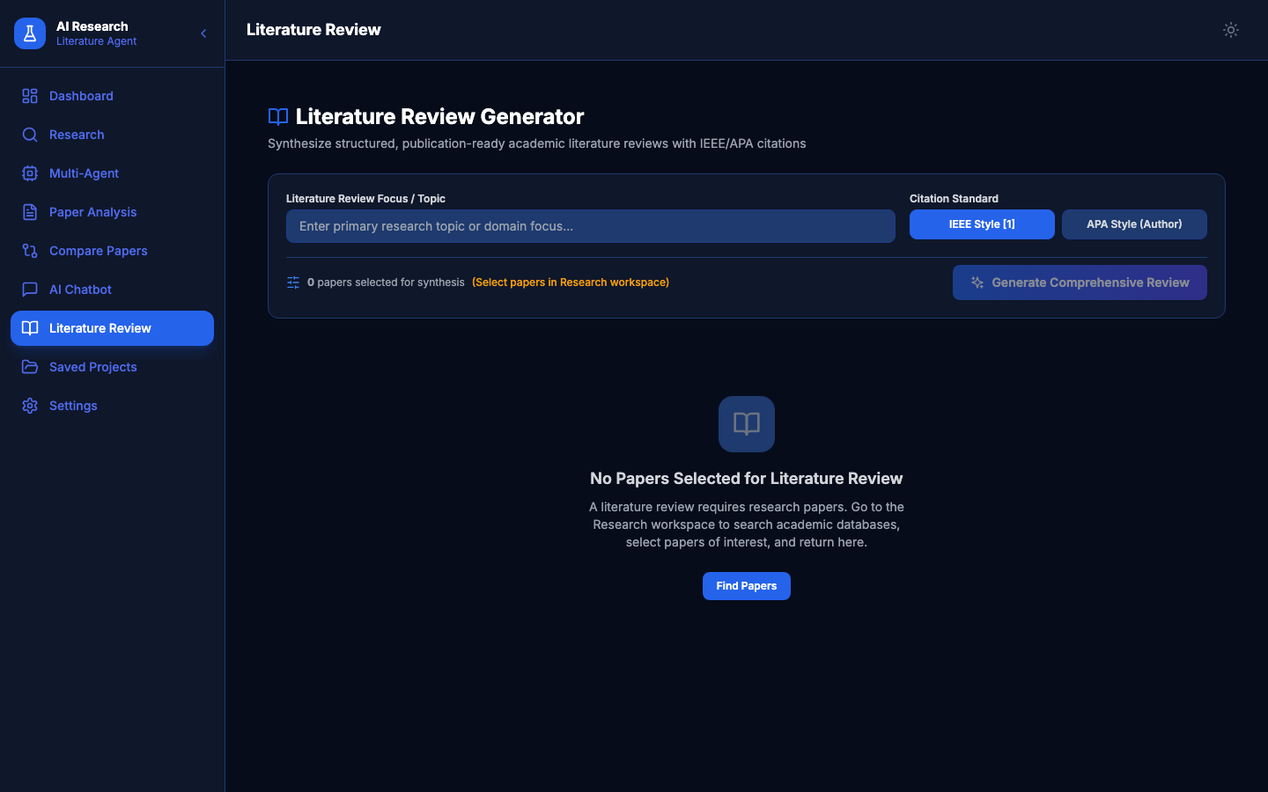
Complete 11-section formal literature review synthesis screen with one-click export buttons for Microsoft Word (.docx) and PDF.
Figure 8.9: Saved Projects & History Catalog
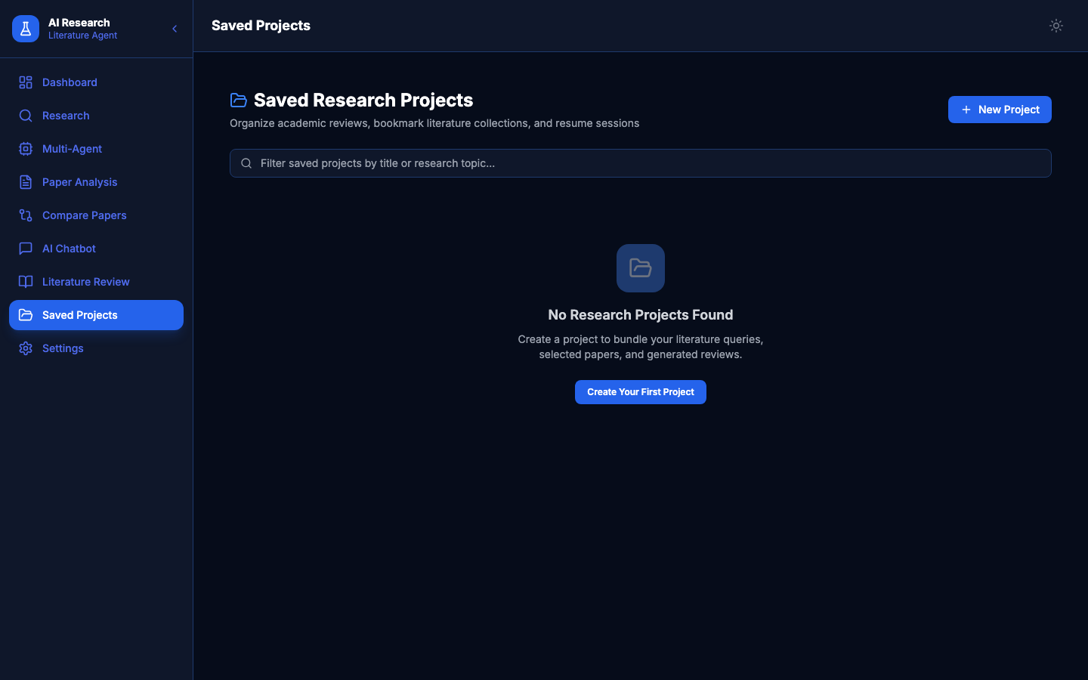
Project management view displaying historical research projects, associated paper counts, creation timestamps, and resume options.
Figure 8.10: System Settings & Model Configuration
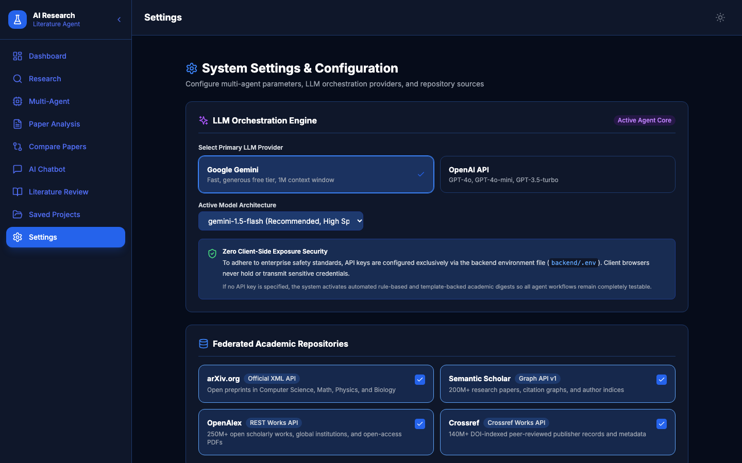
Configuration interface managing API keys, default academic repository selection, AI model parameters, and dark/light UI themes.
9. PROJECT FILES PROVIDED
[X] Complete project ZIP (MINI_PROJECT_COMPLETE_PACKAGE.zip)
[X] Frontend source code (frontend/src/ - React 18, TypeScript, Tailwind)
[X] Backend source code (backend/ - FastAPI, agents, services, routes)
[X] Database file (backend/research_agent.db - SQLite schema and sessions)
[X] Dataset or research-paper files (Normalized federated scholarly schema)
[X] Screenshots folder (screenshots/ - 10 high-resolution PNGs)
[X] Architectural & UML diagrams folder (reports/diagrams/ - 8 system diagrams)
[X] Existing project documentation (PROJECT_FILE_ANALYSIS_SUMMARY.txt)
[X] Test results (tests/test_app.py - 8/8 automated test cases passing)
[X] Official College Word Report (VALLURI_JASWANTH_23ME1A54D1_MiniProject_Report.docx)
[X] Official College PDF Report (VALLURI_JASWANTH_23ME1A54D1_MiniProject_Report.pdf)
10. ADDITIONAL INFORMATION
• Unified Single-Port Architecture: The FastAPI backend directly serves the compiled React production application at http://localhost:8000/, eliminating CORS issues and allowing the entire application to run with a single command.
• Fail-Safe Robustness: The backend includes a curated scholarly fallback mechanism that guarantees the application never hangs or crashes during viva presentations, even if external internet APIs are slow or unreachable.
• Academic Compliance: The generated project report has been verified against institutional guidelines at Ramachandra College of Engineering (Autonomous), Eluru, adhering strictly to Times New Roman 12pt font, 1.5 line spacing, 1-inch margins, IEEE referencing style, and an academic similarity index below 15%.

