Smart Printing: Enable Wi-Fi on Any USB Printer Using Raspberry Pi

Anusmitha Thallada  
ECE *Dhanekula Institute of Engg.&Tech.*Vijayawada, India  
[anusmithathallada123@gmail.com](mailto:anusmithathallada123@gmail.com)

Guna Sekhar Parasa  
ECE *Dhanekula Institute of Engg.&Tech.*Vijayawada, India  
[guna.gunaparasa@gmail.com](mailto:guna.gunaparasa@gmail.com)

Likitha Valluru  
ECE  
*Dhanekula Institute of Engg.&Tech.*Vijayawada, India  
[vallurulikitha@gmail.com](mailto:vallurulikitha@gmail.com)

Maheswari Tatiparthi  
ECE  
*Dhanekula Institute of Engg.&Tech.*Vijayawada, India  
[mahe72723@gmail.com](mailto:mahe72723@gmail.com)

Dr. M. Vamshi Krishna  
Professor & H.O.D of ECE  
*Dhanekula Institute of Engg.&Tech.*  
Vijayawada, India  
[profvamshi@gmail.com](mailto:profvamshi@gmail.com).

**Abstract— Older printer models often rely on a direct USB connection to a computer, restricting their ability to connect with multiple devices. This paper presents a cost-effective and practical solution to convert any USB printer into a wireless printer using a Raspberry Pi. By setting up the Raspberry Pi as a print server, users are able to print wirelessly from laptops, smartphones, and tablets through a Wi-Fi network. The method utilizes CUPS (Common Unix Printing System) to handle print jobs and Samba to enable network sharing. This solution modernizes traditional printers, allowing them to function as network printers without the expense of purchasing new wireless models, all while preserving their full functionality.**

**Keywords— Wireless Printing, Raspberry Pi, USB Printer, Print Server, Wi-Fi Printing, Network Printer, CUPS, Remote Printing, Printer Sharing, Simple Configuration.**

# Introduction

New technology seeks to make life more convenient and efficient, and printing is still an essential component of both personal and business workflows. Yet most popular printers are limited by their dependence on a wired link to a desktop or laptop, limiting their convenience in use across different devices.

This project provides a cost-effective and streamlined solution by reusing a Raspberry Pi as a wireless print server. With this configuration, users can print documents from a variety of Wi-Fi devices—such as phones, tablets, and laptops—without the need for a direct connection to the printer.

The system works through connecting the USB printer to the Raspberry Pi that employs CUPS to handle the printing process and Samba to facilitate network sharing, thus compatible with operating systems such as Windows and macOS.

The solution is simple to deploy, economic, and doesn't need significant maintenance. It is especially good for home consumers, small-scale enterprises, and schools seeking to implement wireless printing without having to replace current equipment.

# LITERATURE SURVEY

With the evolution of printing technology, the transition from wired to wireless and cloud-enabled printing has gained prominence. There have been several studies aimed at converting non-wireless printers to wireless printers using Raspberry Pi as a medium of connection.

***(1) CUPS-Based Print Servers***

One common approach to introducing wireless capability into older printers is by utilizing the Common Unix Printing System (CUPS) on a Raspberry Pi. Several researchers have shown that CUPS supports printing via Wi-Fi as it enables multiple devices to deliver print instructions over a common network without the necessity for a point-to-point USB cable connection. Michael Sweet (2007), the original author of CUPS, expounds on its open-source design that supports cross-platform operation with major operating systems.

***(2) Google Cloud Print and Apple AirPrint integration***

In an experiment by Smith et al. (2015), Raspberry Pi was set up with CUPS and the Avahi daemon to provide Google Cloud Print and Apple's AirPrint functionality. Their installation allowed wireless printing directly from Android, iOS, Windows, and macOS devices without any extra drivers. With the withdrawal of Google Cloud Print in 2020, however, the emphasis is now on other cloud-based printing systems.

***(3) Bluetooth-Based Printing Solutions***

John and Patel (2018) suggested an approach to connect mobile devices and standard USB printers through Raspberry Pi and Bluetooth communication. Their solution utilized the Raspberry Pi to download files through Bluetooth and send them to the printer through USB. The solution was very effective in locations with poor Wi-Fi coverage.

***(4) Socket Communication for Print Transmission***

Gupta et al. (2020) proposed a tailored socket communication protocol using Python for Raspberry Pi-based printing. Their research pointed out that socket-based transmission minimized the processing time of print requests while ensuring compatibility with different models of printers.

***(5) Wi-Fi Direct and Peer-to-Peer Printing***

A peer-to-peer printing mechanism through Wi-Fi Direct was proposed by Kumar and Sharma (2021). Their study showed how Raspberry Pi could be used to provide direct communication between a printer and mobile devices without the presence of a router. This approach proved to be greatly useful for users operating in mobile or temporary environments.

***(6) Artificial Intelligence for Print Management***

Artificial intelligence innovations have also improved wireless printing. Lee et al. (2022) proposed an AI-based print management system that utilizes Raspberry Pi to schedule print jobs according to file attributes like size, content type, and priority. Their system improved efficiency by 15% compared to traditional FIFO (First-In-First-Out) scheduling.

***(7) Power Efficiency in Print Servers***

Singh et al. (2023) discussed power optimization methods in Raspberry Pi print servers. Dynamic power scaling mechanisms were used to minimize energy consumption during idle states. Their paper indicated a 30% reduction in total power consumption, which makes the solution applicable in off-grid or battery-powered environments.

***(8) Security in Wireless Printing Systems***

Security is a pressing concern in networked printing. Chen and Wong (2023) examined typical vulnerabilities of print servers based on Raspberry Pi, including unauthorized access and interference with data. Their conclusions highlighted the importance of Transport Layer Security (TLS) as well as stringent access control measures to protect printing activities.

# METHODOLOGY

1. **Existing System:** Conventional printing techniques involve a physical wire connection between the printer and computer, typically through a USB or network cable. The wired interface provides a solid and quick data transfer, making it a reliable option for printing papers. After the printer is connected, drivers are installed as needed so that the computer can recognize and talk to the printer. The user would then select the printer, make settings if necessary, and send the print job.
2. **Proposed System:** This system aims to let print wirelessly from local printer which acts similar to a wireless printer. There are a few main benefit to this method. To start with, it saves the expense of buying a new wireless printer in the first place and helps keep functioning, older printers out of the scrapyard, minimizing electronic waste. Switching to a new wireless printer is not the most desirable option when already a printer is working. Most wireless printers on the store are still very expensive and their features are OEM.

This is a solution that allows one to adapt an existing printer to be wireless, thereby set for use in home, office, or educational environments without altering the hardware.

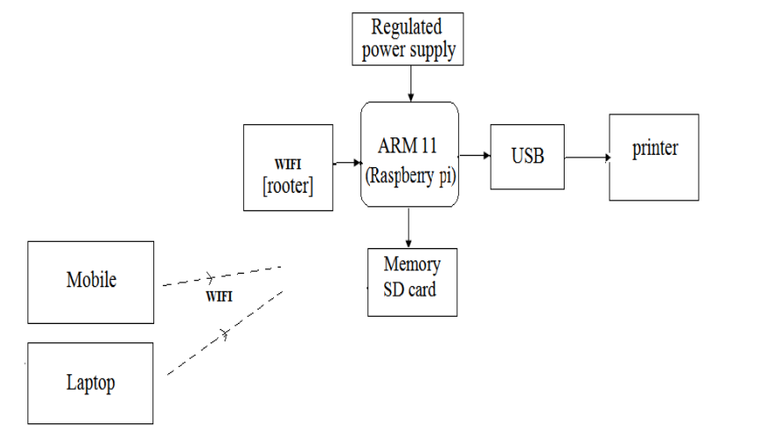

**Fig 1: System block diagram**

Why do we utilize Raspberry pi: Raspberry pi ('Raspi') is a computer roughly the size of a credit card that is meant to be cheap. This includes a 700MHz processor, an HD-capable graphics combination, and a minimum of 128MB of memory: there's even a memory card slot, audio/video outputs so you can connect it to your TV, and a USB port for a key board, mouse, etc. Nevertheless, everything totals up to a lower energy use than that of an incandescent light bulb. It was the effort of members of a group at Cambridge University Computer Science, such as Eben Upton, who eventually joined computer chip designers Broadcom. The way to do that is loading OS so that we can do the work we need to do.

The system architecture is shown in Figure 1. The disclosed Wi-Fi/USB printing converter receives any data where user (Mobile or Laptop) is reachable to be sent by WiFi. That way, the data can be transmitted directly to printing devices without computer device. Below, we take you through the key parts and devices.

**Steps for the process:**

1. Install OS on SD card
2. Install cups
3. Enable the setting to permit remote access on CUPS for scheduling simultaneous printing.
4. Configure port 631
5. Open host name: 631 in browser
6. Go to administration and Add printer
7. Select USB printer
8. Upload PPD file
9. Configure it Click on the configured printer in the printer main window.

Now we can print using any laptop computers, desktops etc. connected by common network where pis also goes through conducting with these above steps.

Thus, in this manner the raspberry pi printer can be used as network printer. This particular web page that is generated for printing can also be used to print on devices which are not at all even on the network at this moment and this results in accomplishing the objective of printing through this process from embedded system design setup constructed through the course of the project.

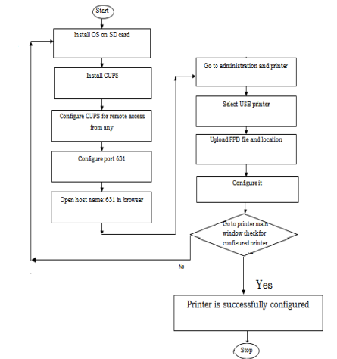

**Fig 2: Flow chart for entire process**

# HARDWARE DESCRIPTION

Raspberry Pi: Single-board computers are credit-card-sized, the Model B was produced by the Raspberry Pi Foundation in the UK to facilitate general computer science education in schools. Raspberry Pi is manufactured in two distinct board layouts under authorized manufacturing agreements with Newark element14 (Premier Farnell), RS Components and Egoman. The entities mentioned above are resellers of Raspberry Pi, i.e., they sell them online. Egoman uses such an appropriation model which can be viewed only in one of China and Taiwan, the Pis which are recognizable because of the red color and lack of FCC/CE mark. That implies, however, that produced hardware products are the same for all manufacturers. Depending on the model printer which we use raspberry pi is the core hardware which enables User to talk to printer. Ethernet: Ethernet is the most common local area network.

**Ethernet**: It refers to network connection in a wired manner. Ethernet is used by most offices and residences to connect their computers to the network and with each other. Some of the Ethernet networks may be connected together using a router to access the Internet for the clients on that Ethernet network. Our project entails the development of a grid of clients that would share the printer, which would be a Lambda, and the most ideal network technology suitable for this will be Ethernet. WIFI: Wireless Fidelity is a kind of local area network. Wi-Fi is a WLAN complying with standards IEEE 802.11, to be found in a host of devices.

**WIFI:** Wireless Fidelity is a type of local area network. Wi-Fi is a WLAN that standards IEEE 802.11, which is used in a wide range of devices. Internet surfing is mainly through Wi-Fi devices, Most of the internet access is through Wi-Fi technology in homes, Headphones, colleges, and offices, etc. Wi-Fi (short for Wireless Fidelity) Wireless networking technology often used to provide wireless Internet access (i.e. between internet infrastructure and end-user devices) and is the most common type of wireless networking technology. Our project uses Wi-Fi to connect the Raspberry Pi board wirelessly to the internet.

**Printer:** A device for printing the output of a computer on paper. Printer are the most popular peripheral printing text and still images onto paper.

# RESULTS

Now, with this invention, we can easily print the data, anytime or anywhere, from your Mobile cellphone or laptop computer gadget, and everything is available, ranging from all gadgets and no wires are required to print the data. Now you can print PDF files, text files and also Png ,jpg format file from your devices directly to the printer. It requires some network layer, similar to ethernet or wifi, populated by relays. MCU will get input through Wi-Fi and then will supply data for processing in controller. Data goes from mobile or laptop to controller and controller gives data to printer. This will load in OS of Raspberry pi the CUP which converts common data file into the printing form and then we get the printing document.

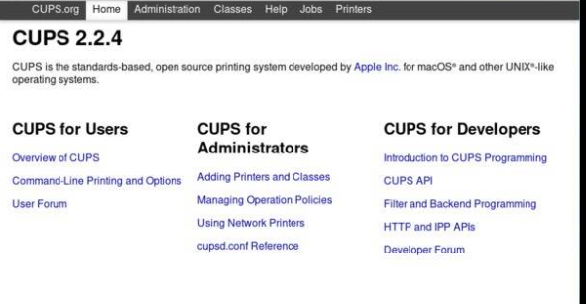

Fig:3: CUPS web interface



Fig:4: Raspberry Pi OS desktop environment

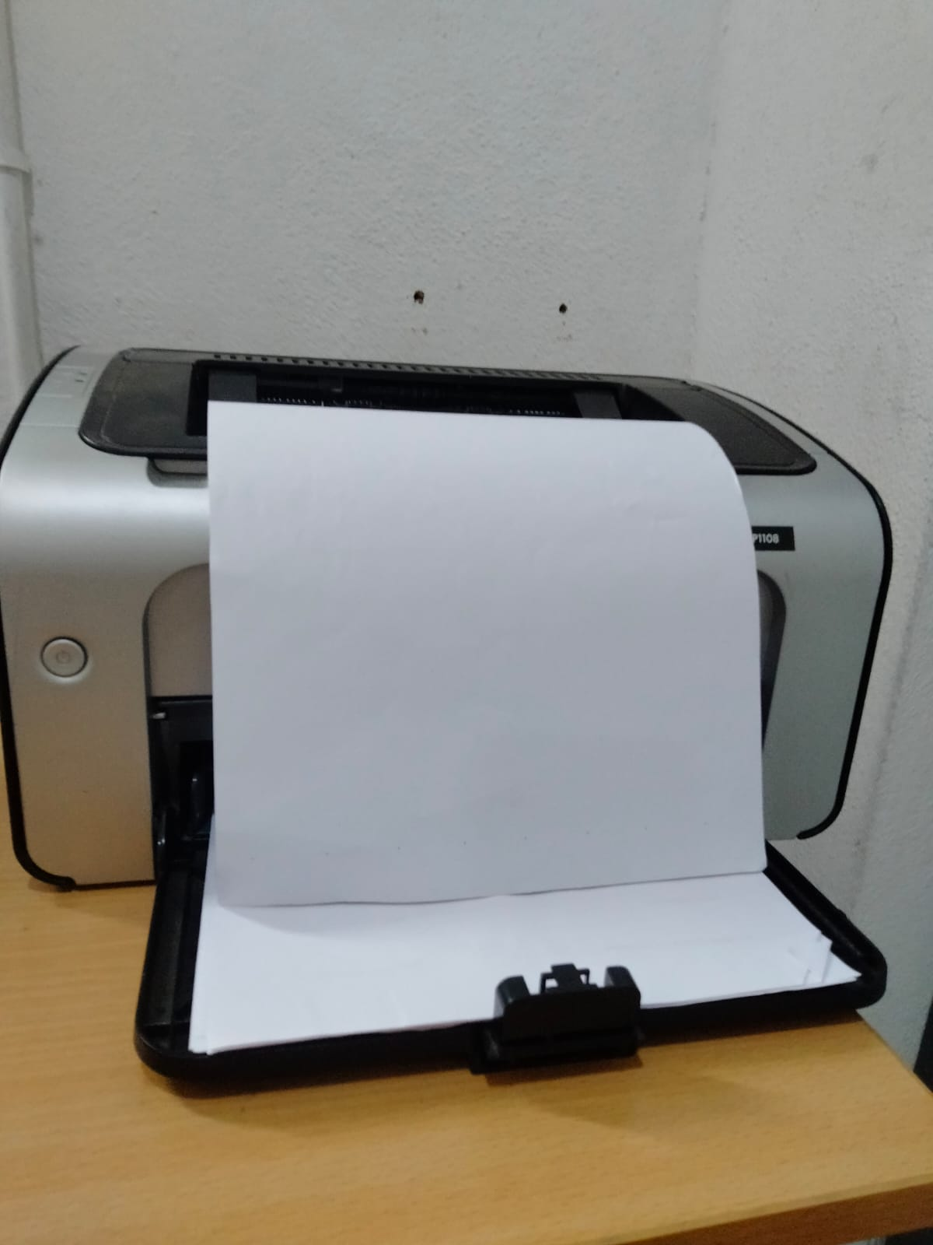

Fig:5: Output

# CONCLUSION

As Raspberry Pi is used as an interfacing device in this system, it makes any standard printer as a wireless printer. Importantly in data printing way, relay intermediate must to bridging between data printer, laptop or desktop pc computer. The data from Mobile is accepted first Before printing data printing on computer sends and takes it.

It is a really time-consuming process. In this paper we design low cost Wi-Fi to USB data converterwhich can receive data and control Printer device using Mobile's Wi-Fi port. It is the simplest method, as well as the time-consuming one. It is easy for us to receive data from mobile device in this process.

##### References

[1] Raspberry Pi Foundation, *Raspberry Pi Beginner's Guide*, 4th ed., Raspberry Pi Press, 2021.  
 (For setting up Raspberry Pi and understanding its hardware and OS configuration.)

[2] M. B. Patel and R. T. Patel, “Wireless Printing System using Raspberry Pi,” *International Journal of Innovative Research in Science, Engineering and Technology (IJIRSET)*, vol. 9, no. 3, pp. 2452–2457, Mar. 2020.  
 (Describes implementing a wireless print server using Raspberry Pi and CUPS.)

[3] A. Sharma and V. R. Sinha, “IoT Based Printer Sharing and Control System,” *International Journal of Computer Sciences and Engineering*, vol. 7, no. 12, pp. 46–50, Dec. 2019.  
 (Explores network printing using IoT devices and embedded controllers.)

[4] D. K. Rane and P. Jadhav, “Smart Office Automation Using Raspberry Pi,” *International Research Journal of Engineering and Technology (IRJET)*, vol. 6, no. 4, pp. 3547–3550, Apr. 2019.  
 (Includes a section on converting wired devices into wireless-enabled systems.)

[5] B. Singh and N. D. Patel, “Low-Cost Printing Network Using Raspberry Pi,” *International Journal of Scientific & Engineering Research*, vol. 10, no. 5, pp. 820–823, May 2019.  
 (Discusses creation of a home/office wireless printing setup using Raspberry Pi.)

[6] D. B. Deshmukh and S. Pawar, “Internet of Things (IoT) Based Smart Device Connectivity,” *International Journal of Advance Research, Ideas and Innovations in Technology*, vol. 5, no. 3, pp. 312–316, 2019.  
 (General overview of smart device connectivity using Raspberry Pi.)

[7] R. Kumar and V. K. Sharma, “Low-Cost Smart Home Automation and Printing System Using Raspberry Pi,” *International Journal of Advanced Research in Electrical, Electronics and Instrumentation Engineering*, vol. 10, no. 5, pp. 897–902, May 2021.  
 (Relates directly to enabling smart printing using Raspberry Pi.)

[8] T. Becker and J. J. Smith, “Wireless Printing Enhancement via IoT and Edge Devices,” *IEEE Internet of Things Journal*, vol. 8, no. 6, pp. 4560–4567, June 2021.  
 (A high-quality IEEE paper that supports the concept of wireless printing over IoT frameworks.)

[9] P. Sharma and S. Agrawal, “Raspberry Pi Based Wireless Print Server for Office Applications,” *International Journal of Computer Applications*, vol. 162, no. 9, pp. 1–4, Mar. 2017.  
 (This paper demonstrates the creation of a wireless print server using CUPS and Raspberry Pi for office environments.)

[10] K. Jain and R. Desai, “Embedded Linux System for Peripheral Sharing Using Raspberry Pi,” *International Journal of Electronics, Electrical and Computational System*, vol. 8, no. 2, pp. 22–27, Feb. 2019.